MEMORANDUM
LIGO LABORATORY

DATE | 5 Nov 2021
TO: | GariLynn Billingsley
CC | Peter Fritschel, Slawek Gras, Calum Torrie
FROM: | Dennis Coyne
SUBJECT: | Waiver: Sputtered Contamination on the A+ ITM 05 Barrel
Refer to: | LIGO-Q2100038-v1

Background:
On Oct 27, 2021 our polishing contractor, Zygo, informed us that after finishing the processing on ITM 05, and removing their tooling, they noticed a line of sputtered contamination on the cylinder/side flats about 1 cm from the R1 surface; see Figure 1. This is a direct result of the unusually large amount IBF work on this optic. It is likely that the other optics have some of this contaminant as well, though much less due to less IBF work.

Zygo has not had a formal analysis done, but due to the location and geometry they are confident that the sputtered material is Delrin. Sputtering conditions that they can share without disclosing confidential information: Kinetic energy transfer by neutral atoms at 10-6 torr. "Equivalent to a vacuum bake.” They believe that the contaminant is probably a hard, strongly adhered layer composed primarily of carbon, possibly containing some nitrogen, silicon or oxygen.

They have tried some “easy” cleaning methods to remove the contaminant without success. Specifically:
- Caustic - NaOH
- Buffing with cerium oxide
- Hydrogen peroxide

Analysis:
The contamination line on the barrel does not present any optical issues.

Since the contamination is an extremely small quantity of pyrolized Delrin residue (carbon, possibly containing some nitrogen, silicon or oxygen) it does not present a vacuum outgassing issue.

The presence of a material on the low loss fused silica test mass substrate could potentially add to the displacement thermal noise floor (strain noise). An analysis of the effect of a 100 nm layer of gold on the entire barrel of a test mass indicates that the effect is ~1% increase in the strain noise Amplitude Spectral Density (ASD). We can use this analysis to get an estimate of the effect of the sputtered contaminant. The plots of strain energy density indicate approximately uniform strain energy density along the barrel (to within a factor of ~4). Assuming spatially uniform strain energy density, and similar elastic modulus for the contaminant and gold, then the total strain energy (normalized by the force amplitude squared) for the contaminant line on the barrel is
$$U_{con}=U_{AU}\left(\frac{πDwt_{con}}{πDHt_{AU}}\right)=0.25U_{AU}$$
where
U_{AU} = total strain energy (normalized by the force amplitude squared) of the gold layer
D = 0.34 m, the optic diameter
H = 0.20 m, the optic thickness
w = 0.5 mm, the width of the contaminant line
t_{AU} = 100 nm, the thickness of the gold layer assumed in the analysis
t_{con} = 10 um, the approximate (assumed) thickness of the contaminant

In the referenced analysis, the presumptive gold barrel coating, with a loss factor of 0.009, resulted in ~1% increase in the strain noise ASD. The contaminant line is comprised of a very hard residue with likely a much lower loss factor. Consequently, the effect of the contaminant line is not consequential and the optic can be accepted without removal of the contaminant.

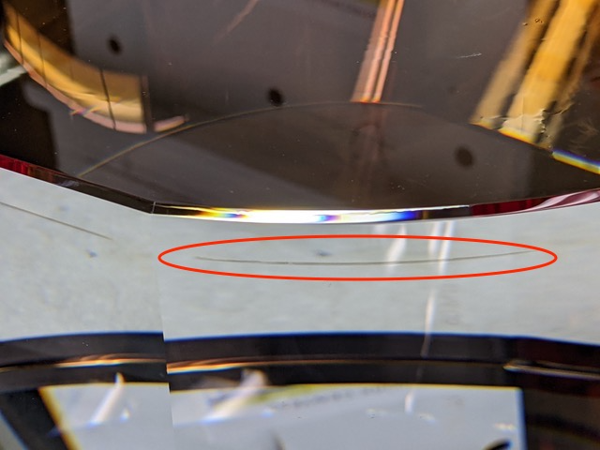
Figure 1 sputtered contamination on the A+ ITM 05 Barrel
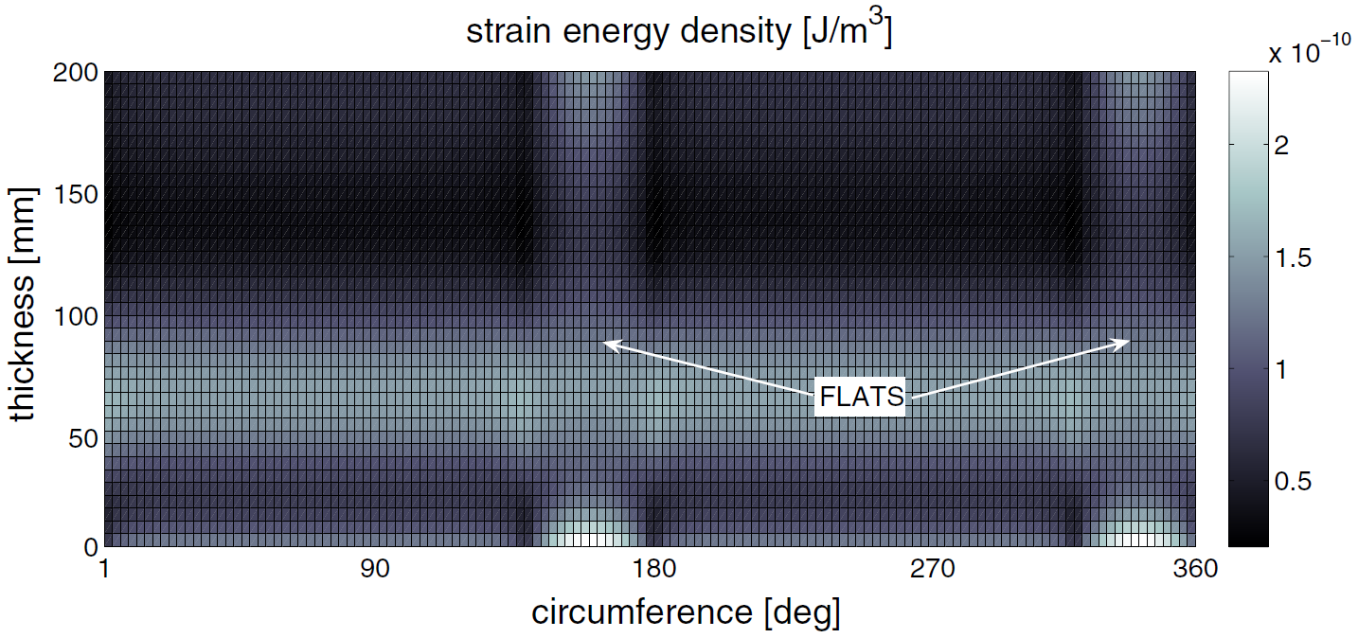
Figure 2 Strain energy density on a TM with flats on the barrel (credit: Slawek Gras)
Note: The referenced analysis assumed an axisymmetric test mass (without flats). The strain energy density plot above for an optic with flats is in rough agreement with the strain energy density plot in the referenced analysis. The strain energy density at the contamination line (at ~10 mm from the front surface) is higher than on the cylindrical barrel by a factor of ~2.

D.Coyne, P. Willems, “Thermal Noise Increase due to a Gold Coated Barrel”, LIGO-T080003

