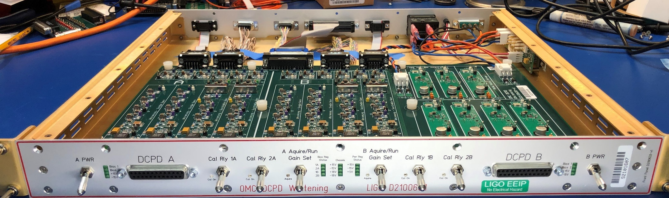
Figure 1: Front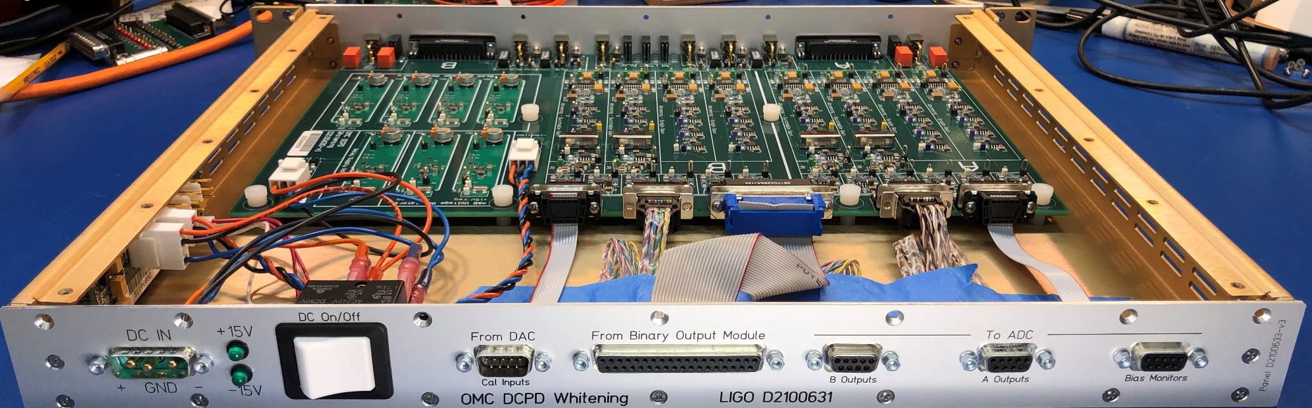
Figure 2: Rear
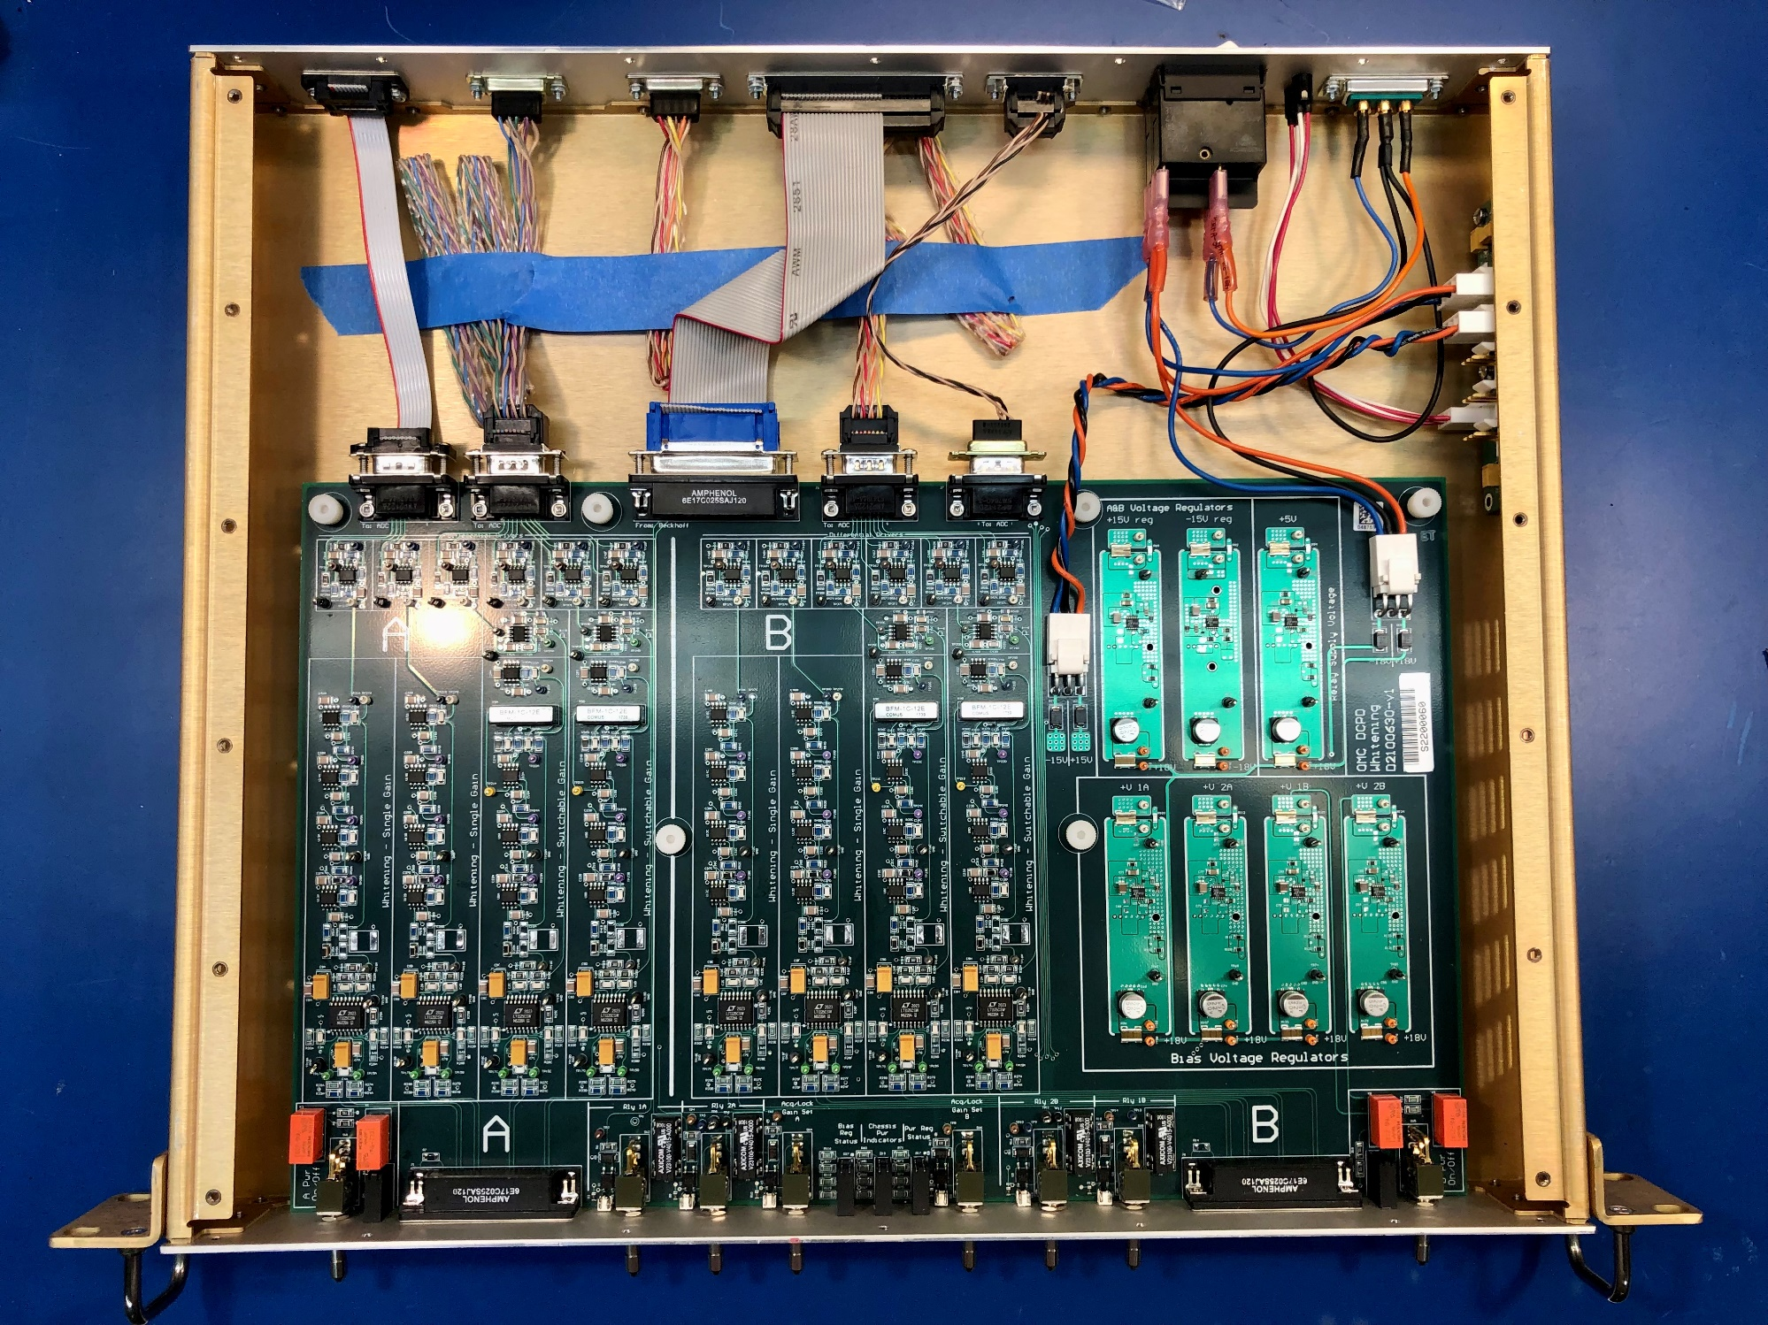
D2200038

D2200036

D2200037

D2200037

D2200039

