LIGO Laboratory / LIGO Scientific Collaboration

LIGO-T2100299-v3 LIGO 8/17/2021

Test Procedure for IO Interface Backplane

Marc Pirello, Daniel Sigg

Distribution of this document:
LIGO Scientific Collaboration

This is an internal working note
of the LIGO Laboratory.

California Institute of Technology  LIGO Project – MS 18-34  1200 E. California Blvd.  Pasadena, CA 91125  Phone (626) 395-2129  Fax (626) 304-9834  E-mail: info@ligo.caltech.edu | Massachusetts Institute of Technology  LIGO Project – NW22-295  185 Albany St  Cambridge, MA 02139  Phone (617) 253-4824  Fax (617) 253-7014  E-mail: info@ligo.mit.edu
LIGO Hanford Observatory  P.O. Box 159  Richland WA 99352  Phone 509-372-8106  Fax 509-372-8137 | LIGO Livingston Observatory  P.O. Box 940  Livingston, LA 70754  Phone 225-686-3100  Fax 225-686-7189
http://www.ligo.caltech.edu/

Introduction
The following Test Procedure describes the test of proper operation of the PCIe Timing Interface.

S/N ________________________ Tester ____________________________________

Date ________________________

Test Equipment
- Voltmeter
- Oscilloscope
- Fiber from a Timing Master/Fanout (optional),
- Windows PC with open motherboard with at least 1 PCIe slot free. Alternatively, use a PC with a PCIe extender like the Adnaco.
- Extra PC ATX power supply
- Adapter: Dual PSU power supply 24-pin adapter cable for ATX motherboard, and
- 2 test adapter board for backplane, D2100184.
- Breakout Boards – DB25 if needed

Preparations
- PC needs to run Windows 10, 64-bit, no secure boot.
- Install the device driver for LIGO Timing.
- Install the LIGOTimingApp program.
- Install a PCIe timing board in the PC and make sure the driver is loaded (it should show up in the Device Manager as “Timing > LIGO Timing Device”).

Caution
When connecting test adapters, backplanes and daughter cards, it is important that the correct FPGA program is loaded. Otherwise, it is possible to short two outputs together which can potentially damage the board.
- The backplane, D20000297, daughter board, D2000331, and the GPS expansion module, D2000301, require the FPGA timing code, E2000337.

Backplane Test
Setup the backplane with the extra ATX power supply and with the dual PSU Power Supply 24-pin adapter cable. Turn on the power.

- Check the voltages and LEDs on the backplane.

TP7 (+12V) ____________________ TP3 (+3.3V) ____________________

TP10 (+5V) ____________________

☐ LED DS1 (green)
☐ LED DS2 (green)
☐ LED DS3 (green)

- Insert PCIe board into PC, connect the DB37 cable.
Run the LIGO Timing App program and make sure it is running.

Set the frequencies of the backplane slots (Converter tab) to 16, 17, 18, 19, 20, 0, 15, -1, 14, and 13. Enable all slots. Set Out1 and Out 2 in the fields with white background.

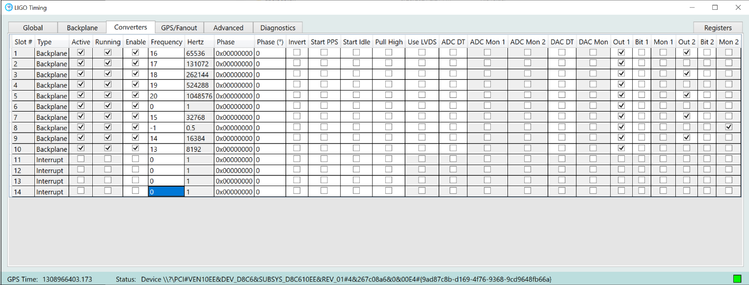
1

1: Device driver connected ☐ Nominal: green
Make sure the backplane is enabled:
2: All enabled ☐ Nominal: check
3: All running ☐ Nominal: green
4: Press watchdog button, and check the watchdog go green for ~2 sec.
5: Watchdog indicator ☐ Nominal: 2sec-green
6: Short pins 1 & 2 on P3 header ☐ Nominal: Temp Alarm goes red

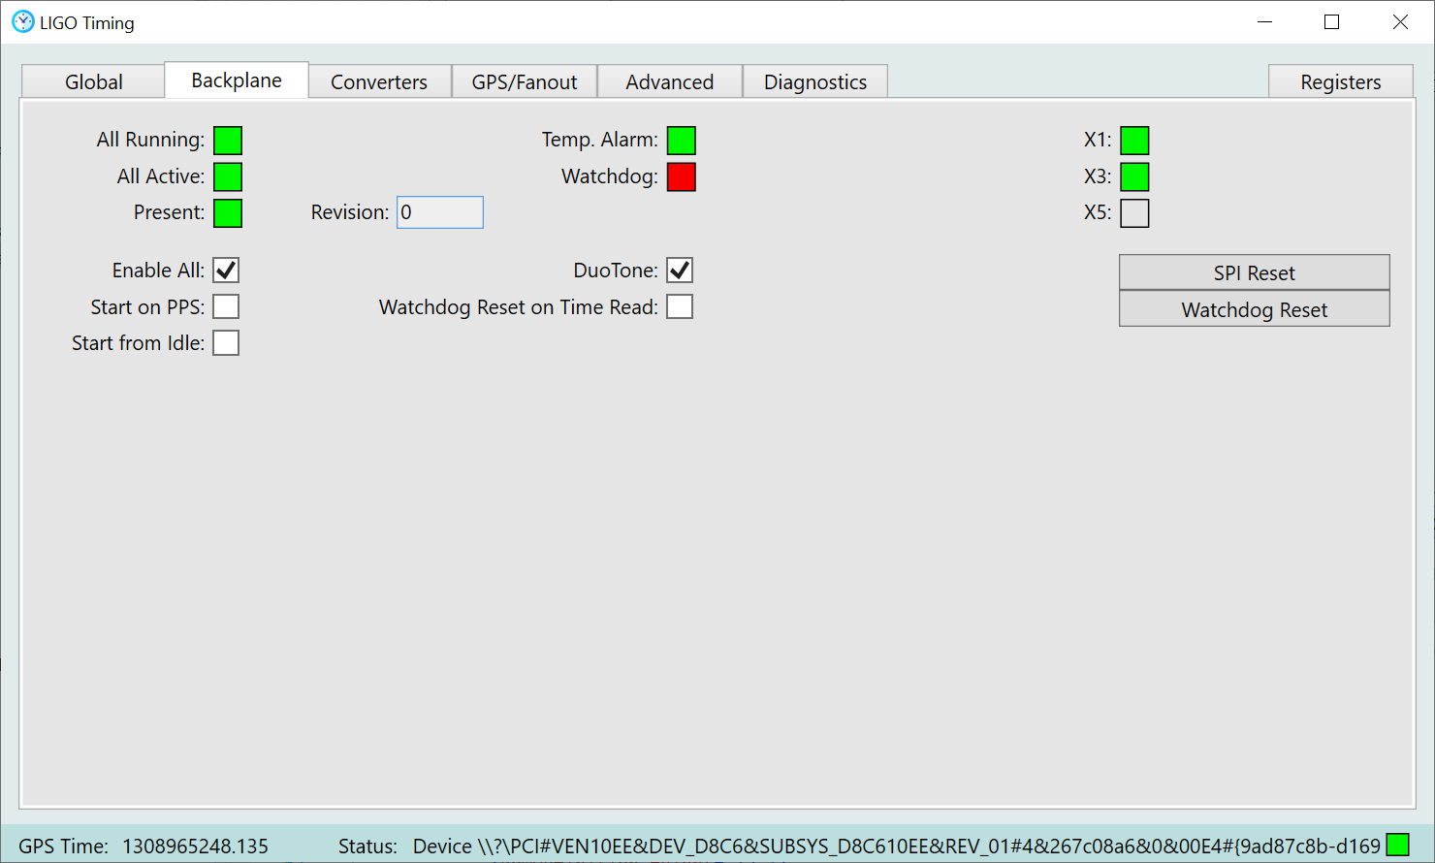
4
5
2
3

- Install two backplane adapter boards into slots 1 and 2, then equip them with DB25 breakout boards.

Toggle Slot 1/ADC DT: ☐ Nominal: Turns off 1st LED in slot 1
Toggle Slot 2/ADC DT: ☐ Nominal: Turns off 1st LED in slot 2
Toggle slot 1/DAC DT: ☐ Nominal: Turns off 2nd LED in slot 1
Toggle slot 2/DAC DT: ☐ Nominal: Turns off 2nd LED in slot 2
Toggle slot 1/Bit 1: ☐ Nominal: Turns on 3rd LED in slot 1
Toggle slot 2/Bit 1: ☐ Nominal: Turns on 3rd LED in slot 2
Toggle slot 1/Bit 2: ☐ Nominal: Turns on 4th LED in slots 1 & 2
Toggle 1st switch in slot 1: ☐ Nominal: ADC Mon 1 comes on in slot 1
Toggle 1st switch in slot 2: ☐ Nominal: ADC Mon 1 comes on in slot 2
Toggle 2nd switch in slot 1: ☐ Nominal: ADC Mon 2 comes on in slot 1
Toggle 2nd switch in slot 2: ☐ Nominal: ADC Mon 2 comes on in slot 2
Toggle 3rd switch in slot 1: ☐ Nominal: DAC Mon 1 comes on in slot 1
Toggle 3rd switch in slot 2: ☐ Nominal: DAC Mon 1 comes on in slot 2

Use a clip to probe the pins on the DB25 breakouts. Repeat after toggling “Use LVDS”. Pin 13 can be used as a ground.

Pin 1/slot 1: ☐ Nominal: 65536 Hz with LVDS on
Pin 2/slot 1: ☐ Nominal: 65536 Hz with LVDS on
Pin 3/slot 1: ☐ Nominal: 131072 Hz with LVDS on
Pin 4/slot 1: ☐ Nominal: 65536 Hz with LVDS off
Pin 5/slot 1: ☐ Nominal: 65536 Hz with LVDS off
Pin 1/slot 2: ☐ Nominal: 131072 Hz with LVDS on
Pin 2/slot 2: ☐ Nominal: 65536 Hz with LVDS on
Pin 3/slot 2: ☐ Nominal: 131072 Hz with LVDS on
Pin 4/slot 2: ☐ Nominal: 131072 Hz with LVDS off
Pin 5/slot 2: ☐ Nominal: 131072 Hz with LVDS off

With an Ohmmeter check short between pin 8 on slots 1 & 2: ☐ Short
With an Ohmmeter check short between pin 21 on slots 1 & 2: ☐ Short
With a scope check for DuoTone on pin 7 in slot 1: ☐ On
With a scope check watchdog on pin 25 in slot 1 (press watchdog button!): ☐ On
With a scope check watchdog on pin 25 in slot 2 (press watchdog button!): ☐ On

- Install two backplane adapter boards into slots 3 and 4, then equip them with DB25 breakout boards.

Toggle Slot 3/ADC DT: ☐ Nominal: Turns off 1st LED in slot 3
Toggle Slot 4/ADC DT: ☐ Nominal: Turns off 1st LED in slot 4
Toggle slot 3/DAC DT: ☐ Nominal: Turns off 2nd LED in slot 3
Toggle slot 4/DAC DT: ☐ Nominal: Turns off 2nd LED in slot 4
Toggle slot 3/Bit 1: ☐ Nominal: Turns on 3rd LED in slot 3
Toggle slot 4/Bit 1: ☐ Nominal: Turns on 3rd LED in slot 4
Toggle slot 3/Bit 2: ☐ Nominal: Turns on 4th LED in slots 3 & 4
Toggle 1st switch in slot 3: ☐ Nominal: ADC Mon 1 comes on in slot 3
Toggle 1st switch in slot 4: ☐ Nominal: ADC Mon 1 comes on in slot 4
Toggle 2nd switch in slot 3: ☐ Nominal: ADC Mon 2 comes on in slot 3
Toggle 2nd switch in slot 4: ☐ Nominal: ADC Mon 2 comes on in slot 4
Toggle 3rd switch in slot 3: ☐ Nominal: DAC Mon 1 comes on in slot 3
Toggle 3rd switch in slot 4: ☐ Nominal: DAC Mon 1 comes on in slot 4

Use a clip to probe the pins on the DB25 breakouts. Repeat after toggling “Use LVDS”. Pin 13 can be used as a ground.

Pin 1/slot 3: ☐ Nominal: 262144 Hz with LVDS on
Pin 2/slot 3: ☐ Nominal: 262144 Hz with LVDS on
Pin 3/slot 3: ☐ Nominal: 524288 Hz with LVDS on
Pin 4/slot 3: ☐ Nominal: 262144 Hz with LVDS off
Pin 5/slot 3: ☐ Nominal: 262144 Hz with LVDS off
Pin 1/slot 4: ☐ Nominal: 524288 Hz with LVDS on
Pin 2/slot 4: ☐ Nominal: 262144 Hz with LVDS on
Pin 3/slot 4: ☐ Nominal: 524288 Hz with LVDS on
Pin 4/slot 4: ☐ Nominal: 524288 Hz with LVDS off
Pin 5/slot 4: ☐ Nominal: 524288 Hz with LVDS off

With an Ohmmeter check short between pin 8 on slots 3 & 4: ☐ Short
With an Ohmmeter check short between pin 21 on slots 3 & 4: ☐ Short
With a scope check watchdog on pin 25 in slot 1 (press watchdog button!): ☐ On
With a scope check watchdog on pin 25 in slot 2 (press watchdog button!): ☐ On

- Install two backplane adapter boards into slots 5 and 6, then equip them with DB25 breakout boards.

Toggle Slot 5/ADC DT: ☐ Nominal: Turns off 1st LED in slot 5
Toggle Slot 6/ADC DT: ☐ Nominal: Turns off 1st LED in slot 6
Toggle slot 5/DAC DT: ☐ Nominal: Turns off 2nd LED in slot 5
Toggle slot 6/DAC DT: ☐ Nominal: Turns off 2nd LED in slot 6
Toggle slot 5/Bit 1: ☐ Nominal: Turns on 3rd LED in slot 5
Toggle slot 6/Bit 1: ☐ Nominal: Turns on 3rd LED in slot 6
Toggle slot 5/Bit 2: ☐ Nominal: Turns on 4th LED in slots 5 & 6
Toggle 1st switch in slot 5: ☐ Nominal: ADC Mon 1 comes on in slot 5
Toggle 1st switch in slot 6: ☐ Nominal: ADC Mon 1 comes on in slot 6
Toggle 2nd switch in slot 5: ☐ Nominal: ADC Mon 2 comes on in slot 5
Toggle 2nd switch in slot 6: ☐ Nominal: ADC Mon 2 comes on in slot 6
Toggle 3rd switch in slot 5: ☐ Nominal: DAC Mon 1 comes on in slot 5
Toggle 3rd switch in slot 6: ☐ Nominal: DAC Mon 1 comes on in slot 6
Toggle 4th switch in slot 6: ☐ Nominal: X1 goes off (backplane tab)

Use a clip to probe the pins on the DB25 breakouts. Repeat after toggling “Use LVDS”. Pin 13 can be used as a ground.

Pin 1/slot 5: ☐ Nominal: 1048576 Hz with LVDS on
Pin 2/slot 5: ☐ Nominal: 1048576 Hz with LVDS on
Pin 3/slot 5: ☐ Nominal: 1 Hz with LVDS on
Pin 4/slot 5: ☐ Nominal: 1048576 Hz with LVDS off
Pin 5/slot 5: ☐ Nominal: 1048576 Hz with LVDS off
Pin 1/slot 6: ☐ Nominal: 1 Hz with LVDS on
Pin 2/slot 6: ☐ Nominal: 1048576 Hz with LVDS on
Pin 3/slot 6: ☐ Nominal: 1 Hz with LVDS on
Pin 4/slot 6: ☐ Nominal: 1 Hz with LVDS off
Pin 5/slot 6: ☐ Nominal: 1 Hz with LVDS off

With an Ohmmeter check short between pin 8 on slots 5 & 6: ☐ Short
With an Ohmmeter check short between pin 21 on slots 5 & 6: ☐ Short
With a scope check watchdog on pin 25 in slot 1 (press watchdog button!): ☐ On
With a scope check watchdog on pin 25 in slot 2 (press watchdog button!): ☐ On

- Install two backplane adapter boards into slots 7 and 8, then equip them with DB25 breakout boards.

Toggle Slot 7/ADC DT: ☐ Nominal: Turns off 1st LED in slot 7
Toggle Slot 8/ADC DT: ☐ Nominal: Turns off 1st LED in slot 8
Toggle slot 7/DAC DT: ☐ Nominal: Turns off 2nd LED in slot 7
Toggle slot 8/DAC DT: ☐ Nominal: Turns off 2nd LED in slot 8
Toggle slot 7/Bit 1: ☐ Nominal: Turns on 3rd LED in slot 7
Toggle slot 8/Bit 1: ☐ Nominal: Turns on 3rd LED in slot 8
Toggle slot 7/Bit 2: ☐ Nominal: Turns on 4th LED in slots 7 & 8
Toggle 1st switch in slot 7: ☐ Nominal: ADC Mon 1 comes on in slot 7
Toggle 1st switch in slot 8: ☐ Nominal: ADC Mon 1 comes on in slot 8
Toggle 2nd switch in slot 7: ☐ Nominal: ADC Mon 2 comes on in slot 7
Toggle 2nd switch in slot 8: ☐ Nominal: ADC Mon 2 comes on in slot 8
Toggle 3rd switch in slot 7: ☐ Nominal: DAC Mon 1 comes on in slot 7
Toggle 3rd switch in slot 8: ☐ Nominal: DAC Mon 1 comes on in slot 8
Toggle 4th switch in slot 8: ☐ Nominal: X3 goes off (backplane tab)

Use a clip to probe the pins on the DB25 breakouts. Repeat after toggling “Use LVDS”. Pin 13 can be used as a ground.

Pin 1/slot 7: ☐ Nominal: 32768 Hz with LVDS on
Pin 2/slot 7: ☐ Nominal: 32768 Hz with LVDS on
Pin 3/slot 7: ☐ Nominal: 0.5 Hz with LVDS on
Pin 4/slot 7: ☐ Nominal: 32768 Hz with LVDS off
Pin 5/slot 7: ☐ Nominal: 32768 Hz with LVDS off
Pin 1/slot 8: ☐ Nominal: 0.5 Hz with LVDS on
Pin 2/slot 8: ☐ Nominal: 32768 Hz with LVDS on
Pin 3/slot 8: ☐ Nominal: 0.5 Hz with LVDS on
Pin 4/slot 8: ☐ Nominal: 0.5 Hz with LVDS off
Pin 5/slot 8: ☐ Nominal: 0.5 Hz with LVDS off

With an Ohmmeter check short between pin 8 on slots 7 & 8: ☐ Short
With an Ohmmeter check short between pin 21 on slots 7 & 8: ☐ Short
With a scope check watchdog on pin 25 in slot 1 (press watchdog button!): ☐ On
With a scope check watchdog on pin 25 in slot 2 (press watchdog button!): ☐ On

- Install two backplane adapter boards into slots 9 and 10, then equip them with DB25 breakout boards.

Toggle Slot 9/ADC DT: ☐ Nominal: Turns off 1st LED in slot 9
Toggle Slot 10/ADC DT: ☐ Nominal: Turns off 1st LED in slot 10
Toggle slot 9/DAC DT: ☐ Nominal: Turns off 2nd LED in slot 9
Toggle slot 10/DAC DT: ☐ Nominal: Turns off 2nd LED in slot 10
Toggle slot 9/Bit 1: ☐ Nominal: Turns on 3rd LED in slot 9
Toggle slot 10/Bit 1: ☐ Nominal: Turns on 3rd LED in slot 10
Toggle slot 9/Bit 2: ☐ Nominal: Turns on 4th LED in slots 9 & 10
Toggle 1st switch in slot 9: ☐ Nominal: ADC Mon 1 comes on in slot 9
Toggle 1st switch in slot 10: ☐ Nominal: ADC Mon 1 comes on in slot 10
Toggle 2nd switch in slot 9: ☐ Nominal: ADC Mon 2 comes on in slot 9
Toggle 2nd switch in slot 10: ☐ Nominal: ADC Mon 2 comes on in slot 10
Toggle 3rd switch in slot 9: ☐ Nominal: DAC Mon 1 comes on in slot 9
Toggle 3rd switch in slot 10: ☐ Nominal: DAC Mon 1 comes on in slot 10

Use a clip to probe the pins on the DB25 breakouts. Repeat after toggling “Use LVDS”. Pin 13 can be used as a ground.

Pin 1/slot 9: ☐ Nominal: 16384 Hz with LVDS on
Pin 2/slot 9: ☐ Nominal: 16384 Hz with LVDS on
Pin 3/slot 9: ☐ Nominal: 8192 Hz with LVDS on
Pin 4/slot 9: ☐ Nominal: 16384 Hz with LVDS off
Pin 5/slot 9: ☐ Nominal: 16384 Hz with LVDS off
Pin 1/slot 10: ☐ Nominal: 8192 Hz with LVDS on
Pin 2/slot 10: ☐ Nominal: 16384 Hz with LVDS on
Pin 3/slot 10: ☐ Nominal: 8192 Hz with LVDS on
Pin 4/slot 10: ☐ Nominal: 8192 Hz with LVDS off
Pin 5/slot 10: ☐ Nominal: 8192 Hz with LVDS off

With an Ohmmeter check short between pin 8 on slots 9 & 10: ☐ Short
With an Ohmmeter check short between pin 21 on slots 9 & 10: ☐ Short
With a scope check watchdog on pin 25 in slot 1 (press watchdog button!): ☐ On
With a scope check watchdog on pin 25 in slot 2 (press watchdog button!): ☐ On

Pass/Fail

☐ Pass

☐ Fail

________________________________________________________________________________________________
________________________________________________________________________________________________
________________________________________________________________________________________________
________________________________________________________________________________________________
________________________________________________________________________________________________
________________________________________________________________________________________________
________________________________________________________________________________________________
________________________________________________________________________________________________
________________________________________________________________________________________________
________________________________________________________________________________________________
________________________________________________________________________________________________
________________________________________________________________________________________________
________________________________________________________________________________________________
________________________________________________________________________________________________
________________________________________________________________________________________________
________________________________________________________________________________________________
________________________________________________________________________________________________
________________________________________________________________________________________________

