Science Summaries: explaining LIGO-Virgo-KAGRA results to the global public

David KEITEL^{*1} for the LIGO Scientific, Virgo and KAGRA collaborations

Abstract. LIGO, Virgo and KAGRA (LVK) form the second-generation global network of gravitational wave detectors. From the first detection of the GW150914 binary black hole merger to the latest results from the recent O3 observing run, our observations are pushing frontiers in observational astrophysics. To continue inspiring the wider public with our findings, one key communications activity of the LVK collaborations are "science summaries" for each of our papers. These texts provide a less technical introduction to the topics covered in each paper and its key results, aimed at both students and interested lay readers. They are published at www.ligo.org and promoted through social media channels of the three collaborations. Before the pandemic, they also proved popular as printouts at science fairs, and we all hope we can return to that mode of outreach soon. As a global collaboration, over recent years we have also significantly stepped up our output of translations of these summaries, drawing on member scientists from across the globe, with materials published in a total of 23 different languages so far.

1. Introduction
Since the first detection of gravitational waves (GWs) announced in 2016 [1], the LIGO and Virgo Collaborations have been successfully “making waves” in the attention of the global audience. By now we are also joined by our KAGRA colleagues. The collaborations sustain a vigorous education and public outreach programme. This covers the basics of our field (what is a GW, what is a black hole, how does an interferometric detector work…), big milestones like the multi-messenger event GW170817 [2] and the 2017 Nobel Prize in Physics, but also the details of our latest scientific results. A key medium for the latter are our “Science Summaries” which we publish for almost all of our scientific papers, covering the key points in a format and style accessible to a wide audience. Here I will cover the philosophy, typical contents, and dissemination strategy of these LVK science summaries. I also focus on our volunteer translation effort, which aims to reach more diverse audiences around the globe and help our member scientists communicate with their local communities.

2. What do we want to achieve?
With science summaries, we want to tell the public about the specific research we do: What are our actual papers about? For the 3 observing runs since 2015, we have published 43 papers from O1, 39 from O2, and 20 from O3 (still counting) [3]. The collaborations are committed to writing summaries for each paper; this is now integrated as a deliverable in project planning and editorial team roles.

*1 Departament de Física, Institut d’Aplicacions Computacionals i de Codi Comunitari (IAC3), Universitat de les Illes Balears, and Institut d’Estudis Espacials de Catalunya (IEEC), Carretera de Valldemossa km 7.5, E-07122 Palma, Spain
david.keitel@ligo.org
The goal is to make the results of our publicly funded research accessible and understandable to the general public, including students at all levels and non-scientists around the world.

3. What are these summaries?
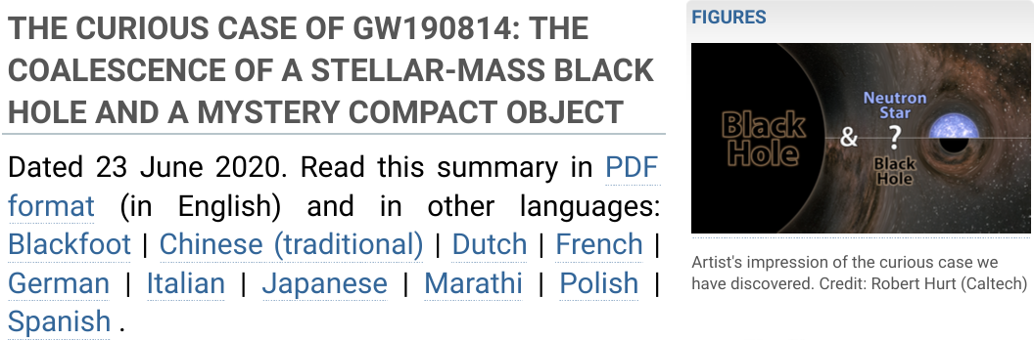
Fig. 1. Start of the online version of an example science summary (GW190814 discovery).

Summaries are usually between 2 and 4 print pages long, including illustrations, figures taken directly from the paper, and text. They introduce the specific paper’s topic, very briefly explain the methods used, and focus on the results and their impact. They are written and reviewed by collaboration members, ensuring some diversity in the degree of familiarity with the technical details as well as in seniority, global distribution, and mother tongue, to make sure the summaries will be understandable to a wide audience. The expected reading level is generally somewhat higher than e.g. in newspaper coverage of scientific results, more similar to dedicated magazines for enthusiastic lay readers. We generally reduce mathematical notation and technical terms as much as possible, but we also try to teach the readers a few new concepts and terms in each text. Each summary also contains a glossary for a few technical terms specific to the current topic, links to previous summaries covering related papers, to dedicated online resources, and to Wikipedia entries, and pointers to freely accessible preprints of the actual scientific paper.
4. How do we disseminate the summaries?
The summaries are published online at ligo.org [4] and advertised through social media, but also provided as attractively formatted PDF files, with prints distributed at real-life outreach events. They are also very useful as resources for starting undergraduate and graduate research students and to give science journalists an overview of new results, with the latter channel giving a large multiplier factor to the impact of the summaries.

5. Translations: improving our global reach
Most of global science and science communication is conducted in English. But to reach the broadest and most diverse audience around the globe, we need to bring our science to people in their own languages. The first LVC science summaries were getting translated into Spanish since 2014, but the effort has significantly picked up since 2016. By now for 22 different languages (beyond English) we have at least one summary translated and, as a record, the GW190521 results were covered in 16 languages.
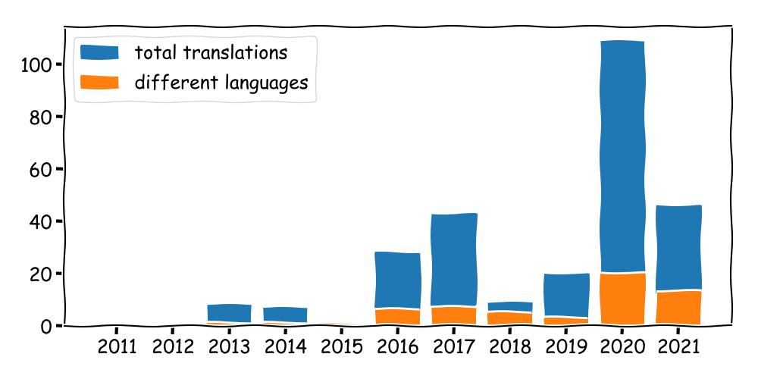
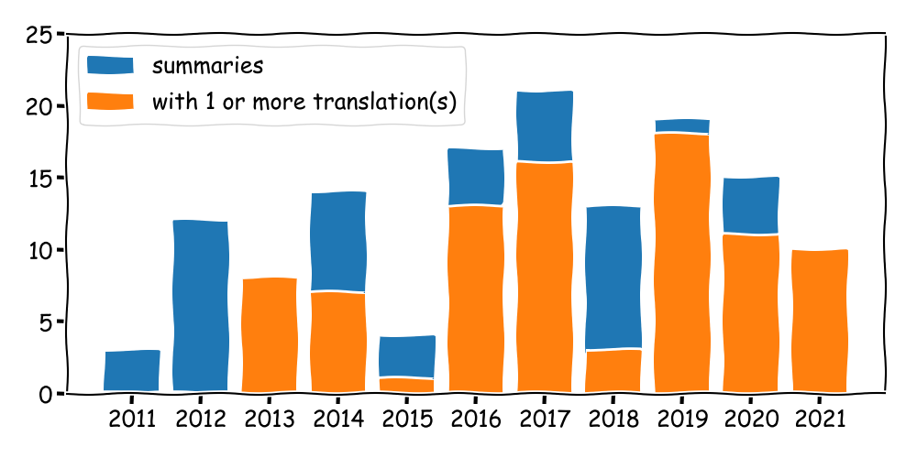
Fig. 2. Statistics of summaries and translations as of 29/06/2021; 2021 numbers are still rapidly rising.

These translations are a fully volunteer-driven effort: very few LVK members are paid for outreach, so most translators are scientists and students who do this in their free time. As a take-away message for readers from other large international collaborations: you likely also have a big talent pool available for doing outreach in general and translations in specific; people just need to be motivated and organised!

6. Volunteer perspectives
To highlight the degree of enthusiasm that goes into translating science summaries, here are some quotes by some of our volunteers. C. Martí, translating into Catalan and Spanish, highlights that “translation [...] provides the opportunity for everyone to understand science”. N. Arnaud, translating into French, says that "explaining [LVK results] in my mother tongue is my way to give back" to his community. H. Shinkai, translating into Japanese, considers the translations also a “good learning experience […] suitable for undergrad students”. And S. Yellowfly, who translates into the Blackfoot language to great public acclaim [5,6], lauds this as “a culture-affirming experience for the Blackfoot people”.

7. Evaluation and room for improvement
Our procedures for drafting, reviewing and translating summaries have greatly improved over recent years, but we are still working to increase automation of the formatting and publishing stages. In addition, we need to improve quantitative evaluation of our online dissemination channels, with the goal to improve reach and impact.

8. Summary
Science summaries are a cornerstone of LVK outreach, telling the global public not only about the basics of GW science, but also the actual results we achieve with each of our papers. Translations are another crucial ingredient to improve global reach and to really bring our science to the people.

References
[1] B. P. Abbott et al. 2016, PRL 116, 061102
[2] B. P. Abbott et al. 2017, PRL 119, 161101
[3] https://pnp.ligo.org/ppcomm/Papers.html
[4] https://www.ligo.org/science/outreach.php
[5] N. Greenfieldboyce 2019, NPR, https://www.npr.org/2019/03/31/706032203
[6] M. Fore 2021, Symmetry Magazine, https://www.symmetrymagazine.org/article/einsteins-garden-translating-physics-into-blackfoot

Acknowledgements
DK is supported by the Ministerio de Ciencia, Innovación y Universidades (BEAGAL 18/00148) and cofinanced by UIB, and by Spanish, Comunitat Autonoma de les Illes Balears, and EU grants PID2019-106416GB-I00/AEI/10.13039/501100011033, RED2018-102661-T, RED2018-102573-E, PRD2018/24, PROMETEO/2019/071, CA18108, CA17137, CA16214, CA16104, and the Tourist Stay Tax Law ITS2017-00. LVK acknowledgements at LIGO-P2100218. This document: LIGO-P2100213

