LIGO LABORATORY
California Institute of Technology
1200 E. California Blvd.
Pasadena, CA 91125

Vacuum Feedthrough Cable Shield Connections
T2000221-v1

This document is for illustration of proper connections of the shell and shield only. For all connections at the Vacuum Feedthrough the shield must be connected only to pins on the air side, and not the back-shell. For 25 pin connectors, pin13 (shield) on the air side of the feed-through becomes pin1 in vacuum, and pin3 (shield) becomes pin 1 on 3 pin connectors. The back-shell must remain electrically isolated on both sides of the feed-through.

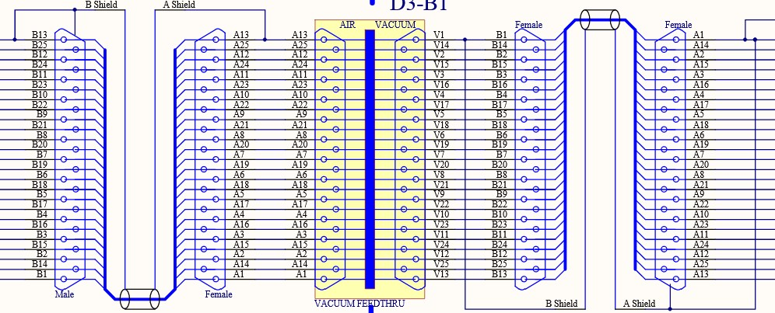
Figure 1: 25pin Shield Connections

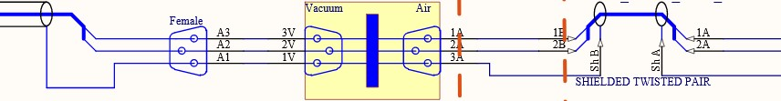
Figure 2: 3pin Shield Connections

