LIGO Laboratory / LIGO Scientific Collaboration
T1900395-v1 | LIGO | June 2019 5

Incoming Test of SQZ Spare Mephisto 1000NE Laser
Jason Oberling

Distribution of this document:
LIGO Scientific Collaboration

This is an internal working note
of the LIGO Laboratory.

California Institute of Technology  LIGO Project, MS 100-36  1200 E. California Blvd.  Pasadena, CA 91125  Phone: (626) 395-2129  FAX: (626) 304-9834  E-mail: info@ligo.caltech.edu | Massachusetts Institute of Technology  LIGO Project, NW22-295  185 Albany St.  Cambridge, MA 02139  Phone: (617) 253-4824  FAX: (617) 253-7014  E-mail: info@ligo.mit.edu
LIGO Hanford Observatory  P.O. Box 159  Richland, WA 99352  Phone: (509) 372-8106  FAX: (509) 372-8137 | LIGO Livingston Observatory  P.O. Box 940  Livingston, LA 70754  Phone: (225) 686-3100  FAX: (225) 686-7189

http://www.ligo.caltech.edu

Scope and Purpose
This document shows the results of the incoming tests performed on the Coherent Mephisto 1000NE S/N 5834 laser system, hereafter referred to as the NPRO. This is the spare NPRO laser for the SQZ subsystem.

Introduction
Upon unpacking, the NPRO powered up without issue. Below are the serial numbers of the NPRO and its power supply, as well as a list of equipment used for the testing.

Serial Numbers
- Mephisto 1000NE, P/N 1309412, S/N GDP.1309412.5834
- Mephisto Controller, P/N 1309412, S/N GDP.1309412.5834

Equipment
- Power meter: Ophir Vega, P/N 7Z01560, S/N 730491
- Calorimeter: Ophir 10A-V2-SH, P/N 1Z02146, S/N 75126
- Beam profiler: Thorlabs BP209-VIS
- Photodiode: Thorlabs PDA36A
- Signal Analyzer: SRS SR785

Laser Settings
The data sheet for the NPRO is located on the DCC file card for this test report. For completeness, the NPRO settings are shown in Table 1.
Table 1: NPRO Settings
NPRO crystal temperature | 26.20 °C
Diode current | 2.14 A
Diode A temperature | 26.01 °C

Output Power
The output power was measured to be 1.12 W after a warm-up period of ~5 minutes.

Free-space Beam Propagation
The free-space beam propagation was measured with the beam profiler listed above and is shown in Figure 1 along with a Gaussian fit. The transmitted beam through a 98/2 (%R/%T) beamsplitter was used to do this measurement. For the purpose of this measurement, zero is the flat front face of the NPRO laser housing.
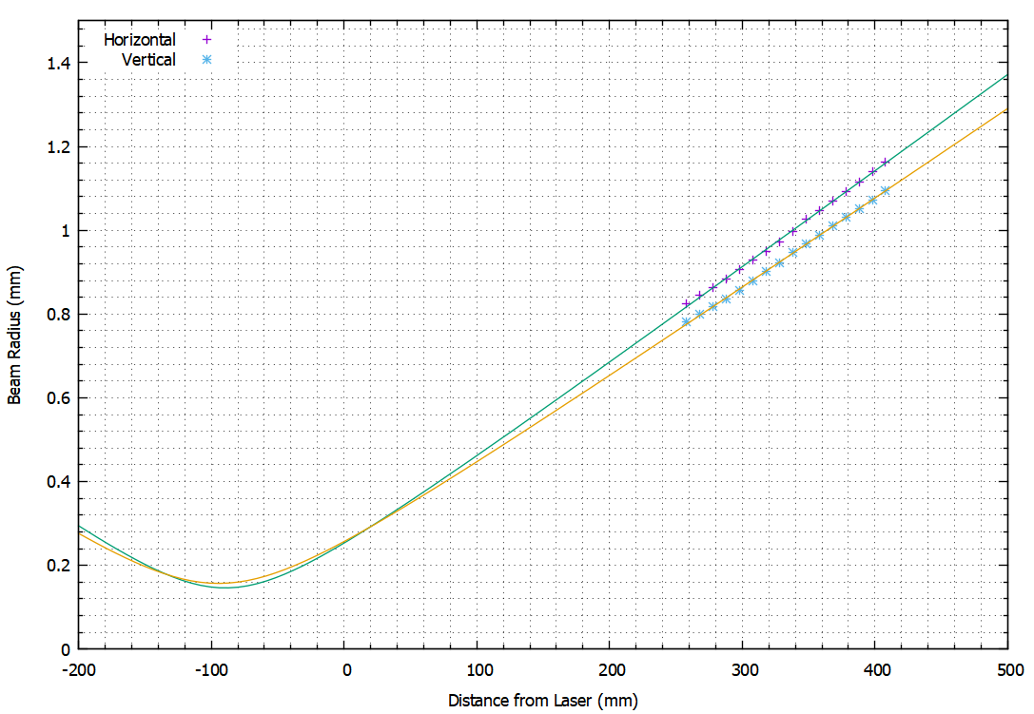
Figure 1: The measured free-space beam propagation.
Table 2 summarizes the NPRO beam waist radius and location. As stated above, zero is the flat front face of the NPRO laser head housing.
Table 2: NPRO Waist Radius and Location
 | Waist Radius (µm) | Waist Location (mm)
Horizontal | 146 | -89.4
Vertical | 157 | -94.4

Relative Power Noise
The measured low-frequency relative intensity noise (RIN) is shown in Figure 2; the measurement was performed with a SR785 Digital Signal Analyzer from Stanford Research Systems. It should be noted that Coherent does not give a performance specification for the RIN below 10 kHz. It simply lists the RIN as better than -140 dB/Hz at frequencies greater than 10 kHz, which the NPRO satisfies.

Figure 2: Measured RIN of Mephisto 1000NE SN5834

