LIGO Laboratory / LIGO Scientific Collaboration

LIGO-E1900223-v1 Advanced LIGO / A+ 7/24/2019

Review Report
Design Requirements and Concept
for the A+ ISC Filter Cavity and
Relay Optics

Valery Frolov, Sheila Dwyer, Adam Mullavey, Koji Arai, Daniel Sigg (chair)

Distribution of this document:
LIGO Scientific Collaboration

This is an internal working note
of the LIGO Laboratory.

California Institute of Technology  LIGO Project – MS 18-34  1200 E. California Blvd.  Pasadena, CA 91125  Phone (626) 395-2129  Fax (626) 304-9834  E-mail: info@ligo.caltech.edu | Massachusetts Institute of Technology  LIGO Project – NW22-295  185 Albany St  Cambridge, MA 02139  Phone (617) 253-4824  Fax (617) 253-7014  E-mail: info@ligo.mit.edu
LIGO Hanford Observatory  P.O. Box 159  Richland WA 99352  Phone 509-372-8106  Fax 509-372-8137 | LIGO Livingston Observatory  P.O. Box 940  Livingston, LA 70754  Phone 225-686-3100  Fax 225-686-7189
http://www.ligo.caltech.edu

Executive Summary
The committee finds the requirements for the inclusion of a filter cavity in Advanced LIGO well-motivated, complete and accurate. A number of caveats are listed the following sections.

Findings
The installation and delivery of the filter cavity, the relay optics and the sensing and controls system is the time between the third and fourth observation run. This is a very short time line to finish both a preliminary design and a final design and to get everything assembled and tested. The committee would like to see the final design wrapped up by the end of the year with a preliminary design completed before the October commissioning break.
One of the drivers for the filter cavity requirements is the back scatter problem from light exiting the output Faraday isolator in the direction of the squeezed light source and then being reflected by the filter cavity. Since the filter cavity is a two-mirror design the reflection is close to 100%.
We are concerned about the locking scheme for the filter cavity. As presented, it requires significantly more CLF power than we were able to run with in the past. We consider this a high risk item and urge the inclusion of alternative locking schemes to mitigate some of the risk. Another risk is the relatively high phase noise that has been inferred from the existing squeezer setup. If true, this would limit the squeezing potential in A+ and we recommend to investigate this further during the current observation run.
A critical feature of the filter cavity design is that we will have to run with significant higher CLF power compared to what we have previously deployed. The current CLF power towards the interferometer is ~1 µW at LHO, compared to ~0.4 µW at LLO. We would need about ~40 µW CLF/RLF power for locking the filter cavity. In the past, higher power in the CLF introduced excess noise in the gravitational readout channel. We believe that this is due to intensity noise on the CLF and can be mitigated by stabilizing both the CLF power and the green pump power of the OPO.
The committee has also identified a number of items that are needed and are very unlikely to change. We therefore approve these items and recommend to start procurement as soon as possible. We have also identified a number of items we consider urgent. We recommend that these items are completed on an accelerated schedule and brought to individual review, so they can proceed to procurement.

Actions

Develop a requirement for initial alignment and positioning
We ask the A+ ISC team to develop requirements for initial alignment and positioning of the filter cavity mirrors, and to the degree this is necessary also for the relay optics. These requirements need to be communicate with IAS and the systems engineering group, so that they can be incorporated into the construction and installation procedures.

Derive a requirement for the green pump and CLF intensity noise
We ask the A+ ISC team to develop a requirement for the intensity noise allowed on the green pump light and on the CLF. We also ask to identify appropriate sensing points. Is the green transmission of the OPO, which is currently only a few ppm, sufficient, or do we need a new mirror with higher green transmission?

Test of the higher power CLF
We consider the requirement on the CLF power one of the major risks in this design. We strongly recommend:
- Implement the intensity stabilization servos in the current system using the ECR process.
- Test the high power CLF in the current configuration as early as possible.

Test of the high speed digital data acquisition
The block diagram introduces a high speed digital data acquisition to record and demodulate the channels that carry information at 105 kHz. We recommend to complete a test by the time of the FDR to see, if the current infrastructure can handle acquisition rates of 2¹⁹ or 2²⁰ Hz. (Data processing can still be handled at 2¹⁵ Hz due to the slow control bandwidth.)

Approved items
Due to the accelerated schedule that requires installation of the filter cavity between O3 and O4, the review committee was looking to identify parts of the design that are ready for procurement and production. We approve to go forward with the following items:
- Design for 200.105 MHz VCXO source, 200 MHz demodulator and 200MHz RF combiner
- Power stabilization of green pump and CLF
- Development of IR QPD chain in transmission of FC (depending on a decision whether to include a far field sensor)
- Development of a low power QPD chain for FC sensing (assuming that sampling the reflected FC beam is adopted as the baseline)
- All electronics associated with the green diagnostics beam
- Production of 2/ifo picomotor controllers for ISC

Near term items
We identify a list of items that are either urgent or are close to be ready. We recommend that these items are brought to a final design very soon and that they are reviewed as they become available, so they can move into procurement.
- The filter cavity optics substrates and coatings.
- The optics tables which are used to capture beams from HAM7 and HAM8. We also recommend to look at a replacement for ISCT6 to capture beams from HAM6. This includes size and location, with considerations what is still available from H2.
- The integrated floor plan with optics tables, racks, and cable trays.

Recommendations

Filter cavity sensing by sampling the reflected beam
We recommend that the ISC team considers to sample the beam in reflection of the filter cavity for sensing both the alignment and the longitudinal degrees-of-freedom. This has the advantage to be independent of the OMC, which makes commissioning easier. And, it has the advantage of lower sensing noise for the alignment. In particular, the OMC QPDs may work poorly for aligning the filter cavity due to the large amount of junk light at the anti-symmetric port. However, the new detectors operate at very low light level with the signal at 105 kHz. We need to investigate, if we can achieve a sufficient SNR.

Add quadrant IR sensor in transmission of the filter cavity
We recommend that the ISC team considers adding a quadrant IR sensor in transmission of the filter cavity to sense the position of the resonant RLF beam. We also recommend to look at the usefulness of the second far field QPD, and possibly eliminate from the design.
We also recommend to lock at the usefulness of the far field QPDs in transmission, and the option to use near field sensors only.

Length sensing with detuned RLF
We recommend that the ISC team considers sensing the filter cavity length using a detuned RLF rather than a resonant one. This has the advantage of a cleaner error signal, since the RLF- sideband generated by the OPO now contributes exactly the same way.

Filter cavity sensing with null servo
We recommend that the ISC team considers sensing the filter cavity length and alignment using an additional CLF2 sideband so that the resulting error signal is close to zero in both demodulation phases.

OMC DCPD response at 3.125 MHz
The OMC DCPD detectors are used by the squeezer LO servo to sense the beat note at 3.125 MHz. However, in-vacuum electronic amplifier was never design for this high a frequency. We recommend to reevaluate, if an update of the in-vacuum electronics is warranted.

OMC QPDs to replace the 42.4 MHz wavefront sensors
We are skeptical that demodulating the OMC QPD sensors by 3.1 MHz will have fewer problems than the AS port wavefront sensors, demodulated at 42.4 MHz. Whereas the 42.4 MHz wavefront sensors are sensitive to the 45.5 MHz RF sideband motion, the 3.1 MHz OMC QPD will be sensitive to carrier junk light. This sensing scheme also requires a DC offset and won’t work with a balanced homodyne. We recommend to drop the dedicated hardware for this. One can always use the hardware that is currently used for the 45.5 MHz demodulation, if this turns out to be required for O4.

Technical Scope

Scope
The scope of this report is to review the design requirements and concept for the A+ ISC filter cavity and relay optics, described in T1800447 and supporting documents.
Supporting documents are located in E1900221:
- Preliminary ISC design: T1900416
- Optics layouts: D1900281
- Electronics block diagram: E1900201
The full scope of A+ ISC also includes additional sub-subsystems for adaptive wavefront compensation (AWC), low-loss Faraday isolators (FI), and the balanced homodyne readout (BHD) as well as the integrated electronic controls infrastructure (ISC CDS). These elements will be reviewed separately in future.

Charge to the Review Committee
1) Please refer to the check list of general LIGO review criteria in section 11.3 of LIGO-M1500263; additional guidance specific to A+ Project design reviews can be found in LIGO-M1800239.
2) Evaluate the DRD T1800447 to insure that it captures all relevant criteria for success. These should include such factors as:
- Clarity of presentation and operating context
- Compatibility with the planned A+ optical and mechanical configuration
- Flexibility to accommodate potential outcomes of the filter cavity R&D program proceeding con
- Compatibility with existing Advanced LIGO infrastructure
- Provisions for installation, testing, commissioning and future maintenance
3) Please investigate and comment on the degree to which requirements for the filter cavity and relay optics may depend on uncertain or optional features of these related components. Identify what provisions, if any, may be required to insure that the designs can proceed independently without risk of incompatibility.
4) Summarize comments and recommendations in a report addressed to Dennis Coyne (LIGO Chief Engineer) and Michael Zucker (A+ Project Lead). Any panel requests for action should be clearly categorized as follows:
- Required change: Panel approval is conditional on implementation.
- Recommendation: Panel advises but does not require adoption.
- Comment/Suggestion: Panel requests the design team investigate and consider, e.g., a potential improvement, or wishes to convey other helpful information.

Review Comments and Questions
Here is a collection of questions and answers which were investigated during the review process.
- DS: Where is the phase noise requirement of 10⁻⁶rad/√Hz coming from?
Lee: The phase noise requirement is that phase noise on the RLF or green will appear as a sensing length-noise, and the cavity control system will inject it as real motion, which will then drive backscatter (violate the length noise requirements due to backscatter). These are sections 8.2-8.3 in the DRD T1800447. The RLF is needed since there is no way to transport the 532 into the chamber and keep its phase as clean.
It is approx 1e-6 rad/√Hz with 3-faradays worth of isolation
It is a "soft" requirement, as we can roll-off the control system and "be clever". It is a similar control/sensing issue as in angular A2L. I am targeting the "pessimistic" 3-faraday goal assuming that if we go beyond it, then we will remove the extra Faraday to the minimal 2 Faradays for lower loss. For O4 near term it is also relaxed since we are not shot-noise limited from 10-20Hz, but I think the 1e-4 rad/rtHz currently on the CLF is still a bit too much. Even if we don't improve the electronics of the OMCPD's to hit shotnoise-limited sensing of the CLF, then increasing the power should get us to 1e-5 rad/rtHz. We can also use the 3'rd Faraday in a double pass form to make an effective 4-Faraday implementation if backscatter is truly bad or we cannot hit the phase-noise requirements.
DS: I don't understand why this is a phase noise requirement. A cavity will sense frequency below the cavity pole and phase above. I assume the control BW of the filter cavity won't be much higher than its cavity pole. So, I would have expected the requirement to be flat in frequency noise!? 10⁻⁶ rad/rtHz is easy at 100 kHz but hard at 1Hz.
Lee: Indeed, it may be conceptually clearer as a frequency noise requirement, call it a requirement for 1e-5 Hz/√Hz at 10-20Hz. That's just hard enough that the only reasonable thing to do is stabilize the SQZ laser to the AS-port carrier, which is the most stable frequency reference in town (I assume...). Any stabilization scheme is then easiest to consider in phase units.
The only other way I see the meet the req. is to send in the homodyne-LO into HAM7 to stabilize the RLF in a separate polarization or something.
This scheme seems much easier, using the fact that the LO-loop stabilizes the CLF to shot-noise, and then piggy-back on that stability for the RLF. If only it will work.
DS: I am still trying to follow the 10⁻⁶ rad/√Hz of phase noise requirement. Sect 8.2 in T1800447 talks about 120dBc at 100Hz falling like 1/f, which translates into 10⁻⁴Hz/√Hz flat. This in turn corresponds to a length requirement of 10⁻¹⁵m/√Hz. So, do figures 10 and 11 show a flat sensing noise of 10⁻⁴Hz/√Hz? In other words, is the phase noise requirement at 10Hz 100dBc?
Lee: I doubled checked how I was calculating it and I believe you are right. I chose some convoluted wording and a reference frequency of 100Hz. Indeed the requirement is the much more reasonable 1e-5 rad/√Hz at 10Hz (100dbc), corresponding to 1e-4 Hz/√Hz. I'll update the DRD first thing next week. Maybe we can have only 2 Faradays after all.
Lee-later: here are the requirements plots based on the reference control implementation in T1800447. This is the acceptable noise level in units of sensing phase noise
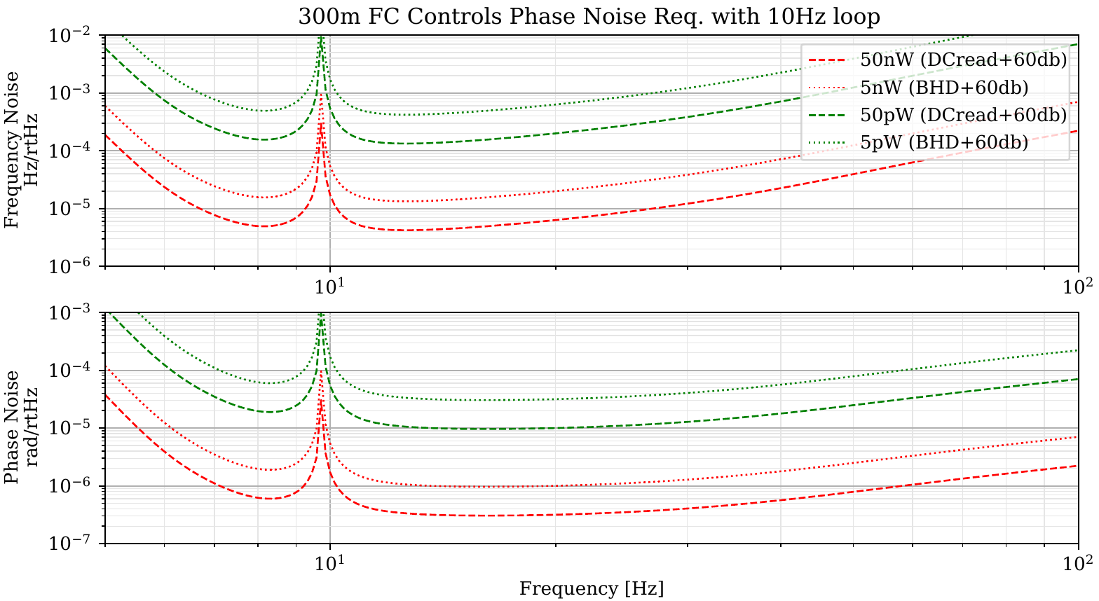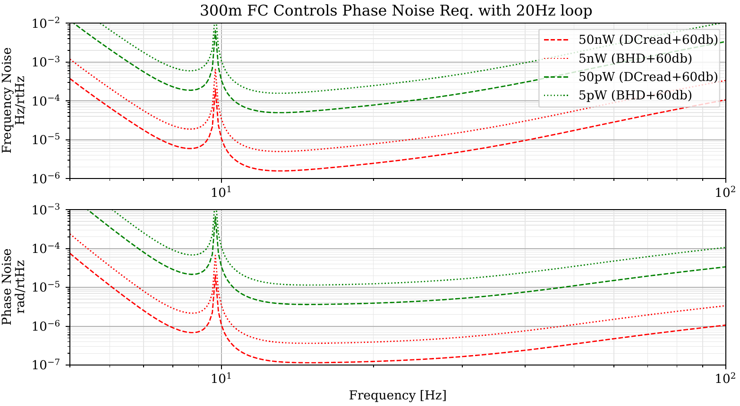
- DS: Intensity noise requirement: Is it the same for CLF & RLF individually or sum?
Lee: Both will be going to OMC. With 1e-6/rtHz RIN from the SQZ laser, then we actually are still safe with 1mW total power on OPO M2 (or about 40uW on OMC, 400nW on OMCPDs). The ISS's on pump/CLF are a safety since the laser has some lines and whatnot, but the intensity noise requirements aren't any better than the laser noise, it's just a broadband source that would be best to stabilize.
We will need the 1mW evenly split between CLF and RLF to hit 1e-6 rad/rtHz on the SQZangle and RLF loops for the phase noise req.
DS: Also, since the CLF-/RLF- sidebands depend on the green pump power and the CLF+/RLF+ power, do you need to stabilize the pump power as well? We are already doing this here at LHO but not at LLO.
Lee: The OPO pump will be modulating RLF sidebands. Since the CLF/RLF intensity noise is important and the pump drives sideband intensity, I've been assuming that pump stabilization is good practice simply from that standpoint, but yes, pump noise is also a path for phase noise.
It may be that phase noise is a stronger driver for a much stronger pump ISS, but 1e-6 RIN/rtHz I would suspect is sufficient for 1e-5 rad/rtHz, however the OPO 1064 finesse ~100 might make a requirement more like 1e-7 RIN/rtHz to achieve that phase noise.
- DS: CLF/pump power stabilization?
Are there requirements for the intensity stabilization of CLF and pump? I can't find anything in T1800447. Using intensity noise numbers from the laser may be too optimistic, see alog 45088.
If you look at the green pump power as measured in reflection and in transmission, there is not much correlation for frequencies <10 Hz. Jitter? See alog 48363.
We only have 325 nW of green in transmission. So, the sensing noise is expected to be ~2x10⁻⁶ RIN/√Hz. This level is reached around ~30 Hz. This is all somewhat miserable, and I am wondering, if we need a new M2 mirror for the OPO with a green transmission between ~1000-3000ppm. This would increase our transmitted OPO power by 300-1000, and improve the sensing noise by ~20.
I am also wondering, if the CLF reflected beam suffers from similar excess noise as the pump? This would make it less ideal for the CLF power stabilization. Using the Q-phase signal in reflection may have more promise, but the equivalent power in the beat note seem to be only a few uW.
Lee: I have not computed/documented requirements yet for the CLF and pump. The CLF should be somewhat straightforward, but the pump may be more difficult.
We could use the homodyne to correlate the transmission and reflection intensity noise of the CLF, similar to what you mention for the pump. If there is a beam jitter issue into the OPO from the CLF, then that would be good to know. Due to the escape efficiency requirements it will be hard to do better for the CLF using the 2F Q-phase since we cannot increase that transmissivity. It is also possible to use the Q-phase signal from the CLF/RLF on the OMCPD's, but it is messy with all of the other controls noise modulating it. It actually may be worth taking a spectrum of that signal to get a sense of the current intensity noise on the CLF now, regardless of whether it is good to control on it. I fear it may be quite alarming. IF we stabilize on the DCPD Q-phase signal, then it is showing the CLF after pump intensity has had a chance to modulate it, in which case the OPO pump ISS may not have to be better than 1e-6.
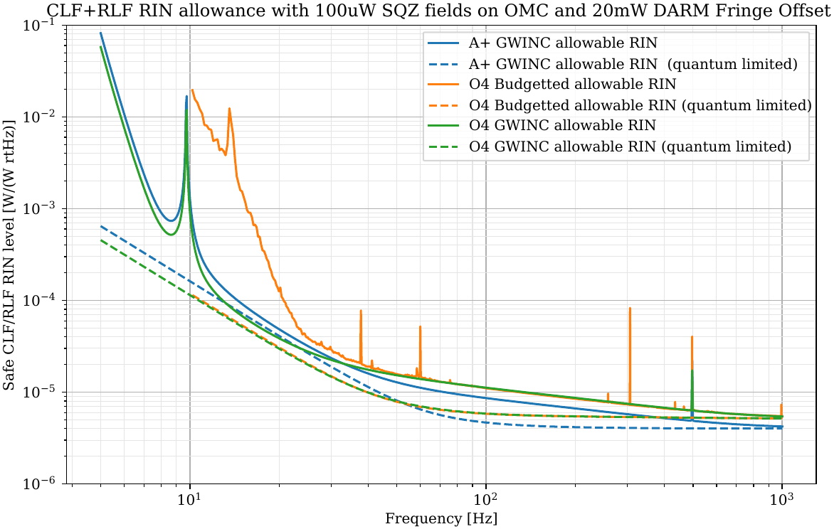
Lee: Here are the CLF/RLF RIN requirements. They include as safety factor of 1/10. I'll put them in the control design doc, but this is a preview.
Suggests to me that even if there is a bit of beam jitter between the CLF fiber and OPO, we could ISS control from the CLFPD DC to get plenty of power. The frequencies with such jitter should be below this budget (TBD... depends on how the fibers couple in this jitter)
The pump requirements are next. They will be established from the intensity noise effect on both the CLF intensity and phase stability, so they are a bit more difficult, but I think at least estimates can be made for the intensity effect.
DS: This means we need only about 100nW for sensing. The 1% pick-off can almost do it! I guess you can always suppress the pump noise with the CLF ISS. If you ask that the green ISS doesn't make it worse, you would require similar amount of green power. Must depend on the NLG I assume.
- DS: Effect of the OPO generated RLF/CLF fields at ~6.25 MHz offset?
In my nomenclature, the RLF- is 6MHz away from RLF+ and is generated by the OPO.
You cannot really avoid it. For high non-linear gains, RLF- would approach RLF+ in amplitude.
There is obviously a CLF- that is also generated by the OPO.
I was looking at your fig 2 in T1900416. It shows the squeeze field detuned in the FC, the RLF+ resonant and the RLF- detuned by 2 cavity pole frequencies. In the current scheme, the FC error
signal would be RLF+ beating against CLF+, but RLF- against CLF- would generate a signal
too. Since they are detuned, this signal isn't very helpful. Doing some math the RLF- will acquire about 126 degree of phase shift, which yields a PDH signal that is about 80% of max. This seems bad.
The figure on the left below shows the error signal in I and Q generated by the RLF+ and CLF+ beat, when the RLF is resonance. Basically, a single sideband type of PDH where the Q signal peaks on resonance. The figure below on the right shows basically the same but I am adding the RLF-/CLF- beat note detuned by 2 FC-pole. RLF-/CLF- have 80% of the RLF+/CLF+ amplitude.

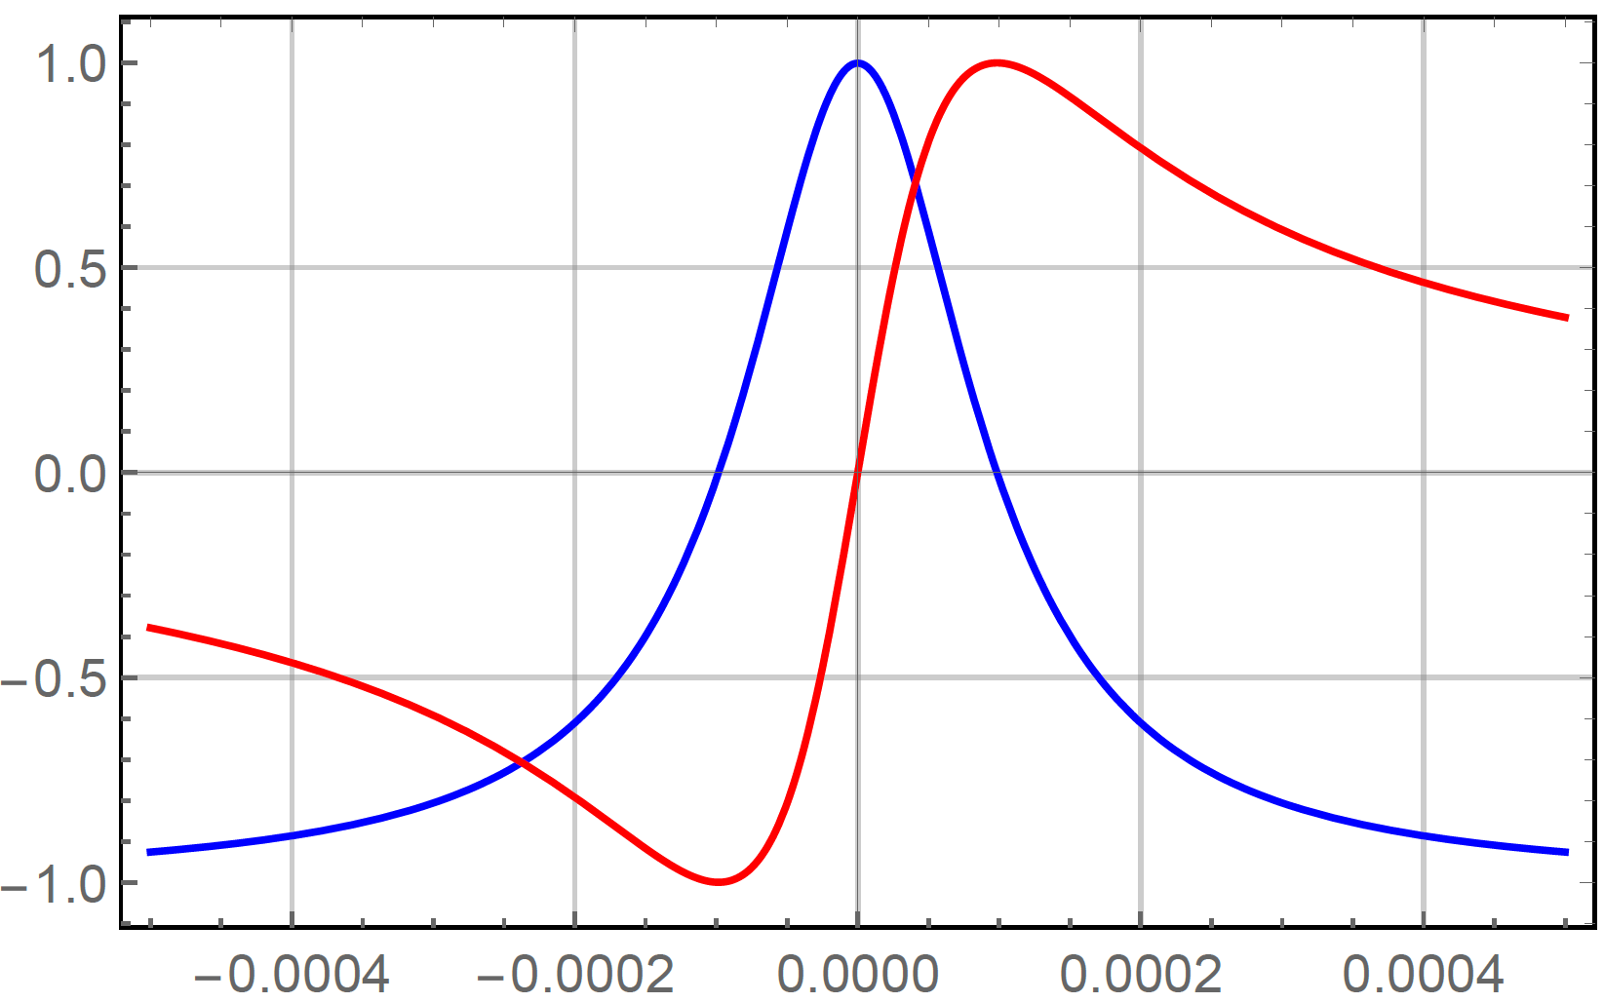 | 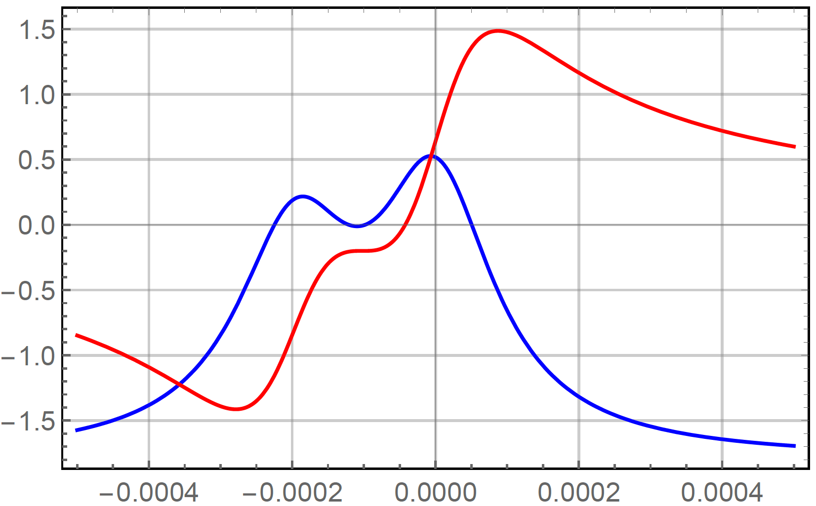
- RLF/CLF locking signals.
Have you considered a scheme where the RLF+ has the same detuning as the squeeze field? Then, RLF- would also have the same detuning and produce exactly the same signal (± some RF phase delay due to the 6MHz difference).
If you look at a single SB set up in reflection, you get the PDH signal in the I-phase, whereas the Q-phase shows a maximum on resonance. But, if you look at the half width point, the roles are reversed, and you might just as well lock at the zero crossing of the Q-phase.
There is a price to pay, when you lock at the half width point, since you lose half the slope. But, since RLF- now contributes rather than does its own thing, you would regain most of the sensitivity.
Lee: OK, I see what you mean. Indeed the error signal is a bit nasty in the existing 2-pole-detune scheme, so I favor the 1-pole balanced scheme.
- DS: Can we make the locking scheme more like a null servo?
I am wondering, if you could generate the RLF and CLF by using a 200 MHz (fixed) AOM followed by a 203.020 MHz (VCXO) AOM, which you strongly modulated at 105 kHz. The CLF1 will then be generated as the upper sideband of this modulation at 3.125 MHz. You would also get a second CLF2 at 2.915 MHz which is useless as a CLF, but would make the cavity locking signal look more like a standard PDH, i.e., no signal in the opposite phase. (In the left panel of Figure 1, it would zero the red trace.) Generally, if you generate a second sideband on the RLF, you can zero the Q phase, if it is PM; or zero the I phase, if it is AM.
In fact, with this AM modulated RLF input at 105kHz you would be left with a nice null servo.
Lee: I'm not sure I understand the advantages of such an AM scheme though. Ok, so perhaps one can use a pickoff to get the RLF PDH with a small Q (or alternatively, I) phase. Is this a worry due to the saturation of PD's, from offsets?
- The optical phase noise stability of the RLF relies on the LO/SQZANG loop using the CLF sideband.
- The CLF loop still creates moderate-sized Q-phase on the OMCPD. I'm not sure why having some residual Q-beatnote on the RLF is bad as long as it is comparable to the CLF's (which the balanced-detuning scheme appears to achieve).
- The additional CLF2 sidebands from the modulation will add to the total RF beatnote power on the OMCPDs (even if the RLF is read out from a SQZ pickoff)
- The filter cavity detuning for SQZ won't in practice be exactly 1-pole, since we will optimize to the IFO power, so there is not a unique operating point. Either we establish a reference point such as I=0 and shift the RLF frequency, or we shift the detune using a demod phase (necessary for the RLF+- balanced detuning).
My primary defense for the existing RLF ssb + CLF ssb injection scheme is based on these points, namely that the RLF will operate identically to the CLF scheme except with cavity sensitivity. This is good since the LO-loop CLF field is the backbone of the phase requirement, and it seems better to have to get that right twice than use a PDH scheme complicated/detuned from passing through the OPO. When the FC is off-resonance/misaligned we will have a witness of the RLF beatnote stability as well, and then just have to lock on the right I/Q at the chosen RLF frequency for the desired detuning. As long as all of the PLL phasings are stable, whatever RLF demod angle is chosen to lock to zero and RLF frequency to drive should end up as stable as the CLF loop is.
DS: One can debate the advantage of null servos over ones with large offsets. In practice, we find that it is mostly the WFS that suffer. In a true null servo the WFS signals are independent of the beam position. Once you add offsets, this tends to go south. But, we can probably make either scheme work. I am not a fan of the OMC QPDs used as WFS for the FC. There is a lot of junk on these sensors which will affect the DC centering, and their sensing noise.
I agree to your point C. CLF2 only adds shot noise and out-of-band signals. In principle, one could make use of it, but I doubt it would be worthwhile.
As to D: I am thinking you can still adjust the exact locking point by changing the 105 kHz frequency. This will generate opposite offsets in the RLF+/CLF+ and RLF-/CLF- beat notes, and hence move the locking point.
To be honest I don't see large advantages or disadvantages of either scheme. It is not that difficult to move from one to the other neither.
- DS: Why is there a green injection into the filter cavity, if we use the RLF?
Lee: The green is to acquire lock and transition to RLF. While we may be able to get lock entirely in red:
- We likely would have to have a higher-bandwidth actuator than the HSTS to acquire, requiring us to transfer control (need more summing points on TTFSS).
- During the transition to IFO lock, we would lose the cavity and have to re-acquire it with potentially large transients in the IFO. May be OK, but seems risky.
- I don't think debugging the cavity/control without the external control field will be easy. I think ultimately, we will save considerable commissioning time to have 532 control, but it is why there are no 532 WFS, as it is not the primary control.
DS: I am still hoping to find a way to get rid of the green beam in the FC. This only has a chance, if you can lock the difference between RLF+ and RLF- to an exact multiple of the FSR (in principle, the CLF servo does this), and if you can distinguish the RLF from the CLF(s). In principle, the later can be done in the AM configuration by requiring the opposite phase to be zero. But, I still need to do some thinking here.
Lee: Do you want to get rid of the FC green beam altogether, or just while RLF-locked? I was assuming the 532 loop would not be used once RLF-locked on the OMCPD. I still think it will be useful to essential for diagnostics.
DS: As part of the review, I think we need to look at the costs of the green diagnostics/locking field. If it is needed as a locking field, this is one thing. But, if it is diagnostics only, one could ask if it is worthwhile. So the first question is, do we need it to lock the FC?
Peter/Lee: It seems impossible to sense the position of the red beam on the end mirror. There is no more than 100 mW of red light in the cavity and the transmission through the end mirror is very small. Hence, we need the green beam in the cavity.
- DS: Add an IR QPD in transmission of FC?
I am wondering, if there really isn't enough light in transmission of the FC end mirror? Having some indication where the red beam position is certainly better than none at all. If I assume 30uW input, I get ~100mW in the cavity and 10nW, if I assume a transmission of 0.1ppm. With a 10-100MOhm transimpedance, you would still get a decent signal.
Looking at our IR QPDs, we have typically a dark noise level of 100fA/rtHz, so the SNR seems fine. Offsets seem large at ~5nA. It might work up to 100Hz-1kHz, if we use in-vac electronics, or bring the beam onto a table. You could freeze out the dark noise by cooling the device, but this may not be necessary. There is also a smaller size device available that should have lower dark current.
Peter: The 5 nA of dark current is with a reverse bias of 5 V. For this case we could operate them with zero bias, and Koji says the zero bias dark current is typically just a few pA. We would need a telescope to reduce the transmission beam from 3 cm to 3 mm.
Lee: Interesting. Seems to be feasible. For aligning such low-light QPDs, I was planning to have a fiber to deliver and couple 1064 through the end mirror for mode-matching / diagnostics purposes. Such a beam can be used to establish an initial alignment reference as well.
Even though the PD's will be InGaAs, at that sensitivity they will be swamped with 532 light unless we filter it. I expect we will disable the 532 field once lock is acquired. Does it make sense to dual-purpose these (may be difficult to make a common telescope functioning at both wavelengths), or to strip off the 532 entirely. If we strip off 532, do we need/want additional 532 QPDs in transmission?
DS: Considering the low power, you probably want an InGaAs QPD for red, whereas 532 needs to be Si. One thing that isn't great with the FCI-Q3000 is the shunt resistance. Typically, it is below 10MOhm. The Q1000 is probably better because it is smaller. There are a few in the >40MOhm regime. Maybe, we can select?
Hamamatsu and GPD seem to spec the QPD shunt resistance. Trying to go much beyond 10 MOhm seems to require cooling for 3 mm devices. 1 mm devices are more promising.
- DS: Transmission QPDs
I am wondering, if we really need 2 red (and green) QPDs in HAM8. Usually we only want to know the beam position on the local mirror (near field). Is the far field information useful for anything?
Lee: I wasn't sure if we might need them for pre-wfs alignment stabilization. We don't have other optical levers in this setup, so if the mirrors are moving >1e-5 rad RMS, then to acquire 1064 lock we might like both mirrors observed. Hopefully in-air 532 QPDs may be sufficient to get to that level though.
Using 1064 QPDs in transmission is a bit chicken and egg. If we need cavity resonance to see the beam on them, then the only strong reason to have them is an alignment loop, in which case we'd want both near/far. If we can see the beam in direct transmission (approx. 1pW of light when using 1mW of seed out of OPO, T=1e-3 IC T=1e-6 end mirror), then indeed we may only be using them to position the beam on the far mirror.
I suppose if we have the SQZ 105kHzWFS pickoff now designed, then that will observe the DC location of the IC beam, so the transmission beam will only need 1 QPD.
DS: We should have some idea about stability and fluctuations from the IMC history. We never use the far field sensor in the transmon to determine the ITM position, because the transmon setup isn't stable enough. Maybe, it works at 300m, but not clear to me.
Having an input reference will help a lot, when you lose the alignment.
- DS: Green locking
I am wondering, if you could save the green locking, if you would interfere the green diagnostics beam with the pump beam in vacuum and lock the beat to an OCXO. The best place to do this is the beamsplitter/dichroic that combines the diagnostics beam with the squeezer beam. There is probably not enough green pump propagating along the squeezer beam to make this work. Is this necessarily the case?
Lee: Also, every dual wavelength optical system has residual between the two. While on paper I think this scheme could meet requirements, we'd have to really model alignment noise effects.
DS: Yes, this might be a problem. I think it would also require a relatively high green finesse, so its sensing can compete with the red line width.
Lee: So far these effects are dominating our and naoj's filter cavity experiments. While A+ will control way better than lab experiments, it's a noteworthy risk of green only sensing.
DS: Even for locking only we need to lock at the stability. I added some links to the rms frequency drift of the VCO in the wiki. Free running seems not so good, so we need a frequency readback. This gives us an rms of ~15 Hz. Your block diagram should add another timing comparator/frequency counter, since we are out of ports with the existing one.
Lee: I'll have to think about that. Seems sound in principle, although you're sacrificing 1064 wfs and trusting in the coalignment of 1064 and 532.
You'd want a double aom scheme on the fc532 to use a low enough offset freq to meet phase noise req in vco, so you'd still need to lock those together. Not sure you could fit optical beatnote stuff on current vopo platform but maybe.
DS: You may need green WFS instead. I am not sure the sensing needs to be on the platform. Probably best to have the longitudinal sensing in-vacuum, but alignment could be in air.
I am only half convinced that the proposed scheme works. So, having some ideas about possible alternatives seems prudent.
- DS: Green diagnostics and 80 MHz sidebands
The 80MHz sidebands used for green locking are somewhat close to an FSR of the filter cavity. Do we have a spec for the green finesse?
Should we just pick off the green diagnostics beam before EOM2 and add an EOM3? For example, 40MHz or 35.5MHz are much closer to a mid FSR.
Lee: Ok with me, if this is a worry. The green finesse should be >100 (was thinking T=1% for IC and EM). Since the aliasing is near the fundamental and not a HOM, it should be well-established by the cavity length, so I think 80MHz is OK.
- DS: What about the audio CLF?
Lee: Actually, I should add the audio field electronics to the diagram. You can use the audio field to directly and in-situ measure the FC detuning.
- DS: Wouldn’t we be better off having a ~1% pick off in reflection of the filter cavity to sense both the length and alignment?
I am not a fan of the OMC QPDs used as WFS for the FC. There is a lot of junk on these sensors which will affect the DC centering, and their sensing noise.
Lee: Ok, I'll at a 1% pickoff mirror for early SQZ WFS, to avoid needing the OMC A/B.
DS: Hmm. If we guide the 1% pick-off onto an in-air table, will this generate back scattering problems?
Lee: Planning on a QPD sled in HAM7. Seems cleaner and reduces the number of beams to SQZT6. It's worth calculating, rough estimate is that the 1e-13 m/√Hz relay requirement needs enough isolation to hit 1e-8 m/√Hz in-air, so lenses and PD's need 100db backscatter isolation if we use in-air.
- DS: The design document doesn't mention the g-factor of the FC. Are there any restrictions?
Lee: No real restrictions. Since it is a flat-curved cavity, it is set such that the beam isn't too big on the end mirror, and so that the 3.125 MHz and 80 MHz are decently far from HOMs. There is some documentation on this choice in the substrates document T1900279.
- DS: Alignment Sensing with OMC QPDs?
There is a 3.125MHz demodulation on the OMC QPDs. Is this for alignment? Does it replace or augment the 42MHz on the AS WFS?
Lee: Yes, this was sneaking in the suggestion to augment or replace the 42 MHz with 3 MHz. It is an optional SQZ upgrade.
DS: Doesn't this require a dc offset? What about the BHD scheme?
This is probably going to work poorly. In H1, the carrier junk before the OMC is as large as the DCPD power. Also, if we maximize the OMC power, we lose about 15% of optical gain.
- DS: Where will the current ISCT6 be located?
Does ISCT6 move? At least some of the drawings show it behind HAM7 towards BSC3.
Lee: The table will be moved to +Y. The current sketch shows them at D1800027.
The fiber-side of the table will be closer to HAM7, laser side +y to reduce the length of the fiber-runs. The location of SQZT7 will require its layout to be mirrored, but ISCT6 shouldn't need changes.
DS: What's the reason for the ISCT6 move? There is an AS beam that currently comes out onto ISCT6 at LHO. You will need 3-5' clearance between the two tables. There are doors on ISCT6 that need to open towards the free side. Flipping this table by 180 degree seems rather inconvenient. Not sure that you will end up with fiber runs that are much shorter than if you leave it where it is. Regardless, we will have to check clearances.
Here is a sketch of the new location:
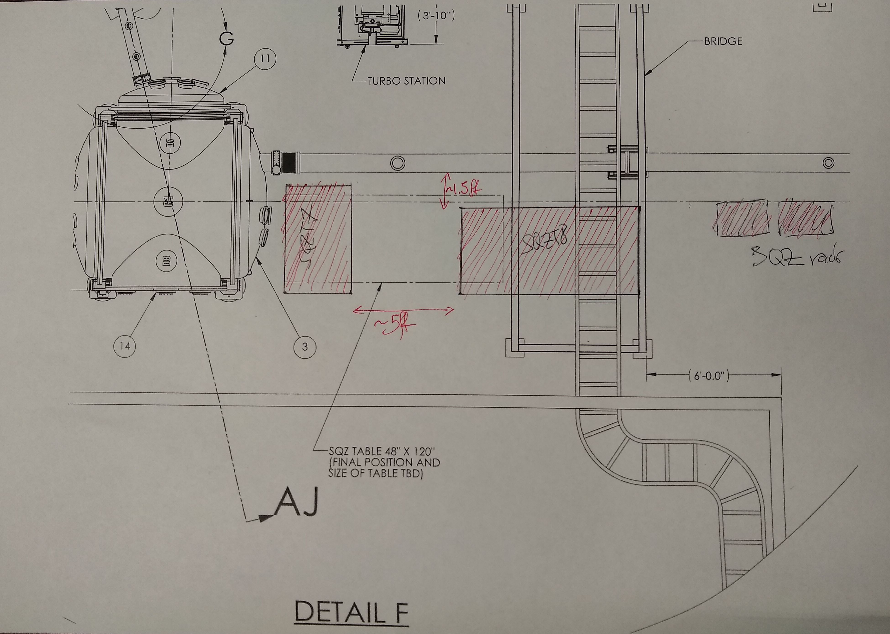
- DS: Optical tables and ISCT6 move
The new position of ISCT6 seems to be downstream of HAM7. At LHO, we have the AS port beam on ISCT6 as well. Currently, we have an OSA installed on this path. I am not sure if I want to give up this capability.
Does the BHD system come with new in-air beams? Are we going to need another table next to ISCT6 down the road?
I am also wondering, if the small table will be large enough. It all looks tidy in D1900281. But once you add the true size of the periscopes, I suspect it will get crowded.
PF: I guess the BHD design isn’t that detailed yet, but it could be an imposed requirement.
DS: A couple of questions come to mind:
- What windows are we using on HAM7? There is a drawing here D1900059. The upper windows seem too high for the existing enclosure and table height. Lower?
- Is the HAM7 ISI table height the same as HAM5, ie. ~9" below beam height? In HAM6 the beam height is only 4-4.5" since we are using a spacer.
- Looking at D1900059, it seems we could consider using a 4x8 optical table and shoot the beams in sidewise. Don't we have 2 ISCT tables without enclosures still floating around from H2?
- What table are we using for HAM8? Are we using a window in transmission, ie. ETM side? I assume we need a table there too? 3x5 or 4x8? Don't we have an extra H2 3x5?
- Do we have enough periscopes? The double beam periscope is here D980329. However, for iLIGO periscopes it is hard to find complete drawings. Some stuff can be found here D980329 and here D980502.
- DS: Picomotors?
Do you have an idea how many new picomotor mirrors we are going to need? Are there picometers in the FC end station? We might need more controllers.
Lee:
+4 in HAM7 for FC532 alignment to FCSQZ,
+4 in HAM7 if we have pickoff DC-QPDs for SQZ in-vacuum
+4 in HAM8 for 1064 DC-QPDs in transmission. Now assuming any 532 QPDs in transmission will be in-air.
Perhaps you get to recover the ones currently on the OFI though?
DS: Thanks. Means we need 2 more controllers.
There is only one on the OFI. There are channels for 4 mirrors available on the existing ISC picomotor controller, but this one will stay in ISC-R3.
- DS: OMC/HD double demodulation
You mention a 3.330MHz anti-image notch in the block diagram. This is to eliminate the image produced by the 105kHz signal sideband of the 3.125 MHz demodulation. The required Q seems to be at least ~100. This seems possible. However, this notch may interfere with the LO loop when you try to lock!
I am wondering, if this is really necessary? And if so, whether demodulating directly at 3.020 MHz may be a better option? Of course, we may not need this, if we use a pick-off to sense the FC length.
Lee: For the LO loop, it will only look like a notch of Q=2 since the lower sideband will still be present. I wasn't thinking it would affect the LO loop much due to this and that the LO loop UGF is much lower than 105kHz. Given power-level requirements on the RLF, it seems good to not contaminate the noise by even sqrt-2.
It isn't strictly necessary in the double-demod, since we digitize both the I and Q, the proper combination during the 105kHz demod will also project away the noise from those frequencies. I just figured a notch would do it better in the event that I/Q aren't exactly 90 deg apart.
The new optical layout includes a 1% pickoff into DC-QPDs for the 105kHz wavefront sensing. Should an additional LSC-PD be used there for the option (with it getting the majority of the pickoff light), or is the length signal OK to synthesize from QPDs?
Oh, hmm. There is also the potential need for a notch in the LO loop itself. The RLF is approx the same magnitude as CLF, so will inject 50-100mRad (1 * LO_ugf / 105kHz) in the LO loop unless we notch it out. After the LO-demod or before the TTFSS.
DS: There is always the chance that you mistakenly lock on the RLF I guess. At LHO that doesn't seem to be a real issue, since we can get within 3kHz of the LO beat note, before we engage the servo.
- KA: OMC transmission for 3.125MHz
Related to Sec 1.3.5 “OMC DCPD Response at 3.125 MHz”, the cavity pole of the current OMC is 300kHz, and thus the CLF is significantly attenuated at the transmission. Combined with the PD response mentioned in Sec 1.3.5, is there a possibility to lower the CLF frequency?
Lee: We could but would need to measure the phase/RIN spectrum of the laser more carefully to make sure it is clean enough at any lower frequency.
DS: If you use a pick-off to deduce the FC error signals, the argument reverses. With a higher frequency, you would be able to increase the CLF power without adding more noise after the OMC. The note about the photodetector readout is true, but it would be better to improve the readout.
- KA: Got confused with Figs. 4 and 5 of T1800447
I believe these plots show the comparison between the expected FC motions and the requirements with various optical configurations. The dashed calculated curves are the requirements, and the thin solid lines are the estimated cavity motions. I could not understand why the requirement is relaxed when the additional 3mrad V2L coupling is considered. Shouldn’t it be opposite? While the requirements change by the additional 3mrad, the expected cavity motions have the same values. What’s the right way to read the plots? It’s also confusing both plots have the same titles.
SD: I also found these two plots confusing.
Lisa/Lee: this is just a mistake, apologies—a different plot should go in Fig 5.
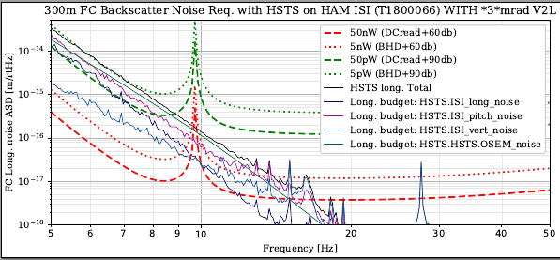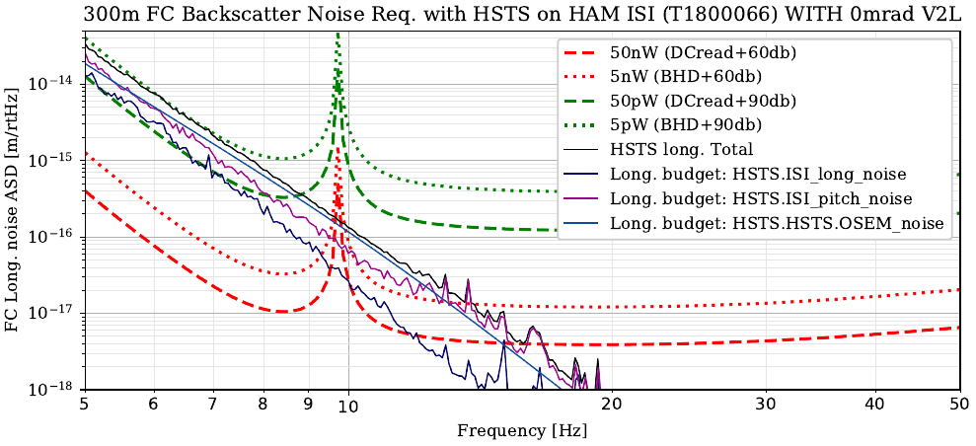
- SD: General comment about T1800447
Sometimes in this document it isn’t clear to me what decisions have already been made, and what options are still open. This is done in the executive summary, but in the body of the document it could be helpful to explicitly say what decisions have been made based on the calculations described. For example, there are 4 scenarios considered for backscatter requirements, but it isn’t clear to me that any of them have been chosen, or which decisions are driven by each scenario. I think that this could help clarify some of my later questions.
Lisa: Yes, you are right. The background is that this document was put together months ago, and at that time we were targeting FDS together with BHD as a baseline, with an O5 horizon. A number of decisions had to be made in the meantime, and they were discussed during A+ meetings but they are not yet reflected in this document as we thought we would put them somewhere else (PDR, etc).
- SD: Is getting rid of the third Faraday worth the complexity and risk?
From my reading of T1800447 it seems that trying to avoid the addition of a second Faraday is driving some design decisions that make the filter cavity implementation more difficult. It might be that accepting the additional Faraday is simpler and less risky solution, and that the loss reduction from eliminating 1 Faraday pass might not be enough to justify the effort.
Lee: Yes, we are now fully expecting to have it and use it. The SF2 is currently in the optical layout at a point where it can either be removed (relatively) easily or even be double-passed for additional ~30db isolation if the phase noise requirement is too difficult (3 physical Faradays, 4 isolating passes).
Lee, again: such a double-passing helps the FC+HSTS phase noise requirement (120db isolation), but makes the SQZ-IFO relays more sensitive (60db isolation, shouldn't plan on double-passing a Faraday..).
DS: Can you please clarify how many Faraday isolator are planned to get installed? The design requirement document never really says, and it generates a great amount of confusion.
Lisa: We asked Florida to make two Faradays for the squeezing path (both SF1 and SF2 in Fig 2 of T1800447).
This is the conservative choice given that without BHD the back scatter noise requirements are even more stringent. Florida didn't like the option of making one Faraday first and postpone the decision about the second one, so we went with both right away.
DS: We will then assume SF2 will be installed during O4 and we can assess, if we still need it when we add the BHD.
SD: Backscattered power estimates agree reasonably well with recent measurements: lho alogs 47729 and 41229.
- SD: Add an overall loss budget to the document, add discuss the impact of getting rid of the additional Faraday
I think a loss budget would be helpful for putting the mode matching requirement parts into context, and also for thinking about the level of risk and complexity to take on to avoid the 3rd Faraday. How much confidence do we have in being able to achieve the 1% loss in T1800398? It seems likely that it will take some time and a lot of effort on the AWC system to achieve the mode matching requirement, and that in that case the extra 1% loss from an additional Faraday would have a small impact.
Lee: Yes, although mode-matching loss behaves differently than other losses (always frequency dependent). The DRD was written before we concluded the O3 squeezer losses were as bad as they are. Happy to have the extra Faraday. The backscatter is scary.
- SD: What is the impact of having the 3rd Faraday on the inspiral range for O4 and for the design sensitivity of A+?
How much of a benefit in inspiral range would there be from getting rid of SFI2 with O4 with current coatings and A+ coatings, with 200-300kW circulating powers and with 700kW, and what about with the current LLO noise budget residual? It would be nice to know what the payoff is for getting rid of that isolator both in the near term and the longer run.
Lee: Probably actually it will only help high frequency, since coating thermal noise will dominate at low frequencies even in A+. Wanting the last 1-5% of losses reduction will be a post-T=20%-SRM world (which also only really improves the high-frequency sensitivity). It's worth a study, but may be difficult to quantify, since it is more general science than inspiral range. I think it will want to be done in the long term to understand what is possible in 3rd generation detectors (not a great reason to think about it now).
- SD: Is the decision to make double suspensions for the relay optics motivated by the desire to get rid of SFI2?
When I read section 6.5.2 it sounds to me like this is the motivation. It seems most likely that we will be using the additional Faraday because of the filter cavity length control noise, at least for the near term. It might make sense to put the resources into designing and building the double suspensions with the long term goal of being able to eliminate SFI2, but it seems the new design could be deferred until after O4 without performance consequences.
Lee: Maybe it was, but it isn't now. The noise performance in the docs is just to set requirements. Now the double suspensions are to have the active wavefront control (AWC). The reason AWC will be on double suspensions is actually mostly driven by their eventual use in the A+ BHD.
- SD: Is the motivation for adding a second control beam (the RLF) motivated by trying to eliminate SFI2, and is that worthwhile for O4?
I haven’t yet read T1900416, but based on section 8.2 and Figure 10 of T1800447 it sounds as though the motivation for introducing another control field is to avoid having VCO noise imposed on the filter cavity length which would require the additional Faraday. If this is really the main motivation, it seems like an option which could be considered for O4 would be using SFI2 for O4 and the CLF for FC length control.
Lee: I believe it would require more than 4-5 Faradays to relax the phase noise to the point where a 532 field could be used without some RLF-like 1064 field stabilized using the SQZANG loop. This is based on the phase noise of the CLF2F control field being 1e-1/√Hz at 10Hz (open-loop). The sensing field for the filter cavity needs to be 1e-5/√Hz at 10Hz (a point that needs to be updated in the doc, as I have it down as 1e-6/√Hz)). The CLF2F loop represents the level of noise that a 532 sensing field would get going from table to vacuum, so the phase noise needs to be controlled with something similarly stable to the IFO as a reference, hence reusing the squeezer control loop. I've been talking a lot with Daniel about that RLF scheme, and in the last week I can model all the demod signals and make a full sensing matrix for it (including things like pump RIN contributions). It's a lot to document, but in the next couple of months I think this new RLF scheme will seem less novel and funky once a bit more is written. We are also meeting some success with it here at MIT (testing a very relatable implementation).
- SD: Several comments about the way optic motion is translated into a path length change
None of these are large differences, but they all would make the requirements more stringent: (final 2 bullets in section 6.2 and same arguments repeated in section 6.5):
Multiplicity: The number of optics is large enough that it seems worthwhile to include. That there is an ambiguity in how to deal with this since there could be both coherent and incoherent motions. Your figure 5-8 all show that osem noise is close to the limiting noise for all the types of suspensions you are considering, so in that case it wouldn’t be too bad to add the contributions from each optic as though they are incoherent, and this would change your requirements by a factor of 1/$\sqrt{6}$.
Lee: Indeed, the OSEM noise turns out to be similar to the ISI residual and so contributes similarly. Those modelled OSEM loops are also very not optimal. With the choice of 3 Faradays total (90db), then there is some room, but I can model them more diligently or plot the combined expected relay phase noise of the chosen implementations.
Double pass: The argument that the second pass phase will be 90degrees out of phase from the first pass doesn’t make sense to me (this isn’t important since it is at worst a 40% disagreement). Even though the filter cavity may rotate the phase by 90 degrees, the path length between the filter cavity and the IFO isn’t locked, and the relative phase of the sidebands added by the motion of the relay optics will depend on the total path length which could be changing by a significant fraction of the wavelength, in addition to the rotation from the filter cavity.
Lee: Yes, only √2 disagreement. The noise is calculated as though the scatter light is at the worst quadrature at every frequency to represent worse-case. With that done, only the overall modulation index is calculated and compared to shot-noise-limited sensitivity. The double pass with cavity effect just changes how strong the modulation is. The phase sidebands before cavity are rotated to amp sidebands at the reflection (same reason PDH is at maximum at 1 cavity BW detuning) the post-cavity pass then imprints phase sidebands again.
Angle of incidence: the path length change from a single pass off a relay mirror should be 2*∆L/cos(theta), which is almost a factor of 3 for 45 degree incidence. Is this included? Also, there is a sentence in section 6.5.1 “For the OPOS, this can be mitigated somewhat by adjusting the input and output angles to have an effectively large angle of incidence”. I think a larger angle of incidence means that the same suspension motion would cause more phase modulation, and it also seems like a small benefit in terms of backscatter wouldn’t be worth the mechanical and aperture problems that could arise.
Lee: No, all relay mirrors are calculated against 4pi/lambda / √2. The √2 is the point above. 4 of the 6 relays in the optical layouts are very near 0 AOI. The current layout is not using any tricks to improve relay phase sensitivity.
Although each of these three quibbles is small, if each one of them is added on top of what is done in this document they would make the requirements stricter by a factor of 10, which seems serious.
Lee: Yes, although 3-4 of the relays will very likely be the new ham double SUS (HDS) to be wavefront control-compatible. Those will have lower noise at 10 Hz. It will be worthwhile and reasonable to combine the plots to model our currently chosen implementation with these multiplicity and coherence increases in the noise.
- SD: How flexible is the choice of input coupler? Are multiple input couplers being ordered and would it be plausible to swap them as the input power is increased?
Since we are adding a filter cavity in O4, how much of a benefit would there be from setting the input coupler reflectivity for a lower circulating power? A version of figure 15 for current coatings and input powers from 200-400kW could be helpful.
Lee: I have made these plots to decide the most effective 1064 coating. A 0.1% Transmissivity input coupler is optimal at ~90 and very minimally sub-optimal at 80W. It will also work at higher power, but will require the SRM to be switched. At lower powers, the cavity detuning can be changed and the majority of the benefit can be achieved. Even at 40W this difference between optimal and the 0.1% coupler is relatively small.
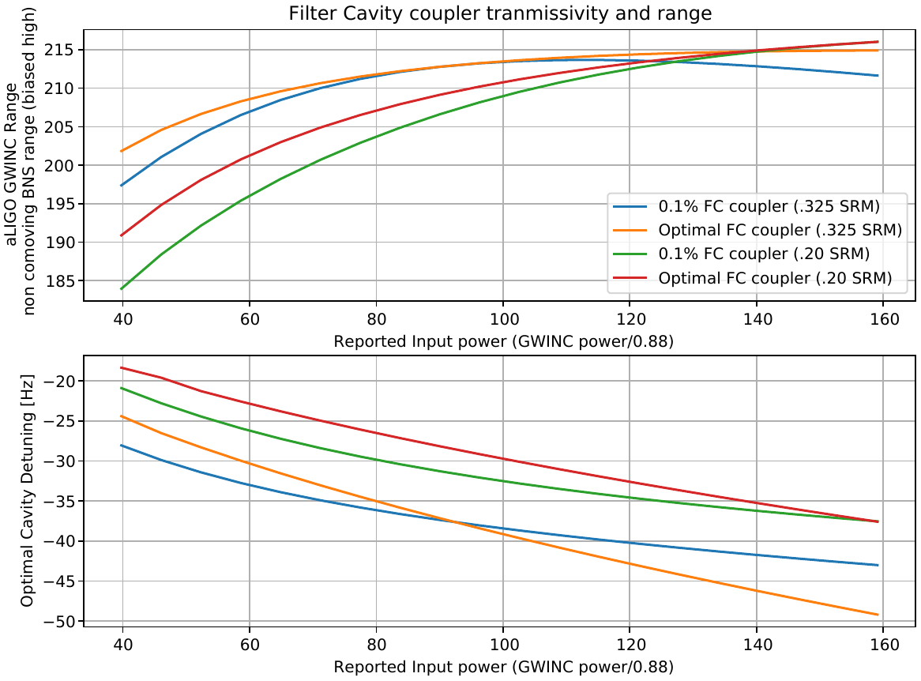 |  | 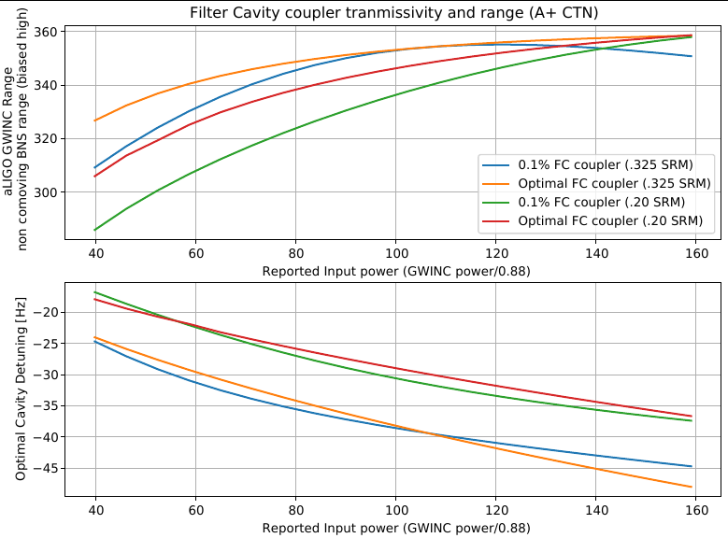
- VF: Back-scatter light noise requirement:
I verified the requirement curves in Fig. 4 and checked the long/pitch noise curves calculations at ~15 Hz. I am guessing the vertical noise is Z_{isi}->Z_{optic}*3e-3 but I don’t see this in the text.
Lee: It should be added to section C.4. It is actually L_optic += 3e-3 * V_optic by modifying the state-space "C" matrix to include the coupling between the mechanical states and optical outputs.
6.5.2 “While a dedicated single stage suspension for a 2" optics is under design (E1800272)…” - the document shows a two stage suspension. So no need for an additional FI?
Lee: The additional FI is still baseline due to the controls requirements.
Is the suspension driver noise negligible compared to the OSEM noise?
Comments on clarity:
I don’t understand the wording of the legend in Fig 3 “below shot noise” - some noises are below and some are above.
Lee: "below" should be reworded "with respect to."
The Fig. 3 caption says “the ratio of the A+ fundamental noises and (unsqueezed) shot noise” but it is actually to the total quantum noise not just shot noise.
Lee: Agreed, with radiation pressure included, shot noise is not a good word choice.
The Fig 4 and 5 seem to be identical with the requirement curves in Fig 5 being 2 times higher.
Lee: This is a mistake and corrections are included with point 20.
The expressions (3)-(6) in 6.3 appear to be the same at the different power levels defeating the purpose of writing them in the form of scaling ~1/√P. Same goes for (8) and (9) in 6.5.
Lee: Agreed, a table is clearer for that.
- VF: Filter cavity control requirements:
The sensing/control noise can subtracted on/offline the same way we currently do the MICH/SRCL sensing/control noises. A factor of x10 subtraction is routinely achieved.
DS: I am not sure how this would work for back scattering, since the phase isn’t locked?
- AM: Also on Back-scatter light noise requirements (and possibly repeating comments/concerns from above):
On Section 6.3 - What are equations (3), (4), (5), (6) supposed to convey? I think that equation (2) with appendix B leads to the dashed/dotted curves in Fig 4, but what do (3)-(6) tell us. Apply this same question to section 6.5 for equations (8) to (9).
Lee: These equations are redundant with the plots, just providing the numbers from non-frequency dependent calculations.
Section 6.4 and Figure 5 - I don't understand what this section and figure are trying to say. What frequency is the bounce mode? You are adding V2L but somehow the requirement is becoming more relaxed?
Lee: This is a mistake, fixed plots with Q:20.
About Multiplicity, I think you are saying that you are not taking this into account. With the significant amount of relay optics in the path, feel like this should be looked at.
Lee: Yes, now with an idea of the optical layouts, I can plot with the multiplicities included.
Please do something about the legends of figs 6-8 so that they’re not covering a significant portion of the plots.
- AM: Section 8 – Filter Cavity Control Requirements:
E1800023 doesn't show this scheme that you are describing in section 8.2. No 532nm locking beam and no feedback to the cavity length at all. The FC readout is fed back to the FC AOMs. This just makes the FC control field follow the FC length and doesn't enforce any locking condition between the Pump laser and the FC. I can imagine this being just for lock acquisition, and then just feeding the control signal to the FC length, or completely handing off to the length.
Lee: Yes that diagram doesn't show the connection, and your assumptions are right about the handoff plan. The AOM actuation signal would be used to stabilize the length and transition to 1064 length control. The diagrams in E1900221, in particular, D1900281, shows more detail of the schemes developed since E1800023.
Where does the 2.6e-14m/√Hz number in eq (17) come from? I think this should represent the FC length noise requirement, but this number seems a little too high. I guess it matches the BHD-3FI case near 5Hz, but above 10Hz (where your 20Hz UGF control loop has 3x gain peaking) it is a factor of 10 below this.
Lee: This number should be 1.3e-14 m/√Hz coming from eq. 8. An older version used 2hω rather than hω/2 for quantum noise limited sensitivity, and this must not have been updated. Eq. 17-18 aren't terribly necessary except to state that the relay optics requirements are not more stringent due to FC sensing noise requirements.
End of section 8.2 - do you expect that you’ll meet this path length noise requirement using a 1064nm frequency shifted beam?
Lee: Yes, or at least I expect it is the only way to come close, using the SQZ loops to assist.
- KA: OMC reflection
Strictly speaking, this is not an FC requirement: If we have ~20mW going into the OMC, and assume ~ppm level backscattering, this will be a few tens of pW backscatter, which is comparable to the case of DC Readout. This is worth keeping in our mind and should be brought up at the BHD review.
- KA: RF Sidebands
The backscatter consideration did not include the presence of the RF sidebands. In fact they are the strongest optical power at the dark port. With the current modulation level in the low noise configuration, we expect to have ~1W of the sideband power at the full power. The OMC is supposed to provide the attenuation of 60ppm at 45MHz. This is equivalent to the 60uW of the carrier light with DC readout. Also the modulation will probably be reduced at the higher power operation. Therefore, this is unlikely to become a problem, but it is worth to note.
Lee: The DC light is compared against quantum sensitivity since the IFO enhances it by RPN. Other forms of intensity noise from RF light must be compared to the actual OMC DCPD spectrum, which is shaped from RPN, this vastly relaxes requirements at 10-20Hz. The CLF RIN requirements plots included demonstrate this, and I suspect it applies to RF sideband backscatter concerns.
- KA: Sec 10
Where does this ½ of Eq.19 come from?
Lee: I think that is an error. It belongs in eq. 20, but not eq. 19.
Eq.20 overestimates the loss, but my numerical integration code says 40mm spot shift gives the loss of 1 ppm, instead of 38 mm. So, it is not so far.
Eq.22 is overestimating the loss. It is 5.1e-4, instead of 3.2e-3. And Eq.23 is 0.48[1/m], instead of 1.5 [1/m]. So the requirement Eq.25 is a factor of 3 relaxed even further.
- VF: Will there be cameras to see the beams on FC optics for the initial alignment?
Lee: Planning to have cameras on the front-face. This is likely the only way to see the beam on initial alignment due to the ID and baffling of the 300m beam tube. The optics will be essentially as large as the tube aperture.
- AM: On section 10.2:
I know you have come to the conclusion that the 15mm beam on the 2 inch optic before the FC is ok, but this seems like a very large beam to me. And based on experience with HAM6 optics, I’m not so confident that we can line up this optic with the cavity axis to within 12.7mm. I know that a double suspension is being looked into, maybe could also look into suspending a larger optic (3 or 4 inches)?
Lee: This is a reasonable worry. If we get the 1m ROC on the FC mirrors, the beam spot will be 10 mm diameter. Furthermore, with the 532 beam, it will be a bit easier to align since all the suspensions can be damped and (won't drift as much in air like the ITM bounce PSL beam), and the beam will be visible on a card even in transmission through the FC input coupler.
- KA: WFS with OMC QPD
In addition to Sections 1.3.1, 1.3.6 and comment 14: OMC QPDs nominally have the beams off-centered. That is also a negative factor for the plan to use them for the WFS.
Lee: Pick-off and dedicated WFS are now included in the design.
- KA: T1900279 Assessment of the substrate lenses of the FC mirrors
Have any considerations done about the FC1 lens?
- Lateral motion of the FC1 causes the input beam misaligned.
- How much impact do we suffer from this for the (mis-)alignment requirement?
- This coupling can make some confusion between pitch/vertical and yaw/horizontal.
- How does this affect the angular control?
- Do we have any spurious effect such as unexpected A2L coupling?
Lee: These haven't been considered, but I agree they should be. The existing HSTS noise models can check alignment noise from lateral motion. The others we will need to think about and model. The virtual waist that the 2 m (or 1 m) lens creates is very small, and so the sensitivities will be very large. This is a general issue for the short telescope baseline to create a 20 mm Ø beam in HAM7 in ~4m and isn't particularly unique to having the lens on the HSTS vs using a curved relay optic. The lens may present a problem in mode matching 532 and 1064 both to the cavity with common relay optics (soon to investigate this).
- KA: T1900416 Section 2.4 CLF/RLF phase and intensity requirement
Could not follow the logic there. Could you elaborate the section more? What is the squeezing improvement? I suppose the audio sidebands around the CLF/RLF are not squeezed.
DS: These questions are addressed in items 1-3. For phase stability the main point is to reduce the cavity motion to keep back scattering small enough.

