Title | Satellite Box Noise Analysis
Author | R. Abbott, L. Sanchez, D. Hoyland, S. Aston
Date | 16 March 2021

Overview
The aLIGO Satellite Amplifier, D0901284 is to be repackaged in a 1U rack-mount format for the A+ upgrade. During this process, it was thought prudent to examine all aspects of the design in case there were parameters that could easily be improved. A cursory examination of the current source used to illuminate the LED used in the OSEMs revealed a factor of ~ five improvement in the current noise is possible by changing some component values. An appendix has been added to aid in analysis of the need for replacing a BOSEM head at end of useful life, LED decay or otherwise.
The performance of the aLIGO Satellite Amplifier has proven to be quite successful over time, so the temptation to change any aspect of the design must be carefully evaluated and well-motivated. Part of this process is to understand and verify all critical aspects of the Satellite Amplifier performance when used with the BOSEM. Displacement sensitivity and noise have been analyzed and documented in this note but are largely a duplication of the original results as seen in the design note LIGO-P1100208.

Summary Data
A simplified diagram depicting the Satellite Amplifier and the associated OSEM is shown in the figure below. As noted, the original design had a Transimpedance Amplifier (TIA) gain of 160k V/A (Ω), whereas the aLIGO production units were modified to have a TIA gain of 120kΩ. The stated whitening pole and zero frequencies are shown in the diagram, but the actual implemented frequencies are slightly different due to the availability of standard value capacitors and resistors.

Figure 1 Simplified diagram of device being measured.
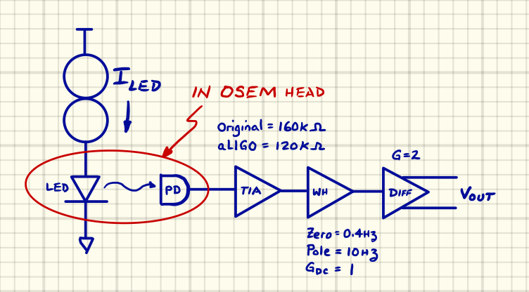

Table 1, Summary of Key Parameters
Parameter | Value | Data Source
Nominal LED DC Current (I_{led)} | 35mA | Design notes and measurement
TIA Gain (original) | 160kΩ | Design Note
TIA Gain (production) | 120kΩ | Visual inspection of production unit
Whitening Zero Frequency (production) | 0.3835Hz | Calculation and measurement of production unit
Whitening Pole Frequency (production) | 10.61Hz | Calculation and measurement of production unit
DC Gain of Whitening Filter | 1 | Visual inspection and measurement of production unit
DC Gain of Differential Output Driver Amplifier | 2 | Visual inspection and measurement of production unit

Measured and Simulated Results
The data below shows a series of measurements performed on three separate BOSEM examples. Two production units (BOSEMs) were sent from LLO for evaluation. A third unit is from a pre-production run and uses a different part number LED than that used in the final production units.
A noise budget compiled from simulations of known BOSEM sensor noise sources is overlaid against the measured data. There is reasonable agreement in the measured vs. simulated data for the production units above approximately 20Hz. Excess noise is visible at lower frequencies and is believed to be attributable to the superposition of 1/f noise and generation-recombination noise intrinsic to the LED semiconductor material. The existence of excess optical noise is probably correlated with material defects within the LED. The noise results may vary depending on LED manufacturer and batch number.

Figure 2, Overlay of simulated and measured BOSEM data.

As can be seen in the graph above, the noise associated with the LED current source is not a significant contributor to the overall noise performance of the BOSEM sensor. For this reason, it was not considered worthwhile to pursue reducing the LED current source noise.

Conclusion
The data taken on the production BOSEM samples seems to reveal excess noise in one case (SN622) and noise almost equivalent to specified sensor sensitivity for SN224. There is no observed benefit to lowering the current noise of the LED drive, but LEDs with better low frequency emission characteristics would be of significant value in improving the overall performance of the BOSEM.
No observed factors impact the repackaging effort of the Satellite Amplifier, but the analysis performed will serve well as a measure of the Satellite Amplifier performance after the repackaging effort is complete.

Appendix - BOSEM Replacement Thresholds
It has been noted that the optical output of the BOSEMs has seen what appears to be a decay in the amount of light emitted by the LED. While there is some debate as to the source of this decay, the question has been raised at what point a replacement is warranted in terms of the desired displacement sensitivity? The following data aims to explore this question.

Figure 3, Noise budget analysis

Figure 4 SNR analysis at two different frequencies

Figure 5 Topology used for analysis.
