Fast Shutter Report

Kavya Sreedhar

Setup and Goals
The setup consists of a payload resting between 2 coils of approximately 500 turns of 32AWG wire. The payload comprises of a block acting as the mirror, magnet, and side holders glued to hold the block and magnet together.
The total mass of the payload with the 1/2" by 1/2” by 1/8” magnet (the taller magnet) was measured to be 7.7g, while that with the 1/2” by 1/4" by 1/8” (the shorter magnet) was measured to be 5.7g.
The resistance of the coil was measured to be 52.6Ω and the inductance 19.2mH.
Our performance goal is to have the payload travel upwards 6mm in less than 1 millisecond with the minimal current necessary, to block light from a laser. In addition, while the payload may bounce up and down after the initial jump and blocking, our goals include sustained blocking of the laser light for a desired set amount of time.

Initial Calculation
Using the relation $d=v_{i}t+\frac{1}{2}at^{2}$, we see that with distance d = 6mm, time t = 1ms, and initial velocity v_{i} = 0m/s, the acceleration of the payload required to achieve our performance goal is $a=\frac{2d}{t^{2}}=\frac{2*\left(6mm\right)}{1ms}=12000\frac{m}{s^{2}}$. This initial calculation assumes constant acceleration since this motion occurs in such a short period of time.
We measured the current to support the payload against the force of gravity to be 40mA for the 1/2" by 1/2” by 1/8” magnet (the taller magnet). In this situation, the magnetic and gravitational forces on the magnet are equal, so we have $c*i_{b}=F_{B}=F_{G}=m*g$, with c a constant, i_{b} the current required for F_{B} to balance F_{G}, m the mass, and g the gravitational constant. Then, $c=\frac{mg}{i_{b}}=\frac{\left(7.7g\right)\left(9.8\frac{m}{s^{2}}\right)}{40mA}.$
To find the current required for an acceleration of $12000\frac{m}{s^{2}}$, we compute
$F_{B}+F_{G}=ma$ => $c*i-m*g=m*a$ => $\frac{mg}{i_{b}}*i-mg=ma$ => $i=i_{b}\left(\frac{a}{g}+1\right)=49A$
Thus, we found that 49A was the current required for our payload to travel 6mm in 1ms, assuming constant acceleration of the payload.

Lab Measurements
We measured the time it took for the payload to move up 6mm and block light from a laser set up for various voltage values. The time difference between when the voltage was applied to the coils and the laser light was blocked was the time recorded. If there were oscillations and the light was repeatedly blocked and then unblocked by the payload, the time it took for the first blocking of the light was recorded.

1/2” by 1/2" by 1/8” magnet (Taller Magnet)
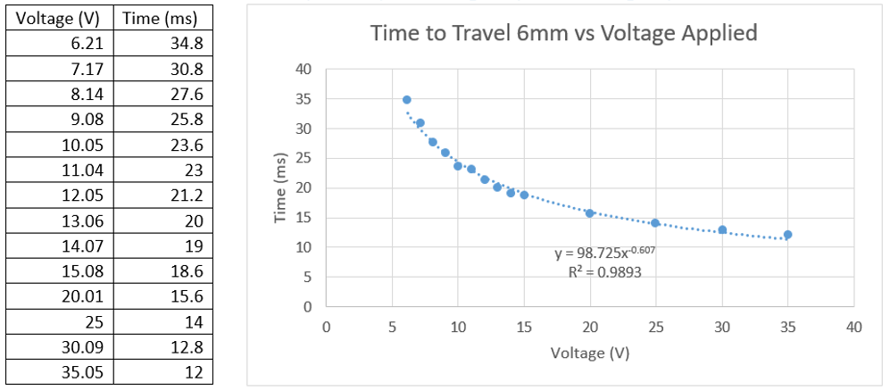
Figure. Chart and graph of time for payload to travel 6mm for various voltages applied to coil for 1/2” by 1/2” by 1/8” magnet.
Since voltage is linearly related to current and acceleration is linearly related to current but proportional to (time)⁻², voltage is proportional to (time)⁻². Thus, time should be proportional to (voltage)^{-0.5}. Fitting the data measured for time vs. voltage, we obtain a power relation, time = 98.725(voltage)^{-0.607}, with R² = 0.99, which is close to our expectation of time proportional to (voltage)^{-0.5}.

1/2” by 1/4" by 1/8” magnet (Shorter Magnet)
When the shorter magnet was glued to the block with the side holders, we found that at least 30V was necessary for there to be enough current for the magnetic force to overcome gravity and lift the magnet in the air. To obtain data points at lower voltages with our current setup, 0.5cm tall cardboard was placed between the two coils for the payload to rest on. With that starting elevated height for the payload, the magnet was able to be visibly impacted by the coil’s magnetic field at lower voltages as well. This indicated that the field of the coil does drop off rapidly, and to minimize current used, there is a particular area in between the coils to position the magnet for it to feel a stronger effect from the coil’s magnetic field, even though the distance between the coil and all parts of the magnet are less than 1/2".
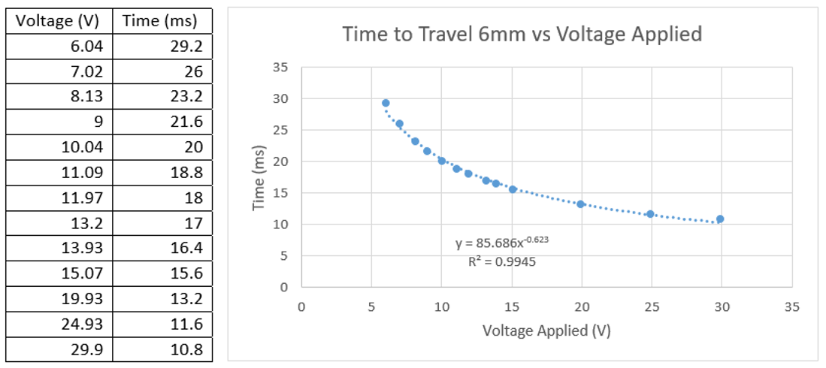
Figure. Chart and graph of time for payload to travel 6mm for various voltages applied to coil for 1/2” by 1/4” by 1/8” magnet.
In this case as well, we would expect time to be proportional to (voltage)^{-0.5} and the power relation fit for this data is accordingly close to that with time = 85.686(voltage)^{-0.623}.

Observations
The voltages at which the times were measured were fairly similar (at most a 2.73% difference) between the taller and the shorter magnets, as shown in the table below. Thus, the time it took for the payloads to travel 6mm were directly compared across similar voltage levels.
Voltage (V) Shorter Magnet | Voltage (V) Taller Magnet | Voltage Difference (V) | Voltage Difference (%) | Time (ms) Shorter Magnet | Time (ms) Taller Magnet | Time Difference (%)
6.21 | 6.04 | 0.17 | 2.73752 | 34.8 | 29.2 | 16.09195
7.17 | 7.02 | 0.15 | 2.09205 | 30.8 | 26 | 15.58442
8.14 | 8.13 | 0.01 | 0.12285 | 27.6 | 23.2 | 15.94203
9.08 | 9 | 0.08 | 0.881057 | 25.8 | 21.6 | 16.27907
10.05 | 10.04 | 0.01 | 0.099502 | 23.6 | 20 | 15.25424
11.04 | 11.09 | 0.05 | 0.452899 | 23 | 18.8 | 18.26087
12.05 | 11.97 | 0.08 | 0.6639 | 21.2 | 18 | 15.09434
13.06 | 13.2 | 0.14 | 1.071975 | 20 | 17 | 15
14.07 | 13.93 | 0.14 | 0.995025 | 19 | 16.4 | 13.68421
15.08 | 15.07 | 0.01 | 0.066313 | 18.6 | 15.6 | 16.12903
20.01 | 19.93 | 0.08 | 0.3998 | 15.6 | 13.2 | 15.38462
25 | 24.93 | 0.07 | 0.28 | 14 | 11.6 | 17.14286
30.09 | 29.9 | 0.19 | 0.631439 | 12.8 | 10.8 | 15.625

The shorter magnet payload travelled faster than the taller magnet payload at the same voltage for all voltages experimented with and was always at least 13.7% faster than the taller magnet, as shown. This data indicates that the extra 1/4" in height that the taller magnet had was not affected enough by the magnetic field of the coils to overcome the extra gravitational force on the payload due to the 2 extra grams of mass. This observation is also consistent with the realization that there is a “best” spot to place the magnet in between the coils for significant differences in the current needed to lift the magnet and that the coil magnet field drops off rapidly, found earlier when collecting data with the shorter magnet.

While the power relation fits for both magnets result in time proportional to voltage to a negative fraction close to 0.5, the exponents were off by around a 20% to 25% error from 0.5. This could potentially be attributed to the fact that the acceleration of the payload is not constant, which would mean the relations between distance, time, and acceleration used in our initial calculations no longer hold.
For the taller magnet, with time = 98.725(voltage)^{-0.607}, we found that 1931V would be needed for time = 1ms, while for the shorter magnet, with time = 85.686(voltage)^{-0.623}, 1266V would be needed for the same time. Neglecting the inductance of the coil initially and just considering the 52.6Ω of resistance of the coil, that requires 37A of current with the taller magnet and 24A with the shorter magnet. The 37A differs significantly from our calculated 49A for the taller magnet, again possibly due to the 1ms time not being fast enough for us to approximate the acceleration of the payload as constant.

Calculations with Inductance
The inductance of the coil was measured as 19.2mH. This inductance results in a series LR circuit with time constant L/R. The current curve $I=1-e^{-\frac{Rt}{L}}$ for L = 19.2mH and R = 52.6Ω from Wolfram Alpha is shown below, with the horizontal axis as t (time) and the vertical axis as I (current). The two pictures below show the same curve, with different time axes, and we see from the graph on the right that at t = 1ms, the current is at 94% of its final value. We can also calculate that by 2ms, the current is at 99.6% of its final value and by 3ms, the current is at 99.97% of its final value.
Since our performance goal is to travel 6mm in 1ms, the inductance likely does have a significant impact our calculations as it goes from 0A to 94% of its final value in that time duration. For all further calculations, we only consider the shorter magnet since that experimentally required less current for the same specifications when compared to the taller magnet.
The 24A current calculated above assumes a constant 24A is applied over 1ms. In reality, the current is exponentially increasing from 0A initially as we see above, due to the inductance of the coil. Thus, having 24A be the final value the current reaches will likely not be enough current for the payload to rise 6mm since the current will be less than 24A for the whole millisecond. Having the current reach 24A at 0.1ms so that the current for rest of the time in the 1ms is greater than or equal to 24A is also not ideal however, because then the final value of the current is around 100A at 1ms and much more current than the 24A needed is being supplied the majority of the time (at 0.2 ms with this scheme, the current is already at 42A). Thus, to balance those 2 extremes, we ideally want a final current that results in an average current of 24A throughout the 1ms. This could be achieved if 24A is reached by 1/e of the total time, i.e. 1/e * 1ms = 0.37ms and that occurs with a final current of 38A. Thus, with 38A as the final current, the current at various times is calculated below, using $I=38(1-e^{-\frac{Rt}{L}})$. The average current is 24.3A, as desired.
Time (ms) | Current (A)
0 | 0
0.1 | 9.106177
0.2 | 16.03018
0.3 | 21.29495
0.4 | 25.29808
0.5 | 28.34192
0.6 | 30.65635
0.7 | 32.41615
0.8 | 33.75425
0.9 | 34.77168
1 | 35.5453

Proposed Future Work
Now that the setup has been characterized with basic calculations theoretically and compared with initial results experimentally, we propose the following be explored in future work.

Geometry and Configuration of Coils
Various other configurations and geometries for the coils can be considered to see if a particular configuration not yet experimented with would minimize the current required and still achieve our performance goal.
Other configurations to consider include but are not limited to placing the payload between two coils vertically, so that the payload is surrounded by a coil on the top and bottom as opposed to the sides as in the current setup. Alternatively, a solenoid cone could be used or even more than 2 coils could be arranged to try to minimize current.
Computer models of these setup ideas can be constructed so that various theories can be simulated without necessarily needing physical experiments. Particularly promising ideas from simulation can then be tested in practice and verified. The setup experimented with earlier with the shorter and taller magnets can be simulated as well to serve as a reference.

Magnet Size
We noticed from our experiments that the shorter magnet performed significantly better than the taller magnet and that the disadvantage of the extra mass of the taller magnet outweighed any height advantage it may have had in the vertical direction. Since the coils in the current setup are oval-shaped with the vertical axis shorter than the horizontal axis, it could be interesting to explore whether a wider magnet (perhaps 1” by 1/2" by 1/8") performs better than the 1/2” by 1/2” by 1/8” magnet we currently refer to as the taller magnet, or whether the wider magnet like the taller magnet actually does worse than a smaller magnet. This size extension is in the direction of the other longer axis and so it is possible that this wider magnet would overlap more with the area in space more affected by the magnetic field of the coil, unlike the taller magnet.

Damping Mechanism
In the current experimental setup with both the shorter and the taller magnet, the magnet jumps up 6mm and then bounces up and down. The bouncing oscillations are large enough that the blocking of the laser light is not sustained from the first time the laser is blocked, which is not desirable as the laser light can then hit and eventually damage the optical shutters. Thus, it is essential that some damping mechanism is created to ensure the payload continually blocks the laser light when the system is activated. One potential solution is to charge capacitors and use them to control the motion of the payload. We propose that idea as well as other damping mechanisms be considered in future work as well.

