LIGO Laboratory / LIGO Scientific Collaboration

LIGO-T1700543-v2 LIGO Nov. 28, 2017

aLIGO all-bolted PMC

Jian Liu, Rick Savage, Peter King, Liyuan Zhang, Stephen Appert et al.

Distribution of this document:
LIGO Scientific Collaboration

This is an internal working note
of the LIGO Laboratory.

California Institute of Technology  LIGO Project | Massachusetts Institute of Technology  LIGO Project
LIGO Hanford Observatory | LIGO Livingston Observatory
http://www.ligo.caltech.edu/

Introduction
This document is the summary of the aLIGO all-bolted PMC project. Including the design, manufacture, assembling and testing results.

Motivation
Previous aLIGO PMCs are contributed by AEI in Hannover which is a bowtie cavity with 4 mirrors glued to a 50-cm-long aluminum spacer. The PMC in L1 was found to become lossy over time. Measurements showed about 1500 ppm/mirror loss (LIGO-T1600204). The loss was attributed to the use of non-UHV PZTs and this was verified by analysis carried out by JPL. This initiated the ''All-bolted'' PMC project. The project aims to build the same aLIGO PMCs with mirrors bolted to the body instead of gluing. This eliminates potential contamination from glue, facilitates easier alignment (relying on machining tolerances), and enables swapping out mirrors more easily should it be required in the future.

aLIGO All-bolted PMC

Mechanical structures
Two prototype all-bolted PMCs were built to test if the machining accuracy is enough to achieve cavity resonance simply by pressing the optics against the surfaces of the spacer. The spacers were from the original PMCs, with the mirrors removed, and were modified by a local workshop (TK Machine in Richland). Counterbores for balls for three-point mounting and tapped holes were added to the original spacer to mount the mirrors using off-the-shelf flexures from Newport Corp. Both of the prototype PMCs resonated without mirror alignment adjustments, verifying the ability to rely on machining tolerances (estimated at 0.0004” absolute between features over the entire length of the spacer).

Eight production All-bolted PMC bodes were fabricated by TK Machine including two for KAGRA. The detailed drawing of PMC body assembly can be seen in LIGO-D1600270. However, during the testing, we found that the way of holding optics using flexures is not good for damping some resonance modes of the PZT and couples the spacer body modes to motion of the the optical surfaces. New parts such as mirror holding caps (LIGO-D1700341) and end clamp dampers (LIGO-D1700510) were developed.

Optical parameters
The aLIGO all-bolted PMC is exactly the same as the original glued PMC in terms of optical properties. Details can be found in LIGO-T0900616.

Assembling
All the components are Class B cleaned and two PMCs (S/N006 and S/N007) were assembled in June 2017 for performance testing and locking servo development. The remaining six were assembled in Nov 2017 after the servo development was finished.

Testing
The major tests of the All-bolted PMC are the locking servo loop transfer function measurement and average (per-mirror) loss measurements. The former is to ensure that the all-bolted PMCs can substitute the current glued PMCs without big modification of the locking servo, making sure the gain margin and phase margin are sufficient. The latter is to check whether the cavity losses are consistent with what would be expected for new, IBS-coated superpolished optics.

Mode damping
The glued PMC has a good PZT actuator transfer function, which enables the locking servo to have a high UGF. However, the all-bolted PMC has a more complex actuator transfer function that could impact the locking servo performance. Since both LHO and LLO operate the PMCs with UGF around 1kHz, we set our target to be UGF at 1 kHz with 15 dB gain margin and 60 degrees’ phase margin. We carried out multiple testes by modifying the PZT interfaces, such as using two flexures to increase the pressure, removing the balls between body and PZT. In the final configuration, a cap with Viton O-ring is used to hold all four mirrors to the spacer instead of flexures.
The PMC body modes coupled to the optics, resulting in multiple peaks in the PMC locking open loop transfer function at 5 kHz, 8 kHz and 12 kHz. The damping achieved with the originally designed mass-Viton dampers was not sufficient. Newly designed end clamp utilizing a crossbars over thin Viton sheets shows good damping of body modes. See LIGO-E1700222 for more testing details.
The PMC was locked on resonance using an SR560 low-noise pre-amplifier (two poles at 10 kHz, gain = 1) and a NewFocus LB1500 servo controller (1 pole at 30 Hz, arbitrary gain), enabling simple gain and corner frequency setting, and a high-voltage amplifier with a 30 Hz pole (see LIGO-D1000273) feeding back to the FAST (PZT) actuator of the NPRO laser frequency. We adjust the gain setting on the LB1500 to set the UGF close to 1 kHz. The servo open loop transfer function for the 8 PMCs are reasonably consistent with each other. All of them show about 20dB gain margin and 72 degrees of phase margin (see Figure 1).
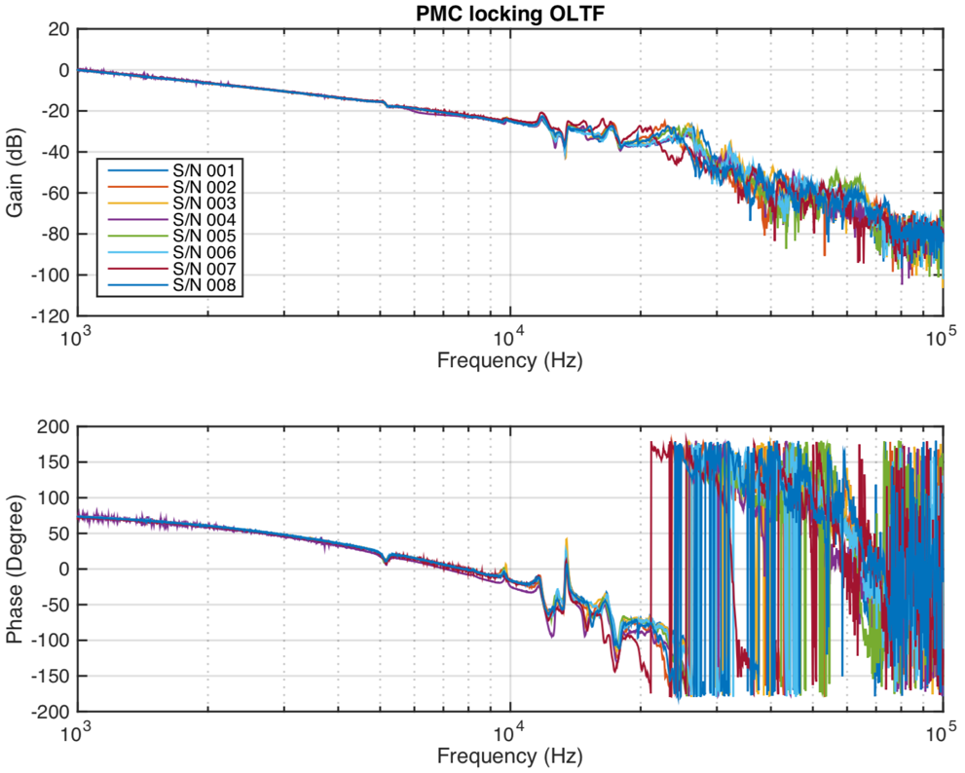
Figure 1 PMC locking servo open loop transfer functions for the eight All-bolted PMCs.
Zooming in to the 4 kHz to 30 kHz frequency band in the OLTF (see Figure 2) shows that PMC S/N 004 and 007 are slightly different from the others, maybe due to the tightness of the bolts, slightly different thickness of the mirror clamped to the PZT or the PZT, or the actuator transfer function. In Figure 3, the OLTF measurement are normalized to the mean of the eight measurements to accentuate differences.
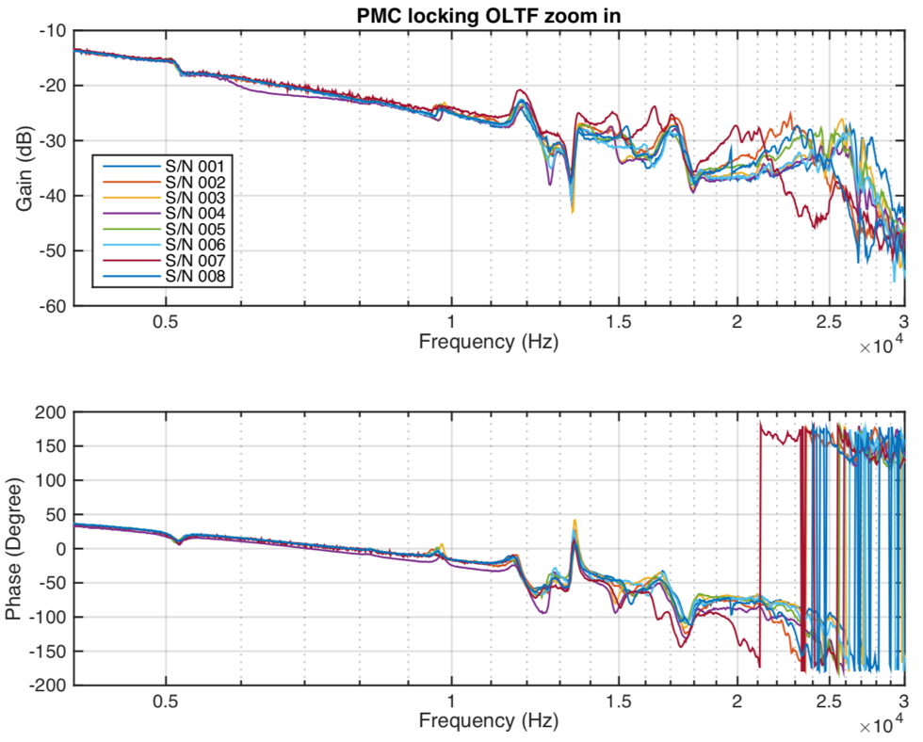
Figure 2 Zoom of PMC OLTF measurements from 4 kHz to 30 kHz.

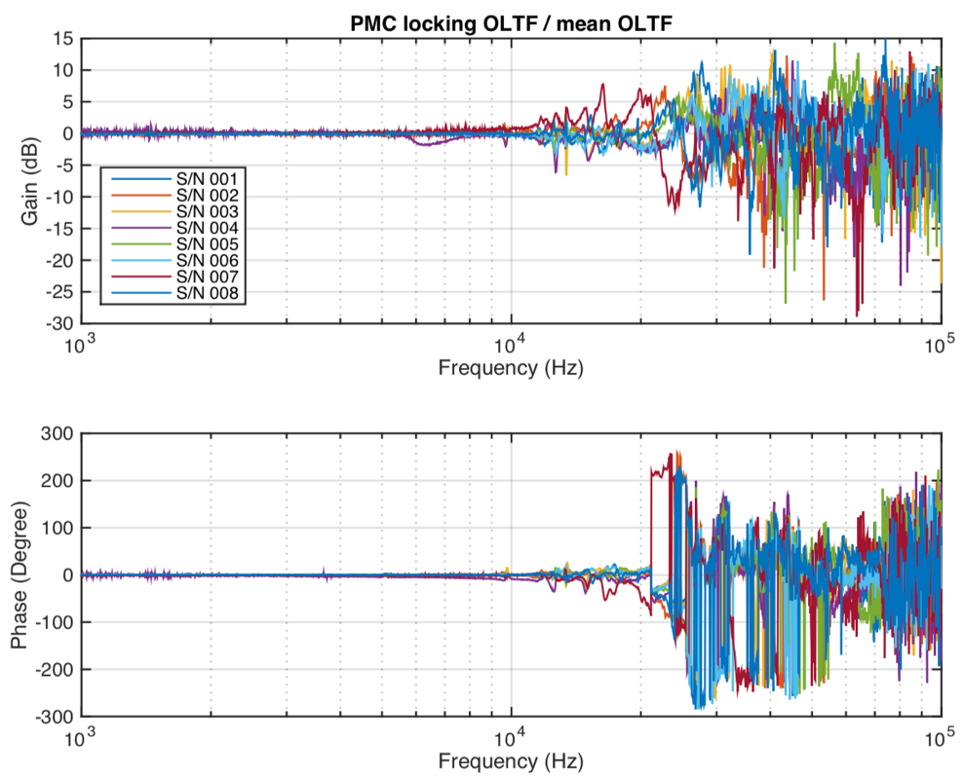
Figure 3 PMC OLTF measurements normalized to the mean of the eight measurements to accentuate differences.

Loss measurements
The loss measurements follow the procedure outlined in LIGO-T1600584. The idea is to measure the output power from all ports and compare with the input power, assuming the loss of each mirror is the same. The expected average loss per mirror is on the order of 5 ppm for new mirrors cleaned with First Contact. This estimate is based on results obtained with the contamination cavity ringdown measurement setup at Caltech. For our PMC cavities, the finesse is approximately 125, so the average number of bounces per mirror for the circulating light is about 40. Thus 6 ppm loss per mirror results in approximately 0.1% (6 ppm x 40 round trips x 4 mirrors)power loss. This makes measuring losses at this level quite challenging. We thus employed three integrating-sphere based power sensors borrowed from the Photon Calibrator system and long averaging times to minimize the impact of laser speckle.
Previously, there were some issues with the set up in the lab. The beam splitter transmission and reflection ratio changed bu up to about 0.5% for different measurements. This introduced more than 30 ppm/mirror loss systematic errors. After changing the beam splitter and cleaning the input alignment mirrors, the fluctuation of beam splitter ratio dropped to less than 0.1%.
Some early measurements indicated losses as high as 30 ppm per mirror. In consultation with Liyuan Zhang and based on procedures implemented for the contamination measurements at Caltech, we decided to clean all the mirrors with First Contact before attaching them to the PMC spacers.
The final loss measurement results are shown in Figure 4. Note that PMC S/N 004 was assembled using mirrors with ten times lower transmission (resulting from an error in specification from an earlier coating run). This enables measuring the cavity losses with ten times lower uncertainty (finesse is ten times higher, so 6 ppm losses would result in 1%, rather than 0.1%, power loss). That fact that measured losses for S/N004 (6 ppm/mirror) are consistent with the losses measured for the other (lower finesse) cavities give us increased confidence in these mirror loss estimates.
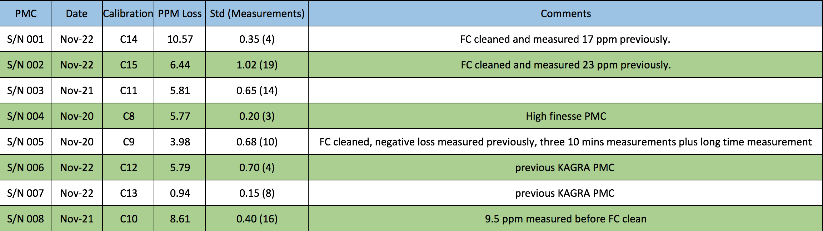
Figure 4 Measured average losses per mirror for the eight All-bolted PMCs.

PMCs S/N 003 and 005 have been sent to KAGRA.

