LIGO Laboratory / LIGO Scientific Collaboration

LIGO-E1700389-v1 LIGO Date 1/22/2018

Notes from mixing and curing the epoxy for vacuum compatibility test performed at CIT

Alena Ananyeva

Distribution of this document:
LIGO Scientific Collaboration

This is an internal working note
of the LIGO Laboratory.

California Institute of Technology  LIGO Project | Massachusetts Institute of Technology  LIGO Project
LIGO Hanford Observatory | LIGO Livingston Observatory
http://www.ligo.caltech.edu/

Introduction
EPO-TEK 302-3M is proposed to be use for acoustic mode dampeners (https://dcc.ligo.org/LIGO-G1702175). This report contains notes from mixing and curing the epoxy for vacuum compatibility test performed at CIT. Experiment resulted in modifying mixing procedure and adding dynamic cure test

Epoxy mixing
The epoxy was mixed according https://dcc.ligo.org/LIGO-T1700524. Two parts of EPO-TEK were mixed by weight (100:45 proportions according to vendor`s data sheet http://www.epotek.com/site/component/products/productdetail.html?cid[0]=21). All tools were ultrasonic cleaned in IPA for 10 min and dried.

First trial fails – epoxy did not cure
We mixed epoxy with graphite in a glass test tube (0.5” diameter) that matched the side of the test tube of our centrifuge. The mixture was applied to glass slides. It did not cure after being left on a flow bench for 24h (room temperature). It was still tacky. A glove print was observed after pressing on one of the epoxy samples (see picture below)
Figure 1. Not completely cured epoxy sample on a glass slide – see the glove print
Possible reason was that stirring for 30 seconds in such thin test tube was not long enough. Secondly, there was an operator mistake who was not running the centrifuge at full speed. Most likely it was rotating at very minimal speed. This probably would not ruin the cure but could result in air bubbles (hard to spot by eye after adding graphite). The samples were nevertheless put in a bake oven for 50 C 48h bake and the load failed (see RGA scans posted here https://ics.ligo-la.caltech.edu/JIRA/browse/Bake-8851 plus the comments).

Second trial – modified mixing procedure
When we mixed the epoxy second time, we used a round glass dish for mixing. In a flat dish it was easy to see that 30 seconds stirring was not enough. We stirred for about 3 min until graphite powder was very uniformly distributed in the epoxy. The batch of samples cured well. We distributed a few extra samples around the lab to see if it was any temperature/air flow related factors could affect the cure. Temperature was within a range between 22 and 28 degrees C. No different was observed. All samples cured. An extra sample was made on a pies of Al foil. The dry epoxy was cracking when bend after the 24h cure at room temperature.

Recommended dynamic cure
A sample of epoxy on Al foil from the successful batch #2 was put on an air bake oven for dynamic cure test recommended by the vendor – 20°C /min ramping up from room temperature up to 200°C, hold 20 min at 200°C. the oven was not behaving well and the thermocouple measured only 185°C C during the bake. Strangely some brown-green color appeared and graphite powder was no longer uniformly distributed. However the epoxy cured and this method is recommended for confirming the mixture before using it for critical items. See figure 2.
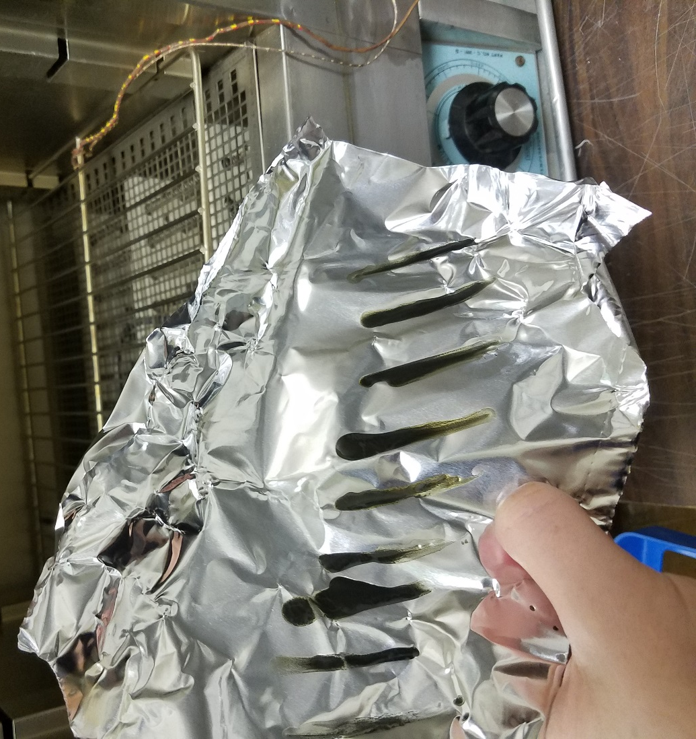
Figure 2. Dynamic cure test in an air bake oven: 20°C /min ramping up to 200°C, 20 min hold at 200°C

