LIGO HANFORD OBSERVATORY
PO BOX 159
RICHLAND WA 99352

TEL: 509.372.8106
FAX: 509.372.8137

MEMORANDUM

DATE: January 3, 2019

TO: | SQZ team
FROM: | Daniel Sigg, Marc Pirello
SUBJECT: | Modifications to the TTFSS V4
Refer to: | LIGO-E1700364-v3

This document lists the modifications to the 4th generation TTFSS, based on PCB D1700346-v1 and on schematics D1700077, D1700076 and D1700078.

Board modifications
Change 1:
U2 is missing the +15V rail. Add a jumper wire between the C5 pad towards U1 and the C46 pad towards U1 (Servo board, D1700077, bottom).

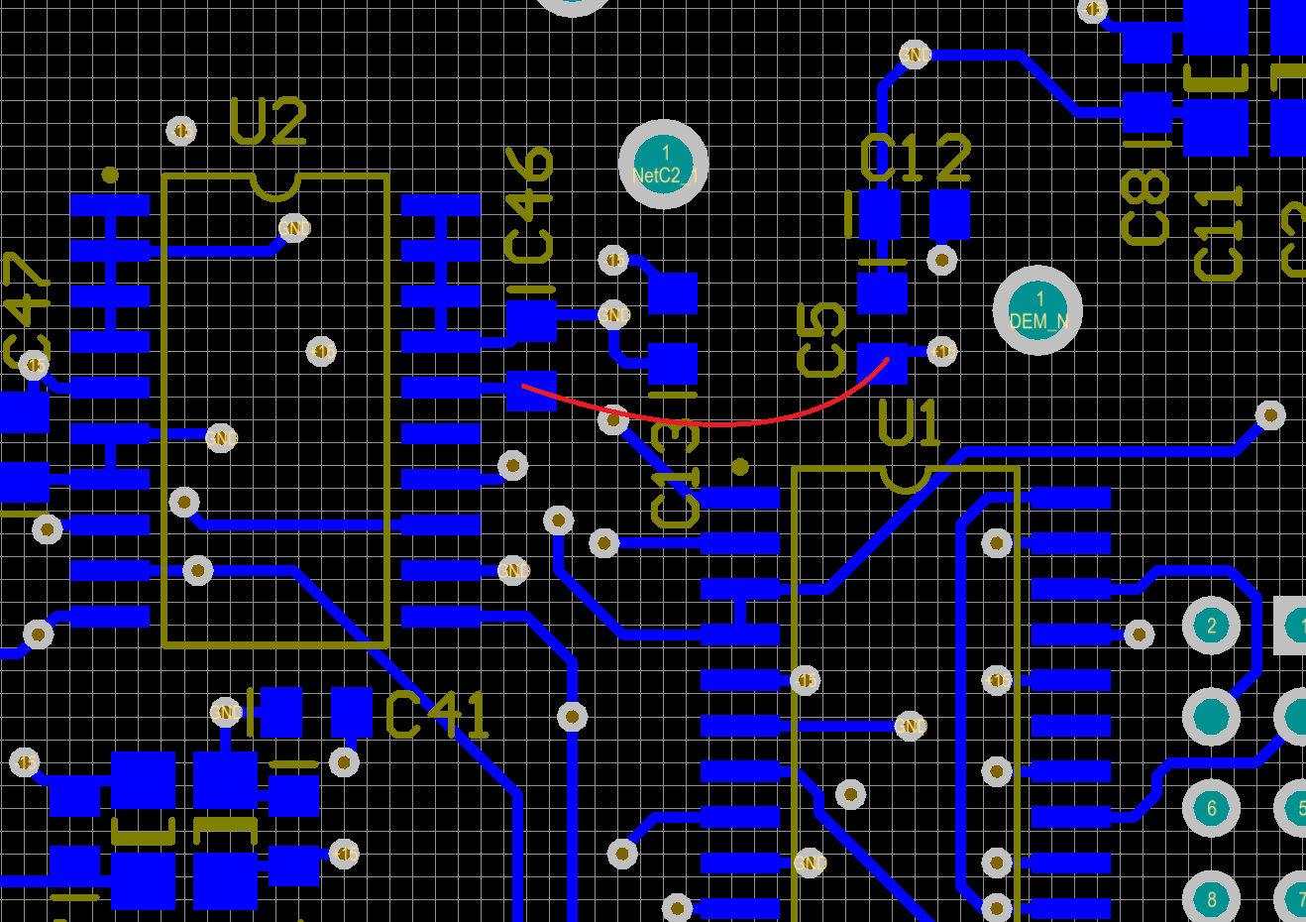

Change 2:
Input to U26 is floating when OPT4 is selected without an option board. Add a 10 kΩ resistor (R174) between pins 8 and 18 of header JP1 (Servo board, D1700077, bottom).

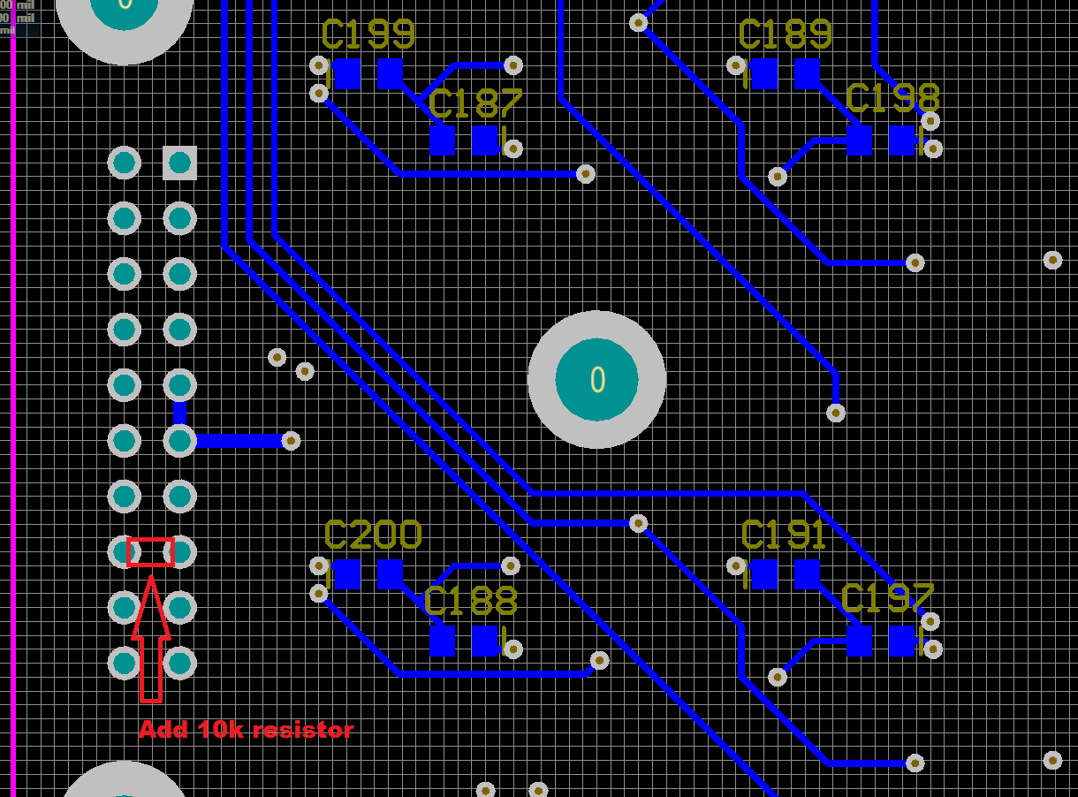

Part modifications:

Change 3:
A couple of AD829 operational amplifiers are missing a small capacitor in the feedback path to make them stable (Servo board, D1700077, top).

C66 → 4.7 pF
C52 → 27 pF
C53 → 27 pF
C101 → 10 pF
C153 → 4.7 pF

Change 4:
The output of the EOM high voltage stage needs a higher output impedance to limit the maximum current drive (HV board, D1700076, top).

R99 → 470 Ω (350V)
C63 → 100 pF (500V)

Change 5:
The common boost filter knee changed to 480 Hz (Servo board, D1700077, top).

R55 → 1 kΩ
R63 → 1 kΩ

Change 6:
The gain in the fast path that is used together with the EOM needs to be increased by 4 (Servo board, D1700077, top).

R65 → 499 Ω
R66 → 499 Ω

Change 7:
The gain in the EOM path is too low and needs to be increased by a factor 10. By increasing R112 we also need to adjust the compensation of OpAmp U33 to stay at a high bandwidth (Servo board, D1700077, top/bottom).

R112 → 10 kΩ
C152 → NL
C165 → NL

Change 8:
A lead compensation is needed in the EOM path to restore a decent phase margin (Servo board, D1700077, top).

R107 → 2 kΩ
C144 → 100 pF (1% or 2%)

Change 9:
Remove pointless EOM path diodes (Servo board, D1700077, top).

D1 → NL
D2 → NL

Change 10:
Add a fourth notch filter in the fast patch to address resonances below 100kHz (Servo board, D1700077, top).

U29 → AD829
R91 → 100 Ω
R95 → NL
R99 → 249 Ω
R103 → 0 Ω
C141 → 10 nF (NP0, 1% or 2%)

Change 11:
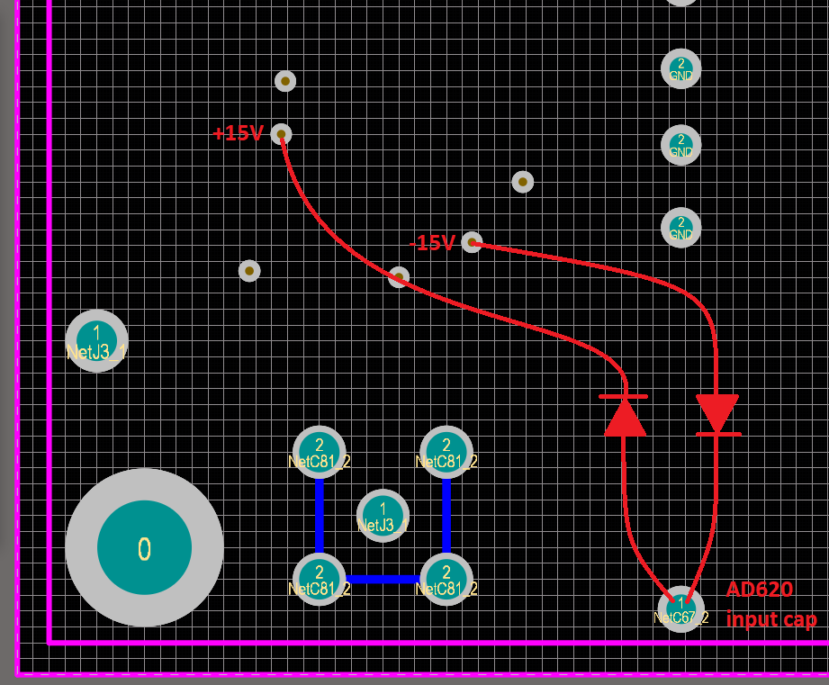
Add protection diodes between the AD620 inputs and the supplies to discharge the input capacitor upon power failure (HV board, D1700076, bottom).
Bottom of HV board, D1700076, beneath U17, AD620.

BOM (for 6 units, changes 1 through 4):
Qty | Item | Distributor | Description
10 | P10KDACT-ND | Digi-Key | Change 2; 10 kΩ
20 | 478-1300-1-ND | Digi-Key | C66,153; 4.7 pF
10 | 311-1099-1-ND | Digi-Key | C101; 10pF
20 | 311-1104-1-ND | Digi-Key | C52,53; 27pF
10 | 1135-1606-ND | Digi-Key | R99; 470 Ω
10 | 80-C1206C101FBG | Mouser | C63; 100 pF

BOM (for 6 units, changes 5 through 10):
Qty | Item | Distributor | Description
10 | P10KDACT-ND | Digi-Key | R112; 10 kΩ
20 | P1.0KDACT-ND | Digi-Key | R55, R63; 1 kΩ
10 | P2.0KDACT-ND | Digi-Key | R107; 2 kΩ
20 | P499DACT-ND | Digi-Key | R65, R66; 499 Ω
10 | 311-3379-1-ND | Digi-Key | C144; 100pF
10 | P100DACT-ND | Digi-Key | R91; 100 Ω
10 | P249DACT-ND | Digi-Key | R99; 249 Ω
10 | A110380CT-ND | Digi-Key | R103; 0 Ω
10 | 490-8295-1-ND | Digi-Key | C141; 10 nF, 1%
7 | AD829ARZ-ND | Digi-Key | U29; OpAmp
BOM (for 6 units, change 11):
Qty | Item | Distributor | Description
20 | 1N3595CT-ND | Digi-Key | low leakage diode

