*LIGO Laboratory / LIGO Scientific Collaboration*

LIGO-T1700433-v2 *Advanced LIGO* June 6, 2018



Modernizing the EtherCAT Slow Controls System



Daniel Sigg, Patrick Thomas

Distribution of this document:

LIGO Scientific Collaboration

This is an internal working note of the LIGO Laboratory.

|  |  |
| --- | --- |
| **California Institute of Technology**  **LIGO Project – MS 18-34**  **1200 E. California Blvd.**  **Pasadena, CA 91125**  Phone (626) 395-2129  Fax (626) 304-9834  E-mail: info@ligo.caltech.edu | **Massachusetts Institute of Technology**  **LIGO Project – NW22-295**  **185 Albany St**  **Cambridge, MA 02139**  Phone (617) 253-4824  Fax (617) 253-7014  E-mail: info@ligo.mit.edu |
| **LIGO Hanford Observatory**  **P.O. Box 159**  **Richland WA 99352**  Phone 509-372-8106  Fax 509-372-8137 | **LIGO Livingston Observatory**  **P.O. Box 940**  **Livingston, LA 70754**  Phone 225-686-3100  Fax 225-686-7189 |

http://www.ligo.caltech.edu/

# Executive Summary

We propose to upgrade our EtherCAT slow controls system to TwinCAT 3.1. TwinCAT 3.1 allows us to take full advantage of modern computer hardware and software: It supports multi-core processors and 64-bit operating systems. With the vacuum system already on TwinCAT 3.1, this should simplify long-term maintenance, and easily accommodate future upgrade needs.

At the same time, we propose to reduce the number of the slow controls computers for the main interferometer controls from three to one. This will keep the costs down and reduce the communication dependencies between different EtherCAT computer systems. We would like to move from one large network ring topology to multiple smaller EtherCAT network interfaces that are working independently.

We also propose to add separate dedicated smaller CPUs for the rotation stages. This allows for independent diagnostics.

# Software Infrastructure

The current TwinCAT 2.11 software has several limitations that are restricting our current setup. It runs on a 32-bit operating system inside a single thread. It cannot take advantage of modern multi-core processors nor any memory beyond 2 GB. It is also limited to four programmable logic controllers (PLCs) and requires a particular programming language referred to as structured text. We are using PLCs to compartmentalize different subsystems, and four is not enough. TwinCAT 3.1 runs on 64-bit operating systems, is multi-threaded, can take advantage of all available main memory, lifts the restriction on the number of PLCs, and supports C++ and Simulink as additional programming languages. However, we will stay with structured text for the foreseeable future, since there is a clear upgrade path from TwinCAT 2.11.

We have begun to upgrade our PLC libraries to TwinCAT 3.1. This process is straight forward, but for now, we need to support both old and new versions simultaneously. We would like to move all of our TwinCAT slow controls software to the new version to reduce the required support. From an operator or commissioner’s point of view, this change will be transparent. The TwinCAT-to-EPICS interface required a few small updates. It will look the same from the EPICS side.

# Network Topology

Currently, the EtherCAT network topology for the main interferometer controls consists of three rings. The largest one originating in the corner, going to each end station, the electronics equipment room (CER) and the main experimental area (LVEA). Two smaller rings originate in the end stations covering their experimental areas (VEAs). We use special bridge terminals to communicate between the corner and end station EtherCAT rings.

We propose to move to a star topology, which allows us to separate subsystems into their own branches. This star topology would originate in the corner and implement branches for each end station, the ISC sub system, the squeezer subsystem, the thermal compensation and laser subsystems, and an auxiliary chain, see Figure 1.

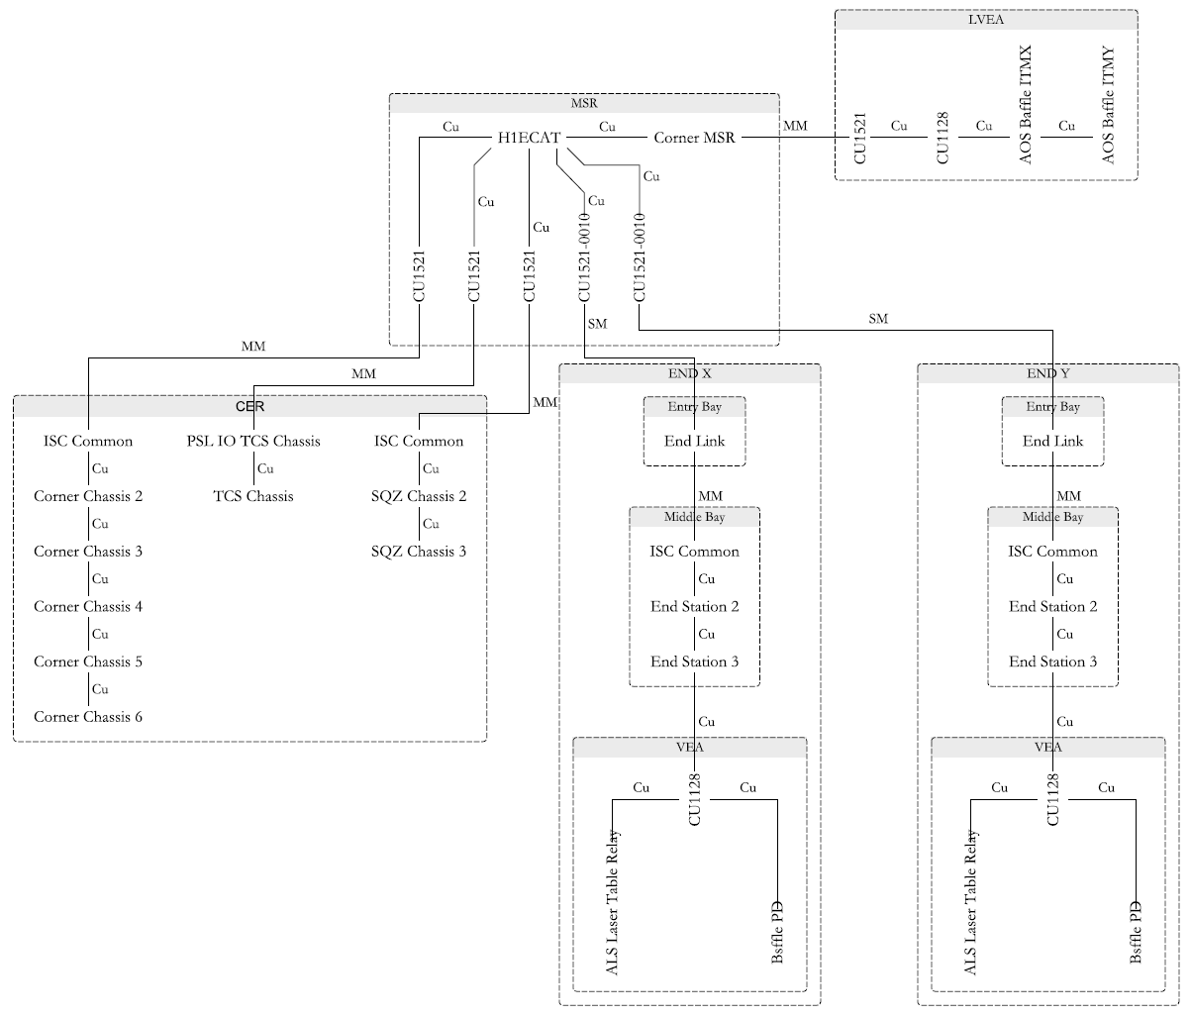

Figure 1: New star topology for the main EtherCAT system.

The rotation stages with their computers will be separate.

# Computer Infrastructure

One of the problems with the current custom computers running TwinCAT 2.11 is that Beckhoff does not support them. We propose to acquire a pre-configured computer from Beckhoff that comes with support. To keep the costs reasonable we also propose to combine the three current machines. This should decrease maintenance and increase reliability at the same time.

# Upgrade Plan

The upgrade can be divided into three steps:

1. Partially upgrade the network topology with the current system. This will not eliminate the end station TwinCAT computers. It will require changes to the EtherCAT chassis that interface the old and new fiber runs, as well as some fiber terminals and boxes. It will require two new fiber runs to from the MSR to the CER.
2. Upgrade the computer in the MSR to the new Beckhoff sourced unit, which is running TwinCAT 3.1.
3. Eliminate the end station TwinCAT computers. This requires the corner station computer to connect to the single-mode fibers directly, and to connect the two rails within the end link chassis in series.

After the completion of both upgrade steps, we can retire the TwinCAT 2.11 software and switch support to TwinCAT 3.1

# Cost Estimates

The costs below are per detector and does include spares.

|  |  |  |  |  |
| --- | --- | --- | --- | --- |
| Qty. | Item | Description | Estimate | Ext. |
| 2 | C5102-0060 C9900-C561 C9900-R260 C9900-M711 FC9022 TC1210-0080 TF6340-0080 TF5000-0080 | Computer w/ TwinCAT 3.1 Window 10 64 IO enterprise | 7000 | 14000 |
| 2 | TBD | Smaller size dedicated computer | 1500 | 3000 |
| 3 | CU1521-0010 | EtherCAT media converter single mode fiber optic | 365 | 1095 |
| 5 | CU1521-0000 | EtherCAT media converter multimode fiber optic | 273 | 1365 |
| 3 | CU1128 | EtherCAT junction with 8 ports |  | ~1000 |
|  |  | Miscellaneous: fibers, cables, enclosures, etc. | 1500 | 1500 |

The estimated costs for the first upgrade step are around $4000 per detector, whereas the second step adds about $7000 per detector.