Test Date | Aug. 2-4, 2017
Author(s) | Liyuan Zhang, Stephen Appert, GariLynn Billingsley
Approval(s)
Specification Doc. | LIGO-E0900041 | Specification | HR<0.5 ppm, AR<1.0 ppm
Procedure Doc. | LIGO-E1000863
S1 HR (Mean ± RMS) | 0.5 ± 0.1 ppm
S2 AR (Mean ± RMS) | 1.1 ± 0.1 ppm
Conclusion | Qualified.

Discussions and Comments:
For each surface, S1 (HR) and S2 (AR), 4 linear scans of 20 mm are carried out along X+- and Y+- outside central 120 mm in diameter. The arrow on barrel is positioned at Y+ direction. The calibration is done by a contamination cavity HR mirror (1” in dia., No. 8128), of which the HR absorption was measured to be 0.6 ppm in the optical contamination test. The results are summarized in Fig.1 and 2 for HR (S1) and AR (S2) respectively.

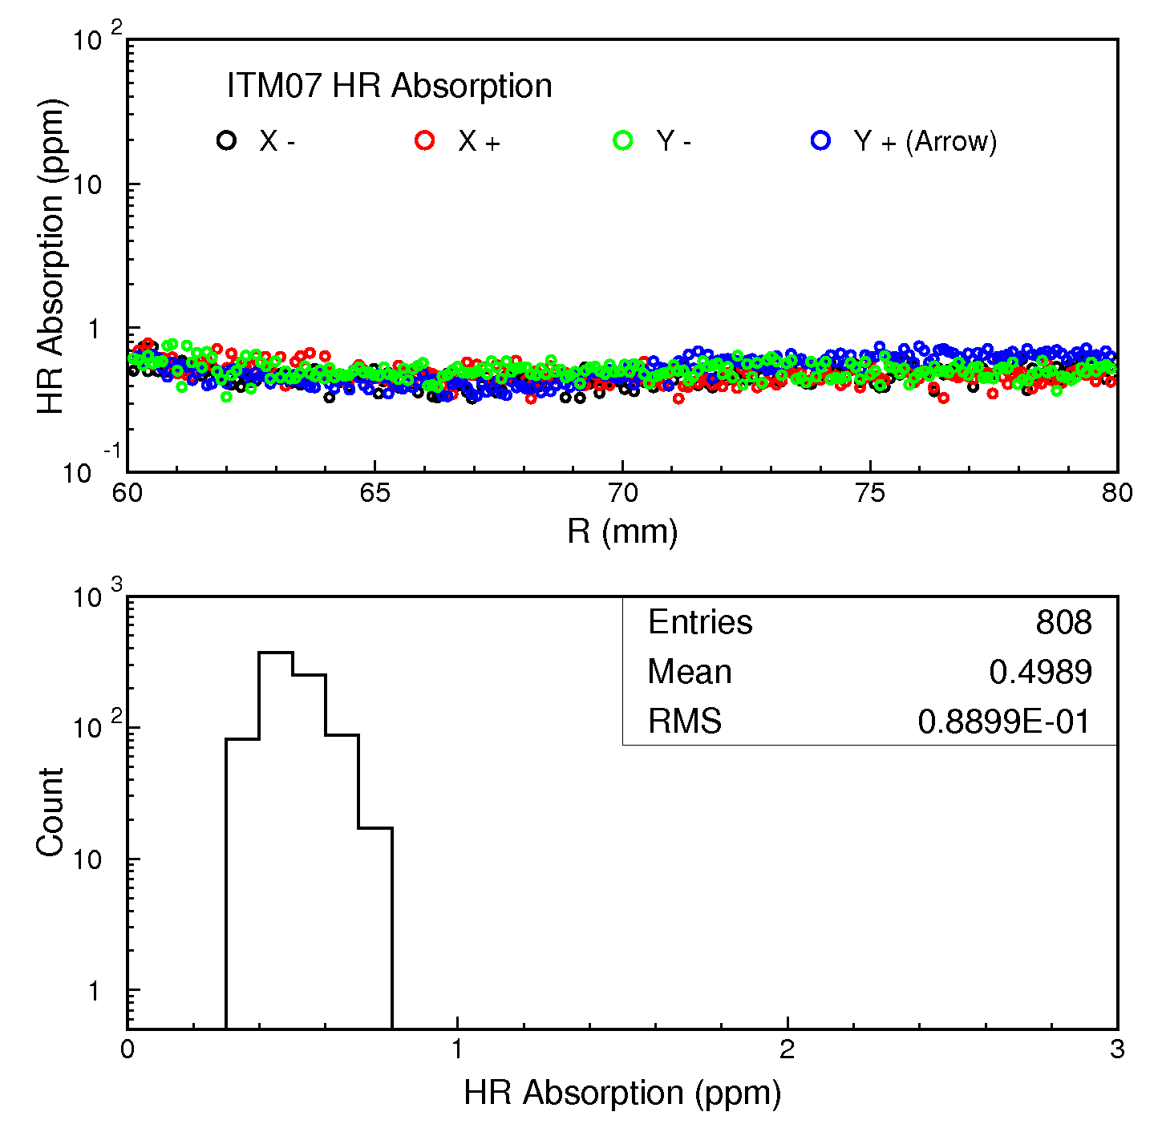
Fig. 1 ITM07 HR absorption measurements along X+- and Y+- outside central 120 mm in diameter.

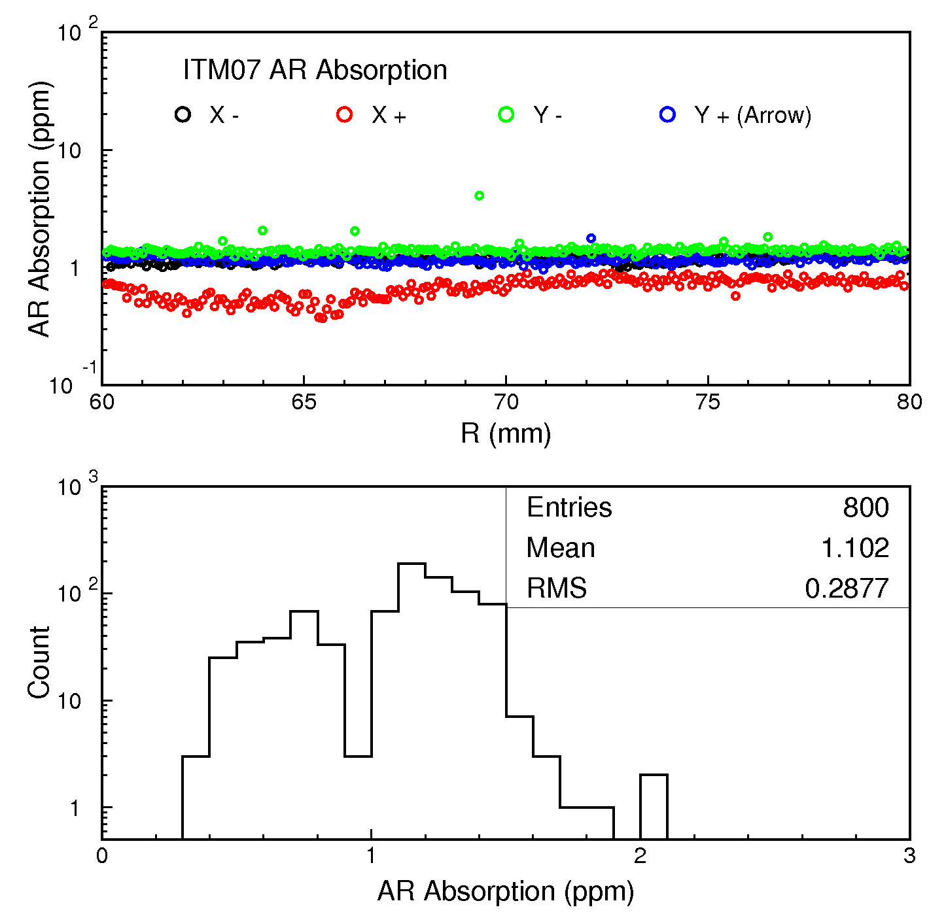
Fig. 2 ITM07 AR absorption measurements along X+- and Y+- outside central 120 mm in diameter.

