Test Date | Jun. 12-14, 2017
Author(S) | Liyuan Zhang, Stephen Appert, GariLynn Billingsley
Approval(s)
Specification Doc. | LIGO-E0900041 | Specification | 0.013-0.015
Procedure Doc. | LIGO-E1000863 | Mean ± Error* | 0.0150 ± 0.0003
Conclusion | Qualified.
*Error is the calibration error, which is ~2%.
Discussions and Comments:
The scan was done over central 160 mm in diameter with the beam and step sizes of 1 mm and positioning the arrow on barrel at Y+ direction, as shown in Fig.1. The calibration is done by normalizing the transmitted signal to the signal without mirror and the variation of laser power during scan is monitored and corrected.

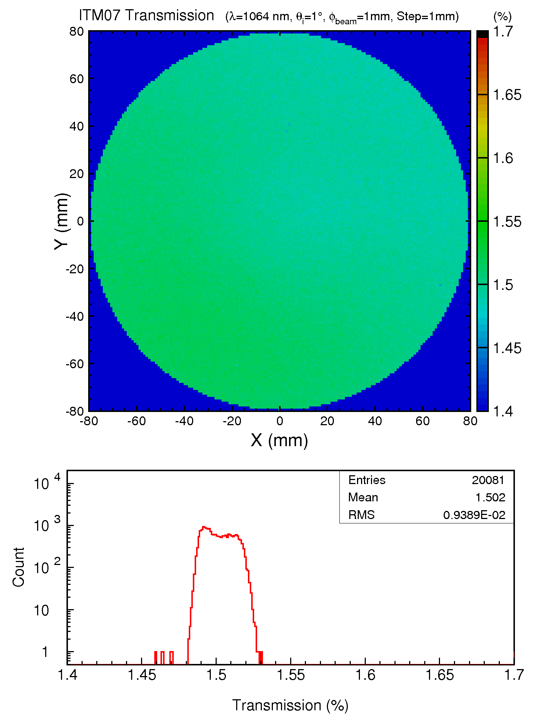
Fig. 1 ITM07 transmission over a 160 mm diameter aperture.

