Abstract
The object of the project is to track spectral and ultimately determine the strength of the line. In order to track the modulation of narrow peaks visible in the gravitational wave the computer model, that stimulates an interferometer, had to be set up.Then a test panel was created to control the parameters of the components that were added to the model to compare the coherence and uncertainty. The present work on the project show the model outcome uncertainty is consistent with calculated uncertainty. The future plan is to looks at the behaviour of signals due to environmental noise and parametric instabilities.
Background/ Introduction
The project will entail working on spectral line tracking and the properties to improve the performance of the interferometer over the ten week program at LIGO Livingston Observatory (LLO). The project's goal is to track the modulation of narrow peaks visible in the gravitational wave channel overtime and to address the limitations of different lines crossing in frequency or disappearing at times.
When observing the LIGO data stream there will a focus on signals that are due to environmental noise. Some lines that modulate in size, large or small, due to environmental influences become undetectable, it is the project's goal to fix that. The detector noise is made up of a combination of broad-band noises and monochromatic features.
In researching the lines behaviour the uncertainty and coherence were looked at. ^{[1]}The coherence measures the power in the response channel (output) that is caused by the power in the reference channel (input). The coherence ranges from zero to one; zero being none of the output power at that frequency is caused by the input and one being the output power at that frequency is caused by the input. The uncertainty is the measure of the deviation of the outcome compared to the actual or predicted outcome.
Methods
In this project Fourier transforms is used as a tool to identify and distinguish signals. It is a general form of the Fourier series that extracts periodic signals out of the gravitational waves/channel. Fourier transform is a method used for converting time domain to a frequency domain. By using this method the board band noises are easily distinguishable from narrow band noise and allows us to identify the lines that has a less contribution from broad band sources. Fourier Transform can be used to extract signals form overwhelming noise present at other frequencies.

Result
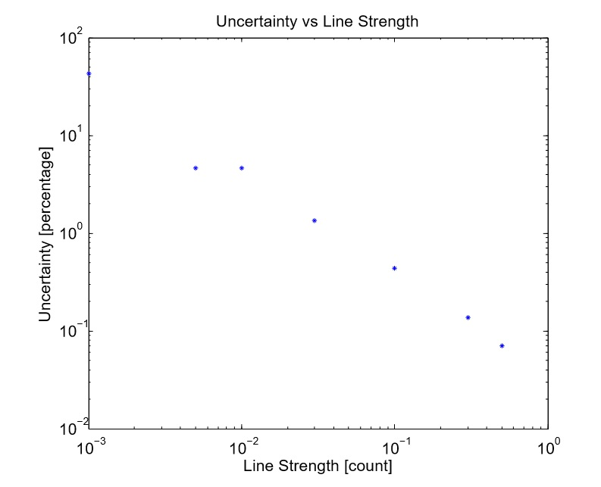
Graph 1: A log-log graph of uncertainty vs line strength

Discussion (On current work)
The computer model that was set up by activating the lower pass and bandpass manually. then accessing past LIGO data stream channel for the interferometer. A test panel was made to then change parameters to observe the coherence and uncertainty changes when the line strength was changed. The test was done on the PCAL line 2, the frequency was set to 331.3 Hz. The PCAL oscillator line strength to 100.0 and the DARM_ERR oscillator line was manipulated overtime to find different plots and outcomes. A whit noise generator was also passed in the computer model which was also controlled on the test panel.
The Diagnostic test tool, which used Fourier Transform, helped in determining the coherence graphically which was compared to the DARM_ERR/PCAL coherence to make sure they are consistent. The uncertainty from the data model was compared to the equation using the coherence from the diagnostic test tool. This was done to also check to see if the calculation was consistent with the output od the model. The relationship between the uncertainty and the line strength was observed in a loglog diagram which shows a relatively line plot in descending order representing the inversely proportional relationship.
Future Plans

….........................................................

References. Authors are responsible for the accuracy of references. References should be numbered sequentially as they appear in the text and should be listed at the end of the paper. Reference numbers should be in superscript when cited in the text.
- What resources will you require?
  - Fundamentals of interferometric gravitational wave detectors by Peter R. Saulson
[1] The Fundamentals of Signal Analysis by *Agilent Technology

