LASER INTERFEROMETER GRAVITATIONAL WAVE OBSERVATORY

-LIGO-

CALIFORNIA INSTITUTE OF TECHNOLOGY

MASSACHUSETTS INSTITUTE OF TECHNOLOGY

|  |
| --- |
| **Technical Note** 1/13/2011 (slightly updated 7/15/2015) |
| **Inserting FS725 Rubidium Clock as a Fail-Safe Mechanism in the aLIGO Timing System Chain**  Zsuzsa Marka, Stefan Countryman,  *Columbia University* |

This is an internal working note

of the LIGO Project.

**California Institute of Technology**

**LIGO Project – MS 51-33**

**Pasadena CA 91125**

Phone (626) 395-2129

Fax (626) 304-9834

E-mail: [info@ligo.caltech.edu](mailto:info@ligo.caltech.edu)

**Massachusetts Institute of Technology**

**LIGO Project, MIT NW22-295,**

**185 Albany St.,Cambridge, MA 02139 USA**

Phone (617) 253 4824

Fax (617) 253 7014

E-mail: [info@ligo.mit.edu](mailto:info@ligo.mit.edu)

**Columbia University**

**Columbia Astrophysics Laboratory  
Pupin Hall - MS 5247**   
**New York NY 10027**  
Phone (212) 854-8209  
Fax (212) 854-8121

E-mail: [geco.cu@gmail.com](mailto:geco.cu@gmail.com)

WWW: <http://www.ligo.caltech.edu>

***Synopsis:***

*This document demonstrates that by inserting a properly constructed Rubidium clock between the GPS Receiver and the Timing Master allows the timing system to tolerate the loss of GPS system for many hours without compromising aLIGO’s timing specifications.*

***------------------------------***

**1) Purpose:**

Implementation of a fail-safe mechanism for reliable 1PPS production in the timing system chain may be useful in order to avoid conditions when GPS satellite coverage drops below the optimal or minimum number of satellites. Such conditions may occur in GPS deprived conditions that might happen in mountainous regions or in case of GPS system failure. Due to space weather conditions small transient deviations can occur in GPS timing on the ~O(10ns) level – such levels are uninteresting for current aLIGO and the ‘flywheels’ of the nominal timing distribution system can effectively mitigate them.

**NOTE: Currently both LLO and LHO have adequate satellite coverage. Implementation of the fail-safe mechanism suggested below is optional, and was tested in case such desire would arise in the future.**

**2)** **Implementation:**

A [Stanford Research Systems FS725 Rubidium Frequency Standard clock](http://www.thinksrs.com/products/FS725.htm) is installed in-line with the timing system chain taking 1PPS input from the GPS receiver box (i.e., [Trimble - ThunderBoltE](http://www.trimble.com/timing/thunderbolt-e.aspx)) and providing a highly precise atomic clock buffered and UTC synchronized 1PPS signal to the Timing Master’s ([D070011](https://dcc.ligo.org/cgi-bin/private/DocDB/ShowDocument?.submit=Number&docid=D070011&version=)) 1PPS input (see left portion of Figure 1.) The [FS725](http://www.thinksrs.com/products/FS725.htm) provides exceptionally well disciplined and low phase noise 5MHz and 10MHz sine outputs as well as a *low jitter 1PPS output that should remain in-sync with UTC for many hours after losing trust in the GPS network and smoothly return to the nominal zero difference to UTC after regaining GPS trustability*.

**3) Test of Fail-Safe Mechanism (medium term):**

The test configuration is depicted in Figure 1

Figure 1 Setup for testing FS725 Rubidium Clock as a Fail-Safe Mechanism. The antenna on the left chain was intermittently disconnected at **X** in order to simulate the loss of reliable GPS signal.

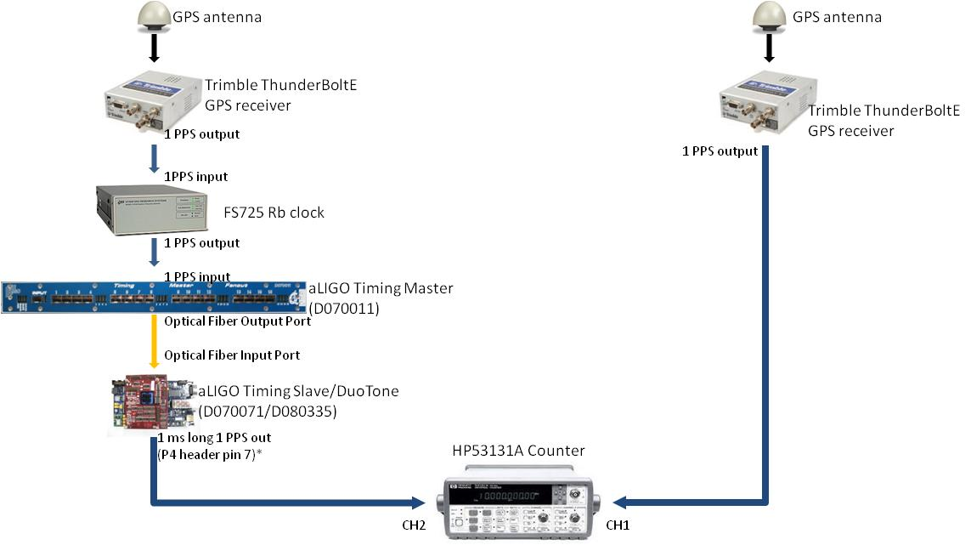

The time difference between the 1PPS output of an additional Trimble ThunderBoltE GPS receiver and the 1PPS output of the Trimble ThunderBoltE – FS725 – Timing Master ([D070011](https://dcc.ligo.org/cgi-bin/private/DocDB/ShowDocument?.submit=Number&docid=D070011&version=)) – Timing Slave/DuoTone assembly ([D070071](https://dcc.ligo.org/cgi-bin/private/DocDB/ShowDocument?.submit=Number&docid=D070071&version=)/[D080335](https://dcc.ligo.org/cgi-bin/private/DocDB/ShowDocument?.submit=Number&docid=D080335&version=)) was recorded for several days using an [HP53131A universal counter](http://www.keysight.com/en/pd-1000001385%3Aepsg%3Apro-pn-53131A/225-mhz-universal-frequency-counter-timer?cc=US&lc=eng). Additional information on the aLIGO timing distribution chain is available from [E090003](https://dcc.ligo.org/LIGO-E090003), [E080541](https://dcc.ligo.org/LIGO-E080541) and from [Class. Quantum Grav. 27 084025 (2010)](http://iopscience.iop.org/0264-9381/27/8/084025).

Channel 1 on the counter was triggered on the rising edge of the Trimble 1PPS output (10µs long). In order to alleviate HP53131A’s counting peculiarities for actual negative time differences we externally introduced a positive 1ms long timeshift on channel 2 by triggering on the 1PPS aligned falling edge of a 1ms long 1PPS output from pin7 of port4 of the Duotone board (D03). (Note: this output of the DuoTone board is not normally programmed for the timing distribution system production DuoTone units. The corresponding FPGA code for D03 1ms long 1PPS is available upon request from the authors.) The length of the 1ms long 1PPS output of the DuoTone board was measured, verified and subtracted from the collected time difference data, and all figures below already take that into account.

Figure 2 below shows the relative drift between true time (as taken from the ‘antenna– GPS receiver’ 1PPS pulse; right side of Figure 1) and the time at the end of the ‘antenna – GPS receiver – Rb clock – Timing Master – Timing Slave/DuoTone’ chain (left side of setup on Figure 1) after the antenna was disconnected (see Figure 1 for complete setup). The test simulates complete loss of GPS satellite coverage as the antenna is disconnected from the GPS receiver at time=0 of data taking.



Figure 2 Timedrift measured at the end of ‘GPS receiver – Rb clock - Master-Slave/DuoTone’ chain in microseconds vs time (in hours) after losing GPS signal coverage. The FS725 Rb clock acts as a Fail-safe mechanism in providing external 1PPS input to the Timing Master.

As Figure 2 shows, after 18 hours of antenna loss the time drift is still below the aLIGO specification of 1µs. (Note: This test was performed essentially ‘cold’ right after powering up the Rb clock and we did not allow for any long lasting initialization or self-calibration period in order to test a conservative scenario.)

Figure 3 below shows a subsequent test when the GPS antenna input to the Trimble receiver was connected for approximately an hour, then disconnected/reconnected several times at times indicated by the vertical green lines on the figure. We find that an hour of antenna loss produces negligible timedrift when using a Rb standard inserted into the timing chain for supplying 1PPS to the Timing Master. We also included a longer disconnect period (15 hours) after which the antenna was reconnected. (Note: The timescale of the change in time drift after the antenna reconnection is indicative of the time constant for the PLL of the Rb clock, which can be set on FS725.) If needed and human resources are available the Rb clock can be calibrated to further mitigate the drift rate, albeit it is unnecessary as there is already more than sufficient time provided by the Rb clock to do an emergency switchover to the Cesium atomic clock (available at the sites for diagnostic purposes). A Cesium clock as a final backup should provide unimpeded running for the timing distribution system for months to a year - depending on its fine calibration status - should a catastrophic failure of the global GPS satellite system arise.

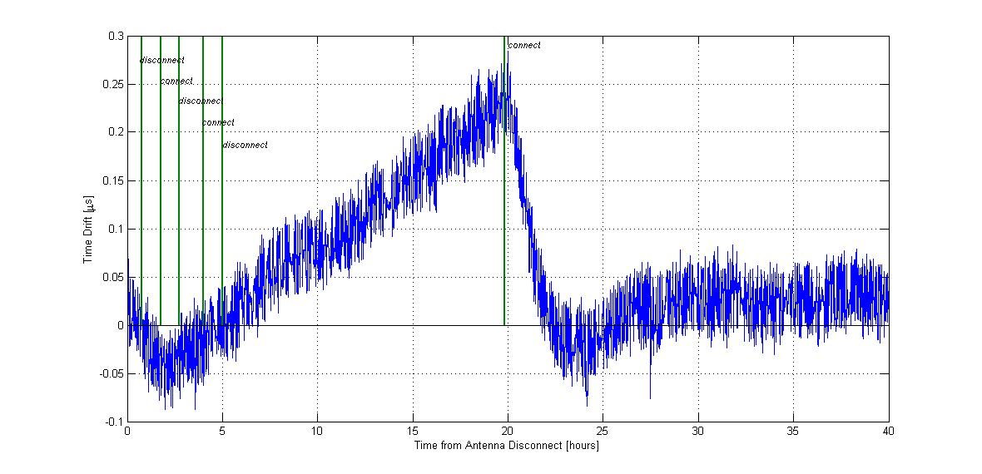

Figure 3 Time difference from true GPS time measured at the end of ‘antenna –GPS receiver – Rb clock – Master – Slave/DuoTone’ chain in microseconds vs time (in hours). The GPS antenna was disconnected/reconnected several times at times indicated by the vertical green lines on the figure.

An additional test with long term connections and disconnections in a running system is shown on Figure 4 below.

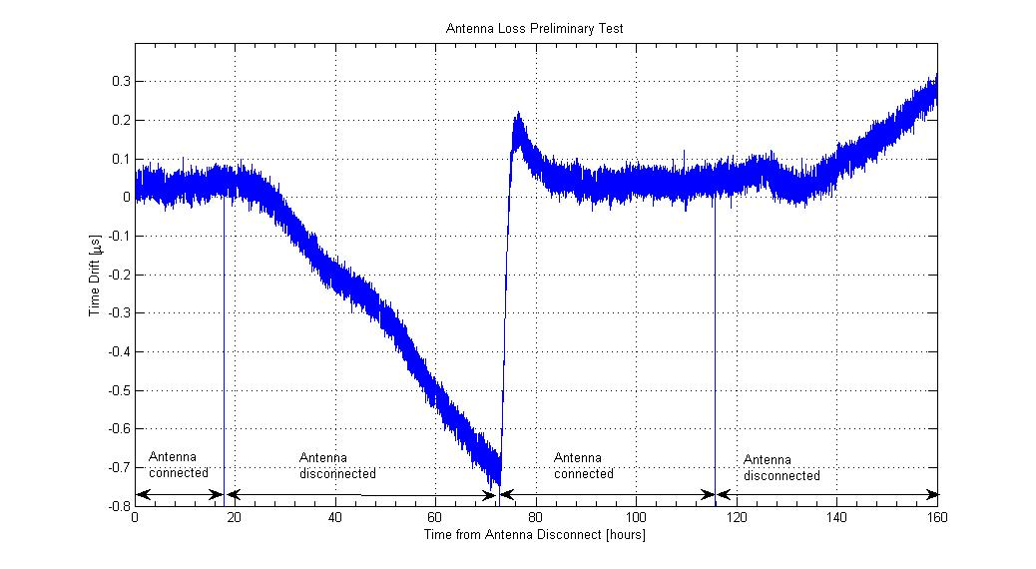

Figure 4 Time difference from true GPS time measured at the end of ‘antenna –GPS receiver – Rb clock – Master – Slave/DuoTone’ chain in microseconds vs time (in hours). The GPS antenna was disconnected/reconnected several times for tens of hour long periods at times indicated by the black arrows on the figure

**Summary:**

A Rb clock, such as FS725 can provide a reliable medium-term fail-safe mechanism even for long term (~many hours) loss of GPS antenna signal that is sufficient to switch over to alternatives and keep aLIGO running long term.