LIGO Laboratory / LIGO Scientific Collaboration

LIGO-E1500264-v3 LIGO 11-17-15

Annular End Reaction Mass Conceptual Design Document
G. Billingsley, N. Robertson, B. Shapiro

Distribution of this document:
LIGO Scientific Collaboration

This is an internal working note
of the LIGO Laboratory.

California Institute of Technology  LIGO Project | Massachusetts Institute of Technology  LIGO Project
LIGO Hanford Observatory | LIGO Livingston Observatory
http://www.ligo.caltech.edu/

Introduction
Annular End Reaction Mass Conceptual Design. This document presents a design which is sufficient to present to vendors for quote and to allow refinement of requirements based on engineering and vendor feedback.

Purpose
Replace the ERM with an annulus ERM with design constraints described in LIGO­E1500263, Annular End Reaction Mass Design Requirements. The replacement should have minimal impact on all subsystems.

Reference Documents
Most reference documents require only the addition of the new mechanical drawing number. The mechanical drawing is new. The polishing and coating specifications used for the ERM are not required since there is no interaction with the interferometer beam.

D0900958­v6 | GOLD COATING PATTERN END REACTION MASS BARREL | Not updated yet
D0902822­v3 | ADVANCED LIGO ERM OPTICS WITH PRISMS ASSEMBLY | Not updated yet
E0900138­v1 | End Reaction Mass Electro Static Drive gold coating specification | Not updated yet
E1000752­v5 | Preparation of a thermal compensation plate (TCP) or end reaction mass (ERM) (Gluing wire break­off prisms and earthquake stops) | Not updated yet
T0900403­v5 | Advanced LIGO SYS Summary of COC/SUS OPTIC Substrates & associated attachments | Not updated yet
T1300016­v2 | Core Optics Components (COC) Long Term Storage for the 3rd aLIGO Interferometer | Not updated yet

Acronyms
ETM – End Test Mass
SUS – Suspension Subsystem
AERM – Annular End Reaction Mass ERM – End Reaction Mass

Design description and analyses
The AERM is identical to the Advanced LIGO end reaction mass (LIGO-D080116) in exterior dimensions. The AERM is made of fused silica. The gold electro static pattern remains the same as for the ERM, there is no requirement for AR coating. The current plan entails rework of the existing ERMs, maintaining all coatings.

Design documents

D1500163-v4 Annular End Reaction Mass (AERM)

Design Detail

Mechanical Interfaces
The AERM will have the same outside form as the ERM. Dimensions are within the previous ERM dimensional tolerances. The existing ESD pattern has a minimum ID of 226 mm, an annulus ID of 222.5 mm allows for the standard 2 mm bevel at a maximum angle of 41 degrees with respect to the optical axis, providing a pseudo beam­dump effect.

New vs. Old | AERM LIGO-D1500163 | ERM LIGO-D080116-v2
Diameter | 340.0 ± 0.25 mm | 340.0 ± 0.25 mm
Thickness | 130.0 ± 0.25 mm | 130.0 ± 0.5 mm
Wedge | < 0.08° Horizontal | 0.04°, +0.04°, ­0.03°  Horizontal
Annulus ID | 222.5 mm ± 0.5 | none
Fiducial Markings | Every 90° WRT wedge. Tolerance 0.1° or 0.3 mm | Every 90° WRT wedge. Tolerance 0.1° or 0.3 mm
Bump Stop recess | Same | Same
Material | Fused Silica | Fused Silica
Mass | Nominal 14.8 kg | Avg as built: 26026 g, 𝜎 27g

Material Properties
Fused silica is chosen as the material for cost and schedule reasons. This requires added mass at the End Penultimate Reaction Mass.

Vacuum Compatibility
Fused silica is widely used in LIGO and is acceptable for high vacuum use.

Moment of inertia, suspension dynamics
If we use the approach to core out the existing ERMs to produce an annular ERM with inner diameter 0.2225 m (just inside the gold pattern), the mass and the moments of inertia are significantly changed. The mass is reduced from its current value of 26 kg to ~14.8 kg. This value should be compared to the thin CP value of 20 kg. Thus the change is more extreme than what was handled when we changed the reaction suspension design for the thin CPs. To compensate for the reduction in ERM mass for this new design of cored-out ERM, extra mass of around 11.2 kg is required to be added to the penultimate reaction mass used in the current ERM suspension, taking it from its nominal value of 53.9 kg to 65.1 kg. Note that the actual value of the PUM reaction mass in each suspension will not necessarily be this nominal value since it is tuned for adjusting blade tip positions. It can be varied with addable and removable masses by of order 1 kg from its nominal.
See T1500563-v2 (case 2, page 2) for how 11.2 kg can be added to the existing PUM reaction mass design. It makes use of replacing steel can inserts with tungsten ones. We have taken the new mass and moments of inertia from the SolidWorks rendering of this design, and new mass and moments of inertia (MOI) for the cored-out ERM and run the MATLAB quad model as referenced in E1500264-v2 for the previous analysis using SF2 material. The new masses and MOIs are given at in the Appendix to this section. We compare the dynamics of the current ERM parameter set from the SUS SVN (revision 7392) with a revised parameter set replacing m2 and its moments of inertia (PUM reaction mass) and m3 and its moments of inertia (ERM) with the new values. No other parameters were changed.
In figures 1 to 6 we show the transfer functions from top of suspension to ERM for the 6 degrees of freedom. Some nominal damping by local control has been included, unchanged between the two models. As expected, some frequencies are shifted slightly in all degrees of freedom. The highest vertical and roll modes (undamped by local control) are higher principally due to the fact that the bottom mass is now considerably lighter and the wire thickness supporting the bottom mass has not been changed. The overall dynamical behaviour is similar between the old ERM and the new cored-out AERM. Isolation in all degrees of freedom is similar between the old and new design by 10 Hz. Most modes remain damped at around the same level. The only concern is that the highest pitch mode at 3.17 Hz is not so well damped for the new ERM compared to the old, using the same damping law. This is because the coupling of the highest pitch mode to the motion at the top mass is reduced. This can be seen in figure 2, blue peak just above 3 Hz. It can also be inferred by consideration of the relative motions of the four masses from top to bottom for this mode. The current ERM values taken from the Suspensions wiki at
https://awiki.ligo-wa.caltech.edu/aLIGO/Suspensions/OpsManual/QUAD/Models/20120831TMproductionERM#modeP4
are
0.1911, -0.4617, 0.3998, -0.7663
Brett has computed the corresponding numbers for the new suspension:
-0.1042, 0.2433, -0.3042, 0.9151
Clearly the relative motion of top mass (where damping is applied) with respect to the bottom mass is significantly decreased. One can increase the gain and reduce the Q of this mode, while more heavily damping the three lower pitch modes. This decreases overall pitch isolation but since this is a reaction chain with plenty of isolation in hand that is not a concern. However there is a limit to how much damping before you start "clamping" the top mass in pitch and not gaining any more damping of this mode (and start to decrease its damping again). For example with a simple damping law (such as in T0900435 section11.5), the maximum damping achieved was a Q of ~ 550, or damping time to 1/e of ~ 55 secs. This is higher than our requirement (damping time ~10 secs).
If this level of damping is not sufficient in operation, it is possible to use as a sensing signal the OSEMs at the PUM and feed that back to the top mass to boost the damping. Brett has modelled this – see figure 7. Here he has taken the damping control law currently in use at LLO for the thin CP suspension as an example. The blue trace is using that damping law “as-is”. The red trace is increasing that damping by a factor of 4 which is approximately the maximum achievable before the damping starts decreasing again. The purple trace shows the effect of boosting the damping using the PUM sensor signal and feeding that back to the top mass. It can be seen that this additional feedback path significantly improves the damping to reach an acceptable level.
It should be noted that in fact the thin CP suspension is similar to the new ERM in this very feature that its highest pitch mode is not well-coupled and therefore not well damped. This was missed at the time the thin CP design was chosen. At present we are not aware of adverse effects in operation from low damping of this mode. However the same technique of using the PUM OSEM signal could be applied in its case too if required.
In conclusion, a reaction chain using the cored-out ERM and heavier PUM to compensate for the reduced mass looks acceptable with regards to its dynamical behavior, noting that we may require to implement additional damping of the highest pitch mode by making use of the PUM sensor signal.

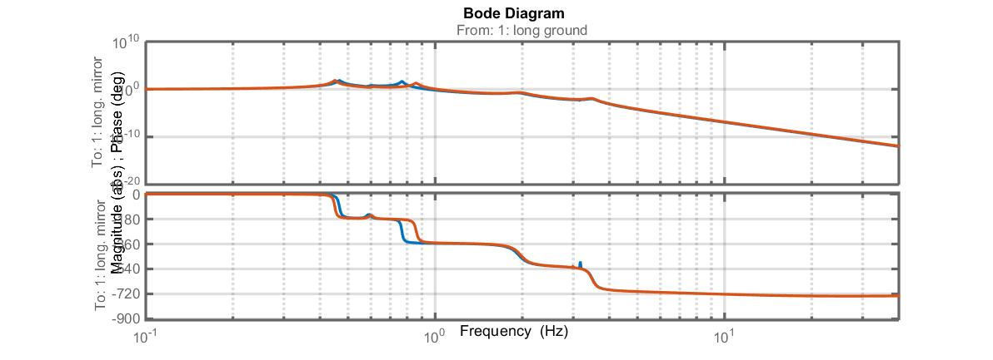
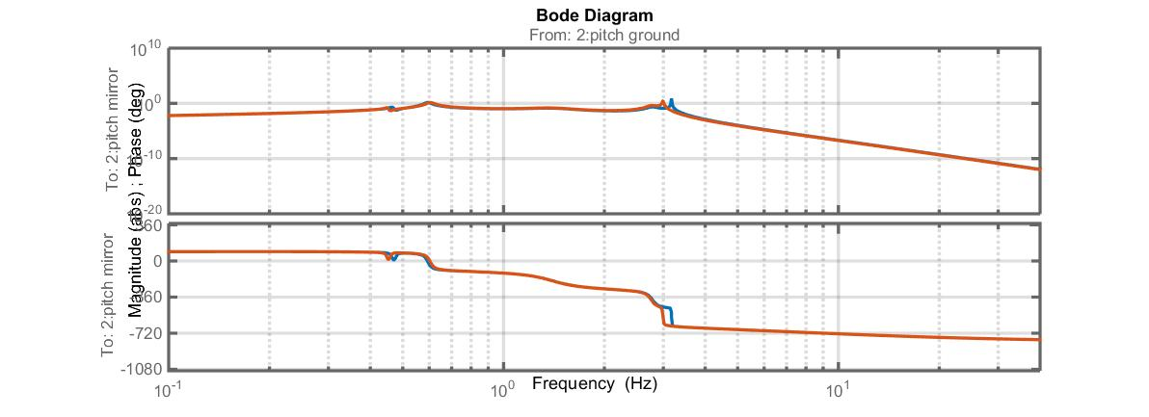
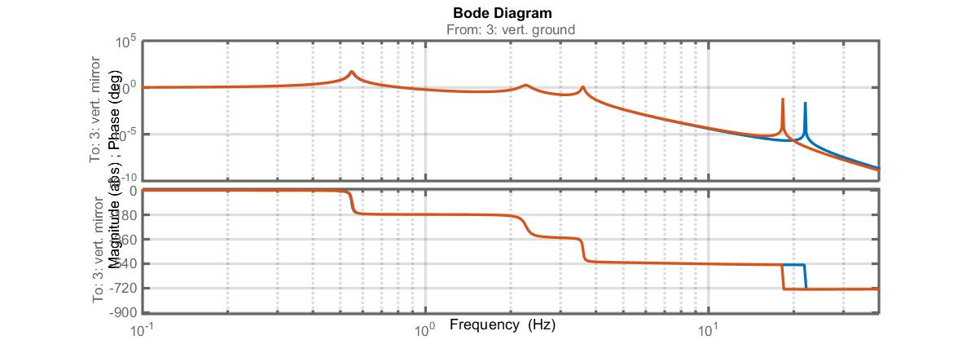
Figures 1, 2 and 3. Longitudinal (top), pitch (middle) and vertical (bottom) transfer functions (magnitude and phase) from top of reaction chain to ERM. Red = current suspension, blue = proposed cored-out ERM.

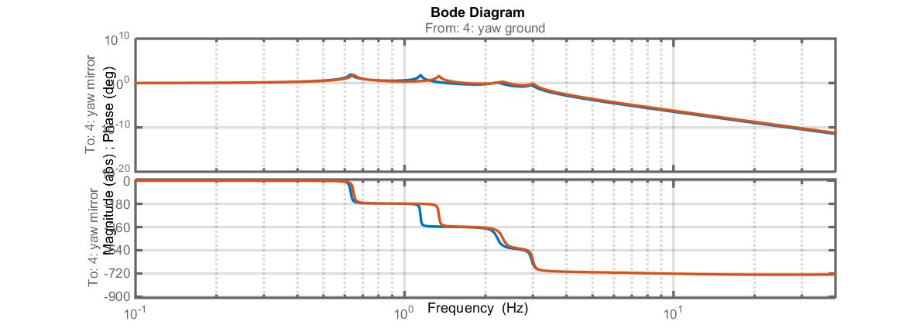
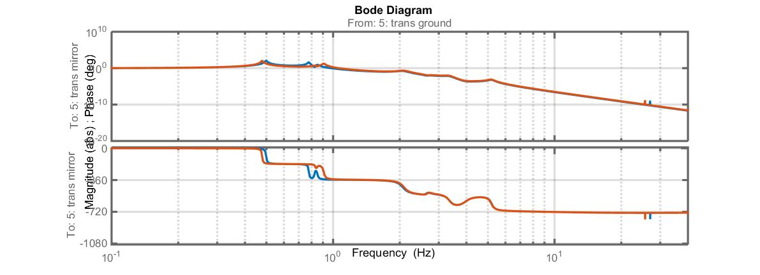
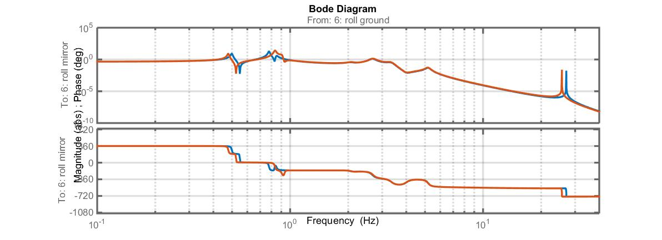 Figures 4, 5 and 6. Yaw (top), transverse (middle and roll (bottom) transfer functions (magnitude and phase) from top of reaction chain to ERM. Red = current suspension, blue = proposed cored-out ERM.

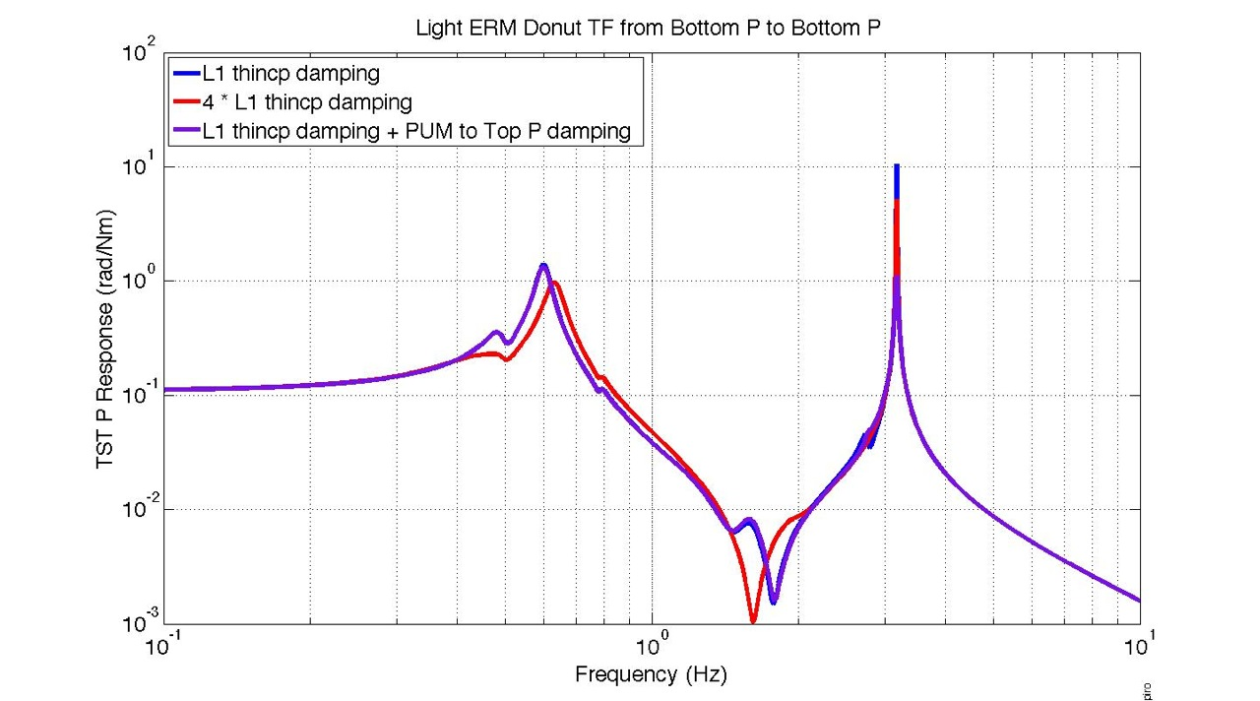

Figure 7. Transfer functions in pitch from bottom mass to bottom mass with various damping applied. The three traces are described in the text.
Appendix
Summary of new mass and moment of inertia parameters for the new PUM (m2) and new ERM (m3) used in MATLAB modeling (in SI units):
m2: 65.0800
I2x: 1.0009
I2y: 0.5771
I2z: 0.5915
I2xy: 3.2900e-04
I2yz: -2.5100e-04
I2zx: 8.6000e-05

den3: 2200
m3: 14.8462
I3x: 0.3064
I3y: 0.1741
I3z: 0.1741
Rout: 0.1700
Rin: 0.11125

Electrical Interfaces
The AERM will have the same electrical interface as the ERM

Optical Interfaces
The AERM will have no required AR coating, since the nearby gold coating is extremely reflective so the AR would be a small effect. The polished glass reflectivity at 1060 is 4%, compare this to the ESD coating which is 99% at 1064 nm. The AR was necessary on the original ERM since the beam passed through the optic.
The surfaces of the AERM are polished similar to all other suspension glass: transparent with no grey, scuffs or scratches. This polish allows use of the optical tool that is currently used to set the gap between the ETM and ERM.
The bevel of the Annulus ID is angled inward at a maximum of 41 degrees with respect to the optical axis as a precaution to avoid retro­reflection.

Impact on Arm Length Stabilization
The green beam is 4.4 cm in radius, with the AERM inner diameter equal to 222.5 mm, there is 3 ppm of green light incident on the annulus, therefore the resulting scatter is inconsequential.

Impact on Thermal Control
Aidan Brooks notes in LIGO-L1500113 that the difference between thermal lensing between an ETM-only system and an ETM + ERM system is 5-10%, the AERM will have a somewhat smaller effect.

Fabrication
The AERM is cut and polished using standard glass making techniques. The gold coating is the same as was used for the ERM.

Logistics
AERMs will require shipping containers. The container design for the existing ERM/CPs, LIGO­D0902001 is used. The Teflon o­ring base plate support for the CP is 242 mm, the annulus ID is at most 226 mm, allowing roughly 9 mm of overlap. The Teflon ring will sit mostly on uncoated glass, between the first two gold “rings” of the ESD pattern. We believe that there is minimal risk of “cutting” the gold trace, based on our experience with the CP and ERM gold coatings used in aLIGO.

Tooling
A new design is required for an additional Ergo Arm Vacuum plate.

Testing
- Dimensions and fiducial locations will be verified by LIGO per LIGO­Q1100083 “Measuring Core Optics with a Height Gauge and Calipers.”
- Electrical continuity will be checked upon receipt and after each handling event.
- There are no optical tests required.

