LIGO Laboratory / LIGO Scientific Collaboration

LIGO-T1500115-v4 LIGO April 6, 2016

Real-time Code Generator (RCG)
SDF Software

R. Bork, D. Barker, K. Thorne, J. Hanks

Distribution of this document:
LIGO Scientific Collaboration

This is an internal working note
of the LIGO Laboratory.

California Institute of Technology  LIGO Project | Massachusetts Institute of Technology  LIGO Project
LIGO Hanford Observatory | LIGO Livingston Observatory
http://www.ligo.caltech.edu/

1 Introduction 3
2 Documentation History 3
3 Overview 3
4 Basic Concept 3
5 Setpoint Definition Files (SDF) 4
5.1.1 SDF Format 4
5.1.2 File Channel Entries 5
5.1.3 File Location and Naming Convention 6
5.1.4 Continued Use of BURT with RCG V2.9 and later 6
6 SDF Monitoring and Reporting 6
6.1 SDF Log File 6
6.2 GDS_TP Screen 8
6.3 SDF Table Display 9
6.3.1 Setpoint Monitor Statistics Section 10
6.3.2 Setpoint Table Section 11
6.3.3 Setpoint Change Area 13
6.3.4 Using the SDF Table Display to Make Setpoint and Monitoring Changes 14
7 SDF Save and Restore 17
7.1 SDF Restore 17
7.1.1 SDF Restore MEDM Screen 17
7.1.2 Loading the Monitoring Table with New Values from and SDF File 18
7.1.3 Alternative SDF File Read Options 19
7.1.4 SDF Restore via Scripts 19
7.2 SDF Save 21
7.2.1 Using the SDF SAVE Screen to Save Files 21
7.2.2 Saving SDF Files Via Scripts 22
8 The EPICS Channel Access build of SDF 23
8.1 Installing the CA version of SDF 23
8.1.1 The CA SDF Model 23
8.1.2 Installation 23
8.2 Specifying Channel Lists 23
8.3 Differences in the Channel Access build 23
8.3.1 Start up behavior 23
8.3.2 Expanded precision in *.snap files 23
8.3.3 Differences in the SDF_TABLE 23

Introduction
The purpose of this document is to provide a description of the built-in control settings monitoring functions provided with the CDS Real-time Code Generator (RCG) software.

Documentation History
- Initial SDF software release, as provided with the RCG release V2.9, see RCG V2.9 Release Notes, LIGO-T1400570-v4.
- Setpoint monitoring, as provided with RCG release V2.9.1 and later.
- Revision to incorporate changes made for RCG release V3 and later.

Overview
The capability for the monitoring of control setpoints by the RCG generated code running on real-time application computers was a feature first added in RCG V2.9. After gaining operational experience with the system, the SDF code has been modified and bug fixes made for RCG V2.9.1, as described in this document.
Since this software makes use of a file format, known as a Setpoint Definition File, to define setpoint requirements, this software has become commonly referred to as SDF software. This SDF acronym is used throughout this document in describing this software.
The addition of SDF code to the RCG generated software was made primarily for two reasons:
- Performance. For large control models, such as for ASC, EPICS Back Up and Restore Tool (BURT) files could take in excess of 20 seconds to load using EPICS Channel Access (CA). By having the EPICS code, generated by the RCG, directly read the file and using EPICS database access (DBA) routines, the time to read and load settings was reduced by as much as a factor of 100.
- LIGO CDS contains on the order of 100,000 control settings, of which about 80% are set once and not normally changed. However, if a setting is changed unexpectedly, for any number of possible reasons, it would be very difficult, at best, to track it down. Therefore, with the FEC now reading in the BURT file, it can also now monitor settings and report if and when a setting has changed.
In addition during O1 the SDF system was extended to monitor arbitrary EPICS channels via EPICS Channel Access. This was developed to allow monitoring of the Beckhoff TwinCAT slow controls systems without requiring direct modifications of the CDS TwinCAT IOC.

Basic Concept
The primary function of the SDF code is to monitor those ~80% of control settings that do not change on a regular basis once control loops are tuned. Guardian automation scripts, which regularly change the other 20% of settings based on interferometer control states, are responsible for monitoring the rest.
The SDF code is provided as part of the EPICS runtime software generated by the RCG. Specifically, it involves custom code additions to the EPICS software provided main.c code module, which gets compiled into every EPICS runtime application.
This software operates basically as follows:
- On code start:
  - The code scans the EPICS database for operator setpoint entry records by checking the type of each record. By RCG standards, setpoints can be one of three record types:
    - Analog Input (ai)
    - Binary Input (bi)
    - String Input (stringin)
  - The code reads the safe.snap file, which provides the initial startup settings information. This file uses the EPICS Back Up and Restore Tool (BURT) file format, with the addition of an extra field for each channel (see next section). In previous RCG releases, the startup script generated by the RCG would execute an EPIC burt restore command to read this file and set the associated EPICS records. This method used EPICS Channel Access (CA) to write the initial values. In the case of the new software, EPICS Data Base Access (DBA) methods are used. Since DBA provides pointers to the EPICS database records, as loaded in local memory, this is a much faster access method.
  - Settings information from the safe.snap file is loaded into a local memory SDF table, for use in monitoring for setpoint changes. These settings are also set in the associated EPICS database records.
  - An fec.snap file is written, with the contents of the SDF memory table. This file will update whenever any future changes are made to the table. Note that this file has one additional column for each channel indicating whether or not the channel has been initialized (1) or not (0).
  - Note that the SDF software does not monitor alarm settings. If the safe.snap file contains alarm settings, which most presently do:
    - Settings are applied to associated EPICS database records.
    - A safe_alarms.snap file is created, and all alarm settings written to that file. This file is used during SDF file saves to append alarm settings to those files.
- The code then continuously reads the values of EPICS setpoint records, at ~8Hz using DBA, and compares these values against the values provided by the safe.snap, or other operator selected, file.
- If the code detects differences between the reference setpoint and the value read back from the EPICS database record, information on the errant channel(s) is provided via SDF EPICS database records and an EPICS MEDM monitoring screen generated for each code model.

Setpoint Definition Files (SDF)
SDF files are essentially the same as BURT snapshot files, with an additional entry for each channel defined in the file.

SDF Format
To maintain compatibility with BURT, the new SDF file format remains ASCII text based. Each file maintains the standard BURT header. An example is shown below.
--- Start BURT header
Time: Thu Mar 26 09:15:24 2015
Login ID: controls ()
Eff UID: 1001
Group ID: 1001
Keywords:
Comments:
Type: Absolute
Directory /home/controls
Req File: autoBurt.req
--- End BURT header
Settings information is contained in one line per channel. The first three columns are the same as for a BURT file, namely:
- Col 1: Channel Name
- Col 2: Number of values associated with the signal name.
  - This is presently 1 for all LIGO CDS setpoint channels, as data arrays are not used.
- Col 3: Channel Value
To enable set point monitoring, a fourth column is added, which defines the ‘mask setting’:
- If zero (0) or not defined, the FE code will not monitor this setting, nor report if it has changed. (Exception is Monitor All option, described later)
- If set to one (1), the FE code will continuously monitor this channel and report any changes.
- For fine grained monitoring of filter banks a bitmask may be specified. The monitor value may be a bit mask, written as a 32 bit hexadecimal value with a leading 0x. As an example 0xffffffc3 monitors all bits except filter modules 3, 4, 5, and 6. The mask value is only valid on SW1 and SW2 channels, and the combined value (by bitwise logical OR) is used to create the final monitoring mask. For backward compatibility 1 may be used to specify monitor all bits.
A file with this additional column may still be used with BURT restore. However, BURT will ignore the last column.
H1:FE3-TIM02_T1_ADC_FILTER_1_TRAMP 1 4.000000000000000e+00
H1:FE3-TIM02_T1_ADC_FILTER_1_OFFSET 1 1.700000000000000e+01 1
H1:FE3-TIM02_T1_ADC_FILTER_1_GAIN 1 1.000000000000000e+00 1
H1:FE3-TIM02_T1_ADC_FILTER_1_LIMIT 1 0.000000000000000e+00 1
H1:FE3-TIM02_T1_ADC_FILTER_1_SW1S 1 2.184000000000000e+04 1
H1:FE3-TIM02_T1_ADC_FILTER_1_SW2S 1 8.530000000000000e+02 1

File Channel Entries
The SDF FE code supports reading of files which contain anywhere from one setting to a complete list of setting channels. It is, however, strongly recommended that the safe.snap file contain the complete list of channels and their associated safe state startup settings and monitor masks. Subsequent file loads may contain partial lists of channels, in which case only the channels listed will be updated.

File Location and Naming Convention
The location of these files is to remain the same as before, namely the /opt/rtcds/<site>/<ifo>/target/<modelname>/<modelname>epics/burt directory. All files are saved with the .snap suffix.

Continued Use of BURT with RCG V2.9 and later
While the intent is to eventually move all systems over to exclusive use of the SDF FE code to load settings from file, this new release does not preclude the continued use of BURT. There are, however, a few caveats to note:
- A safe.snap file, of either standard BURT format or SDF format, must exist in the models burt directory. The FE code will not start without this file present.
- If BURT is used to restore settings, the FE code will not be aware of the new settings and will continue to monitor and report errant settings based on the last settings file that it read.
- If BURT is used to save settings, the resulting file will not contain any of the mask column settings.

SDF Monitoring and Reporting
On startup, all real-time applications now directly read and load settings from the safe.snap file from the model’s ‘burt’ directory. Previously, the RCG startup script would call BURT to load the file. Note that due to this change, it is now required that all models have a safe.snap file to start operation, which has been standard practice in LIGO for sometime.
The FE code will load all settings from the file, including alarm settings, into the EPICS database records. Note that alarm settings are not monitored and not loaded into the local memory setpoint table. The monitoring code is simply tracking the set point channel EPICS .VAL field, no others.

SDF Log File
For RCG V2.9 and later, a new directory needs to be created for the writing of EPICS and SDF log files. This directory in of the form: /opt/rtcds/<site>/<ifo>/log/<modelname>. Two log files will be written here:
- iocIFO.log: This is the standard EPICS log file, which was previously written to the target/<modelname>/<modelname>epics directory. This file is created every time the FE code is started.
- ioc.log: This is a new file used to write SDF code information. Unlike the iocIFO.log file, this is a persistent log, appended by the FE SDF code continuously. This file contains information about code restarts, SDF file reads/saves, etc.
An example of information written to the ioc.log file is shown in the following figure.
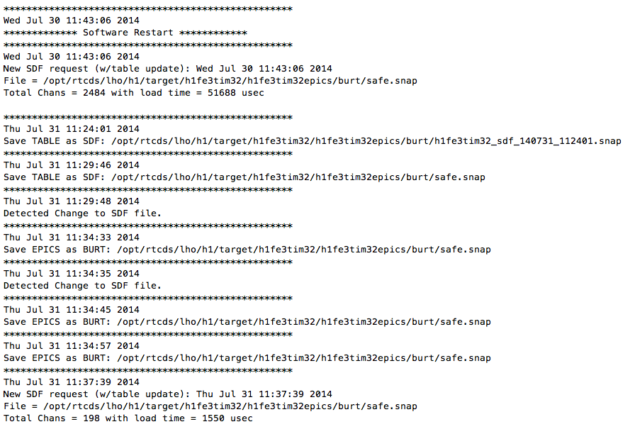
Figure 1: Example ioc.log file

GDS_TP Screen
As of RCG V2.9, a few items have been moved and an SDF area added, as shown in the following screenshot.
- Loading of files, including SDF, filter coefficient and DAQ configuration files have been added/moved to the right most column of the screen.
- GPS Time and Diag Reset have been moved to upper right below the date/time field.
The StateWord now includes an additional bit: CFC (Configuration File Change). This bit is set whenever the presently loaded coefficient definition or DAQ configuration files do not match those presently on the file server ie a change is pending.
The new SDF area of the screen includes:
- A ‘Related Display’ icon (SDF TABLE), which brings up the SDF_TABLE screen, described in the following section.
- A ‘DIFFS’ counter. This is reported by the FE code as the number of settings that do not match the loaded SDF file settings.
- The name of the last SDF file loaded, in this example ‘safe’.
- The time (local) that the last SDF file was loaded by the FE code.
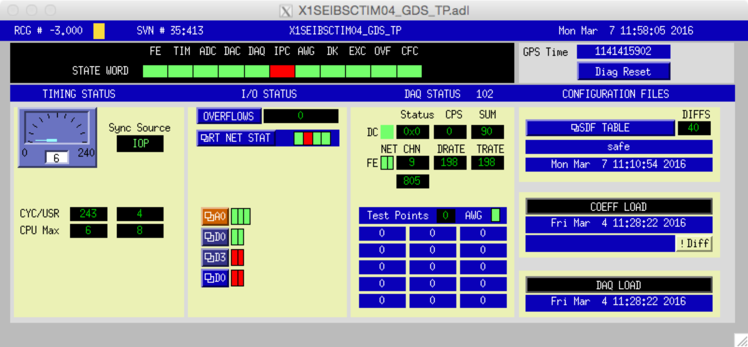

SDF Table Display
To provide additional information on SDF monitored channels, and affect changes, a tabular display is provided, with examples shown below. This display, for purposes of description, is divided into three parts:
- As setpoint monitoring statistics section (upper left).
- A table section, with 5 columns and 40 rows for displaying channel information and various entries to change what is displayed in the table.
- A setpoint change area, upper right and right hand side of the display.
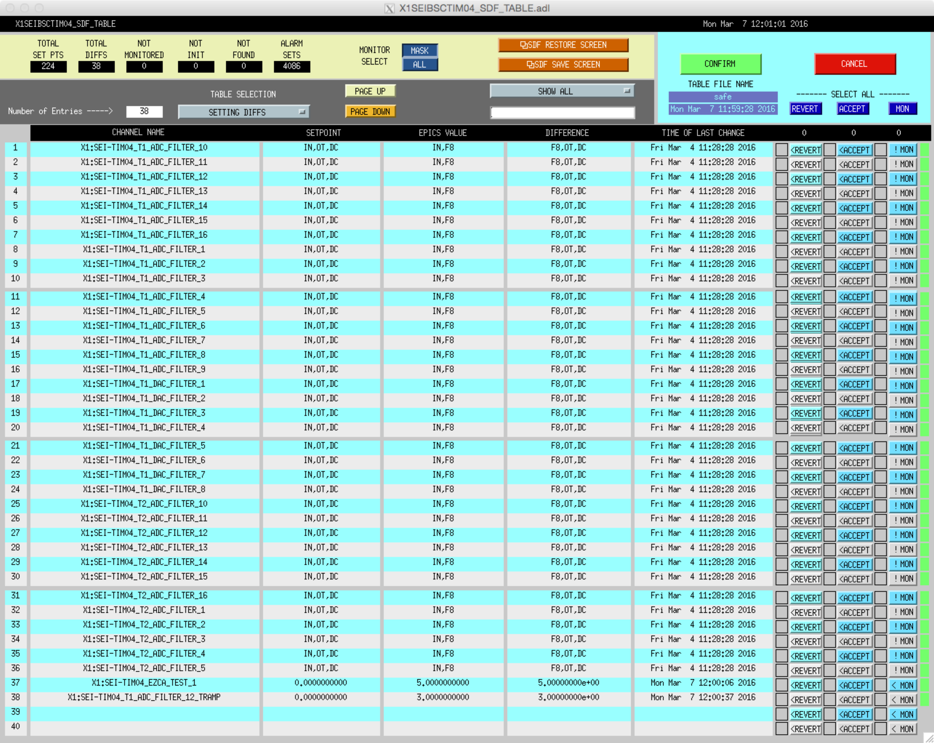
Figure 2: SDF TABLE MEDM Screen

Setpoint Monitor Statistics Section
This area of the MEDM screen is highlighted in the following figure. This section provides:
- Numerical statistics on the state of set points and monitoring.
- Provides a selector switch icon (MASK/ALL) allowing the user to switch monitoring modes.
  - MASK: Only monitor and report those channels that have the mask column set to ‘1’.
  - ALL: Monitor and report on all channels, not just those marked by a mask setting.
- Two related display icons to bring up the SDF Save and Restore screens

Figure 3: Setpoint Monitoring Section
The numerical statistics shown in this section, left to right, with there associated EPICS channel names, are listed below. Note that SDF EPICS channel names all have an <IFO>:FEC-<DCUID>_SDF_ prefix.
- Total Set Pts (FULL_CNT): When the FE code starts up, it scans its local EPICS database, determines which records are associated with set points, and writes the channel names into its local table. The number presented here are the total number of set points the FE code found during its startup scan.
- Total Diffs (DIFF_CNT): The total count of EPICS set points that vary from what was read in from the SDF file. In order to be counted in this total, a channel must have its monitor mask set to ‘1’ in the SDF.
- Not Monitored (UNMON_CNT): This is the total number of set point channels read from the SDF file that do not have a monitor mask set and therefore will not be monitored for changes by the FE code.
- Not Init(ialized) (UNINIT_CNT): The number of set point channels that did not have an entry in the safe.snap file on startup. This is intended as a diagnostic to the user, indicating that safe.snap file does not contain the complete database. For example, perhaps some new channels were added to the control model, but initial/safe settings were not added to the safe.snap file.
- Not Found (DROP_CNT): Indicates the number of channels names found in an SDF file but do not exist in the EPICS database itself. Again, could be because the control model was changed with some previous channels deleted and safe.snap needs to be updated. This could also be the case (non-zero) where a single SDF file contains settings for multiple control models, in which case the FE code will read/set those that has locally and ignore the others.
- Alarm Sets (ALARM_CNT): The number of alarm channel settings contained in the last SDF file read. This is simply provided as an indicator that the SDF file contained alarm settings and that they were subsequently set in the EPICS database by the FE code.

Setpoint Table Section
This section is highlighted in the following figure.
This section contains:
- A counter, indicating the total number of entries in the table.
- A menu selection bar, allowing the user to indicate what information is to be displayed in the table. Options are:
  - SETTING DIFFS: Fills in the table information for all channels where the setting in the settings file does not match the present value of the associated EPICS record.
  - CHANS NOT INIT: List of channels found in the database but were not found in the safe.snap file.
  - CHANS NOT MON: Listing of channels not being monitored by the FE code for changes.
  - CHANS NOT FOUND: Listing of channels found in the settings file but that do not exist in the running EPICS database.
  - FULL TABLE: Lists information on all EPICS setpoint channels for this application.
- Page Up and Page Down icons, to allow paging of the table when >40 items are present in the table.
- A string comparison selection menu icon and string entry field. The menu selections available are:
  - SHOW ALL
  - SORT ON SUBSTRING: In this mode, the table will show only those entries which contain the exact string of characters entered into the string entry field below the menu selection icon. In the example screen shot above, the substring to match is set to FILTER, and therefore only items that contain that string in the EPICS channel name are displayed in the table.
- A tabular form with 40 rows and 5 columns, with columns defined as:
  - CHANNEL NAME: The name of the EPICS database channel.
  - SETPOINT: The set point value read from the SDF file.
  - EPICS VALUE: The current setting for that channel in the EPICS database.
  - DIFFERENCE: The difference between SETPOINT and EPICS VALUE.
  - TIME OF LAST CHANGE: Time the EPICS value was last set. Note that the time presented is LOCAL time.
In the case of errant filter module switch settings (SW1S and SW2S), as shown in the example above, a single line entry appears in the table,.
- Channel Name: Name of the filter module.
- Setpoint: String representation of the filter module switches which should be ON.
- Epics Value: Filter module switches that are presently switched ON.
- Difference: Filter module switch(es) that are not set as required.
This string representation uses a short form of the individual filter module switch names to keep the string representation within the string record character limit. The short form for each switch is:
- IN = Input
- OF = Offset
- F1 thru F10 = Filter 1 thru 10
- LT = Limit
- OT = Output
- DC = Decimation
- HD = Hold Output

Setpoint Change Area
New in V2.9.1 is the ability to modify entries on a channel by channel basis from the SDF TABLE display.
A expanded view of the new SDF TABLE display area to support this is highlighted in the following figure.

Figure 4: SDF TABLE – Setting Change Area
This section contains:
- For each table entry, a pushbutton to select the line item for a pending change. Note that each push of these buttons will toggle the selection, with the block to the left of each button indicating if the item is selected (YELLOW) or not (BLANK).
  - REVERT: Change the EPICS record value back to that required by the SDF file loaded into the table.
  - ACCEPT: Replace the SDF table entry with the present EPICS value.
  - MON: Flip the monitor (mask) setting.
    - For filter banks the MON button will open a secondary window to allow individual monitoring bits to be selected.
- To the far right is an indicator of the mask setting. If the mask is set to monitor the particular channel, then a GREEN block will appear. If not, the far right space will be empty.
- For each of the options above, a counter appears at the top of each column to indicate the total number of items of each type that have been selected for change.
- A REVERT, ACCEPT, MON pushbutton at the top of each row which, when pushed, will select ALL channels in that row.
- Table File Name: The name of the file that is presently being used to set up the monitoring table.
- CANCEL/CONFIRM pushbuttons: After individual items are selected for change, the changes will only take effect after pushing the CONFIRM button. One may also clear out all change selections by pushing the CANCEL button.

Using the SDF Table Display to Make Setpoint and Monitoring Changes
The following screen shot is provided to help show how to make changes to settings and/or the SDF file.

Figure 5: SDF TABLE – Change Selection Example

General Notes
- No action is taken by the code to make any changes until the CONFIRM button is pushed. Pushing any of the REVERT, ACCEPT, or MON button simply selects an item for change.
- Once any selection is made:
  - A RED rectangle will appear around the upper right section of the display, as shown above, along with a message “CHANGES PENDING -- TABLE UPDATE LOCKED”.
  - The counter above the selected item will increment, indicating the total number of items in the column that are now selected for change.
  - Once in this state, EPICS values will no longer be updated in the display table, as they would normally be if no change selections were made.
  - One cannot change the SHOW ALL / SORT ON SUBSTRING parameters.
- REVERT and ACCEPT cannot be selected for an individual channel at the same time. For example, if REVERT has been selected, now the user pushes ACCEPT for the same channel, the REVERT selection will be cleared and the ACCEPT selection set, and vice versa.
- Pressing CONFIRM with channels selected by ACCEPT or MON will result in:
  - A backup copy of the present table settings being made with a date_time suffix. The date_time suffix is of the form <year><month><day>_<hour><minute><second>. As an example, if the safe.snap file is in use, the backup file will be named safe_150322_103455.snap.
  - SDF monitoring table being overwritten with the new values.
  - The table file, as shown under TABLE FILE NAME, will be overwritten with the new values. Therefore one should verify that this is the correct file before initiating any changes of this type.
  - If a filename_alarms.snap exists, then it will be appended to those files for purposes of maintaining alarm settings.

Reverting Settings
Reverting settings is defined as returning the present EPICS channel settings back to those defined in the SDF table. To revert settings from the SDF TABLE display:
- Set the SDF TABLE SELECTION to show “SETTING DIFFS”.
- Select the channel(s) to revert to table setting using either the REVERT button at the end of each table line to select an individual channel or the REVERT button at the top of the REVERT column to select ALL channels.
  - If one selects a channel by mistake, simply push the REVERT button for that channel again and it will be deselected.
  - To clear all REVERT selections, push the CANCEL button.
  - As items are selected/deselected, the counter at the top of the REVERT column will increment/decrement to indicate the total number of channels selected.
- Once one verifies that their selections are correct, push the CONFIRM button. This will result in:
  - Settings from the SDF table being sent to the selected EPICS channels. Note that in the case of filter module switch settings, both SW1S and SW2S will be reset.
  - The reverted channels should now disappear from the differences table list.
  - The number of Total Diffs, at the upper left of the display, should be reduced by the number of items selected to be reverted.
  - The fec.snap file will be updated with the latest SDF table settings.

Accepting New Settings
If one wants to change the setpoint in the monitoring table, and the file used to load the monitoring table, to the present value of the associated EPICS record, then ACCEPT is used.
- Set the SDF TABLE SELECTION to show “SETTING DIFFS”.
- Select the channel(s) to accept using either the ACCEPT button at the end of each table line to select an individual channel or the ACCEPT button at the top of the ACCEPT column to select ALL channels.
  - If one selects a channel by mistake, simply push the ACCEPT button for that channel again and it will be deselected.
  - To clear all ACCEPT selections, push the CANCEL button.
  - As items are selected/deselected, the counter at the top of the ACCEPT column will increment/decrement to indicate the total number of channels selected.
- Once one verifies that their selections are correct, push the CONFIRM button. This will result in files table updates and the writing of files, as described in the previous general notes section.

Changing the Monitoring (Mask) Settings
For simple string and numeric data the SDF monitor mask is simply a zero (do not monitor the channel for differences) or a one (monitor channel for differences). Selection, and subsequent confirmation, for a change to a channel monitor mask will simply flip the value from one to zero, or zero to one, depending on its present state in the SDF table.
For filter banks the monitor mask is a bitmask. The bits correspond to the SWSTAT bits. For compatibility with RCG 2.9 when a 1 is stored as the mask value it is interpreted as completely monitored. The mask is modified through a supplemental display, which allows each of the components of the filter bank to be monitored. When using the monitor all button the monitor masks are set to monitor all bits.
The monitor mask can be changed with the table display set to:
- SETTING DIFFS: Since this view typically shows only channels being monitored, this table setting would normally be used to set monitor masks to zero (disable monitoring).
- NOT MONITORED: This view shows all of the channels that are not presently being monitored and therefore would be used to turn on monitoring (set mask to one).
- FULL TABLE: Since this view shows all channels, monitoring can be turned on or off from this display.
To make the change to the monitor mask from any of these display views:
- Check the present state of the monitor mask by checking the far right of the display
  - A GREEN block to the right of the MON button indicates that monitoring is presently enabled.
  - No block to the right of the MON button indicates that monitoring for this channel is presently disabled.
- Select the channel for changing the monitor setting by pressing the associated MON button, or the MON button at the top of that column to select all channels.
- Once the user verifies the selections, press the CONFIRM button to affect the changes. This will result in files table updates and the writing of files, as described in the previous general notes section.

Monitoring individual bit on a filter bundle.
Clicking the '! MON' button on the SDF Table will bring up the SDF_FILT_MONITOR screen for the selected filter module.
This screen shows two values, the SWSTAT value for the filter bundle and a SDF monitoring mask. The SWSTAT value shows which bits are set in light blue. The monitoring line shows bits that are set for monitoring with yellow.
The monitor mask is changed one bit at a time by pressing the buttons over each bit. The button toggles the value of the individual bit. No changes to the monitor mask happen until the confirm button is pressed on the main SDF table view.
Switching table views on the SDF table will reset any unsaved changes in the current window.
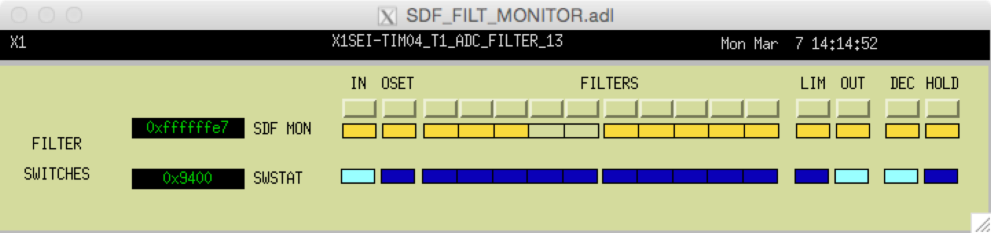
Figure 7: Change individual monitoring bites.

SDF Save and Restore
The initial SDF use model is to maintain a single (safe.snap) SDF file to be used for all setpoint monitoring, with the SDF_TABLE MEDM screen used to make occasional changes. However, the SDF software does provide basic save and restore functions, similar to EPICS BURT.

SDF Restore
While not planned at this time, a possible use case for SDF is to startup with the safe.snap file, then load new, partial settings SDF files as control states change. It may also be desirable to make use of SDF in a fashion similar to EPICS BURT ie load new EPICS database record values along with updating the SDF monitoring table.
Note that the new SDF code does not require that a file contain a complete list of all channels that exist in the database i.e. a file may contain just a small subset.

SDF Restore MEDM Screen
An example SDF_RESTORE screen is shown in the following figure. It is divided into 3 sections:
- Monitoring Statistics, same as found on the SDF TABLE display.
- SDF file read and restore settings from file to the monitoring table, which is the anticipated prominent use of this screen.
- SDF file read and restore settings, special cases.

Loading the Monitoring Table with New Values from and SDF File
- Press the ‘!SELECT REQUEST FILE’ icon.
  - This will pop up a file browser window, such as shown below. This browser window will automatically start at the <modelname>epics/burt directory.
- Select the desired file from the browser window.
  - Highlight and click ‘OPEN’, or
  - Double click the file name.
- The browser window will now close and the name of the selected file will appear in the REQUEST field of the display. A message indicating that a new file has been selected, but not yet loaded, will appear in the TIME field.
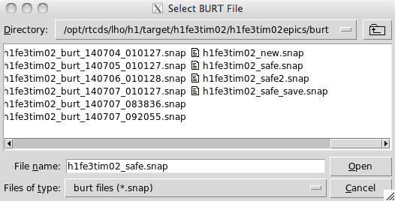
- Press the LOAD TABLE button.
  - All settings are read from the file and the SDF internal monitor table of settings is updated.
  - The TABLE LOAD field should now contain the name of the new file.
  - The TIME field should indicate time now.

Alternative SDF File Read Options
Two other options for the loading of SDF files are provided in the lower section of the SDF RESTORE screen. Selecting the file to read is done in the same fashion as described above for TABLE ONLY. Reading of the file and subsequent action of the SDF code is initiated by pushing one of the two buttons in this area:
- LOAD TABLE + EDB (EPICS Database): This operation will read the specified file and load its settings into both the SDF monitoring table and to the actual EPICS database records. Once this button is pressed:
  - Both the TABLE LOAD and EDB LOAD fields on the screen should indicate the name of the loaded file.
  - TIME field should indicate time now.
- LOAD EDB ONLY: File is read and values loaded into the EPICS database channels. The internal SDF table of settings is not updated.
  - Only the EDB LOAD field should now contain the name of the new file.
  - TIME field should indicate time now.

SDF Restore via Scripts
Using EPICS Channel Access (ECA) routines, it is possible to invoke the loading of new SDF files via scripts. The EPICS records to access this capability are, all prefixed by <IFO>:FEC-<DcuIdNumber>_:
- SDF_NAME: Name of the file to restore settings from.
  - The file must exist in /opt/rtcds/<site>/<ifo>/target/<modelname>/<modelname>epics/burt directory.
  - DO NOT include the .snap file extension.
- SDF_RELOAD: Integer to indicate action to occur when file is read. Only the following values are defined. All other values will be ignored as a NOOP.
  - 1 = Load file values into the monitoring table AND write values to EPICS database records.
  - 2 = Load file values into the monitoring table only.
  - 4 = Load file values into EPICS database records only.
- SDF_RELOAD_STATUS: Indicates that status of the last file read operation:
  - 0 = Fault
  - 1 = OK
The typical sequence of the script, using the above records, would be, for example:
- caput H1:FEC-91_SDF_NAME mysettings (File to read)
- caput H1:FEC-91_SDF_RELOAD 2 (Load monitoring table only)
- caget H1:FEC-91_SDF_RELOAD_STATUS (Verify file read operation).

SDF Save
The SDF software provides basic capabilities, similar to EPICS BURT, to save SDF table and EPICS database record values to file, via the SDF SAVE MEDM screen.

Using the SDF SAVE Screen to Save Files

The procedure for saving settings to a file is:
- Use the FILE TYPE SELECTION to set the file format. This is a pull down menu with the following options:
  - TABLE TO FILE: Write out the contents of the SDF code internal monitoring table
  - EPICS DB TO FILE: This will read the present values of the EPICS database records and write them to file, the same as the BURT tool.
- Select a file option from the FILE OPTIONS SELECTION menu.
  - TIMENOW: The name of the file will be the same as presently loaded with the addition of a date_time suffix.
  - OVERWRITE: With this option, the last file read will be overwritten with the present SDF settings. The name of the file that will be overwritten is shown below the OVERWRITE FILE NAME label on the screen. A backup copy of the present file will be made first, with the timenow suffix.
  - SAVE AS: This option allows the user to create a new file name. If this option is chosen, then the user must also enter the desired file name in the SAVE AS FILE NAME entry area.
- Click the SDF SAVE FILE icon. The file will now be saved in the model burt directory.
Once a file has been saved, its name and timestamp will be displayed in the LAST FILE SAVED area.

Saving SDF Files Via Scripts
Since SDF save file commands are all done via SDF EPICS records, it is possible to invoke the saving of files from scripts. The EPICS records involved, all with an <IFO>:FEC-<DCUID>_ prefix, are:
- SDF_LOADED = Name of the latest file used to load the SDF table.
- SDF_SAVE_AS_NAME: Name of the file to be used in saving files with the SAVE AS option, listed below.
- SDF_SAVE_TYPE:
  - Setting of 0 or “TABLE TO FILE” = Save Table to File
  - Setting of 1 or “EPICS DB TO FILE” = Save present EPICS database record values to file.
- SDF_SAVE_OPTS:
  - Setting of 0 or “TIME_NOW” = Saved file name will be SDF_LOADED + TIMENOW suffix.
  - Setting of 1 or “OVERWRITE” = The SDF_LOADED will be overwritten after a backup is made of the form modelname_timedate.
  - Setting of 2 or “SAVE AS” = File will be saved using the SDF_SAVE_AS_NAME entry.
- SDF_SAVE_CMD
  - Setting to “1” will start the file saving process. This is a momentary record that the RCG code will set back to zero (0) when the command is received.

The basic save file from a script sequence is:
- Set the SDF_SAVE_TYPE.
- Set the SDF_SAVE_OPTS.
  - Set the SDF_SAVE_AS_NAME if SAVE AS option is to be used.
- Set the SDF_SAVE_CMD to one (1)

The EPICS Channel Access build of SDF
The channel access (CA) build was designed to reuse the majority of the SDF code and interfaces. This section lists the differences.

Installing the CA version of SDF

The CA SDF Model
A minimal model is needed in order for RCG to generate a SDF. The main control block must have a parameter 'casdf=1'.

Installation
The SDF system does not need a real time component. It is built and installed with the install-nort- option.
For example installing x1sysecatc1plc1sdf would be done as follows (from the build directory)
make x1sysecatc1plc1sdf
make install-nort-x1sysecatc1plc1sdf
At this point the CA SDF build must be told which channels to monitor and what the reference values to use in a safe.snap file.

Specifying Channel Lists and reference values

Channel lists - monitor.req
The main SDF build retrieves the channel list from the local EPICS database. The CA build requires a new file in the <modelname>epics/burt directory named 'monitor.req'. This is a BURT request file containing a simple list of channels to monitor, no other values or fields.

Reference values – safe.snap
The CA build of SDF does not generate any initial safe.snap file. It is designed to be separate from the IOC being monitored. As such an appropriate safe.snap file must be provided, or the current state of the system must be saved as a safe.snap file.

Differences in the Channel Access build

Start up behavior
The CA build does not do a restore operation on startup. Because the generated IOC is not the IOC directly controlling the hardware, it cannot make assumptions about the lifecycle of the channels being monitored. So it will not reset values to safe.snap on startup.

Expanded precision in *.snap files
Because the CA build does not reset all the values to known safe values it must deal with the precision of the currently running system. As such the *.snap file saves values to a higher fidelity of 20 decimal places.

Differences in the SDF_TABLE
The CA build adds two metrics, 'DISCONN CHANS' and 'DROPPED CHANS'. ‘DISCONN CHANS’ lists the number of channels that are currently disconnected. If the list of channels to monitor exceeds the internal table size the ‘DROPPED CHANS’ metric will display the number of channels that could not me monitored.
In addition there is a new table mode, 'DISCONNECTED CHANS' which displays the channels that are currently not connected. No monitoring operations are possible from this table view.

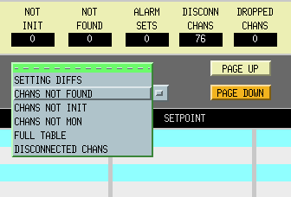
Differences in the SDF Table

