*LIGO Laboratory / LIGO Scientific Collaboration*

LIGO-T1500009-v1 *LIGO* 13 Jan 2015

Test Mass Discharging System (TMDS)

Structural Support Design

Dennis Coyne

Distribution of this document:

LIGO Scientific Collaboration

This is an internal working note

of the LIGO Laboratory.

|  |  |
| --- | --- |
| **California Institute of Technology**  **LIGO Project – MS 18-34**  **1200 E. California Blvd.**  **Pasadena, CA 91125**  Phone (626) 395-2129  Fax (626) 304-9834  E-mail: info@ligo.caltech.edu | **Massachusetts Institute of Technology**  **LIGO Project – NW22-295**  **185 Albany St**  **Cambridge, MA 02139**  Phone (617) 253-4824  Fax (617) 253-7014  E-mail: info@ligo.mit.edu |
| **LIGO Hanford Observatory**  **P.O. Box 159**  **Richland WA 99352**  Phone 509-372-8106  Fax 509-372-8137 | **LIGO Livingston Observatory**  **P.O. Box 940**  **Livingston, LA 70754**  Phone 225-686-3100  Fax 225-686-7189 |

http://www.ligo.caltech.edu/

Contents

1 Introduction 3

2 Structural Support Design Concept 4

3 Loads 5

4 Structural sizing/analysis 5

**List of Figures**

Figure 1: A BSC Chamber Door (Type I, PSI dwg V049-4-014) with a conceptual support structure and an adjacent NEG Pump (SAES model D3500) and gate valve 3

Figure 2: Support Structure for Prototype TMDS 4

Figure 3: Structural Support Concept 6

Figure 4: Finite Element Model Geometry 8

Figure 5: Deformed under 1 kN vertical tip load – oblique view 9

Figure 6: Deformed under 1 kN vertical tip load – side view 10

Figure 7: Equivalent stress under 1 kN vertical tip load 11

Figure 8: Equivalent stress under 1 kN vertical tip load – vacuum envelope only 12

**List of Tables**

Table 1: Finite Element Static Stress Analysis Results for Support Structure Sizing 7

# Introduction

The ionizer for the Test Mass Discharging System (TMDS, see [T1400713](https://dcc.ligo.org/LIGO-T1400713)) is housed in a vacuum shell, or “tree”, which is cantilevered off of a 10” conflat port on the BSC door (Figure 1). The adjacent BSC door ports may be used for other purposes such as for optical viewports or mounting a Non-Evaporable Getter (NEG) pump. The length of the cantilevered vacuum tree and its relatively small diameter tube (1.5” outer diameter) makes it vulnerable to damage in the event that a load is imposed on the end of the vacuum tree (as was pointed out in the TMDS design review report; [L1400202](https://dcc.ligo.org/LIGO-L1400202)).

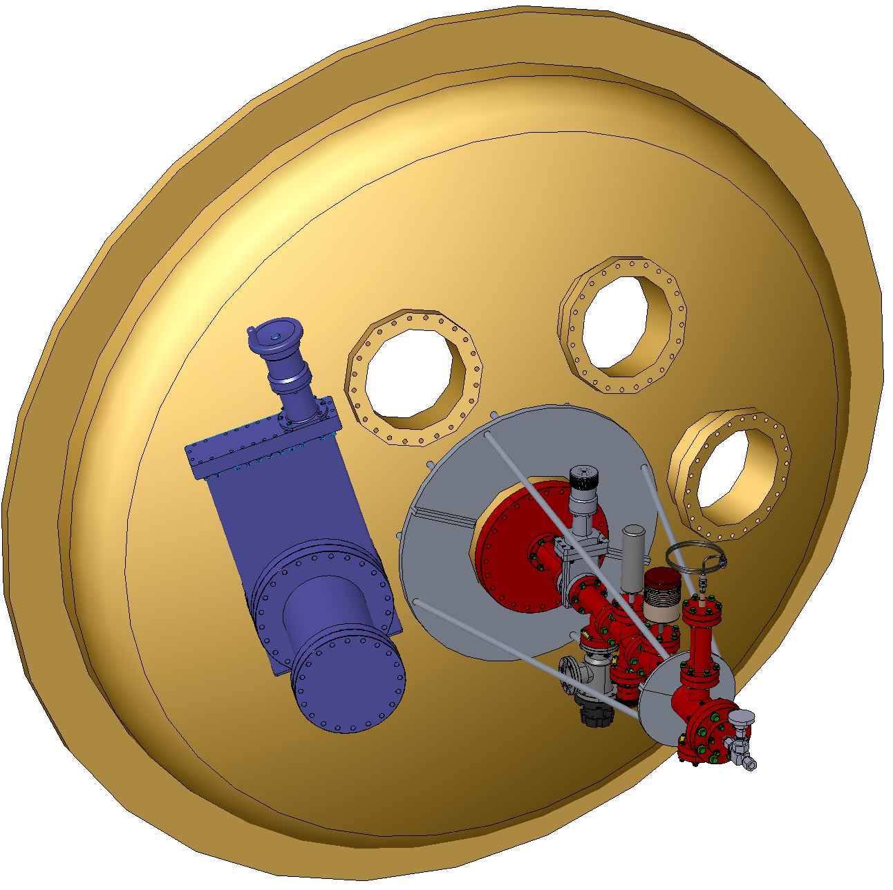

Figure : A BSC Chamber Door (Type I, PSI dwg V049-4-014) with a conceptual support structure and an adjacent NEG Pump (SAES model D3500) and gate valve

The prototype was supported off of the floor (Figure 2). However (as noted in the TMDS design review; [L1400202](https://dcc.ligo.org/LIGO-L1400202)), mechanical support from the floor or other independent structure may subject the assembly to moments/loads due to thermal and barometric flexing of the vacuum system. Consequently the structural support for the TMDS ionizer should transmit moments to the 10” conflat port (8” diameter tube nozzle), or to the main 60.5” diameter door flange. Transferring loads to the main door flange is less desirable (than using the 10” conflat port) since it impedes access and complicates the door removal.

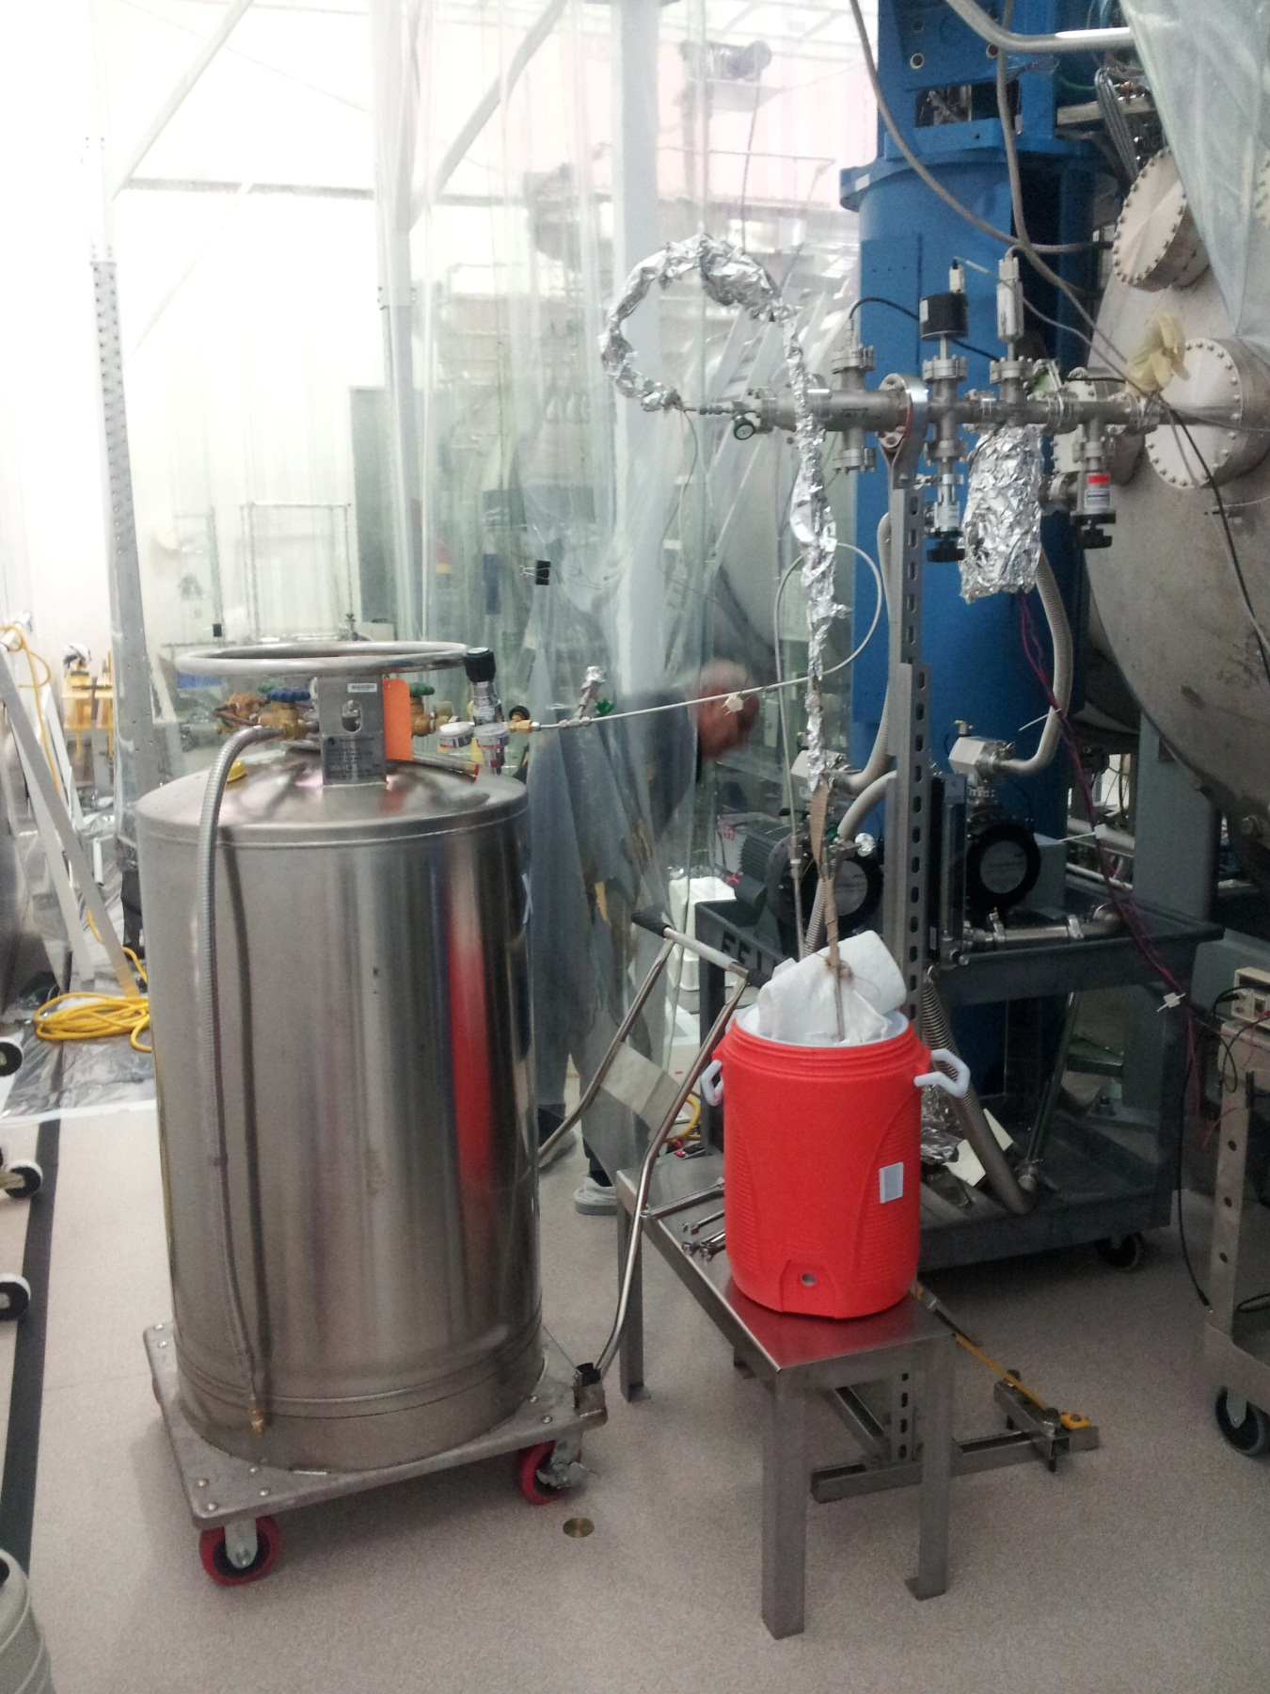

Figure : Support Structure for Prototype TMDS

# Structural Support Design Concept

The structural support concept is to use struts to transfer end loads and moments to the 8” diameter nozzle to which the TMDS is attached, as depicted in Figure 3. The struts could either be guy wires, capable of only transferring tension, or rods capable of transferring tension or compression. In either case the struts need to be length adjusted so that the two semi-annular clamp plates at each end, are tight against the vacuum flanges. In the case of guy wires this is most easily accomplished with turnbuckles. For rods, this may best be accomplished with threaded rods and bolts pinching the clamp plates from both sides.

# Loads

Intentional, operational loads on the TMDS ionizer subassembly should be very small. While it is impractical to protect the TMDS ionizer subassembly from extremely large and unlikely loads (e.g. such as resulting from driving a forklift into the subassembly), the system should be capable of sustaining, plausible, accidental loads such as resulting from a person grabbing the vacuum tree as they lose their footing or trip. This type of load would be on the order of 1000 N (225 lbf).

# Structural sizing/analysis

With no structural support a vertical end load of 1000 N (225 lbf) would result in excessive bending stress at the root of the 1.5” diameter tube (about twice the yield stress). An approximate finite element analysis of the unsupported vacuum tree results in a 17 mm tip deflection and 440 MPa equivalent (von Misses) stress compared to a (conservative yield stress of 215 MPa (MatWeb for 304 stainless steel, annealed). For comparison, a simple cantilevered beam with the TMDS ionizer length (29”) with a constant 1.5” outer diameter and 0.0625” thick wall tube would result in a 20 mm tip deflection and a peak stress of 406 MPa.

The several different structural support configurations and sizings considered, with an approximate finite element analysis, are summarized in Table. With only guy wires, the clamp plate deflects significantly. Since the struts are not so very long, it is practical for them to transfer compressive load (without buckling) to the BSC door via the bolts which are adjusted to snug up to the plate. (Note that the bolts on the tension side pull away from the BSC door).

With ½” diameter threaded 316 SS rod, ½” thick large 6061-T6 aluminum clamp plates (around the 8” nozzle) and ¼” thick small 6061-T6 aluminum clamp plates (around the outer 4-way cross), the resulting factors of safety on yield stress are all greater than 2.5. The support structure weight is about 17 lbs (7.7 kg).



Figure : Structural Support Concept

Table : Finite Element Static Stress Analysis Results for Support Structure Sizing



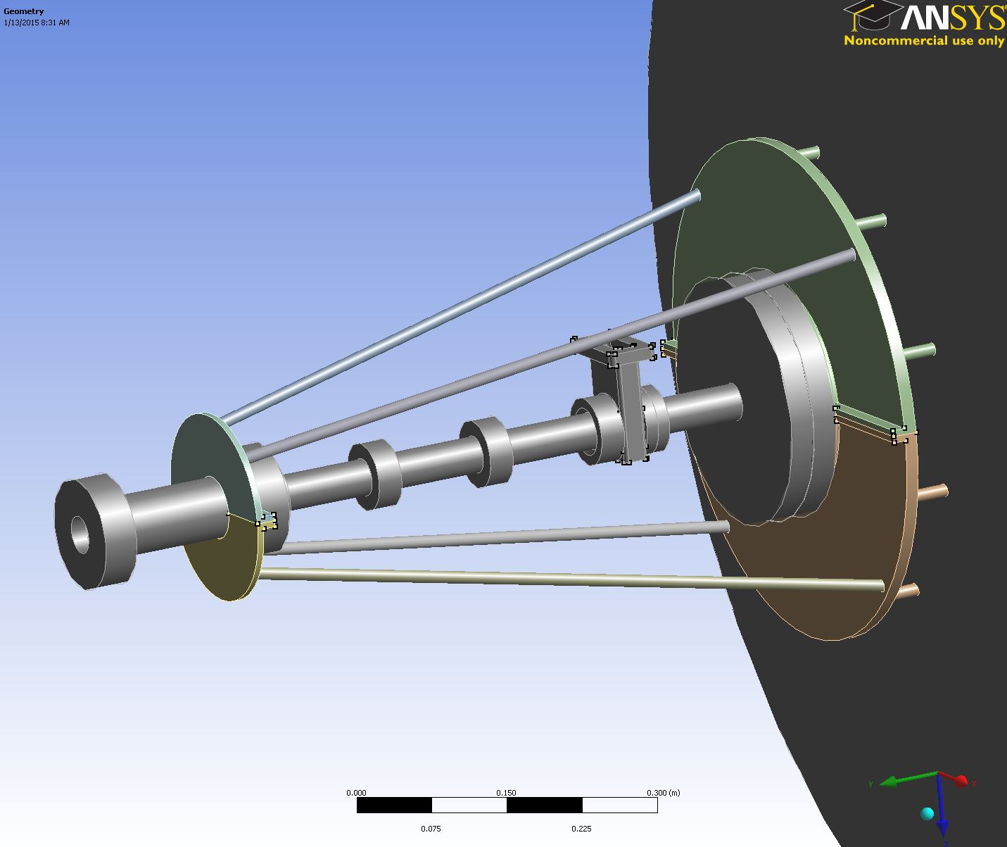

Figure : Finite Element Model Geometry

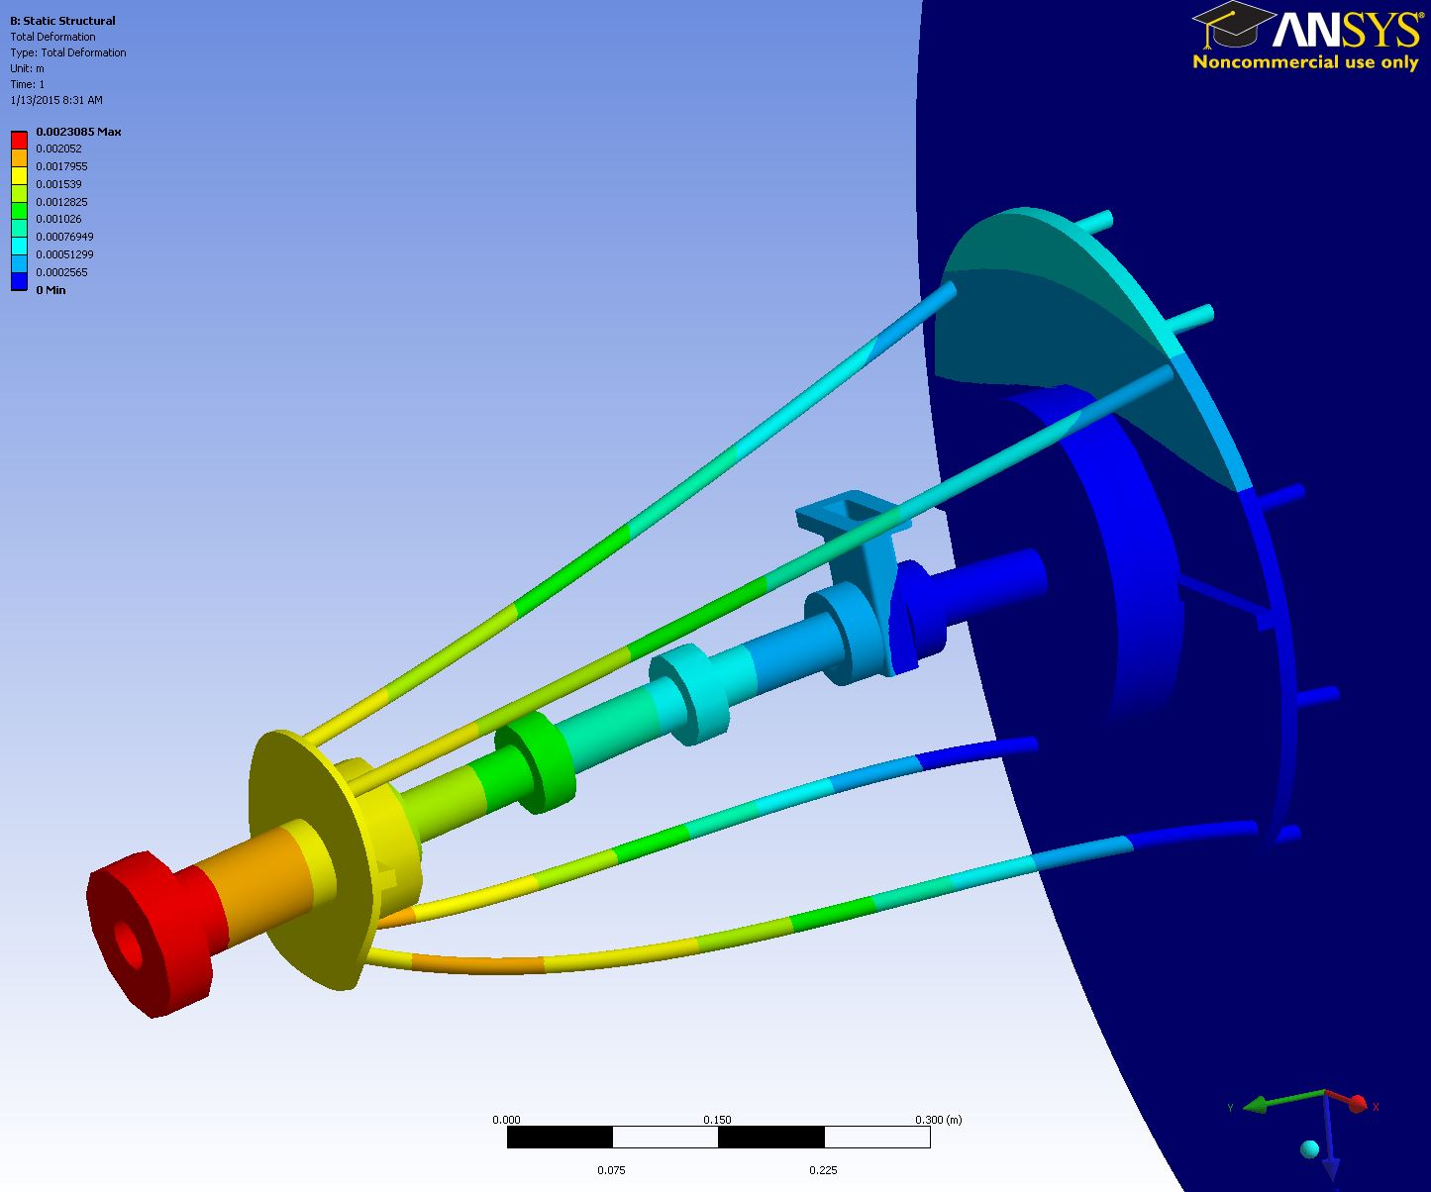

Figure : Deformed under 1 kN vertical tip load – oblique view

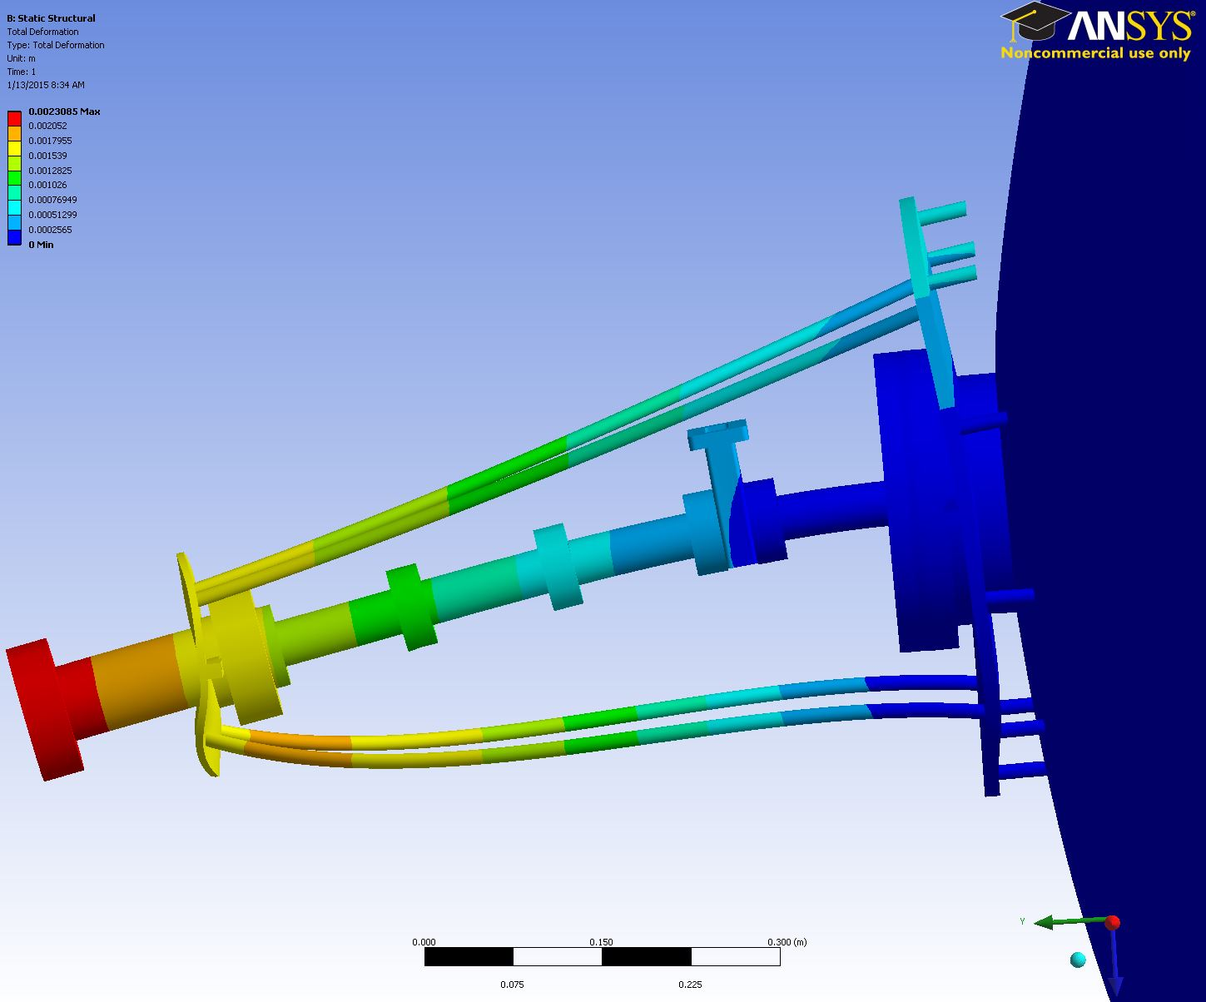

Figure : Deformed under 1 kN vertical tip load – side view

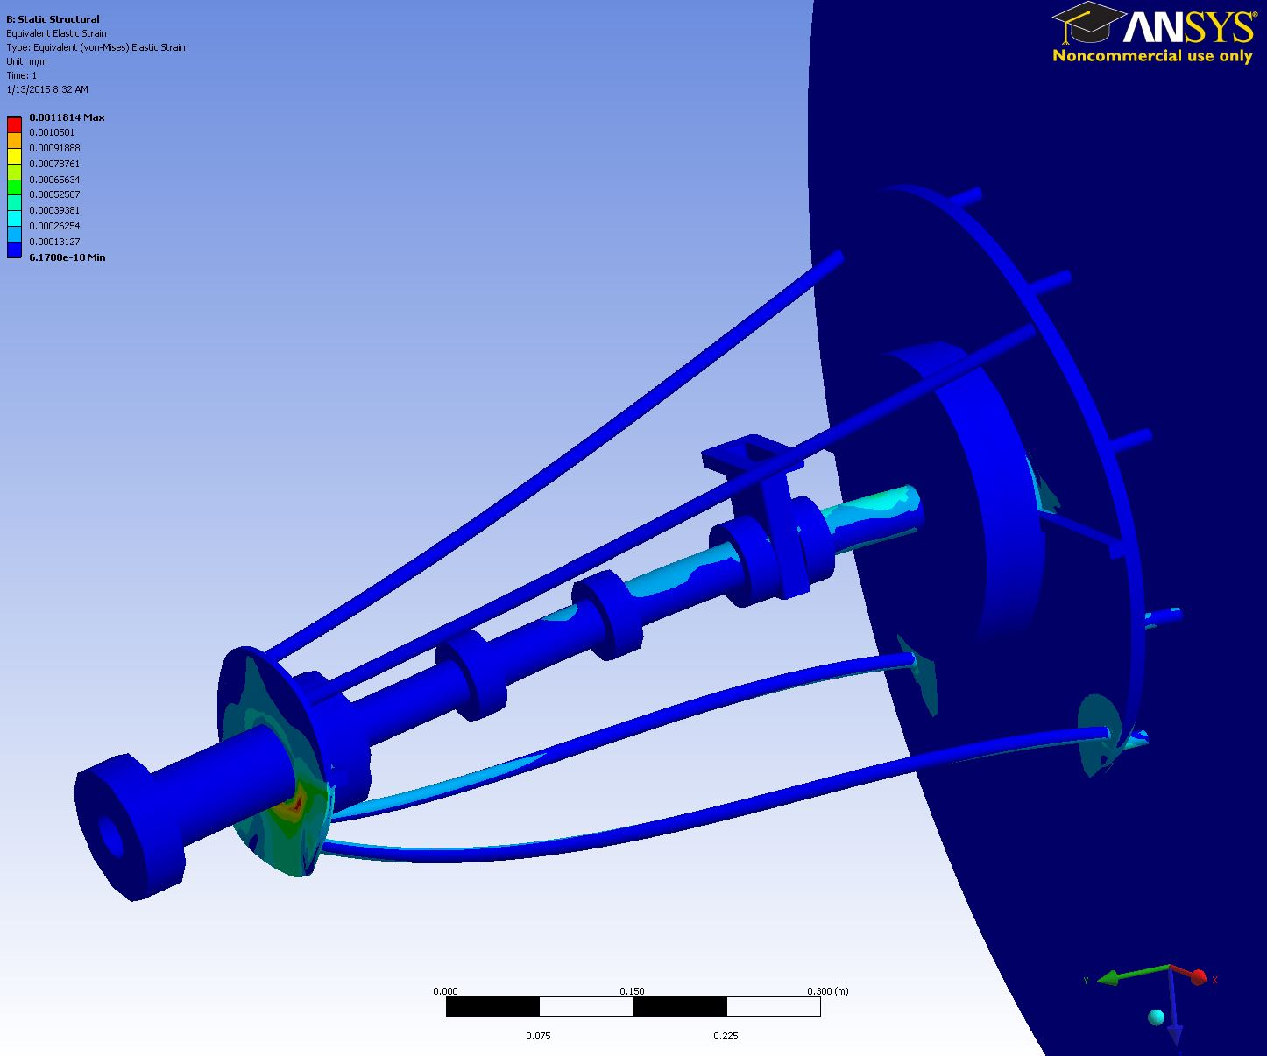

Figure : Equivalent stress under 1 kN vertical tip load

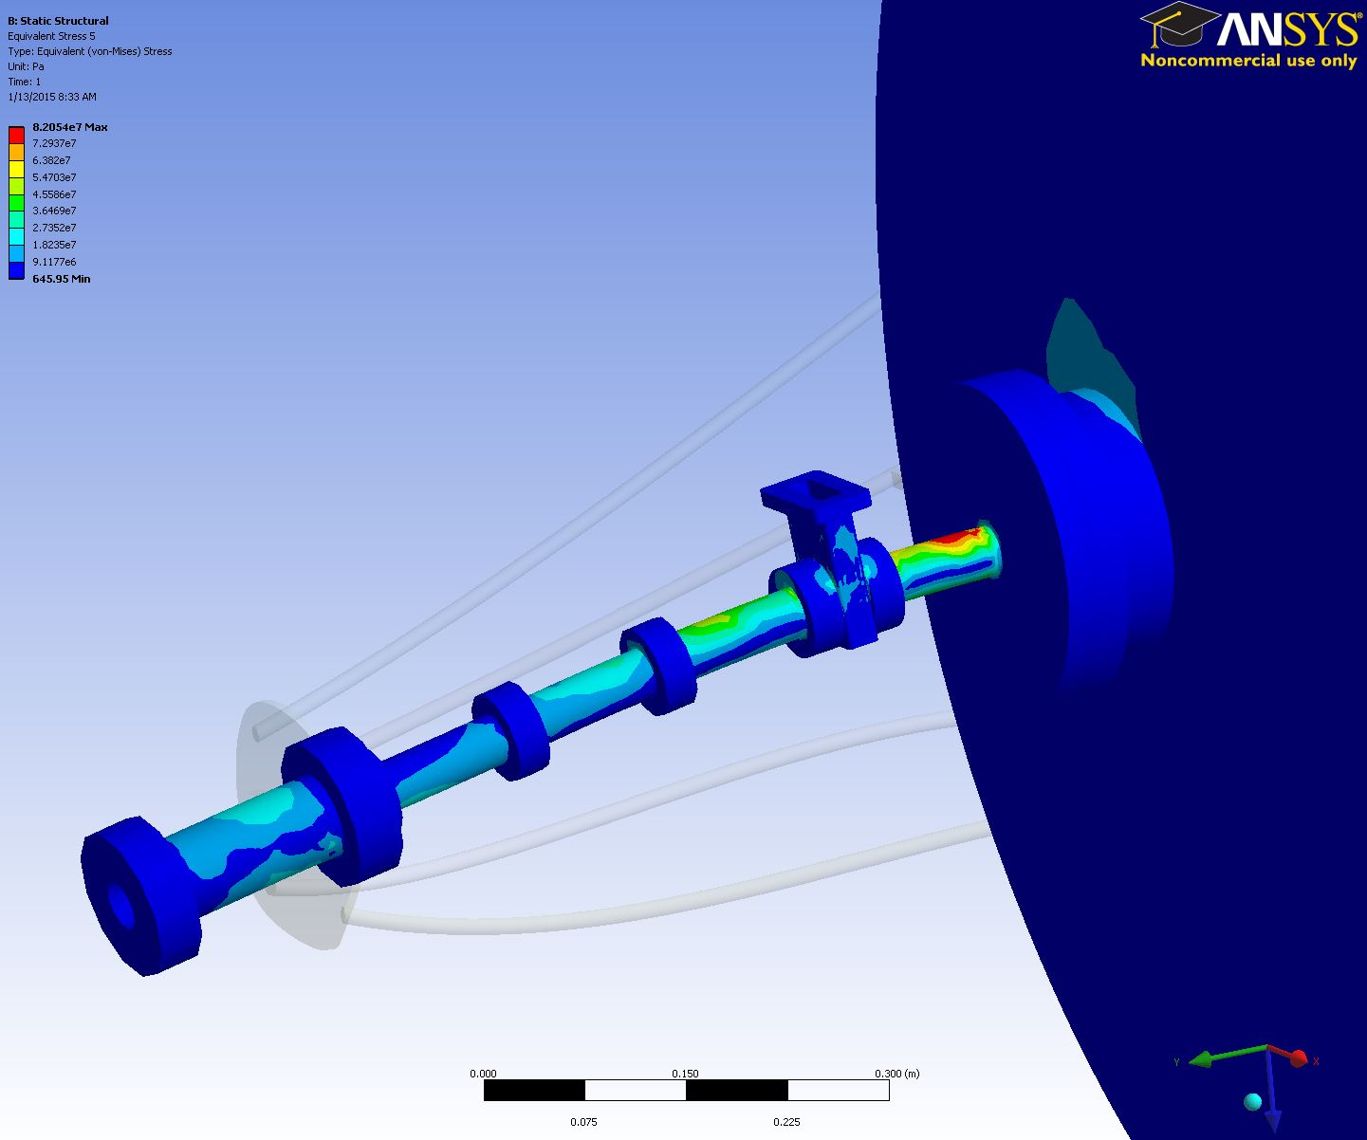

Figure : Equivalent stress under 1 kN vertical tip load – vacuum envelope only