*LIGO Laboratory / LIGO Scientific Collaboration*

LIGO-T1400713-v2 *LIGO* 12 Nov 2014

Test Mass Discharging System:

Design Document

Eddie Sanchez, Calum Torrie, Rich Abbott, Dennis Coyne

Distribution of this document:

LIGO Scientific Collaboration

This is an internal working note

of the LIGO Laboratory.

|  |  |
| --- | --- |
| **California Institute of Technology**  **LIGO Project** | **Massachusetts Institute of Technology**  **LIGO Project** |
| **LIGO Hanford Observatory** | **LIGO Livingston Observatory** |

http://www.ligo.caltech.edu/

Contents

1 Motivation & Background 3

2 System Requirements 3

3 System Description 4

4 Design Changes from Prototype 5

5 Design 5

5.1 Gas Source 5

5.2 Gas Field Ionization Source (GFIS) 6

5.2.1 Prototype Gas Flow Considerations 6

5.2.2 Revised Design Gas Flow Considerations 7

5.2.3 Ionization Needles 8

5.2.4 Pin Receptacles 9

5.2.5 Ionizer Assembly 9

5.3 Vacuum “Tree” Assembly 11

5.4 Electronics 12

5.4.1 Electrometer 12

5.4.2 Ion Generator Power Supply 13

6 Quantities 14

7 BOM 15

8 Safety 15

9 Open Issues 15

10 Open Design Tasks 15

11 References & Notes 17

Figure 1 Block Diagram 4

Figure 2 As-built dimensions of the prototype stainless steel needle. 6

Figure 3 As-built dimensions of the prototype alumina needle holder. 7

Figure 4 Prototype needle in holder and ionizer block, showing gas flow paths. 7

Figure 5 possible pin receptacle for the Needles (Emitters) 9

Figure 6 Cross-section of preliminary proposed ionizer design 10

Figure 7 Needle holder retention features 10

Figure 8 Overall Vacuum “Tree” Assembly 11

Figure 9 Emitter and Aperture separation 12

Figure 10 Sampling Electrometer 12

Figure 11 Voltage waveform for emitter excitation 13

Figure 12 Ion Generator Power Supply 14

Table 1 Quantities 15

# Motivation & Background

Significant electrostatic charging has been measured for the aLIGO test masses in operation[1],[2],[3]. While there is some uncertainty and doubt about the principal sources or causes for this charging[4], the most likely sources appear to be (a) ion pump UV and/or soft x-ray emission (ETMs only) and (b) residual (negative) charge from First Contact™ removal. In order to address ETM ionization from the ion pump, a proposal has been made to move the ion pump a considerable distance (~280 m) from the ETM onto a port along the beam tube and to replace the end station ion pump with a comparable NEG pump2. In order to address the residual ionization from First Contact™ removal, an improved discharging procedure[5] has been put into place using an ion gun and a more sensitive electrometer. Based upon initial operational experience it seems clear that we need a means of discharging the TMs, regardless of the charging source. A system for discharging the TMs is the subject of this document.

A prototype system for discharging the TMs has been developed and successfully tested at LASTI[6],[7] and LHO[8],[9],[10]. This prototype system will soon be tested at LLO. This system injects equal amounts of positively and negatively ionized, clean, dry gas into the TM chamber, up to a pressure of ~ 1 torr.

The purpose of this document is to present a production (revised) design of the discharging system. The design intent was not to optimize or improve upon the prototype, but rather to deviate as little as possible/practical from the prototype design so as not to require more experimentation and testing to qualify a new design. For expediency, this document will principally call out changes from the prototype design.

 As of this release of the Test Mass Discharging System design document, not all design has been completed, and not all quotes have been received for parts. This preliminary version of the document will be updated into a final design, and then as-built design update version, as the effort proceeds. However a sufficient amount of design information & cost estimation has been resolved to enable:

* technical review of the design,
* budget/account authorization via the ACR process, and
* procurement (for parts which are finalized)

# System Requirements

The requirements of the Test Mass Discharging System (TMDS) are as follows:

1. Discharge the test mass optic in situ, without opening the vacuum system. Vacuum pressure is permitted to increase to ~1 torr with dry gas.
2. The optical properties of the coatings of the installed optics shall not be damaged by the use of the TMDS.
3. Residual TM surface charge density2 should be < 4 x 10-14 C/cm2, as inferred (measured) with the TM electrostatic drive (ESD) system after pumping back down to hard vacuum.
4. Limit particulate generation through material and construction choices.
5. Limit water and hydrocarbons introduced into the vacuum system by the use of either gaseous nitrogen (GN2) produced by liquid nitrogen (LN2) boil-off, or the LIGO dry purge air system.

# System Description

The TMDS (Figure 1) generates a low pressure (~1 torr) ionized gas with equal negative and positive ions (neutral) within the vacuum volume that contains the TM optic. The ions are created by electric field effect ionization. Gas is directed past the emitter tips which have an alternating polarity of high voltage imposed. The ions are entrained into the gas flow created by a pressure differential.



Figure Block Diagram

A sampling electrometer is used to check the balance of positive and negative ions in the gas stream. Impressed HV and flow conditions can be monitored and adjusted to balance the positive and negative ions generated. A scroll pump is used to (approximately) setup the flow conditions prior to opening the gate valve which isolates the TMDS from the main vacuum system. The operational steps10 to prepare and operate the TMDS (with GN2) are described in T1400497.

The top assembly drawing[11] and associated bill of materials (BOM) for the vacuum “tree” and the ion generator are found in [D1400331](https://dcc.ligo.org/LIGO-D1400331). The sub-assembly and part drawings are linked as “related documents” under [D1400331](https://dcc.ligo.org/LIGO-D1400331).

# Design Changes from Prototype

The principal changes from the prototype design documented in REF are as follows:

1. Revised Ion Generator Power Supply: The prototype employs a Variac as the adjustable voltage input to a step-up, high voltage (neon sign) transformer in order to excite the field emission with a sinusoid. We propose to generate a square wave HV signal by solid-state switching between adjustable positive and negative HV DC-to-DC supplies.
2. Possible Gas Source Change: To date the gas source has been LN2 boil-off. Although the prototype testing at LASTI demonstrated equal positive and negative ion currents, it is more difficult to create negative ions than positive ions with GN27. More recent testing on the LHO Y-end have not been as well balanced. One possibility is to use some oxygen in the gas to make positive ion production easier. We can accomplish this by using the purge air source (20% oxygen). However the oxygen ions are more aggressive and may attack the optical coatings. In addition ozone may be produced which could attack (for example) Viton™ in the system. We plan to test the effect on the mirror coatings before committing to the use of air as the gas.
3. Improved packaging of the Gas Field Ionization Source (GFIS): The basic design of the GFIS remains the same, but is “packaged” for easier assembly and for improved robustness. These design changes are discussed in a section below.
4. Reduced pumping and valving complexity: The prototype employed two dry scroll pumps and two gate valves (see Figure 2 of [T1400535-v2](https://dcc.ligo.org/LIGO-T1400535-v2)). The added capability to adjust the flow conditions was found to be unnecessary in testing. The production design employs a single gate valve and dry scroll pump.

# Design

Many of the parts are standard commercial-off-the-shelf (COTS) components. Some are modified COTS parts. There are only two custom assemblies:

1. Gas Field Ionization Source (GFIS): a custom field ionization source (section 5.2)
2. Electrometer: The electrometer (described in REF) is simple, and (except for the sensing wires in the header) external to the vacuum system, and proposed to be unchanged.
3. High Voltage Exciter: The prototype version of the HV supply for the emitter is essentially a neon sign step-up transformer supplied by a Variac for operator adjustment of the peak voltage. The production unit will sum in a variable HV DC bias adjustment in order to have more control of the ion production balance (+ and – ions) for all pressure and flow conditions.

## Gas Source

The prototype was initially used with just gaseous nitrogen (GN2) from boil-off of liquid nitrogen (LN2). Since it is more difficult to create N2 ions, especially balanced ions (equal negative and positive N2 ions), and the positive ions may be shorter lived, dry air was recently tested[12] with the prototype. The extant purge air (-40C dew point) was used for the gas source without need for any conditioning (dry and particulate free).

This system will be designed to accommodate either gas source option. Equipment to plumb in either gas source will be provided.

## Gas Field Ionization Source (GFIS)

We looked into the possibility of procuring commercial GFIS units. It was found that manufacturers of electrostatic discharging systems for use in air were generally unfamiliar with ionizing GN2 only, ionizing at low pressures (near the Paschen curve) and unfamiliar with UHV materials and practices. Manufacturers of ionization sources for use in vacuum generally used other ion generation methods (e.g. thermionic) and accelerated these generated ions into beams or processing steps, and not familiar with overall charge-neutral ion streams. As a consequence we decided to build upon the successful prototype discharging system.

### Prototype Gas Flow Considerations

The dimensions of the prototype needle (emitter) and the needle holder (measured from a single sample of each part) are shown in Figure 2 and Figure 3, respectively. A cross-sectional view of the prototype ionizer block with a single needle holder and needle in the central hole is depicted in Figure 4.

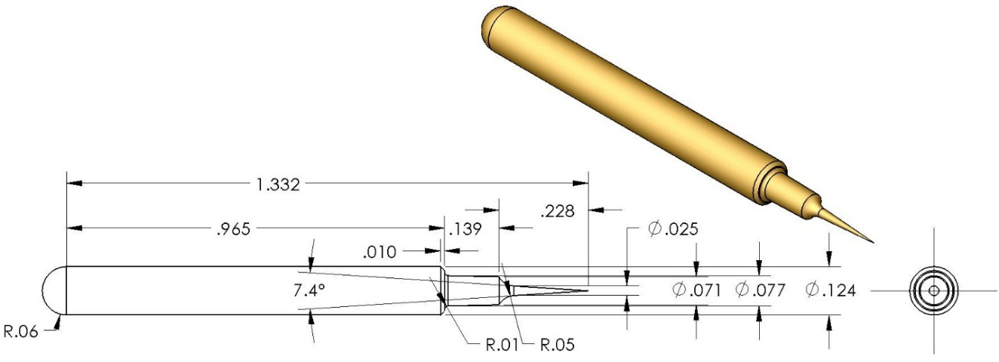

Figure As-built dimensions of the prototype stainless steel needle.

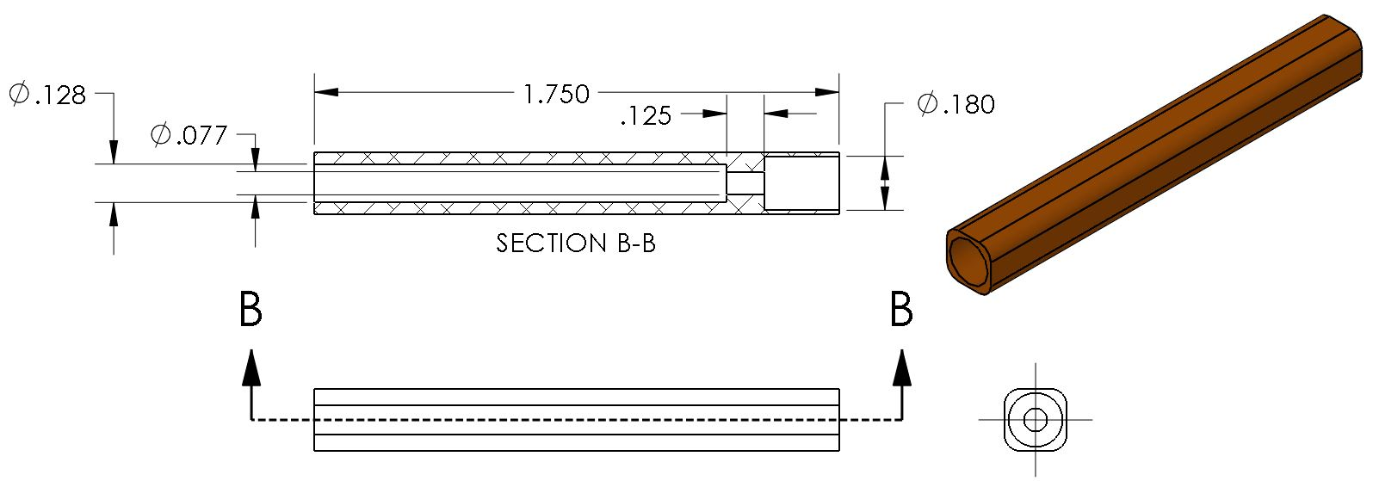

Figure As-built dimensions of the prototype alumina needle holder.

|  |  |
| --- | --- |
|  | b) Detail of interface of prototype needle (emitter) and the needle holder. |
| a) cross-section of a center needle (emitter) in its holder within the ionizer block (prototype ionizer) | c) cross-sectional view through the largest diameter section of the needle within its holder showing the cross-section of the gas channels. Along this section of the needle, the radial gap between the needle holder bore and the needle is .004” |

Figure Prototype needle in holder and ionizer block, showing gas flow paths.

The flow past the needle can be choked off as the needle is moved axially further into the holder. The design intent for the prototype was to set the tip back from the face of the holder by 1 mm (.040”). With the needle tip set-back from the front face of the holder and ionizer block by .020”, the radial gap varies from .001” to .004” along the constricted .125” length section of the holder. The gas flows primarily between the square cross section alumina insulators and the round holes in the needle holder block. The ions are formed near the tip of the needle and incorporated (entrained) into the gas flow.

### Revised Design Gas Flow Considerations

For the revised design we wish to achieve the same Poiseuille flow conditions. The flow rate, Q, for the same pressure differential, ΔP, varies inversely as the channel length, L, and as the 4th power of the hydraulic diameter, Dh:

The hydraulic diameter, Dh, is equal to 4 times the channel cross-sectional area divided by the perimeter of the channel.

The prototype needle (emitter) folder has L = 1.75”, a channel gap width of .021” and Dh = .0212”. The revised design has L = 0.85” ”, a channel gap width of .0131” and Dh = .0174”.

### Ionization Needles

The prototype unit used a stainless steel needle (emitter) with a somewhat elaborate profile. Most commercially available emitter points (ionization needles) are simply small diameter rods with a conical tip machined at one end. The base diameter of the conical feature on the prototype emitter is ~.025”.

Commercial units use other materials such as Tantalum and Titanium. Since the applied voltage (~3.5 kV peak) is far in excess of the material’s work function, the only reason to consider other materials might be reduced particulate generation (wear). However since the duty cycle for our unit should be quite low, any resulting particulate generation and wear should not be a significant concern.

Replacement ionization needles for commercial in-air systems are available (some are Ti), but dimensional information is missing. We could pursue with the manufacturers as a potential source for our ion generator. For example [replacement titanium emitters for Terra Universal ionizing bars](http://www.terrauniversal.com/laminar-flow-hoods/ionizing-bars.php) and [Simco Ion Technical Note “emitter points”](https://technology-ionization.simco-ion.com/LinkClick.aspx?fileticket=QU4RAOxKEjE%3d&tabid=546). This later link has interesting information about the tendency of emitters to produce episodic particle bursts. However this is likely at higher voltages and currents than we will employ for this design. Simco Ion has emitters comprised of single crystal silicon, a tungsten alloy and titanium. The only dimensional information available on the web site are the emitter lengths; Some (1.28” and 1.32” lengths) may fit into our proposed design.

[Semprex has punch/probe needles](http://www.semprex.com/catalog/index.php?cName=punch-probe-needles) in stock or special order but only for Tungsten Carbide (WC), Beryllium Copper (BeCu) and Steel (M2 HSS). Diameters are .025”, .028”, .031” in lengths from .5” to 2”

Titanium rod is available in diameters of .125” and larger. Titanium wire is spooled (not straight). However Ti welding rod is available in “sticks” from [Titanium Joe](http://www.titaniumjoe.com/index.cfm/products/weld-wire/): CP2, .030” dia. and 6AL-4V, .035” dia. [Tricor Metals](http://www.tricormetals.com/weldwire.html) also has straight Ti rod with .030” diameter.

For Tantalum only larger diameter rod is available and would have to be machined down to a suitable diameter.

We propose to use a small diameter rod with a conical machined (ground) tip with dimensions similar to the tip of the prototype needles and the Semprex needles.

Attaching or joining the needle to the electrical lead can be challenging depending upon the material. The prototype needle was tinned and soldered to the resistor lead. Most commercial emitters are friction gripped for easy replacement after wear. Since the duty cycle for our emitters are extremely low, we really don’t need to worry about wear. However a friction grip (using a pin receptacle generally employed on printed circuit boards) would allow us to (a) adjust axial position and (b) replace with different needle materials or geometries easily for experimentation.

### Pin Receptacles

One means of providing a friction grip on the needle is to use printed circuit board (PCB) pin receptacles. Mill-Max is one source. Based on the Semprex needles, the Ti welding rod and the base dia of Rai’s needle, diameters in the range of .025” to .035” are good choices. Mill-Max part #0305 mates with .025” - .037” diameter pins in a thru-hole arrangement:

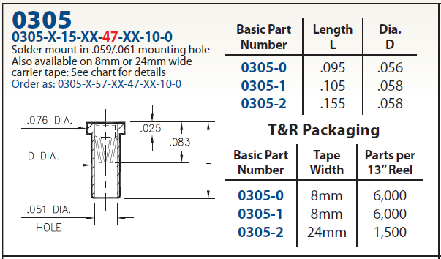

Figure possible pin receptacle for the Needles (Emitters)

### Ionizer Assembly

The proposed ionizer unit design (Figure 6) is re-packaged to incorporate the following features and changes:

* Needle Holder composed of Macor (rather than Alumina, for ease of machining)
* Positive retention of the Needle Holder (for the prototype a small amount of indium was used to secure, by an interference fit, within the bores of the ionizer block); see Figure 7
* The resistor “pack” joined electrically and mechanically via Printed Circuit Boards (PCBs)[13]. The PCBs are comprised of Kapton and are ‘sandwiched’ for structural support by PEEK components.
* The resistor “pack” secured to the ionizer block with hex stand-offs
* An o-ring gland added to the ionizer block (in the prototype the o-ring had no gland)
* The Needles (Emitters) have a simpler, more typical, profile



Figure Cross-section of preliminary proposed ionizer design

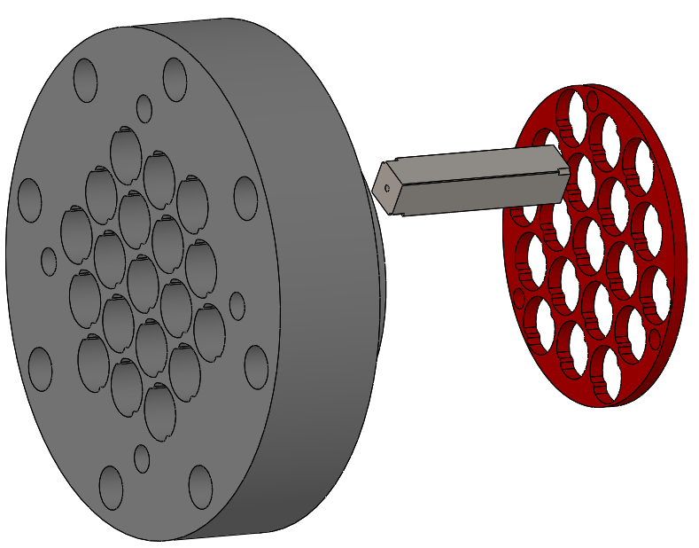

Figure Needle holder retention features

## Vacuum “Tree” Assembly

The vacuum envelope (or “tree”) is essentially the same as the prototype design (Figure 8), with the reduction of one gate valve).

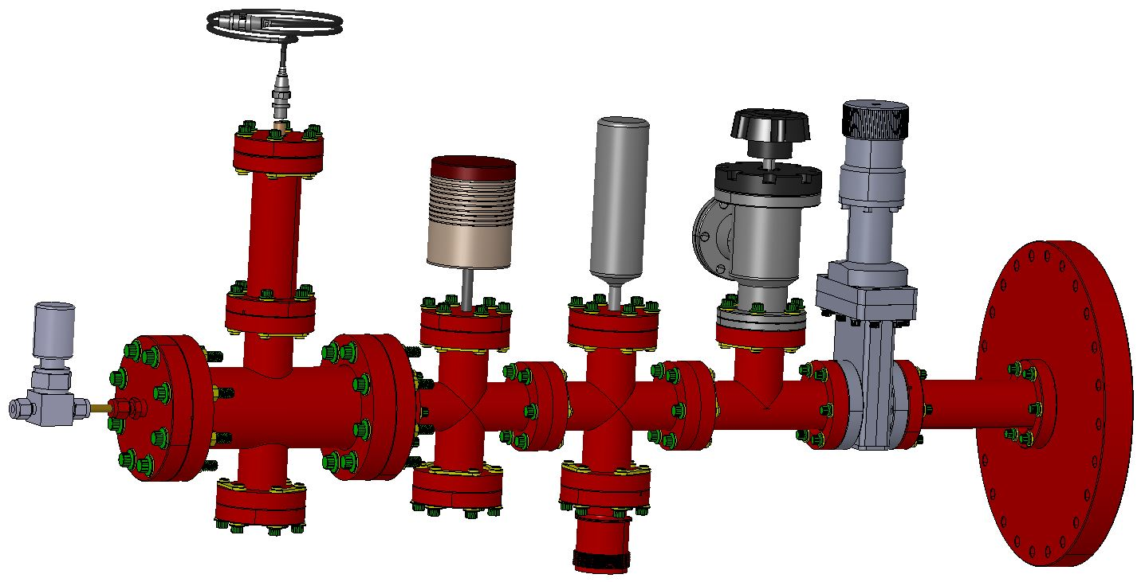

Figure Overall Vacuum “Tree” Assembly

The aperture plate separates the ion generator at modest pressure (~200 to ~900 torr) from the test mass chamber at low (~1 torr) pressure. Although the ionizer block has been shortened in the production version, the distance from the emitter tips to the aperture plate remains the same (Figure 9).



Figure Emitter and Aperture separation

The 19 emitter points are aligned to 19 holes in an aperture plate. Alignment marks on the aperture plate, the ionizer block and the vacuum cross will be[14] included in the design.

## Electronics

All of the electronics will be placed into (or on) a small/short rolling electronics rack (or table) for ease in moving the system in case access near the BSC chamber is needed.

The electronics (Figure 1) consist of the following modules:

* Ion Generator Power Supply, including a frequency trigger and 24V DC Power Supply (for the HV DC-to-DC converters)
* Sampling Electrometer, including a ±15V DC Power Supply and a square wave generator
* Baratron power supply and read-out (COTS)
* Pirani gauge controller (COTS)

The two electronics modules which are not commercial-off-the-shelf (COTS) are briefly described below.

### Electrometer

The sampling electrometer amplifier will be identical to the design employed in the prototype7 (Figure 10). A multi-pin electrical feedthrough (header) is used to project a set of pins into the ionized gas flow. The central row of pins are electrically connected together and to a monolithic electrometer operational amplifier (AD549). The two rows of pins on either side of the central row are electrically connected together and to a square wave generator which imposes a 20 V pp signal with a frequency of ~0.1 Hz. The voltage impressed on the adjacent rows of pins causes that same polarity of ions toward the center pins. Each time the square wave reverses polarity, the electrometer reverses the ion polarity that it is measuring.



Figure Sampling Electrometer

### Ion Generator Power Supply

Generation of positive and negative ions will be accomplished by switching the voltage applied to the needles (emitters) between a positive HV level and a negative HV level (Figure 11). The HV power supplies are DC-to-DC converters which run on 24 V input. The positive and negative levels can be controlled by input voltage commands, which might help to generate balanced (equal + and -) ion production[15]. Switching is accomplished with a MOSFET Push/Pull Switch, as shown in Figure 12. A square wave should improve the rate of ion production relative to a sinusoid.



Figure Voltage waveform for emitter excitation

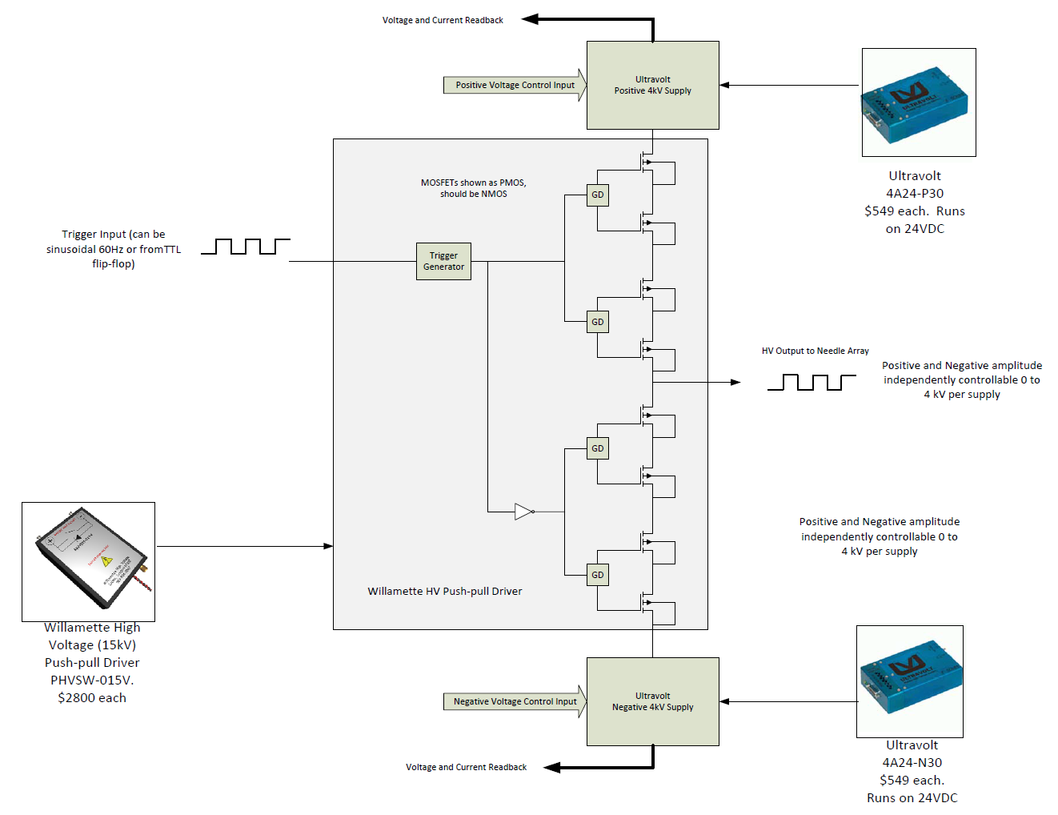

Figure Ion Generator Power Supply

# Quantities

Initially we thought we might only rarely need to discharge a TM and so we thought about employing one discharge system per observatory and roaming the system as needed (with gate valves installed on each chamber). We are no longer sure that discharging will be a rare event. So, we now propose to outfit every chamber, plus one spare per observatory, plus LASTI (for off-line test capability), plus in-process sparing. The quantities for various units, and the derivation of these quantities (reasoning), are listed in Table 1. In addition, in-process spares are really only needed for custom parts (e.g. not standard vacuum trees).

Table Quantities

|  |  |  |
| --- | --- | --- |
| # of basic units | 3 IFOs x (4 TMs/IFO + 1 spare/IFO) + 1 LASTI + 1 in-process spare | 17 |
| # of vacuum envelope parts & gauges | 4 TM chambers/IFO x 3 IFOs + LASTI (no in-process spares | 13 |
| # of scroll pump systems | [3 vacuum volumes/Obs - 1 Scroll Pump/Obs avail] x 2 Obs  (Not providing scroll pumps for 3rd IFO or LASTI; Std equipment.) | 4 |
| # purge air gas source subsystems | The observatories have the clean SS flexible tubsing, tri-clamps and gaskets on hand already. | 0 |
| # LN2 boil-off source subsystems | [3 vacuum volumes/Obs - 1 Dewer/Obs avail] x 2 Obs  (Not providing dewers for 3rd IFO or LASTI; Std equipment.) | 4 |

# BOM

The Bill Of Materials (BOM)[16], with part quantities and associated cost estimates, is given in [E1400447](https://dcc.ligo.org/LIGO-E1400447).

# Safety

A revised operation procedure10 (revision of [T1400497](https://dcc.ligo.org/LIGO-T1400497)) and a hazard analysis will be written before operating the production units. The basic potential hazards are as follows:

1. Overpressure of the LN2 tank: mitigated by procedure and an over-pressure relief valve
2. Overpressure of the moderate GN2 pressure section of the TMDS: mitigated by procedure and pressure regulators on the supply
3. Personnel injury from LN2 exposure: mitigated by procedure, training and safety features in the design of the COTS dewar
4. Personnel injury from high voltage shock/exposure: the system will be designed to prevent access to energized components
5. Component damage due to arcing: current limiting resistors prevent component damage with sustained arcing.

# Open Issues

1. Is purge air an acceptable gas source for the ion generator, or does the ionized oxygen cause damage to the optical coatings? Optical absorption measurements of one coating (from a sample optic exposed to the ions at close range) indicate much higher absorption (~20 ppm)

# Open Design Tasks

1. Detailed, final design/implementation of the sampling electrometer.
2. Detailed final design/implementation of the HV source for the ion generator.
3. Selection of the gas source type: GN2 from boil-off LN2, purge air, or both.
4. Finalizing quantities for components of the discharging system (see section 6)
5. Incorporate alignment marks/references to facilitate alignment of the emitter array to the aperture plate holes.
6. Revision of the mechanical design details based on manufacturer feedback.

# References & Notes

1. [G1401265](https://dcc.ligo.org/LIGO-G1401265), R. Weiss, “ESD and Charging; LHO F2F (10/28/2014)”
2. [G1401153](https://dcc.ligo.org/LIGO-G1401153), R. Weiss, “charging presentation to systems group”
3. [T1400620](https://dcc.ligo.org/LIGO-T1400620), R. Weiss, additional notes on charging (in response to G1401153 presentation)”
4. [T1400647](https://dcc.ligo.org/LIGO-T1400647), R. Weiss, “Significant puzzle in explaining the charging mechanism of the test masses”
5. [E1300017](https://dcc.ligo.org/LIGO-E1300017), C. Torrie et. al., “First Contact Spray Application & Removal Procedure”
6. [G1100364](https://dcc.ligo.org/LIGO-G1100364), R. Weiss, Ion Neutralization”
7. [T1100332](https://dcc.ligo.org/LIGO-T1100332), R. Weiss, “Surface charge control of the Advanced LIGO mirrors using externally introduced ions”
8. [T1400477](https://dcc.ligo.org/LIGO-T1400477), R. Weiss, “Preparations for discharging the test mass at LHO ETMY and hypotheses about the charging”
9. [T1400535](https://dcc.ligo.org/LIGO-T1400535), R. Weiss, “Experience with discharging the ETMY test mass at LHO in August 2014”
10. [T1400497](https://dcc.ligo.org/LIGO-T1400497), R. Weiss, “Steps in operation of the ionizer”
11. [D1400331](https://dcc.ligo.org/LIGO-D1400331), aLIGO, Surface Charge Control Ionizer
12. [T1400705](https://dcc.ligo.org/LIGO-T1400705), R. Weiss, “Ionizer Research at LHO (10/28 – 11/3/2014)”
13. We originally pursued alumina or macor PCBs which would not have required the PEEK support parts that the Kapton PCBs require. However the lead time was too long, and we had some concerns about the fragility of the alumina (or macor) PCBs.
14. The alignment marks have not yet been incorporated into the design drawings.
15. It was suggested by people in the electrostatic discharging business that adjusting a DC voltage level in addition to the AC level could be used to balance ion generation. This was found not to be the case for GN2 (see T1400705). However it may be applicable to air.
16. [E1400447](https://dcc.ligo.org/LIGO-E1400447), BOM: Test Mass Discharging System