LIGO Laboratory / LIGO Scientific Collaboration
E1300889-v1 | aLIGO | November, 2013

aLIGO PSL VCO Amplifier Assembly Instructions
Peter King

Distribution of this document:
LIGO Scientific Collaboration

This is an internal working note
of the LIGO Laboratory.
California Institute of Technology  LIGO Project, MS 18-34  1200 E. California Blvd.  Pasadena, CA 91125  Phone: (626) 395-2129  FAX: (626) 304-9834  E-mail: info@ligo.caltech.edu | Massachusetts Institute of Technology  LIGO Project, NW22-295  185 Albany St.  Cambridge, MA 02139  Phone: (617) 253-4824  FAX: (617) 253-7014  E-mail: info@ligo.mit.edu
LIGO Hanford Observatory  P.O. Box 159  Richland, WA 99352  Phone: (509) 372-8106  FAX: (509) 372-8137 | LIGO Livingston Observatory  P.O. Box 940  Livingston, LA 70754  Phone: (225) 686-3100  FAX: (225) 686-7189

http://www.ligo.caltech.edu

Scope
This document lists the steps required to assemble the aLIGO PSL VCO Amplifier (D1201423-v1). It assumes that the person assembling the chassis is authorized and trained in the safe use of hand tools and electronics tools.

Fabrication of the Type N Cable
Cut the LMR-195-FR cable to length as per D1201427. Strip each end of the cable as per the dimensions given in Figure 1.
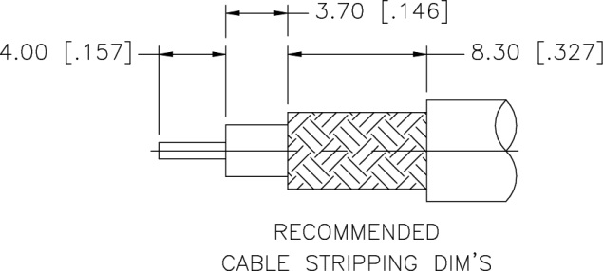
Figure 1. Cable stripping dimensions for the N connectors. The dimensions listed are metric, those enclosed within the brackets are imperial.
Insert the centre conductor of the cable into the contact pin and solder on the cable. Then slide the ferrule onto the cable. Insert the main body into the braid and dielectric. Slide the ferrule over the braid and crimp it using the 0.213” die size of the Amphenol Connex ratcheting hand crimp tool (P/N 47-10180).
Check the continuity of the cable centre conductor and shield using a multimeter. Check that the connection between the centre conductor and the shield is open circuit.

Fabrication of the SMA Cable
Cut the LMR-195-FR cable to length as per D1201428. Strip each end of the cable as per the dimensions given in Figure 2.
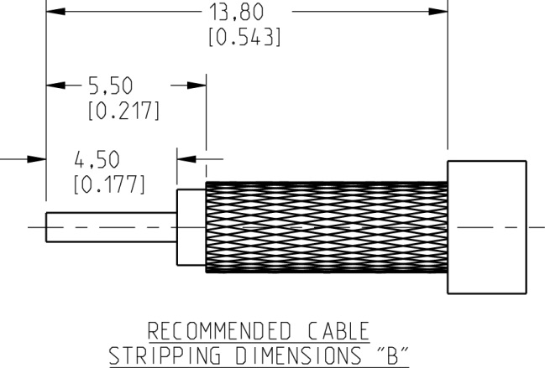

Figure 2. Cable stripping dimensions for the SMA connectors. The dimensions listed are metric, those enclosed within the brackets are imperial.
Slip the PTFE spacer over the centre conductor of the cable before inserting the centre conductor of the cable into the contact pin. Solder the contact pin on the cable. Slide the ferrule over the cable. Insert the main body into the braid and dielectric. One should hear a slight “click” that signifies that the main body and centre pin are engaged properly. Slide the ferrule over the braid and crimp it using the 0.213” die size. The parts assembly order is shown in Figure 3.

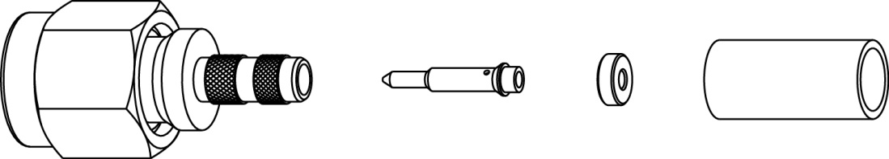

Figure 3. Parts of the SMA connector.

Chassis Mounting Holes
Mark the positions of the mounting holes as per D1201426. Drill and tap through for 4-40 UNC threads. The tap drill for 4-40 is a #43 (0.089 in.) drill.

Power Connections
Cut off a white coloured piece of hook wire (D1301002) and a black coloured piece of hook up wire (D1301003). Using a pair of wire strippers, remove about ~7/16” of the insulation from each end of the wire. At one end crimp on a Scotchlok terminal using a 3M TR-490 crimp tool. Do this for both pieces of wire. Tin the other end of the wire with some solder. Slide some heat shrink tubing over the end of the wire prior to soldering the tinned end of the wire into the power D-sub connector.

Assembly
Assemble the front and rear panels, see D1201514 for the overall layout of the assembly; the front panel with its bulkhead mount type N connector and SMA connector, the rear panel with the thermal circuit breaker and power D-sub connector. Solder the ground connection from the centre pin of the power D-sub to the turret mount of the Mini-Circuits ZHL-1-2W amplifier. Solder the power connection – the white wire – to the sharp pointed terminal mounted on the amplifier.
Mount the amplifier into the 2U chassis. At the input to the amplifier, connect the UNAT-6+ attenuator. For all the type N connections, do not use more than 15 lb-in torque to tighten the connections. Attach the type N elbow fitting to the attenuator.
At the output of the amplifier connect the VAT-2W2+ attenuator. For all SMA connections, do not use more than 15 lb-in torque to tighten the connections. Use of a SMA torque wrench is recommended. Attach the SMA elbow fitting to the attenuator.
Attach the two LMR-195-FR cables to their respective bulkhead mounted ends prior to attaching the front panel to the chassis as this makes assembling the unit easier depending on how long the cables are made.

