LIGO Laboratory / LIGO Scientific Collaboration

LIGO- E1300903-v4 Advanced LIGO 12/17/2013

ISC End Station User’s Manual
Daniel Sigg, Keita Kawabe, Sheila Dwyer, Kiwamu Izumi, Stefan Ballmer and Alexa Staley

Distribution of this document:
LIGO Scientific Collaboration

This is an internal working note
of the LIGO Laboratory.

California Institute of Technology  LIGO Project – MS 18-34  1200 E. California Blvd.  Pasadena, CA 91125  Phone (626) 395-2129  Fax (626) 304-9834  E-mail: info@ligo.caltech.edu | Massachusetts Institute of Technology  LIGO Project – NW22-295  185 Albany St  Cambridge, MA 02139  Phone (617) 253-4824  Fax (617) 253-7014  E-mail: info@ligo.mit.edu
LIGO Hanford Observatory  P.O. Box 159  Richland WA 99352  Phone 509-372-8106  Fax 509-372-8137 | LIGO Livingston Observatory  P.O. Box 940  Livingston, LA 70754  Phone 225-686-3100  Fax 225-686-7189
http://www.ligo.caltech.edu/

Table of Contents
1 Introduction 4
1.1 Block Diagram 4
1.2 Naming 4
1.3 Operations screens 4
1.4 Applicable Documents 5
2 Transmission Monitor 5
2.1 Controls Configuration 5
2.1.1 TMS Beam Centering Servo 6
2.1.2 TMS Suspension 6
2.1.3 IR Transmission Monitor 7
2.2 Standard Operating Parameters 7
2.2.1 QPD Whitening/Anti-whitening 7
2.2.2 Green QPD sum 8
2.2.3 TMS Suspension 8
3 ISC End Station Optics Table 9
3.1 Fiber Beam Setup 9
3.1.1 Corner Station Setup 9
3.1.2 Polarization Correction 9
3.2 Prometheus Laser Setup 9
3.2.1 Power Adjust 9
3.2.2 Frequency Setup 9
3.2.3 SHG Temperature Adjust 10
3.3 Nominal Laser Power Levels 10
3.3.1 Fiber Path 10
3.3.2 IR Laser Path 11
3.3.3 Green Laser Path 11
3.4 Beam Alignment 11
3.5 Input Steering Mirrors 11
3.5.1 Setup 11
3.5.2 Controls Parameters 12
4 Laser Locking 12
4.1 Controls Configuration 12
4.2 Standard Operating Parameters 13
4.2.1 Conditions 13
4.2.2 Filter and Gain Settings 13
4.2.3 Performance Checks 13
4.3 Failure Modes 13
5 Cavity Locking 13
5.1 Controls Configuration 13
5.2 Standard Operating Parameters 13
5.2.1 Conditions 13
5.2.2 Filter and Gain Settings 13
5.2.3 Performance Checks 13
5.3 Failure Modes 13

Introduction
This manual covers the setup and operations of the interferometer sensing and control equipment located in the end station.

Block Diagram

Naming

Operations screens
Under the “ALS” button on the site map (Figure 1: MEDM Site Map. ALS button and end station SUS buttons are highlighted here. There should be two buttons named “End X Overview” and “End Y Overview”, which are linked to the ALS overview screen of corresponding end stations (Figure 2).
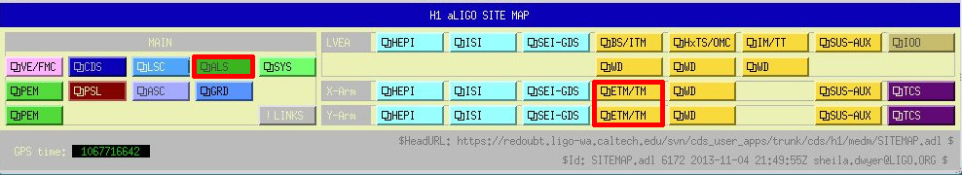
Figure 1: MEDM Site Map. ALS button and end station SUS buttons are highlighted here.
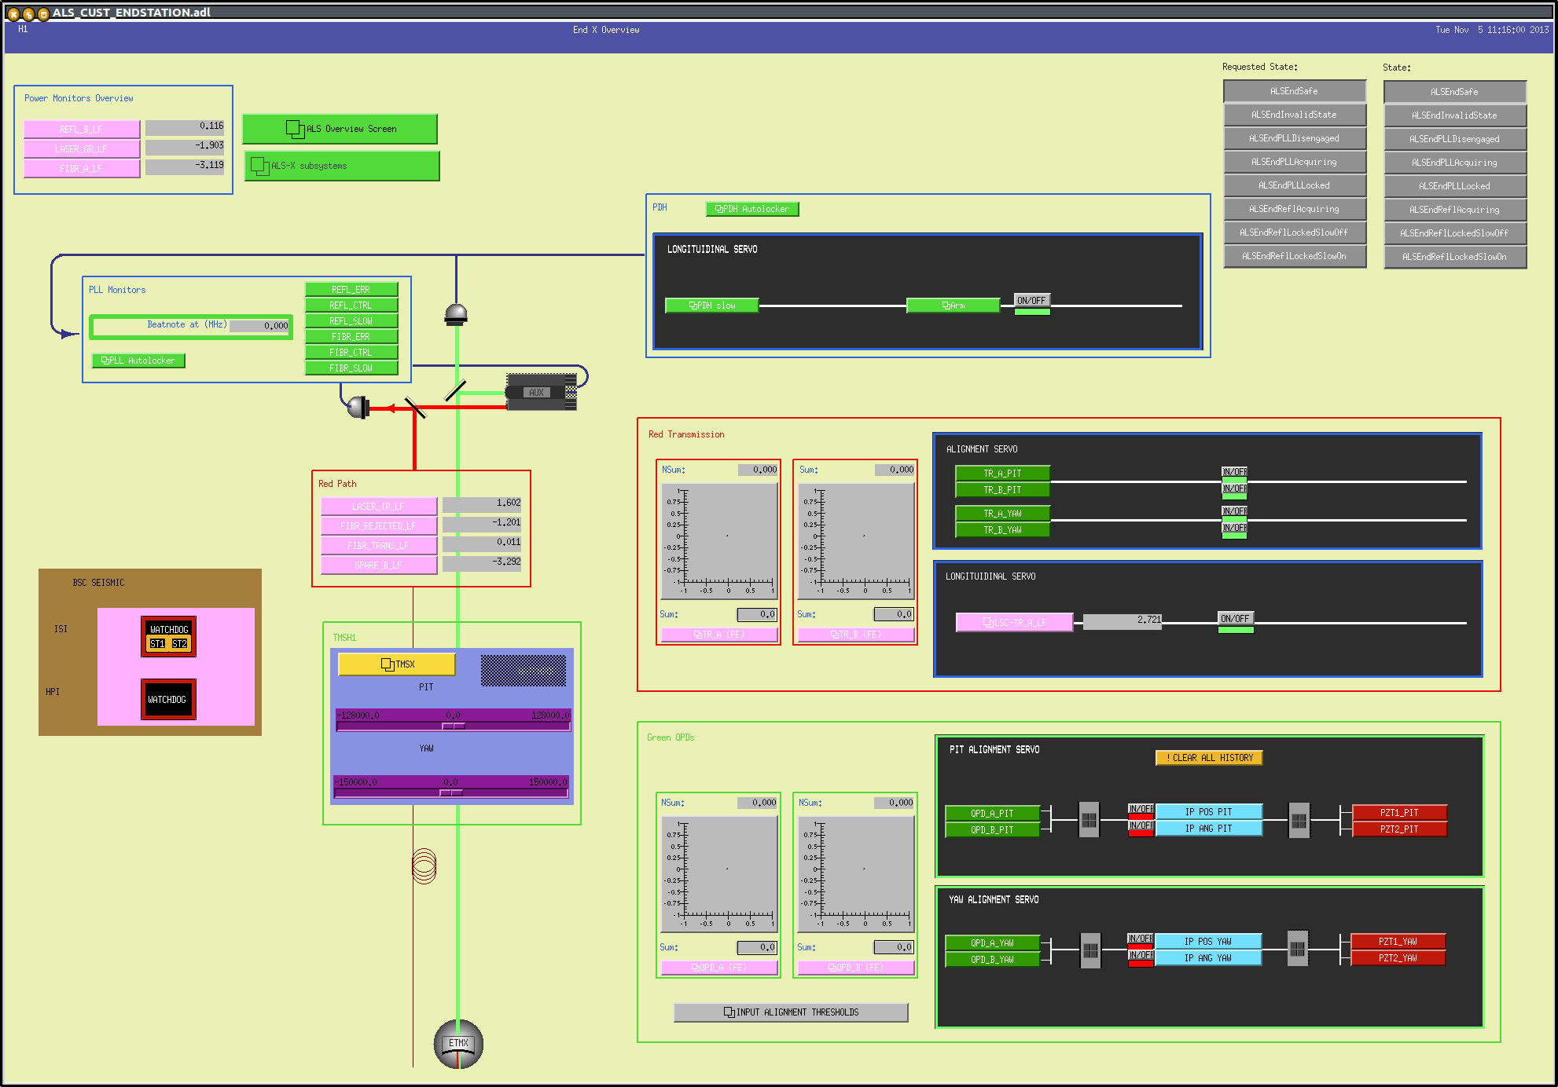
Figure 2: ALS X overview screen.

Applicable Documents

Transmission Monitor
The Transmission Monitor comprises a beam reduction/expansion telescope, an IR QPD “sled” to monitor the transmission of 1064 nm beam from the arm cavity, a green QPD “sled” to monitor 532 nm beam injected from the end station ISCT to the BSC. The entire structure is suspended by the Transmission Monitor Suspension (TMS). The transmission monitor system as a whole is sometimes also referred to as TMS.

Controls Configuration
The ALS End station overview MEDM screen (Figure 2) provides convenient links to most of important TMS functionality.
Two PZT mirrors on the in-air ISC table (ISCTEX and ISCTEY) will change the green beam pointing into the chamber, and the green QPD sled is used as the sensor to monitor the alignment of the green beam into the TMS telescope. Together they are used for a beam centering servo to automatically align the green beam to the TMS.
Once the green beam is “fixed” to the TMS via the servo, the TMS suspension biases change the pointing of the green beam leaving the telescope without affecting the beam path on the telescope.
When the IR light resonates inside the arm cavity, an IR QPD sled will work as an ASC sensor for the interferometer. A fraction of the IR beam is also directed towards the ISC table where a high gain photodiode is used to measure light levels during lock acquisition. Once the interferometer control transitions to science mode, a beam diverter will guide the IR beam leaving the vacuum towards an in-vacuum beam dump.

TMS Beam Centering Servo
On the bottom right of the ALS End station overview (Figure 2), the graphics inside a green rectangle are for the green QPD sled (represented by two X-Y monitors), and the beam centering servo (some buttons and matrices in black rectangle). The input of the servo is the QPD error signal, and the output is connected to the PZT mirrors.
To turn the servo on or off, click the ON/OFF button of four servo filters. This toggles the on/off indicator of each filter between green (ON) and red (OFF). In Figure 2 all filters are off.
The servo filters have an integrator, so disabling the servo means that the output of the filters are held constant until the servo is turned on again. This is convenient as turning them on/off doesn’t suddenly throw the alignment off. When desired, you can reset the servo filters by “Clear all history” button.
The PZT control voltage is unipolar (0V to 10V) and is biased to mid range (5V) for a nominal zero.

TMS Suspension
The TMS suspension is used to change the angle of the TMS telescope, which in turn changes the green beam pointing towards the ETM (and thus ITM). From the ALS End station overview you can directly adjust the bias sliders to the TMS suspension.
If there is a problem with the TMS suspension, you should open the TMS suspension MEDM screen (Figure 3) to further diagnose the problem.
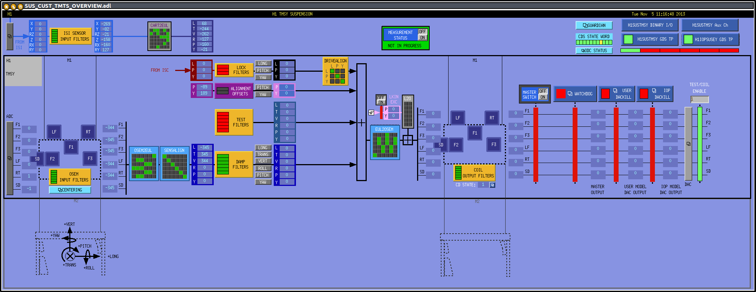
Figure 3: TMS Suspension screen. In this example the master ON/OFF switch is off (the first of the four red vertical bars next to the right most green bar) and the watchdog/DACKILL are also tripped (three red bars next to the master switch) so nothing should be working.

IR Transmission Monitor
IR QPD sled output and associated ASC and LSC servo boxes are in a red rectangle above the green QPD centering servo box (Figure 2).

Standard Operating Parameters

Parameter | Value
Whitening gain for IR QPDs
Number of whitening/anti-whitening stages for IR QPDs
Whitening gain for green QPDs
Number of whitening/anti-whitening stages for green QPDs
Minimum light level on the green QPDs (normalized sum field) | >0.7
Nominal unity gain frequency of the green beam steering servos
Table 1: Standard Operating Parameters for the Transmission Monitor.

QPD Whitening/Anti-whitening
Pressing buttons like “TR A (FE)” (for transmission monitor A) or “QPD B (FE)” (for green injection monitor B) in the ALS End station overview will open the QPD overview for a corresponding QPD. Press “whiten” button, and read the numbers in the whitening gain slider.
There are three stages of switchable analog whitening and digital anti-whitening for all four quadrants of each of QPDs. The state of these can be monitored by the same screen as the whitening gain slider. It is extremely important that whitening and anti-whitening stages are enabled/disabled as a pair. If not (e.g. whitening stage 2 is on but anti-whitening stage 2 is off), check the nominal status by trending H1:ALS-Y_QPD_A_WHITEN_FILTER_2 and H1:ALS-Y_QPD_A_AWHITEN_SET2, etc., and determine if they are enabled or disabled.
There is a non-switchable analog whitening stage, and a corresponding anti-whitening stage in FM4 of the input filter for each quadrant. You should not disable these, but if you suspect that they are disabled, open each of the filters (e.g. from the aforementioned QPD overview by pressing buttons labeled as “SEG1” “SEG2” etc.).

Green QPD sum
Check if the light level on the green QPDs is nominal (see Table 1). If the sum is significantly lower, first check if anything is coming in to the digital system. Check the whitening settings (see the previous section), move the whitening gain slider up and down and see if you’re getting any signal. Don’t forget to restore the slider back to normal after this. If you’re not getting anything you need to call a CDS or ISC expert.
If the readbacks are alive, the problem might be that the output of the QPD centering servo railed because of some unusual circumstance (e.g. somebody blocked the beam for a short period). To verify this, first turn off the beam centering servo for all four filters, then reset the integrators of the servo by pressing “Clear All History” button. If you are getting some light in both of the QPDs, turn on the servo again. If not, check if the offsets in the PZT output filters are lost. Open the PZT output filter screen by pressing buttons labeled “PZT1_PIT” etc., check the offset in the filter (it should be enabled and non-zero). If the offsets are off, enable them. If the offsets are zero, burt-restore them as necessary. If the offsets for all four filters are non-zero and enabled, trend these offsets and see if the current numbers are significantly different from a known good time. Set them back to the known good values.
If that doesn’t recover the sum, check if the TMS suspension bias is on, and if there is a large offset. Trend H1:SUS-TMSY_M1_OPTICALIGN_P_OUTPUT etc. and compare the current numbers with the known working numbers.
If the green QPD sums are still too low, call an ISC expert.

TMS Suspension
Usually, the TMS suspension should be damped with an alignment bias. These are handled in the same way as quad suspensions.

ISC End Station Optics Table

Fiber Beam Setup

Corner Station Setup
On the PSL table a portion of the reference cavity transmission is coupled into the fiber for ALS. We start with 9 mW in the path towards the fiber, and get 70% coupling into the fiber. This fiber goes to the Fiber Distribution Box (document tree E1200121). It has a 160 MHz AOM, when this AOM is driven the outputs for each end station contain just under 10% of the input power. There are PDs controlled by the slow controls system that monitor the power into the fiber, the power received in the fiber distribution box. They have medm screens which are accessible under DCPDs under LSC on the sitemap. These should be calibrated (by setting the responsivity) and the nominal powers set. The end station PLL autolocker will generate an error message if the power is low on these PDs.

Polarization Correction
The outputs from the fiber distribution box goes to a polarization controller (located in the MSR), MPC1, the manual is available at T1200496. From here it is launched into the fiber to the end station, arriving at the end station with about 50%-75% loss. We need at a minimum 40 µW coming out of the fiber at the end station, again there are DC PDs monitoring this power, and the polarization of the output. These PDs need to be calibrated, and limits and nominal values set. The PLL autolocker also checks the values of these PDs and will generate error messages when the polarization drifts or the power drops. The polarization needs to be adjusted manually using MPC1 when it drifts far enough.

Prometheus Laser Setup
The Prometheus manual can be found in LIGO-T1000643. The Prometheus has a noise eater for intensity stabilization which should be disabled. The noise eater can oscillate making it impossible to lock the PLL until someone resets it. There is a noise eater monitor available on the laser head which is available in the laser MEDM screen, but this does not work and sometimes indicates that there is no oscillation when there is in reality an oscillation.

Power Adjust
Adjust the laser diode current near its nominal settings as indicated by the data sheet belonging to the specific laser. Sometimes the factory setting indicates that the current should be set to the maximum, in this case set it slightly below the maximum.

Frequency Setup

Nominal Frequency
Nominal frequencies are listed in LIGO-T1300883. The X-end stations are using a down-shifted laser frequency, whereas the Y-end stations are using an up-shifted laser frequency. The X-end stations are using a down-shifted laser frequency, whereas the Y-end stations are using an up-shifted laser frequency. The PLL autolocker screen is available from the small grey box that says “X (or Y) Arm PLL” in the corner of the ALS overview screen. On this screen you can choose Above PSL or below PSL to set the polarity of the locking.

Temperature Adjust
The coarse adjustment of the laser frequency needs to be done with the crystal temperature. A higher temperature corresponds to a lower frequency. However, mode hopes will occur every ~2° C and reset the frequency back by some amount.
Use an RF spectrum analyzer with at least 500 MHz bandwidth to look for the beat note on the broadband LSC detector, FIBR_A. The initial frequency can be off by GHz which might be too far off to be detected by the photodetector. Scan the temperature until the beat note appears. Then, adjust it approximately to the desired frequency.
There is an interaction between the laser diode current adjust and the crystal temperature. We use this to make sure we are in the middle of a mode hopping region. First, move the temperature up and down and watch for the mode hope. If the desired frequency is close to a mode hope region, adjust the diode current by 0.1 A, and try again. Repeat this procedure until the desired frequency is near the approximately centered between two mode hope regions.

SHG Temperature Adjust
Monitor the green laser power and make sure that the temperature of the SHG is adjusted to deliver maximum green power.

Nominal Laser Power Levels

Fiber Path
The nominal power levels in the fiber path are as follows:
Parameter | Nominal | Minimum
Reference cavity transmission | 10 mW
Coupled into fiber | 7 mW | 4 mW
Receive in MSR | 300 µW | 100 µW
Send to end station | 300 µW | 100 µW
Receive at end station | 150 µW | 50 µW
On ISC table | 150 µW | 40 µW
On monitor photodiode (FIBR_TRANS) | 9 µW | 2.5 µW
On fiber locking photodiode (FIBR_A) | 75 µW | 40 µW

IR Laser Path
The nominal power levels for the IR path of the Prometheus laser are as follows:
Parameter | Nominal | Minimum
Laser output | 1.1 W | 100 mW
After attenuation | 50 mW | 25 mW
On monitor photodiode (LASER_IR) | 350 µW | 100 µW
On fiber locking photodiode (FIBR_A) | 25 mW | 600 µW

Green Laser Path
The nominal power levels for the green path of the Prometheus laser are as follows:
Parameter | Nominal | Minimum
Laser output | 20 mW | 10 mW
After first Faraday isolator | 17 mW | 8 mW
On monitor photodiode (LASER_GR) | 800 µW | 400 µW
After second Faraday isolator | 14 mW | 6 mW
At periscope into vacuum chamber | 12 mW | 5 mW
Return from ETM on reflection photodiode (REFL_A) | 12 mW | 3 mW
Return from ETM on reflection photodiode (REFL_A) | 12 mW
Received at ISCT1 (X arm) |  | <5 mW
Received at ISCT1 (Y arm) |  | <5 mW

Beam Alignment

Input Steering Mirrors

Setup
The manual for the PZTs and controllers are available at E1300870. The controllers should be operated in the low bandwidth mode. To do this you need to move a jumper in the controller, instructions are in the manual. The input steering PZTs have two axes, Y rotates yaw and X rotates Pitch. They operate with inputs from 0-10V, so the initial alignment should be done with 5V input to the controllers. Before the initial alignment the sensor offset should also be adjusted according to the manual. Once the initial alignment is done and the TMS offsets set so that the retroreflection returns to the PD, the alignment of optics near the PZTs should be adjusted so that the beam is centered on the TMS QPDs when they are operated at the middle of their range.

Controls Parameters

Laser Locking

Controls Configuration
The autolocker for locking the PLL is in the Twin CAT library, a state diagram is available at T1300891. The autolocker screen is available by clicking on the small grey box labeled X ARM PLL (or Y arm) in the ALS overview screens at each end station. The autolocker checks several locking conditions, if any of these are not met an error message will appear at the bottom of the screen and the locking conditions text will have a red background. To clear all of these each of the relevant DC PDs will need to be calibrated, and some of them will need to have limits set.

Standard Operating Parameters

Conditions

Filter and Gain Settings

Performance Checks

Failure Modes

Cavity Locking

Controls Configuration

Standard Operating Parameters

Conditions

Filter and Gain Settings

Performance Checks

Failure Modes

