*LIGO Laboratory / LIGO Scientific Collaboration*

LIGO- E1300824 *LIGO* November 1st, 2013

**aLIGO HEPI Assembly Validation Procedure**

E1300824

Fabrice Matichard, Sebastien Biscans, Hugo Paris for the SEI Team

Distribution of this document:

Advanced LIGO Project

This is an internal working note

of the LIGO Laboratory

|  |  |
| --- | --- |
| **California Institute of Technology**  **LIGO Project – MS 18-34**  **1200 E. California Blvd.**  **Pasadena, CA 91125**  Phone (626) 395-2129  Fax (626) 304-9834  E-mail: info@ligo.caltech.edu | **Massachusetts Institute of Technology**  **LIGO Project – NW22-295**  **185 Albany St**  **Cambridge, MA 02139**  Phone (617) 253-4824  Fax (617) 253-7014  E-mail: info@ligo.mit.edu |
| **LIGO Hanford Observatory**  **P.O. Box 1970**  **Mail Stop S9-02**  **Richland WA 99352**  Phone 509-372-8106  Fax 509-372-8137 | **LIGO Livingston Observatory**  **P.O. Box 940**  **Livingston, LA 70754**  Phone 225-686-3100  Fax 225-686-7189 |

Contents

Sub-Components Testing 5

Assembly Validation 5

1Load Cells assembly 5

2Bellows 6

3Boot Location 6

4Check Stops Gaps 8

5Gaps check 10

6IPS Centering 12

7Sensor ASD 12

8SUS-watchdogs interaction test 13

9Static Test local drive 14

10Linearity Test/Range of motion in the local basis 17

11Actuator Plate to Shields gap 19

12Valve Check 19

13Local-to-local measurements 20

14Alignment offsets: 22

The Gap Checks are all specific to the HAM, if doing all this is reasonable, why not specify doing it for the BSC?

\

Introduction

This document summarizes the steps to be done to validate HEPI assemblies. Corresponding reports must be posted in :

LIGO-E1300454: aLIGO HEPI Testing Reports

# Sub-Components Testing

* Kaman Inductive Position Sensors: calibration, linearity, factory data, noise measurements (E0900426 – HEPI Kaman Sensor Receiving Analysis - Results posted in the SVN )
* HEPI actuator linearity test (E1100338 – aLIGO HEPI Actuators Test Results)
* L4C test (Q0900007)

# Assembly Validation

After installation along procedure Exxxxxx, and aligment along procedure Exxxxxx, and once HEPI is in final configuration (alignment completed).

## Load Cells assembly

* Spring attachment

For the BSC HEPI springs, check the assembly per D030324. See LLO aLOG 7162 for more details.

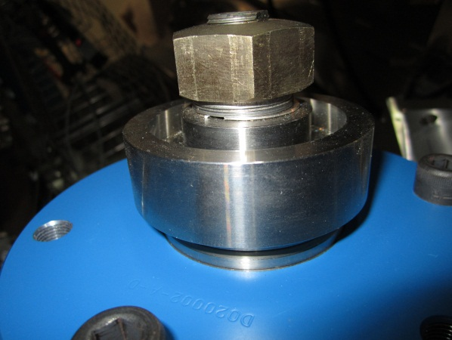

* Load cell values

BSC HEPI load cell capacity → 3000 lbs

HAM HEPI load cell capacity → 2000 lbs

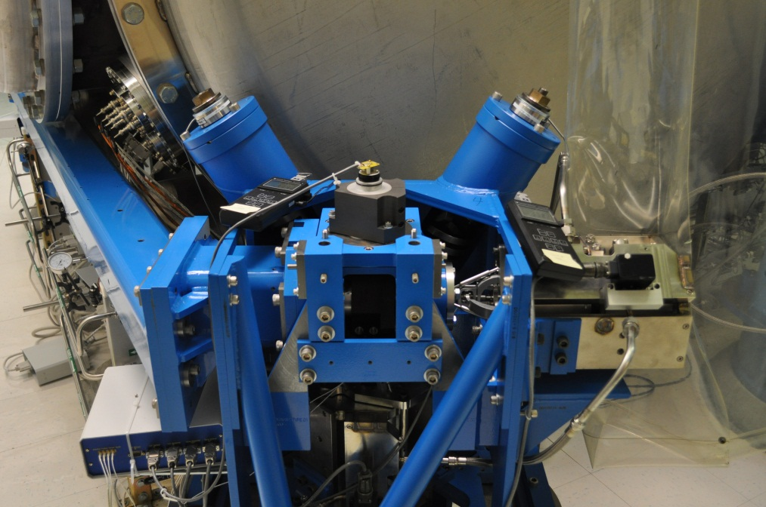

Right Spring

**HAM-HEPI example at LASTI**

|  |  |  |
| --- | --- | --- |
|  | **Left Spring (lbs)** | **Right Spring (lbs)** |
| **Pier 1** | 1347 | 949 |
| **Pier 2** | 1458 | 1631 |
| **Pier 3** | 1267 | 1157 |
| **Pier 4** | 1142 | 1722 |

**Acceptance criteria:**

* The values must not exceed 80% of the load cell capacity (2400lbs for BSC and 1600lbs for HAM).

**Test result: Passed: Failed: X .**

## Bellows

The bellows are hard to access and tests are hard to proceed. After several discussions and brainstorming sessions, it has been decided not to measure the gaps on HEPI-HAM and HEPI-BSC.

## Boot Location

**Tangential Left: 5.380”**

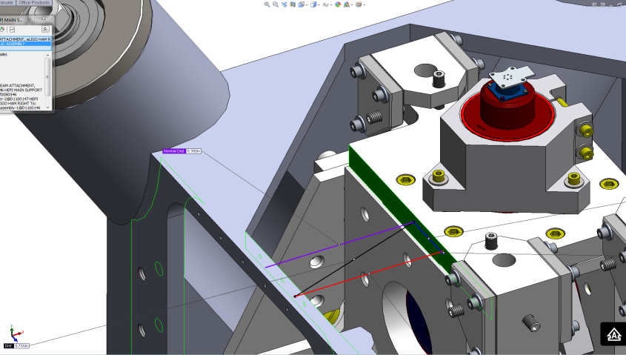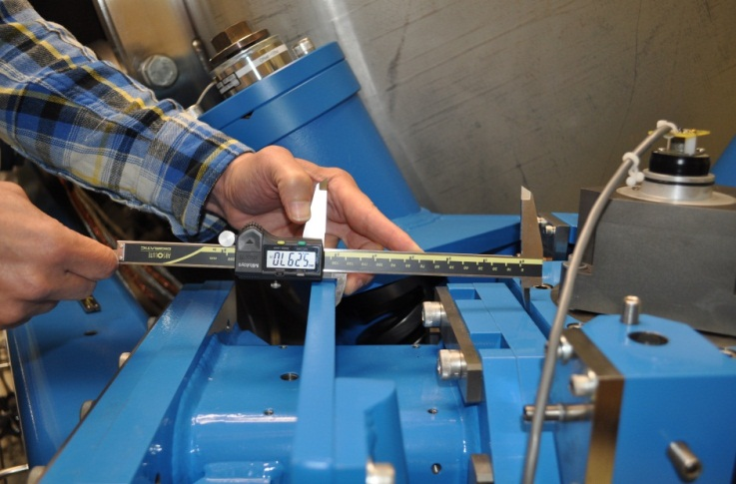

**Tangential Right: 5.380”**

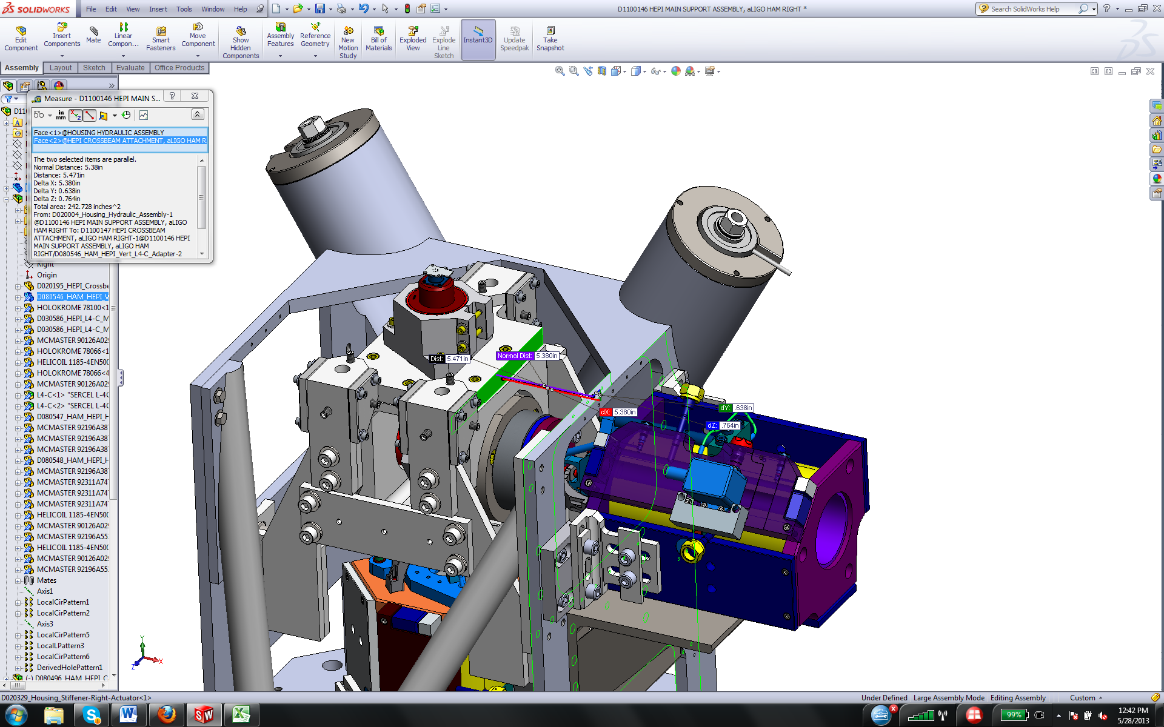 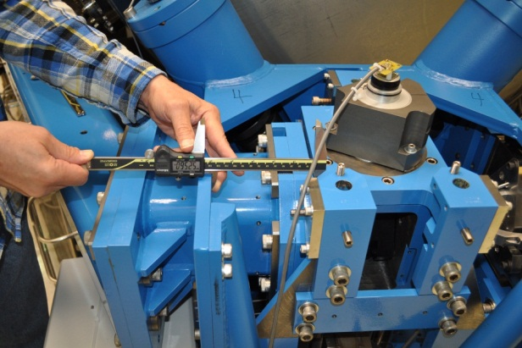

**Radial Back: 1.17”**

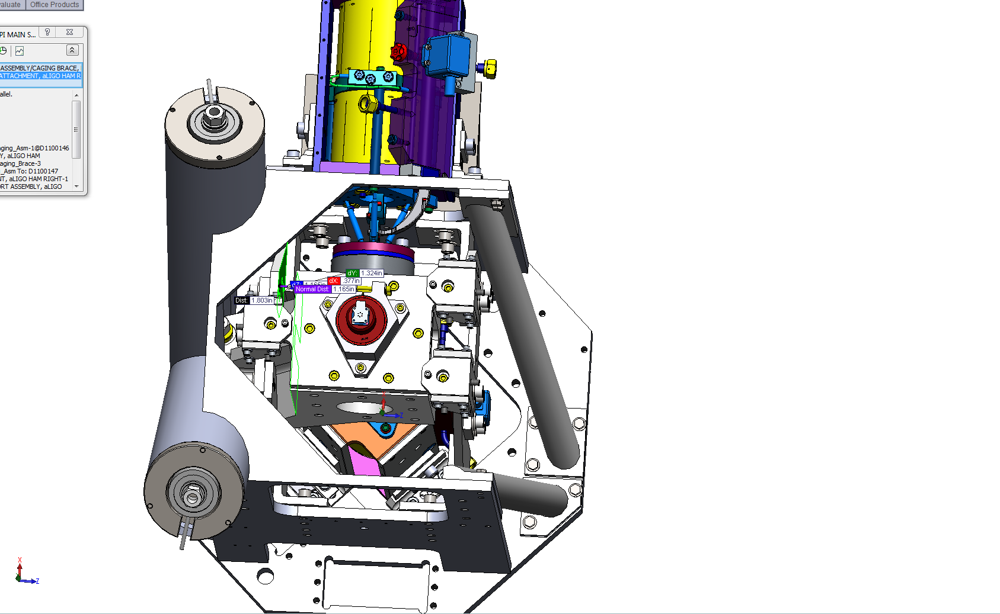 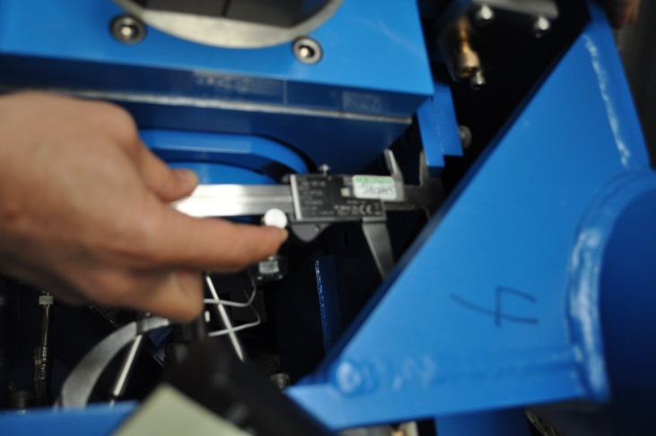

**Radial Front: 1.42”**

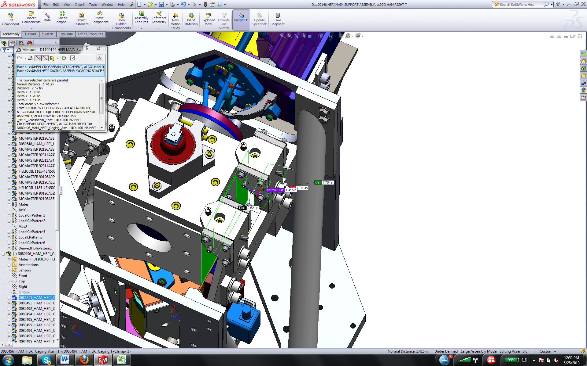 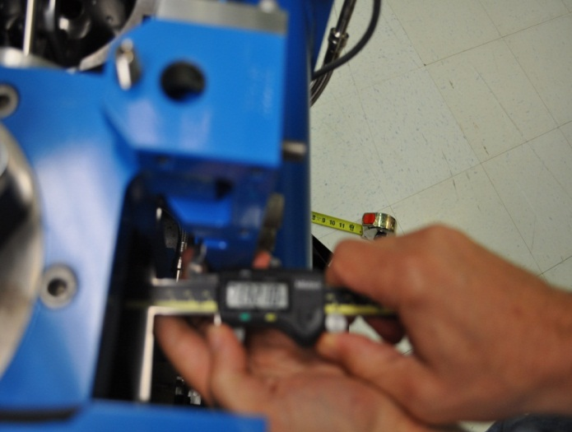

**Vertical: 0.32”**

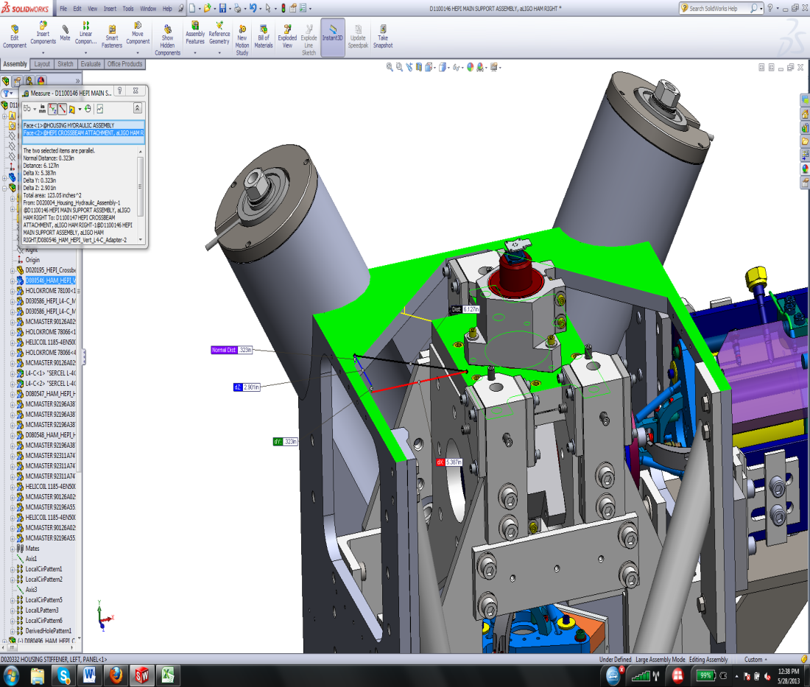 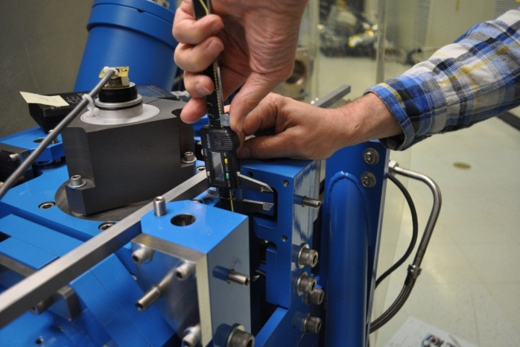

A description...

A description...

**Acceptance criteria:**



**Test result: Passed: X Failed: .**

Argument for by bypassing this test.

In a world of perfect fabrication & assembly and never moving the Crossbeam location, this data might be useful. It might have made sense to make these measurements during initial assembly of each housing assembly but we used jigs to position the Foot in the Housing and so these would have been perfect. And, we aren't going back to that state—back to individual housings.

However, after installation, the platforms are moved, often more than a couple mm, in response to the initial alignment. Additionally, when payloaded the HAM HEPI Crossbeam twists tilting the Foot in the Housing. The measurements made do not really check any clearances. If the fabrication of the Housing and the Foot were perfect and the IAS shift and payloading shifts did not occur, it would give an indication of potential clearance problems elsewhere.

## Check Stops Gaps

The stops must not touch the boot. There is 15 stops per boot, 5 per F bracket. There is actually only 13 stops and one of those is not accessible.

Argument for bypassing this test: If these stops were used as an Earthquake stop and set to an exact depth, and, if they were never locked again after setting, maybe then it would be worth doing this. But the locks have been opened and closed many times during the commissioning of the platform so only the last time would it really have any validity. When unlocking the platforms, these gaps (where visible, are check visually and are opened way more than 1/16”.

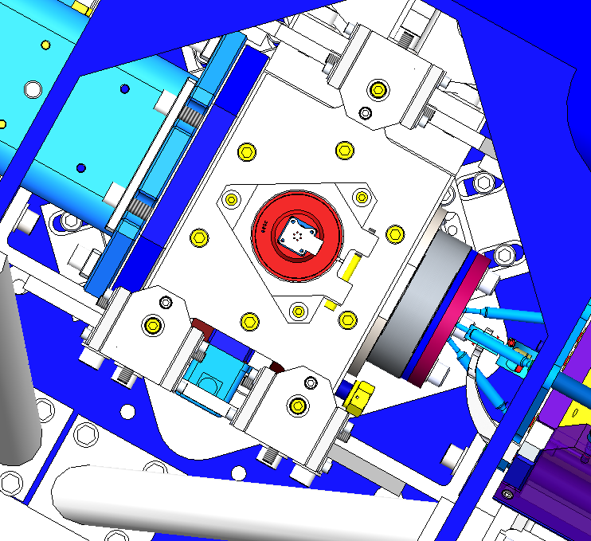

**Acceptance criteria:**

* A 0.062” shim must fit into the gaps

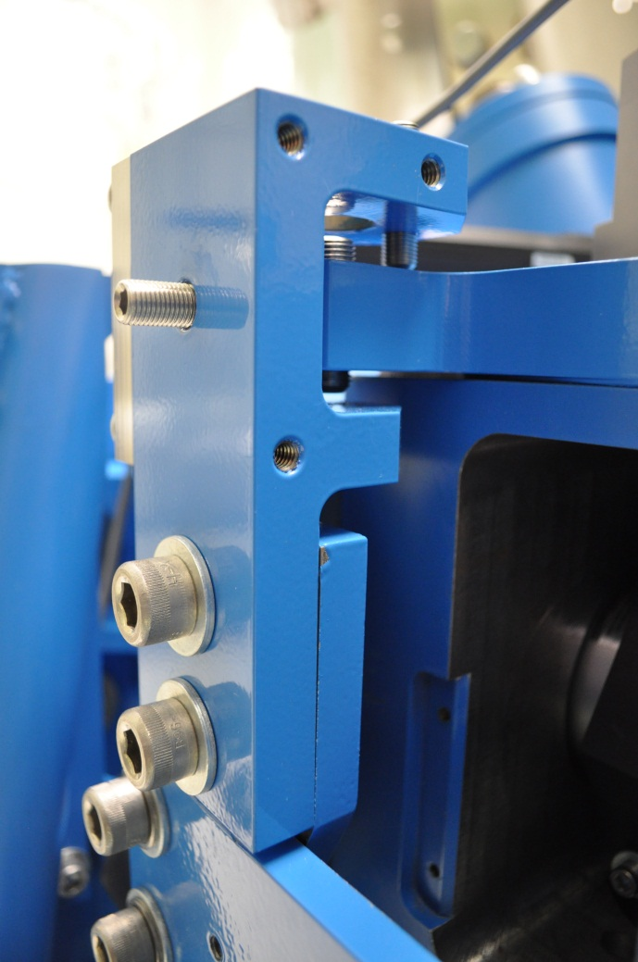

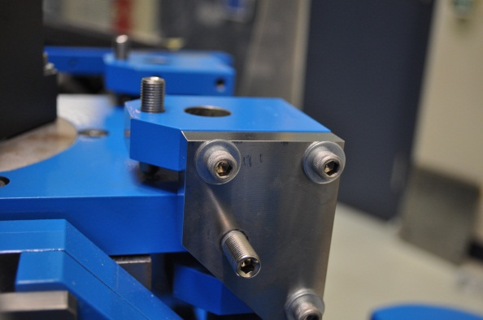

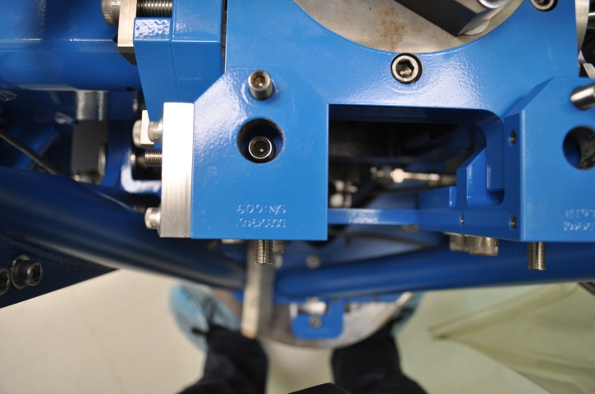

|  |  |  |  |  |  |  |  |  |  |  |  |  |  |  |  |  |  |  |
| --- | --- | --- | --- | --- | --- | --- | --- | --- | --- | --- | --- | --- | --- | --- | --- | --- | --- | --- |
|  | **Bracket 1** | | | | | | **Bracket 2** | | | | | | **Bracket 3** | | | | | |
|  | **Gap1** | **Gap2** | **Gap3** | **Gap4 above** | **Gap4 under** | **Gap5** | **Gap1** | **Gap2** | **Gap3** | **Gap4 above** | **Gap4 under** | **Gap5** | **Gap1** | **Gap2** | **Gap3** | **Gap4 above** | **Gap4 under** | **Gap5** |
| **Pier 1** | Go | Go | Go | Go | Go | Go | Go | Go | Go | Go | Go | Go | Go | Go | Go | Go | Go | Go |
| **Pier 2** | Go | Go | Go | Go | Go | Go | Go | Go | Go | Go | Go | Go | Go | Go | Go | Go | Go | Go |
| **Pier 3** | Go | Go | Go | Go | Go | Go | Go | Go | Go | Go | Go | Go | Go | Go | Go | Go | Go | Go |
| **Pier 4** | Go | Go | Go | Go | Go | Go | Go | Go | Go | Go | Go | Go | Go | Go | Go | Go | Go | Go |

**Test result: Passed: X Failed:**

## Gaps check

Four particular gaps need to be check.

Argument against checking these Gaps: All subsequent actuation test confirm that these close points are not touching. These are checked visually and by hand however. Maybe now however, that we have a final IFO operation point, these gaps should be checked again.

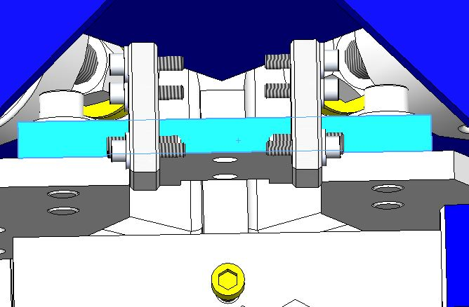

**The F bracket has been removed for a better visibility**

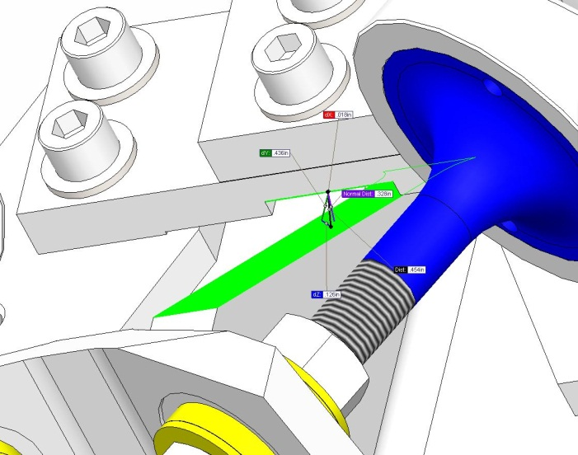A description...

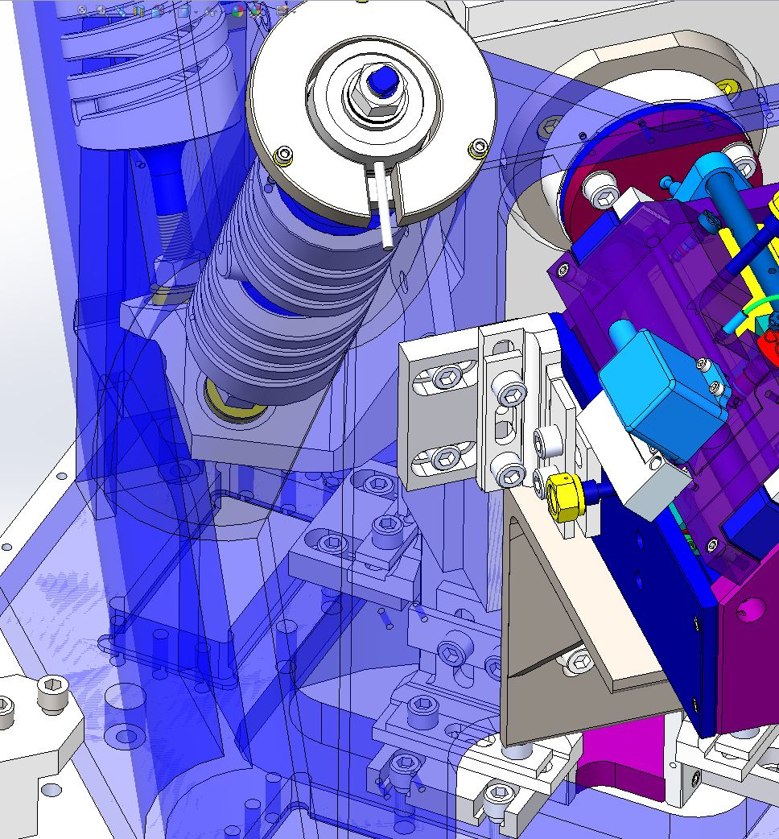

Gap #4

**Acceptance criteria:**

* a 0.08” shim must fit in these two gaps

Issues/difficulties/comments regarding this test: Gap#1 is tricky to reach. At LASTI, the solution found was to tape the shim to an extension (rod, rigid ruler, etc.).

Gap#2 should be reachable by hand.

Gap#3 and 4 are tricky, but should also be doable (no picture)

**Gap#1**

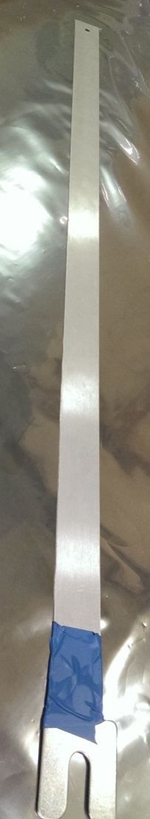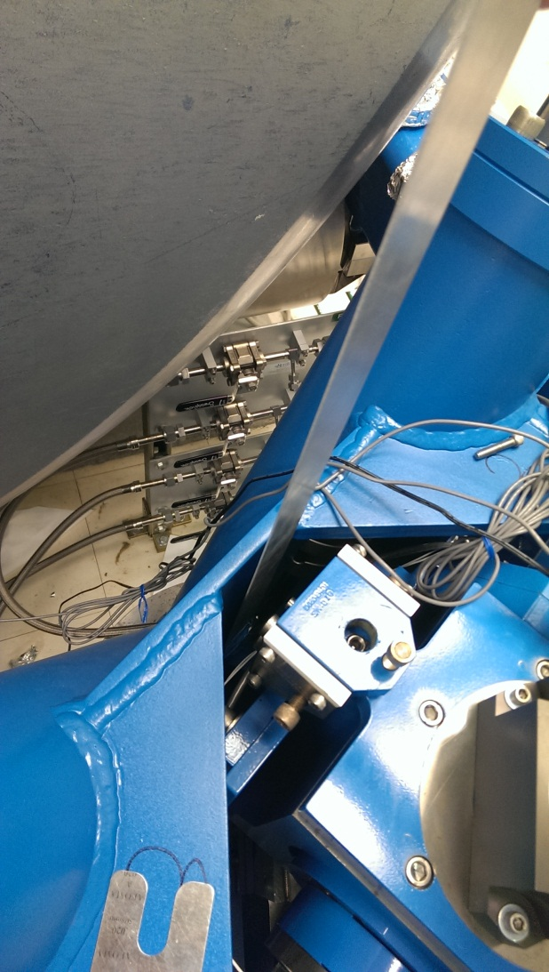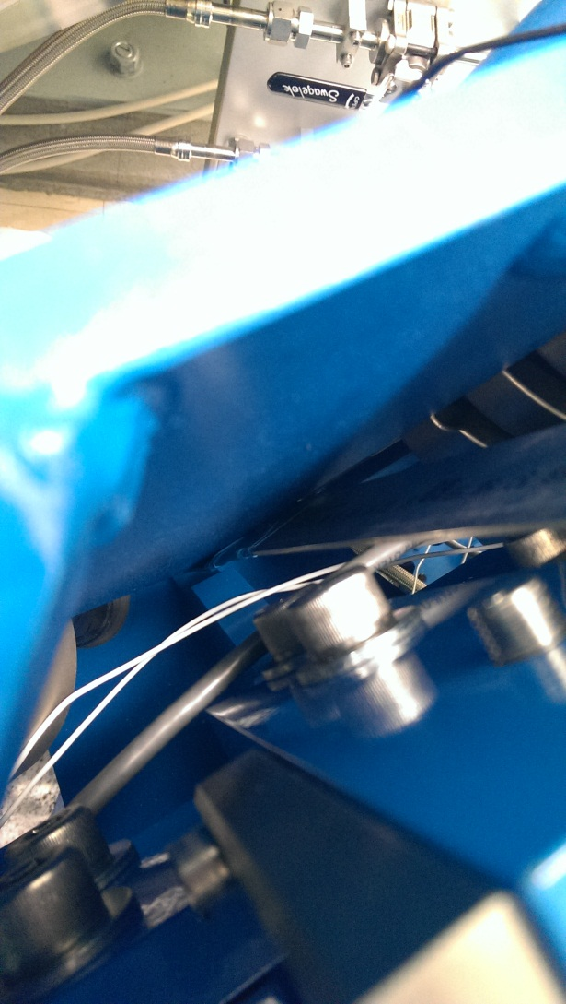

**Gap#2**

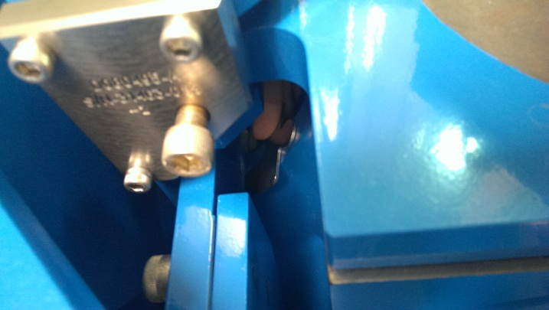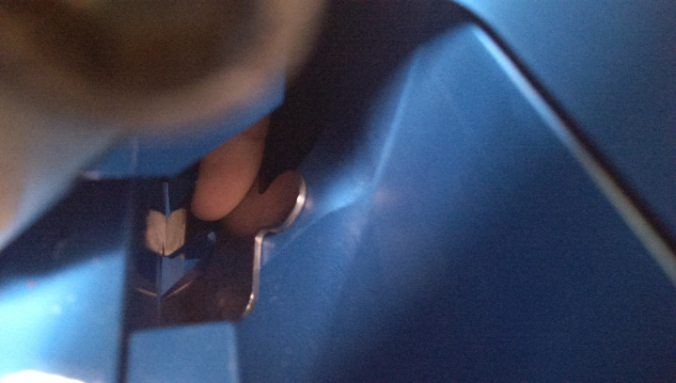

|  |  |  |  |  |
| --- | --- | --- | --- | --- |
|  | **Gap#1** | **Gap#2** | **Gap#3** | **Gap#4** |
| **Pier 1** | Go | Go | Go | Go |
| **Pier 2** | Go | Go | Go | Go |
| **Pier 3** | Go | Go | Go | Go |
| **Pier 4** | Go | Go | Go | Go |

**Test result: Passed: X Failed: .**

## IPS Centering

**Scripts files for processing and plotting in SVN at:**

/SeiSVN/seismic/HEPI/Common/Testing_Functions_HEPI/Offset_STD_IPS_HEPI.m

All the loops must be turned off during this test.

|  |  |  |  |  |  |  |  |  |
| --- | --- | --- | --- | --- | --- | --- | --- | --- |
|  | H1 | H2 | H3 | H4 | V1 | V2 | V3 | V4 |
| Mean (counts) |  |  |  |  |  |  |  |  |
| Acceptance | +/- 15000 | +/- 15000 | +/- 15000 | +/- 15000 | +/- 15000 | +/- 15000 | +/- 15000 | +/- 15000 |

**Test result: Passed: X Failed:**

Comments—For this measurement to have meaning different from Section 15, it must be specified when the data is to be taken. The IPS values collected in section 15, would be those just after initial alignment and the Actuators are first attached. Before that point, the IPS readings should be more like zero, not at half their range. For much of the installation, electronics were not available and platform motion was monitored with Dial Indicators.

## Sensor ASD

**Scripts files for processing and plotting in SVN at:**

/SeiSVN/seismic/HEPI/Common/Testing_Functions_HEPI/ASD_Measurements_Local_HEPI.m

**Data in SVN at:**

SeiSVN/seismic/HEPI/M1/HAMX/Data/Spectra/Undamped/

M1_HPI_HAMX_ASD_m_IPS_L4C_2013_06_03_120859.mat

**Figures in SVN at:**

/SeiSVN/seismic/HEPI/M1/HAMX/Data/Figures/Spectra/Undamped

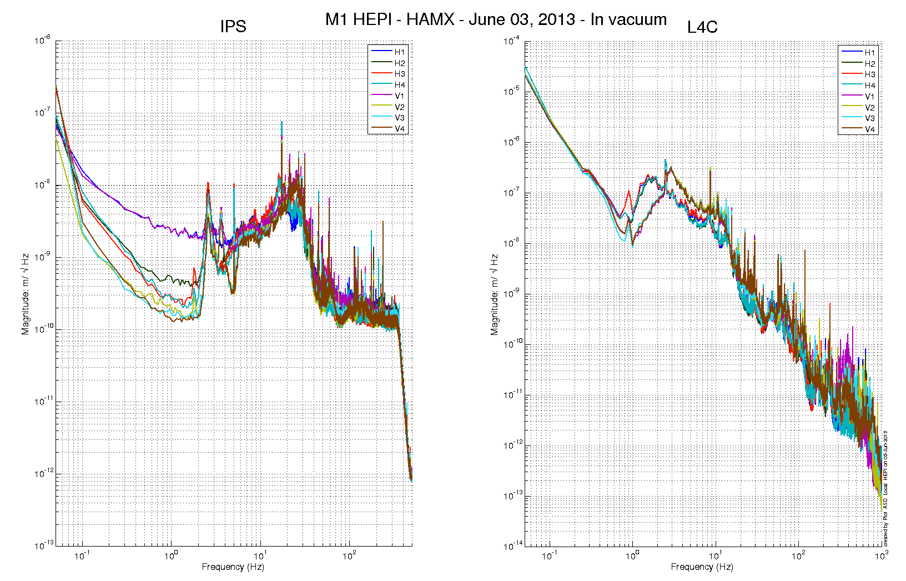

Issues/difficulties/comments regarding this test:

Measurements were performed with all PreFilters ON.

**Acceptance criteria: A reference good spectra might be a good thing to have here.**

**Test result: Passed: Failed: .**

## SUS-watchdogs interaction test

**This test will be obsolete very soon, as the payload-HEPI WD connection is planned for removal.**

## Static Test local drive

**Scripts files for processing in SVN at:**

/SeiSVN/seismic/HEPI/Common/Testing_Functions_HEPI/Static_Test_Local_Basis_HEPI.m

. ***Drive of 100 counts (in progress)***

|  |  |  |  |  |  |  |  |  |
| --- | --- | --- | --- | --- | --- | --- | --- | --- |
|  | H1 | H2 | H3 | H4 | V1 | V2 | V3 | V4 |
| H1 | 8350.9418 | -5056.1049 | -327.0384 | -1879.51872 | -178.9088 | 209.3388 | 192.18836 | -370.0864 |
| H2 | -4104.049 | 8306.5349 | -1822.531974 | -448.11792 | 134.8916 | -100.465 | -301.80668 | 139.7868 |
| H3 | -233.5984 | -2065.5751 | 8170.4572 | -4615.56692 | 178.7694 | -183.7838 | -239.1095 | 118.1154 |
| H4 | -1807.7793 | -701.3897 | -4558.2268 | 9000.50088 | -488.2914 | 367.591 | -1.00976 | -441.0128 |
| V1 | -87.0864 | 1.56718 | 302.0506 | -174.51156 | 7490.8344 | 918.82254 | -1656.35338 | 784.3534 |
| V2 | 182.2748 | -404.56522 | -128.0876 | 486.57564 | 833.8752 | 7402.042 | 675.00182 | -1629.1482 |
| V3 | 309.8688 | -477.33554 | -80.087 | 272.82164 | -1436.731 | 1099.12212 | 7236.42762 | 695.124 |
| V4 | -177.839 | 74.78868 | 291.7698 | -126.46464 | 955.694 | -1414.8926 | 824.44686 | 7487.4108 |

*Table - Main couplings and cross couplings*

. ***Drive of 1000 counts (in progress)***

|  |  |  |  |  |  |  |  |  |
| --- | --- | --- | --- | --- | --- | --- | --- | --- |
|  | H1 | H2 | H3 | H4 | V1 | V2 | V3 | V4 |
| H1 | 8350.9418 | -5056.1049 | -327.0384 | -1879.51872 | -178.9088 | 209.3388 | 192.18836 | -370.0864 |
| H2 | -4104.049 | 8306.5349 | -1822.531974 | -448.11792 | 134.8916 | -100.465 | -301.80668 | 139.7868 |
| H3 | -233.5984 | -2065.5751 | 8170.4572 | -4615.56692 | 178.7694 | -183.7838 | -239.1095 | 118.1154 |
| H4 | -1807.7793 | -701.3897 | -4558.2268 | 9000.50088 | -488.2914 | 367.591 | -1.00976 | -441.0128 |
| V1 | -87.0864 | 1.56718 | 302.0506 | -174.51156 | 7490.8344 | 918.82254 | -1656.35338 | 784.3534 |
| V2 | 182.2748 | -404.56522 | -128.0876 | 486.57564 | 833.8752 | 7402.042 | 675.00182 | -1629.1482 |
| V3 | 309.8688 | -477.33554 | -80.087 | 272.82164 | -1436.731 | 1099.12212 | 7236.42762 | 695.124 |
| V4 | -177.839 | 74.78868 | 291.7698 | -126.46464 | 955.694 | -1414.8926 | 824.44686 | 7487.4108 |

*Table - Main couplings and cross couplings*

. ***Drive of 5000 counts (Nominal value handled by testing script)***

|  |  |  |  |  |  |  |  |  |
| --- | --- | --- | --- | --- | --- | --- | --- | --- |
|  | H1 | H2 | H3 | H4 | V1 | V2 | V3 | V4 |
| H1 | 8350.9418 | -5056.1049 | -327.0384 | -1879.51872 | -178.9088 | 209.3388 | 192.18836 | -370.0864 |
| H2 | -4104.049 | 8306.5349 | -1822.531974 | -448.11792 | 134.8916 | -100.465 | -301.80668 | 139.7868 |
| H3 | -233.5984 | -2065.5751 | 8170.4572 | -4615.56692 | 178.7694 | -183.7838 | -239.1095 | 118.1154 |
| H4 | -1807.7793 | -701.3897 | -4558.2268 | 9000.50088 | -488.2914 | 367.591 | -1.00976 | -441.0128 |
| V1 | -87.0864 | 1.56718 | 302.0506 | -174.51156 | 7490.8344 | 918.82254 | -1656.35338 | 784.3534 |
| V2 | 182.2748 | -404.56522 | -128.0876 | 486.57564 | 833.8752 | 7402.042 | 675.00182 | -1629.1482 |
| V3 | 309.8688 | -477.33554 | -80.087 | 272.82164 | -1436.731 | 1099.12212 | 7236.42762 | 695.124 |
| V4 | -177.839 | 74.78868 | 291.7698 | -126.46464 | 955.694 | -1414.8926 | 824.44686 | 7487.4108 |

*Table - Main couplings and cross couplings*

Issues/difficulties encountered during this test:

**Acceptance criteria:**The results in these three tables must be the same (within xxx%)

**Test result: Passed: Failed: .**

**Looking at the diagonal drives and offset coupling is certainly valid. However, this script was never in a form (at LHO) to run the three offset rounds and then normalize the results. This seems excessive and I (HughR) had not looked at this document, I only looked at previous assembly validation reports, HAM2 for example notes:**

***Drive of 1000 and 2500 counts were skipped. Static_Test_Local_Basis_HEPI.m drives at 5000***

***counts only.***

**It makes more sense to speak specifically about the range of acceptable amplitudes on the off diagonal groups:**

**The elements inside the above red boxes should be significantly less than those off diagonal elements in the green boxes to their left or right. That being said, note too the size of the element in H1 row and the H3 Column and how much smaller it is than the adjacent H2 & H4 Columns. The H1 Actuation (H1 Row) moves H2 the most as it is the same crossbeam, it pivots about the opposite corner (H3—smallest value.)**

## Linearity Test/Range of motion in the local basis

**Scripts files for processing and plotting in SVN at:**

/SeiSVN/seismic/HEPI/Common/Testing_Functions_HEPI/Linearity_Test_Awgstream_HEPI.m

**Data in SVN at:**

SeiSVN/seismic/HEPI/M1/HAMX/Data/Spectra/Undamped/

M1_ISI_HAMX_ASD_m_CPS_T240_L4C_GS13_Locked_vs_Unlocked_2012_02_07.mat

**Figures in SVN at:**

/SeiSVN/seismic/HEPI/M1/HAMX/Data/Figures/Spectra/Undamped

|  |  |  |
| --- | --- | --- |
|  | Slopes | Offsets |
| H1 | 1.63 | 1800.40 |
| H2 | 1.88 | -522.55 |
| H3 | 1.63 | 1959.94 |
| H4 | 1.76 | -177.98 |
| V1 | 1.54 | -4082.29 |
| V2 | 1.54 | -1558.79 |
| V3 | 1.42 | -516.54 |
| V4 | 1.56 | -5144.56 |

Issues/difficulties encountered during this test:

**Acceptance criteria: Very important test, some range of acceptable values would be nice to have, Fabrice?**

**Test result: Passed: X Failed: .**

## Actuator Plate to Shields gap

**Perform this test ONLY if the range of motion test failed.**

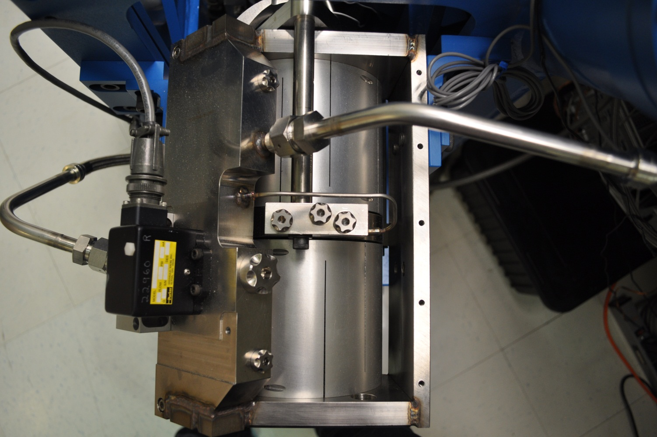Gap#3

Gap#2

Three gaps per actuator need to be checked.

**Acceptance criteria:**

* A 0.1” shim must fit into the gap #1
* A 0.05 shim must fit into gap #2 and #3

|  |  |  |  |  |  |  |
| --- | --- | --- | --- | --- | --- | --- |
|  | **Horizontal** | | | **Vertical** | | |
|  | **Gap #1** | **Gap #2** | **Gap #3** | **Gap #1** | **Gap #2** | **Gap #3** |
| **Pier 1** | Go | Go | Go | Go | Go | Go |
| **Pier 2** | Go | Go | Go | Go | Go | Go |
| **Pier 3** | Go | Go | Go | Go | Go | Go |
| **Pier 4** | Go | Go | Go | Go | Go | Go |

**Test result: Passed: X Failed:**

Arguments against checking these gaps—Welding fabrication of the bellows to the Actuator plate will likely result in the two surfaces not being parallel(gaps 2 & 3.) Likewise, the assembly of the Tripod to Actuator Plate will make the parallelism of the Tripod base and the Actuator top plate iffy. Given the surfaces involved, seeing, much less checking everywhere for the gap makes a single gap check insufficient. The ROM and Linearity Tests will confirm that these gaps are obstruction free.

## Valve Check

**Scripts files for processing and plotting in SVN at:**

/SeiSVN/seismic/HEPI/M1/HAMX/Scripts/Valve_Check/plot_valve_check.m

**Data in SVN at:**

SeiSVN/seismic/HEPI/M1/HAMX/Data/Spectra/Undamped/

/SeiSVN/seismic/HEPI/M1/HAMX/Scripts/Valve_Check

**Figures in SVN at:**

/SeiSVN/seismic/HEPI/M1/HAMX/Scripts/Valve_Check

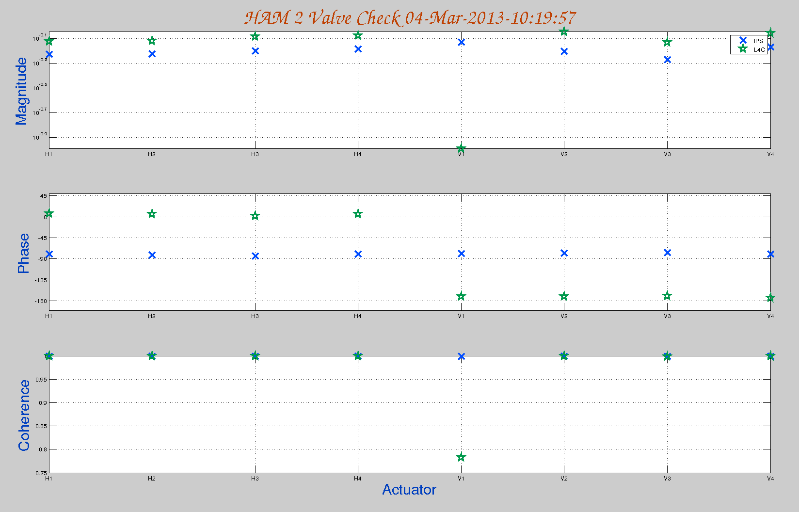

**Acceptance criteria:**

**Test result: Passed: Failed: .**

This function script never worked at LHO and I (HughR) only tried it a couple times. Depends on who you talk to, the check is okay or not worth doing. The Static Test Local Drive is sufficient.

## Local-to-local measurements

|  |  |  |  |  |  |  |
| --- | --- | --- | --- | --- | --- | --- |
| **Band (Hz)** | **Resolution** | **Amplitude** | **Nreps** | **Time (s)** | **Time (min)** | **Time (h)** |
| **100 - 500** | 0.5 | 4000 - 4000 | 250 | 4176 | 69.6 | 1.2 |
| **10 - 100** | 0.25 | 4000 - 4000 | 200 | 6592 | 109.9 | 1.8 |
| **0.7 - 10** | 0.05 | 4000 - 4000 | 75 | 12320 | 205.3 | 3.4 |
| **0.1 - 0.7** | 0.025 | 4000 - 4000 | 30 | 10080 | 168.0 | 2.8 |
| **0.01 - 0.1** | 0.01 | 4000 - 4000 | 10 | 8960 | 149.3 | 2.5 |
| **0.002 - 0.01** | 0.002 | 4000 - 4000 | 2 | 12160 | 202.7 | 3.4 |
|  |  |  |  |  |  | **15.1** |

**Data files in SVN at:**

/SeiSVN/seismic/HEPI/M1/HAMX/Data/Transfer_Functions/Measurements/Undamped/

* M1_HPI_HAMX_Data_TF_L2L_200Hz_1000Hz_20120201-174407.mat
* M1_HPI_HAMX_Data_TF_L2L_5Hz_200Hz_20120201-183140.mat
* M1_HPI_HAMX_Data_TF_L2L_500mHz_5Hz_20120201-191513.mat
* M1_HPI_HAMX_Data_TF_L2L_100mHz_500mHz_20120201-202848.mat
* M1_HPI_HAMX_Data_TF_L2L_10mHz_100mHz_20120201-212025.mat

**Data collection script files:**

/SeiSVN/seismic/HEPI/Common//Transfer_Function_Scripts/

* Run_TF_L2L_10mHz_100mHz.m
* Run_TF_L2L_100mHz_500mHz.m
* Run_TF_L2L_500mHz_5Hz.m
* Run_TF_L2L_5Hz_100Hz.m
* Run_TF_L2L_100Hz_1000Hz.m

**Scripts files for processing and plotting in SVN at:**

/SeiSVN/seismic/HEPI/M1/HAMX/Scripts/Control_Scripts/release/

* Step_1_TF_Loc_to_Loc_M1_HEPI_HAMX.m

**Figures in SVN at:**

/SeiSVN/seismic/HEPI/M1/HAMX/Data/ Figures/Transfer_Functions/Measurements/Undamped/

* M1_HPI_Unit_1_TF_L2L_Raw_from_ACT_to_CPS_2012_02_02_With_3_Washers_Under_Top_Mass.fig
* M1_HPI_Unit_1_TF_L2L_Raw_from_ACT_to_GS13_2012_02_02_With_3_Washers_Under_Top_Mass.fig

**Storage of measured transfer functions in the SVN at:**

/SeiSVN/seismic/HEPI/M1/HAMX/Data/Transfer_functions/ Simulations/Undamped/

* M1_HPI_Unit_1_TF_L2L_Raw_2012_02_02_With_3_Washers_Under_Top_Mass.mat

The local-to-local transfer functions are presented below.

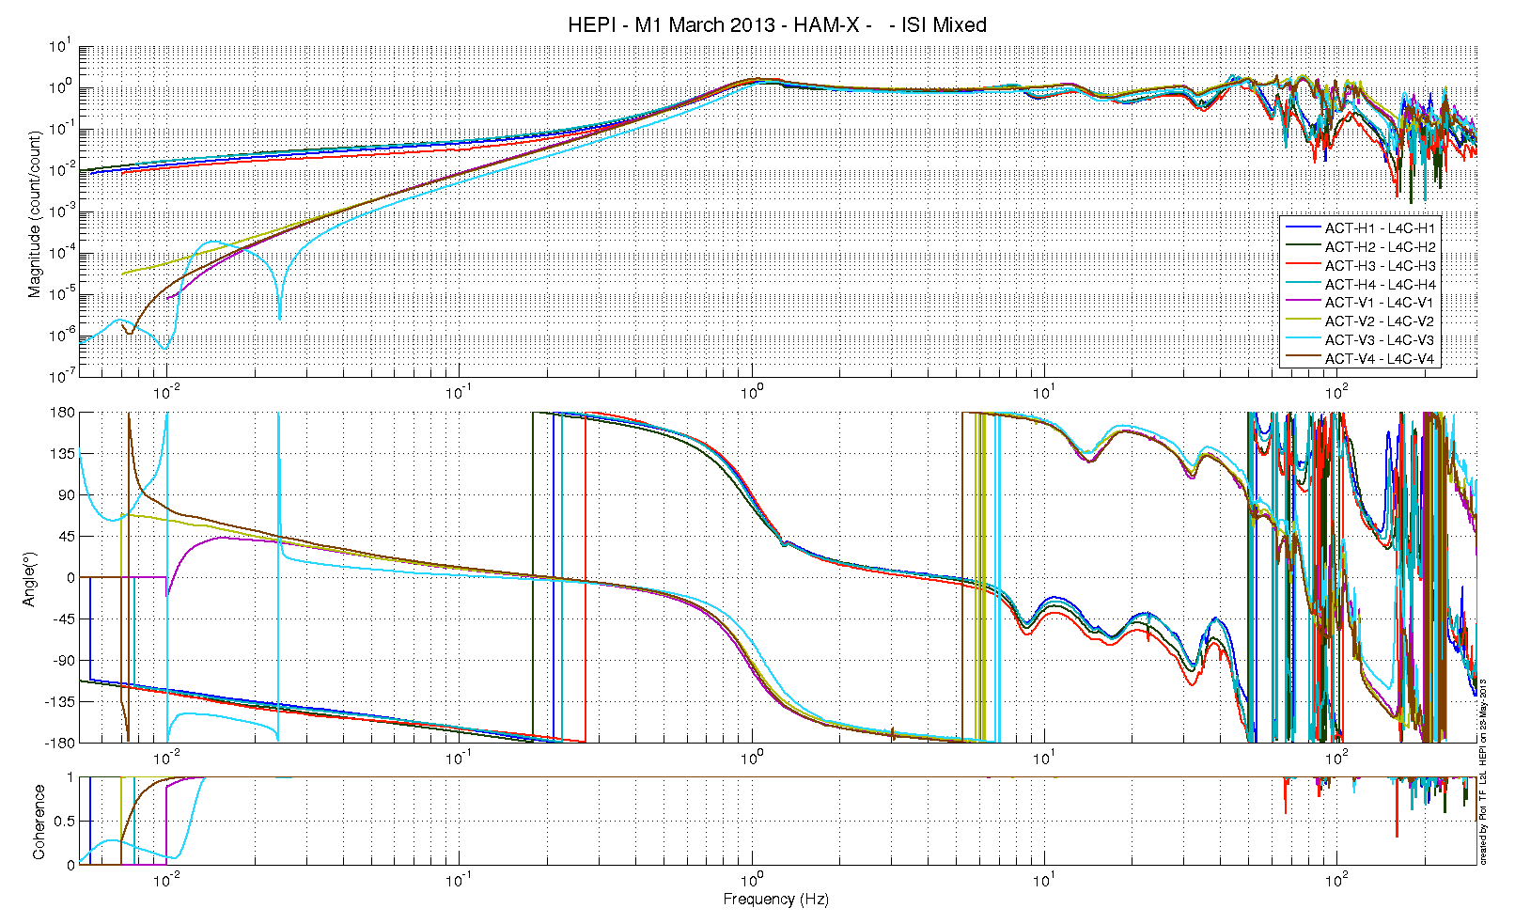

A description...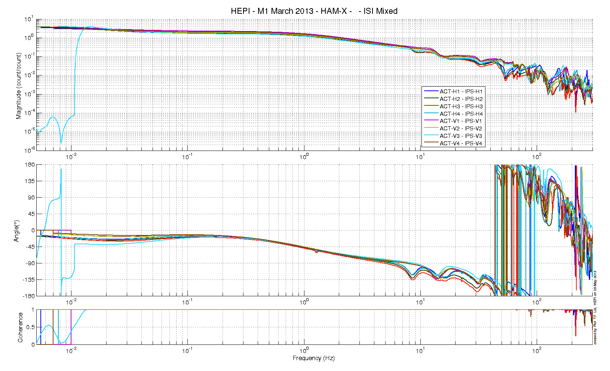

Issues/difficulties/comments regarding this test:

**Acceptance criteria:**

* On IPS, the phase must be 0º at DC
* On geophones, the phase must be 90º at DC
* Identical shape in each corner

**Test result: Passed: X Failed: .**

## Alignment offsets:

Those are the IPS readouts that were recorded with HEPI locked, after alignment work was performed. The opposite of those values is to be installed as offset of the IPS filter banks when the Isolation loops are turned on. This way, HEPI will be operating in its *preferred alignment* state.

|  |  |  |
| --- | --- | --- |
|  | IPS Readouts HEPI Locked | Offset Value |
| H1 | 1331.1 | -1331.1 |
| H2 | 957.72 | -957.72 |
| H3 | 2157.4 | -2157.4 |
| H4 | -1303.6 | 1303.6 |
| V1 | -2742.7 | 2742.7 |
| V2 | -511.83 | 511.83 |
| V3 | 1034 | -1034 |
| V4 | -2882.9 | 2882.9 |

**Acceptance criteria:**

Offsets were recorded.

**Test result: Passed: Failed: .**

Comments: The values right after alignment and Actuator attachment will shift as subsequent testing (everything else in this report) will settle and shift the platform at into a more stable and unstressed state.

The process should be, Align and attach the Actuator, run all the tests, disconnect the Actuator and recenter them. Confirm the alignment and then reattach the Actuators.