*LIGO Laboratory / LIGO Scientific Collaboration*

LIGO- E1300824 *LIGO* November 1st, 2013

**aLIGO HEPI Assembly Validation Procedure**

E1300824

Fabrice Matichard, Sebastien Biscans, Hugo Paris for the SEI Team

Distribution of this document:

Advanced LIGO Project

This is an internal working note

of the LIGO Laboratory

|  |  |
| --- | --- |
| **California Institute of Technology**  **LIGO Project – MS 18-34**  **1200 E. California Blvd.**  **Pasadena, CA 91125**  Phone (626) 395-2129  Fax (626) 304-9834  E-mail: info@ligo.caltech.edu | **Massachusetts Institute of Technology**  **LIGO Project – NW22-295**  **185 Albany St**  **Cambridge, MA 02139**  Phone (617) 253-4824  Fax (617) 253-7014  E-mail: info@ligo.mit.edu |
| **LIGO Hanford Observatory**  **P.O. Box 1970**  **Mail Stop S9-02**  **Richland WA 99352**  Phone 509-372-8106  Fax 509-372-8137 | **LIGO Livingston Observatory**  **P.O. Box 940**  **Livingston, LA 70754**  Phone 225-686-3100  Fax 225-686-7189 |

Contents

Sub-Components Testing 4

Assembly Validation 4

1.1 Load Cells assembly 4

1.2 Bellows 5

1.3 Boot Location 6

1.4 Check Stops Gaps 9

1.5 Gaps check 11

1.6 IPS Centering 14

1.7 Sensor ASD 14

1.8 SUS-watchdogs interaction test 15

1.9 Static Test local drive 16

1.10 Linearity Test/Range of motion in the local basis 18

1.11 Actuator Plate to Shields gap 19

1.12 Valve Check 20

1.13 Local-to-local measurements 21

1.14 Alignment offsets: 23

\

Introduction

This document summarizes the steps to be done to validate HEPI assemblies. Corresponding reports must be posted in :

LIGO-E1300454: aLIGO HEPI Testing Reports

# Sub-Components Testing

* Kaman Inductive Position Sensors: calibration, linearity, factory data, noise measurements (E0900426 – HEPI Kaman Sensor Receiving Analysis - Results posted in the SVN )
* HEPI actuator linearity test (E1100338 – aLIGO HEPI Actuators Test Results)
* L4C test (Q0900007)

# Assembly Validation

After installation along procedure Exxxxxx, and aligment along procedure Exxxxxx, and once HEPI is in final configuration (alignment completed).

## Load Cells assembly

* Spring attachment

For the BSC HEPI springs, check the assembly per D030324. See LLO aLOG 7162 for more details.

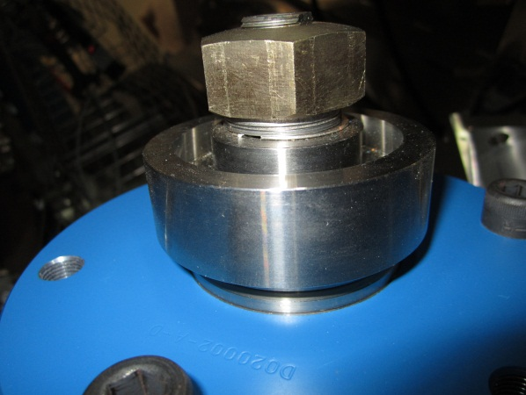

* Load cell values

BSC HEPI load cell capacity → 3000 lbs

HAM HEPI load cell capacity → 2000 lbs

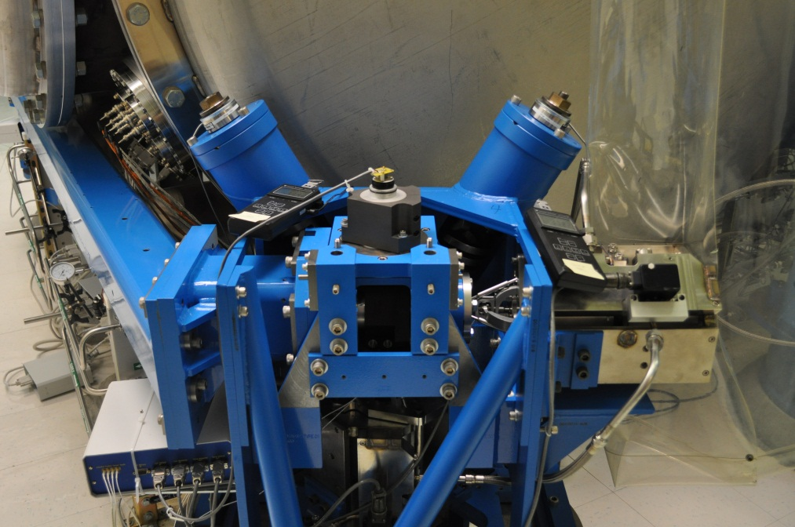

Left Spring

Right Spring

**HAM-HEPI example at LASTI**

|  |  |  |
| --- | --- | --- |
|  | **Left Spring (lbs)** | **Right Spring (lbs)** |
| **Pier 1** | 1347 | 949 |
| **Pier 2** | 1458 | 1631 |
| **Pier 3** | 1267 | 1157 |
| **Pier 4** | 1142 | 1722 |

**Acceptance criteria:**

* The values must not exceed 80% of the load cell capacity (2400lbs for BSC and 1600lbs for HAM).

**Test result: Passed: Failed: X .**

## Bellows

The bellows are hard to access and tests are hard to proceed. After several discussions and brainstorming sessions, it has been decided not to measure the gaps on HEPI-HAM and HEPI-BSC.

## Boot Location

**Tangential Left: 5.380”**

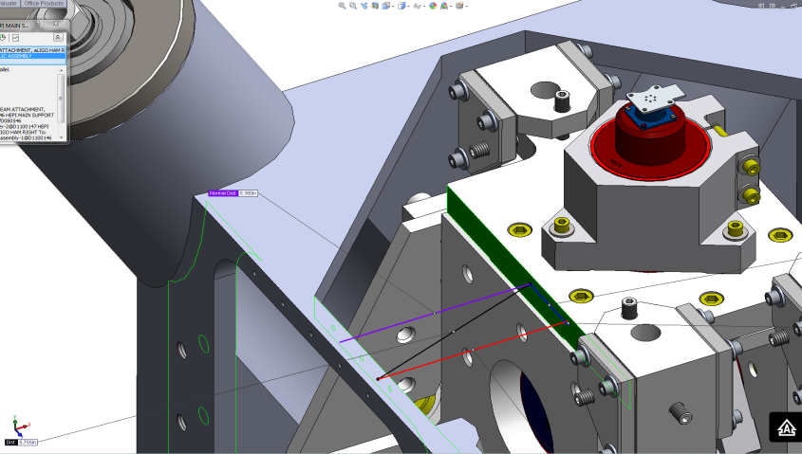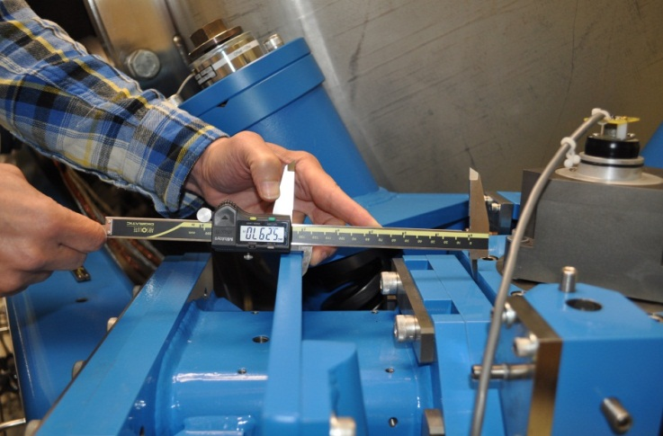

**Tangential Right: 5.380”**

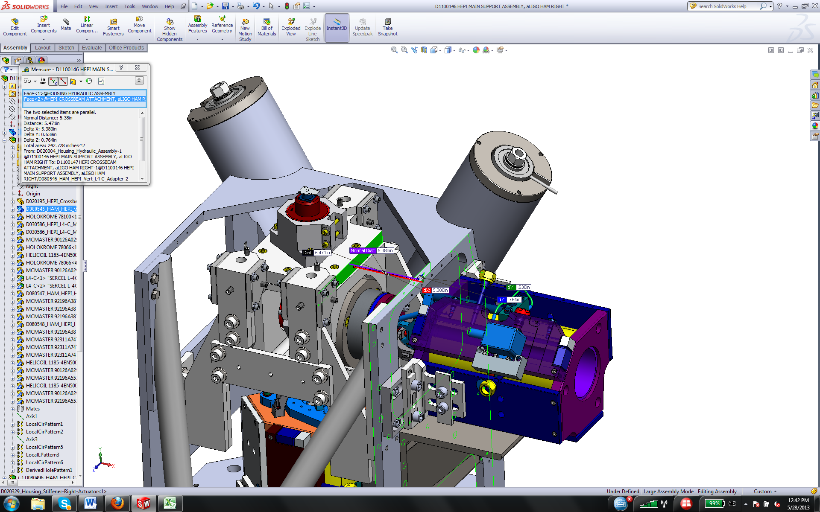 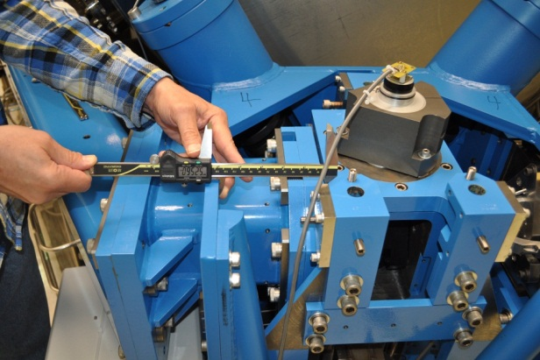

**Radial Back: 1.17”**

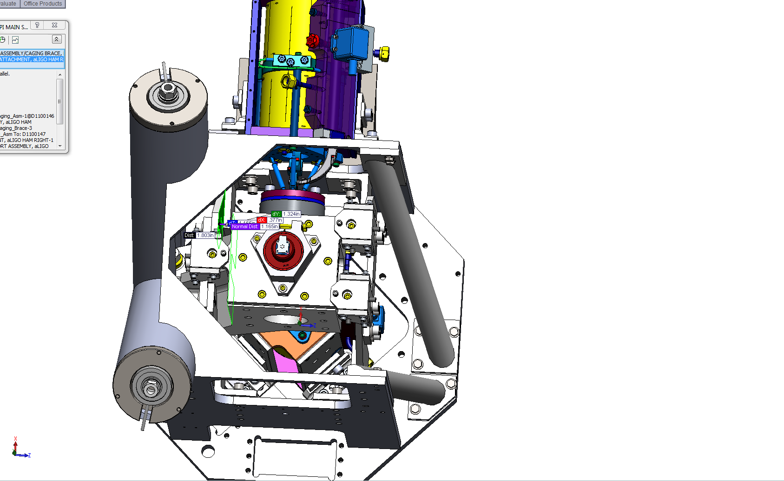 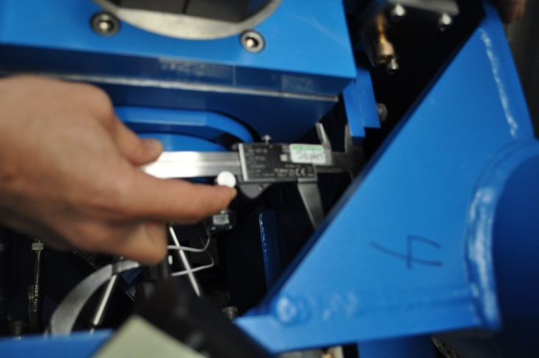

**Radial Front: 1.42”**

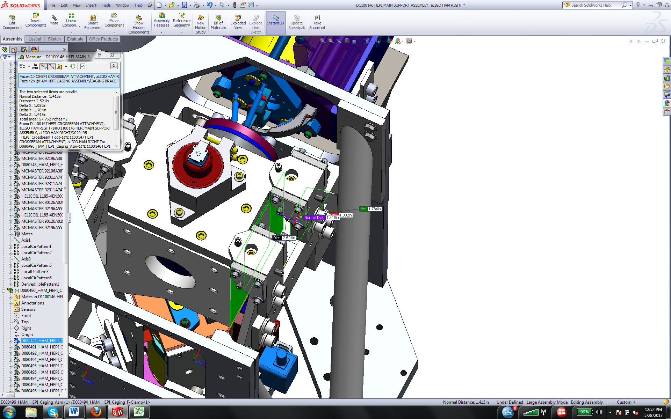 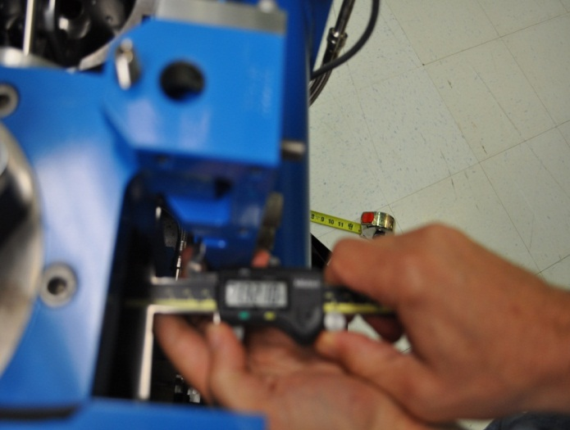

**Vertical: 0.32”**

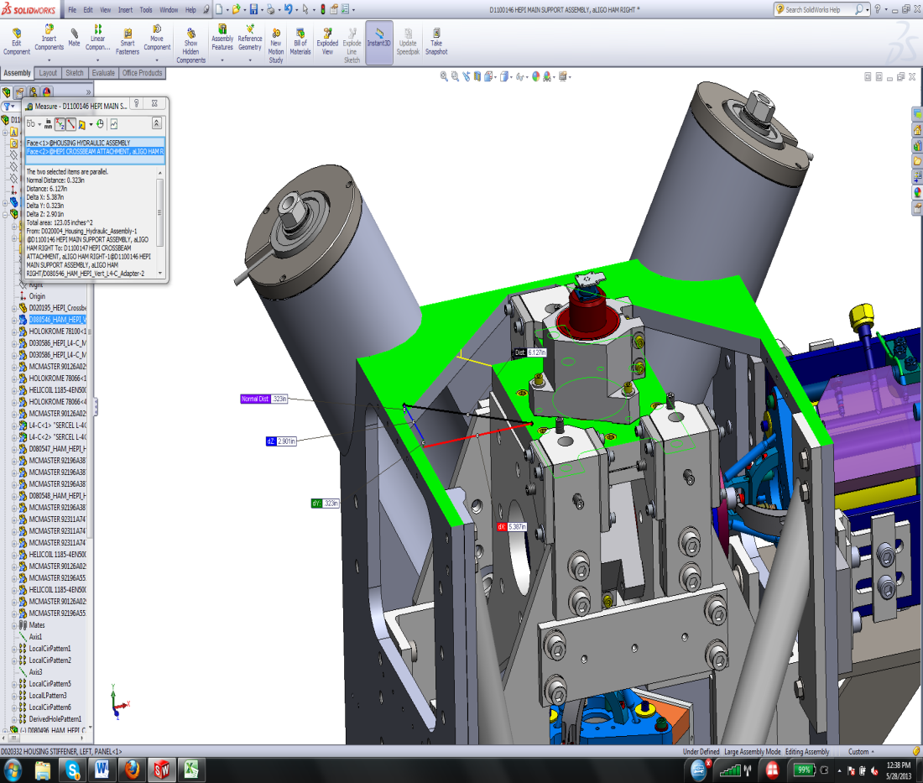 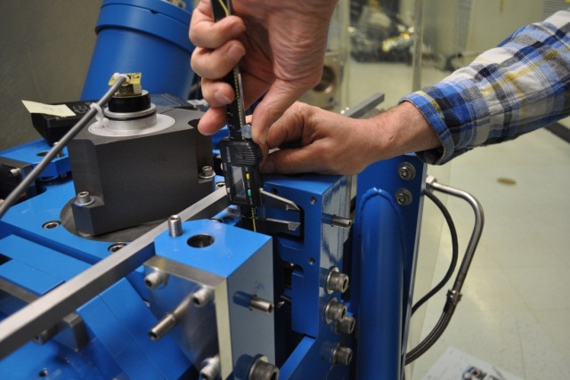





**Acceptance criteria:**



**Test result: Passed: X Failed: .**

## Check Stops Gaps

The stops must not touch the boot. There is 15 stops per boot, 5 per F bracket.

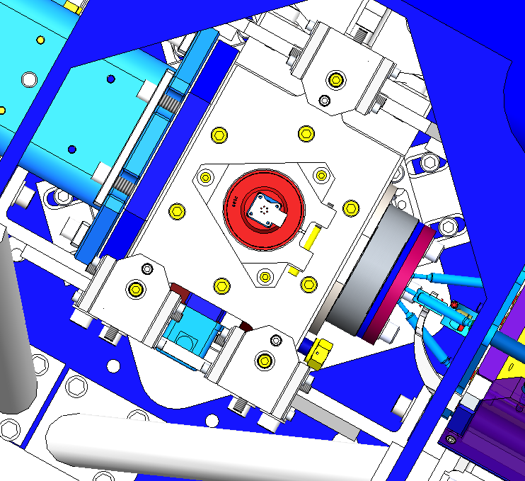

**#1**

**#2**

**#3**

**#4**

**#5**

**Bracket 1**

**Bracket 2**

**Bracket 3**

**Acceptance criteria:**

* A 0.062” shim must fit into the gaps

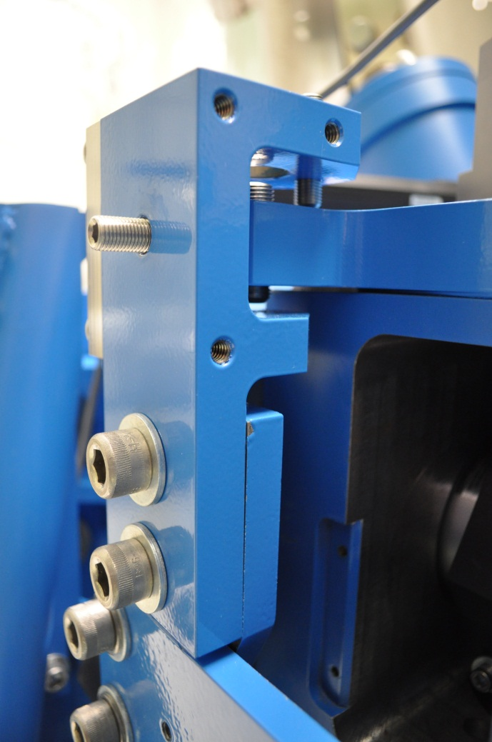

A 0.062” must fit into the gaps

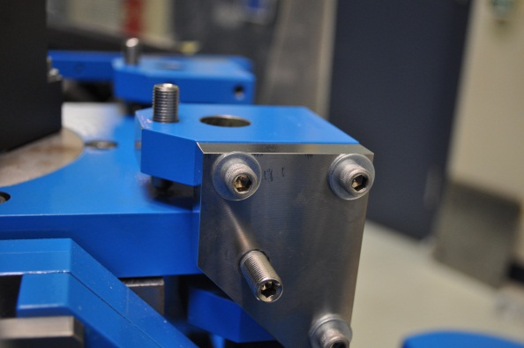

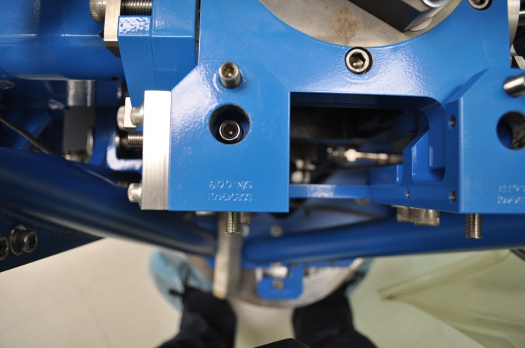

|  |  |  |  |  |  |  |  |  |  |  |  |  |  |  |  |  |  |  |
| --- | --- | --- | --- | --- | --- | --- | --- | --- | --- | --- | --- | --- | --- | --- | --- | --- | --- | --- |
|  | **Bracket 1** | | | | | | **Bracket 2** | | | | | | **Bracket 3** | | | | | |
|  | **Gap1** | **Gap2** | **Gap3** | **Gap4 above** | **Gap4 under** | **Gap5** | **Gap1** | **Gap2** | **Gap3** | **Gap4 above** | **Gap4 under** | **Gap5** | **Gap1** | **Gap2** | **Gap3** | **Gap4 above** | **Gap4 under** | **Gap5** |
| **Pier 1** | Go | Go | Go | Go | Go | Go | Go | Go | Go | Go | Go | Go | Go | Go | Go | Go | Go | Go |
| **Pier 2** | Go | Go | Go | Go | Go | Go | Go | Go | Go | Go | Go | Go | Go | Go | Go | Go | Go | Go |
| **Pier 3** | Go | Go | Go | Go | Go | Go | Go | Go | Go | Go | Go | Go | Go | Go | Go | Go | Go | Go |
| **Pier 4** | Go | Go | Go | Go | Go | Go | Go | Go | Go | Go | Go | Go | Go | Go | Go | Go | Go | Go |

**Test result: Passed: X Failed:**

## Gaps check

Four particular gaps need to be check.

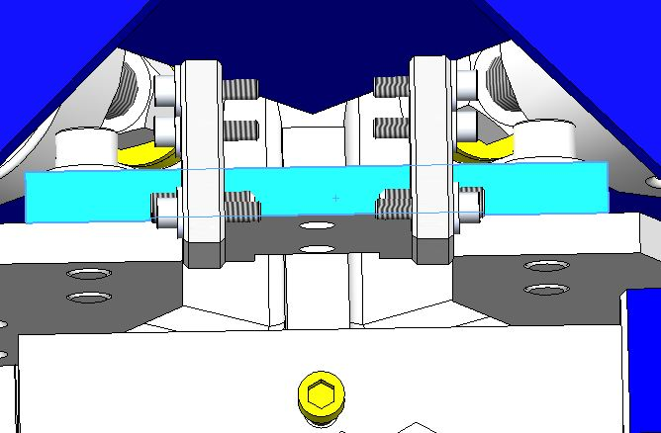

Gap #1

Gap #2

**The F bracket has been removed for a better visibility**

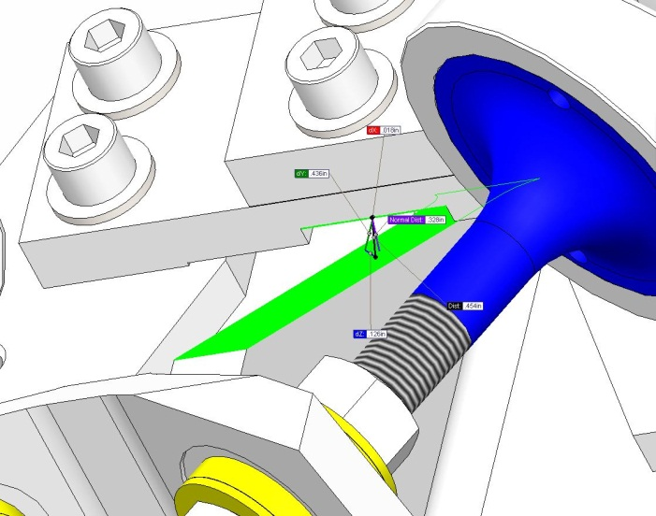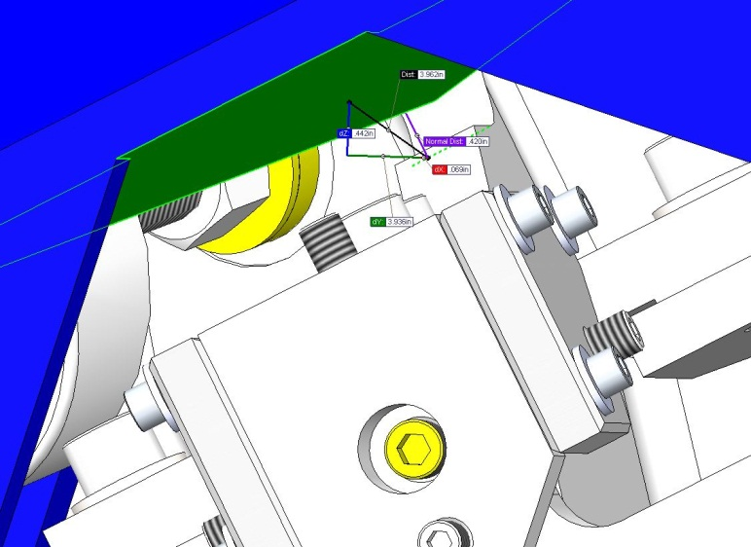

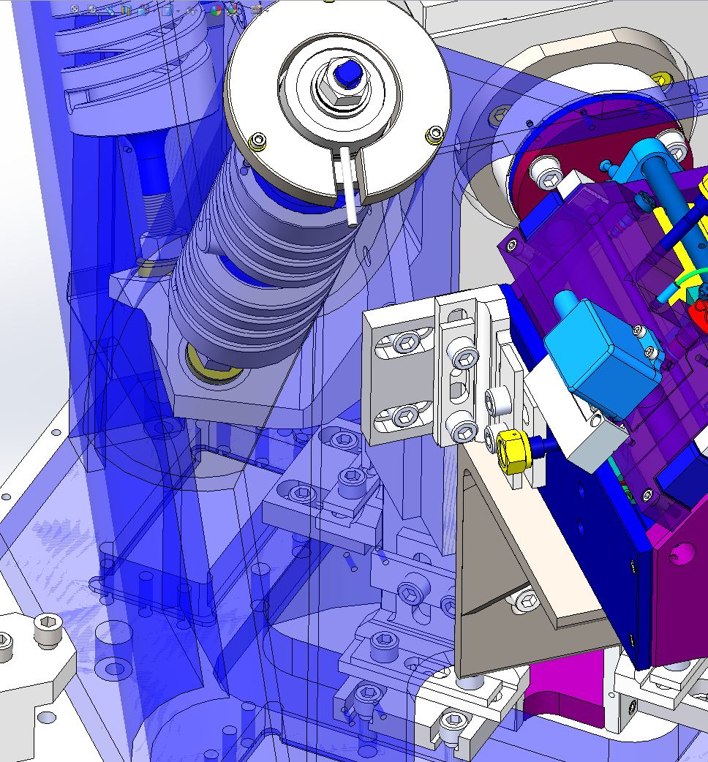

Gap #3

Gap #4

**Acceptance criteria:**

* a 0.08” shim must fit in these two gaps

Issues/difficulties/comments regarding this test: Gap#1 is tricky to reach. At LASTI, the solution found was to tape the shim to an extension (rod, rigid ruler, etc.).

Gap#2 should be reachable by hand.

Gap#3 and 4 are tricky, but should also be doable (no picture)

**Gap#1**

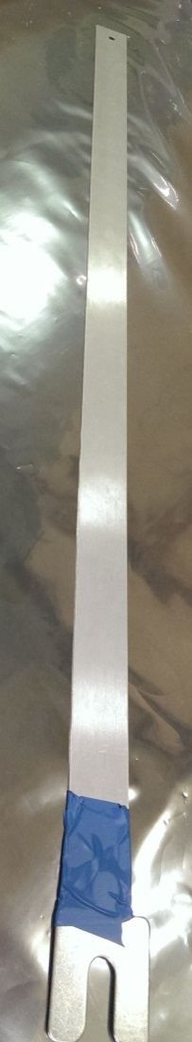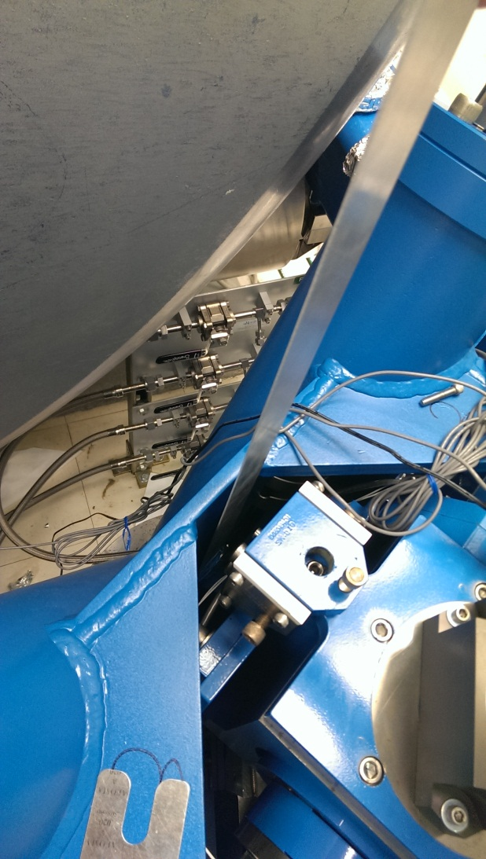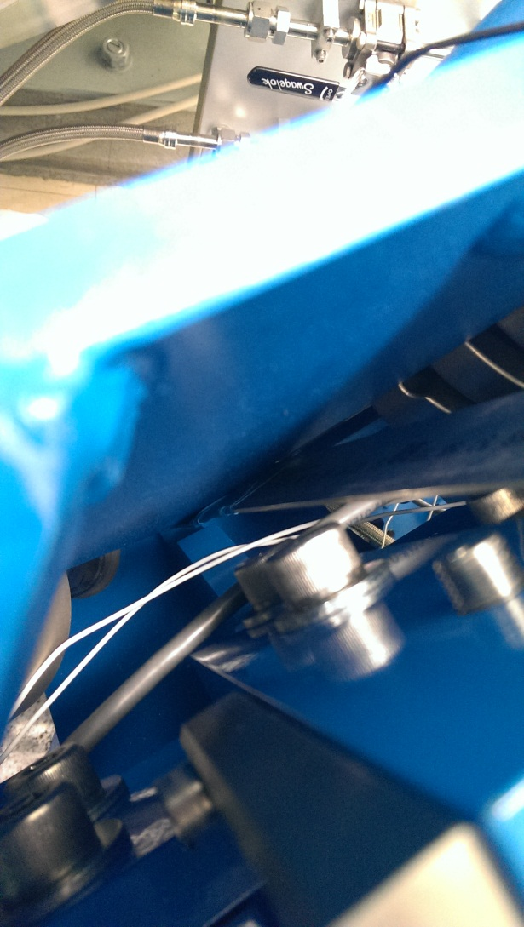

**Gap#2**

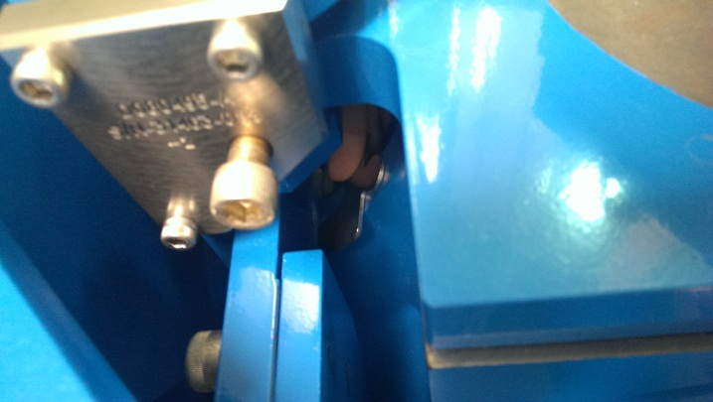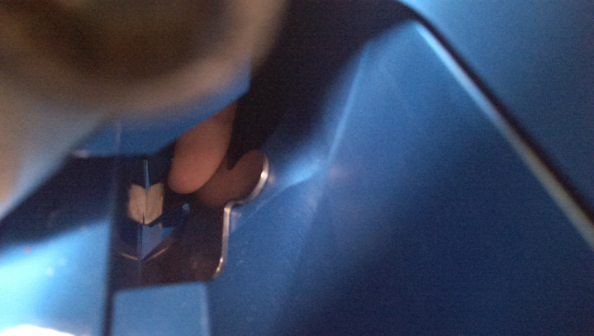

|  |  |  |  |  |
| --- | --- | --- | --- | --- |
|  | **Gap#1** | **Gap#2** | **Gap#3** | **Gap#4** |
| **Pier 1** | Go | Go | Go | Go |
| **Pier 2** | Go | Go | Go | Go |
| **Pier 3** | Go | Go | Go | Go |
| **Pier 4** | Go | Go | Go | Go |

**Test result: Passed: X Failed: .**

## IPS Centering

**Scripts files for processing and plotting in SVN at:**

/SeiSVN/seismic/HEPI/Common/Testing_Functions_HEPI/Offset_STD_IPS_HEPI.m

All the loops must be turned off during this test.

|  |  |  |  |  |  |  |  |  |
| --- | --- | --- | --- | --- | --- | --- | --- | --- |
|  | H1 | H2 | H3 | H4 | V1 | V2 | V3 | V4 |
| Mean (counts) |  |  |  |  |  |  |  |  |
| Acceptance | +/- 15000 | +/- 15000 | +/- 15000 | +/- 15000 | +/- 15000 | +/- 15000 | +/- 15000 | +/- 15000 |

**Test result: Passed: X Failed:**

## Sensor ASD

**Scripts files for processing and plotting in SVN at:**

/SeiSVN/seismic/HEPI/Common/Testing_Functions_HEPI/ASD_Measurements_Local_HEPI.m

**Data in SVN at:**

SeiSVN/seismic/HEPI/M1/HAMX/Data/Spectra/Undamped/

M1_HPI_HAMX_ASD_m_IPS_L4C_2013_06_03_120859.mat

**Figures in SVN at:**

/SeiSVN/seismic/HEPI/M1/HAMX/Data/Figures/Spectra/Undamped

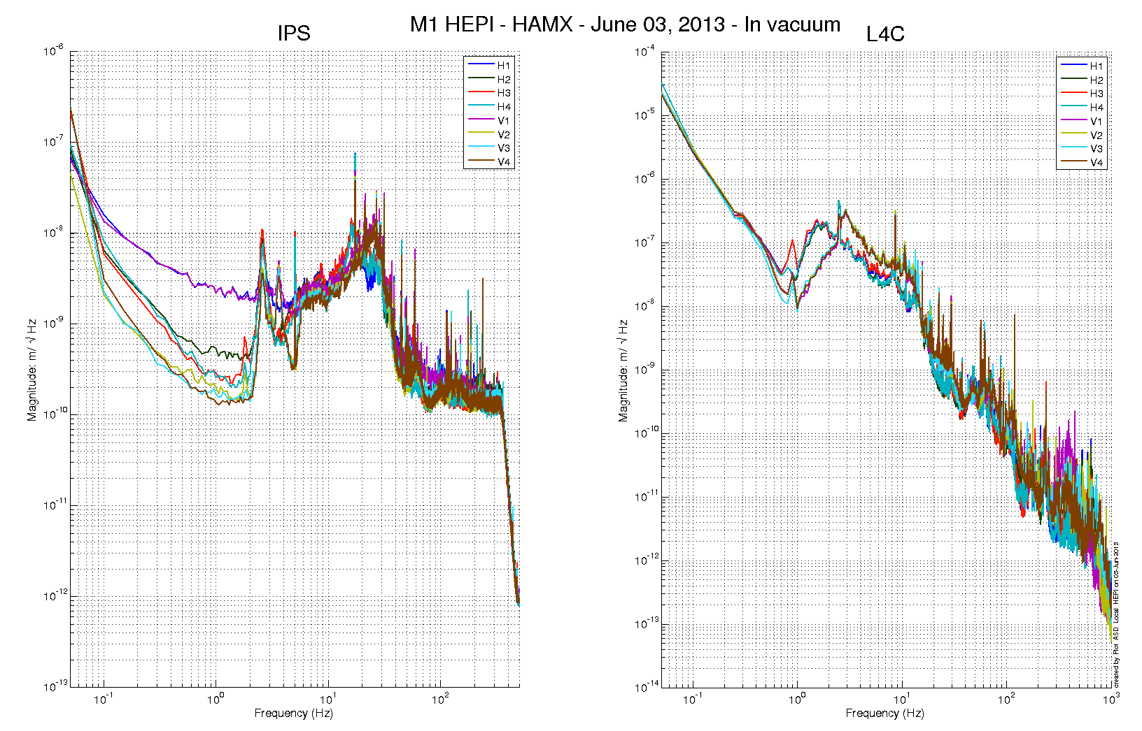

Issues/difficulties/comments regarding this test:

Measurements were performed with all PreFilters ON.

**Acceptance criteria:**

**Test result: Passed: Failed: .**

## SUS-watchdogs interaction test

**This test will be obsolete very soon, as the payload-HEPI WD connection is planned for removal.**

. Set up a zero value on the payload watchogs.

. Check that the payload watchdog screen of HEPI tripped.

. In the payload watchdog screen, click on the OVERRIDE button and reset the watchdog.

. Do the same process for all the payloads

**Acceptance criteria:**

* The HEPI must trip when the payload watchdogs are tripped
* The HEPI watchdogs could be reset when the OVERRIDE button is ON

**Test result: Passed: X Failed: .**

When this test is done, reset everything (OVERRIDE button OFF, put back the value on the payload watchdog).

## Static Test local drive

**Scripts files for processing in SVN at:**

/SeiSVN/seismic/HEPI/Common/Testing_Functions_HEPI/Static_Test_Local_Basis_HEPI.m

. ***Drive of 100 counts (in progress)***

|  |  |  |  |  |  |  |  |  |
| --- | --- | --- | --- | --- | --- | --- | --- | --- |
|  | H1 | H2 | H3 | H4 | V1 | V2 | V3 | V4 |
| H1 | 8350.9418 | -5056.1049 | -327.0384 | -1879.51872 | -178.9088 | 209.3388 | 192.18836 | -370.0864 |
| H2 | -4104.049 | 8306.5349 | -1822.531974 | -448.11792 | 134.8916 | -100.465 | -301.80668 | 139.7868 |
| H3 | -233.5984 | -2065.5751 | 8170.4572 | -4615.56692 | 178.7694 | -183.7838 | -239.1095 | 118.1154 |
| H4 | -1807.7793 | -701.3897 | -4558.2268 | 9000.50088 | -488.2914 | 367.591 | -1.00976 | -441.0128 |
| V1 | -87.0864 | 1.56718 | 302.0506 | -174.51156 | 7490.8344 | 918.82254 | -1656.35338 | 784.3534 |
| V2 | 182.2748 | -404.56522 | -128.0876 | 486.57564 | 833.8752 | 7402.042 | 675.00182 | -1629.1482 |
| V3 | 309.8688 | -477.33554 | -80.087 | 272.82164 | -1436.731 | 1099.12212 | 7236.42762 | 695.124 |
| V4 | -177.839 | 74.78868 | 291.7698 | -126.46464 | 955.694 | -1414.8926 | 824.44686 | 7487.4108 |

*Table - Main couplings and cross couplings*

. ***Drive of 1000 counts (in progress)***

|  |  |  |  |  |  |  |  |  |
| --- | --- | --- | --- | --- | --- | --- | --- | --- |
|  | H1 | H2 | H3 | H4 | V1 | V2 | V3 | V4 |
| H1 | 8350.9418 | -5056.1049 | -327.0384 | -1879.51872 | -178.9088 | 209.3388 | 192.18836 | -370.0864 |
| H2 | -4104.049 | 8306.5349 | -1822.531974 | -448.11792 | 134.8916 | -100.465 | -301.80668 | 139.7868 |
| H3 | -233.5984 | -2065.5751 | 8170.4572 | -4615.56692 | 178.7694 | -183.7838 | -239.1095 | 118.1154 |
| H4 | -1807.7793 | -701.3897 | -4558.2268 | 9000.50088 | -488.2914 | 367.591 | -1.00976 | -441.0128 |
| V1 | -87.0864 | 1.56718 | 302.0506 | -174.51156 | 7490.8344 | 918.82254 | -1656.35338 | 784.3534 |
| V2 | 182.2748 | -404.56522 | -128.0876 | 486.57564 | 833.8752 | 7402.042 | 675.00182 | -1629.1482 |
| V3 | 309.8688 | -477.33554 | -80.087 | 272.82164 | -1436.731 | 1099.12212 | 7236.42762 | 695.124 |
| V4 | -177.839 | 74.78868 | 291.7698 | -126.46464 | 955.694 | -1414.8926 | 824.44686 | 7487.4108 |

*Table - Main couplings and cross couplings*

. ***Drive of 5000 counts (Nominal value handled by testing script)***

|  |  |  |  |  |  |  |  |  |
| --- | --- | --- | --- | --- | --- | --- | --- | --- |
|  | H1 | H2 | H3 | H4 | V1 | V2 | V3 | V4 |
| H1 | 8350.9418 | -5056.1049 | -327.0384 | -1879.51872 | -178.9088 | 209.3388 | 192.18836 | -370.0864 |
| H2 | -4104.049 | 8306.5349 | -1822.531974 | -448.11792 | 134.8916 | -100.465 | -301.80668 | 139.7868 |
| H3 | -233.5984 | -2065.5751 | 8170.4572 | -4615.56692 | 178.7694 | -183.7838 | -239.1095 | 118.1154 |
| H4 | -1807.7793 | -701.3897 | -4558.2268 | 9000.50088 | -488.2914 | 367.591 | -1.00976 | -441.0128 |
| V1 | -87.0864 | 1.56718 | 302.0506 | -174.51156 | 7490.8344 | 918.82254 | -1656.35338 | 784.3534 |
| V2 | 182.2748 | -404.56522 | -128.0876 | 486.57564 | 833.8752 | 7402.042 | 675.00182 | -1629.1482 |
| V3 | 309.8688 | -477.33554 | -80.087 | 272.82164 | -1436.731 | 1099.12212 | 7236.42762 | 695.124 |
| V4 | -177.839 | 74.78868 | 291.7698 | -126.46464 | 955.694 | -1414.8926 | 824.44686 | 7487.4108 |

*Table - Main couplings and cross couplings*

Issues/difficulties encountered during this test:

**Acceptance criteria:**

* The results in these three tables must be the same (within xxx%)

**Test result: Passed: Failed: .**

## Linearity Test/Range of motion in the local basis

**Scripts files for processing and plotting in SVN at:**

/SeiSVN/seismic/HEPI/Common/Testing_Functions_HEPI/Linearity_Test_Awgstream_HEPI.m

**Data in SVN at:**

SeiSVN/seismic/HEPI/M1/HAMX/Data/Spectra/Undamped/

M1_ISI_HAMX_ASD_m_CPS_T240_L4C_GS13_Locked_vs_Unlocked_2012_02_07.mat

**Figures in SVN at:**

/SeiSVN/seismic/HEPI/M1/HAMX/Data/Figures/Spectra/Undamped

|  |  |  |
| --- | --- | --- |
|  | Slopes | Offsets |
| H1 | 1.63 | 1800.40 |
| H2 | 1.88 | -522.55 |
| H3 | 1.63 | 1959.94 |
| H4 | 1.76 | -177.98 |
| V1 | 1.54 | -4082.29 |
| V2 | 1.54 | -1558.79 |
| V3 | 1.42 | -516.54 |
| V4 | 1.56 | -5144.56 |

Issues/difficulties encountered during this test:

**Acceptance criteria:**

**Test result: Passed: X Failed: .**

## Actuator Plate to Shields gap

**Perform this test ONLY if the range of motion test failed.**

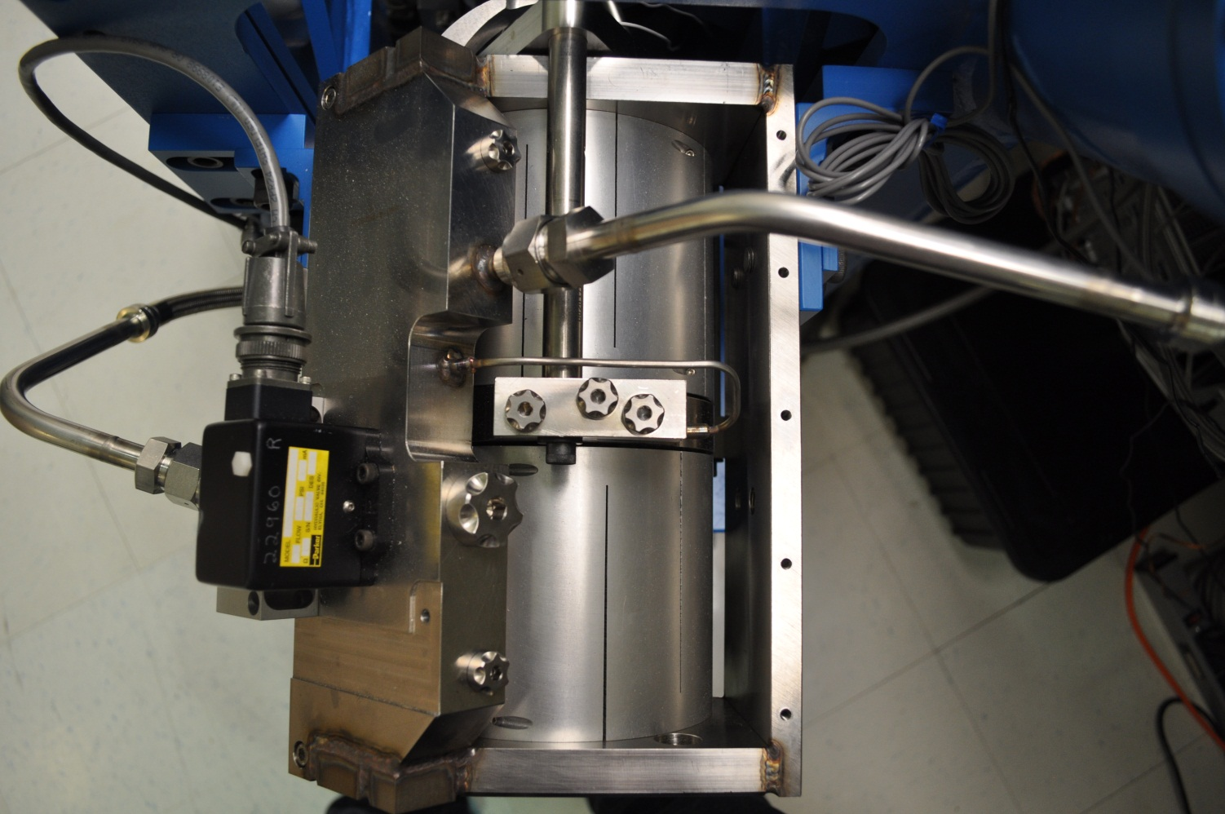

Gap#3

Gap#2

Gap#1

Three gaps per actuator need to be checked.

**Acceptance criteria:**

* A 0.1” shim must fit into the gap #1
* A 0.05 shim must fit into gap #2 and #3

|  |  |  |  |  |  |  |
| --- | --- | --- | --- | --- | --- | --- |
|  | **Horizontal** | | | **Vertical** | | |
|  | **Gap #1** | **Gap #2** | **Gap #3** | **Gap #1** | **Gap #2** | **Gap #3** |
| **Pier 1** | Go | Go | Go | Go | Go | Go |
| **Pier 2** | Go | Go | Go | Go | Go | Go |
| **Pier 3** | Go | Go | Go | Go | Go | Go |
| **Pier 4** | Go | Go | Go | Go | Go | Go |

**Test result: Passed: X Failed:**

## Valve Check

**Scripts files for processing and plotting in SVN at:**

/SeiSVN/seismic/HEPI/M1/HAMX/Scripts/Valve_Check/plot_valve_check.m

**Data in SVN at:**

SeiSVN/seismic/HEPI/M1/HAMX/Data/Spectra/Undamped/

/SeiSVN/seismic/HEPI/M1/HAMX/Scripts/Valve_Check

**Figures in SVN at:**

/SeiSVN/seismic/HEPI/M1/HAMX/Scripts/Valve_Check

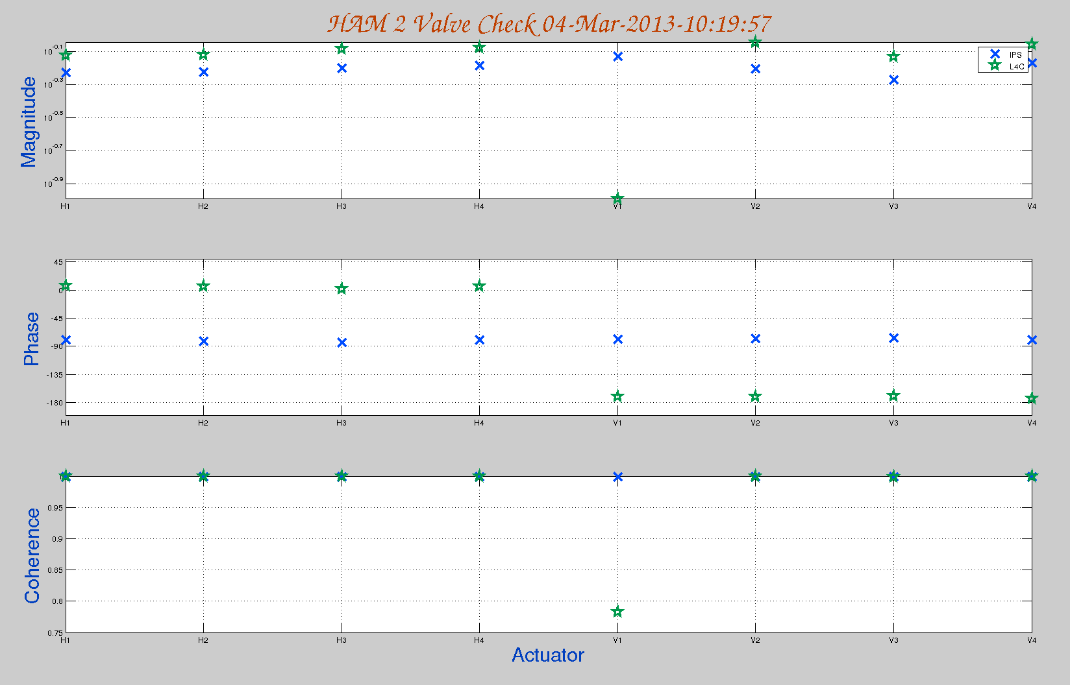

**Acceptance criteria:**

**Test result: Passed: Failed: .**

## Local-to-local measurements

|  |  |  |  |  |  |  |
| --- | --- | --- | --- | --- | --- | --- |
| **Band (Hz)** | **Resolution** | **Amplitude** | **Nreps** | **Time (s)** | **Time (min)** | **Time (h)** |
| **100 - 500** | 0.5 | 4000 - 4000 | 250 | 4176 | 69.6 | 1.2 |
| **10 - 100** | 0.25 | 4000 - 4000 | 200 | 6592 | 109.9 | 1.8 |
| **0.7 - 10** | 0.05 | 4000 - 4000 | 75 | 12320 | 205.3 | 3.4 |
| **0.1 - 0.7** | 0.025 | 4000 - 4000 | 30 | 10080 | 168.0 | 2.8 |
| **0.01 - 0.1** | 0.01 | 4000 - 4000 | 10 | 8960 | 149.3 | 2.5 |
| **0.002 - 0.01** | 0.002 | 4000 - 4000 | 2 | 12160 | 202.7 | 3.4 |
|  |  |  |  |  |  | **15.1** |

**Data files in SVN at:**

/SeiSVN/seismic/HEPI/M1/HAMX/Data/Transfer_Functions/Measurements/Undamped/

* M1_HPI_HAMX_Data_TF_L2L_200Hz_1000Hz_20120201-174407.mat
* M1_HPI_HAMX_Data_TF_L2L_5Hz_200Hz_20120201-183140.mat
* M1_HPI_HAMX_Data_TF_L2L_500mHz_5Hz_20120201-191513.mat
* M1_HPI_HAMX_Data_TF_L2L_100mHz_500mHz_20120201-202848.mat
* M1_HPI_HAMX_Data_TF_L2L_10mHz_100mHz_20120201-212025.mat

**Data collection script files:**

/SeiSVN/seismic/HEPI/Common//Transfer_Function_Scripts/

* Run_TF_L2L_10mHz_100mHz.m
* Run_TF_L2L_100mHz_500mHz.m
* Run_TF_L2L_500mHz_5Hz.m
* Run_TF_L2L_5Hz_100Hz.m
* Run_TF_L2L_100Hz_1000Hz.m

**Scripts files for processing and plotting in SVN at:**

/SeiSVN/seismic/HEPI/M1/HAMX/Scripts/Control_Scripts/release/

* Step_1_TF_Loc_to_Loc_M1_HEPI_HAMX.m

**Figures in SVN at:**

/SeiSVN/seismic/HEPI/M1/HAMX/Data/ Figures/Transfer_Functions/Measurements/Undamped/

* M1_HPI_Unit_1_TF_L2L_Raw_from_ACT_to_CPS_2012_02_02_With_3_Washers_Under_Top_Mass.fig
* M1_HPI_Unit_1_TF_L2L_Raw_from_ACT_to_GS13_2012_02_02_With_3_Washers_Under_Top_Mass.fig

**Storage of measured transfer functions in the SVN at:**

/SeiSVN/seismic/HEPI/M1/HAMX/Data/Transfer_functions/ Simulations/Undamped/

* M1_HPI_Unit_1_TF_L2L_Raw_2012_02_02_With_3_Washers_Under_Top_Mass.mat

The local-to-local transfer functions are presented below.

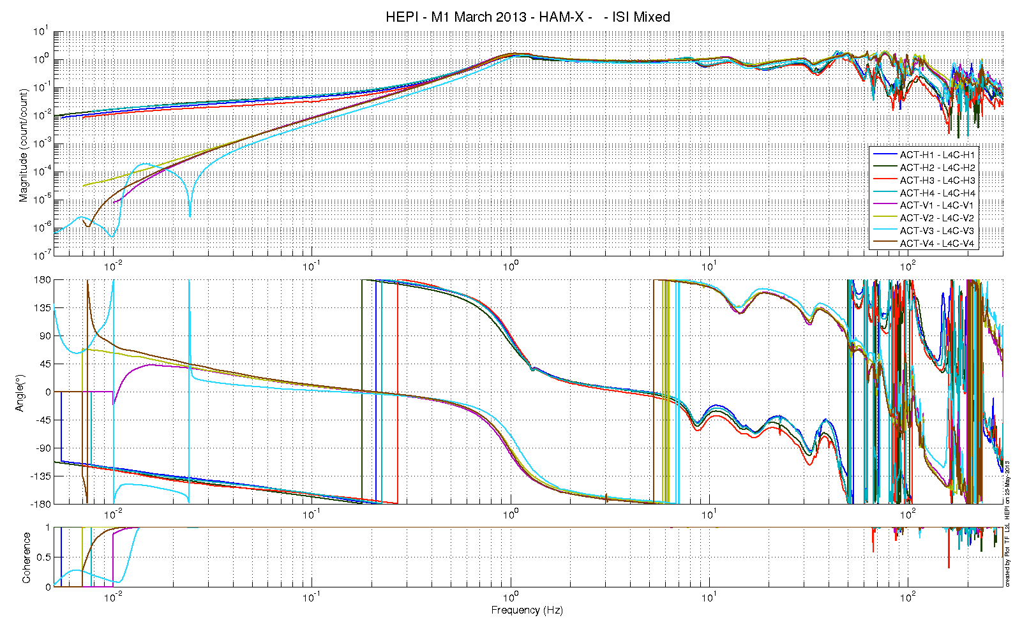

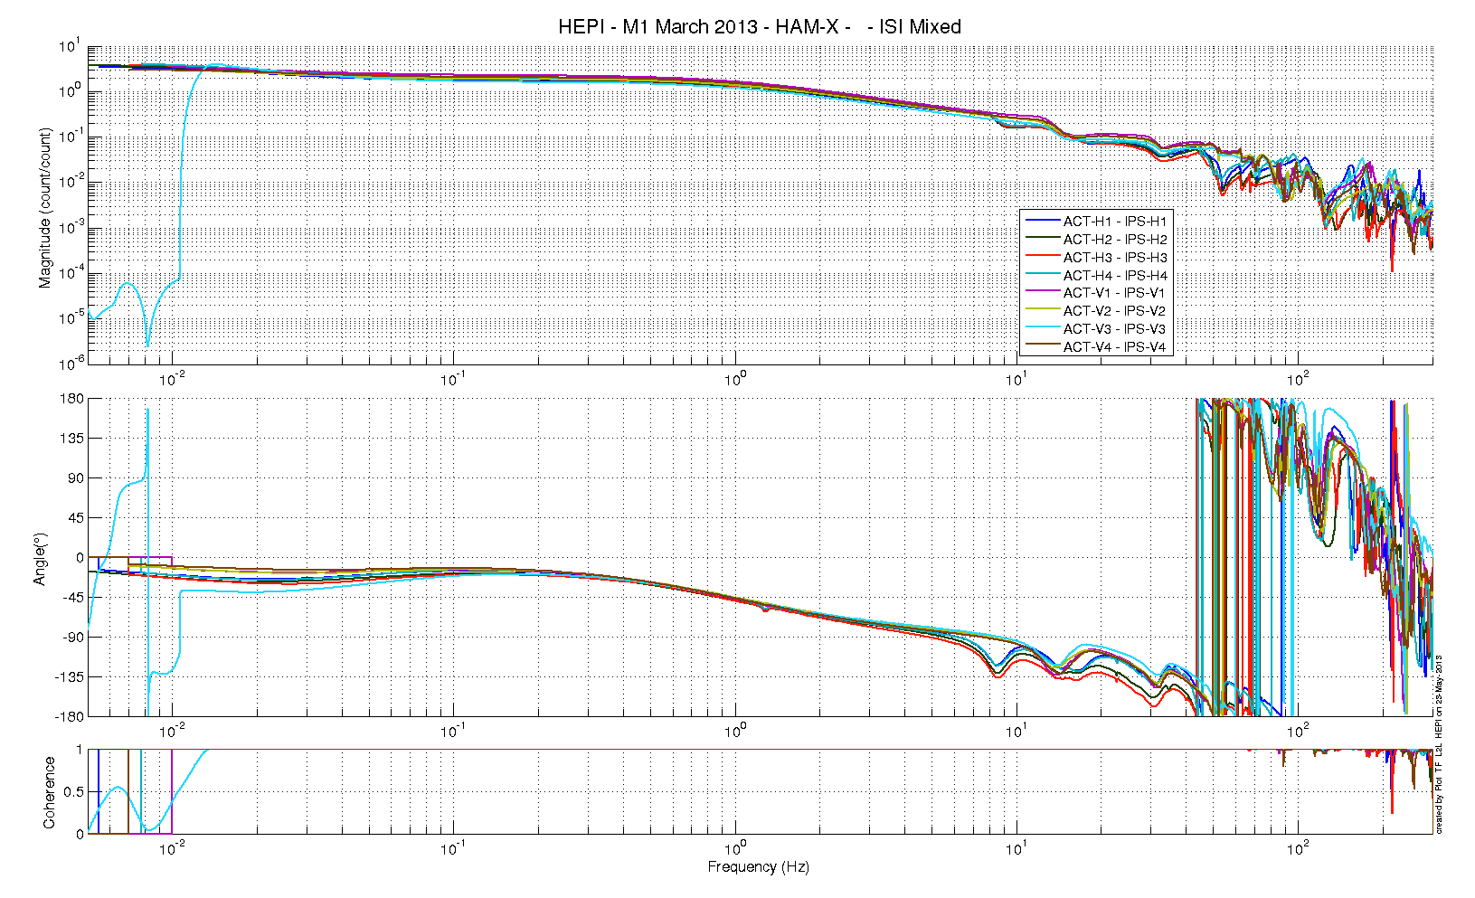

Issues/difficulties/comments regarding this test:

**Acceptance criteria:**

* On IPS, the phase must be 0º at DC
* On geophones, the phase must be 90º at DC
* Identical shape in each corner

**Test result: Passed: X Failed: .**

## Alignment offsets:

Those are the IPS readouts that were recorded with HEPI locked, after alignment work was performed. The opposite of those values is to be installed as offset of the IPS filter banks when the Isolation loops are turned on. This way, HEPI will be operating in its *preferred alignment* state.

|  |  |  |
| --- | --- | --- |
|  | IPS Readouts HEPI Locked | Offset Value |
| H1 | 1331.1 | -1331.1 |
| H2 | 957.72 | -957.72 |
| H3 | 2157.4 | -2157.4 |
| H4 | -1303.6 | 1303.6 |
| V1 | -2742.7 | 2742.7 |
| V2 | -511.83 | 511.83 |
| V3 | 1034 | -1034 |
| V4 | -2882.9 | 2882.9 |
|  |  |  |
|  |  |  |

**Acceptance criteria:**

Offsets were recorded.

**Test result: Passed: Failed: .**