LASER INTERFEROMETER GRAVITATIONAL WAVE OBSERVATORY
CALIFORNIA INSTITUTE OF TECHNOLOGY
MASSACHUSETTS INSTITUTE OF TECHNOLOGY
Laser SOP LIGO-M1300500-v1 10 September 2013
Temporary SOP for LLO Arm Length Stabilization Assembly

Submitted By:
Bram Slagmolen

LIGO Hanford Observatory LIGO Livingston Observatory
P.O. Box 159 19100 LIGO Lane
Richland, WA 99352 Livingston, LA 70754
Phone (509) 372-8106 Phone (225) 686-3100
Fax (509) 372-8137 Fax (225) 686-7189
E-mail: info@ligo.caltech.edu E-mail: info@ligo.caltech.edu

California Institute of Technology Massachusetts Institute of Technology
LIGO Project – MS 18-34 LIGO Project – NW22-295
Pasadena, CA 91125 185 Albany St. Cambridge, MA 01239
Phone (626) 395-2129 Phone (617) 253-4824
Fax (626) 304-9834 Fax (617) 253-7014
E-mail: info@ligo.caltech.edu E-mail: info@ligo.mit.edu

APPROVAL SIGNATURES

Bram Slagmolen, Author Date

David Kinzel, LLO Laser Safety Officer, Author Date

Richard Oram, Operations Manager Date

Joe Giaime, LLO Head Date

Peter King, LIGO Laser Safety Officer Date

David Nolting, LIGO Safety Coordinator Date

Contents
PREFACE 4
1. INTRODUCTION 4
2 HAZARDS 9
2.1 Nominal Hazard Zone 9
3. CONTROLS 10
3.1 Access and Administrative Controls 10
3.2 Physical Controls: Exposure Control 10
3.3 Physical Controls: Electrical Controls 11
3.4 Eye Protection 11
4. OPERATING PROCEDURES 12
4.1 Responsible Laser Operator 12
4.2 Laser Startup Sequence 13
4.3 Operational of the Prometheus 50NE 14
4.4 Laser Shutdown Procedure 15
5. TRAINING 15
6. RESPONSIBILITIES 16
7. References 17

PREFACE
Table of Documentation Hierarchy

Tier 1 = M950046 (LIGO Laboratory System Safety Plan)
Tier 2 = M960001 (LIGO Laser Safety Program)
Tier 3 = M1000228 (LLO Laser Safety Plan) (Site-specific)
Tier 4 = Site-specific, laser-specific SOPs, FMEAs, and special procedures
Tier 5 = Operating, user, or other technical manuals from the manufacturer
Tier 6 = Wiki entries instructing operators "how-to".

This document is for individuals who require basic knowledge about this laser equipment. It is not a substitute for operating manuals or for one-on-one training. Standard operating procedures (SOPs) are site-specific and equipment-specific documents that fall under the jurisdiction of the site laser safety officer. Candidate laser operators must read and understand all site-specific laser safety plans as well as laser-specific SOPs. Candidate laser operators must understand that reading this documentation is necessary, but does not automatically qualify personnel to work on this laser equipment. Neither does it clear anyone to operate identical hardware at any other LIGO location.

1. INTRODUCTION
This document is the Standard Operating Procedure governing the operation of the ISC Arm Length Stabilization laser at LLO during the initial setup in the LVEA North. This SOP is designed to ensure the safety of all personnel and equipment in and around the experiment while it is operating. Its role falls within the overall laser safety plan is described in LIGO-M960001, LIGO Laser Safety Plan.

The Arm Length Stabilization Assembly area is use to assemble the ISCTEX (ISCTB4L) and ISCTEY (ISCTB5R) laser tables (figure 1), which are to be installed in the respective VEA in the end-stations. The 8ft x 4ft ISCTEX/EY optical tables have a standard aluminum enclosure with HEPA filter, and two access doors. On the optics tables, within the enclosures is an InnoLight Prometheus laser, which emits 1W at 1064nm and 50mW at 532nm.
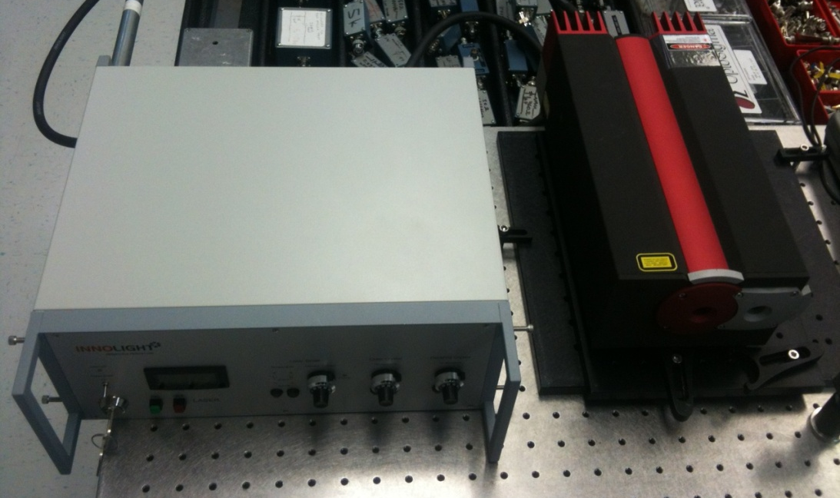
Laser Controller
Laser Head
Figure 1. Prometheus 50NE laser controller and head.
The Arm Length Stabilization Assembly area will be defined by temporary portable laser barriers. The Nominal Hazard Zone is coincidental with the with the laser barriers. (See Figure 1 and Figure 2)
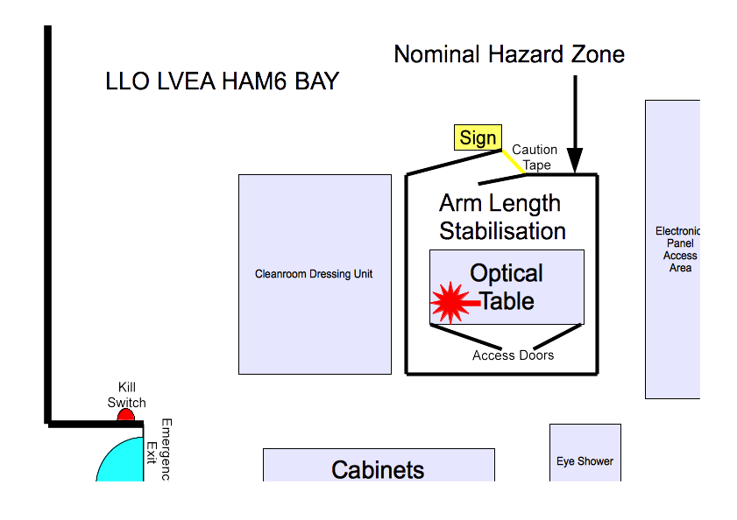
Figure 1 – The Arm Length Stabilization Assembly area – The NHZ is defined by the laser barrier surrounding the 8ft x 4ft optics table.
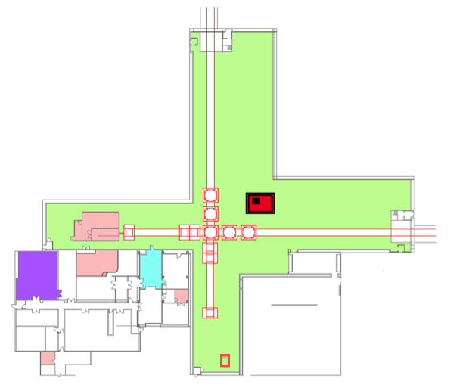
The ALS NHZ
Figure 2 - The Arm Length Stabilization Assembly area is surrounded by a laser barrier located in the corner station’s LVEA. This area is the nominal hazard zone (NHZ) pointed out above.

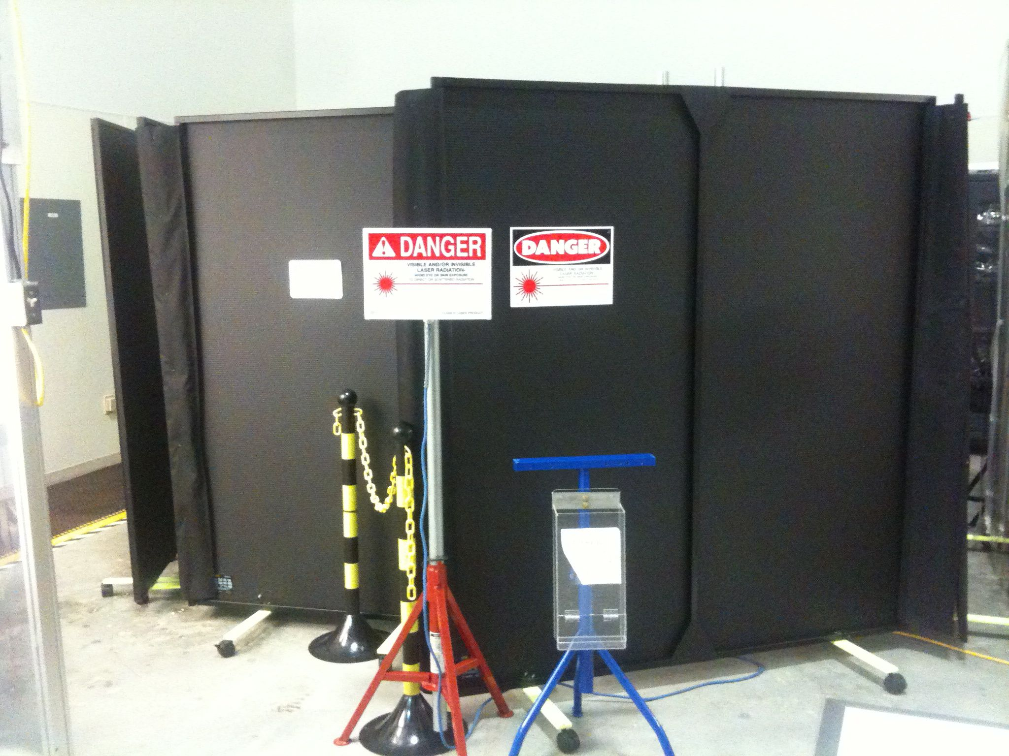
Laser Barrier Curtain

Laser Barrier Curtain Door

Laser Safety Light
Laser Safety Sign
Laser Safety Goggles holder
Figure 3 – The Arm Length Stabilization Assembly area – The NHZ
The laser OFF Button is located on the front of the control unit.
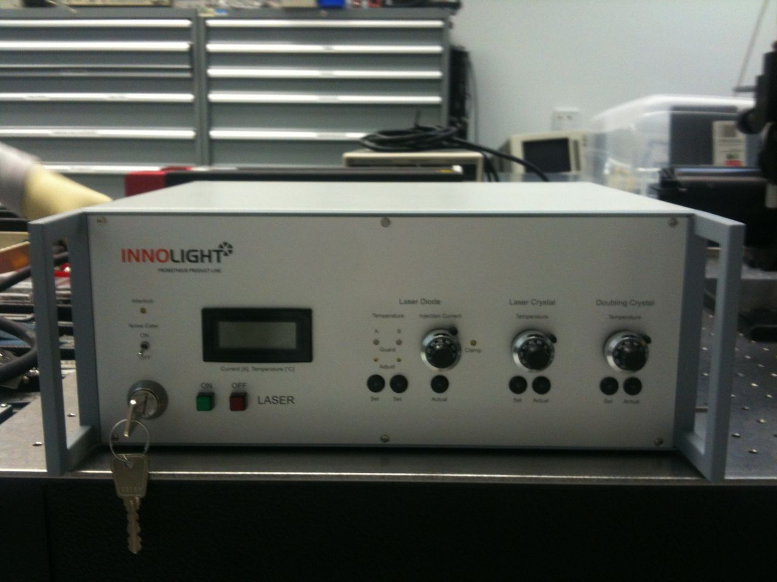
ON Button
OFF Button
Display
Key operated Master Switch
Laser Diode Current control knob
Laser Diode ‘Actual’ button
Figure 5 – Prometheus Laser Controller with the key operated Master switch and the ON and OFF buttons.
The optical parameters for the Prometheus 50NE are listed in Table 1.
Table 1: Laser parameters.
Description | Value/Designation – 1064nm | Value/Designation – 532nm
Laser Type | Nd:YAG | Doulbed Nd:YAG
Class | 4 | 3B
Emission center wavelength | 1064nm | 532nm
Emission repetition rate | Continuous Wave | Continuous Wave
Emission waist (minimum radius) | <100um | <100um
Waist location | Within the laser head | Within the laser head
Beam divergence | >6.8 mrad | >3.4 mrad
Output polarization | Vertical | Vertical
Maximum power output | 1.2 W Maximum | 50mW Maximum
Interlocked | No | No
Authorized locations | LVEA ALS Assembly Area, VEA | LVEA ALS Assembly Area, VEA

The Operator’s Manual for the Prometheus 50NE lasers is T1000643.

2 HAZARDS
- The Prometheus laser emits simultaneously and continuously both 532nm and 1064nm wavelength during operations.
- Class 3B lasers are hazards to the eye via direct exposure and/or specular reflection. The 532 nm light benefits some from being visible and thus more easily detected by the human eye, triggering an aversion response.
- Class 4 lasers are hazards to the eye via direct exposure, specular reflection, and potentially diffuse reflection.
- Class 4 lasers are also capable of burning skin and causing fires if not properly controlled and dumped. The 1064 nm light poses an additional hazard as it is infrared and not visible to the unaided human eye.

2.1 Nominal Hazard Zone
The nominal hazard zone (NHZ) for the Prometheus 50NE is considered to be the enclosed and partitioned region behind the laser curtain barriers that surround the temporary laser curtain barrier (see Figure 2, Figure 3 and Figure 4).

3. CONTROLS

3.1 Access and Administrative Controls
Access to the Prometheus 50NE in the Arm Length Stabilization Assembly Area is controlled to ensure site personnel safety. Access to the area restricted to qualified laser operators. These individuals gain access to the NHZ by observing the need-to-access property of this NHZ. The laser barrier and its entrance must be “chained off” while the lab is under “laser hazard” conditions (see Figure 3).

People who are not qualified laser operators must be escorted by qualified laser operators at all times. Any authorized person escorting unauthorized personnel inside the NHZ (entire Lab) shall assume responsibility for compliance with all governing laboratory laser safety procedures as well as the safety of the escorted person.

All operations in the Arm Length Stabilization Assembly Area must be follow LIGO work permit procedures.
Laser operation outside of normal business hours must conform to LIGO-M1100264, (Guidelines for Work at a LIGO Observatory).
A lighted warning sign is located at the Arm Length Stabilization Assembly Area (the NHZ) entrance and indicates either a “Laser Hazard” or “Laser Safe” condition (see Figure 3).
Laser warning signs are displayed attached to the laser curtain barriers that surround the NHZ.
Improperly dressed individuals are not permitted inside the Arm Length Stabilization Assembly Area. When working on the optics table, the person needs to follow the dress code as if it was the optics lab (a frog in addition to the LVEA dress code).

3.2 Physical Controls: Exposure Control
The laser table has a full aluminium enclosure on top to mitigate dust and acoustic coupling during installed operation. This enclosure also acts as a laser barrier. Beam dumps are provided to terminate unused beams or mitigate scattered light.
A 7-foot tall, latching laser curtain barrier blocks off the NHZ to the rest of the LVEA.
The key will be removed when the laser is unattended. There will be a lock-out tag-out attached to the 120VAC plug on the laser chassis when the laser is unattended.
Access to the NHZ is blocked by a plastic yellow chain, supported by two black and yellow posts.

3.3 Physical Controls: Electrical Controls
All control and monitoring functions for the Prometheus 50NE are accessed at the laser controller, located on top of the table enclosure.

In an emergency the red OFF Button is pressed. This button is located at the front of the laser controller (see Figure 5).

3.4 Eye Protection
All personnel working in the Arm Length Stabilization Assembly NHZ, while the Prometheus 50NE laser is capable of being or is energized, will wear protective laser safety eyewear whose optical density includes that which is specified in Table 2.
Table 2: Laser safety eyewear minimum optical density (OD) for the Prometheus 50NE.
Wavelength (nm) | Minimum O.D. | Beam parameters (estimate)
1064 | 2.9 | 1.2 W
532 | 2.1 | 50 mW

- Required protective eyewear for the Prometheus 50NE must have an optical density (OD) of greater than 2.9 or higher for 1064 nm wavelength radiation and 2.1 or higher for 532 nm wavelength radiation.

- A sign posting the appropriate optical density and wavelength for the required laser safety eyewear is posted near the entrance.

- Proper eyewear is shelved near the entry door to the Lab.

- The laser safety eyewear is never intended for intra-beam viewing.

- Laser safety eye wear is to be worn any time the laser is capable of running.

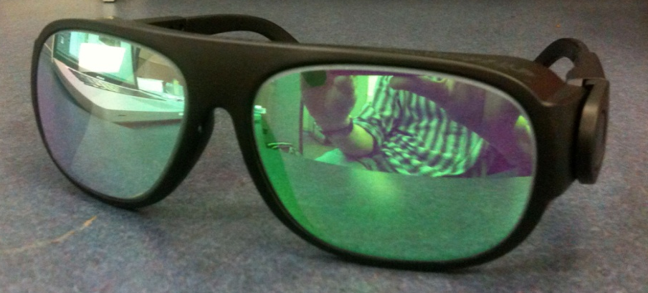
List with optical density per wavelength
Figure 4 – Example of dual wavelength laser safety glasses used when operating the Prometheus 50NE. OD 7+ @532nm and OD 5+ @1064nm.

4. OPERATING PROCEDURES

4.1 Responsible Laser Operator
Only qualified laser operators are permitted to activate the Prometheus 50NE.
The Responsible Laser Operator (RLO) is the qualified laser operator who is designated to coordinate tasks within the Arm Length Stabilization Assembly Area. The RLO informs the on-duty control room operator when work is about to be started and when it is completed. A work permit is required and must be filed before any work begins. The RLO is named on the work permit.
Access to the Arm Length Stabilization Assembly Area NHZ is handled by a need-to-access regime. Others wanting access to the Arm Length Stabilization Assembly NHZ must contact the RLO before they enter the area.
The RLO is responsible for managing the laser hazard state of the Arm Length Stabilization Assembly Area. The laser hazard condition sign must be transitioned from “laser safe” to “laser hazard” before the Prometheus 50NE is capable of operating. The laser warning sign must be energized and all persons entering the NHZ are required to wear eye protection as described in 3.4 Eye Protection above, before entering and at all times while working within the NHZ.

Prior to powering up the laser, the Responsible Laser Operator shall ensure that all persons in the NHZ are aware of the intent to power up the laser and that they are in compliance with all laser safety requirements, eye protection in particular.

The RLO shall also coordinate activities on or in the vicinity of the laser optical table. Multiple independent activities involving manipulation of the laser beams shall occur simultaneously only when the RLO deems it safe to do so.

NOTE: If multiple laser systems are to be operated simultaneously in proximity, all of the RLOs for each contingent laser system must agree that it is safe to have multiple systems running. All eyewear must be compatible for all concurrently running lasers. When in doubt, consult the Laser Safety Officer.

4.2 Laser Startup Sequence
The following is a list of general guidelines.
The Arm Length Stabilization Assembly NHZ must transition to laser-hazard status. When the Arm Length Stabilization Assembly NHZ is in a safe condition, the key may not be re-inserted until the NHZ has completed the transition to laser hazard – the transition must take place before the hazard exists.

- Prior transitioning to laser hazard, an announcement over the PA is made stating ‘Temporary ALS Hazard Area – is in transition to hazard’ (by the on duty operator of the RLO). The laser warning sign will be energized, caution chain put across the entrance, and all persons entering the NHZ are required to wear protective eye wear as described in section 3.4 above.

- At this point an announcement over the PA is made stating ‘Temporary ALS Hazard Area is in Laser Hazard’ as well as an alog entry is made (by the on duty operator of the RLO). After this, the laser in can be energized (power plugged in).

- Prior to powering up the laser, the Responsible Laser Operator (RLO, the person actively in charge of the laser) shall ensure that all persons in the NHZ are aware of his/her intent to power up the laser and that they are in compliance with all laser safety requirements, eye protection in particular.

- When work is required in the ALS NHZ, the RLO is the person who activates the laser(s). If they are already activated on entering, those present should decide who will assume the role of RLO. The RLO shall coordinate activities on or in the vicinity of the laser optical table. Multiple independent activities involving manipulation of the laser beams shall only occur simultaneously when the RLO deems it safe to do so.

- On conclusion of work with the lasers active, the table itself will either be fully enclosed or the lasers deactivated. The lasers will not be allowed to run uncovered and unattended. A lock out tag out box will be attached to the unplugged, laser supply cord when the table is left unattended. All eyewear must be compatible for all laser systems running concurrently. When in doubt, check with the Laser Safety Officer. When multiple lasers are being used, the governing SOP must consider safety compatibility.

- Any times the laser beams will be manipulated, e.g. by inserting, removing or adjusting optical components, persons not directly participating in the beam manipulation activity will move to a safe location until the activity is completed.

- Before and during insertion or removal of any optical component, the power of all affected laser beams shall be reduced to the lowest working power setting or be blocked upstream by an appropriate device, such as a ceramic wand.

- All persons manipulating the laser beams, e.g. by placing objects such as mirrors, lenses, power meters, or beam dumps into or near the laser paths, must remove all jewelry such as wrist watches and rings.

- Immediately after inserting, removing, or making significant adjustments to any optical component, the optical table shall be scanned with a thermal imaging camera to ensure that all stray beams are dumped.

- Scattering of laser light shall be kept to a minimum at all times by maintaining proper alignment of optics, utilization of beam dumps, and ensuring that optics are securely fastened.

- If a laser beam with power in excess of 2 mW is found (reported by any observer) leaving the optics table, the laser will be shut down by the LSO and will remain OFF, until start up authorization is received.

NOTE: By policy, if a laser beam with power in excess of 2 mW is found (reported by any observer), leaving the optics table, the laser will be shut down by the LSO and will remain “OFF” until start-up authorization is received.
NOTE: It is the responsibility of each person working within the Laser Nominal Hazard Zone (NHZ) to ensure that LIGO standards for safe laser operation are being followed at all times

4.3 Operational of the Prometheus 50NE
The following steps are taken to power up the Prometheus 50NE laser for nominal use on the Laser Controller.
  - Inform the operator and make an alog entry

  - The laser power plug is removed from the logout box, and plugged into the mains.

  - Turn the key-switch to the right.

  - Press the green ON button

  - Press the set button of the ‘Laser Diode’ to display the diode drive current.

  - Turn the ‘Injection Current’ knob to the right until the display show 1.1 A.

  - Proceed to Section 4.4 for laser shutdown.

4.4 Laser Shutdown Procedure
Only qualified laser operators are permitted to deactivate the Prometheus 50NE in a controlled manner. (Any person may deactivate the laser in an emergency.)
The Arm Length Stabilization Assembly Area “hazard-to-safe” transition protocol is as follows:
- Turn the ‘Injection Current’ knob to the left, until the display shows 0.0 A.
- Press the red OFF button.
- Turn the key-switch to the left.
- Lock-out the laser power plug into the logout box.
- Unplug (turn off) the light on the portable warning sign outside the Arm Length Stabilization Assembly Area NHZ.
- Inform the operator of the transition to laser safe and make an alog entry.
- The transition is complete. The Arm Length Stabilization Assembly Area is now laser-safe.

5. TRAINING
LIGO basic laser safety training must be completed before any individual can work around any class 3B and/or class 4 laser emission.
Access to the Silica Fiber Welding Machine is only on an “as needed” basis for qualified laser operators. To become a qualified laser operator, an individual must complete the following requirements.
- Received LIGO basic laser safety training
- Have a full understanding of this SOP and its associated FMEA
- Understand emergency and safety procedures
- Received authorization from the LIGO Livingston laser safety officer
NOTE: Training on any specific laser system does not automatically qualify individuals for other lasers at the LIGO facilities and associated university labs.

6. RESPONSIBILITIES
- Each person working with the Arm Length Stabilization Assembly is responsible for ensuring that safe laser practices are being followed at all times.
- The responsible laser operator is responsible for the conducting tasks on a specific laser system in accordance with the prescribed control measures and in compliance with the specific SOP for that laser.
- The responsible laser operator is responsible for informing any and all assisting personnel regarding the control measures and SOP for the specific laser system.
- The responsible laser operator shall be responsible for any communications with other site personnel regarding changes in the operational status of the specific laser system.
- In case of safety incidents, contact the immediate personnel and (if necessary) emergency medical services as soon as possible.
- Any identified flaws in procedures or potential improvements that could enhance safety should be brought to the attention of the LLO Laser Safety Officer or cognizant laser personnel.

7. References
- American National Standard for Safe Use of Lasers, ANSI Z136.1-2007
Laser Institute of America, ISBN 0-912035-65-X
- LIGO-M950046 (LIGO Laboratory System Safety Plan)
- LIGO-M960001 (LIGO Laser Safety Program)
- LIGO-M1000228 (LLO Laser Safety Plan)
- LIGO-M0900241 (Laser Safety Training for Certification and Recertification of LIGO Personnel)
- LIGO-M080368 (LLO NHZ Transition Procedures)
- LIGO-M1100264 (Guidelines for Work at a LIGO Observatory)
- LIGO-G0901007 (LIGO Basic Laser Safety Training Presentation)
- LIGO-G1000017 (LLO Addendum to Basic Laser Safety Training)
- LIGO-E13xxxxx (Hazard Analysis for ISCTEX and ISCTEY End-Station Laser tables)

