LIGO Laboratory / LIGO Scientific Collaboration

LIGO-T1300642-v1 LIGO 7/24/13

Sapphire Prism Bond Tests: Results

G. Billingsley, J. Lewis, N. Robertson, C. Torrie

Distribution of this document:
LIGO Scientific Collaboration

This is an internal working note
of the LIGO Laboratory.

California Institute of Technology  LIGO Project – MS 18-34  1200 E. California Blvd.  Pasadena, CA 91125  Phone (626) 395-2129  Fax (626) 304-9834  E-mail: info@ligo.caltech.edu | Massachusetts Institute of Technology  LIGO Project – NW22-295  185 Albany St  Cambridge, MA 02139  Phone (617) 253-4824  Fax (617) 253-7014  E-mail: info@ligo.mit.edu
LIGO Hanford Observatory  P.O. Box 159  Richland WA 99352  Phone 509-372-8106  Fax 509-372-8137 | LIGO Livingston Observatory  P.O. Box 940  Livingston, LA 70754  Phone 225-686-3100  Fax 225-686-7189
http://www.ligo.caltech.edu/

Introduction
Several bond configurations were tested as candidate replacements for the sapphire silica bond that induced fracture in a fused silica penultimate mass. Background is documented in aLIGO bug 195.

Description of Bonds
EP30-2 epoxy was prepared and proofed per LIGO-T1300322-v3. All bonds were done in one session, with the borosilicate glass spheres being added for the final four bonds on prisms 3, 4 and 5.

Prism # | 1-Control Same as current PUM | 2 | 3 | 4 | 5
Prism Material | Sapphire | Sapphire | Sapphire | Sapphire | Sapphire
First bond | EP30 | EP30 | EP30 plus 125 µm spheres | EP30 plus 125 µm spheres | EP30 plus 125 µm spheres
10 mm diam. spacer | -- | 1 mm thick  fused silica | 1 mm thick  fused silica | 1 mm thick  fused silica | 0.5 mm thick  fused silica
Second bond | -- | EP30 | EP30 plus 125 µm spheres | EP30 | EP30
Substrate:  IBS coated fused silica  232 mm diam. x 12.8 mm thick | fused silica | fused silica | fused silica | fused silica | fused silica

Gluing was finished 15:13, 7-10-2013. This was followed by a room temperature cure of approx. 17 hours to 8.15 am the next day, and then by 34 C° bake. Total 34 C° bake is estimated at roughly 22 hours, ending 6:45 am 7-12-2013: Curing Ramp started 8:15 am 7-11-2013. The controller on the oven was found to stop controlling after reaching 34 C°. This was attempted several times. A final, manual, bake was accomplished beginning ~4:30 pm, 7-11 and ending ~6:45 am, 7-12. It is doubtful that the oven ever returned to room temperature during the day on 7-11 as we were messing with it most of the day.

Oven Ramp Testing
We carried out a series of observations throughout the day on 12th July, increasing the temperature of the oven after each observation.
The plate was taken from the oven. We set the controller temperature to 48 deg C and waited for oven temp. to stabilize. At around 8.45 am, when plate temperature was ~ 24.5 deg C (on thermocouple attached to plate) it was placed into oven. We waited an hour by which time thermocouple read 44.8 deg C and removed it from oven and took pictures. All pictures were taken from the other side of the silica disc from the prisms, looking at the base of the prism. We continued this process as follows.
Controller temp set to 58 deg C one hour bake, plate temp. 53.9 deg C, pictures.
Controller temp set to 78 deg C, one hour bake, plate temp. reached 71.8 deg C, pictures.
Controller temp set to 93.1 deg C, one hour bake, plate temp. reached 86.1 deg C, pictures.
Controller temp set to 108 deg C, one hour bake, plate temp. reached 100.5 deg C, pictures.
Controller temp set to 123 deg C, one hour bake, plate temp. apparently reached 119.4 deg C. However when we removed the plate on this occasion we found that thermocouple had come off plate, so we cannot say exactly what temp. the plate itself reached. Took pictures.
From now on we used the thermocouple inside the oven as a measure of the temp. of the plate, noting from our previous measurements that the actual plate would be of order 10 degrees less than the oven temp.
Controller temp set to 138 deg C, one hour bake, internal temp. reached 135.8 deg C, pictures.
Controller temp set to 158 deg C, one hour bake, internal temp. reached 155.9 deg C, pictures.
After this set of pictures the oven was switched off. No cracks appeared at any time. We also note that we exceeded the quoted upper working temperature of the glue in the final hour. That temperature is 300 deg F or 149 deg C. For completeness we include a set of pictures as an example, those taken after the 100 deg C bake. Column one shows temperature and prisms 1 and 2. Column 2 shows prism 3,4 and 5.
On Sat. 13th July at approx. 9.10 am we put the plate (left out overnight) into the oven at 158 deg C. We left it for approx. 3 hours, took it out and took pictures. No cracks. We then put it back into the oven for the rest of the weekend.
The fused silica plate was finally removed from the oven 7-15-2013 at 7:40 am. The oven thermocouple read 151 C°. All exposed bonds had a golden brown color, as did the proof dish, which had baked with the plate over the weekend. After cooling, the plate was doused with acetone in an attempt to begin prism removal, the acetone had evaporated within 30 minutes.

Heat Gun Testing
The goal of the heat gun testing was to suddenly heat the sapphire prism in hopes of inducing a stress fracture in the fused silica plate.
The gun was pre-heated for roughly one minute before each test. The gun was aimed directly at the sapphire prism for a total time of two minutes. A household fan was then directed at the prism side of the plate to cool the prism and plate.

Fifty millimeter distance
Each prism was heated for two minutes. At the end of two minutes the temperature was recorded by reading thermocouples that had been placed at two places.
Air: hanging in air, touching the fused silica plate near the base of the sapphire prism.
Prism: tucked underneath the prism in the gap provided next to the fused silica spacer.

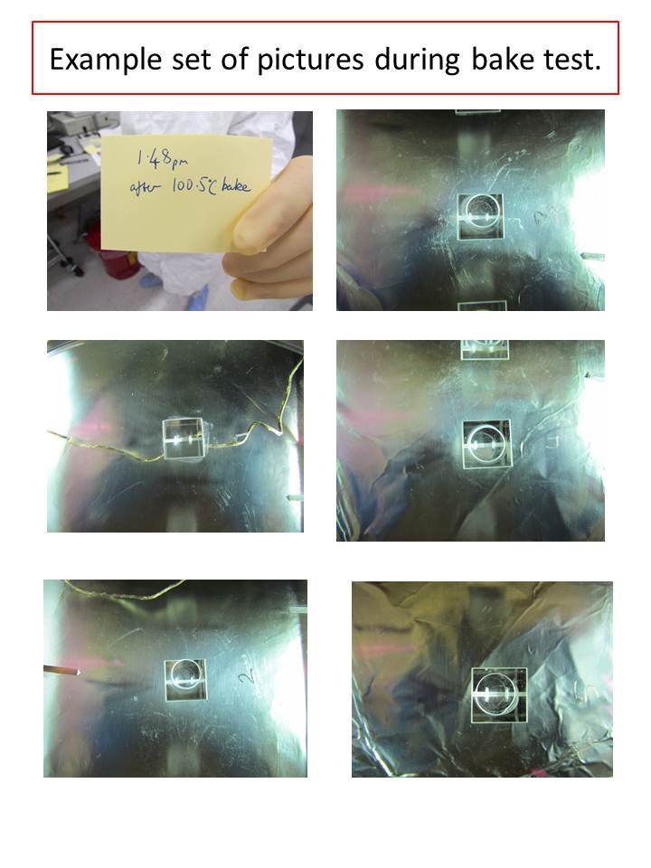

Prism # | 1 | 2 | 3 | 4 | 5
Air thermocouple C° | 116 | 106 | 106 | 140 | 110
Prism thermocouple C° | -- | 100 | 100 | 100 | 92
The temperatures were recorded before the heat gun was turned off (steady state.) Heat gun setting was 5. The household fan was used to cool the plate between trials.
No debonding or fracturing were noted.

Bringing prism one to failure: Ten Millimeter distance
Noting that this process could take all day, the decision was made to concentrate on the most likely to fail prism, #1. The set up is the same as above, but the heat gun dial was set progressively higher.
Heat Gun Setting | Air thermocouple reading (ºC)
5.2 | 165
6 | 213
6.25 | 248
7 | 284

No debonding or fracturing were noted. G. Billingsley tugged/twisted on the prism at the end of this to see if it might move. The household fan was used to cool the plate between trials. The thermocouple read in the low 30s before the beginning of each trial

Ten millimeter distance plus copper in contact with the prism
In an effort to further stress the prism and replicate the welding environment, a copper box was placed next to the flat side of the prism.
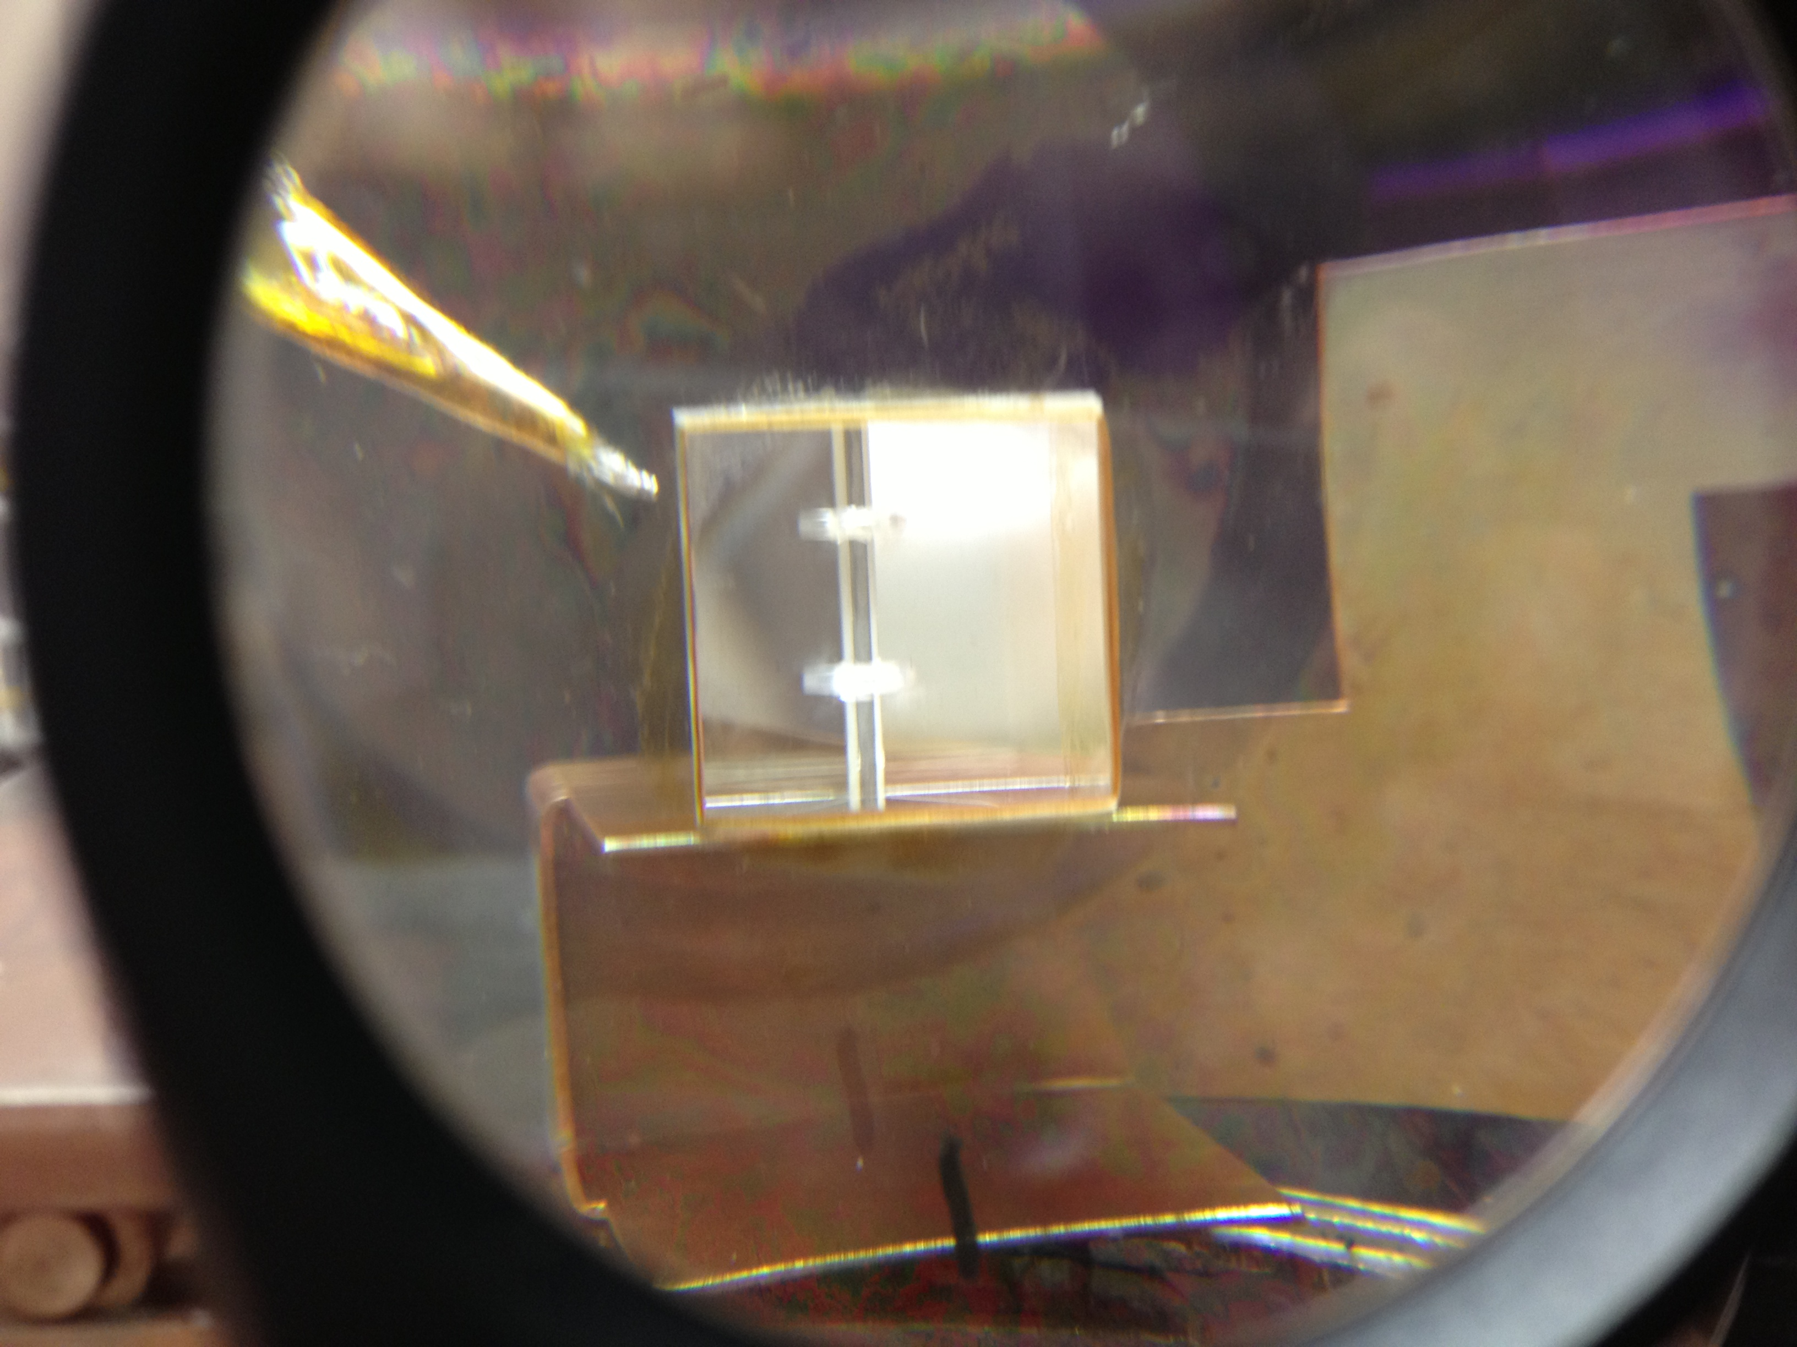
Showing the location of the “Air” thermocouple and configuration of the copper.
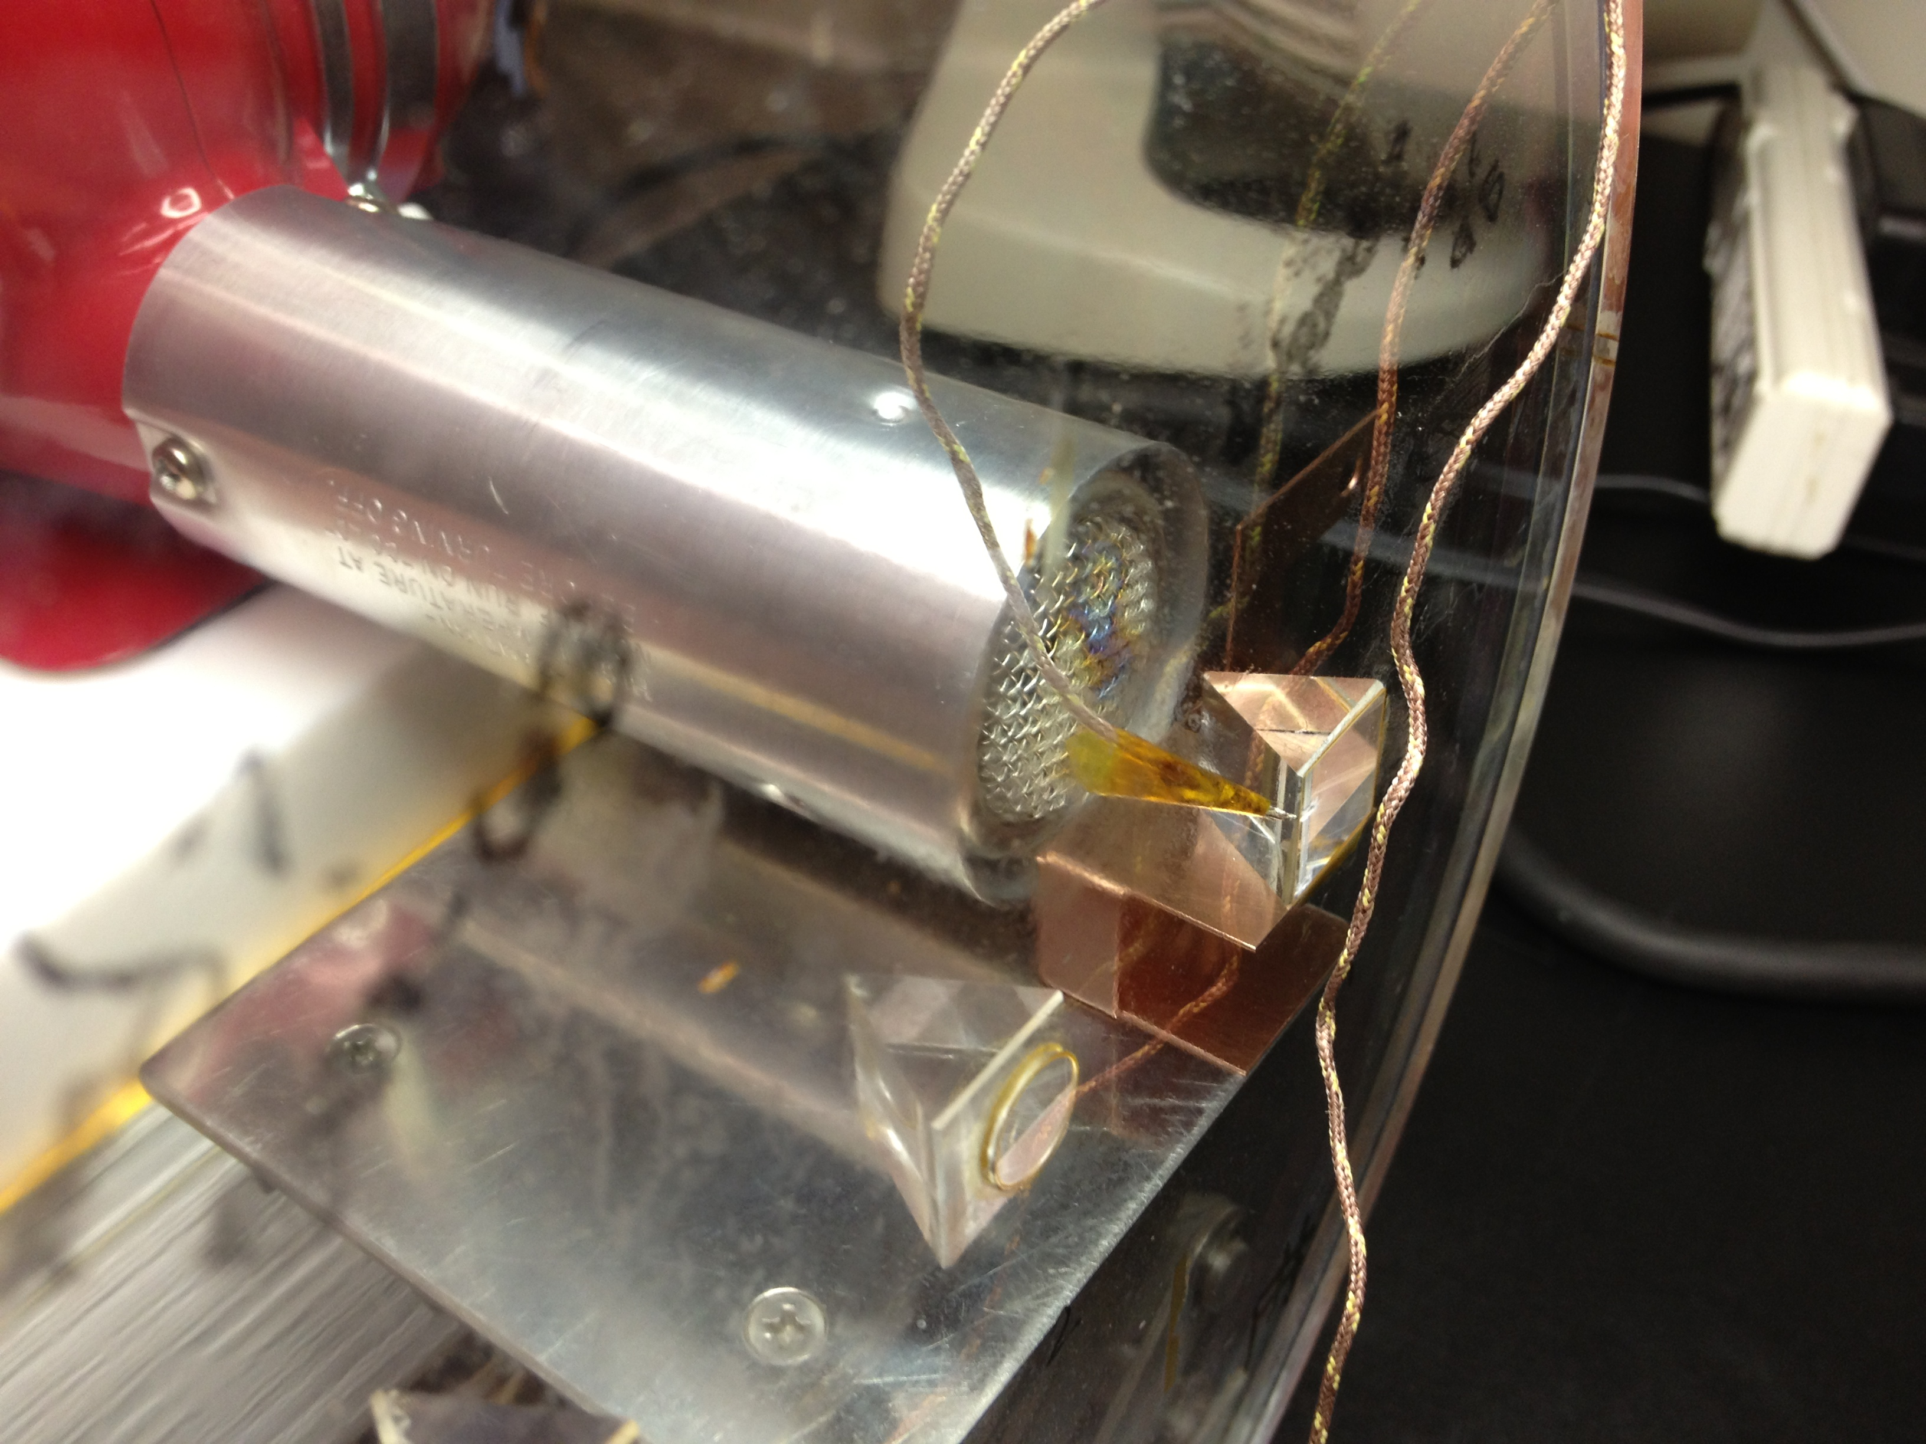
Showing the proximity of the heat gun to the copper and prism.

Heat Gun Setting | Air thermocouple reading
5 | 146
6 | 211
7 | 295
7.5 | 328 – debonding showing at corners
Once again the prism was pushed and tugged, but did not move.

Ten millimeter distance plus sideways pressure on the prism
To further stress the bond, pressure was added by cranking the lab jack until the fused silica plate lifted from the top of the lab bench.
A heat gun setting of 8 was used, at 2 minutes the air thermocouple read 339 C°. Prism one debonded from the fused silica leaving epoxy on the fused silica.

Bond failure
All other prisms failed at a setting of 7.5 on the heat gun using sideways pressure on the prism applied by the copper box.
Prism | Time of failure | Temp at failure Air: | Temp at failure Prism:
2 | 1min 30 sec
3 | 2 min
4 | 2 min | 331 | 323
5 | 1 min 41sec | 400-not in contact with substrate
In all cases the prism came away from the silica spacer, which remained firmly bonded to the silica plate. In all cases the epoxy was left on the silica spacer (beads could be seen in all cases – higher density of beads on prism 3, consistent with the two applications of epoxy with beads.)

Conclusions
None of the tests were able to crack the fused silica substrate even though the temperature greatly exceeded those seen during the fibre welding process.
EP30 maintains significant strength well beyond the rated max. usage temperature of 300 deg F (149 deg C).

