LIGO Laboratory / LIGO Scientific Collaboration

LIGO- T1300585-v2 LIGO 1/10/14

Setup and Alignment of Pcal Periscope Pre-Alignment Support Cradles

R. Savage, C. Conley

Distribution of this document:
LIGO Scientific Collaboration

This is an internal working note
of the LIGO Laboratory.

California Institute of Technology  LIGO Project – MS 18-34  1200 E. California Blvd.  Pasadena, CA 91125  Phone (626) 395-2129  Fax (626) 304-9834  E-mail: info@ligo.caltech.edu | Massachusetts Institute of Technology  LIGO Project – NW22-295  185 Albany St  Cambridge, MA 02139  Phone (617) 253-4824  Fax (617) 253-7014  E-mail: info@ligo.mit.edu
LIGO Hanford Observatory  P.O. Box 159  Richland WA 99352  Phone 509-372-8106  Fax 509-372-8137 | LIGO Livingston Observatory  P.O. Box 940  Livingston, LA 70754  Phone 225-686-3100  Fax 225-686-7189
http://www.ligo.caltech.edu/

Introduction
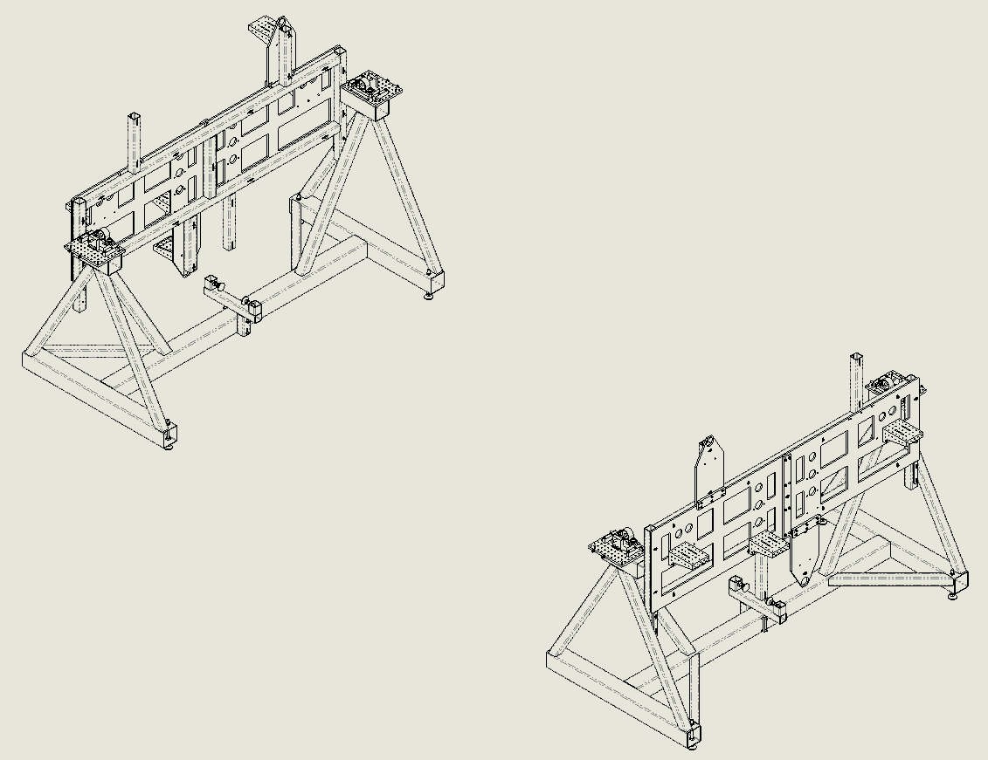
This document outlines procedures for setting up and aligning the Pcal Periscope Pre-Alignment Support Assemblies (Cradles), per Layout D1201412, in the H2 PSL anteroom.
Figure 1 Complete Pre-Alignment Setup

Marking Cradle Positions and Positioning the Cradles
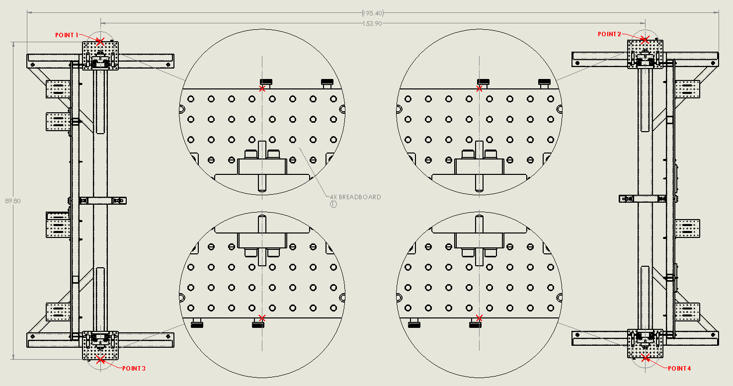
- Required: 3 persons and 2 (20’ minimum) tape measures or steel rules.
Figure 2 Pre-Alignment Setup, plan view, showing the two Periscope Support Assemblies (Cradles). Before positioning, four points are to be marked on the floor in a true rectangle of dimensions 153.90” x 89.80”.
- Mark point 1
  - Pick a point approximately 4’ from the enclosure anteroom entrance (East) wall, and near the South wall as space permits. This will be the first of the four points, and all others will be referenced to this point.
- Mark point 2
  - Point 2 is 153.90” from point 1 toward the enclosure anteroom West wall, directed parallel to the South wall.
- Mark point 3 (reference: The hypotenuse of the 153.90” x 89.80” rectangle is 178.18”.)
  - To accurately locate point 3 (refer to Figure 2 for it’s general location), two persons hold tape measures, one at point 1, and another at point 2.
  - A third person, by crossing the two tape measures at the vicinity of point 3, locates and marks its precise position 89.80” from point 1 and 178.18” from point 2.
- Mark point 4 using the same technique as used for point 3, again (or still) holding one tape measure at point 1, and another at point 2. The third person now crosses the two tape measures at the vicinity of point 4 and marks its precise position 178.18” from point 1 and 89.80” from point 2.
- Double check that all distances, including diagonals, between points match with the desired 153.90” x 89.80” rectangle. All measurements should check within 1/32” of expected dimensions.
- Using plumb bobs hung over the Breadboard shoulder screws (see Figure 2) at either end of a Cradle, position each Cradle to its two designated points.

Leveling and Alignment of the Four Breadboards and Plumbing of the Template Assemblies (Templates)
- Using a bubble level, an optical level, and a surveying target, set each of the four Breadboards level within 0.6 mrad (i.e. within 0.005” over surface), and coplanar within 0.01”. Keep the Template of each Cradle plumb across its height within 0.02”. To do all of the above, make adjustments to the Cradle leveling feet, and shim the Breadboards at their three attachment points, as needed.
Figure 3 Pre-Alignment Setup, elevation view, showing the two Periscope Support Assemblies (Cradles).
- Check with plumb bobs to see whether each cradle is still well positioned to its floor marks. Adjust positions if necessary, then re-check the Breadboards’ co-planarity. Make final adjustments if necessary.
- The final elevation of the four-Breadboard plane should be within +/- 0.2” of 42.7”. The bottoms of the Cradle weldments should be within +/- 0.2” of 2.0” above the floor.

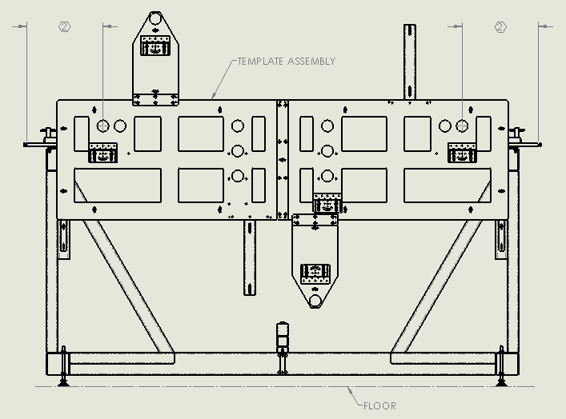
Template Horizontal Centering
Figure 4 Center each Template horizontally within its Cradle to be equidistant from the noted 2” diameter holes to the Breadboards. For each Template, these two dimensions should match within 0.02”.
- The Template should be supported from below by slotted brackets at its two ends, attached to the Cradle such as shown in Figure 4.
- To adjust the Template’s position, loosen all of its mounting screws and nuts. The Template can then be moved vertically and horizontally. Exercise caution not to affect the Cradle’s position on the floor, i.e. be careful not to push or pull on the cradle horizontally in any direction.
- Before horizontally centering the Template, roughly level and position its elevation slightly below (to allow for shimming) the specified final elevation relative to the Breadboards (see section 5 and Figure 5 for specified final elevation).
- Use plumb bobs and D1300072 Target Disks (not shown) at the outer 2” diameter holes (Figure 4) for the centering process, measuring from the noted ends of the Breadboards to the plumb bob strings.

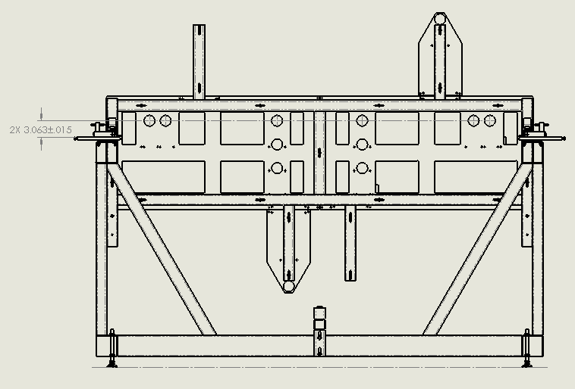
Template Vertical Positioning and Alignment
- Insert D1300072 Target Disks (not shown) at the outer 2” diameter holes of each Cradle’s Template.
Figure 5 Survey and shim the Templates vertically so that the upper rows of 2” diameter holes are level, and 3.063+/-.015” above the four-Breadboard plane.
- Using an optical level and surveying target, shim the elevations of the two Templates to be matched and level (per the precision of the optical level), and within 3.063+/-.015” above the four-Breadboard plane.

