LIGO Laboratory / LIGO Scientific Collaboration

LIGO-E1300431-v1 LIGO 5/14/2013

Surface figure measurement of ETM09

G. Billingsley

Distribution of this document:
LIGO Scientific Collaboration

This is an internal working note
of the LIGO Laboratory.

California Institute of Technology  LIGO Project – MS 18-34  1200 E. California Blvd.  Pasadena, CA 91125  Phone (626) 395-2129  Fax (626) 304-9834  E-mail: info@ligo.caltech.edu | Massachusetts Institute of Technology  LIGO Project – NW22-295  185 Albany St  Cambridge, MA 02139  Phone (617) 253-4824  Fax (617) 253-7014  E-mail: info@ligo.mit.edu
LIGO Hanford Observatory  P.O. Box 159  Richland WA 99352  Phone 509-372-8106  Fax 509-372-8137 | LIGO Livingston Observatory  P.O. Box 940  Livingston, LA 70754  Phone 225-686-3100  Fax 225-686-7189
http://www.ligo.caltech.edu/

Introduction
The purpose of this note is to memorialize the results of figure measurement of ETM09.

Method
This is the average of eight measurements taken every 45 degrees, the optic under test is rotated. See T1100370-v2 for more detail.

Uncertainty
The final uncertainty in the measurement of ETM07 is estimated to be of order 0.6nm rms over 300mm and 0.19nm rms over 160mm. This uncertainty is the combination of environmental and Reference File errors. See Section 4.1 of T1100370-v2.

Results
The ETM is measured every 45 degrees in 8 orientations. The final map is the average of all 8 datasets rotated to one orientation (arrow up.) The Reference file is subtracted from each data set before averaging. A key to the coefficients listed on data images is found in figure 1; for instance coef 4 corresponds to term# 4 in the list of Zernike polynomials.

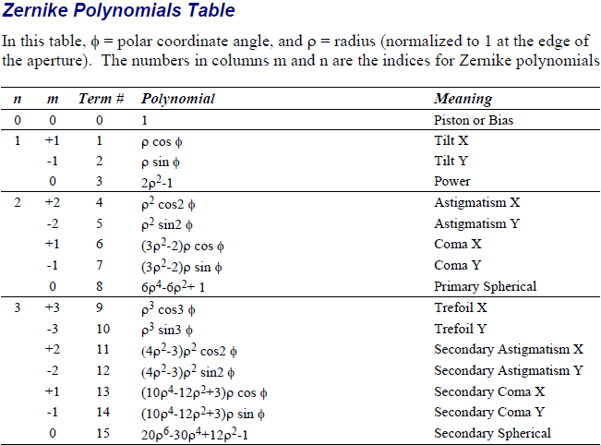

Radius of curvature : 2242.4
The radius of curvature was measured against the known radius of the reference sphere (-2100m) and calculated as the sum of saggital heights of the part as measured, plus cavity distance, plus reference saggita. The ROC data were taken over a period of 72 hours. The saggita had a standard deviation of 0.19nm, over 160 mm diameter. This corresponds to an uncertainty due to environment of 0.29 meters in radius.

High Frequency data
Data have been taken at 0.023 and 0.047mm/pixel, these data are self referencing (averaged to get a local, current image of the reference. The reference is temperature dependent at High Spatial frequency. These data are best viewed as a PSD. A sampling of raw files will be uploaded to the DCC. The raw files have central rings which come from the internal reflections of the interferometer, these rings should be avoided when analyzing the high spatial frequency data.

Low Frequency Data
Side One 160 mm diameter, power subtracted
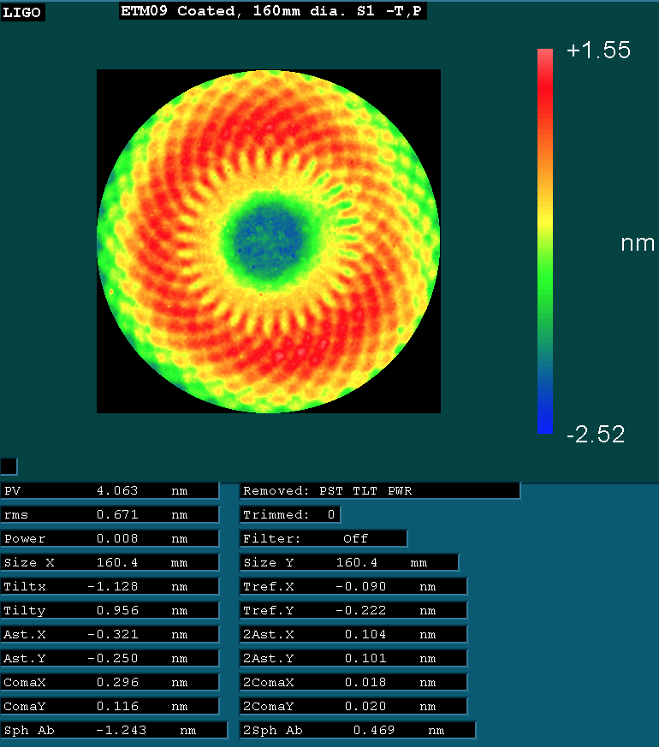

Side One 160 mm diameter, power and astigmatism subtracted
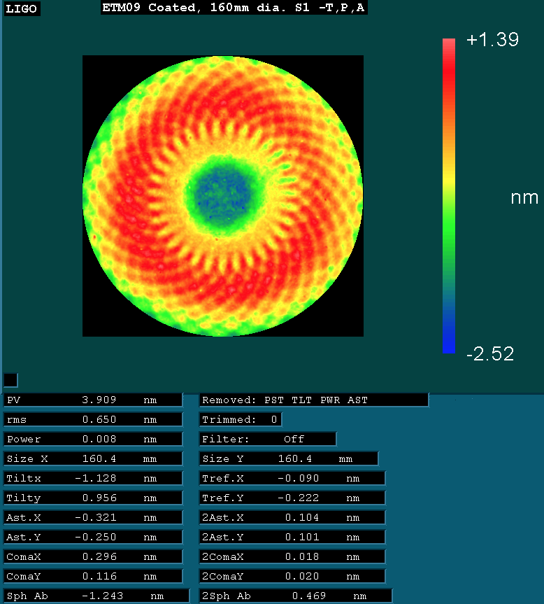

Amplitude of the spiral at R=43mm
