LIGO Laboratory / LIGO Scientific Collaboration

LIGO- E1300408-v1 LIGO 5/9/13

Install Manifold/Cryo Baf LHO ITM Y Test
Michael Smith

Distribution of this document:
LIGO Scientific Collaboration

This is an internal working note
of the LIGO Laboratory.

California Institute of Technology  LIGO Project – MS 18-34  1200 E. California Blvd.  Pasadena, CA 91125  Phone (626) 395-2129  Fax (626) 304-9834  E-mail: info@ligo.caltech.edu | Massachusetts Institute of Technology  LIGO Project – NW22-295  185 Albany St  Cambridge, MA 02139  Phone (617) 253-4824  Fax (617) 253-7014  E-mail: info@ligo.mit.edu
LIGO Hanford Observatory  P.O. Box 159  Richland WA 99352  Phone 509-372-8106  Fax 509-372-8137 | LIGO Livingston Observatory  P.O. Box 940  Livingston, LA 70754  Phone 225-686-3100  Fax 225-686-7189
http://www.ligo.caltech.edu/

1 Introduction 5
2 Acceptance Tests 5
2.1 Y-Arm Manifold-Cryopump Baffle Alignment Test & Exit Check List 7

Abstract
This document presents the data for the LHO ITM Y Manifold/Cryo Baffle Installation Acceptance Test.

Introduction
This document presents the data for the LHO ITM Y Manifold/Cryo Baffle Installation Acceptance Test.

Acceptance Tests

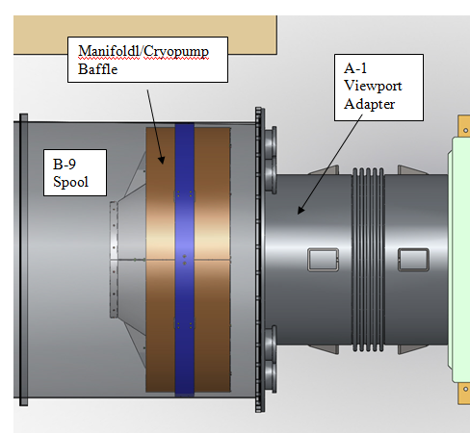
6.0 in
17.5 in
6.0 in

Figure 1: Manifold/Cryo Baffle placed 6.0 in away from A1 Adapter at Corner Station

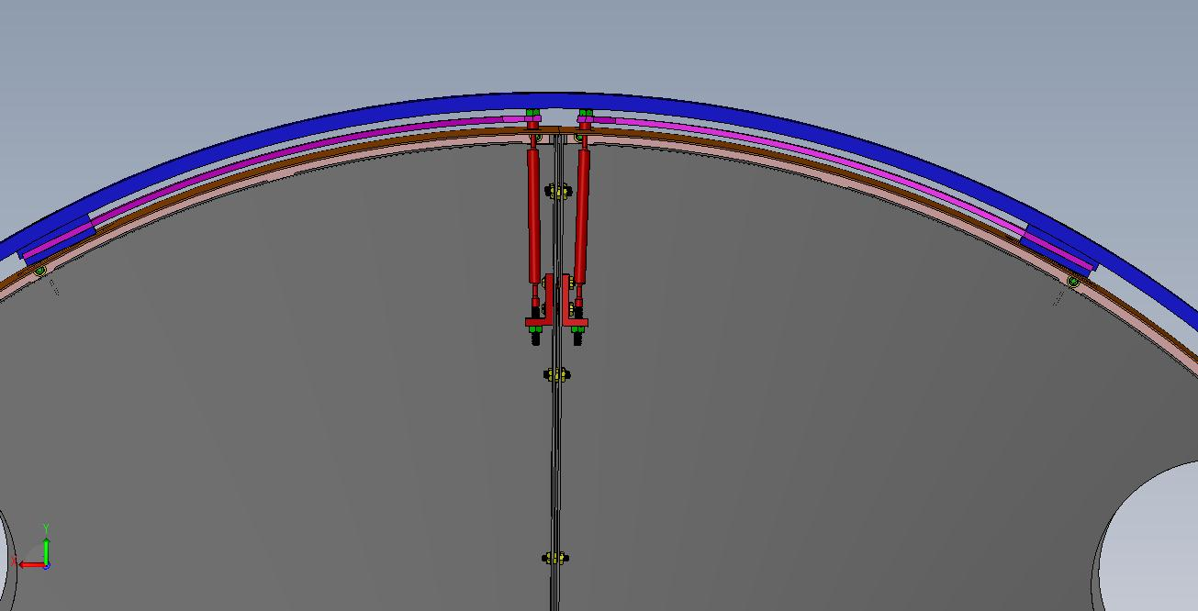
Pendulum Rod
Blade Spring
Figure 2: Close up of Blade Spring and 2-Wire Pendulum Suspension Mechanism

.
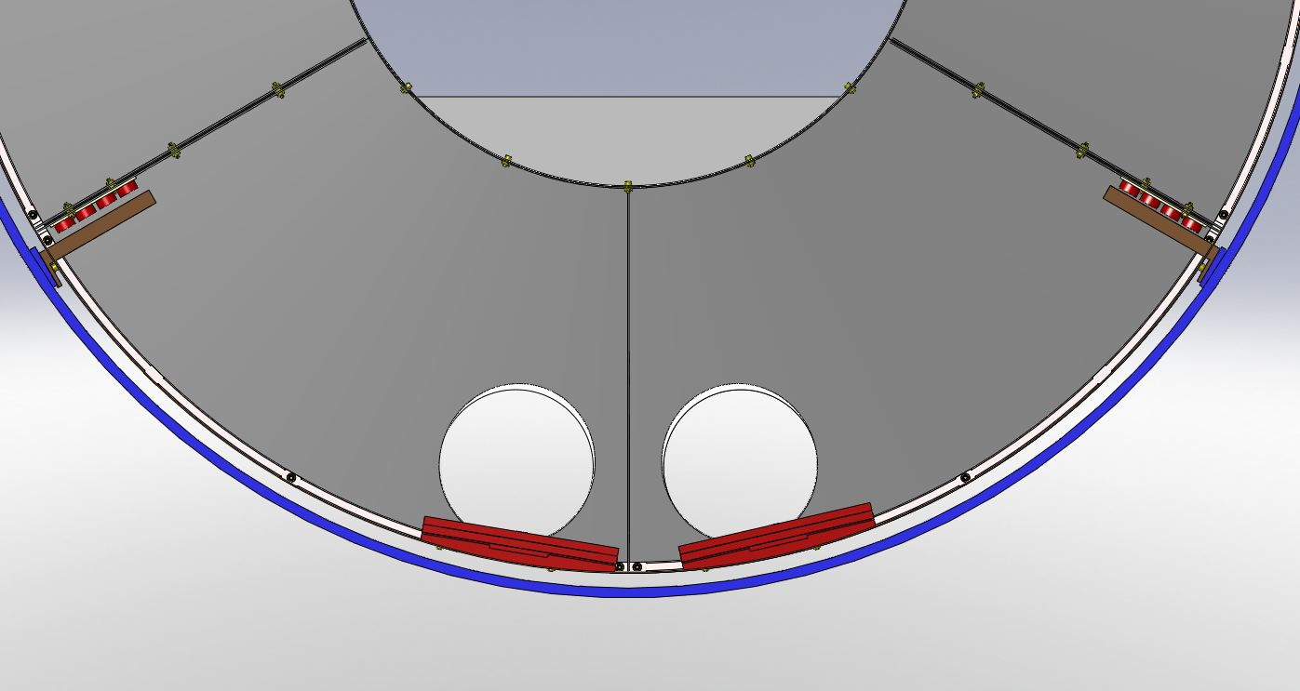
Fixed Weights
Outer Support Ring
Magnets
Cu Plate
Balance Weights
Figure 3: Magnet Gap and Balance Weights

Y-Arm Manifold-Cryopump Baffle Alignment Test & Exit Check List

