LIGO Laboratory / LIGO Scientific Collaboration

LIGO-T1300081-v2 February 4, 2013

OMC Lower Wire Clamp Development, Crimp and Testing Procedures

Jeff Lewis

This is an internal working note
of the LIGO Laboratory

California Institute of Technology
Massachusetts Institute of Technology
LIGO Hanford Observatory
LIGO Livingston Observatory

http://www.ligo.caltech.edu/

1. Introduction
New fused silica wire brackets (D1102209) were designed to be UV bonded to the aLIGO fused silica breadboard bench. These new brackets prohibited the use of traditional screw-type wire clamps which are common among the LIGO suspensions.
Beryllium copper clamps (D1200971) were designed to be crimped onto the 0.0079” diameter suspension music wire and still fit into the available space in the fused silica wire brackets. The clamps provide two cylindrical sections to be crimped; both above and below the cone shaped feature which engages with the wire brackets.

2. Crimp Method Background
The clamps were originally intended to be crimped with an indent-style crimper from Astro Tool, PN 612118. However this method yielded inconsistent results and often caused the music wire to break within the clamp. Presumably the discrete indents applied too much stress/deformation to the wire inside of the clamp. Decreasing the indent depth resulted in wire slippage.
A successful test was made by crushing a clamp with a traditional vice, as is commonly found on a Bridgeport mill.
Another successful test was made by soldering the music wire on one of the clamp. It was thought that it would be difficult to know if the solder wicked into the ID of the clamp and therefore it would be difficult to know that the connection was solid unless each wire/clamp assembly was proof tested.
Finally, the jaws of a pair of Amphenol crimpers model CTL-9 were modified per D1300081 by adding grooves top and bottom which give a flat crush to the clamps. The part number of these crimpers in the DCC and ICS is D1300083. The target amount of crush was the same as the successful vice test mentioned above. These crimpers provide an easy to use and repeatable method to apply a crimp above and below the cone. This is the method which was finally selected to crimp the D1200971 clamps for the aLIGO OMC.
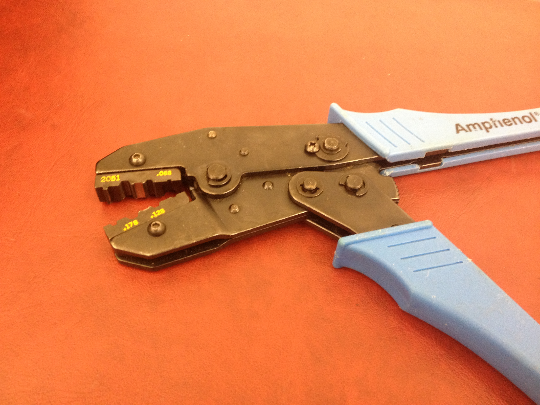
Figure 1. Modified Amphenol Crimpers → D1300083 (the blue handles were removed before C&B)

3. Amphenol Crimper Procedure

Insert the music wire through the D1200971 clamp.

Place one side of the clamp into the custom machined groove in the crimper jaws, referring to D1300081 if necessary. It doesn’t matter which side is crimped first. Try to keep the clamp perpendicular and centered in the groove. Refer to Figures 2 and 3.

Squeeze the handles of the crimpers together until they bottom out. The handles will not re-open or release the clamp until the handles have been fully actuated. This guarantees a repeatable crush.

Repeat the same procedure for the other end of the clamp. The orientation of the crush flats, relative to each other, above and below the cone is not important. Aesthetically, the clamps probably look best to have the crush flats aligned with each other but there should be no functional difference.

Referring to Figure 5, the thickness of the crimped ends should be verified with calipers to be within .057-.062”. There is a multi-position adjustment dial on the crimpers which can be adjusted to change the amount of crush. This dial was set on the loosest setting (full CW) when sent out from CIT February 1, 2013. It is not envisioned that this dial should be reset often, if ever. Please contact Jeff Lewis or Systems Engineering if there is difficulty achieving the desired crush amount.

Trim the short end of the wire so that there is only ~0.5mm sticking out. Leaving this amount allows for visual verification that the wire has not slipped when weighted.

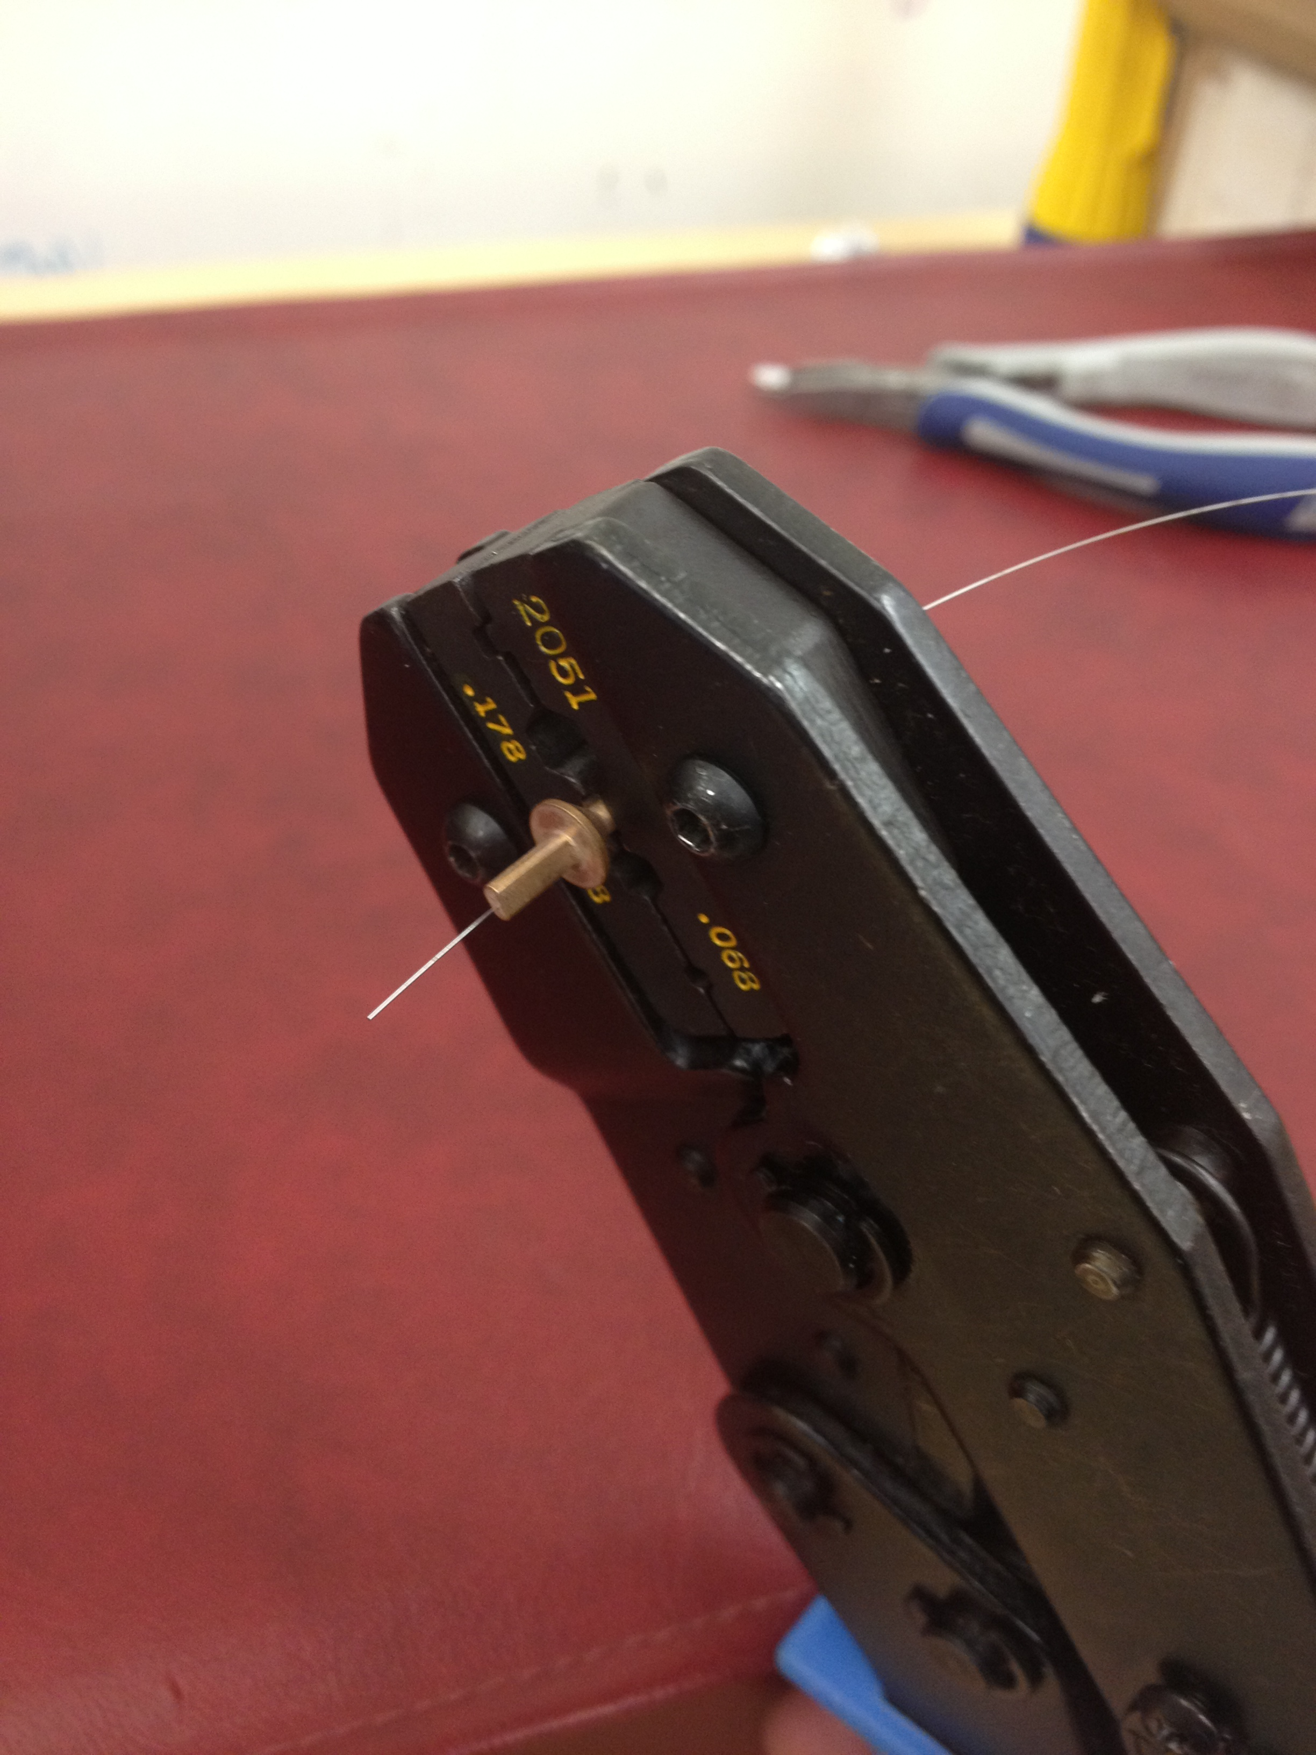
Figure 2. Crimping the clamp

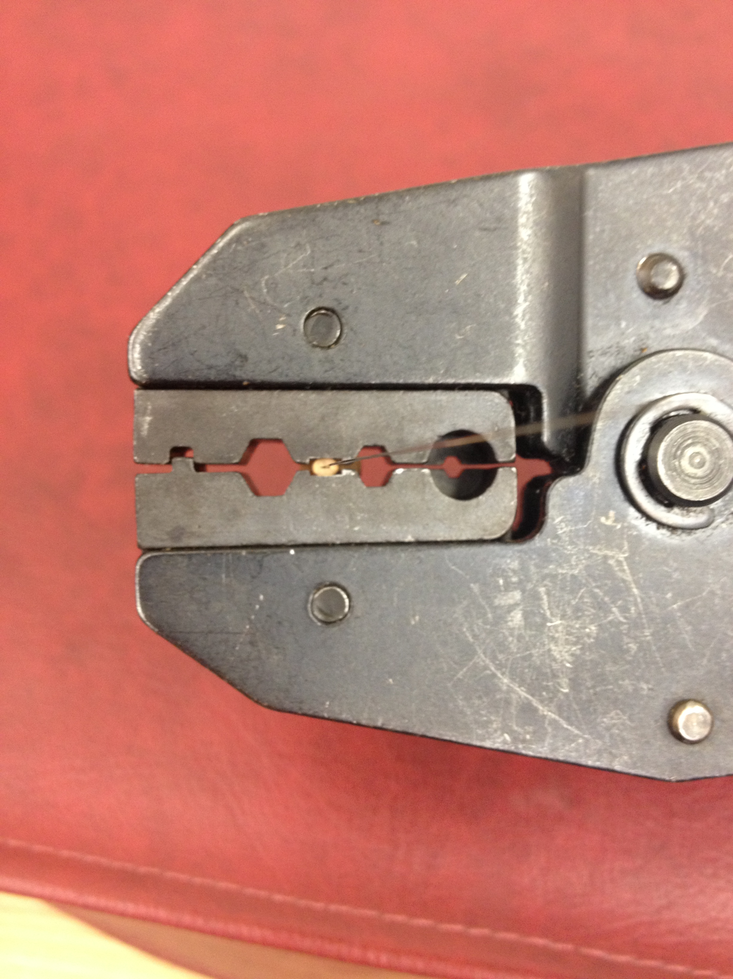
Figure 3. End view – not fully crimped yet

Figure 4. Detail of a fully crimped clamp

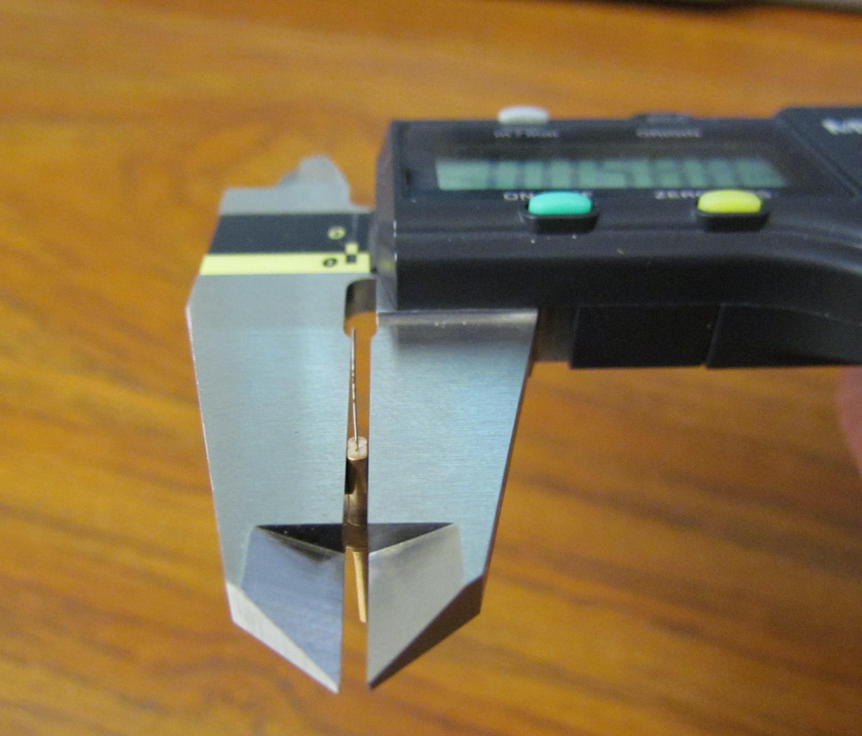
Figure 5. Position the end of the clamp flush with the calipers jaws to measure the thickness

4. Test Method
The same test setup was used during development and final testing of the wire clamps and crimp method. A pair of vice grips was c-clamped to a cantilevered aluminum block. The jaws of the vice grips were used to engage the cone feature of the D1200971 clamps, but the vice grip jaws were never clamped onto the D1200971 clamp itself. In other words, the clamps were always loose in the jaws of the vice grips.
A loop was formed in the lower end of the music wire with the use of a screw-type wire clamp. In 1 kg increments, mass was added to a hook attached to the wire loop.

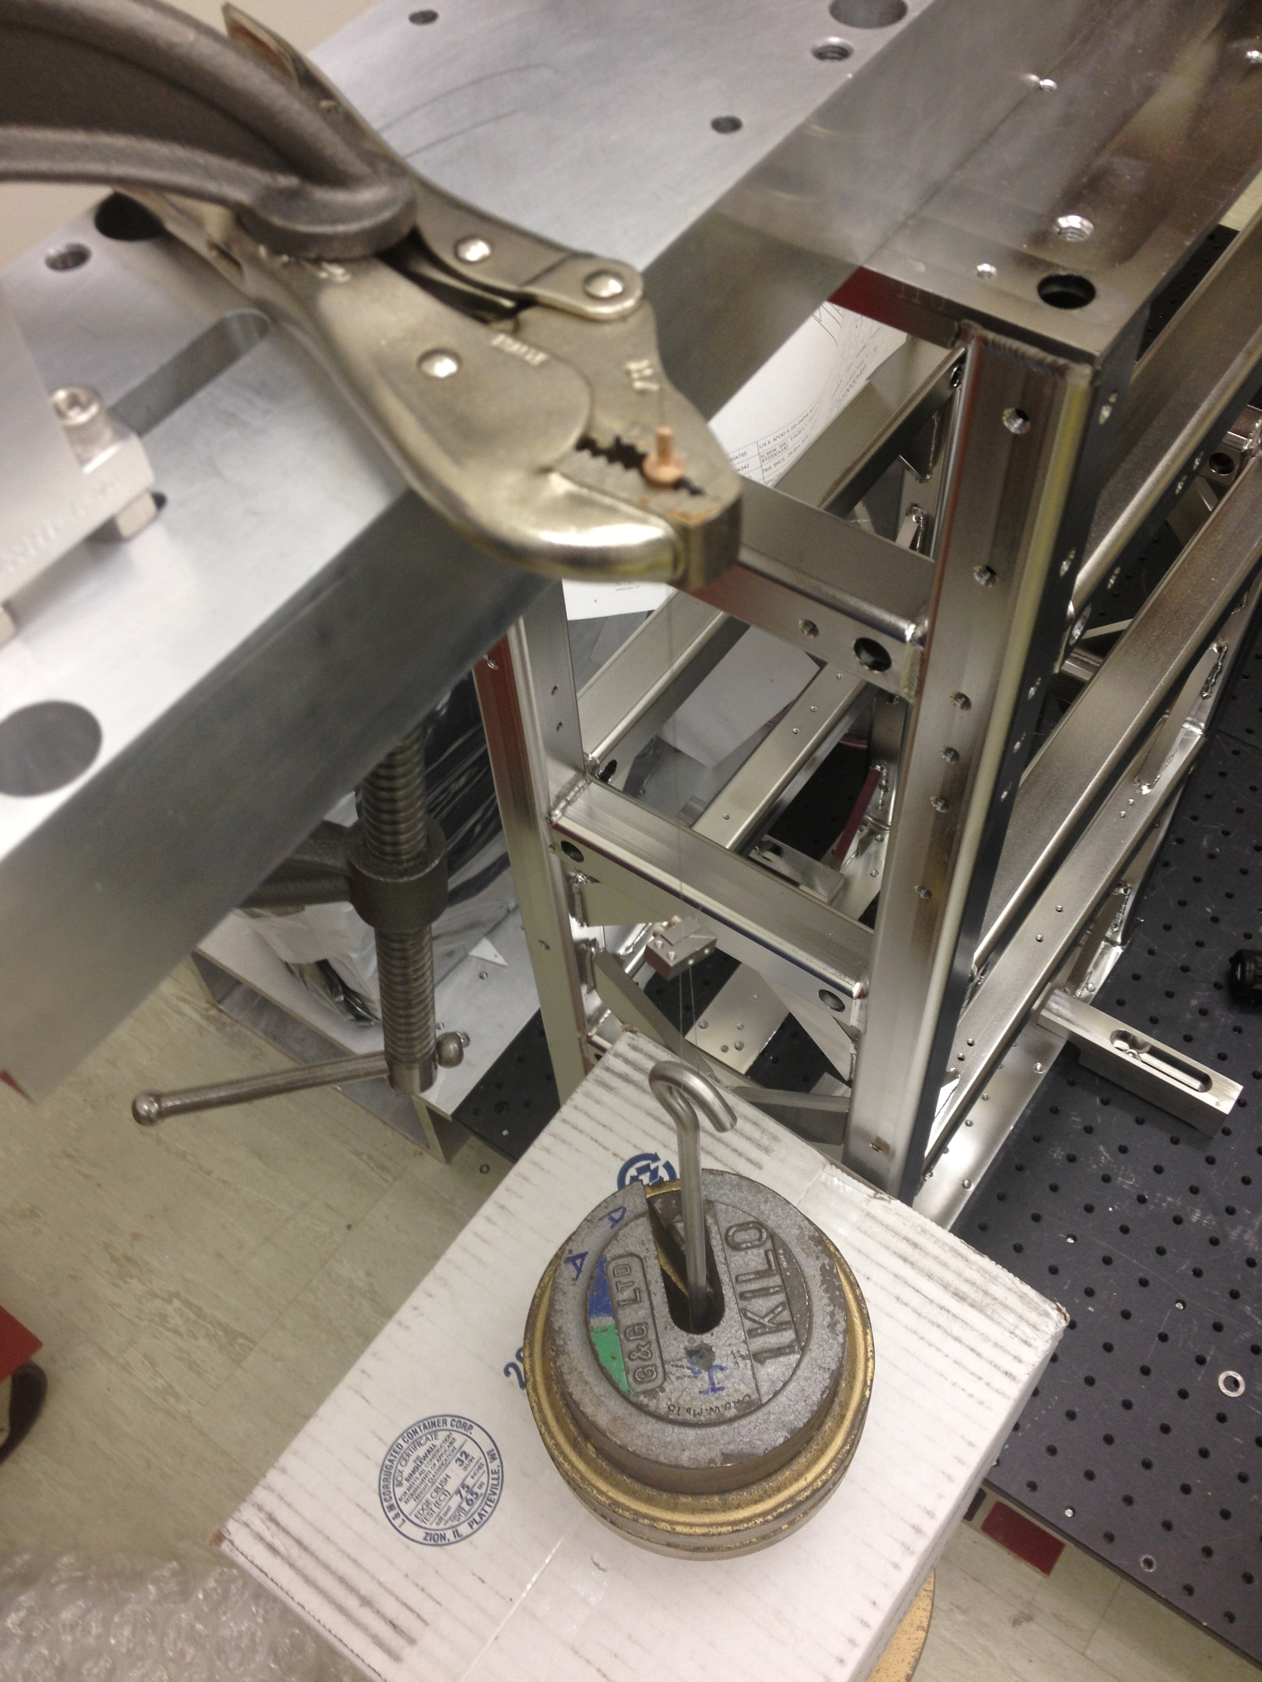
Figure 6. Test Setup
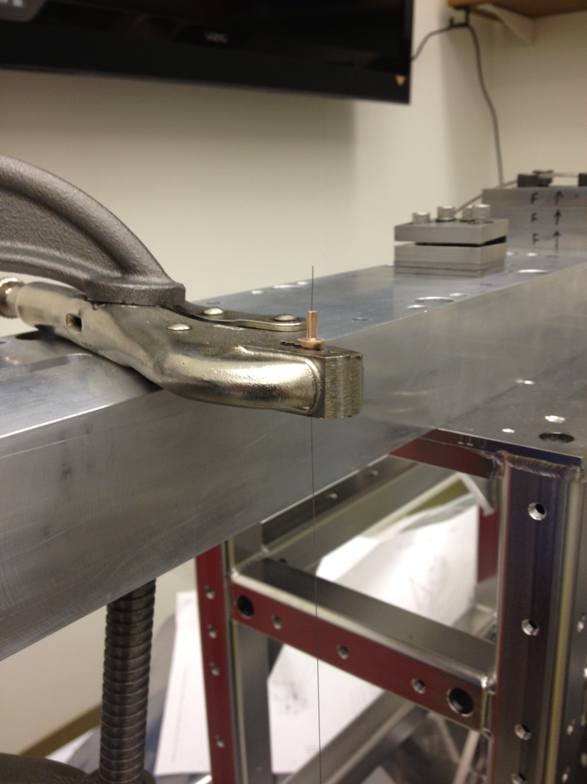
Figure 7. Vice grip and D1200971 clamp detail

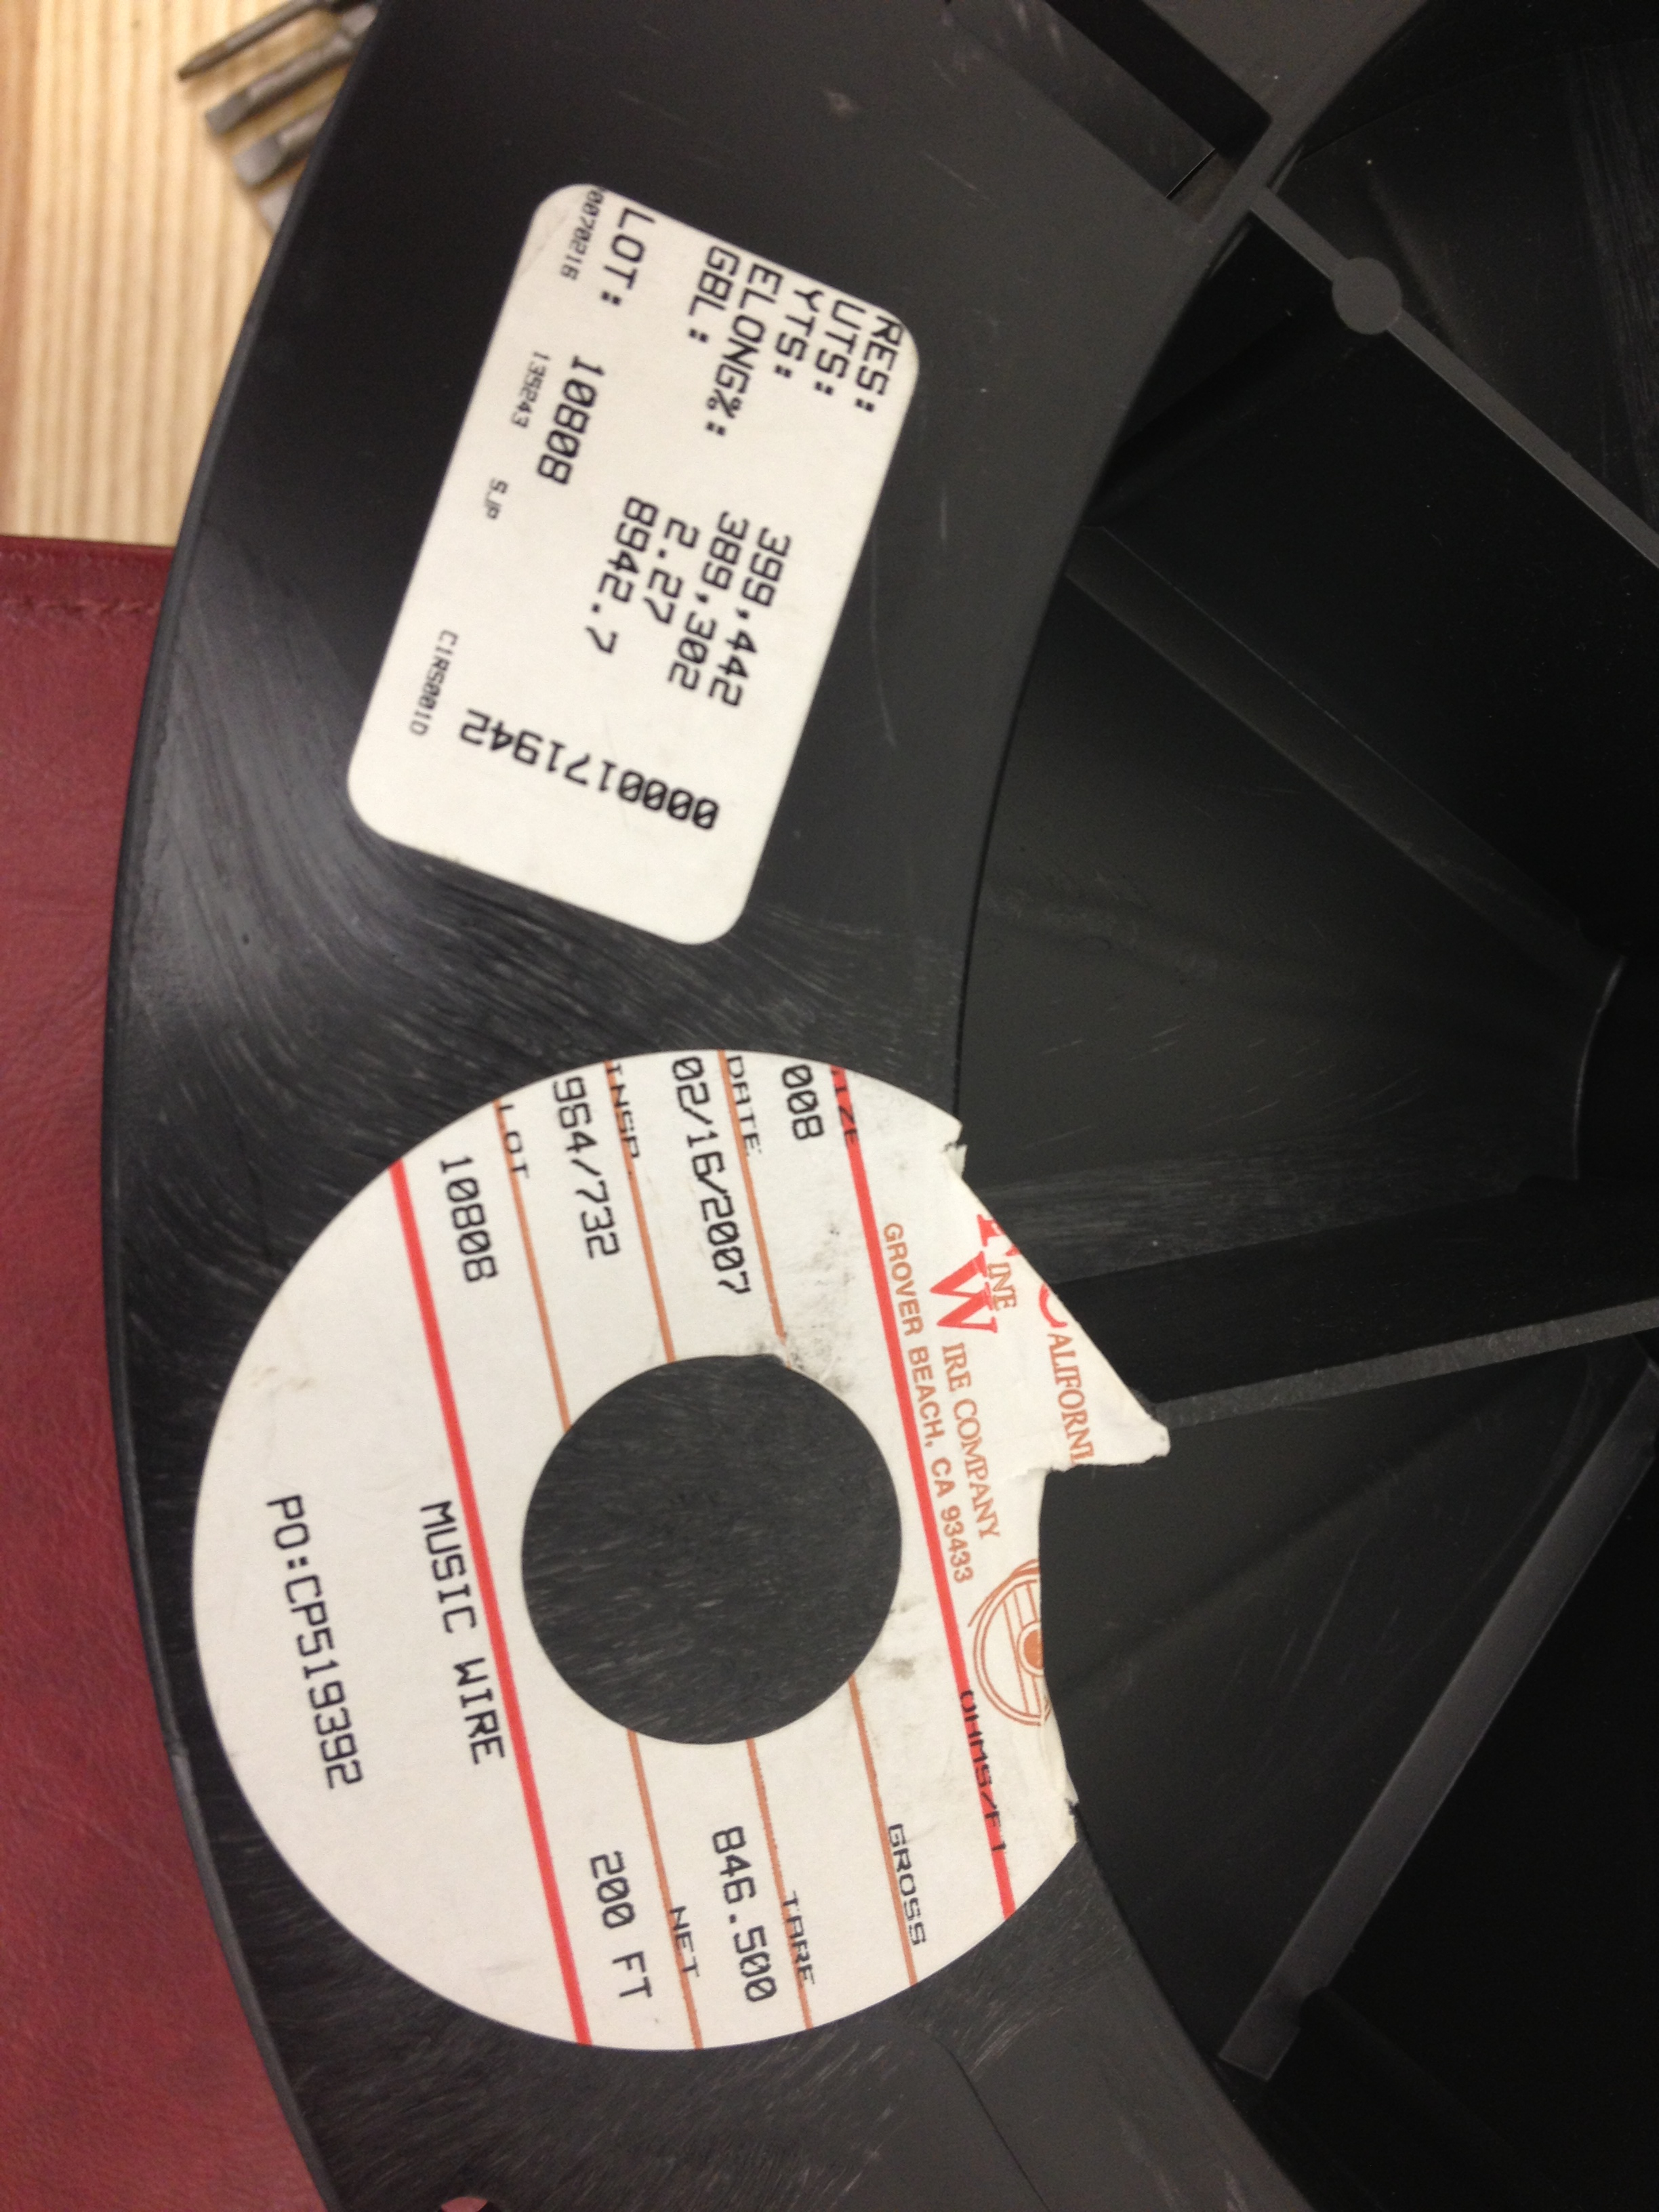
Figure 8. Music wire used for all tests

5. Test Results
Table 1. Test results using the Amphenol Crimpers D1300083 SN001
Clamp S/N | Maximum Load (kg) * | Failure Mode | Thickness,  Short End (inch) | Thickness,  Long End (inch)
018 | 5+ | Wire broke between clamps – failure not associated with either clamp ** | .0585 | .0580
019 | 7+ | Wire broke between clamps – failure not associated with either clamp | .0595 | .0585
038 | 6+ | Wire broke between clamps – failure not associated with either clamp ** | .0580 | .0620
022 | 7+ | Wire broke between clamps – failure not associated with either clamp | .0595 | .0575
023 | 7+ | Wire broke between clamps – failure not associated with either clamp | .0580 | .0585

* The maximum load successfully held is listed in this column. The “+” symbol indicates that the wire broke while adding an additional 1kg of mass.

** The wire used had been stored in air for some months or years and had visible signs of rust in places. An attempt was made to not have rusty section of wire inside of the clamp. The relatively lower breaking loads seen with S/Ns 018 and 038 were probably due to the rust having compromised the strength of the wire.

6. Conclusion
The combined mass of the aLIGO OMC Breadboard (D1201439) is 7.00 kg and is suspended by 4 wires. Therefore, each wire is responsible for holding 1.75 kg in static tension. The test results above show that the D1200971 clamps are capable of holding at least 7 kg each, which gives a 4X safety factor over the static load.
The D1300083 crimpers provide a repeatable method of easily crimping the D1200971 clamps.

There is a small lever between the handles which can be pushed upward to release the crimpers in the event that the crimpers are unable to close all the way, such as if the jaws are closed on an object that is too large to fully crush.

