Analysis of Rosin Core Solder for UHV Applications
R. Abbott, J. Lewis, C. Torrie
1 November, 2012
T1200491-v1

- Overview – A 2 inch by 4 inch flat copper plate was coated on one side with Kester brand, SN63PB37, “44” Rosin Core Solder using a heat gun to melt the solder. The plate is to undergo the normal UHV cleaning and baking cycle. An RGA scan will be performed, and then the sample will be analyzed in the ringdown cavity material analysis lab.
- Images

Figure 1, solder
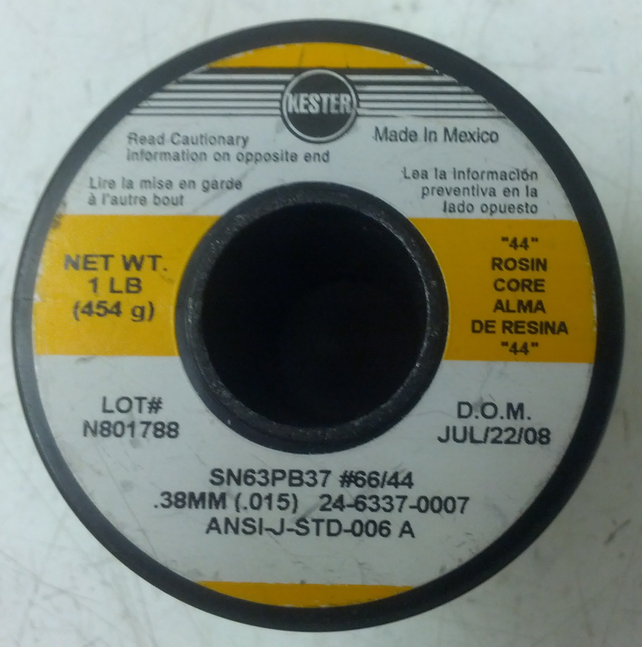

Figure 2, bare copper plate
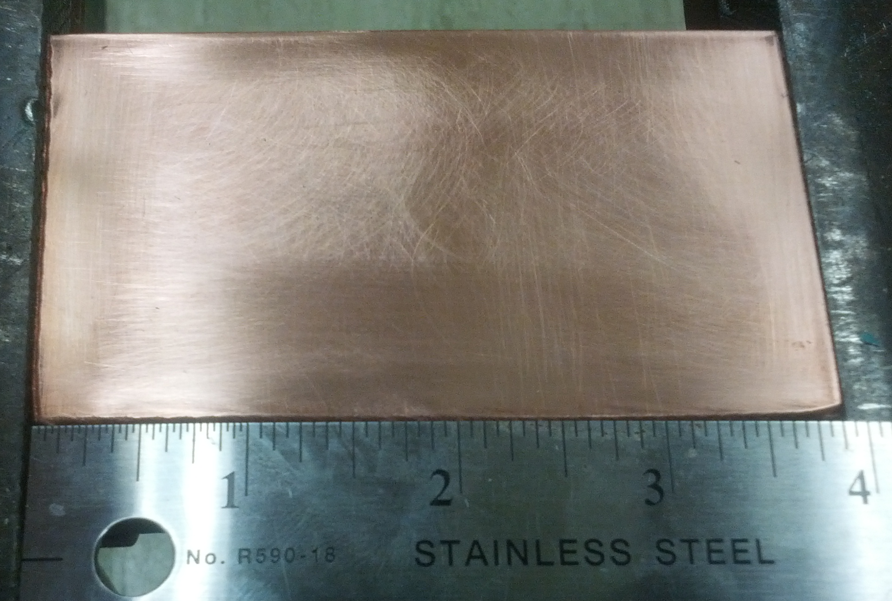

Figure 3, plate with solder applied and flux visible
