E1200798-v2

Notes on Initial Alignment of WBSC2 Optics

Supplementary notes to the alignment solutions calculated in E1200797-v7

Dennis Coyne  
27 Mar 2013

# Cartridge Assembly alignment on the test stand

Only the BS Optic and the BS AR and HR Elliptical Baffles are aligned while the cartridge assembly is on the test stand. The BS AR & HR Elliptical Baffles must be aligned to the BS optic while on the test stand. (Installation and alignment of these baffles in the chamber is not an option.) The two ITM Elliptical Baffle suspensions are not part of the test stand/cartridge assembly.

The WBSC2 cartridge assembly is to be assembled on LHO Mechanical Test Stand #2 (TS2), which is the test stand toward the southeast in the west wing (see D1100408 and D1101596). This test stand is rotated 90 degrees with respect to the orientation of the support tubes for chamber WBSC2. As a consequence the cartridge assembly will need to be rotated 90 degrees as it is “flown” from the test stand to the WBSC2 chamber. The crane hook has a rotation bearing to permit this and this is routinely done with lifts.

The BS optic will be placed onto the SEI BSC ISI optics table with its HR face pointing northwest (+X and +Y direction), as indicated in Figure 1 and Figure 2.

At ~45 deg incidence angle, both the AR surface and the HR surface have relatively weak reflection (as indicated in Table 3 of T1000230-v7) at the Newport LDS1000 Laser Autocollimator (LAC) wavelength (670 nm), but higher than required for the autocollimator (2%). The reflectance at normal incidence angle has not been measured or calculated (as yet) for these coatings. We might expect that both the HR and AR surfaces will create a return signal, although experience with the LBSC2 BS indicates that only one surface had a discernible return signal; It is imperative to establish which surface has a return reflectance – this is TBD.

Since the wedge angle of the BS optic is small (0.073 deg on average, 0.076 deg for SN06 intended for WBSC2), the separation angle of the beams will be quite small as well (~3.86 milliradians). Since the LAC beam is 31 mm diameter, with a 100 microradian divergence angle, we need a separation of > 32 mm. This requires that the distance from the Total Station to the BS optic be at least 9 m.

A direct view normal (i.e. perpendicular to) the HR (50/50) face of the BS optic is blocked by the test stand leg for all but a 2 in diameter region (see Figure 3).

The view normal to the AR face of the BS optic is not obscured, as shown in Figure 4. We cannot angularly align the BS optic in pitch and yaw from the AR side since there is insufficient room to get 9 m from the AR surface (the vacuum manifold tube interferes). However from the view normal to the AR side we can see features to position the BS optic:

(a) the lateral edges of the optic can be used to position the optic left and right, and

(b) the stand-off, wire prisms can be used to confirm that the vertical position of the optic is correct (or determine how far off the optic is in height),

(c) alternatively the height of the BS optic can be checked (and adjusted if necessary) prior to attaching the BS AR Elliptical Baffle

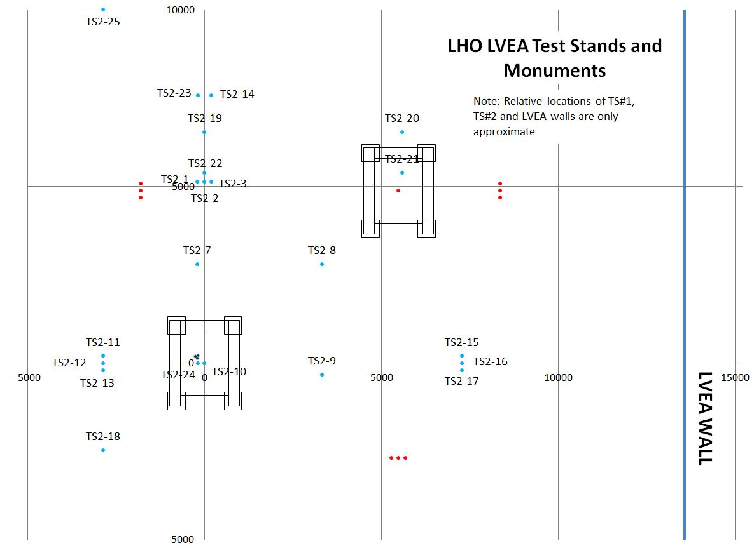

Figure 1: WBSC2 Cartridge on the Test Stand

Red markers are TS1 monuments. Blue markers are TS2 monuments.

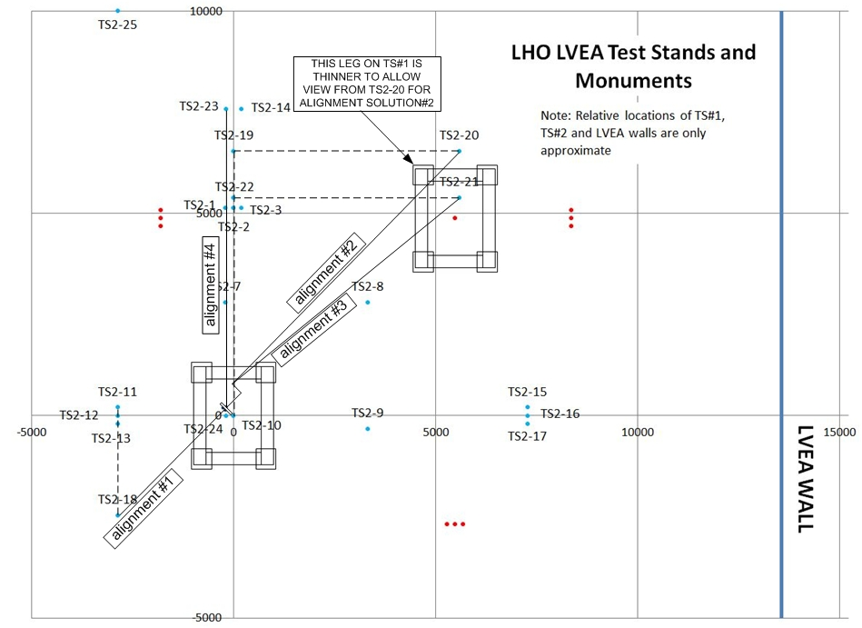

Figure 2: WBSC2 Cartridge on Test Stand#2 -- Alignment Solutions Sketch

|  |  |
| --- | --- |
| view normal to the HR face of the BS optic | close up view |

Figure 3: The view normal to the HR face is blocked by the test stand leg

We can then add a retroreflector to the BS structure on the AR side directed (approximately) normal to the AR face to enable a measurement of the third direction with the Total Station distance measurement capability (time of flight).

|  |  |
| --- | --- |
| view normal to the AR face of the BS optic | close up view |

Figure 4: The view normal to the AR face is not obscured

For the view normal to the AR face we can also use the Total Station to position the AR elliptical baffle. The yaw angles to the left and right edges should be equal; The lateral position of the AR elliptical baffle can be adjusted until the yaw angles are equal. Likewise, the pitch angles to the top & bottom of the AR elliptical baffle should be equal; The vertical position of the AR elliptical baffle can be adjusted until the pitch angles are equal.

In order to align the BS angularly (pitch and yaw), we can use a PLX Hollow Lateral Transfer Periscope (LHTP) to view the BS optic and keep the Total Station back by at least 9 m to allow the HR and AR reflections to separate. We cannot simply align the BS using the ~2 inch diameter edge visible without the PLX since this is not through one of the two First Contact™ “windows” at the center and at 12 o’clock, defined in [T1200198](https://dcc.ligo.org/cgi-bin/private/DocDB/ShowDocument?docid=91080).

We have two choices for pitch and yaw alignment of the BS optic. We can either retroreflect off of the HR face, or retroreflect off the AR face, in transmission though the HR face. Since both return signals are about equal in intensity (for 45 deg incidence, not known for 90 deg incidence) and both are likely to be weak, alignment solutions have been determined for retroreflection from both the HR and the AR surfaces. In the case of the AR retroreflection solution, it was not possible to get sufficient distance from the optic to completely separate the reflections from the two surfaces (due to the proximity of the LVEA wall). Consequently it may be necessary to add an aperture (e.g. iris) to the Newport LDS-Vector Laser Autocollimator in order to reduce the aperture slightly (from 31 mm diameter to 29 mm diameter).

In order to position the HR elliptical baffle, a target is attached to the baffle and the baffle is viewed looking in the +X-direction on the beamline (-Y direction on Test Stand #1), as shown in Figure 5. The removable target (to be provided by SLC) allows IAS to position the HR BS Elliptical Baffle left/right and up/down so that it is centered on the optic.

|  |  |
| --- | --- |
| view in the +X direction, showing the HR face of the BS optic and the HR BS elliptical baffle (without the target) | view in the +X direction, showing the HR face of the BS optic and the HR BS elliptical baffle with a conceptual target (to be provided by SLC) |

Figure 5: View of the BS in the +X-direction showing the use of the target on the HR BS Elliptical Baffle

At this point the BS optic and both the HR and AR BS Elliptical Baffles have been aligned on the test stand.

The alignment solutions (calculated in [E1200798](https://dcc.ligo.org/cgi-bin/private/DocDB/ShowDocument?docid=96071)-v1) are summarized in the Table below. The monument references are shown in Figure 1 and have been added to the LHO monument list in [D1100291](https://dcc.ligo.org/cgi-bin/private/DocDB/ShowDocument?docid=38749)-v4. The alignment procedure for the WBSC2 cartridge alignment on LHO Test Stand #2 is given in [E1200795](https://dcc.ligo.org/cgi-bin/private/DocDB/ShowDocument?docid=96033).

Table 1: Details of the alignment solutions for the WBSC2 Cartridge on the LHO Test Stand #2

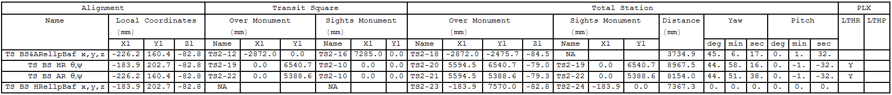

# Cartridge Assembly alignment in the chamber

Once in the chamber, IAS must align:

* the BS Optic in {x,y,z, yaw} by moving the entire cartridge assembly with HEPI as a rigid body
* the BS Optic in pitch, by adjusting the suspension
* the ITMy Elliptical Baffle
* the ITMx Elliptical Baffle

but not the BS AR & HR Elliptical Baffles, since these baffles were properly located relative to the BS optic on the test stand.

For the beamsplitter (BS) we set the yaw angle with a laser autocollimator (co-boresighted to the total station) viewing the BS HR surface through a LTHP, as shown in the sketches below.

We can set the lateral (y) and vertical (z) position of the BS with the target on the BS HR Elliptical Baffle when viewed looking in the +X direction along the beam line.

We need a retroreflector mounted at 45 deg to the BS optic, facing the –X direction, in order to get the third positioning degree of freedom (x).

The ITM Elliptical Baffles have targets at their aperture centers which can (hopefully) be viewed in reflection from, and in transmission through, the BS optic, by the Total Station theodolite pointed in the +X direction.

|  |  |
| --- | --- |
|  |  |

View normal to the BS HR face. The BS HR face cannot be viewed through the WBSC2 main port.

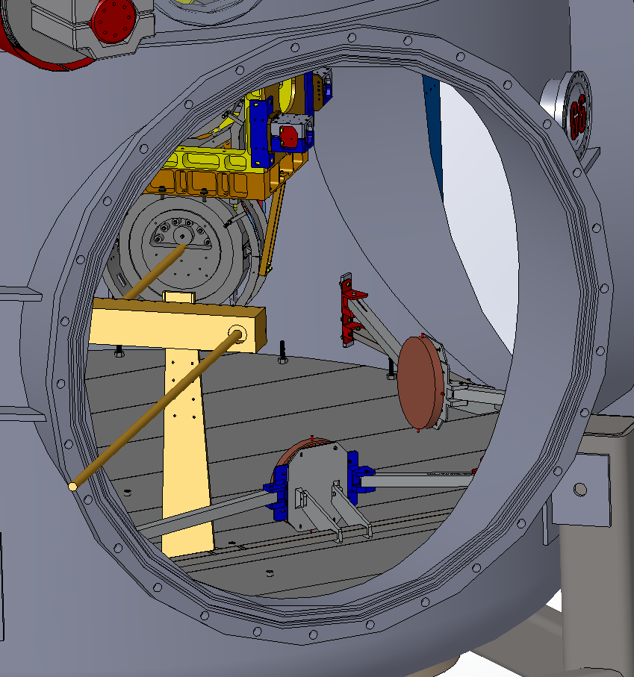

A PLX Lateral Transfer Hollow Periscope (LTHP) on the PLX mount can easily relay a view of the center of the BS HR face out the WBSC2 port. NOTE: The PLX mount shown is not complete; Need to raise the D980472, PLX Mount, Support Weldment above the floor.

## Solution #1

Set the Total Station on the beam line path from the center of the BS to the center of PR3, looking at the center of the BS, in order to align the position (x, y, z) of the WBSC2 cartridge, using the HR Elliptical Baffle target (x, z) and the retro-reflector (y)



## Solution # 2:

Set the Lateral Transfer Hollow Periscope (LTHP) in the BSC2 chamber in the –X direction from the BS. The Total Station (TS) sits atop monument “LHO AM 507” and derives it’s yaw reference either from monument LV22 or by retroreflection from the Optical Square (which sits atop monument LV26 and is aligned to monument LV25). The TS yaws to retroreflect off of the BS HR face through the LTHP in order to set pitch and yaw of the BS optic.



Table : Details of the alignment solutions for the LBSC2 Cartridge in the BSC2 Chamber

