T1200314 - Elimination of ECDs, and suggestions for re-design

The function of parts D060408, D060413 and D060317
D060413
D060317
D060408

D060408

- To house the ECD magnets

D060413

- To mount the ECD magnet holder on to the top mass
- To provide a “pin in hole” visual aid to align the top mass/ECDs with the tablecloth/ECD blocks
- To provide a physical stop for the top mass, in order to protect the flags and ECD magnets during alignment and during an Earthquake.

D060317

- To Provide EC damping for the top mass
- To provide an alignment hole for the top mass
- To provide a physical stop to protect the top mass magnets and flags.

Function of parts after removing primary (damping) function

On removing the need for EC damping of the top mass, there are still outstanding functions for the parts described:
- To provide visual alignment for the top mass
- To provide a physical stop to protect the OSEM flag

The first function of alignment is less important if the need to align magnets with ECD block has been removed, however, it is still a useful reference.
The second function of providing a physical stop to protect the OSEM flag remains a very important function, and this should be retained through this design modification.

Suggestion for re-design

In order to maintain the functionality of the parts highlighted, I suggest that you maintain all the parts in the assembly. I believe this can be achieved while remaking only one part.
D060408 - Remake
D060413 - No modification required
D060408 - No modification required

Modification of part D060408

Thickened st.steel plate
Thin Al alloy plate

Change of material from al.alloy to st.steel allows the mass to be made up without adding too much to the thickness of the part.

This allows the block to fit in without modifications to and of the surrounding parts
Alignment pin/hole, and physical stop maintained.
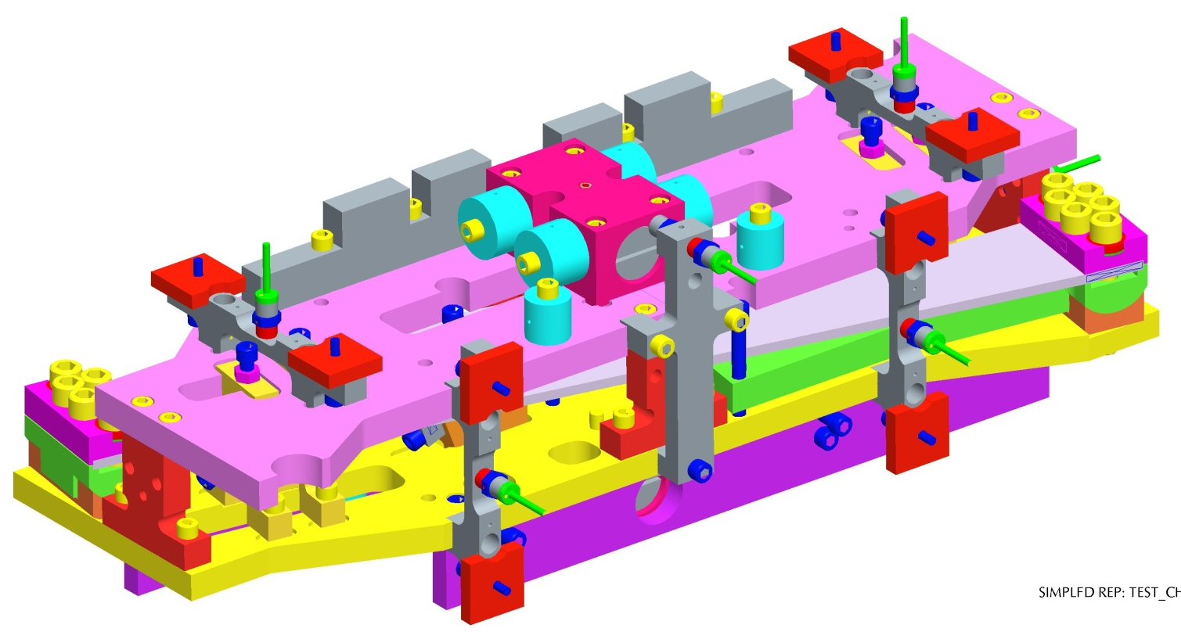

Related issues

Some time ago we discussed the fact that there was a sigh imbalance in the top mass, due to an incorrect setting of the magnet mount plate density. This created a small offset in the C of G (email conversation copied in below). This imbalance was dealt with using the addable/removable mass, however, this caused a few minor problems, and this seems a perfect time to address this issue. By adding a small amount to the thickness of the plates, I suspect we could correct the imbalance, removing the necessity to compensate for the imbalance using the addable/removable mass.
Since these masses are being modified anyway, it seems that this could be achieved without any extra fuss!
If it helps I can look into this design further and add the required amount of mass to balance the Quad, and send a drawing... Any thoughts?
Email Quote (below) – from conversation between JOD, NAR, Jeff, Betsy and Virginia on 12/Oct/2011.

Hi Norna,

I had started looking into this too, as there also seemed to be a similar imbalance in the mass vertically at LHO. This is less obvious because it does not manifest itself as a pitch, but as coupling of Yaw to Pitch at the top mass. I investigated the mass itself while I was at LHO and found that I had to move 200 g of mass from bottom to top of the mass in order to remove this extra coupling.

This narrows it down to only very few components. I need to carry out some further investigation, but I believe that it is down to an incorrect setting of the density of the ECD magnet mounting plates in the model. I have run out of time, today, and I need to investigate further, as this would also affect the top mass of the Quad.

Looking at the numbers I have, after righting the incorrect density setting, it appears that there is an offset in the C of G of the BS top mass in the pitch affecting direction of ~ 0.35mm, and in the vertical direction of ~ 0.25.

This would account for a part of both of the affects we have seen (although not fully, because I find that I do not need to move as much mass in the model as we have needed to move at the sites). It probably accounts for enough of it that we can put the rest down to machining tolerances, etc, since I have combed the model, and cannot find any other issues.

More to follow on this...

Regards

Joe O'Dell
Project Engineer
Technology Division
STFC - RAL
+44 01235 445212

-----Original Message-----

From: Norna Robertson [mailto:nroberts@ligo.caltech.edu]
Sent: 11 October 2011 19:21
To: ODell, Joe (STFC,RAL,TECH)
Cc: Betsy Bland; Virginia Brocato; Jeff Kissel
Subject: BS/FM imbalance

Hi Joe

At today's SUS telecon the point was raised that we have had to add ~
200 gm to balance in pitch the top mass of the FM at LHO and now also the BS at LLO. Virginia reports mass had to be moved from back to front at LLO and this was same as done at LHO. This suggests there may be a C of M imbalance built into the mass which we are correcting for. Can you look into your model and let us know?

thanks
Norna

--
Dr Norna A Robertson
LIGO Laboratory
California Institute of Technology
Mail Stop #100-36
Pasadena, CA 91125
USA
nroberts@ligo.caltech.edu
Tel: 626 395 2130

