*LIGO Laboratory / LIGO Scientific Collaboration*

[LIGO- E1200508](https://dcc.ligo.org/cgi-bin/private/DocDB/ShowDocument?docid=91480) *LIGO* Jan 23rd, 2014

**aLIGO HAM-ISI, Installation Test Report, Phase II**

**Chamber-Side Testing & Initial Chamber Testing**

**LHO HAM4-ISI (unit #7)**

E1200508-V5

Hugo Paris, Fabrice Matichard

Hugh Radkins, Jim Warner, Greg Grabeel, Corey Gray, Mitchell Robinson, Eric Allwine

Distribution of this document:

Advanced LIGO Project

This is an internal working note

of the LIGO Laboratory

|  |  |
| --- | --- |
| **California Institute of Technology**  **LIGO Project – MS 18-34**  **1200 E. California Blvd.**  **Pasadena, CA 91125**  Phone (626) 395-2129  Fax (626) 304-9834  E-mail: info@ligo.caltech.edu | **Massachusetts Institute of Technology**  **LIGO Project – NW22-295**  **185 Albany St**  **Cambridge, MA 02139**  Phone (617) 253-4824  Fax (617) 253-7014  E-mail: info@ligo.mit.edu |
| **LIGO Hanford Observatory**  **P.O. Box 1970**  **Mail Stop S9-02**  **Richland WA 99352**  Phone 509-372-8106  Fax 509-372-8137 | **LIGO Livingston Observatory**  **P.O. Box 940**  **Livingston, LA 70754**  Phone 225-686-3100  Fax 225-686-7189 |

**Table of contents:**

INITIAL IN CHAMBER TESTING 6

Step 1: Cables Inventory 6

Step 2: Electronics Inventory 7

1.Step 3: Level of Stage 1 7

[Step 4: Mass Budget   
 9](#__RefHeading__5129_113360635)

2.Step 5: Shim Thickness 11

3.Step 6: Blade Spring Profile 12

4.Step 7: Lockers Adjustment 12

5.Step 8: CPS Gap 13

Step 9: CPS and GS13 Spectra - ISI Unlocked 15

6.Step 10: GS13 ASD - Tabled Tilted 16

[7.Step 11: GS13 pressure readout  
 16](#__RefHeading__5143_113360635)

8.Step 12: Actuators Sign and range of motion (Local drive) 17

Step 13: Static Testing (Tests in the local basis) 18

9.Step 14: Linearity test 20

10.Step 15: Frequency response 22

11.Step 15.1: Local to local measurements 22

12.Step 15.2: Local to local measurements V.S. LLO 23

PHASE II Testing

The phase II of HAM-ISI testing corresponds to the tests performed after the *Assembly Validation*, and before the *Control and Commissioning* of the Units. It is divided in two parts. The present document is divided in two sections: One for each part of the Phase II testing:

**Part.1** Chamber-Side testing

**Part.2** Initial Chamber Testing

**Chamber-Side Testing** is a basic sensor check with a spectrum analyzer. Units can be inserted in their chamber of destination once they pass.

**Initial Chamber Testing** takes place in open chamber, with the optics off, and HEPI locked. The ISI is then connected to the electronic rack with the final in-field cables. Models are installed and running. Tests are performed with Matlab® scripts.

Optics and Suspensions can be installed right after the end of this phase of testing. No test is performed during their installation.

**Final Chamber Testing** starts once Optics and Suspensions are installed. The lockers and the CPSs usually need to be reset at this point.

Introduction

*Chamber-Side Testing*

HAM-ISI Unit #7 was intended to populate HAM4 chamber.

Conclusion

*Chamber-Side Testing*

HAM-ISI Unit #7 was intended to populate HAM4 chamber. No chamber-side testing was performed.

Introduction

*Initial Chamber Testing*

This part of the Phase II testing takes place in open chamber, with the optics off, and HEPI locked. The ISI is then connected to the electronic rack with the final in-field cables. Models are installed and running. Tests are performed with Matlab® scripts.

Optics and Suspensions can be installed right after the end of this phase of testing. No test is performed during their installation.

*Final Chamber Testing*starts once Optics and Suspensions are installed. The lockers and the CPSs usually need to be reset at this point.

# INITIAL IN CHAMBER TESTING

HAM4-ISI was installed in in its chamber on May 21st 2013. This initial in chamber testing was conducted after Jan 22nd 2014.

## Step 1: Cables Inventory

Actuator cables were replaced in chamber to reach the feedthrough. S/N were recorded.

|  |  |  |  |  |
| --- | --- | --- | --- | --- |
| Cable Connects | Cable S/N | | | |
| Part Name | Configuration | Corner 1 | Corner 2 | Corner 3 |
| GS13 | Horizontal |  |  |  |
| Vertical |
| L4C | Horizontal |  |  |  |
| Vertical |  |  |  |
| Actuator | Horizontal |  |  |  |
| Vertical |  |  |  |

Table – Cables inventory

**Acceptance Criteria:**

Inventory is complete

**Test result: Passed: X Failed: .**

## Step 2: Electronics Inventory

|  |  |  |
| --- | --- | --- |
| Hardware | LIGO reference | S/N |
| Coil driver | D0902744 |  |
|  |
| Anti Image filter | D1100202 |  |
| Anti aliasing filter | D1000269 |  |
|  |
| Interface chassis | D1000067 |  |
|  |

**Acceptance Criteria:**

Inventory is complete

**Test result: Passed: X Failed: .**

## Step 3: Level of Stage 1

The optical table is level within a +/-0.1mm tolerance.

**Max angle = 0.008” / 86” = 93µrad**

**Acceptance Criteria**

* The maximum angle of the table with the horizontal mustn’t exceed ~100µrad

**Test result: Passed: X Failed: .**

## *Step 4: Mass Budget*

|  |  |  |  |  |  |  |  |  |  |
| --- | --- | --- | --- | --- | --- | --- | --- | --- | --- |
|  | 00 | 01 | 02 | 03 | 04 | 05 | 06 |  |  |
|  | 0.6 | 1.1 | 2.2 | 4.5 | 7.9 | 15.6 | 27.2 | lbs | kgs |
| w9 |  |  | 1 | 1 | 1 |  | 1 | 41.8 | 19 |
| w1 |  |  |  | 2 | 1 |  |  | 16.9 | 7.7 |
| w2 | 1 | 3 | 2 | 1 |  |  | 1 | 37.8 | 17.1 |
| w3 |  |  |  |  |  |  | 1 | 27.2 | 12.3 |
| w4 |  |  |  |  |  |  |  |  |  |
| w5 | 1 |  | 1 | 1 |  |  | 1 | 34.5 | 15.6 |
| w6 |  |  |  |  |  |  | 1 | 27.2 | 12.3 |
| w7 |  | 1 |  |  |  |  | 1 | 28.3 | 12.8 |
| w8 |  | 1 |  |  |  |  | 1 | 28.3 | 12.8 |
| Side Masses Total | 2 | 5 | 4 | 5 | 2 | 0 | 7 | 242 | 109.7 |

Table – Wall masses distribution

|  |  |  |  |  |  |  |  |  |  |
| --- | --- | --- | --- | --- | --- | --- | --- | --- | --- |
|  | 00 | 01 | 02 | 03 | 04 | 05 | 06 |  |  |
|  | 0.6 | 1.1 | 2.2 | 4.5 | 7.9 | 15.6 | 27.2 | lbs | kgs |
| k1 |  |  |  |  | 1 |  | 1 | 35.1 | 15.92 |
| k2 |  |  |  |  |  | 2 |  | 31.2 | 14.15 |
| k3 |  |  |  |  | 1 |  | 1 | 35.1 | 15.92 |
| k4 |  |  |  |  |  | 2 |  | 31.2 | 14.15 |
| k5 |  |  |  |  | 1 |  | 1 | 35.1 | 15.92 |
| k6 |  |  |  |  |  | 2 |  | 31.2 | 14.15 |
| Keel Masses Total | 0 | 0 | 0 | 0 | 3 | 6 | 3 | 198.9 | 90.22 |

Table – Keel masses distribution

|  |  |  |  |
| --- | --- | --- | --- |
| 50lbs | 597lbs | 10kg | Total (kg) |
| 4 | 1 | 0 | 361.4 |

Table – Optic table masses distribution

|  |  |  |  |  |
| --- | --- | --- | --- | --- |
|  | Side | Keel | Top | Total |
| Weigh (kg) | 109.7 | 90.22 | 361.4 | 561.3 |

**Table – Mass budget sum up**

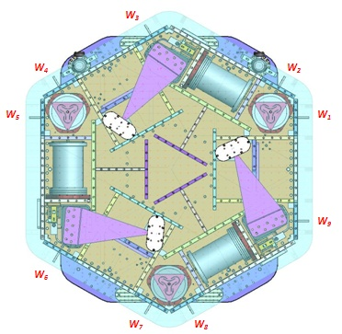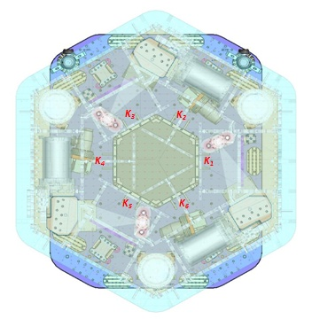

Figure – Wall Masses (W) and Keel masses (K) location. *South of picture = corner 1*

Issues/difficulties/comments regarding this test:

The mass budget was reported to be 576.22kgs during Assembly Validation. It is now 15kg lighter.

* The ISI was roughly balanced for the Initial In Chamber Testing.

**Acceptance Criteria**The Mass budget must be

* 579.1 Kg (cf. E1100427)+/-25Kg (5%)

**Test result: Passed: X Failed: .**

## Step 5: Shim Thickness

Issues/difficulties/comments regarding this test:

* The shims for locker D needed to be changed in-chamber, from .123” to .127”.

|  |  |
| --- | --- |
| Lockers | Shim thickness (mils) |
|
| A | 124 |
| B | 127 |
| C | 125 |
| D | 127 |

Table – Shims Thickness

**Test result: Passed: X Failed:**

**.**

## Step 6: Blade Spring Profile

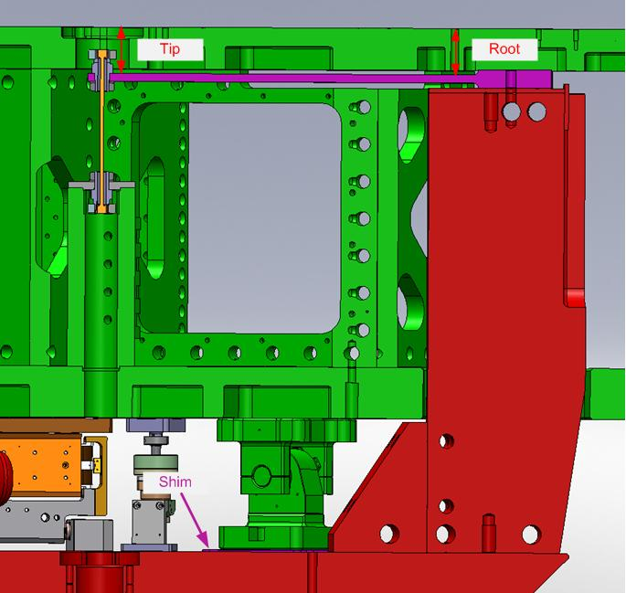

**figure – Blade spring profile measurement points**

|  |  |  |  |
| --- | --- | --- | --- |
| Blade # | Root (Mils) | Tip(Mils) | Flatness (mils) |
| 1 | 380 | 375 | 5 |
| 2 | 393 | 376 | 17 |
| 3 | 391 | 394 | 3 |

Table – Blade Spring Profile

Issues/difficulties/comments regarding this test:

Blade #2 is slightly out of the preferred range. The measurement was performed on a locked ISI. The locked position is not optimal, as lockers need to be reset.

**Acceptance Criteria:**

* Recorded for traceability.
* Flatness preferred within 0.015" inches.

**Test result: Passed: X Failed: .**

## Step 7: Lockers Adjustment

The maximum difference recorded on the CPSs between the unlocked and the locked positions is about 1V which roughly corresponds to 3280cts

Issues/difficulties/comments regarding this test:

* The maximum difference recorded on the CPSs between the unlocked and the locked positions is out of the preferred +/-1600cts range.
* Lockers should be set up with CPS Gaps, after this phase of testing.
* Lockers are reset after the installation of suspensions.

**Acceptance criteria:**

* Recorded for traceability
* Preferred within +/-1600cts

**Test result: Passed: Failed: X .**

**.**

## Step 8: CPS Gap

|  |  |
| --- | --- |
| H1 readout (count) | 1794 |
| H2 readout (count) | 2222 |
| H3 readout (count) | -3023 |
| V1 readout (count) | 1341 |
| V2 readout (count) | 42 |
| V3 readout (count) | -1088 |

**Table – CPS sensor readouts – ISI Unlocked, no drive**

Issues/difficulties/comments regarding this test:

* CPS mean readouts are out of the preferred +/-400cts range.
* CPS Gap should not be set up during this phase of testing.
* CPSs are reset after the installation of suspensions.

**Acceptance criteria:**

* Recorded for traceability
* Preferred within +/-400cts

**Test result: Passed: X Failed: .**

## Step 9: CPS and GS13 Spectra - ISI Unlocked

**Data files in SVN at:**

/seismic/HAM-ISI/H1/HAM4/Data/Spectra/Undamped/

- LHO_ISI_HAM4_ASD_m_CPS_T240_L4C_GS13_Locked_vs_Unlocked_2014_01_23.mat

**Scripts files for taking and processing the data, and plotting it in SVN at:**

seismic/HAM-ISI/Common/Testing_Functions_HAM_ISI/

* Plot_ASD_Unlocked_Locked_HAM_ISI.m
* Plot_ASD_Unlocked_Locked_Group_HAM_ISI.m

**Figures in SVN at:**

seismic/HAM-ISI/H1/HAM4/Data/Figures/Spectra/Undamped/

- LHO_ISI_HAM4_ASD_m_GS13_Requirements_Locked_vs_Unlocked_2014_01_23.fig

**-** LHO_ISI_HAM4_ASD_m_CPS_Requirements_Locked_vs_Unlocked_2012_01_23.fig

**CPS calibration:**

The CPS power spectrums are calibrated by using a sensitivity of 30.2 nm/count.

A description...

Figure - Calibrated CPS power spectrum – ISI Unlocked/Locked

A description...

Figure – Power spectrum Calibrated GS13 – ISI Unlocked/Locked

Issues/difficulties/comments regarding this test:

* Locked data was recorded during the weekend, after the optical table payload was removed (421.51kg).

**Acceptance criteria:**

* No cross talk (peaks at low frequencies + harmonics on measurements)
* Magnitudes of power spectra must be between requirement curves such as in the following figures (dashed lines)

**Test result: Passed: X Failed: .**

Comment:

GS13 requirement curves need to be updated.

## Step 10: GS13 ASD - Tabled Tilted

Not performed.

**Test result: Waived X Passed: Failed: .**

## Step 11: GS13 pressure readout

A description...

Figure – Pressure Readouts (01/23/2014)

**Acceptance criteria:**

- The pressure on *GS13_P* channels must be 102KPa +/-8 KPa (25000 counts +/- 3000 counts)

- *GS13_P* must vary the same way in each corner and *GS13_DIFF* must be constant (channels follow comparable trend)

**Test result: Passed: X Failed: .**

## Step 12: Actuators Sign and range of motion (Local drive)

|  |  |  |  |
| --- | --- | --- | --- |
|  | Negative drive | No Drive | Positive drive |
| H1 readout (count) | -23313 | 1793 | 24345 |
| H2 readout (count) | -23516 | 2209 | 23745 |
| H3 readout (count) | -26077 | -3049 | 23196 |
| V1 readout (count) | -17968 | 1361 | 21018 |
| V2 readout (count) | -23484 | 26 | 26979 |
| V3 readout (count) | -23434 | -1084 | 21278 |

Table - Range of motion - Local drive

**Acceptance criteria:**

* Main couplings sensors readout must be at least 16000 counts (~0.02”)
* A positive offset drive on one actuator must give positive sensor readout on the collocated sensor. Signs will also be tested when measuring local-to-local transfer functions.

**Test result: Passed: X Failed: .**

## Step 13: Static Testing (Tests in the local basis)

|  |  |  |  |  |  |  |
| --- | --- | --- | --- | --- | --- | --- |
|  | Sensors (counts) | | | | | |
| H1 | H2 | H3 | V1 | V2 | V3 |
| H1 | 1880 | 1177 | 1170 | -6 | 2 | -2 |
| H2 | 1175 | 1873 | 1167 | -10 | -2 | -1 |
| H3 | 1199 | 1196 | 1909 | -16 | -11 | 15 |
| V1 | 178 | 173 | -349 | 1339 | -33 | -586 |
| V2 | -343 | 184 | 172 | -593 | 1344 | -32 |
| V3 | 180 | -359 | 185 | -40 | -602 | 1425 |

Table - Main couplings and cross couplings

Issues/difficulties/comments regarding this test:

**Acceptance criteria:**

* **Vertical**

For a +1000 count offset drive on vertical actuators

* + Collocated sensors must be 1400 counts +/- 10%
* **Horizontal**

For a +1000 count offset drive on horizontal actuators

* + Collocated sensors must be 2000 counts +/- 10%
  + Non-collocated horizontal sensors must be 1250 counts +/-10%

**Test result: Passed: X Failed: .**

## Step 14: Linearity test

|  |  |  |  |  |
| --- | --- | --- | --- | --- |
|  | Slope | Offset | Average slope | Variation from average(%) |
| H1 | 1.88 | 1800 | 1.89 | -.5 |
| H2 | 1.87 | 2220 | -.7 |
| H3 | 1.91 | -3000 | 1.3 |
| V1 | 1.35 | 1350 | 1.37 | -1.6 |
| V2 | 1.35 | 43 | -1.7 |
| V3 | 1.42 | -1086 | 3.3 |

Table - Slopes and offset of the triplet Actuators - HAM-ISI - Sensors

A description...

Figure - Horizontal and vertical actuators x HAM-ISI x sensors

**Scripts files for taking data in SVN at:**

seismic/HAM-ISI/Common/Testing_Functions_HAM_ISI/

* Linearity_Test_Awgstream_HAM_ISI.m

**Data files in SVN at:** seismic/HAM-ISI/L1/HAM4/Data/Linearity_Test/

* LHO_ISI_HAM4_Linearity_test_20140123.mat

**Figures in SVN at:**

seismic/HAM-ISI/H1/HAM4/Data/Figures/Linearity_Test/

* LHO_ISI_HAM4_Linearity_test_20140123.fig

Issues/difficulties/comments regarding this test:

V3 actuator is out of spec.

**Acceptance criteria:**

* Horizontal and vertical slopes of the triplet actuators x HAM-ISI x sensors = Average slope +/- 1.5%

**Test result: Passed: X Failed: .**

## Step 15: Frequency response

All input/output filters are ON. HEPI is locked. The chamber is closed with sheets on.

## Step 15.1: Local to local measurements

**Data files in SVN at:**

seismic/HAM-ISI/H1/HAM4/Data/Transfer_Functions/Measurements/Undamped/

* H1_HAM4_ISI_Data_TF_L2L_5Hz_200Hz_20140124-174341.mat
* H1_HAM4_ISI_Data_TF_L2L_10mHz_100mHz_20140124-231906.mat
* H1_HAM4_ISI_Data_TF_L2L_100mHz_500mHz_20140124-223721.mat
* H1_HAM4_ISI_Data_TF_L2L_200Hz_800Hz_20140124-141943.mat
* H1_HAM4_ISI_Data_TF_L2L_500mHz_5Hz_20140125-101949.mat

**Data collection script files:**

seismic/HAM-ISI/H1/HAM4/Scripts/Data_Collection/

* Run_Exc_Batch_H1_HAM4.m

**Scripts files for processing and plotting in SVN at:**

seismic/HAM-ISI/H1/HAM4/Scripts/Control_Scripts/Version_2/

* Step_1_TF_Loc_to_Loc_H1_ISI_HAM4.m

**Figures in SVN at:**

seismic/HAM-ISI/H1/HAM4/Data/Figures/Transfer_Functions/Measurements/Undamped/

* H1_ISI_HAM4_TF_L2L_Raw_from_ACT_to_CPS_2014_01_24 .fig
* H1_ISI_HAM4_TF_L2L_Raw_from_ACT_to_GS13_2014_01_24 .fig

**Storage of measured transfer functions in the SVN at:**

seismic/HAM-ISI/H1/HAM4/Data/Transfer_Functions/Simulations/Undamped/

* H1_ISI_HAM4_TF_L2L_Raw_2014_01_24.mat

The local to local transfer functions and presented below.

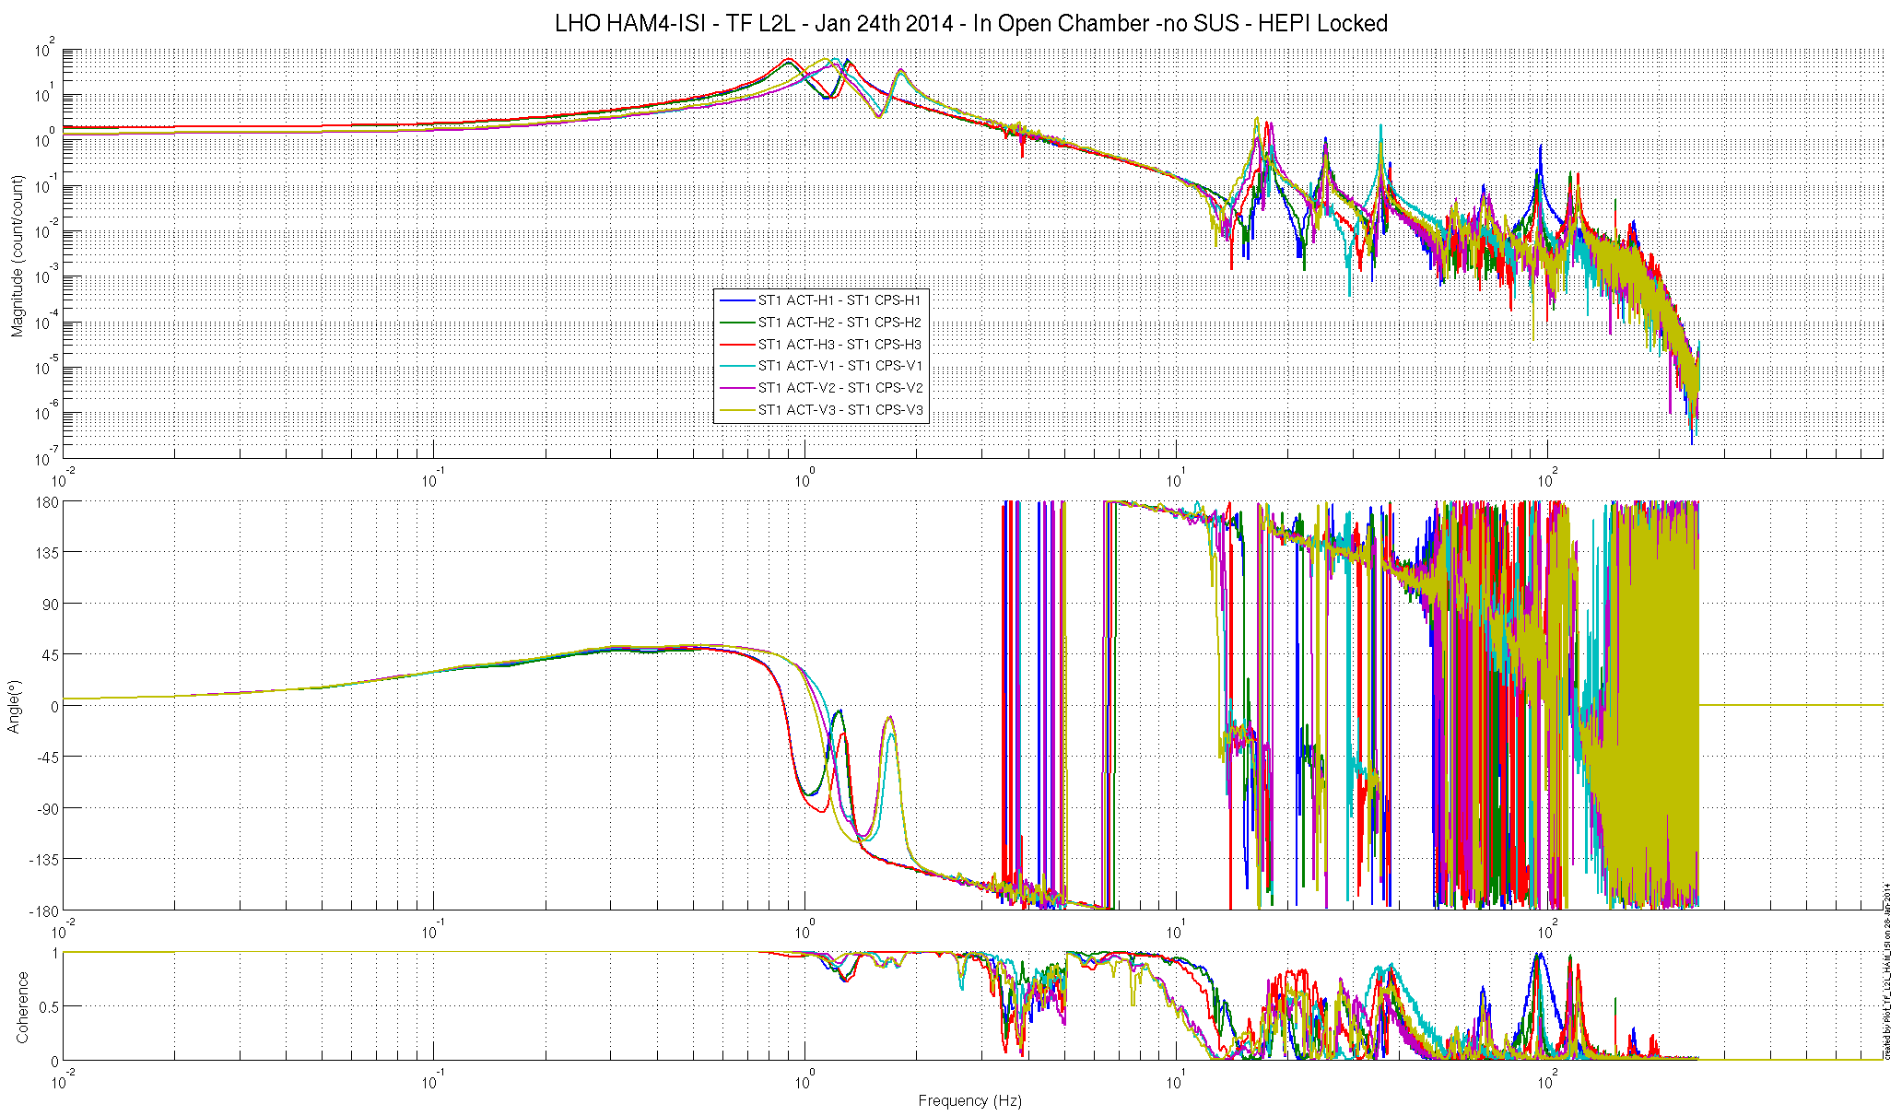

Figure - Local to Local Measurements –Capacitive Position Sensors

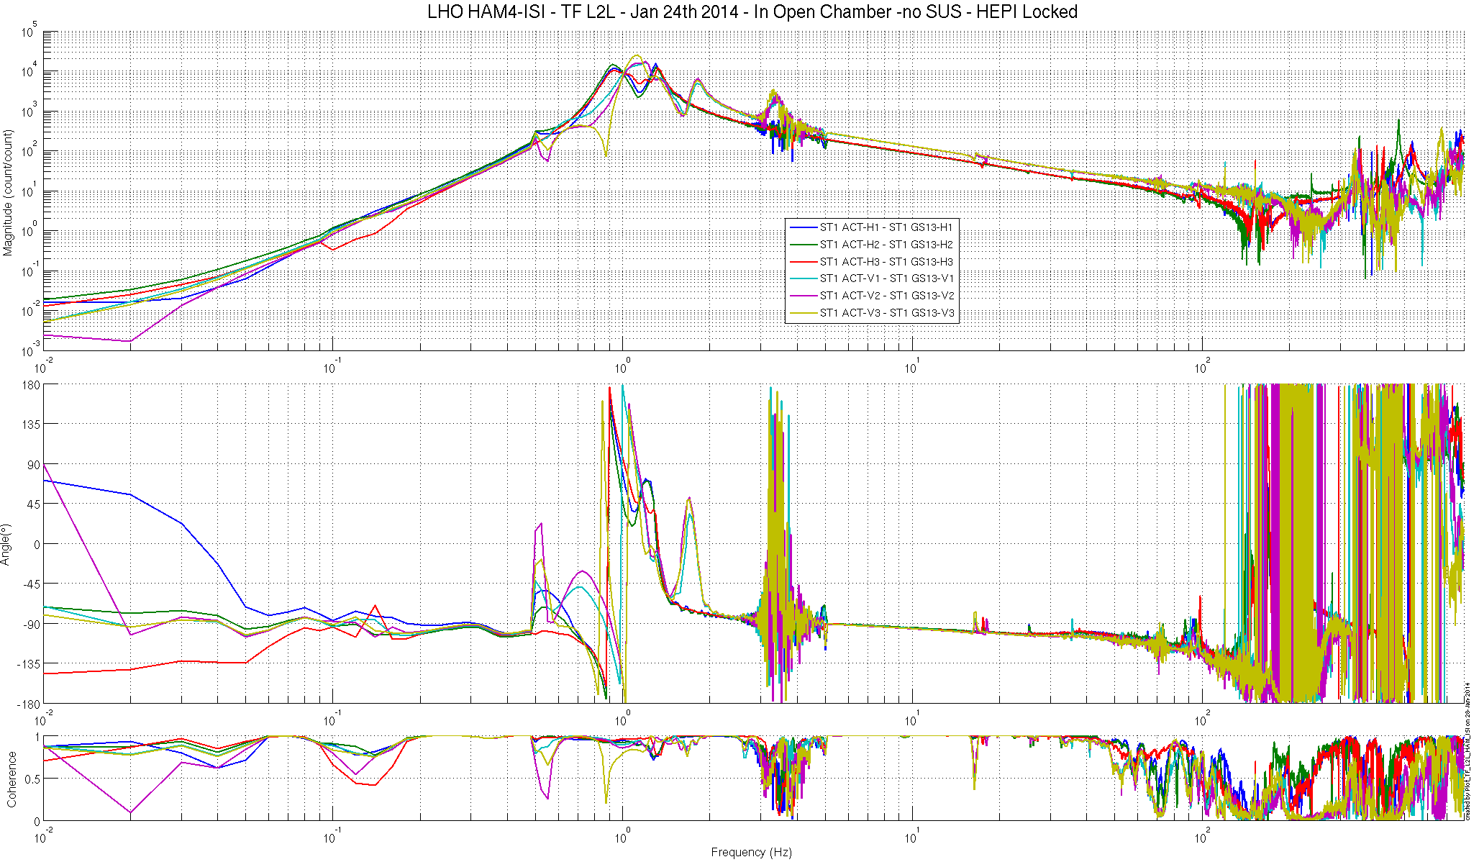

Figure - Local to Local Measurements – Inertial sensors

## Step 15.2: Local to local measurements V.S. LLO

**Data files in SVN at:**

**LHO:**

seismic/HAM-ISI/H1/HAM4/Data/Transfer_Functions/Measurements/Undamped/

* H1_HAM4_ISI_Data_TF_L2L_5Hz_200Hz_20140124-174341.mat
* H1_HAM4_ISI_Data_TF_L2L_10mHz_100mHz_20140124-231906.mat
* H1_HAM4_ISI_Data_TF_L2L_100mHz_500mHz_20140124-223721.mat
* H1_HAM4_ISI_Data_TF_L2L_500mHz_5Hz_20140124-194728.mat
* H1_HAM4_ISI_Data_TF_L2L_200Hz_800Hz_20140124-141943.mat

**Scripts files for processing and plotting in SVN at:**

seismic/HAM-ISI/H1/HAM4/Scripts/Control_Scripts/Version_2/

* Step_1_TF_Loc_to_Loc_H1_ISI_HAM4.m
* Plot_TF_L2L_HAM_with_LLO.m

Figure – TF L2L – Horizontal CPS

**Figure – TF L2L – Vertical CPS**

**Figure – TF L2L – Horizontal GS13**

**Figure – TF L2L – Vertical GS13**

**Acceptance criteria:**

* Good concordance with TF measured under the same conditions at LLO.
* Local to local measurements
  + On CPS, the phase must be 0º at DC
  + On Geophones, the phase must be -90º at DC
  + Identical shape in each corner
* Cartesian to Cartesian measurements
  + On CPS, the phase must be 0º at DC
  + On Geophones, the phase must be -90º at DC
  + Identical shape X/Y and RX/RY

**Test result: Passed: X Failed: .**

Conclusion  
Initial In-Chamber testing

The ISI was tested between Tuesday January 22nd and Saturday January 28th 2014. All the tests presented here were performed during that period. Other tasks were also performed then:

* Models were installed
* In-field cables were installed

A few major issues were found, as well as a number of normal minor issues.

Minor:

* CPSs and lockers will need to be reset after SUS install, as expected
* Several model errors were uncovered during testing. They have now been resolved. HAM5 had similar issues that have also been corrected.

Major:

* There are problems with the GS13 sections of the transfer functions. In the .5-5hz range the transfer function looks bad. The curves are not smooth up to the first resonance, only on the vertical sensors.
* At ~3 hz there is an additional resonance that may be caused by purge air. Many sensors also show low coherence here.
* The .5-5hz section was repeated with careful tuning in DTT and the issues can not be reproduced. This issue is still being looked into.
* The asci files for the DTT tf's are in the LHO H1 SVN at:
* seismic/HAM-ISI/H1/HAM4/Data/Transfer_Functions/Measurements/Undamped/

DTT_TF_20140128_GS13

DTT_TF_20140128_GS13_coh

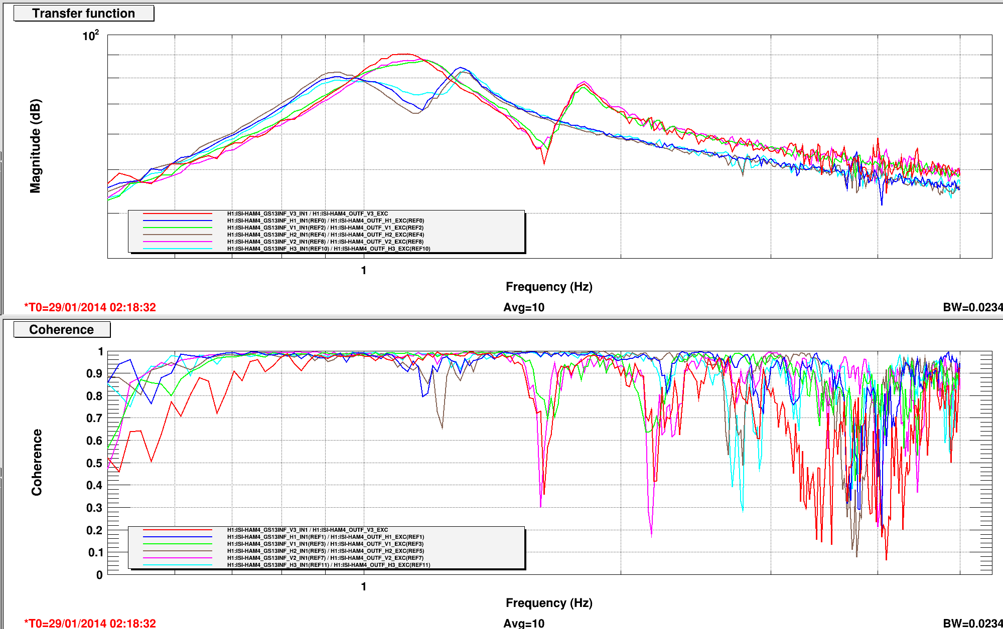

**Figure – TF L2L – GS13 in DTT**

Figure - Local to Local Measurements –Capacitive Position SensorsA description...

**Figure - Local to Local Measurements – Inertial sensors** 