LIGO Laboratory / LIGO Scientific Collaboration

LIGO- E1200424-v5 Advanced LIGO 1/21/2013

TwinCAT Library for ISC Whitening Chassis

Daniel Sigg

Distribution of this document:
LIGO Scientific Collaboration

This is an internal working note
of the LIGO Laboratory.

California Institute of Technology  LIGO Project – MS 18-34  1200 E. California Blvd.  Pasadena, CA 91125  Phone (626) 395-2129  Fax (626) 304-9834  E-mail: info@ligo.caltech.edu | Massachusetts Institute of Technology  LIGO Project – NW22-295  185 Albany St  Cambridge, MA 02139  Phone (617) 253-4824  Fax (617) 253-7014  E-mail: info@ligo.mit.edu
LIGO Hanford Observatory  P.O. Box 159  Richland WA 99352  Phone 509-372-8106  Fax 509-372-8137 | LIGO Livingston Observatory  P.O. Box 940  Livingston, LA 70754  Phone 225-686-3100  Fax 225-686-7189
http://www.ligo.caltech.edu/

Library
Title | IscWhitening
Version | 5
TwinCAT version | 2.11
Name space | IscWhitening
Author | Daniel Sigg
Description | Controls an ISC whitening chassis, D1002559, through the 384-channel binary IO chassis, D1100251. The binary IO chassis is controlled through a Modbus interface using four Acromag ES2113 that are connected to an EtherCAT-to-Modbus gateway, HMS AB9000. The setup instructions can be found in T1100607 and C1107420.  The ISC whitening chassis contain 8 channels of whitening, D1001530. Each whitening channel employs a gain slider and 3 separately switchable filter stages. The ISC whitening chassis are used to interface the I and Q readouts of an LSC demodulator to the DAQ system, they are used to interface the I and Q readouts of a ASC wavefront sensor, and they are used to interface the 4 segments of a QPD (quad photodiode). Four LSC demodulators can be controlled from a single ISC whitening chassis, or one wavefront sensor, or two QPDs. Up to 6 ISC whitening chassis are controlled from a 384-channel binary IO chassis.  This library is organized in two parts:  - An interface to the binary IO chassis that controls individual IO lines and organizes them by ISC whitening chassis, and  - Individual interfaces for the LSC PDs, ASC WFSs and QPDs which interface with the above binary IO chassis data structures.
Error codes | 0x0001 – Illegal chassis number  0x0002 – Illegal channel index number  Individual channel error indications:  0x0004 – Invalid data (first channel)  0x0008 – Invalid data (second channel)  …  0x0200 – Invalid data (eighth channel)  For unified interfaces over multiple channels:  0x0400 – Readback different  0x0800 – Gain different  0x1000 – GainStep different  0x2000 – Filter different  0x4000 – Set different  0x8000 – Toggle different
Library dependencies | Error, SaveRestore, TcSystem, TcEtherCAT

Hardware Input Type
TYPE IscWhiteningInStruct :
STRUCT
LiveList: ARRAY[1..8] OF BYTE;
PCB: ARRAY[1..4,1..13] OF WORD;
InfoData: IscWhiteningInfoDataStruct;
END_STRUCT
END_TYPE
Type name | IscWhiteningInStruct
Description | Structure of the hardware inputs that mapped into the EtherCAT memory space by the EtherCAT-to-Modbus gateway. For mapping see next page.
Definition | STRUCT
Element | Name: LiveList  Type: ARRAY[1..8] OF BYTE  Description: Information about the active connections, see HMS AB9000 manual
Element | Name: PCB  Type: ARRAY[1..4,1..13] OF WORD  Description: Readbacks form the binary IO chassis, see HMS AB9000 and ES2113 manual
Element | Name: InfoData  Type: IscWhiteningInfoDataStruct  Description: State and AMS address information of the gateway.

Hardware Output Type
TYPE IscWhiteningOutStruct :
STRUCT
PCB: ARRAY[1..4,1..6] OF WORD;
LiveList: ARRAY[1..8] OF BYTE;
InfoData: IscWhiteningInfoDataStruct;
END_STRUCT
END_TYPE
Type name | IscWhiteningOutStruct
Description | Structure of the hardware outputs that mapped into the EtherCAT memory space by the EtherCAT-to-Modbus gateway. The outputs LiveList and InfoData are used in configurations where multiple 384-channel binary IO chassis are read through the same EtherCAT-to-Modbus gateway. In this case only the first IO chassis connects to the LiveList and InfoData of the gateway, whereas the following chassis daisy chain with the corresponding outputs of the previous chassis. For mapping see next page.
Definition | STRUCT
Element | Name: PCB  Type: ARRAY[1..4,1..6] OF WORD  Description: Controls to the binary IO chassis, see HMS AB9000 and ES2113 manual
Element | Name: LiveList  Type: ARRAY[1..8] OF BYTE  Description: Information about the active connections, see HMS AB9000 manual. This output list strips the first 12 bits and shifts the result by 12 bits to the left, effectively removing the live bits of the chassis associated with this structure. This can be used in a daisy chain configuration as an input live list for the next chassis in the chain.
Element | Name: InfoData  Type: IscWhiteningInfoDataStruct  Description: State and AMS address information of the gateway.

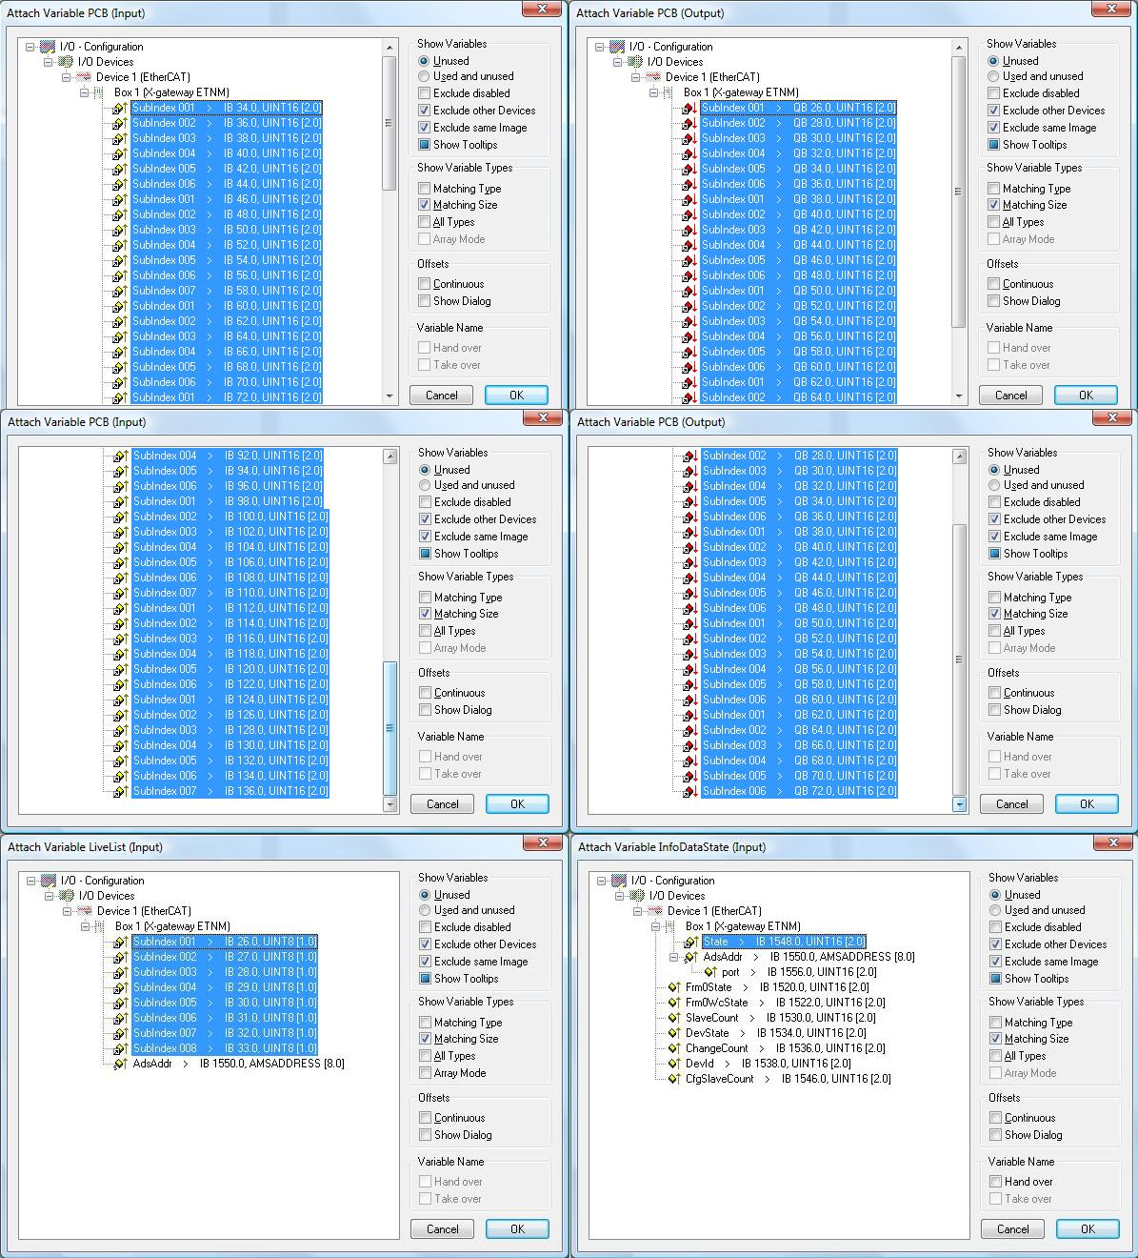

Fig 1. Mapping of IO structures into the EtherCAT memory space.

Internal Interface Type
TYPE IscWhiteningStruct :
STRUCT
Chassis: ARRAY[1..6] OF IscWhiteningRawChassisStruct;
END_STRUCT
END_TYPE
Type name | IscWhiteningStruct
Description | Internal interface structure between the binary IO chassis function blocks and the ISC whitening chassis function blocks
Definition | STRUCT
Input/Output Tag | Name: Chassis  Type: ARRAY[1..6] OF IscWhiteningRawChassisStruct  Description: Contains the binary IO data organized by chassis and channel.

Function Block
FUNCTION_BLOCK IscWhiteningInterfaceFB
VAR_INPUT
Request: SaveRestoreEnum;
SequenceID: INT;
In: IscWhiteningInStruct;
END_VAR
VAR_OUTPUT
Out: IscWhiteningOutStruct;
END_VAR
VAR_IN_OUT
Val: IscWhiteningStruct;
ValInit: IscWhiteningStruct;
END_VAR
Name | IscWhiteningInterfaceFB
Description | Controls a 384-channel binary IO chassis.
Input argument | Name: Request  Type: SaveRestoreEnum  Description: Request for save/restore/safemode or noop.
Input argument | Name: SequencID  Type: INT  Description: Must be set to 1 for the first binary IO chassis, 2 for the second, etc.
Input argument | Name: In  Type: IscWhiteningInStruct  Description: Input hardware structure
Output argument | Name: Out  Type: IscWhiteningOutStruct  Description: Output hardware structure
In/out argument | Name: ValInit  Type: IscWhiteningStruct  Description: Save/restore variable in persistent memory
In/out argument | Name: Val  Type: IscWhiteningStruct  Description: Internal interface structure

User Interface Type
TYPE IscWhiteningChannelStruct :
STRUCT
Error: ErrorStruct;
Gain: INT;
GainStep: INT;
Filter: ARRAY [1..3] OF BOOL;
Set: ARRAY [1..3] OF BOOL;
Toggle: ARRAY [1..3] OF BOOL;
Readback: BYTE;
END_STRUCT
END_TYPE
 | IscWhiteningChannelStruct
Description | Structure of the user interface tags that are used to control a single channel of the ISC whitening chassis
Definition | STRUCT
Output Tag | Name: Error  Type: ErrorStruct  Description: Calls error handler
In/Out Tag | Name: Gain  Type: INT  Description: Whitening gain in dB from 0 dB to 45 dB in 3 dB steps.  This value is tight to GainStep. Any change in one of the two variables will updated the other.
In/Out Tag | Name: GainStep  Type: INT  Description: Whitening gain in steps from 0 to 15.  This value is tight to Gain. Any change in one of the two variables will updated the other.
Output Tag | Name: Filter  Type: ARRAY [1..3] OF BOOL  Description: True if the whitening filter is on. Each array index represents a filter section.
Input Tag | Name: Set  Type: ARRAY [1..3] OF BOOL  Description: Set value for the whitening filters. Each array index represents a filter section.
Input Tag | Name: Toggle  Type: ARRAY [1..3] OF BOOL  Description: Set to True to toggle the state of a whitening filter. Each array index represents a filter section.
Output Tag | Name: Readback  Type: BYTE  Description: Bit encoded readback value from the whitening chassis

Function Block
FUNCTION_BLOCK IscWhiteningChannelFB
VAR_INPUT
Request: SaveRestoreEnum;
Chassis: INT; (* 1 to 6 *)
Index: INT; (* 1 to 8 *)
END_VAR
VAR_IN_OUT
IscWhitening: IscWhiteningStruct;
ChannelInit: IscWhiteningChannelStruct;
Channel: IscWhiteningChannelStruct;
END_VAR
Name | IscWhiteningChannelFB
Description | Controls a single channel in the whitening chassis (1 byte)  Call this function block before IscWhiteningInterfaceFB.
Input argument | Name: Request  Type: SaveRestoreEnum  Description: Request for save/restore/safemode or noop.
In/Out argument | Name: IscWhitening  Type: IscWhiteningStruct  Description: Internal interface structure
Input argument | Name: Chassis  Type: INT  Description: Select the chassis: Values from 1 to 6
Input argument | Name: Index  Type: INT  Description: Select the channel: Index from 1 to 8
In/out argument | Name: ChannelInit  Type: IscWhiteningChannelStruct  Description: Save/restore variable in persistent memory
In/out argument | Name: Channel  Type: IscWhiteningChannelStruct  Description: User Interface structure for a single channel of ISC whitening

User Interface Type
TYPE IscWhiteningDemodIQStruct :
STRUCT
Error: ErrorStruct;
I: IscWhiteningChannelStruct;
Q: IscWhiteningChannelStruct;
END_STRUCT
END_TYPE
Type name | IscWhiteningDemodIQStruct
Description | Structure of the user interface tags that are used to control two channels of the ISC whitening chassis which are used for an LSC demodulator
Definition | STRUCT
Output Tag | Name: Error  Type: ErrorStruct  Description: Calls error handler
In/Out Tag | Name: I  Type: IscWhiteningChannelStruct  Description:
In/Out Tag | Name: Q  Type: IscWhiteningChannelStruct  Description: Whitening gain in steps from 0 to 15.  This value is tight to Gain. Any change in one of the two variables will update the other.

Function Block
FUNCTION_BLOCK IscWhiteningDemodIQFB
VAR_INPUT
Request: SaveRestoreEnum;
Chassis: INT; (* 1 to 6 *)
Index: INT; (* 1, 3, 5 or to 7 *)
END_VAR
VAR_IN_OUT
IscWhitening: IscWhiteningStruct;
DemodInit: IscWhiteningDemodIQStruct;
Demod: IscWhiteningDemodIQStruct;
END_VAR
Name | IscWhiteningDemodIQFB
Description | Controls two channels in the whitening chassis (2 bytes)  Call this function block before IscWhiteningInterfaceFB.
Input argument | Name: Request  Type: SaveRestoreEnum  Description: Request for save/restore/safemode or noop.
In/Out argument | Name: IscWhitening  Type: IscWhiteningStruct  Description: Internal interface structure
Input argument | Name: Chassis  Type: INT  Description: Select the chassis: Values from 1 to 6
Input argument | Name: Index  Type: INT  Description: Select the channel: Index is 1, 3, 5, or 7  The selected index represents the quad-phase channel, whereas Index+1 represents the in-phase channel.
In/out argument | Name: DemodInit  Type: IscWhiteningDemodIQStruct  Description: Save/restore variable in persistent memory
In/out argument | Name: Demod  Type: IscWhiteningDemodIQStruct  Description: User Interface structure for two channels of ISC whitening describing the I and Q channels of a LSC demodulator.

User Interface Type
TYPE IscWhiteningSimpleDemodIQStruct:
STRUCT
Error: ErrorStruct;
Gain: INT;
GainStep: INT;
Filter: ARRAY [1..3] OF BOOL;
Set: ARRAY [1..3] OF BOOL;
Toggle: ARRAY [1..3] OF BOOL;
IReadback: BYTE;
QReadback: BYTE;
END_STRUCT
END_TYPE
 | IscWhiteningSimpleDemodIQStruct
Description | Simplified structure of the user interface tags that are used to control two channels of the ISC whitening chassis which are used for an LSC demodulator. All channels are switched simultaneously.
Definition | STRUCT
Output Tag | Name: Error  Type: ErrorStruct  Description: Calls error handler
In/Out Tag | Name: Gain  Type: INT  Description: Whitening gain in dB from 0 dB to 45 dB in 3 dB steps.  This value is tight to GainStep. Any change in one of the two variables will updated the other.
In/Out Tag | Name: GainStep  Type: INT  Description: Whitening gain in steps from 0 to 15.  This value is tight to Gain. Any change in one of the two variables will updated the other.
Output Tag | Name: Filter  Type: ARRAY [1..3] OF BOOL  Description: True if the whitening filter is on. Each array index represents a filter section.
Input Tag | Name: Set  Type: ARRAY [1..3] OF BOOL  Description: Set value for the whitening filters. Each array index represents a filter section.
Input Tag | Name: Toggle  Type: ARRAY [1..3] OF BOOL  Description: Set to True to toggle the state of a whitening filter. Each array index represents a filter section.
Output Tag | Name: IReadback  Type: BYTE  Description: Bit encoded readback value from the whitening chassis I-phase channel
Output Tag | Name: QReadback  Type: BYTE  Description: Bit encoded readback value from the whitening chassis Q-phase channel

Function Block
FUNCTION_BLOCK IscWhiteningSimpleDemodIQFB
VAR_INPUT
Request: SaveRestoreEnum;
Chassis: INT; (* 1 to 6 *)
Index: INT; (* 1, 3, 5 or to 7 *)
END_VAR
VAR_IN_OUT
IscWhitening: IscWhiteningStruct;
DemodInit: IscWhiteningSimpleDemodIQStruct;
Demod: IscWhiteningSimpleDemodIQStruct;
END_VAR
Name | IscWhiteningSimpleDemodIQFB
Description | Controls two channels in the whitening chassis (2 bytes). All channels are switched simultaneously.  Call this function block before IscWhiteningInterfaceFB.
Input argument | Name: Request  Type: SaveRestoreEnum  Description: Request for save/restore/safemode or noop.
In/Out argument | Name: IscWhitening  Type: IscWhiteningStruct  Description: Internal interface structure
Input argument | Name: Chassis  Type: INT  Description: Select the chassis: Values from 1 to 6
Input argument | Name: Index  Type: INT  Description: Select the channel: Index is 1, 3, 5, or 7  The selected index represents the quad-phase channel, whereas Index+1 represents the in-phase channel.
In/out argument | Name: DemodInit  Type: IscWhiteningSimpleDemodIQStruct  Description: Save/restore variable in persistent memory
In/out argument | Name: Demod  Type: IscWhiteningSimpleDemodIQStruct  Description: User Interface structure for two channels of ISC whitening describing the I and Q channels of a LSC demodulator.

User Interface Type
TYPE IscWhiteningDemodWfsStruct :
STRUCT
Error: ErrorStruct;
Seg: ARRAY [1..4] OF IscWhiteningDemodIQStruct;
END_STRUCT
END_TYPE
Type name | IscWhiteningDemodWfsStruct
Description | Structure of the user interface tags that are used to control eight channels of the ISC whitening chassis which are used for an ASC wavefront sensor demodulator.
Definition | STRUCT
Output Tag | Name: Error  Type: ErrorStruct  Description: Calls error handler
In/Out Tag | Name: Seg  Type: ARRAY [1..4] OF IscWhiteningDemodIQStruct  Description: The four segments of a wavefront sensor

Function Block
FUNCTION_BLOCK IscWhiteningDemodWfsFB
VAR_INPUT
Request: SaveRestoreEnum;
Chassis: INT; (* 1 to 6 *)
END_VAR
VAR_IN_OUT
IscWhitening: IscWhiteningStruct;
DemodWfsInit: IscWhiteningDemodWfsStruct;
DemodWfs: IscWhiteningDemodWfsStruct;
END_VAR
Name | IscWhiteningDemodWfsFB
Description | Controls eight channels in a whitening chassis (8 bytes)  Call this function block before IscWhiteningInterfaceFB.
Input argument | Name: Request  Type: SaveRestoreEnum  Description: Request for save/restore/safemode or noop.
In/Out argument | Name: IscWhitening  Type: IscWhiteningStruct  Description: Internal interface structure
Input argument | Name: Chassis  Type: INT  Description: Select the chassis: Values from 1 to 6
In/out argument | Name: DemodWfsInit  Type: IscWhiteningDemodWfsStruct  Description: Save/restore variable in persistent memory
In/out argument | Name: DemodWfs  Type: IscWhiteningDemodWfsStruct  Description: User Interface structure for eight channels of ISC whitening describing the I and Q channels of a four segment ASC wavefront sensor demodulator.

User Interface Type
TYPE IscWhiteningSimpleDemodWfsStruct:
STRUCT
Error: ErrorStruct;
Gain: INT;
GainStep: INT;
Filter: ARRAY [1..3] OF BOOL;
Set: ARRAY [1..3] OF BOOL;
Toggle: ARRAY [1..3] OF BOOL;
IReadback: DWORD;
QReadback: DWORD;
END_STRUCT
END_TYPE
 | IscWhiteningSimpleDemodWfsStruct
Description | Simplified of the user interface tags that are used to control eight channels of the ISC whitening chassis which are used for an ASC wavefront sensor demodulator. All channels are switched simultaneously.
Definition | STRUCT
Output Tag | Name: Error  Type: ErrorStruct  Description: Calls error handler
In/Out Tag | Name: Gain  Type: INT  Description: Whitening gain in dB from 0 dB to 45 dB in 3 dB steps.  This value is tight to GainStep. Any change in one of the two variables will updated the other.
In/Out Tag | Name: GainStep  Type: INT  Description: Whitening gain in steps from 0 to 15.  This value is tight to Gain. Any change in one of the two variables will updated the other.
Output Tag | Name: Filter  Type: ARRAY [1..3] OF BOOL  Description: True if the whitening filter is on. Each array index represents a filter section.
Input Tag | Name: Set  Type: ARRAY [1..3] OF BOOL  Description: Set value for the whitening filters. Each array index represents a filter section.
Input Tag | Name: Toggle  Type: ARRAY [1..3] OF BOOL  Description: Set to True to toggle the state of a whitening filter. Each array index represents a filter section.
Output Tag | Name: IReadback  Type: DWORD  Description: Bit encoded readback value from the four whitening chassis I-phase channels. Least significant byte is first channel.
Output Tag | Name: QReadback  Type: DWORD  Description: Bit encoded readback value from the four whitening chassis Q-phase channel. Least significant byte is first channel.

Function Block
FUNCTION_BLOCK IscWhiteningSimpleDemodWfsFB
VAR_INPUT
Request: SaveRestoreEnum;
Chassis: INT; (* 1 to 6 *)
END_VAR
VAR_IN_OUT
IscWhitening: IscWhiteningStruct;
DemodWfsInit: IscWhiteningSimpleDemodWfsStruct;
DemodWfs: IscWhiteningSimpleDemodWfsStruct;
END_VAR
Name | IscWhiteningSimpleDemodWfsFB
Description | Controls eight channels in a whitening chassis (8 bytes). All channels are switched simultaneously.  Call this function block before IscWhiteningInterfaceFB.
Input argument | Name: Request  Type: SaveRestoreEnum  Description: Request for save/restore/safemode or noop.
In/Out argument | Name: IscWhitening  Type: IscWhiteningStruct  Description: Internal interface structure
Input argument | Name: Chassis  Type: INT  Description: Select the chassis: Values from 1 to 6
In/out argument | Name: DemodWfsInit  Type: IscWhiteningSimpleDemodWfsStruct  Description: Save/restore variable in persistent memory
In/out argument | Name: DemodWfs  Type: IscWhiteningSimpleDemodWfsStruct  Description: User Interface structure for eight channels of ISC whitening describing the I and Q channels of a four segment ASC wavefront sensor demodulator.

User Interface Type
TYPE IscWhiteningQpdStruct :
STRUCT
Error: ErrorStruct
Seg: ARRAY [1..4] OF IscWhiteningChannelStruct;
END_STRUCT
END_TYPE
Type name | IscWhiteningQpdStruct
Description | Structure of the user interface tags that are used to control four channels of the ISC whitening chassis which are used for an ASC quadrant photo detector.
Definition | STRUCT
Output Tag | Name: Error  Type: ErrorStruct  Description: Calls error handler
In/Out Tag | Name: Seg  Type: ARRAY [1..4] OF IscWhiteningChannelStruct  Description: The four segments of a QPD sensor

Function Block
FUNCTION_BLOCK IscWhiteningQpdFB
VAR_INPUT
Request: SaveRestoreEnum;
Chassis: INT; (* 1 to 6 *)
Index: INT; (* 1 or 5 *)
END_VAR
VAR_IN_OUT
IscWhitening: IscWhiteningStruct;
QpdInit: IscWhiteningQpdStruct;
Qpd: IscWhiteningQpdStruct;
END_VAR
Name | IscWhiteningQpdFB
Description | Controls four channels in a whitening chassis (4 byte)  Call this function block before IscWhiteningInterfaceFB.
Input argument | Name: Request  Type: SaveRestoreEnum  Description: Request for save/restore/safemode or noop.
In/Out argument | Name: IscWhitening  Type: IscWhiteningStruct  Description: Internal interface structure
Input argument | Name: Chassis  Type: INT  Description: Select the chassis: Values from 1 to 6
Input argument | Name: Index  Type: INT  Description: Select the channel: Index from 1 or 5  The selected index represents the first channel of a QPD, whereas Index+1, Index+2 and Index+3 represent the second, third and forth channel, respectively.
In/out argument | Name: QpdInit  Type: IscWhiteningQpdStruct  Description: Save/restore variable in persistent memory
In/out argument | Name: Qpd  Type: IscWhiteningQpdStruct  Description: User Interface structure for four channels of ISC whitening describing the channels of a four segment ASC quad photodiode.

User Interface Type
TYPE IscWhiteningSimpleQpdStruct:
STRUCT
Error: ErrorStruct;
Gain: INT;
GainStep: INT;
Filter: ARRAY [1..3] OF BOOL;
Set: ARRAY [1..3] OF BOOL;
Toggle: ARRAY [1..3] OF BOOL;
Readback: DWORD;
END_STRUCT
END_TYPE
 | IscWhiteningSimpleQpdStruct
Description | Simplified structure of the user interface tags that are used to control four channels of the ISC whitening chassis which are used for an ASC quadrant photo detector. All channels are switched simultaneously.
Definition | STRUCT
Output Tag | Name: Error  Type: ErrorStruct  Description: Calls error handler
In/Out Tag | Name: Gain  Type: INT  Description: Whitening gain in dB from 0 dB to 45 dB in 3 dB steps.  This value is tight to GainStep. Any change in one of the two variables will updated the other.
In/Out Tag | Name: GainStep  Type: INT  Description: Whitening gain in steps from 0 to 15.  This value is tight to Gain. Any change in one of the two variables will updated the other.
Output Tag | Name: Filter  Type: ARRAY [1..3] OF BOOL  Description: True if the whitening filter is on. Each array index represents a filter section.
Input Tag | Name: Set  Type: ARRAY [1..3] OF BOOL  Description: Set value for the whitening filters. Each array index represents a filter section.
Input Tag | Name: Toggle  Type: ARRAY [1..3] OF BOOL  Description: Set to True to toggle the state of a whitening filter. Each array index represents a filter section.
Output Tag | Name: Readback  Type: DWORD  Description: Bit encoded readback value from the four whitening chassis QPD channels. Least significant byte is first channel.

Function Block
FUNCTION_BLOCK IscWhiteningSimpleQpdFB
VAR_INPUT
Request: SaveRestoreEnum;
Chassis: INT; (* 1 to 6 *)
Index: INT; (* 1 or 5 *)
END_VAR
VAR_IN_OUT
IscWhitening: IscWhiteningStruct;
QpdInit: IscWhiteningSimpleQpdStruct;
Qpd: IscWhiteningSimpleQpdStruct;
END_VAR
Name | IscWhiteningSimpleQpdFB
Description | Controls four channels in a whitening chassis (4 byte). All channels are switched simultaneously.  Call this function block before IscWhiteningInterfaceFB.
Input argument | Name: Request  Type: SaveRestoreEnum  Description: Request for save/restore/safemode or noop.
In/Out argument | Name: IscWhitening  Type: IscWhiteningStruct  Description: Internal interface structure
Input argument | Name: Chassis  Type: INT  Description: Select the chassis: Values from 1 to 6
Input argument | Name: Index  Type: INT  Description: Select the channel: Index from 1 or 5  The selected index represents the first channel of a QPD, whereas Index+1, Index+2 and Index+3 represent the second, third and forth channel, respectively.
In/out argument | Name: QpdInit  Type: IscWhiteningSimpleQpdStruct  Description: Save/restore variable in persistent memory
In/out argument | Name: Qpd  Type: IscWhiteningSimpleQpdStruct  Description: User Interface structure for four channels of ISC whitening describing the channels of a four segment ASC quad photodiode.

Program Example:

PROGRAM Whitening
VAR
IscWhiteningIn AT %IB0: IscWhiteningInStruct;
IscWhiteningOut AT %QB0: IscWhiteningOutStruct;
IscWhitening: IscWhiteningStruct;
IscWhiteningChassis: IscWhiteningInterfaceFB;

LenSensor: ARRAY [1..4] OF IscWhiteningDemodIQStruct;
Power: IscWhiteningChannelStruct;
Wfs: ARRAY [1..2] OF IscWhiteningDemodWfsStruct;
Qpd: ARRAY [1..2] OF IscWhiteningQpdStruct;
DemodLen: ARRAY [1..4] OF IscWhiteningDemodIQFB;
MonitorPower: IscWhiteningChannelFB;
DemodWfs: ARRAY [1..2] OF IscWhiteningDemodWfsFB;
MonitorQpd: ARRAY [1..2] OF IscWhiteningQpdFB;

SaveRestore: SaveRestoreFB;
GotoSafe: BOOL;
Request: SaveRestoreEnum;
I: INT;
END_VAR
VAR PERSISTENT
IscWhiteningInit: IscWhiteningStruct;
END_VAR

SaveRestore(SaveInterval := T#1m, GotoSafe := GotoSafe, Request => Request);
(* Process individual sensors *)
FOR I := 1 TO 4 DO
DemodLen[I] (IscWhitening := IscWhitening, Chassis := 1, Index := I, Demod := LenSensor[I]);
END_FOR;
MonitorPower (IscWhitening := IscWhitening, Chassis := 1, Index := 5, Channel := Power);
FOR I := 1 TO 2 DO
DemodWfs[I] (IscWhitening := IscWhitening, Chassis := I+1, DemodWfs := Wfs[I]);
END_FOR;
FOR I := 1 TO 2 DO
MonitorQpd[I] (IscWhitening := IscWhitening, Chassis := 4, Index := I+4, Qpd := Qpd[I]);
END_FOR;

(* Process whitening chassis after individual sensors *)
IscWhiteningChassis (Request := Request, SequenceID := 1, In := IscWhiteningIn,
Out => IscWhiteningOut, Val := IscWhitening, ValInit := IscWhiteningInit);

Visual
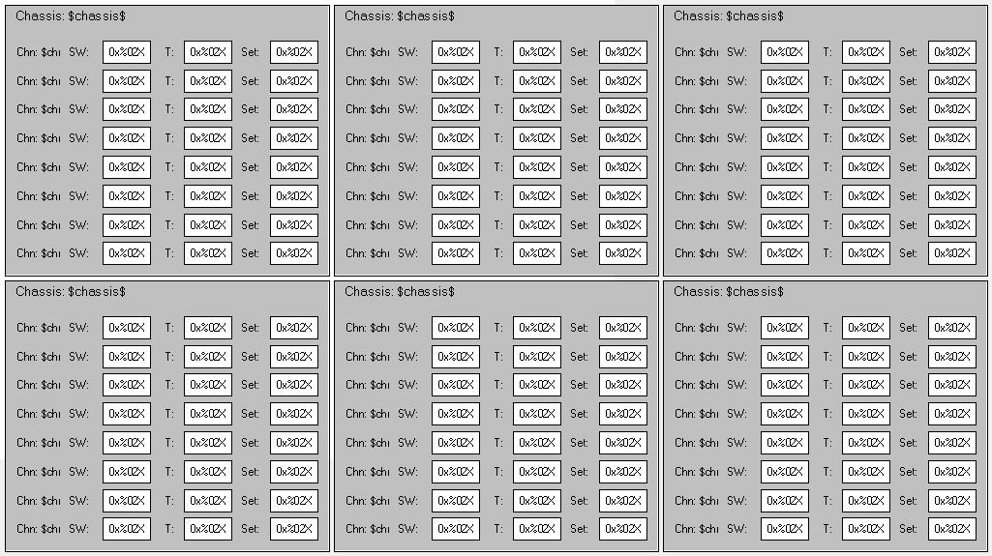
Name | IscWhiteningVis
Description | Displays the tags of an 384-channel binary IO chassis organized in six ISC whitening chassis which in turn show a list of 8 channels each. Each channel has 8 bits (1 byte) and shows the readback value. It lets you choose a new set value or apply a toggle value. The channel background turns red if the value is invalid.
Placeholder | Name: whitening  Type: IscWhiteningStruct  Description: Internal interface structure

Visual
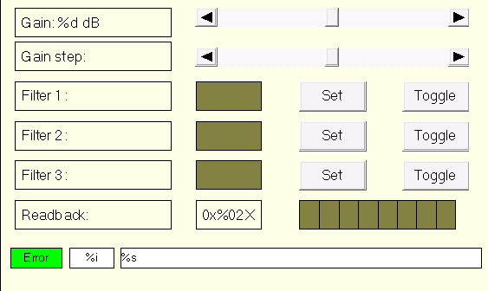
Name | IscWhiteningChannelVis
Description | Displays the tags of single channel of whitening
Placeholder | Name: channel  Type: IscWhiteningChannelStruct  Description: ISC whitening channel structure

Visual
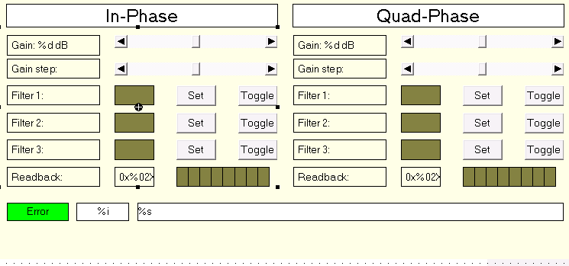
Name | IscWhiteningDemodIQVis
Description | Displays the tags of two channels of whitening
Placeholder | Name: demod  Type: IscWhiteningDemodIQStruct  Description: ISC whitening IQ demodulator structure

Visual
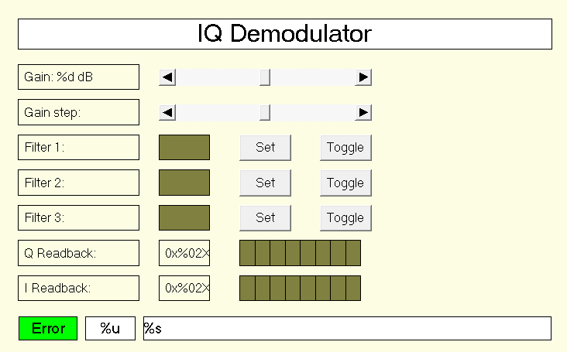

Name | IscWhiteningSimpleDemodIQVis
Description | Displays the tags of two channels of whitening
Placeholder | Name: demod  Type: IscWhiteningSimpleDemodIQStruct  Description: Unified ISC whitening IQ demodulator structure

Visual
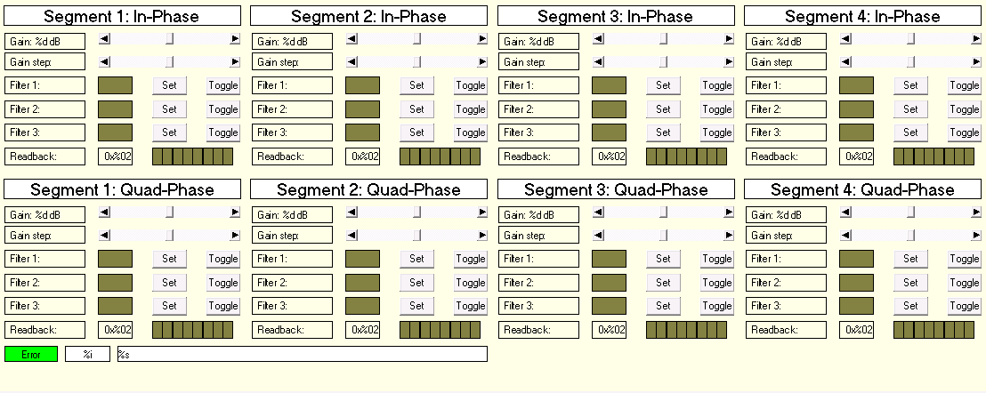
Name | IscWhiteningDemodWfsVis
Description | Displays the tags of eight channels of whitening
Placeholder | Name: wfs  Type: IscWhiteningDemodWfsStruct  Description: ISC whitening WFS demodulator structure

Visual
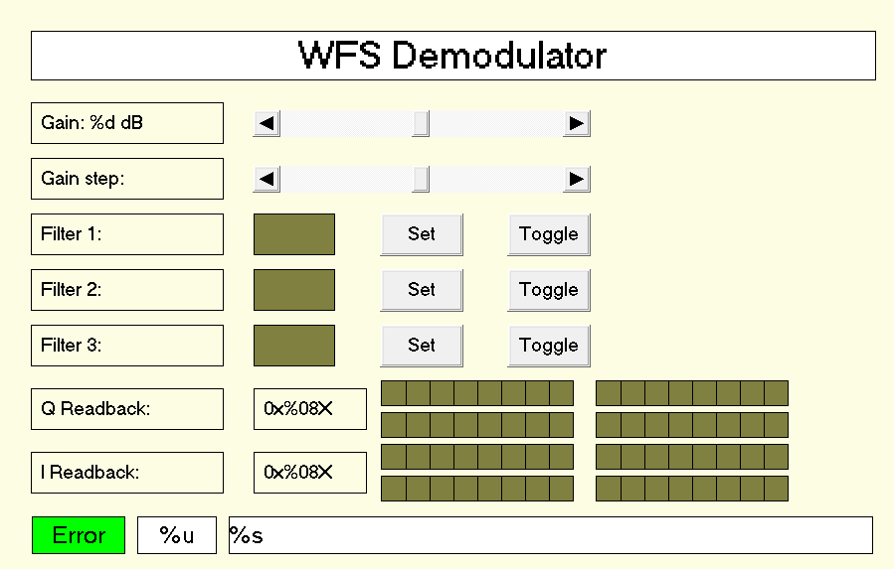
Name | IscWhiteningSimpleDemodWfsVis
Description | Displays the tags of eight channels of whitening
Placeholder | Name: wfs  Type: IscWhiteningSimpleDemodWfsStruct  Description: Unified ISC whitening WFS demodulator structure

Visual
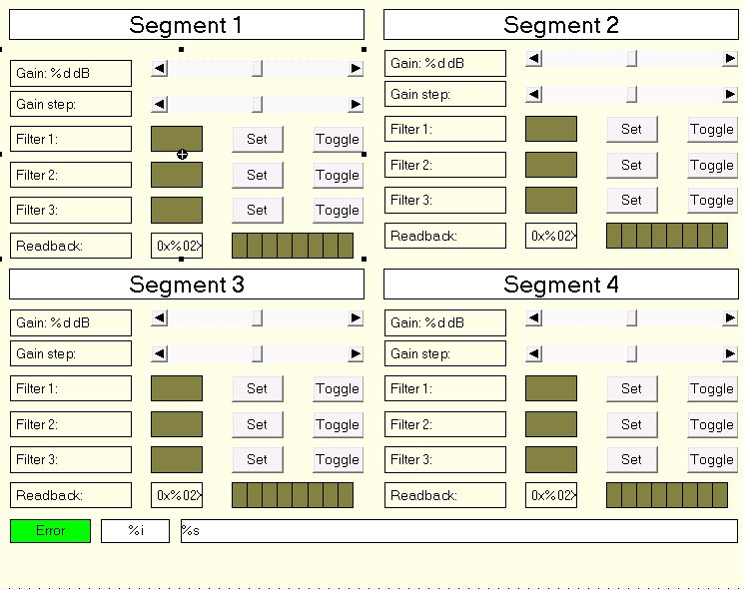
Name | IscWhiteningQpdVis
Description | Displays the tags of four channels of whitening
Placeholder | Name: qpd  Type: IscWhiteningQpdStruct  Description: ISC whitening quad photodiode structure

Visual
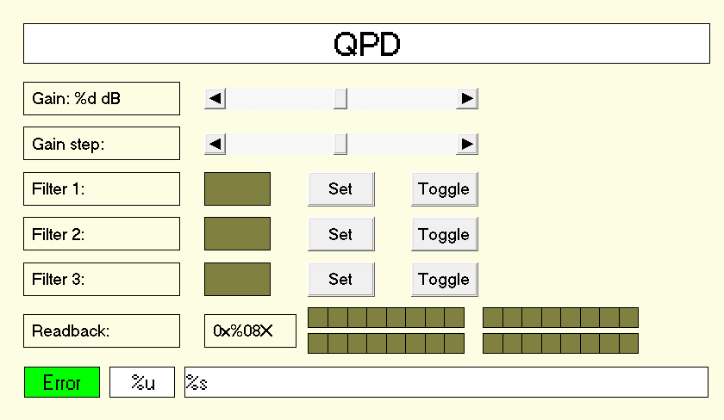
Name | IscWhiteningSimpleQpdVis
Description | Displays the tags of four channels of whitening
Placeholder | Name: qpd  Type: IscWhiteningSimpleQpdStruct  Description: Unified ISC whitening quad photodiode structure

