|  |  |  |
| --- | --- | --- |
| **AUTHOR(S)** | DATE | Document Change Notice, Release or Approval |
| Doug Cook, Dennis Coyne,  Eric Gustafson, Joe Hanson, Eric James, Gary Traylor | 3 August 2012 | see LIGO DCC record Status |

*Instructions on the use of this document:*

*1) Use, and complete, this document on a laptop computer while the work is proceeding. When operating in a cleanroom, use a cleanroom compatible laptop. This procedure must be available at all times during the alignment process. In addition, all of the applicable documents must also be available for reference during the procedure from the laptop computer.*

*2) Use this alignment procedure as a check list for preparation and during the alignment; As each step is completed, enter the name of the person completing the work (or approving or checking the step), as well as the date and any comments or notes. In particular, note any discrepancies or deviations and augment with any missing definition. ALL NOTES MUST BE RECORDED IN THE COMPLETED VERSION OF THIS DOCUMENT (NOT IN OTHER NOTEBOOKS OR FILES). If the additional notes are too cumbersome to include within the body of this completed procedure, then electronically attach them to the completed procedure.*

*3) Once completed, file the document in the LIGO Document Control Center (DCC) as the next highest version of the procedure and add a note that this is a completed/finished procedure.*

*4) File any significant notes or data from the completed procedure in the electronic logbook (such as any deviations); as a minimum note in the electronic logbook that the alignment was completed in accordance with this procedure (cite document number and revision).*

Contents

1 SCOPE 2

2 APPLICABLE DOCUMENTS 2

3 COORDINATE SYSTEMS/REFERENCES 3

3.1 BSC Chamber 3

3.2 Mechanical Test Stand 3

4 PREREQUISITES FOR CARTRIDGE ALIGNMENT 3

5 REQUIRED EQUIPMENT LIST 4

6 PROCEDURE FOR CARTRIDGE ASSEMBLY ALLIGNMENT 5

6.1 Basic approach 7

6.2 Cartridge set-up 8

6.2.1 Check optics table level on the BSC mechanical test stand 8

6.2.2 Approximately align the Cartridge Assembly element with the template. 9

6.3 L1 Beam Splitter (BS) 9

6.3.1 Setup the BS Retro-reflector Assembly 9

6.3.2 Setup SET IIB 12

6.3.3 Set the BS longitudinal position 12

6.3.4 Set the BS horizontal position 12

6.3.5 Coarse Align the BS Yaw 13

6.3.6 Iterate/re-Check 13

6.3.7 Check the BS vertical position 14

6.3.8 Set the PLX Later Transfer Hollow Periscope (LTHP) 15

6.3.9 Fine Align the BS Yaw 16

6.3.10 Align the BS pitch 16

6.4 Install and align the BS Elliptical Baffle, AR side 16

6.4.1 Set the BS Elliptical Baffle horizontal position 16

6.4.2 Set the BS Elliptical Baffle vertical position 17

6.5 Set up for aligning the BS Elliptical Baffle, HR side 18

6.5.1 Set the Total Station 18

7 ALIGN THE CARTRIDGE ASSEMBLY IN THE BSC CHAMBER (IN SITU) 18

7.1 Level the Optics Table and set its vertical position 19

7.2 Setup the Total Station, Laser Autocollimator and LTHP 19

7.3 Measure BS Pitch & Yaw Errors 21

7.4 BS Fine Pitch & Yaw Error Correction 22

7.5 Measure the BS Lateral and Vertical Positions 22

7.6 Measure the BS Longitudinal Position 23

7.6.1 Set the BS longitudinal position 23

8 ALIGN ITM ELLIPTICAL BAFFLE ASSEMBLIES 23

9 ALIGN CO2 STEERING MIRRORS 23

# SCOPE

The scope of this procedure is alignment of the optical elements of the LBSC2 chamber, which includes alignment of the following optical elements:

1. L1 Beam Splitter (BS) (part of the triple suspension assembly, ([D0900431](https://dcc.ligo.org/cgi-bin/private/DocDB/ShowDocument?.submit=Number&docid=d0900431&version=))
2. L1 Beam Splitter Elliptical Baffle assembly ([D1200750](https://dcc.ligo.org/cgi-bin/private/DocDB/ShowDocument?.submit=Number&docid=d1200750&version=)).
3. ITM Elliptical Baffles ([D0900525](https://dcc.ligo.org/cgi-bin/private/DocDB/ShowDocument?.submit=Number&docid=d0900525&version=)). LBSC2 has two of these.

(Note: need to add a monument to the pipe bridge shelf for the BS beam line. Check the visible transmission and reflection of the optic using the Theodolite while on the test stand to better determine whether we will see the targets).

1. CO2 Steering Mirrors. LBSC2 has two of these as part of the TCS CO2 Steering Optics Assembly ([D1101851](https://dcc.ligo.org/cgi-bin/private/DocDB/ShowDocument?docid=71106)).

(Note: Mindy – Alignment requirements for CO2 optics).

This procedure starts with the preliminary alignment of the optical payload elements of the LBSC2 chamber in the “cartridge assembly” and then proceeds to the alignment of these same optical payload elements within the LBSC2 chamber. The “cartridge assembly” is comprised of the BSC ISI system with all of the payload elements (which are capable of fitting onto the test stand) integrated onto the optics table and the stage 0 structure of the BSC-ISI. The cartridge assembly is integrated and aligned while on the BSC mechanical test stand. The cartridge is then lifted, flown to the chamber and lowered into position onto the BSC support tubes.

This procedure does not cover the procedures for installing assemblies onto the BSC-ISI platform or for balancing and leveling the BSC-ISI optics table; these procedures are defined in separate documentation.

# APPLICABLE DOCUMENTS

Listed below are all of the applicable and referenced documents for the initial alignment procedures. This list gives the latest revisions of the documents; Within the alignment steps, only the document number (and not the revision) is quoted.

|  |  |  |
| --- | --- | --- |
| **Document No.** | **Rev.** | **Document Title** |
| [E0900047](https://dcc.ligo.org/cgi-bin/private/DocDB/ShowDocument?.submit=Number&docid=e0900047&version=) |  | LIGO Contamination Control Plan |
| [T1000230](https://dcc.ligo.org/cgi-bin/private/DocDB/ShowDocument?.submit=Number&docid=t1000230&version=) |  | AOS Initial Alignment Requirements Final Design Document |
| [T080307](https://dcc.ligo.org/cgi-bin/private/DocDB/ShowDocument?.submit=Number&docid=T080307&version=) |  | Initial Alignment System Design Requirements Document |
| [D0900428](https://dcc.ligo.org/cgi-bin/private/DocDB/ShowDocument?docid=1267) |  | aLIGO Systems, BSC2-L1 Top Level Chamber Assembly |
| [D0900431](https://dcc.ligo.org/cgi-bin/private/DocDB/ShowDocument?.submit=Number&docid=d0900431&version=) |  | aLIGO SUS BSC2-L1, XYZ Local CS for BS HR |
| [D0900525](https://dcc.ligo.org/cgi-bin/private/DocDB/ShowDocument?.submit=Number&docid=d0900525&version=) |  | aLIGO SUS BSC2-L1 Local CS for Elliptical Baffle (ITMX, ITMY) |
| [D1101851](https://dcc.ligo.org/cgi-bin/private/DocDB/ShowDocument?docid=71106) |  | aLIGO TCS CO2P Steering Optics Assy. |
| [D0900431](https://dcc.ligo.org/cgi-bin/private/DocDB/ShowDocument?.submit=Number&docid=d0900431&version=) |  | See Sheet 3 for Template Layout, BSC-2 |
| [E1100374](https://dcc.ligo.org/cgi-bin/private/DocDB/ShowDocument?.submit=Number&docid=e1100374&version=) |  | Survey Data for LLO |
| [T1100318-v1](https://dcc.ligo.org/cgi-bin/private/DocDB/ShowDocument?.submit=Number&docid=t1100318&version=) |  | Total Station modifications for stabilizing unit when Laser Autocollimator is Attached |
| [D1200076](mailto:https://dcc.ligo.org/cgi-bin/private/DocDB/ShowDocument?docid=78483) |  | Alignment Monument Layout, LHO Y-End Station, BSC Mechanical Test Stand |
| [T080230](https://dcc.ligo.org/DocDB/0008/T080230/001/T080230-v1.pdf) |  | Quad Pendulum Structure Pushers |
| [M1100068](https://dcc.ligo.org/cgi-bin/private/DocDB/ShowDocument?docid=57864) |  | BSC Door Removal and Installation Procedure |
| [E1200485](https://dcc.ligo.org/cgi-bin/private/DocDB/ShowDocument?docid=91446) |  | AOS IAS - Initial Alignment Document Tree |

# COORDINATE SYSTEMS/REFERENCES

## BSC Chamber

The local BSC chamber coordinate system origin is the point where the horizontal, cylindrical axes of the main access portals meet. The local BSC chamber coordinate system axes are aligned to the local gravity vector. Z is vertical (+Z is up). X and Y are both horizontal and approximately aligned to the global coordinate axes (as defined in [T980044](https://dcc.ligo.org/cgi-bin/private/DocDB/ShowDocument?docid=2366)). The local BSC chamber coordinate system origin is nominally located 1742 mm below the BSC-ISI optics table surface.

## Mechanical Test Stand

The local mechanical test stand coordinate system origin is located 1742 mm below the BSC-ISI optics table surface and centered between the row of mounting holes which interface to the BSC-ISI stage-0 structure (and represent the support tubes installed into the BSC chambers). The local mechanical test stand coordinate system axes are aligned to the local gravity vector. Z is vertical (+Z is up). X and Y are both horizontal and approximately aligned to the global coordinate axes.

# PREREQUISITES FOR CARTRIDGE ALIGNMENT

* The BSC mechanical test stand must be set so that the interface plane with the BSC-ISI stage 0 is horizontal.
* The features of the BSC mechanical test stand which interface to the BSC-ISI platform shall be used to establish a centerline and two offset lines with alignment monuments/references in the floor, as depicted in the [E1100374](https://dcc.ligo.org/cgi-bin/private/DocDB/ShowDocument?.submit=Number&docid=e1100374&version=) (see also **Error! Reference source not found.**).
* An appropriate clean room should be installed over the test stands.

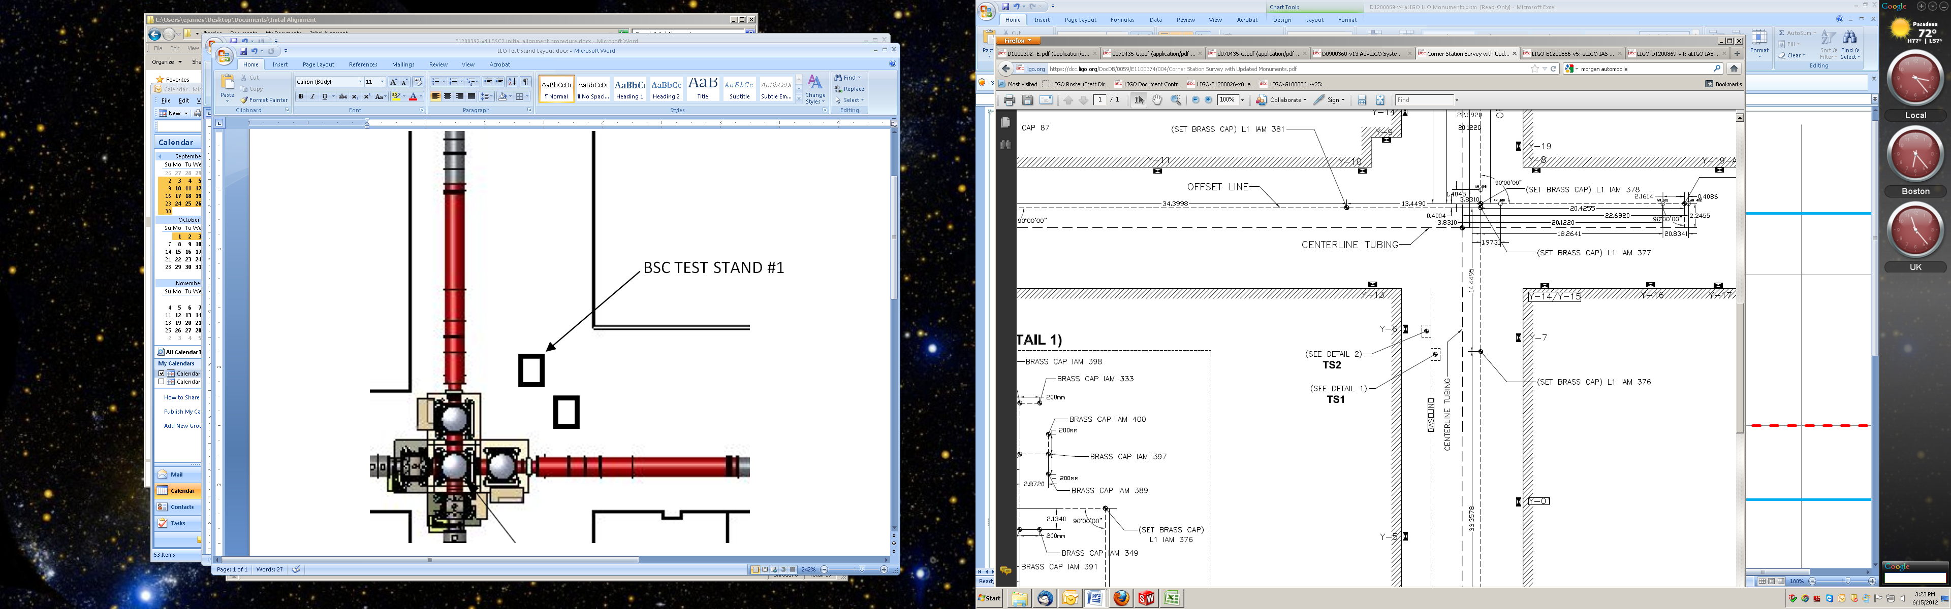

Figure 1 Test Stand location within the Corner Station VEA

* All payload assemblies must be acceptance tested (to the extent possible and planned) prior to integration into the cartridge assembly.
* The BS suspension must be capable of being electronically damped while on the test stand and later when in the chamber.
* All IAS operations on the cartridge assembly are to be made with the BSC ISI in its locked mode. Verify that the ISI is locked.

*completed, approved or checked by:   
date:   
comments (optional):*

# REQUIRED EQUIPMENT LIST

* + Total station (either a Sokkia Set2BII or a Sokkia SetX1 modified per [T1100318](https://dcc.ligo.org/cgi-bin/private/DocDB/ShowDocument?.submit=Number&docid=t1100318&version=)) with tripod stand
  + Laser autocollimator (Newport LDS Vector and LDS1000 controller)
  + Optical level (Sokkia B2o AutoLevel with micrometer option, or equivalent) with tripod stand
  + Precision bubble level
  + Optical Transit Square (Brunson model 75-H) with stand
  + Mechanical locating templates for BS suspension ([D1101048](https://dcc.ligo.org/cgi-bin/private/DocDB/ShowDocument?.submit=Number&docid=d1101048&version=) -9 and -10), cleaned to Class B per [E0900047](https://dcc.ligo.org/cgi-bin/private/DocDB/ShowDocument?.submit=Number&docid=e0900047&version=) and E960022)
  + Precision pushers ([D060052](https://dcc.ligo.org/cgi-bin/private/DocDB/ShowDocument?.submit=Number&docid=d060052&version=), cleaned to Class B per [E0900047](https://dcc.ligo.org/cgi-bin/private/DocDB/ShowDocument?.submit=Number&docid=e0900047&version=) and [E960022](https://dcc.ligo.org/cgi-bin/private/DocDB/ShowDocument?.submit=Number&docid=e960022&version=))
  + Mover assemblies ([D1100018](https://dcc.ligo.org/DocDB/0030/D1100018/002/LIGO-D1100018-v2.pdf), cleaned to Class B per [E0900047](https://dcc.ligo.org/cgi-bin/private/DocDB/ShowDocument?.submit=Number&docid=e0900047&version=) and [E960022](https://dcc.ligo.org/cgi-bin/private/DocDB/ShowDocument?.submit=Number&docid=e960022&version=))
  + Retro reflector assembly ([D1101340](https://dcc.ligo.org/cgi-bin/private/DocDB/ShowDocument?.submit=Number&docid=d1101340&version=), cleaned to Class B per [E0900047](https://dcc.ligo.org/cgi-bin/private/DocDB/ShowDocument?.submit=Number&docid=e0900047&version=) and [E960022](https://dcc.ligo.org/cgi-bin/private/DocDB/ShowDocument?.submit=Number&docid=e960022&version=))
  + Coordinate Measuring Machine (CMM, Romer model Infinite 2.0, or MicroScribe 6MX) or a Depth Gauge with plastic probe tip (and sufficient range to measure the distance from the optic to the retro-reflector)
  + BSC table height target (D1101611).
  + Various optical or tripod stands

# PROCEDURE FOR CARTRIDGE ASSEMBLY ALLIGNMENT

Only the BS Optic and the BS AR and HR Elliptical Baffles are aligned while the cartridge assembly is on the test stand.

The LBSC2 cartridge assembly is to be assembled on LLO Mechanical Test Stand #1 (TS1), which is the test stand to the southeast (see [E1100374](https://dcc.ligo.org/cgi-bin/private/DocDB/ShowDocument?.submit=Number&docid=e1100374&version=) and figure 1). The support tubes are oriented in the Y-direction, or north-south direction. The LBSC2 cartridge has been placed on the test stand rotated 90 degrees clockwise from the orientation it will have in LBSC2. The reference monuments for the cartridge assembly on test stand #1 are given in [E1100374](https://dcc.ligo.org/cgi-bin/private/DocDB/ShowDocument?.submit=Number&docid=e1100374&version=), and in Figure 3 for convenience.

The LBSC2 cartridge assembly is depicted in . The major optics assembly integrated into the LBSC2 cartridge is the Beam Splitter, a part of the suspension assembly ([D1000392](https://dcc.ligo.org/cgi-bin/private/DocDB/ShowDocument?docid=9458)). The two Elliptical Baffles ([D0900525](https://dcc.ligo.org/cgi-bin/private/DocDB/ShowDocument?.submit=Number&docid=d0900525&version=)) are not installed on the cartridge assembly while it is on the test stand due to interference with the test stand structure. They will be installed after the cartridge is installed in the chamber. The positions and Lines Of Sight (LOS) for the LBSC2 cartridge assembly alignment are depicted in .

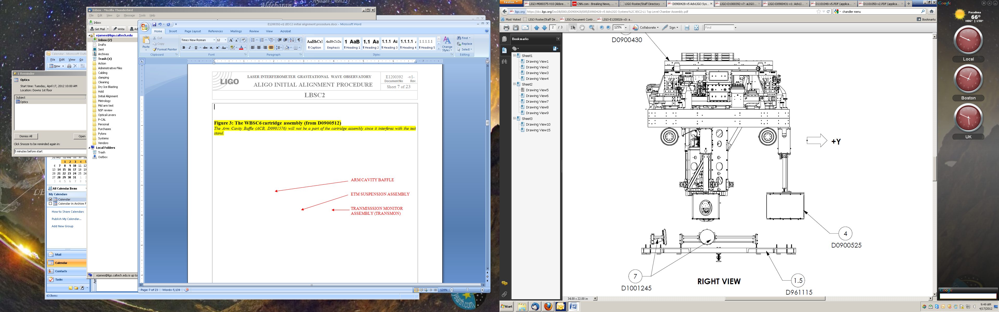

BS SUSPENSION ASSY

ELLIPTICAL BAFFLES

CO2 STEERING MIRRORS

Figure 2: The LBSC2 cartridge assembly (from D0900428)

*The Elliptical Baffles (D0900525) will not be a part of the cartridge assembly as they interfere with the test stand. The CO2 Steering Mirrors (D1101851) are not part of the cartridge assembly.*

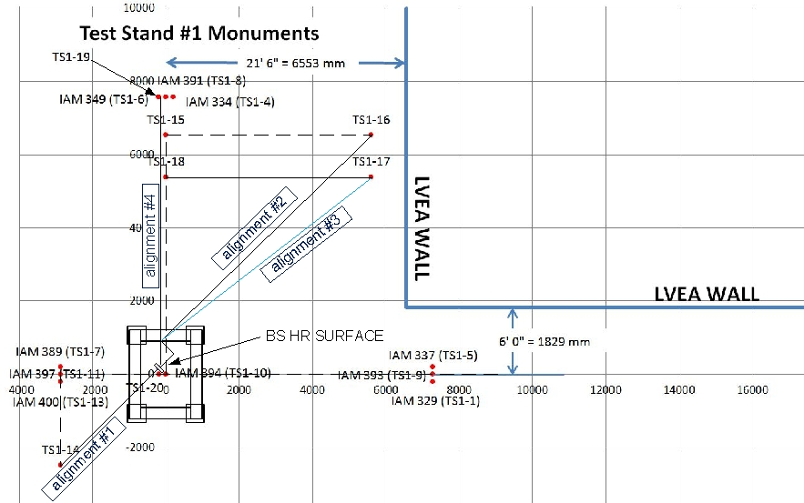

Figure 3: IAS Instrument Positions and Lines Of Sight (LOS) for the LBSC2 Cartridge Assembly Alignment

## Basic approach

Since the HR surface is mostly obscured by the test stand leg, we will align the BS from the AR side which is unobscured. From the same setup we can align the BS Elliptical Baffle, AR side.

Set up SET IIB Theodolite on AR.

In order to position the HR side of the BS Elliptical Baffle, a target is attached to the baffle and the baffle is viewed looking in the +X-direction on the beamline, as shown in Figure 4. The removable target (to be provided by SLC) allows IAS to position the HR BS Elliptical Baffle left/right and up/down so that it is centered on the optic.

Remove and replace First Contact – Baffles should relocate to aligned position.

|  |  |
| --- | --- |
| view in the +X direction, showing the HR face of the BS optic and the HR BS elliptical baffle (without the target) | view in the +X direction, showing the HR face of the BS optic and the HR BS elliptical baffle with a conceptual target (to be provided by SLC) |

Figure : View of the BS in the +X-direction showing the use of the target on the HR BS Elliptical Baffle

Test the transmission and reflection as seen through the total station.In preparation for ITM elliptical baffle alignments

At this point the BS optic and both the HR and AR BS Elliptical Baffles have been aligned on the test stand.

## Cartridge set-up

### Check optics table level on the BSC mechanical test stand

Datum: Local gravity

Equipment: Optical level on tall tripod and targets on invar rods suspended from the optics table

Accuracy: ± 100 microrad (0.1 mm differential height)

Procedure:

* Attach 3 invar rods with targets to the table (equal lengths sufficient to be seen by optical level on tripod). Position the rods so that all 3 can be observed from a single optical level position.
* Place optical level on a tall tripod and sight the relative difference in target heights to determine tip and tilt of optics table.
* Adjust ISI trim/balance mass per [E0900357](https://dcc.ligo.org/cgi-bin/private/DocDB/ShowDocument?.submit=Number&docid=e0900357&version=) (v20, section 1.84) **(SEI – Joe ?)**
* Record table levelness:

|  |  |
| --- | --- |
| Tip (rotation about x) | microrad |
| Tilt (rotation about y) | microrad |

### Approximately align the Cartridge Assembly element with the template.

Datum: Bolt holes in optical table.

Equipment: Alignment templates ([D1101048](https://dcc.ligo.org/cgi-bin/private/DocDB/ShowDocument?.submit=Number&docid=d1101048&version=) -9 and -10). Each suspension has two sets of templates. Either set may be used but not both.

Accuracy: Clearance in bolt holes

Procedure:

* Install [D1101048](https://dcc.ligo.org/cgi-bin/private/DocDB/ShowDocument?.submit=Number&docid=d1101048&version=) -9 or -10) template per [D0900431](https://dcc.ligo.org/cgi-bin/private/DocDB/ShowDocument?.submit=Number&docid=d0900431&version=), sheet 3.
* If needed, install precision pushers ([D060052](https://dcc.ligo.org/cgi-bin/private/DocDB/ShowDocument?.submit=Number&docid=d060052&version=)) per [T080230](https://dcc.ligo.org/DocDB/0008/T080230/001/T080230-v1.pdf) adjacent to ETM structures opposite of the templates.
* Push BS structure to contact the templates per [T080230](https://dcc.ligo.org/DocDB/0008/T080230/001/T080230-v1.pdf).
* Lock down suspension structures.
* Remove all templates.

## L1 Beam Splitter (BS)

### Setup the BS Retro-reflector Assembly

Datum: Optical axis of the test mass.

Equipment: Retro-reflector assembly (D1200124), CMM or depth gauge with plastic contact

Accuracy: ± 0.2 mm

Procedure:

* Attach the retro-reflector assembly to the structure in front of the BS AR face.
* Measure offset error of fixed mounted corner cube to optic barrel and record.
* Write down x,y,z coordinates of retro center to optic center.

|  |  |
| --- | --- |
| BS X, Y, Z coordinates | mm |

|  |  |  |  |
| --- | --- | --- | --- |
| |  |  | | --- | --- | |  | mm | |  |

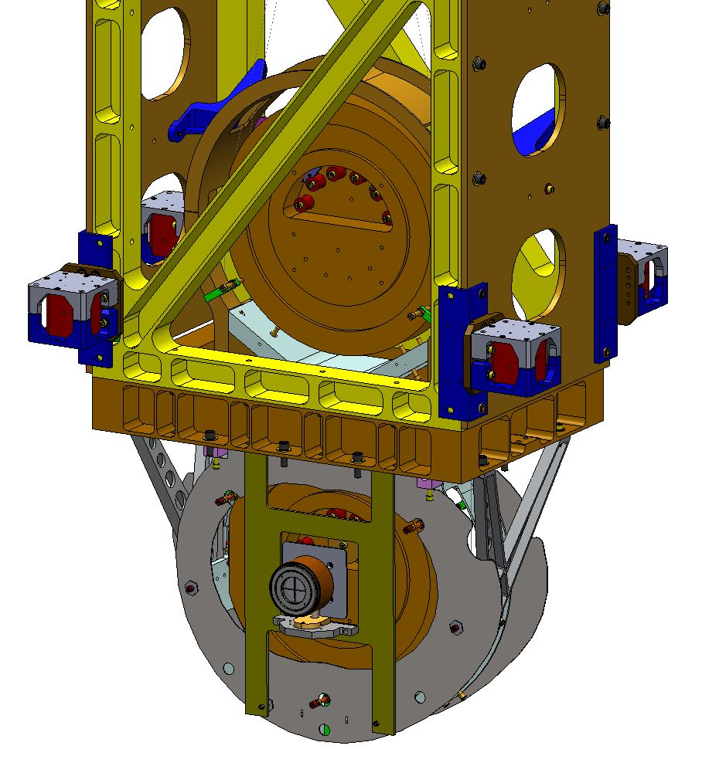

Figure 5: Retro-reflector Assembly attached to BS Structure over the BS Elliptical Baffle.

|  |  |
| --- | --- |
| mnt1.JPG  X  Z | mnt2.JPG  RETRO-REFLECTING PLANE IS FRONT FACE OF THIS PLATE  HR SURFACE OF TEST MASS  Y |

Figure 6: X, Y and Z offsets between the HR face center and the Retro-Reflector Center

### Setup SET IIB

Datum: Monument TS1-14, ISI table surface as referenced by height target.

Equipment: Total station, height target (D1101611).

Accuracy: ±1 mm, ±10 microradians

Procedure:

* Set the total station over TS1-14 at beam height (1016 mm above the floor).
* Set the total station to back sight from monument TS1-21.
* Attach the height target to the optics table near the table edge toward the total station. TS1-14.
* Yaw the total station to sight the height target and adjust total station height to match height target. The total station is now at the height of the BS (1742 mm rod and scale).
* Yaw the SET IIB total station 45°-5'-56" (check). The total station is now on the beam line towards the center of the AR surface of the BS (44° 54' 4" for AR side).

### Set the BS longitudinal position

Datum: Optical axis established with the Total Station

Equipment: Total station

Accuracy: ±3 mm

Procedure:

* Use total station EDM to set position to 3728.1mm (remember to account for the offset distance from the retro-reflector to the optic AR face). Compensate for corner cube to HR surface.
* Record position.

|  |  |  |  |
| --- | --- | --- | --- |
|  | Trial 1 | Trial 2 | Trial 3 |
| Retro-reflector to AR face offset + AR to HR using new mount | mm | mm | mm |
| Retroreflector inherent offset | 30 mm (Compensated in total station) | mm | mm |
| EDM Distance | mm | mm | mm |
| Sum = BS HR longitudinal distance | mm | mm | mm |

### Set the BS horizontal position

Datum: Optical axis as established by the total station.

Equipment: total station, pusher assembly (D060052).

Accuracy: ± 1mm (BS optic top center edge - corresponds to ±??)

Procedure:

* Sight the retro-reflector target with the SET IIB total station and use the “slider/supports” and “pusher assemblies” (D060052) to shift the BS structure so that the retro-reflector center is centered in the theodolite. Or, sight barrel of optic and center and record the offset to the crosshairs.
* Measure & record the translation position.

|  |  |
| --- | --- |
| Translation position to retro-reflector center | microrad |

### Coarse Align the BS Yaw

Datum: Optical axis as established by the SET 1X total station.

Equipment: Laser autocollimator mounted on top of the Total Station

Accuracy: ±1 milliradians goal

Procedure:

* Set up the PLX HTP to propagate the laser collimator beam to the HR side of the BS.
* Use the laser autocollimator to measure the BS optic yaw angle. Use the pusher assemblies to reduce the yaw angle to as close to 45° 5’ 56” as possible (< 1 mrad). 0.44° 58' 16" total station YAW.
* Then rotate structure to reduce the residual error.
* Use the laser autocollimator to measure the BS optic yaw angle.
* Reiterate as required.
* Record residual yaw error.

|  |  |
| --- | --- |
| BS yaw error | microrad |

### Iterate/re-Check

Datum: Local gravity, optical axis as established by the total station.

Equipment: Optical level on tall tripod and targets on invar rods suspended from the optics table, total station

Accuracy:

levelness: ±100 microrad (0.1 mm differential height)

lateral position: ±1 mm

longitudinal position: ±3mm

yaw: ±160 microradians

Procedure:

* Re-check table level
* Re-check the lateral & longitudinal position and yaw and iterate until all are within required accuracy.
* Remove the retro-reflector and mount assembly from the BS.

Once this step has been completed, the BS “frame” has been set; All further adjustments to the BS are on the suspension chains.

### Check the BS vertical position

Datum: Optical axis as established by the total station.

Equipment: SET IIB Total Station

Accuracy: ± 1mm (corresponds to ± 140 microradians of pitch error when sighting top and bottom edges of optic, on vertical centerline)

* With the Total Station at zero yaw angle, sight the bottom edge of the optic. Record the pitch angle.
* Sight the top edge of the optic. Record the pitch angle.
* Sight and compare to prism positions (roll accuracy and double check).
* The optic height was set during the SUS assembly and should be correct. However, if it is out of tolerance, then use the SUS procedure in E#?, (shim blades), add section ?, to adjust the test mass height until it is within the required accuracy. See Figure 8

|  |  |  |  |
| --- | --- | --- | --- |
|  | Trial 1 | Trial 2 | Trial 3 |
| Bottom optic edge  (-A) | mrad | mrad | mrad |
| Top optic edge (+B) | mrad | mrad | mrad |
| Center error angle  E = (A+B)/2 – 213 microrad | microrad | microrad | microrad |
| Center error distance  3725.2 * E | mm | mm | mm |

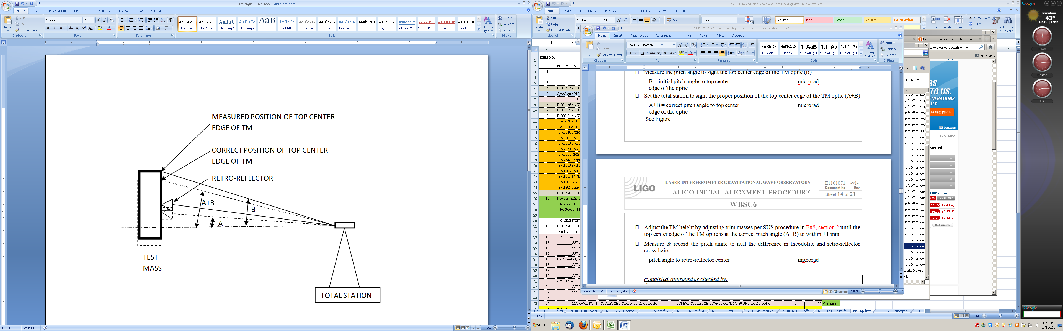

BS

BS

BS

Figure 7: Determination of the height of the optic center

### Set the PLX Later Transfer Hollow Periscope (LTHP)

Datum: Optical axis as established by the total station.

Equipment: Total station, PLX LTHP mounted on a tripod.

Accuracy: ±1 mm, ±10 microradians

Procedure:

* Set the LTHP approximately 1016 above the floor in approximately the position shown in Figure 3.
* Align the LTHP by sighting on the LTHP targets with the Total Station. The LTHP ouput beam is now aligned to the center of the BS HR surface.

### Fine Align the BS Yaw

Datum: Optical axis as established by the total station.

Equipment: Laser autocollimator

Accuracy: ±100 microradians (limited by air buffeting in the test stand/cleanroom environment)

Procedure:

* Set the SET 1X total station over TS1-16 and retro-reflect from BS.
* Then use the top blade adjusters to reduce the residual error further, using the SUS procedures
* Record the yaw error

|  |  |  |  |
| --- | --- | --- | --- |
|  | Trial 1 | Trial 2 | Trial 3 |
| BS yaw error | millirad | millirad | millirad |

### Align the BS pitch

Datum: Optical axis as established by the SET 1X total station.

Equipment: SET 1X total station, PLX LTHP

Accuracy: ±100 microradians (limited by air buffeting in the test stand/cleanroom environment)

Procedure:

* Set the total station pitch (UP) to 213 microradians (44 arcsec or 0° 0’ 44”) DOWN. Using the LAC, measure the pitch error.

|  |  |
| --- | --- |
| Initial BS pitch error | microradians |

* If the pitch error is < 100 microradians, record the error.
* If > 100 microradians, then adjust the upper intermediate mass pitch balance per SUS procedures.

|  |  |
| --- | --- |
| Final BS pitch error | microradians |

## Install and align the BS Elliptical Baffle, AR side

Note: Also see [E1200556-v7](https://dcc.ligo.org/DocDB/0091/E1200556/007/E1200556-v7%20aligo%20IAS%20alignment%20solutions.pdf) for further explanations.

### Set the BS Elliptical Baffle horizontal position

This procedure is nearly identical to the procedure used to set the BS alignment and uses the same SET IIB Total Station setup. However, the baffle is moved with respect to the BS suspension structure. The BS suspension structure itself is not moved.

Datum: Optical axis as established by the total station.

Equipment: Total Station

Accuracy: ± 0.5mm

Procedure:

* Sight on the right hand edge of the baffle aperture. Record the yaw angle.
* Sight on the left-hand edge of the baffle aperture. Record the yaw angle.
* Adjust the horizontal position so that the left and right-hand yaw angles are equal.

|  |  |  |  |
| --- | --- | --- | --- |
|  | Trial 1 | Trial 2 | Trial 3 |
| Right yaw angle | mrad | mrad | mrad |
| Left yaw angle | mrad | mrad | mrad |

### Set the BS Elliptical Baffle vertical position

This procedure is nearly identical to the procedure used to set the BS vertical position. However, the baffle is moved with respect to the BS suspension structure. The BS suspension structure itself is not moved.

Datum: Optical axis as established by the total station.

Equipment: Total Station

Accuracy: ± 0.5mm

* With the Total Station at zero yaw angle, sight the bottom edge of the baffle opening. Record the pitch angle.
* Sight the top edge of the baffle opening. Record the pitch angle.
* Adjust vertical position to the correct readings.

|  |  |  |  |
| --- | --- | --- | --- |
|  | Trial 1 | Trial 2 | Trial 3 |
| Bottom opening edge  (-A) | mrad | mrad | mrad |
| Top opening edge (+B) | mrad | mrad | mrad |
| Center error angle  E = (A+B)/2 – 213 microrad | microrad | microrad | microrad |
| Center error distance  3725.2 * E | mm | mm | mm |

## Set up for aligning the BS Elliptical Baffle, HR side

### Set the Total Station

Datum: Monument TS1-19, TS1-20, (TS1-19 shares monument TS1-6 with 183.9 mm separation in the -X direction), ISI table surface as referenced by height target (1742 mm).

Equipment: SET 1X total station, height target (D1101611) (ref 1742 mm).

Accuracy: ±1 mm, ±10 microradians

Procedure:

* Attach the height target to the optics table near the table edge toward the total station.
* Set the total station over TS1-19.
* Yaw the total station to sight the height target and adjust total station height to match height target. The total station is now at the height of the BS.
* Attach the HR baffle alignment target to baffle.
* Using the total station back sight to TS1-20.
* Adjust the baffle to place the HR baffle crosshairs in line with the total station cross hairs.

# ALIGN THE CARTRIDGE ASSEMBLY IN THE BSC CHAMBER (IN SITU)

Once in the chamber, IAS must align:

* the BS Optic in {x,y,z, yaw} by moving the entire cartridge assembly with HEPI as a rigid body
* the BS Optic in pitch, by adjusting the suspension
* the ITMy Elliptical Baffle
* the ITMx Elliptical Baffle

but not the BS AR & HR Elliptical Baffles, since these baffles were properly located relative to the BS optic on the test stand.

## Level the Optics Table and set its vertical position

Datum: Local gravity, BSC-ISI capacitive position sensors

Equipment: Optical Level, 3 metering rods, BSC-ISI capacitive position sensors.

Accuracy: 100 microradians (0.1 mm differential height)

Procedure:

* Make sure all payload and balance/ballast weight is on the BSC-ISI Assembly
* Attach 3 metering rods onto the Optics Table so that all 3 can be viewed from a single Optical Level position, on a tall tripod, through the open BSC door.
* Check the Optics Table levelness optically before unlocking BSC-ISI.
* Check the height of the Optics Table by referencing elevation mark TBD with the Optical Level
* If needed, adjust the table to be level using HEPI static adjustment per procedure [E040011](https://dcc.ligo.org/cgi-bin/private/DocDB/ShowDocument?docid=20879), “HEPI Assembly and Installation Procedures”
* Unlock the BSC-ISI and compare the capacitive position sensors offset values to the offsets measured on the cartridge test stand. If necessary, adjust the balance mass to get the same capacitive position sensor offsets as achieved on the test stand.
* Confirm the Optics Table levelness (again) with the Optical Level

## Setup the Total Station, Laser Autocollimator and LTHP

Datum:

1. Monuments IAM22, IAM25 and IAM26 (as defined in [E1100374](https://dcc.ligo.org/cgi-bin/private/DocDB/ShowDocument?.submit=Number&docid=e1100374&version=)) – axis along the Y centerline
2. Elevation mark TBD [*Need height references for the Livingston corner station]*

Equipment: Total Station; Newport Electronic Visible Laser Autocollimator (LAC); Brunson Optical Square; Metering Rods/Targets; 8” diameter Flat Mirror on a Newport Gimbal Mount and Tripod, Lateral Transfer Hollow Periscope (LTHP).

Accuracy: ±1 mm, ±40 microradians rss, alignment reference transfer (see [T1000230](https://dcc.ligo.org/cgi-bin/private/DocDB/ShowDocument?docid=11150)-v6, section 17)

Procedure:

* Remove the spool between LBSC2 and LHAM3.
* Set the LTHP on its stand so that it is approximately normal to the BS and positioned so that one line of site can see the BS surface and the other can see out the BSC door. See figure 10.
* Adjust the Total Station height to be -80.0 mm (global coordinate system) using elevation mark TBD
* Setup the large Flat Mirror with gimbal mount/tripod with an unobstructed view of, and a few meters from, the Total Station/LAC
* Co-boresight the Total Station and LAC with the Flat Mirror
* Setup the Brunson Optical Square directly over monument AM400, at the same height as the Total Station, and sight L1 IAM382 to get alignment parallel to the X global axis
* Set the Total Station over monument TBD and square with respect to the Brunson Optical Square and able to see the LTHP when yawed 45 degrees.
* Yaw the Total Station precisely 44° 58' 18" and set this yaw angle reference to zero. (The Total Station is now pointing along a vector which is normal to the beam splitter and offset from the vertical center by 400 mm to account for the LTHP.

|  |  |
| --- | --- |
|  |  |

Figure

* Align the LTHP so that the input beam is collinear with the Total Station (see Figure 8).

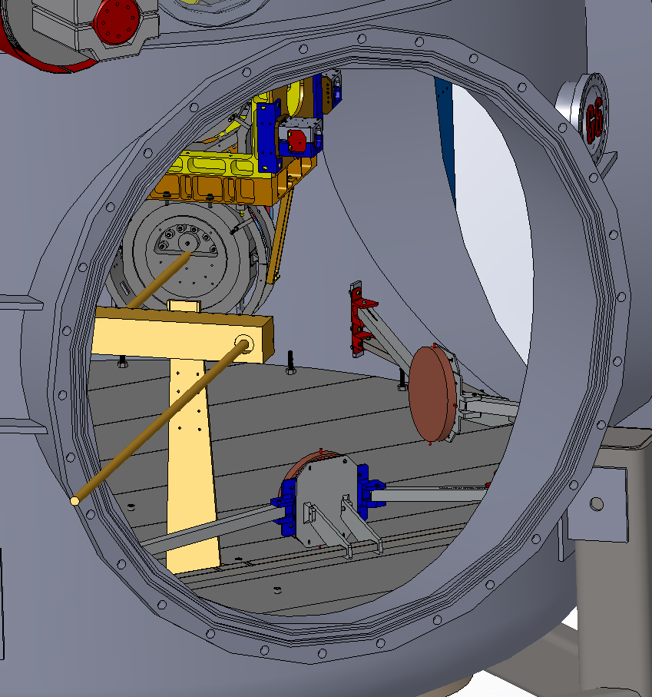

Figure

## Measure BS Pitch & Yaw Errors

Datum: Optical axis as established by the total station.

Equipment: Newport Electronic, Visible Laser Autocollimator (LAC)

Accuracy: ±10 microradians goal

Procedure:

* Insure that the optics and masses, of the main suspension chain, are free (not ‘clamped’ or on the mechanical stops or earthquake stops)
* Engage damping controls for the BS suspension
* Use the LAC to measure the BS optic pitch and yaw error angles. All personnel should exit the chamber. Purge air flow should be off or minimized. Electronic damping should be active for the suspension. If necessary, use a low pass filtering amplifier and display the pitch and yaw on an oscilloscope with trace persistence and cursors to get the average angles
* If the yaw error is > than the allowed error, then use HEPI (per procedure [E040011](https://dcc.ligo.org/cgi-bin/private/DocDB/ShowDocument?docid=20879), “HEPI Assembly and Installation Procedures”) to adjust the BSC-ISI yaw angle.
* If the pitch error is > than the allowed error, then use the SUS procedure ([E1000686](https://dcc.ligo.org/cgi-bin/private/DocDB/ShowDocument?.submit=Number&docid=e1000686&version=), section 7.1, “BS Assembly and Alignment Procedure”) to adjust the pitch error.
* Record the pitch and yaw errors:

|  |  |  |  |
| --- | --- | --- | --- |
|  | Trial 1 | Trial 2 | Trial 3 |
| Yaw error | microrad | microrad | microrad |
| Pitch error | microrad | microrad | microrad |

## BS Fine Pitch & Yaw Error Correction

Datum: Monuments TBD.

Equipment: BS Suspension actuation (BOSEMs), Newport Electronic Visible Laser Autocollimator

Accuracy: ±10 microradians goal

Procedure:

* Use the Laser Autocollimator to measure the BS optic pitch and yaw angles. All personnel should exit the chamber. Purge air flow should be off or minimized. Electronic damping should be active for the suspension. If necessary, use a low pass filtering amplifier and display the pitch and yaw on an oscilloscope with trace persistence and cursors to get the average angles
* Use the BS Suspension controls interface to set pitch and yaw bias values to correct the residual errors
* Record the pitch and yaw bias values:

|  |  |
| --- | --- |
| Pitch bias | counts |
| Yaw bias | counts |

## Measure the BS Lateral and Vertical Positions

Datum: Monuments TBD.

Equipment: BS Suspension actuation (BOSEMs), Newport Electronic Visible Laser Autocollimator

Accuracy: ±10 microradians goal

Procedure: Total Station; Newport Electronic Visible Laser Autocollimator (LAC); Brunson Optical Square; Metering Rods/Targets; Lateral Transfer Hollow Periscope (LTHP).

* Set up the Total Station on TBD.
* Adjust the Total Station height to be -80.0 mm (global coordinate system) using elevation mark TBD
* Set the Total Station to be square to the Brunson Optical Square.
* Yaw 90 degrees so that the Total Station is collinear with the X-axis.
* Site on the target fixed to the BS Elliptical Baffle.
* Record the horizontal and vertical errors:

|  |  |
| --- | --- |
| BS horizontal error | mm |
| BS vertical error | mm |

## Measure the BS Longitudinal Position

### Set the BS longitudinal position

Datum: Optical axis established with the Total Station

Equipment: Total station, retro-reflector

Accuracy: ±3 mm

Procedure:

* Install the retro-reflector mounted at 45 degrees to the BS optic, facing in the -X direction.
* Use total station EDM to set position to 4449.1 mm (remember to account for the offset distance from the retro-reflector to the optic HR face)
* Record position.

|  |  |  |  |
| --- | --- | --- | --- |
|  | Trial 1 | Trial 2 | Trial 3 |
| Retroreflector to HR face offset | mm | mm | mm |
| Retroreflector inherent offset | mm | mm | mm |
| EDM Distance | mm | mm | mm |
| Sum = BS HR longitudinal distance | mm | mm | mm |

# ALIGN ITM ELLIPTICAL BAFFLE ASSEMBLIES

Datums: Optical axis as established by the total station

Equipment: Total station, pusher assembly ([D060052](https://dcc.ligo.org/DocDB/0017/D060052/000/D060052-A.pdf)), mover assembly ([D1100018](https://dcc.ligo.org/DocDB/0030/D1100018/002/LIGO-D1100018-v2.pdf)).

Accuracy: ±7mm

Procedure:

* Install and suspend the Elliptical Baffle from stage-0 of the ISI using procedure [E1101021](https://dcc.ligo.org/cgi-bin/private/DocDB/ShowDocument?docid=73486), “AOS SLC ITM Elliptical Baffle Installation Procedure”.
* Install front and rear targets.
* Check alignment by using the Total Station to sight on front and rear targets.
* If vertical positional error is < 7mm, then proceed to next step. Otherwise, reposition by adjusting vertical threads in suspension rod.
* If pitch angle error is <7mm (relative displacement between front and rear targets) adjust counter weights to correct error.
* If yaw angle error is <7mm (relative displacement between front and rear targets) use pusher assembly ([D060052](https://dcc.ligo.org/DocDB/0017/D060052/000/D060052-A.pdf)), mover assembly ([D1100018](https://dcc.ligo.org/DocDB/0030/D1100018/002/LIGO-D1100018-v2.pdf)) to rotate baffle suspension to correct error.

# ALIGN CO2 STEERING MIRRORS

Datums: CO2 beam axis as established by the total station.

Equipment: Total station

Accuracy: TBD

Procedure:

* This procedure is described in [T1200002](https://dcc.ligo.org/cgi-bin/private/DocDB/ShowDocument?.submit=Number&docid=t1200002&version=). *Note: T1200002 describes a similar procedure intended for H2. A new procedure will be written for L1 by the TCS team.*