AUTHOR: Billingsley, G. | DATE:09/12/12 | Document Change Notice, Release or Approval
 |  | see LIGO DCC record Status

Objective
This document explains the procedure that was developed for use of first contact in removing water-soluble contaminants.
How do I know? In the event a regular application of First Contact per E1000079 does not leave a pristine surface, it is likely that the contaminant is water-soluble. This can be verified by wetting a swab in deionized water or spectroscopic grade water, wiping and immediately following with an Isopropyl Alcohol or Methanol rinse.
This process works equally well in vertical or horizontal application. Horizontal is easier.

Applicable Documents
E1000079 First Contact Application and Removal Procedure
E1000128 First Contact FTIR, 2010
T0900438 LIGO vacuum qualification of First Contact
T1000137 Drag Wiping and First Contact Tests
T1000425 First Contact Hazard Analysis
T060161 FTIR and Residue tests, 2006
T070280 Photonic Cleaning Technologies Technical Information
T0900351 FC Peeling and Charging Tests

Materials

This is a 2 person job. Prepare, then get help.

List of required materials, manufacturer and part number:

1. Red First Contact, Photonic Cleaning Technologies Part# FCL for 1 Liter
2. Red First Contact thinner, Photonic Cleaning Technologies Part#TFCL for 1 Liter
3. Deionized or spectroscopic grade water > 0.25 liter (~8 oz.)
4. First Contact spray bottle – see “Care of spray bottles” at the end of this document
5. Clean room gloves, VWR Part #79999-xxx or best current glove
6. Texwipe Alpha 10 or best current soft clean room fabric wipe. Big enough to completely cover the surface to be cleaned
7. Lint-free Berkshire lenswipes, 9’’x9’’. VWR part number 52847-150
8. Acetone
9. Clean room Foil
10. Kapton tape

Preparation
- Apply and remove First Contact per E1000079 over as large an area as possible. This is to ensure there are no large boulders that can be later rubbed into the surface.
- Fill Water Bottle. Fill a clean squirt bottle with clean deionized water or spectroscopic grade water. At least 250 ml or ~8oz.
- Mix First Contact Spray 2 parts Red First Contact to 1 part Red First Contact Thinner (clear/red are NOT interchangeable) Test the spray on a piece of aluminum foil to be sure the pump is working and to get a feel for how far away to hold the bottle to avoid drips.
- Control the mess. Protect bench top with clean room foil or wipes for at least 2’ on all sides of the optic. Place clean room wipes along the barrel of the optic, chain together with kapton tape. Cover any prisms or ears. 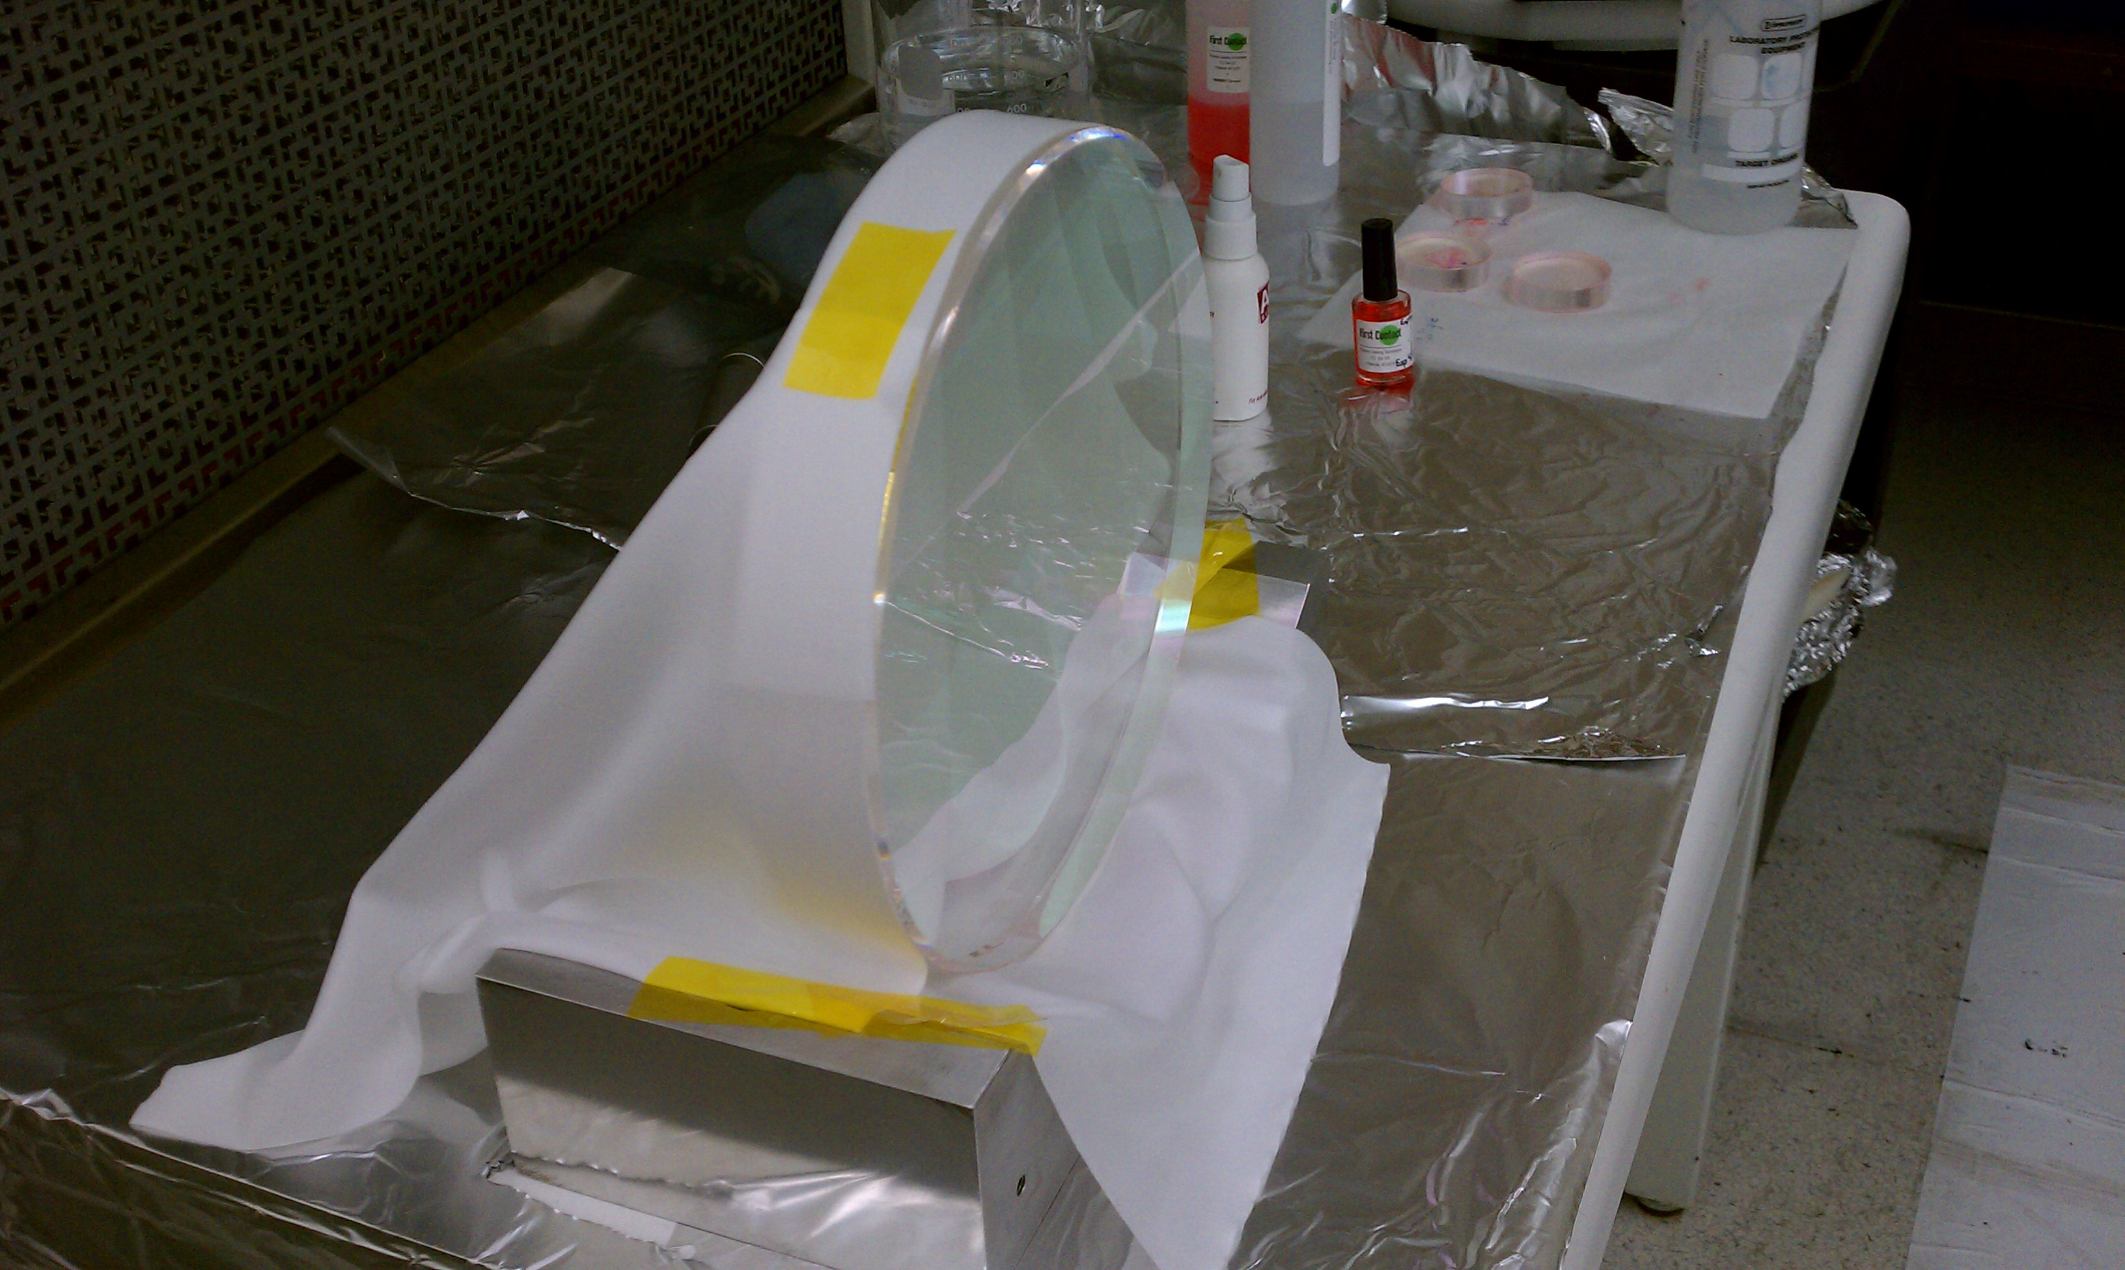
Figure 1: Mask to minimize overspray mess

Application
- Soak clean room wipe. Use ultraclean deionized water or spectroscopic grade water. Use a wipe larger than the optic diameter. Multiple wipes may be used. The optic must be continuously covered with water
- Adhere and scrub. Let the wipe cling to the surface, minimize bubbles, add water to be sure the surface STAYS WET during the scrubbing. This will make a mess. To scrub; move portions of the wipe in small circles using your palm, raster to be sure you scrub every part of the surface. The mechanical action is required in order to remove water soluble contamination.
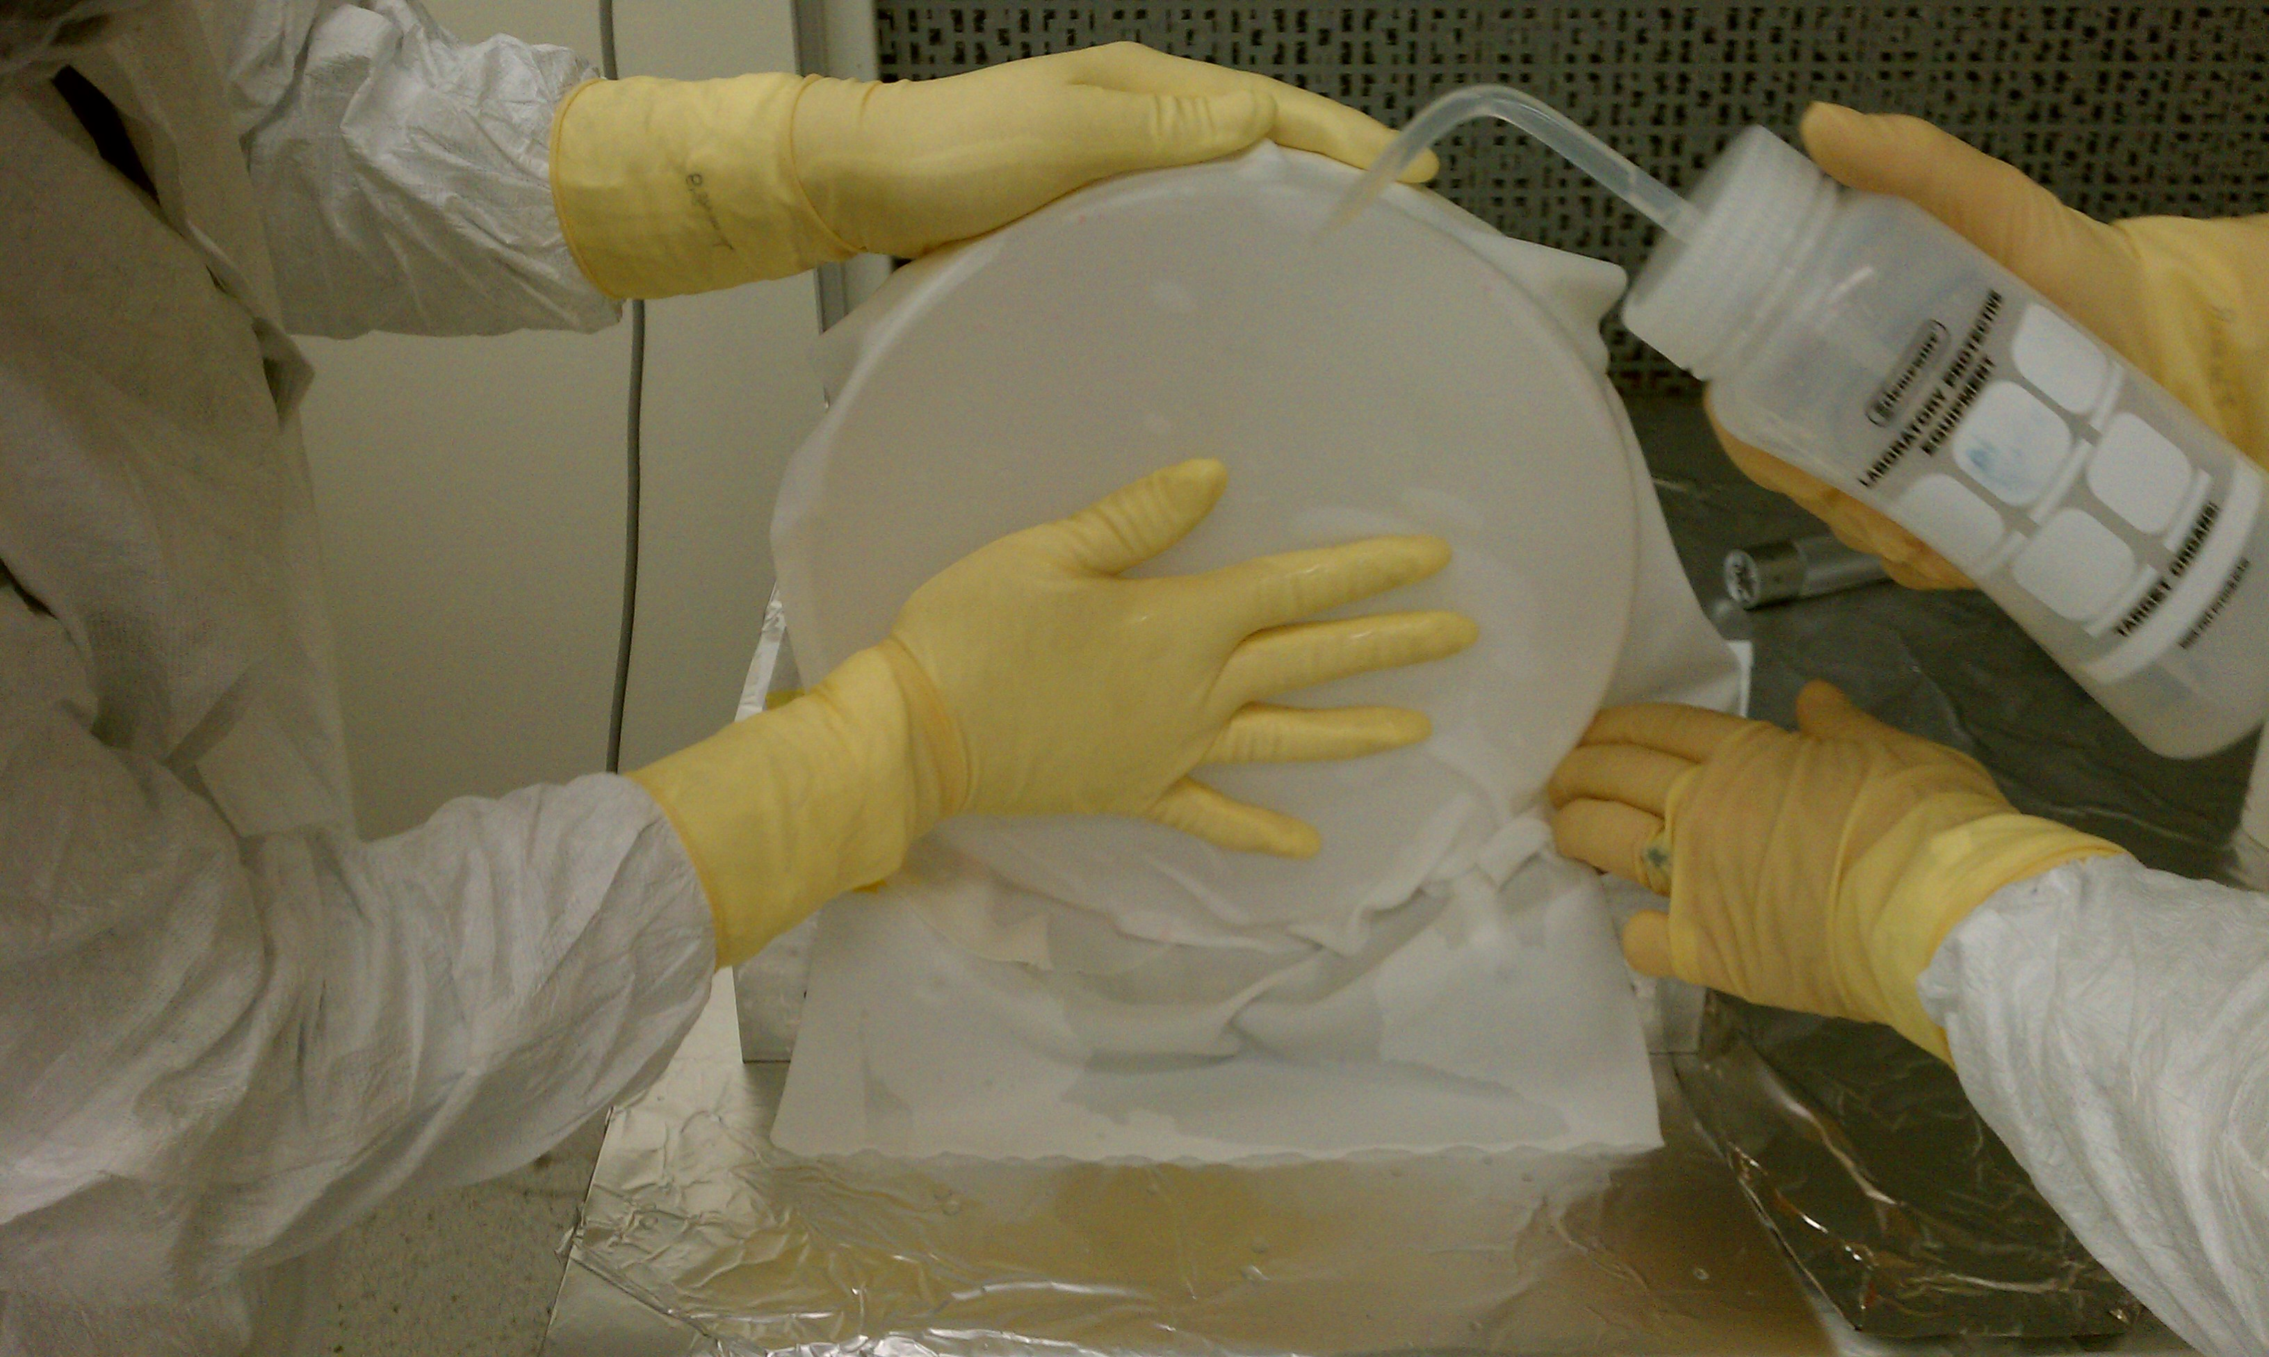
Figure 2. Scrub every part of the surface

- Remove Horizontally. Begin to pull the wipe horizontally, continue adding water to the wipe. As parts of the optical surface are exposed QUICKLY SPRAY one layer of First Contact on the surface as soon as it is exposed. It is imperative to NOT LET THE WATER EVAPORATE. It is OK if the spray gets on gloves and the wet wipe. It will run and look awful.
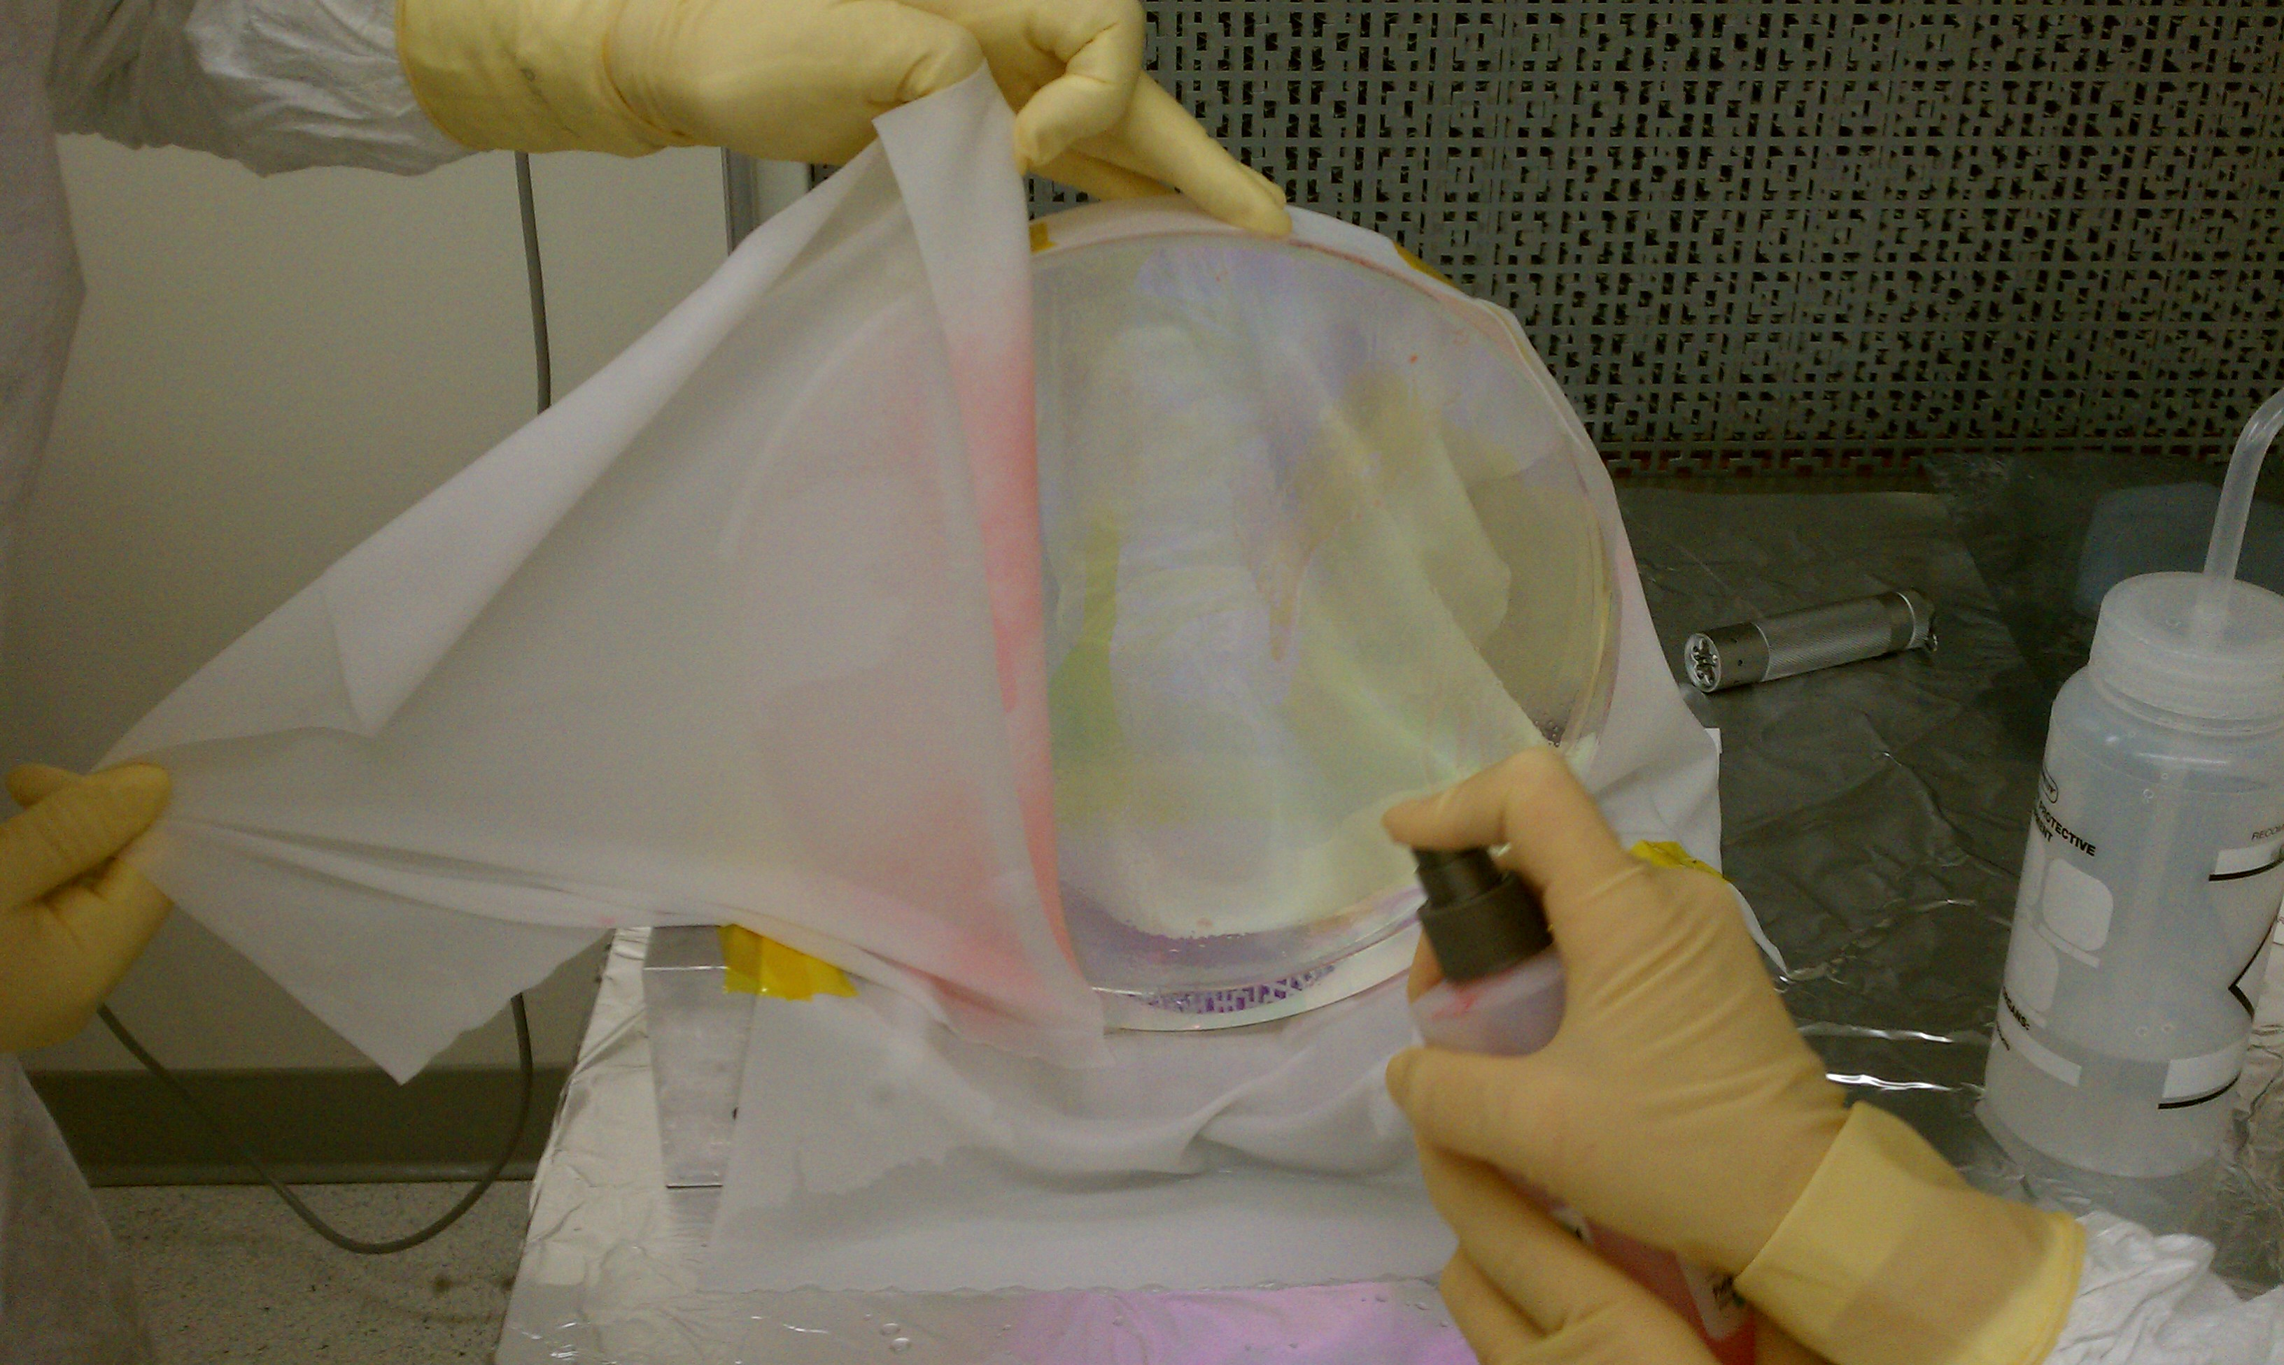
Figure 3: Spray First Contact quickly before surface dries

- Wait 1-2 minutes to allow the first layer of First Contact to absorb the water.
- Spray another full coverage layer of First Contact. Apply several layers with 3-10 minutes in between applications until the First Contact becomes clear and loses the cloudy appearance. Additional First contact may be applied by brush our poured on until the layer is thick enough to stay together for removal.
- Remove per E1000079. Clean overspray from edges and bevels with Acetone and Berkshire (paper) wipes.

Care Of Spray Bottles
Leaving for a short break – turn the first contact spray bottle upside down and spray into a solvent disposal can, or onto foil, until the spray tube is empty and nothing comes out. Wipe the nozzle.
Leaving for a day or more – Insert the suction end of the spray tube into a beaker holding a few ml of thinner. Spray First Contact thinner through the nozzle into a disposal can to clean. End by removing the tube from the thinner and pumping air to clear the tube. Wipe the nozzle.

Additional Information
First Contact has an expiration date of 1 year from the date of purchase.
DO NOT use methanol to wipe an optic that has been cleaned with first contact. See T1000137 for reasons why.
Each layer of brushed FC will take about 20 minutes to set, i.e. to be dry enough to allow for the next layer to be applied. For three layers it is good to leave them overnight to ensure it is completely dry.
Dry time is longer at cooler temperatures.
If the layer sticks or stretches enough to break while removing it is not dry yet.
The dried film must leave the optic in one single INTACT piece.
If the dried film is too thin it will break while peeling. If this happens, stop peeling and brush another layer over the dry layer to make a thicker coating and allow re-drying before peeling off again.
When brushing on polymer with a brush do not allow bristles to scour the optic surface.

