**Linear High Current Regulator Thermal Evaluation**

**LIGO T12000006-v1**

**Richard Abbott, Steve O’Connor, Jay Copti**

**Caltech, 6 January, 2012**

1. **Overview**

The aLIGO DC power distribution system supplies +/-18 volts DC and +/-24 volts DC as standard outputs for use within the LIGO instrumentation and control racks. There are occasions where additional voltages are required for such things as cameras, commercial photodiodes, commercial amplifiers, etc. A relatively high current regulator board was designed using a Micrel MIC29752 regulator IC. The key performance specs are shown in Table 1.

Table

|  |  |
| --- | --- |
| **Parameter** | **Specification** |
| Maximum Output Current | 7.5 amperes |
| Maximum Operating Input Voltage | 26 VDC |
| Package Type | TO247 |
| Thermal Impedance, (junction to case) | 1.5 C per watt |
| Worst case dropout voltage | 0.75 volts |
| Minimum load current | 10mA |
| Output voltage adjustment range | 1.25 to 25 VDC |
| Regulator Tab Potential | Tab is at ground potential |

The regulator IC has the normal compliment of protective circuitry including: output current limiting, and maximum power dissipation. The convenience of being able to ground the regulator tab to the heatsink is nice.

1. **Tests**

A series of tests were performed using a heatsink to determine the temperature of the regulator case vs. regulator power dissipation. A schematic of the test setup is shown in figure Figure 1.

Figure



A single Kepco power supply provided the input voltage that is adjusted to change the dissipated power in the regulator elements. This particular version of the regulator board has two individual MIC29752 regulators, labeled “REG 1” and “REG 2” in Figure 1. The loads consisted of two 5 ohm power resistors located on a separate remote heatsink. The voltages to each 5 ohm load are labeled as V1 and V2. The physical location of the point of temperature measurement on the heatsink is shown and labeled point 1 and 2.

The input voltage was adjusted over a range of 15 to 24 VDC, and four temperatures were recorded for each voltage. During the measurement, the output voltage of each regulator was constant at ~12VDC yielding a total supply current of ~4.8 amps. The results are shown in Table 2 and Table 3.

The grounded tab of each regulator allowed us to put heat-sinking compound directly on each regulator and to bolt it to the heatsink without an additional gasket.

Table

|  |  |
| --- | --- |
| **Fixed Parameters** |  |
| Ambient Temperature (F) | 75.2 |
| Voltage V1 | 12.2 |
| Voltage V2 | 11.9 |
| Current I1 | 2.4 |
| Current I2 | 2.4 |

Table

|  |  |  |  |  |  |
| --- | --- | --- | --- | --- | --- |
| **Input Voltage (VDC)** | **Temperature Regulator 1 (F)** | **Temperature Regulator 2 (F)** | **Temperature Heatsink point 1 (F)** | **Temperature Heatsink point 2 (F)** | **Total Calculated Power into Heatsink (W)** |
| 15 | 93 | 93 | 93 | 92.3 | 14.1 |
| 18 | 114.1 | 113.4 | 113.5 | 113.5 | 28.6 |
| 20 | 129 | 129.9 | 127.8 | 128.5 | 38.3 |
| 22 | 143.8 | 145.4 | 147.4 | 147.6 | 47.9 |
| 24 | 163.3 | 161.4 | 160.2 | 161.1 | 57.6 |

1. **Plots**

The following plots show the junction temperature of each regulator during the test. The junction temperature is calculated based on the measured case temperature and the junction to case thermal impedance (1.5C per watt). Figure 2 shows regulator 1 and Figure 3 shows regulator 2

Figure

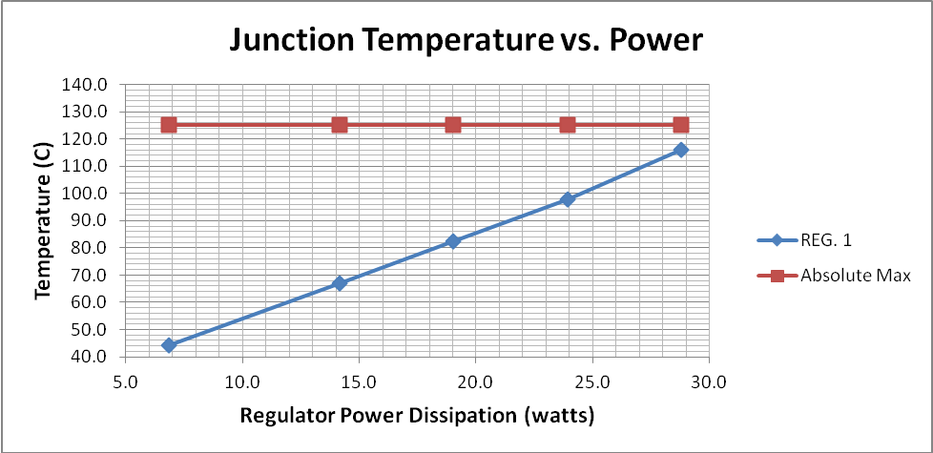

Figure

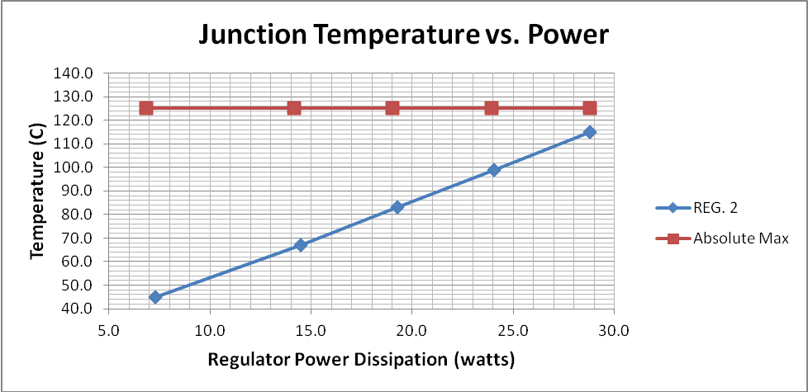

1. Schematic

Shown in Figure 4 is a the rough schematic of the Micrel regulator used during this experiement. The wires leading off the bottom of the schematic went to a relay used to turn the regulator on and off remotely.

Figure



Figure 5 shows the regulator board bonded to the heatsink with all the life support in place.

Figure

