LIGO Laboratory / LIGO Scientific Collaboration

LIGO-T1000718-v3 Advanced LIGO Date: 28-Nov-11

aLIGO Hartmann Sensor Optics and Opto-Mechanical components (H1, L1, H2): Input Test Masses

Author(s): Aidan Brooks

Distribution of this document:
LIGO Scientific Collaboration

This is an internal working note
of the LIGO Laboratory.

California Institute of Technology  LIGO Project – MS 18-34  1200 E. California Blvd.  Pasadena, CA 91125  Phone (626) 395-2129  Fax (626) 304-9834  E-mail: info@ligo.caltech.edu | Massachusetts Institute of Technology  LIGO Project – NW22-295  185 Albany St  Cambridge, MA 02139  Phone (617) 253-4824  Fax (617) 253-7014  E-mail: info@ligo.mit.edu
LIGO Hanford Observatory  P.O. Box 159  Richland WA 99352  Phone 509-372-8106  Fax 509-372-8137 | LIGO Livingston Observatory  P.O. Box 940  Livingston, LA 70754  Phone 225-686-3100  Fax 225-686-7189
http://www.ligo.caltech.edu/

Table of Contents
1 References 3
2 Introduction 3
3 In-vacuum components 4
3.1 H1, L1: X & Y 4
3.1.1 H1, L1: X & H2: Y 8
3.1.2 H1, L1: Y & H2: X 10
4 Extra-vacuum optics and opto-mechanics 11
4.1 H1, L1: X [S-polarization] 11
4.2 H1, L1: Y [P-polarization] 14
4.3 Summary of Optics and opto-mechanics 16
4.4 Unresolved issues 17

References
- T1000179, aLIGO Hartmann Sensor Optical Layouts (H1, L2, H2): Input Test Masses, Aidan Brooks.
- D1003125, In-vacuum Hartmann steering optics platforms.

Introduction
The purpose of this document is to itemize the optics and opto-mechanics needed for the H1, L1 and H2 ITM Hartmann Wavefront Sensors in aLIGO. The document is divided into two sections – the in-vacuum components and the extra-vacuum components.

In-vacuum components

H1, L1: X & Y
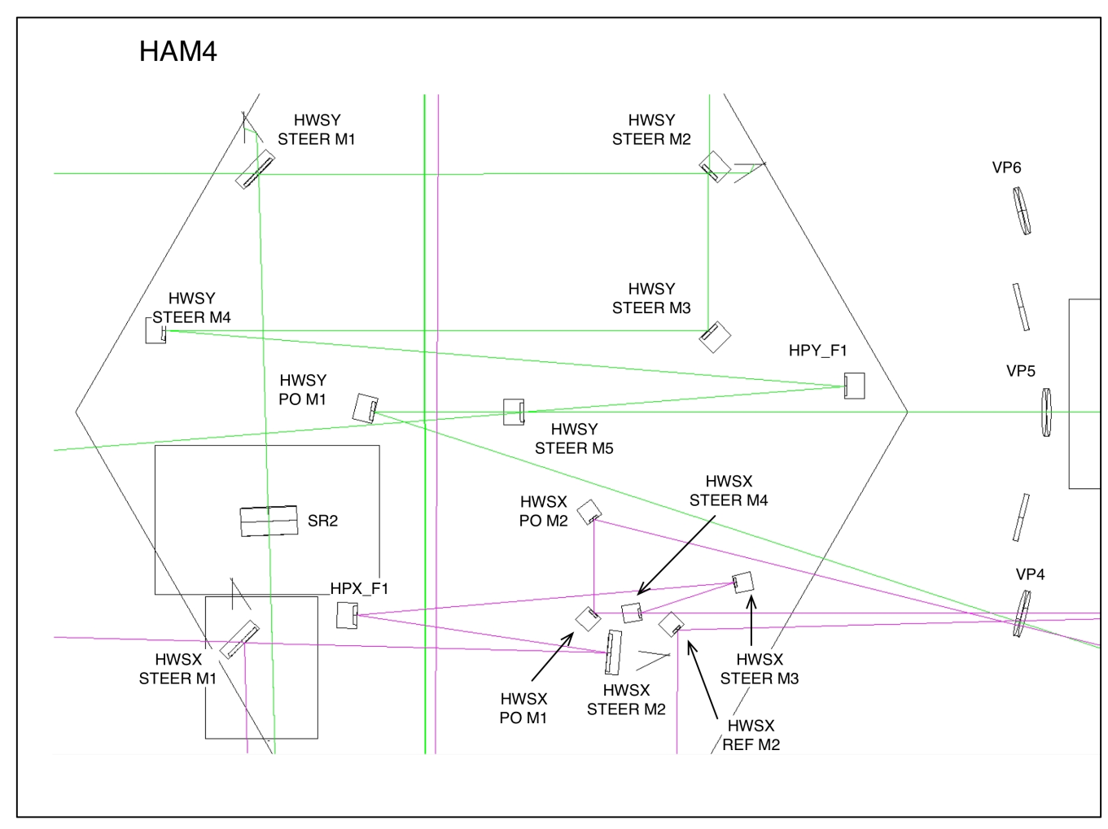
Figure 1: HAM4 region and HWS optics

The HAM4-HWS in-vacuum optics are shown in
Figure 1.
Figure 2: HAM10 region and HWS optics
The H2:HAM10 region shown in Figure 2 is the mirrored layout of the H1/L1:HAM4 region shown in Figure 1.
The beam sizes for the four different HWS imaging configurations (H1/L1:X, H2:X, H1/L1:Y and H2:Y) are shown in Figure 3, plotted from the SR2 AR surface for those beams injected through SR2 and the PO mirror for those beams reflected off the BS_AR surface. Reviewer’s comment, MRS; Please label the mirror locations on this figure.
The H1 and H2 configurations are similar enough that we can make the optics identical between each configuration. We only need verify the beam sizes on the optics are small enough to avoid significant diffraction in both cases.
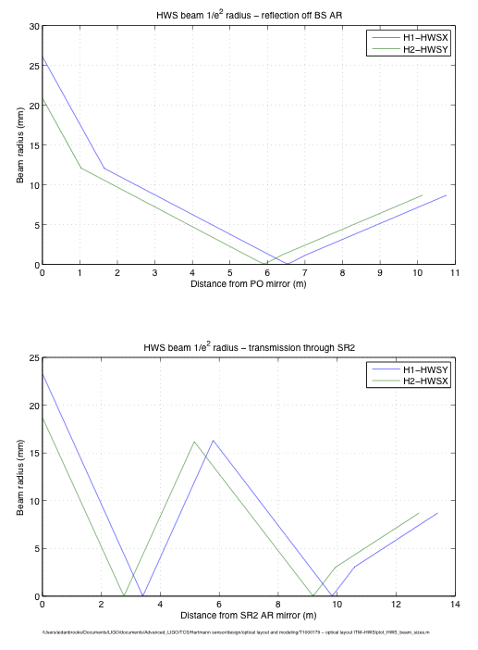
Figure 3: HWS beam size vs distance: (upper) H1-HWSX, H2-HWSY and (lower) H1-HWSY, H2-HWSX.

H1, L1: X & H2: Y
The in-vacuum optics for H1, L1:X and H2:Y are listed below in Table 1. The beam sizes are calculated in the Mathematica notebooks in DCC entry T1000179. All beam sizes are derived assuming the optimum beam diameter at the HWS of CCD_diameter × SQRT[2] which is the maximum beam size used.

Table 1: H1, L1: X & H2: Y optics (see T1100463 and T1100471) – the names given for the optics are for the H1:X case.
Name | Optic Type | Max beam diam. | AOI | Optic diam. | Notes
HWSX STEER M1 | Flat super-polished mirror. Dichroic BS | 52.2mm | ~ 45° | 4” | Super-polished mirror, wedged  1064nm: front surface T>99.5%, rear surface AR coating.  500-880nm: front surface reflects
HWSX STEER M2 | Flat super-polished mirror. Dichroic BS | 35.7mm | ~ 4° | 4” | Super-polished mirror, wedged  1064nm: front surface T>99.5%, rear surface AR coating.  500-880nm: front surface reflects
HPX_F1 | Curved mirror | 24.1mm | ~ 6° | 2” | f = -2.0m, R = -4.0m convex  Super-polished mirror, wedged  Super-broadband coating 500-1100nm
HWSX STEER M3 | Flat mirror | 19.7mm | ~ 6° | 2” | Super-polished mirror, wedged  Super-broadband coating 500-1100nm
HWSX STEER M4 | Flat mirror | 17.8mm | ~ 6° | 2” | Super-polished mirror, wedged, partially transmitting at 543nm, highly reflective at 700-1100nm
HWSX PO M1 | Flat mirror | ~ 3 mm | ~ 45° | 1” | Super-polished mirror, wedged  Super-broadband coating 500-1100nm
HWSX PO M2 | Flat mirror | ~ 3 mm | ~ 45° | 1” | Super-polished mirror, wedged  Super-broadband coating 500-1100nm
HAM4 VP4 | Viewport | ~13mm | ~ 1° | 6” | See E1000604-v2
Secondary beam
HWSX REF M2 | Off-axis paraboloid | ~2mm | ~ 45° | 1” | F = 1.0m  Super-broadband coating 500-1100nm
HWSX REF M1 | Curved mirror | ~50mm | 0° | 4” | F = 7.5m  Super-broadband coating 500-1100nm
Some optics will require left or right handed mounts. The orientation for left and right handed mounts, as defined by Newport is shown in Figure 4.
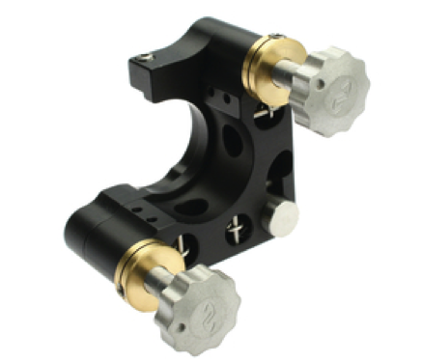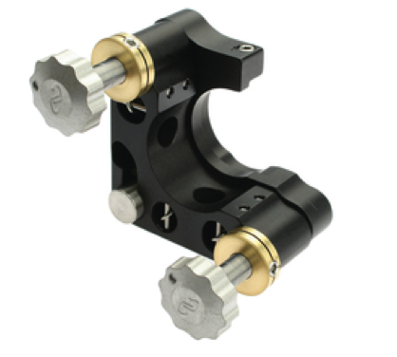
Figure 4: (left) left-handed mirror mount and (right) right-handed mirror mount
There are at least four types of coatings required for the optics in Table 1:
- Super-broadband coating 500-1100nm for s- and p-polarizations from 0-45° specify the coating for each mirror
- Partially transmitting, R ~ 10% at 543nm and highly reflective at 700-1100nm at close to normal incidence which mirror?
- Dichroic mirrors. Front surface: T > 99.5% for 1064nm at 45°, R > 95% for s- and p- polarization at 45°. Rear surface: AR coating for 1064nm at 45° specify AR coating
- Dichroic mirrors. Front surface: T > 99.5% for 1064nm at ~4°, R > 95% for s- and p- polarization at ~4°. Rear surface: AR coating for 1064nm at ~4° specify AR coating

The opto-mechanics necessary for the optics listed above are listed in Table 2. This includes the mirror mounts and the platforms necessary to raise the mounts to the correct beam heights.

Table 2: H1, L1: X & H2: Y opto-mechanics
Name | Mirror mount | Platform | Clamps | Chirality | Notes
HWSX STEER M1 | 4” mirror mount | D1101820 | Yes | H1/L1: LH  H2: LH | Custom Siskiyou 4” mount
HWSX STEER M2 | 4” mirror mount | D1101820 | Yes | RH/LH | Custom Siskiyou 4” mount
HPX_F1 | 2” mirror mount | D1101821 | Yes | RH/LH | Siskiyou 2” mirror mount
HWSX STEER M3 | 2” mirror mount | D1101821 | Yes | RH/LH | Siskiyou 2” mirror mount
HWSX STEER M4 | 2” mirror mount | D1101821 | Yes | RH/LH | Siskiyou 2” mirror mount
HWSX PO M1 | 1” mirror mount | D1101822 | Yes | RH | Siskiyou 1” mirror mount
HWSX PO M2 | 1” mirror mount | D1101822 | Yes | RH | Siskiyou 1” mirror mount
Secondary beam
HWSX REF M2 | 1” mirror mount | D1101822 | Yes | RH | For off-axis paraboloid
HWSX REF M1 | 4” mirror mount | D1101820 | Yes | RH/LH | Custom Siskiyou 4” mount

H1, L1: Y & H2: X
The in-vacuum optics for H1, L1:Y and H2:X are listed below in Table 3. specify the coating for each mirror
Table 3: H1, L1: Y & H2: X optics
Name | Optic Type | Beam diam. | AOI | Optic diam. | Notes
HWSY STEER M1 | Dichroic BS | 34.4mm | ~ 45° | 4” | Super-polished mirror, wedged  1064nm: front surface T>99.5%, rear surface AR coating.  500-880nm: front surface reflects
HWSY STEER M2 | Dielectric mirror | 17.9mm | ~ 45° | 2” | Super-polished mirror, wedged  1064nm: front surface T>99.5%, rear surface AR coating.  500-880nm: front surface reflects
HWSY STEER M3 | Dichroic BS | 12.2mm | ~ 45° | 2” | Super-polished mirror, wedged  Super-broadband coating 500-1100nm
HWSY STEER M4 | Dichroic BS | 7.7mm | ~ 4° | 1” | Super-polished mirror, wedged  Super-broadband coating 500-1100nm
HPY_F1 | Curved mirror | 32.6mm | ~ 4° | 2” | F = 1.5m, (R = 3.0m concave)  Super-polished mirror, wedged  Super-broadband coating 500-1100nm
HWSY STEER M5 | Dielectric mirror | 25.7mm | ~ 4° | 2” | Super-polished mirror, wedged, partially transmitting at 543nm, highly reflective at 700-1100nm
HWSY RR PO | 1” mirror mount | ~ 3mm | ~ 20° | 1” | Super-polished mirror, wedged  Super-broadband coating 500-1100nm
HAM4 VP5 | Viewport | ~22mm | ~ 1° | 6” | See E1000604-v2

The opto-mechanics necessary for the optics listed above are listed in Table 4. The size of mirror mount is listed, as is the platform necessary to raise the center of the optic to the beam height.
Table 4: H1, L1: Y & H2: X opto-mechanics
Name | Mirror mount | Platform | Clamps | Chirality | Notes
HWSY STEER M1 | 4” mirror mount | D1101820 | Yes | LH | Custom Siskiyou 4” mount
HWSY STEER M2 | 2” mirror mount | D1101821 | Yes | LH | Siskiyou 2” mirror mount
HWSY STEER M3 | 2” mirror mount | D1101821 | Yes | RH | Siskiyou 1” mirror mount
HWSY STEER M4 | 1” mirror mount | D1101820 | Yes | RH | Siskiyou 1” mirror mount
HPY_F1 | 2” mirror mount | D1101821 | Yes | LH | Siskiyou 2” mirror mount
HWSY STEER M5 | 2” mirror mount | D1101821 | Yes | LH | Siskiyou 2” mirror mount
HWSY RR PO | 1” mirror mount | D1101820 | Yes | RH/LH | Siskiyou 1” mirror mount

Extra-vacuum optics and opto-mechanics
Note: the exterior vacuum optics will be subject to some re-arrangement from what is shown here to get the imaging lengths correct. The quantity of optics may vary marginally, but the functionality and basic design will not.

H1, L1: X & H2:Y [S-polarization]
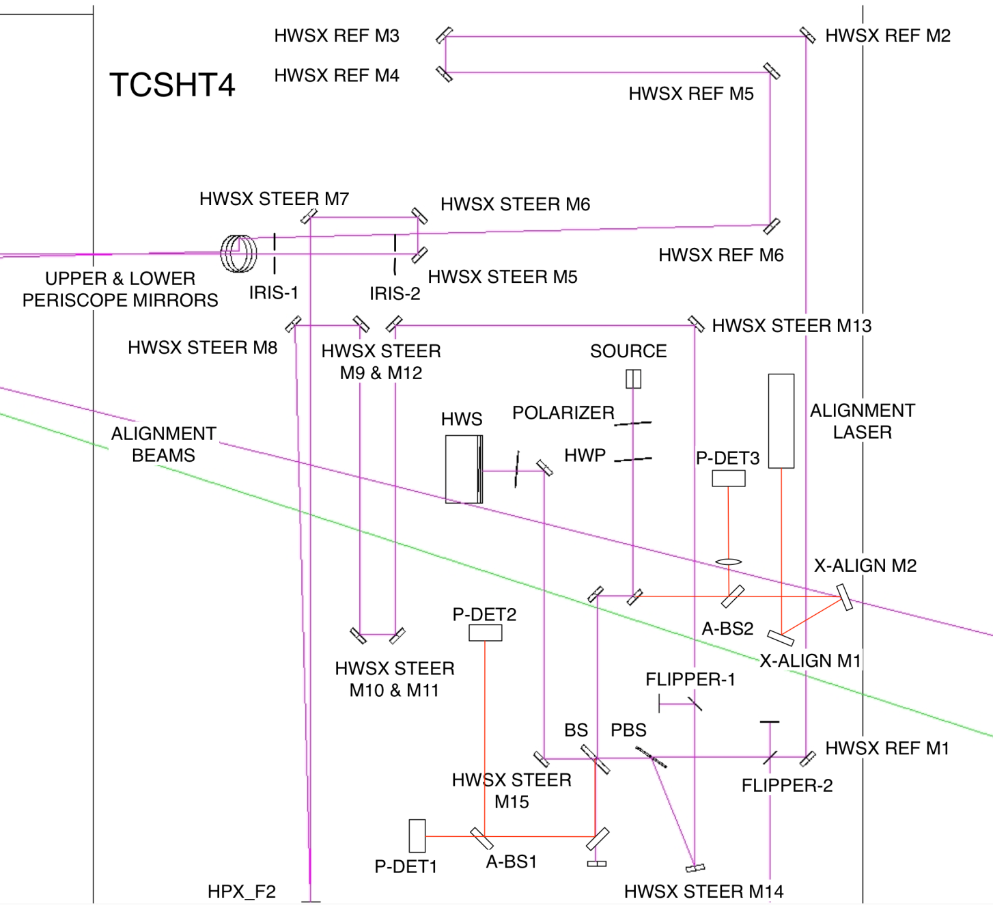
Figure 5: H1, L1 exterior table opto-mechanics

The extra-vacuum optics for H1, L1:X are listed below in Table 5. specify the coating for each mirror
Table 5: H1, L1: X extra-vacuum optics
Name | Optic Type | Beam diam. | AOI | Optic diam. | Notes
HPX_STEER_UPM | Dielectric mirror | 8.0mm | ~ 45° | 3”
HPX_STEER_LPM | Dielectric mirror | 4.6mm | ~ 45° | 3”
HWSX STEER M6 | Dielectric mirror | 3.3mm | ~ 45° | 1”
HWSX STEER M7 | Dielectric mirror | 3.1mm | ~ 45° | 1”
HWSX STEER M8 | Dielectric mirror | 2.4mm | ~ 45° | 1”
HPX_F2 | Curved mirror | 2.4mm | ~ 1° | 1” | F = 2.5m, Super-polished mirror, RoC = 5.0m, concave
HWSX STEER M9 | Dielectric mirror | 5.6mm | ~ 45° | 1”
HWSX STEER M10 | Dielectric mirror | 5.9mm | ~ 45° | 1”
HWSX STEER M11 | Dielectric mirror | 7.6mm | ~ 45° | 2”
HWSX STEER M12 | Dielectric mirror | 7.8mm | ~ 45° | 2”
HWSX STEER M13 | Dielectric mirror | 9.5mm | ~ 45° | 2”
HWSX STEER M14 | Dielectric mirror | 11.2mm | ~ 45° | 2”
FLIPPER MIRROR-P | Dielectric mirror | ~13mm | ~ 45° | 1”
HWSX STEER M15 | Dielectric mirror | 14.2mm | ~ 15° | 2”
HPX_PBS | Polarizing beam splitter | 14.8mm | ~ 65° | 2”
HWSX STEER M16 | Dielectric mirror | 15.4mm | ~ 45° | 2”
BAND PASS FILTER |  |  |  | 1”
HARTMANN SENS. | Hartmann sensor | 17.4mm | ~ 1° | N/A
BS | Beam Splitter | ~15 mm | ~ 45° | 2”
HWSX SOURCE M2 | Dielectric mirror | ~17mm | ~ 45° | 2”
HWSX SOURCE M1 | Dielectric mirror | ~17mm | ~ 45° | 2”
HWSX HWP | Half wave plate | ~17mm | ~ 1° | 2”
HWSX POLARIZER | Polarizer | ~17mm | ~ 1° | 2”
HWSX SOURCE COLLIMATOR | Lens | ~17mm | ~ 0.5° | 2”
LIGHT SOURCE | Fiber output
Secondary beam
FLIPPER MIRROR-S | Dielectric mirror |  | ~ 45° | 1”
HWSX BEAM2 STEER M1 | Dielectric mirror |  | ~ 45° | 2”
HWSX BEAM2 STEER M2 | Dielectric mirror |  | ~ 45° | 2”
HWSX BEAM2 STEER M3 | Dielectric mirror |  | ~ 45° | 2”
HWSX BEAM2 STEER M4 | Dielectric mirror |  | ~ 45° | 2”
HWSX BEAM2 STEER M5 | Dielectric mirror |  | ~ 45° | 1”
HWSX BEAM2 STEER M6 | Dielectric mirror |  | ~ 45° | 1”
BEAM DUMP 1
BEAM DUMP 2
BEAM DUMP 3
Alignment laser
X-ALIGN M0 | Dielectric mirror | ~17mm | 45° | 2”
X-ALIGN M1 | Dielectric mirror | ~17mm | 45° | 2”
X-ALIGN M2 | Dielectric mirror | ~17mm | 45° | 2”
A-BS1 | 50/50 Beam splitter | ~17mm | 45° | 2”
A-BS2 | 50/50 Beam splitter | ~17mm | 45° | 2”
P-DET1 | GigE CMOS camera | ~17mm | ~ 0.5° |  | See T1100149
P-DET2 | GigE CMOS camera | ~17mm | ~ 0.5° |  | See T1100149
P-DET3 LENS | Lens | ~3mm | ~ 0.5° | 1” | See T1100149
P-DET3 | QPD | ~0.5mm | ~ 0.5° |  | See T1100149

The extra-vacuum opto-mechanics for H1, L1:X are listed below in Table 6.
Table 6: H1, L1: X extra-vacuum opto-mechanics
Name | Mount type | Base | Mount | Notes
HPX_STEER_UPM | 3” mirror mount |  |  | Custom periscope required
HPX_STEER_LPM | 3” mirror mount |  |  | Custom periscope required
HWSX STEER M6 | 1” mirror mount | Pedestal | Newport SS100-F2KN | Translation stage required to span M6 and M7. Newport 426?
HWSX STEER M7 | 1” mirror mount | Pedestal | Newport SS100-F2KN | See note above
HWSX STEER M8 | 1” mirror mount | Pedestal | NewFocus 8816-6 | Remotely steerable.  Gouy phase = -84.8°
HPX_F2 | 1” mirror mount | Pedestal | NewFocus 8816-6 | Remotely steerable  Gouy phase = 84.7°
HWSX STEER M9 | 1” mirror mount | Pedestal | Newport SS100-F2KN
HWSX STEER M10 | 1” mirror mount | Pedestal | Newport SS100-F2KN
HWSX STEER M11 | 2” mirror mount | Pedestal | Newport U200-A2K | Translation stage required to span M11 and M12. Newport 426?
HWSX STEER M12 | 2” mirror mount | Pedestal | Newport U200-A2K | See note above
HWSX STEER M13 | 2” mirror mount | Pedestal | Newport U200-A2K
HWSX STEER M14 | 2” mirror mount | Pedestal | Newport U200-A2K
FLIPPER MIRROR-P | Flipper mirror | Pedestal | Newfocus 8892-K
HWSX STEER M15 | 2” mirror mount | Pedestal | Newport U200-A2K
HPX_PBS | 2” mirror mount | Pedestal | Newport U200-A2K
HWSX STEER M16 | 2” mirror mount | Pedestal | Newport U200-A2K
BAND PASS FILTER | ??
HARTMANN SENS. | D1000715 | N/A | N/A
BS | 2” mirror mount | Pedestal | Newport U200-A2K
HWSX SOURCE M2 | 2” mirror mount | Pedestal | Newport U200-A2K
HWSX SOURCE M1 | 2” mirror mount | Pedestal | Newport U200-A2K
HWSX HWP | Rotation stage | Pedestal | New Focus 9401??
HWSX POLARIZER | Rotation stage | Pedestal | New Focus 9401?? – maybe 2”
HWSX SOURCE COLL. | 2” lens mount | Pedestal
LIGHT SOURCE | Fiber-free space coupler | Pedestal | New Focus 9091 | Possibly in-house?
Secondary beam
FLIPPER MIRROR-S | Flipper mirror |  | Newfocus 8892-K
HWSX BEAM2 STEER M1 | 2” mirror mount | Pedestal | Newport U200-A2K
HWSX BEAM2 STEER M2 | 2” mirror mount | Pedestal | Newport U200-A2K
HWSX BEAM2 STEER M3 | 1” mirror mount | Pedestal | Newport SS100-F2KN
HWSX BEAM2 STEER M4 | 1” mirror mount | Pedestal | Newport SS100-F2KN
HWSX BEAM2 STEER M5 | 1” mirror mount | Pedestal | Newport SS100-F2KN
HWSX BEAM2 STEER M6 | 1” mirror mount | Pedestal | Newport SS100-F2KN
BEAM DUMP 1 | Beam dump | Pedestal | Newport PL15
BEAM DUMP 2 | Beam dump | Pedestal | Newport PL15
BEAM DUMP 3 | Beam dump | Pedestal | Newport PL15
Alignment laser
X-ALIGN M0 | 2” mirror mount | Pedestal | Newport U200-A2K
X-ALIGN M1 | 2” mirror mount | Pedestal | Newport U200-A2K
X-ALIGN M2 | 2” mirror mount | Pedestal | Newport U200-A2K
A-BS1 | 2” mirror mount | Pedestal | Newport U200-A2K
A-BS2 | 2” mirror mount | Pedestal | Newport U200-A2K
P-DET1 |  | Pedestal |  | See T1100149
P-DET2 |  | Pedestal |  | See T1100149
P-DET3 LENS | 1” lens mount | Pedestal |  | See T1100149
P-DET3 | QPD | Pedestal | In-house | See T1100149

H1, L1: Y [P-polarization]
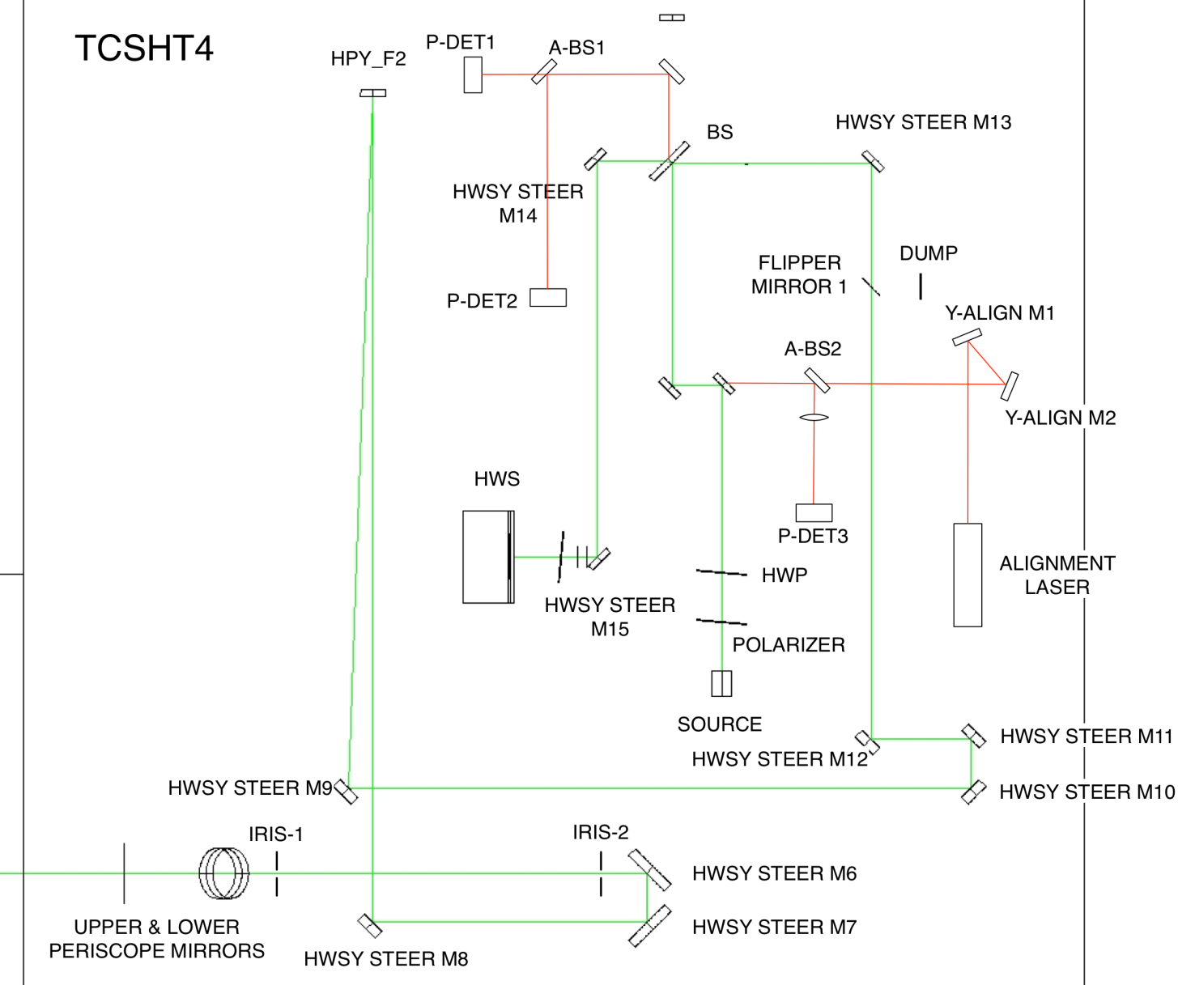
Figure 6: H1, L1 exterior table opto-mechanics

The extra-vacuum optics for H1, L1:Y are listed below in Table 7. specify the coating for each mirror
Table 7: H1, L1: Y extra-vacuum optics
Name | Optic Type | Beam diam. | AOI | Optic diam. | Notes
HPY_STEER_UPM | Dielectric mirror | 12.2mm | ~ 45° | 3”
HPY_STEER_LPM | Dielectric mirror | 6.7mm | ~ 45° | 3”
HWSY STEER M6 | Dielectric mirror | ~3 mm | ~ 45° | 1”
HWSY STEER M7 | Dielectric mirror | ~3 mm | ~ 45° | 1”
HWSY STEER M8 | Dielectric mirror | ~ 3mm | ~ 45° | 1”
HPY_F2 | Curved mirror | 6.1mm | ~ 1° | 1” | F = 1.5m, super-polished mirror, (RoC = 3.0m, concave).
HWSY STEER M9 | Dielectric mirror | ~ 3mm | ~ 45° | 1”
HWSY STEER M10 | Dielectric mirror | 0.6mm | ~ 45° | 1”
HWSY STEER M11 | Dielectric mirror | 8.9mm | ~ 45° | 2”
HWSY STEER M12 | Dielectric mirror | 11.4mm | ~ 45° | 2”
HWSY STEER M13 | Dielectric mirror | 11.6mm | ~ 45° | 2”
HPY_PBS | Polarizing beam splitter | 14.8mm | ~ 65° | 2”
HWSY STEER M14 | Dielectric mirror | 12.0mm | ~ 45° | 2”
HWSY STEER M15 | Dielectric mirror | 14.2mm | ~ 45° | 2”
BAND PASS FILTER | Filter | 17.4mm |  | 1”
HARTMANN SENS. | Hartmann sensor | 17.4mm | ~ 1° | N/A
BS | Beam Splitter | ~15 mm | ~ 45° | 2”
HWSY SOURCE M2 | Dielectric mirror | ~17mm | ~ 45° | 2”
HWSY SOURCE M1 | Dielectric mirror | ~17mm | ~ 45° | 2”
HWSY HWP | Half wave plate | ~17mm | ~ 1° | 2”
HWSY POLARIZER | Polarizer | ~17mm | ~ 1° | 2”
HWSY SOURCE COLLIMATOR | Lens | ~17mm | ~ 0.5° | 2”
LIGHT SOURCE | Fiber output
Alignment laser
Y-ALIGN M0 | Dielectric mirror | ~17mm | 45° | 2”
Y-ALIGN M1 | Dielectric mirror | ~17mm | 45° | 2”
Y-ALIGN M2 | Dielectric mirror | ~17mm | 45° | 2”
A-BS1 | 50/50 Beam splitter | ~17mm | 45° | 2”
A-BS2 | 50/50 Beam splitter | ~17mm | 45° | 2”
P-DET1 | GigE CMOS camera | ~17mm | ~ 0.5° |  | See T1100149
P-DET2 | GigE CMOS camera | ~17mm | ~ 0.5° |  | See T1100149
P-DET3 LENS | Lens | ~3mm | ~ 0.5° | 1” | See T1100149
P-DET3 | QPD | ~0.5mm | ~ 0.5° |  | See T1100149

The extra-vacuum opto-mechanics for H1, L1:Y are listed below in Table 8.
Table 8: H1, L1: Y extra-vacuum opto-mechanics
Name | Mount type | Base | Mount | Notes
HPY_STEER_UPM | 3” mirror mount |  | Periscope | LIGO periscope required
HPY_STEER_LPM | 3” mirror mount |  | Periscope | LIGO periscope required
HWSY STEER M6 | 1” mirror mount | Pedestal | Newport SS100-F2KN | Translation stage required to span M8 and M9. Newport 426?
HWSY STEER M7 | 1” mirror mount | Pedestal | Newport SS100-F2KN | See note above
HWSY STEER M8 | 1” mirror mount | Pedestal | NewFocus 8816-6 | Remotely steerable.  Gouy Phase = -78.2°
HPY_F2 | 1” mirror mount | Pedestal | NewFocus 8816-6 | Remotely steerable  Gouy Phase = 87.5°
HWSY STEER M9 | 1” mirror mount | Pedestal | Newport SS100-F2KN
HWSY STEER M10 | 1” mirror mount | Pedestal | Newport SS100-F2KN | Translation stage required to span M11 and M10. Newport 426?
HWSY STEER M11 | 2” mirror mount | Pedestal | Newport U200-A2K | See note above
HWSY STEER M12 | 2” mirror mount | Pedestal | Newport U200-A2K
HWSY STEER M13 | 2” mirror mount | Pedestal | Newport U200-A2K
HPY_PBS | 2” mirror mount | Pedestal | Newport U200-A2K
HWSY STEER M14 | 2” mirror mount | Pedestal | Newport U200-A2K
HWSY STEER M15 | 2” mirror mount | Pedestal | Newport U200-A2K
BAND PASS FILTER | Prism mount | Pedestal
HARTMANN SENS. | 2” mirror mount | Pedestal | Newport U200-A2K
BS | ?? | ?? | ??
HWSY SOURCE M2 | 2” mirror mount | N/A | N/A
HWSY SOURCE M1 | 2” mirror mount | Pedestal | Newport U200-A2K
HWSY HWP | Rotation stage | Pedestal | New Focus 9401
HWSY POLARIZER | Rotation stage | Pedestal | New Focus 9401
HWSY SOURCE COLL. | 2” lens mount | Pedestal
LIGHT SOURCE | Fiber-free space coupler | Pedestal | New Focus 9091
Alignment laser
X-ALIGN M0 | 2” mirror mount | Pedestal | Newport U200-A2K
X-ALIGN M1 | 2” mirror mount | Pedestal | Newport U200-A2K
X-ALIGN M2 | 2” mirror mount | Pedestal | Newport U200-A2K
A-BS1 | 2” mirror mount | Pedestal | Newport U200-A2K
A-BS2 | 2” mirror mount | Pedestal | Newport U200-A2K
P-DET1 |  | Pedestal |  | See T1100149
P-DET2 |  | Pedestal |  | See T1100149
P-DET3 LENS | 1” lens mount | Pedestal |  | See T1100149
P-DET3 | QPD | Pedestal | In-house | See T1100149

Unresolved issues
- Periscope design – will be LIGO design describe the function and location
- Fiber-free space collimators (invar) – LIGO design? Look for source explain this in more detail
- In-vacuum optics manufacturers – most will be custom
- Gouy phase adjustment for remote steering? – want Gouy phase difference to be ~90 deg explain this in more detail
- Extra-vacuum optics curved mirror manufacturers
- Collimating lens for fiber. – need to choose one to produce correct mode explain this in more detail

A physical optics analysis shows that the diffraction from a 2” HPY_F1 optic is not significant compared to the other apertures in the system.

