AUTHOR(S) | DATE | Document Change Notice, Release or Approval
Ken Mason, Jason Oberling, Doug Cook, Dennis Coyne, Eric James | 23 May 2014 | see LIGO DCC record Status
Instructions on the use of this document:
1) Use, and complete, this document on a laptop computer while the work is proceeding. When operating in a cleanroom, use a cleanroom compatible laptop. This procedure must be available at all times during the alignment process. In addition, all of the applicable documents must also be available for reference during the procedure from the laptop computer.
2) Use this alignment procedure as a check list for preparation and during the alignment; as each step is completed, enter the name of the person completing the work (or approving or checking the step), as well as the date and any comments or notes. In particular, note any discrepancies or deviations and augment with any missing definition. ALL NOTES MUST BE RECORDED IN THE COMPLETED VERSION OF THIS DOCUMENT (NOT IN OTHER NOTEBOOKS OR FILES). If the additional notes are too cumbersome to include within the body of this completed procedure, then electronically attach them to the completed procedure.
3) Once completed, file the document in the LIGO Document Control Center (DCC) as the next highest version of the procedure and add a note that this is a completed/finished procedure.
4) File any significant notes or data from the completed procedure in the electronic logbook (such as any deviations); as a minimum note in the electronic logbook that the alignment was completed in accordance with this procedure (cite document number and revision).

Contents
1 SCOPE 3
2 APPLICABLE DOCUMENTS 3
3 COORDINATE SYSTEMS/REFERENCES 4
4 PREREQUISITES 4
5 REQUIRED EQUIPMENT LIST 4
6 CHAMBER ALIGNMENT PROCEDURE 5
6.1 Chamber set-up 9
6.1.1 Level table LHAM4 9
6.1.2 Level table LHAM5 9
6.1.3 Set LHAM4 and LHAM5 Positions 9
6.1.4 Approximately align the Suspension Structures with the templates 11
6.2 SR2 11
6.2.1 Setup the SR2 Retro-reflector Assembly (D1101340) 11
6.2.2 Set Total Station into position for SR2 for X, Y, and Z positioning 12
6.2.3 Align the SR2 axial position 13
6.2.4 Align the SR2 vertical position 13
6.2.5 Align the SR2 horizontal position 14
6.2.6 Set Total Station into position for SR2 pitch/yaw alignment 15
6.2.7 Set up PLX Lateral Transfer Periscope 15
6.2.8 Align SR2 in Yaw 16
6.2.9 Set SR2 pitch 16
6.2.10 Iterate/re-Check 17
6.3 SR3 17
6.3.1 Setup the SR3 Retro-reflector Assembly (D1101340) 17
6.3.2 Set Total Station into position for SR3 for X, Y, and Z positioning 18
6.3.3 Align the SR3 axial position 19
6.3.4 Align the SR3 vertical position 19
6.3.5 Align the SR3 horizontal position 20
6.3.6 Set Total Station into position for SR3 pitch/yaw alignment 21
6.3.7 Align SR3 in Yaw 21
6.3.8 Set SR3 pitch 21
6.3.9 Iterate/re-Check 22
6.4 SRM Surrogate (SRM-s) 22
6.4.1 Setup the SRM-s Retro-reflector Assembly (D1101340) 22
6.4.2 Set Total Station into position for SRM-s for X, Y, and Z positioning 23
6.4.3 Align the SRM-s axial position 24
6.4.4 Align the SRM-s vertical position 24
6.4.5 Align the SRM-s horizontal position 25
6.4.6 Set Total Station into position for SRM-s pitch/yaw alignment 26
6.4.7 Align SRM-s in Yaw 26
6.4.8 Set SRM-s pitch 27
6.4.9 Iterate/re-Check 27
6.5 Hartmann Wave Front Sensors Alignment (LHAM4) 28

SCOPE
The scope of this procedure is alignment of the optical elements of the LHAM4 and LHAM5 chambers, which includes alignment of the following optical elements:
- SR2, a part of the HSTS assembly (D0900424)
- SR3, a part of the HAM Large Triple Suspension (HLTS) assembly (D0900461)
- SRM, a part of the HAM Small Triple Suspension (HSTS) assembly (D0900463)
- Hartmann Wave Front Sensor Optics Assembly for HAM4 (D1101863)
- Hartmann Wave Front Sensor Optics Assembly for HAM5 (D1101849)

This procedure describes the preliminary alignment of the optical payload elements of the LHAM4 and LHAM5 chambers. These two chambers contain the Signal Recycling Cavity Optics which are aligned as a set.

This procedure does not cover the procedures for installing assemblies onto the HAM-ISI platforms or for balancing and leveling the HAM-ISI optics tables; these procedures are defined in separate documentation.

APPLICABLE DOCUMENTS
Listed below are all of the applicable and referenced documents for the initial alignment procedures. This list gives the latest revisions of the documents; within the alignment steps, only the document number (and not the revision) is quoted.

Document No. | Document Title
E0900047 | LIGO Contamination Control Plan
T1000230 | AOS Initial Alignment Requirements Final Design Document
T080307 | Initial Alignment System Design Requirements Document
D1101864 | Installation Plate Layout, LHAM4
D1102449 | Installation Plate Layout, LHAM5
D1102450 | L1 SRM Installation Plate
D1101855 | L1 SR2 Installation Plate
D1102451 | L1 SR3 Installation Plate
D1200047 | L1/H1 Faraday Isolator Installation Plate
E1100374 | Survey Data for LLO
T1100318 | Total Station modifications for stabilizing unit when Laser Autocollimator is Attached
D0902359 | Suspension Alignment Pusher Assembly
D0900421 | HAM4-L1 Top Level Chamber Assembly
D0900456 | HAM5-L1 Top level Chamber Assembly
T1100468 | Baffle locations
T1100149 | Vertex Hartmann Sensor: Alignment Procedures

COORDINATE SYSTEMS/REFERENCES
The local HAM chamber coordinate system origin is the point where the horizontal, cylindrical axes of the main access portals meet. The local HAM chamber coordinate system axes are aligned to the local gravity vector. Z is vertical (+Z is up). X and Y are both horizontal and approximately aligned to the global coordinate axes (as defined in T980044). The local HAM chamber coordinate system origin is nominally located 12.8 in [325.0 mm] above the HAM-ISI optics table surface for LHAM4 and LHAM5.

PREREQUISITES
- An appropriate clean room should be installed over the chambers
completed, approved or checked by:
date:
comments (optional):
- Remove spool piece between HAM4 and BSC2
completed, approved or checked by:
date:
comments (optional):
- All payload assemblies must be acceptance tested (to the extent possible and planned) prior to integration into the cartridge assembly
completed, approved or checked by:
date:
comments (optional):
- The SRM, SR2 and SR3 suspensions must be capable of being electronically damped while on the test stand and later when in the chamber
completed, approved or checked by:
date:
comments (optional):

REQUIRED EQUIPMENT LIST
  - Total station (either a Sokkia Set2BII or a Sokkia SetX1 modified per T1100318) with tripod stand
  - Laser autocollimator (Newport LDS Vector and LDS1000 controller)
  - Optical level (Sokkia B2o AutoLevel with micrometer option, or equivalent) with tripod stand
  - Precision bubble level
  - Optical Transit Square (Brunson model 75-H) with stand
  - Mechanical locating templates for SRM suspension (D1102450), SR2 suspension (D1101855), SR3 suspension (D1102451), and OFI (D1200047) cleaned to Class B per E0900047 and E960022)
  - Precision pushers (D060052, cleaned to Class B per E0900047 and E960022)
  - Retro-reflector assembly (D1200125), cleaned to Class B per E0900047 and E960022)
  - Depth gauge
  - Height scales
  - PLX Lateral transfer retro-reflector assembly (D1200839-x0)

CHAMBER ALIGNMENT PROCEDURE
The LHAM4 optical table assembly (D0900421) is depicted in Figure 1. The major optics assemblies integrated into the LHAM4 chamber are the Signal Recycling Mirror #2 (SR2) suspension assembly (D0900424) and the Hartmann Wave Front Sensor Assembly (D1101863). The basic alignment setup is depicted in Figure 3.

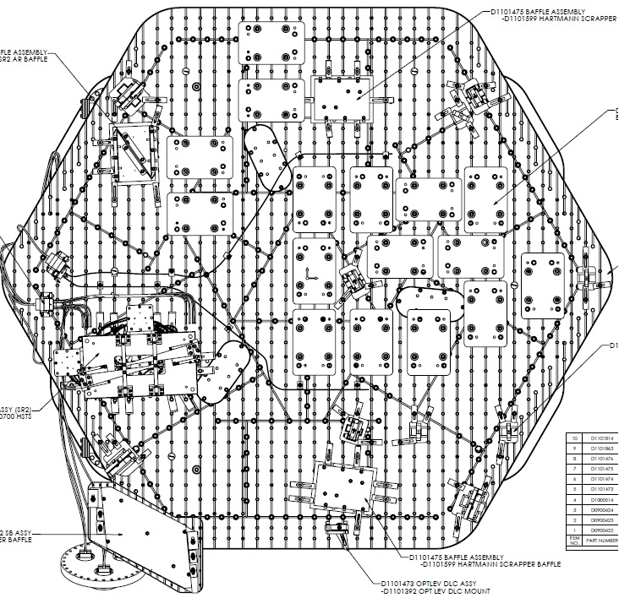
SR2
HWS
HWS

Figure 1: L1 HAM 4

The LHAM5 optical table assembly (D0900456) is depicted in Figure 2. The major optics assemblies integrated into the LHAM5 chamber are the Signal Recycling Mirror (SRM) suspension assembly (D0900463), the Signal Recycling Mirror #3 (SR3) (D0900461), the Output Faraday Isolator Assembly (D0900527), and the Hartmann Wavefront Sensor (HWS) (D1102287). The basic alignment setup is depicted in figure 3.

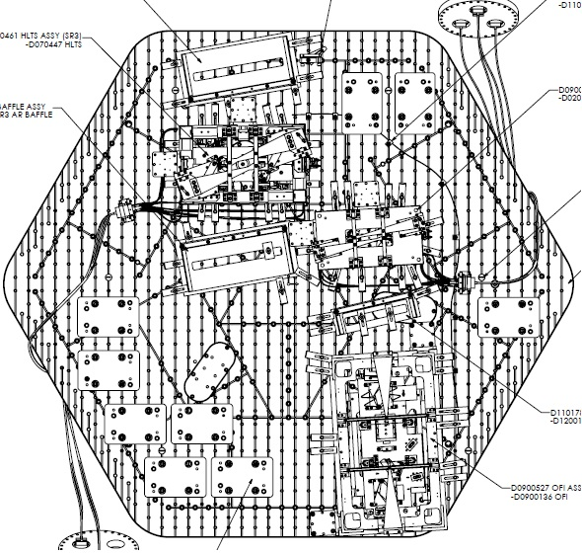
OFI
SRM
SR3

Figure 2: L1 HAM 5
M
C
2
IAS Iris
Location

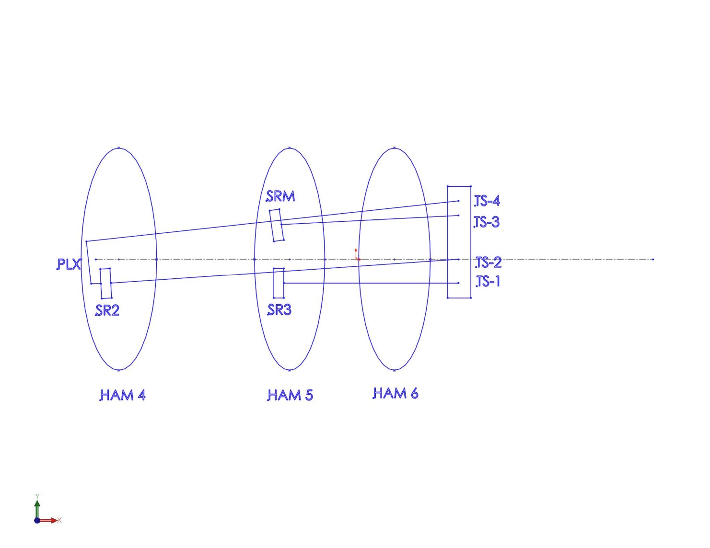

Figure 3: Basic alignment setup

Chamber set-up

Level table LHAM4
Datum: Local gravity
Equipment: Optical level on tall tripod and height scales placed on the optics table
Accuracy: 100 microrad (0.1 mm differential height)
Procedure:
- Place height scales on the table so that they can be seen by the optical level
- Record table height for LHAM4:
LHAM4 Height | +0.3 mm
- Adjust ISI trim/balance mass as needed
- Record table level:
LHAM4 Level | 0.12 mm

completed, approved or checked by:
date:
comments (optional):

Level table LHAM5
Datum: Local gravity
Equipment: Optical level on tall tripod and height scales placed on the optics table
Accuracy: 100 microrad (0.1 mm differential height)
Procedure:
- Place height scale on the table so that they can be seen by the optical level
- Record table height for LHAM5:
LHAM5 Height | -0.4 mm
- Adjust ISI trim/balance mass as needed
- Record table level:
LHAM5 Level | 0 mm

completed, approved or checked by:
date:
comments (optional):

Set LHAM4 and LHAM5 Positions
Datum: Monuments AM 403, AM 404, bolt hole arrays on tables
Equipment: Total Station, sight gauges, retro-reflector
Accuracy: Longitudinal: ±1mm
Lateral: ±1mm
Yaw: ±400 microradians
Procedure:
- Set LHAM4 table position
  - Set up Total station along X-arm offset line adjacent to LHAM4 over monument AM 403
  - Place sight gauges on table, one on the near side of the table, and one on the far side of the table. Sight gauges reference the hole array on the table and will be ~2 m apart.
  - Record table longitudinal readings for LHAM4:
LHAM4 longitudinal reading 1 | 0.33 mm
LHAM4 Longitudinal reading 2 | 0.08 mm
  - Calculate yaw angle from longitudinal readings above:
Yaw = arctan [((Long. reading1- nominal)-(Long. reading2 - nominal))/2000]
LHAM4 yaw angle | 125 microradians CW
  - If longitudinal distance and/or yaw angle is outside of the above tolerances, use HEPI to move the HAM table until it is within these tolerances
  - Place retro-reflector on table at known location wrt table center.
  - Using EDM on Total station, record lateral distance:
LHAM4 lateral reading | -0.1 mm
  - If lateral distance is more than 2mm from the nominal value then use HEPI to properly position the HAM table
  - Repeat the above measurements until the HAM table is within all tolerances
- Set LHAM5 table position
  - Set up Total station along X-arm offset line adjacent to LHAM5 over monument AM 404
  - Place sight gauges on table, one on the near side of the table, and one on the far side of the table. Sight gauges reference the hole array on the table.
  - Record table longitudinal readings for LHAM5:
LHAM5 longitudinal reading 1 | 0 mm
LHAM5 Longitudinal reading 2 | 0 mm
  - Calculate yaw angle from longitudinal readings above:
Yaw = arctan [((Long. reading1- nominal)-(Long. reading2 - nominal))/1000]
LHAM5 yaw angle | 0 microradians
  - If longitudinal distance and/or yaw angle is outside of the above tolerances, use HEPI to move the HAM table until it is within these tolerances
  - Place retro-reflector on table at known location wrt table center.
  - Using EDM on Total station, record lateral distance:
LHAM5 lateral reading | 0 mm
  - If lateral distance is more than 2mm from the nominal value then use HEPI to properly position the HAM table
  - Repeat the above measurements until the HAM table is within all tolerances

Approximately align the Suspension Structures with the templates
Datum: Bolt holes in optical table per D1101864 (LHAM4) and D1102449 (LHAM5)
Equipment: Alignment templates:
SRM Suspension: D1102450
SR2 Suspension D1101855
SR3 Suspension: D1102451
OFR: D1200047
Accuracy: Clearance in bolt holes
Procedure:
- Install D1102450 template per D1102449
- Install D1101855 template per D1101864
- Install D1102451 template per D1102449
- Install D1200047 template per D1102449
- Install pushers (D0902359) adjacent to SRM, SR2, SR3, and OFI structures opposite the templates
- Push SRM, SR2, SR3, and OFI structures to contact the templates
- Lock down suspension structures
- Remove all templates
completed, approved or checked by:
date:
comments (optional):

SR2

Setup the SR2 Retro-reflector Assembly (D1101340)
Datum: Optical axis as established by the total station
Equipment: HAM Triple Retro-reflector assembly, Depth Gauge
Accuracy: ±1 mm
SR2 | X | Y | Z | Pitch | Yaw | Distance
Position (TS-2) | +367.43 | -27000.0 | -81.60 | 90° 0' 0" | 87° 35' 15" | 22842.04
Angle (TS-3) | +651.00 | -27000.0 | -190.45 | 0° 58' 44" | 87° 35' 15" | N/A
** Must subtract measured retroreflector distance
Procedure:
- Set the retro-reflector assembly in front of the HSTS in front of the SR2 HR face
N.B. If necessary for stability, use dog clamps to stabilize the retro-reflector mount
- Use the depth gauge to measure the offset distance from the retro-reflector assembly reference plate (square plate behind corner cube retro-reflector) to the SR2 HR face. Do this on the right and left side of the plate and average two values to get the offset distance.
Take care to clean the depth gauge, especially the contact feature. Contact the optic either on the outer perimeter of the HR face where there is no First Contact ™ film or in the interior but only on the First Contact™ film and be sure to contact very gently.
- Record the offset distance (remember to add 10mm for the distance from the retro-reflector assembly reference plate to the corner cube reference plane)
Offset distance from the SR2 HR face to the Reference Plane of the Retro-reflector | mm

completed, approved or checked by:
date:
comments (optional):

Set Total Station into position for SR2 for X, Y, and Z positioning
Datums: Monument TS-2, wall mark TBD with attached scale
Equipment: Total station, height scale
Accuracy:
Procedure:
- Set theodolite up on monument TS2 with height set to the of optic at Z = -81.6
- Adjust total station height to match height target. The total station is now at the height of SR2
- Remove or push aside baffle in front of optic.
- Yaw the total station +87° 35’ 15” to point at SR2
- Set pitch to 90° 0’ 0” to point at SR2
completed, approved or checked by:
date:
comments (optional):

Align the SR2 axial position
Datum: Total station EDM, Retro-reflector and offsets to the HR face
Equipment: Total station, retro-reflector
Accuracy: ±3 mm
Procedure:
- Use total station EDM to set position to L = 22842.0 mm (remember to subtract the offset distance from the retro-reflector to the optic HR face)
- Record position
 | Trial 1 | Trial 2 | Trial 3
Retro-reflector to HR face offset | mm | mm | mm
EDM Distance | mm | mm | mm
Sum = L (SR2 HR longitudinal distance) | 22843.2 mm | mm | mm

completed, approved or checked by:
date:
comments (optional):

Align the SR2 vertical position
Datum: Optical axis as established by the total station
Equipment: total station
Accuracy: ±3.4 mm (as per T0800307)
Procedure:
- With the Total Station at the proper yaw angle, sight the bottom edge of the optic. Record the pitch angle
- Sight the top edge of the optic. Record the pitch angle
N.B. EQ stop brackets may need to be removed in order to see the top and/or bottom edges of the optic.
- Calculate the Center Error Distance (formula given in table below)
 | Trial 1 | Trial 2 | Trial 3
Bottom optic edge  (-A) | mrad | mrad | mrad
Top optic edge (+B) | mrad | mrad | mrad
Center error angle  (A+B)/2 | microrad | microrad | microrad
Center error distance  L * (A+B)/2 | -1.82 mm | mm | mm
- The optic height was set during the SUS assembly and should be correct. However, if it is out of tolerance then use the SUS procedures to adjust the test mass height until it is within the required accuracy
completed, approved or checked by:
date:
comments (optional):

Align the SR2 horizontal position
Datum: Optical axis as established by the total station
Equipment: total station, pusher assembly (D0902359)
Accuracy: ±5.1 mm (as per T0800307)
Procedure:
- With the Total Station at zero elevation angle, sight the left edge of the optic. Record the yaw angle
- Sight the right edge of the optic. Record the yaw angle.
 | Trial 1 | Trial 2 | Trial 3
Left optic edge (-A) | mrad | mrad | mrad
Right optic edge (+B) | mrad | mrad | mrad
Center error angle  (A+B)/2 | microrad | microrad | microrad
Center error distance  L * (A+B)/2 | -2.19 mm | mm | mm
- Calculate the Center Error Distance (formula given in table below)
- Use the “slider/supports” and “pusher assemblies” (D060052) to shift the lateral position of the quad structure as needed, so that the center error distance falls within the required accuracy
completed, approved or checked by:
date:
comments (optional):

Set Total Station into position for SR2 pitch/yaw alignment
Datum: Monuments TS-3, Mark on wall for height w/ attached scale
Equipment: Total station, Newport visible laser autocollimator (LAC), height scale
Accuracy:
Procedure:
- Set the total station over monument TS-4
- Yaw the total station to sight the scale on wall mark
- Adjust total station height to -190.45 mm (global coordinate system). The LAC is now at the correct height for SR2 alignment.
Zero the total station yaw
- Yaw the total station 87° 35’ 15” and pitch it up by 0° 58’ 44” to point at the AR surface of SR2 via the PLX periscope
completed, approved or checked by:
date:
comments (optional):

Set up PLX Lateral Transfer Periscope
Datum: Optical Axis as established by the Total Station
Equipment: PLX Periscope, Total station, Newport visible laser autocollimator (LAC)
Accuracy:
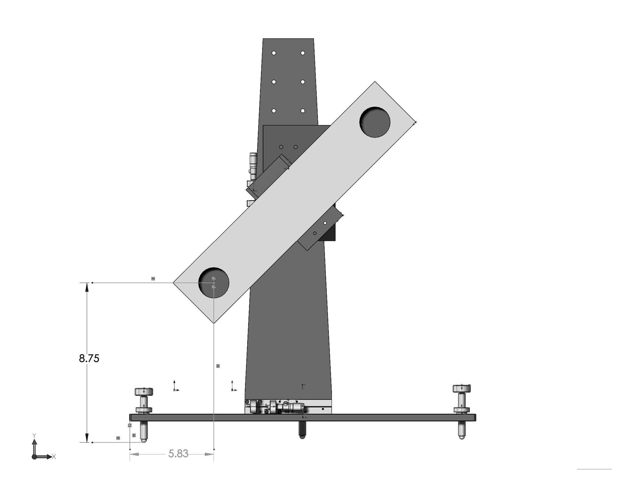
Procedure:
- Set the PLX Lateral Transfer Periscope assembly outside of the HAM2 North door using the 45 ° adapter plate
- Orient the PLX tilted forward 1° and as shown in Figure 3
- Align the PLX to the LAC beam
  - Translate the PLX horizontally and vertically until the beam from the LAC is centered on the entrance port
  - Yaw the PLX until the beam exits the center of the exit port
  - Repeat until the beam enters and exits from the center of the respective ports on the PLX. The PLX is now directing the LAC beam at the AR surface of the SR2
completed, approved or checked by:
date:
comments (optional):

Align SR2 in Yaw
Datum: Optical axis as established by the total station
Equipment: Laser autocollimator
Accuracy: ±820 microradians
Procedure:
- Use the laser autocollimator to measure the yaw angle
  - Zero the yaw using the pusher assemblies down to ±820 microradian residual error
  - Use the top blade adjusters to reduce the residual error further, using the SUS procedures
- Record residual yaw error
SR2 yaw error | 250 microrad CCW
completed, approved or checked by:
date:
comments (optional):

Set SR2 pitch
Datum: Optical axis as established by the total station
Equipment: Total station
Accuracy: ±520 microradians
Procedure:
- Use the LAC to measure the initial pitch error.
SR2 pitch initial error | microradians
- If the pitch error is < 520 microradians, record the value and proceed to step 6.2.10
- If > 520 microradians, then adjust the upper intermediate mass pitch balance per SUS procedures until the required accuracy is met. Record the residual error
SR2 pitch error | 155 microradians up
completed, approved or checked by:
date:
comments (optional):

Iterate/re-Check
Datum: Local gravity, optical axis as established by the total station
Equipment: Optical level on tall tripod, height scales, total station
Accuracy:
levelness: ±100 microrad (0.1 mm differential height)
lateral position: ±5.1 mm
longitudinal position: ±3mm
vertical position: ±3.4 mm
yaw: ±820 microradians
pitch: ±520 microradians
Procedure:
- Re-check LHAM4 table level
- Re-check the longitudinal, lateral, and vertical position and pitch and yaw of the optic. Correct errors as necessary
- Repeat until all are within required accuracy
completed, approved or checked by:
date:
comments (optional):

SR3

Setup the SR3 Retro-reflector Assembly (D1101340)
Datum: Optical axis as established by the total station
Equipment: HAM Triple Retro-reflector assembly, Depth Gauge
Accuracy: ±1 mm
Procedure:
- Set the retro-reflector assembly in behind the HSTS in front of the SR3 AR face.
N.B. If necessary for stability, use dog clamps to stabilize the retro-reflector mount
- Use the depth gauge to measure the offset distance from the retro-reflector assembly reference plate (square plate behind corner cube retro-reflector) to the SR3 HR face. Do this on the right and left side of the plate and average two values to get the offset distance.
Take care to clean the depth gauge, especially the contact feature. Contact the optic either on the outer perimeter of the HR face where there is no First Contact ™ film or in the interior but only on the First Contact™ film and be sure to contact very gently.
- Record the offset distance (remember to add 10mm for the distance from the retro-reflector assembly reference plate to the corner cube reference plane)

Offset distance from the SR3 HR face to the Reference Plane of the Retro-reflector | mm

completed, approved or checked by:
date:
comments (optional):

Set Total Station into position for SR3 for X, Y, and Z positioning
Datums: Monument TS-1, wall mark TBD with attached scale
Equipment: Total station, height scale
Accuracy:
SR3 | X | Y | Z | Pitch | Yaw | Distance
Position(TS-1) | -73.430 | -27000.0 | -8.987 | 90° 34' 30" | 89° 12' 37" | 7283.20
Angle(TS-1) | -73.430 | -27000.0 | -161.97 | 90° 34' 30" | 89° 12' 37" | N/A
** Must subtract measured retroreflector distance
Procedure:
- Set theodolite up on monument TS1 with height set to the of optic at Z = -161.97
- Adjust total station height to match height target. The total station is now at the height of for SR3 positioning
- Remove or push any optic or mass in view of the optic
- Yaw the total station +89° 12’ 37” to point at SR3
- Set pitch to 90° 34’ 30” to point at SR3
completed, approved or checked by:
date:
comments (optional):

Align the SR3 axial position
Datum: Total station EDM, Retro-reflector and offsets to the HR face (determined in section Error! Reference source not found.)
Equipment: Total station, retro-reflector
Accuracy: ±3 mm
Procedure:
- Use total station EDM to set position to L = 7283.2 mm (remember to subtract the offset distance from the retro-reflector to the optic HR face)
- Record position
 | Trial 1 | Trial 2 | Trial 3
Retro-reflector to AR face offset | mm | mm | mm
EDM Distance | mm | mm | mm
Sum = L (SR3 AR longitudinal distance) | 7284.02 mm | mm | mm

completed, approved or checked by:
date:
comments (optional):

Align the SR3 vertical position
Datum: Optical axis as established by the total station
Equipment: total station
Accuracy: ±3.0 mm (as per T0800307)
Procedure:
- With the Total Station at the proper yaw angle, sight the bottom edge of the optic. Record the pitch angle
- Sight the top edge of the optic. Record the pitch angle
N.B. EQ stop brackets may need to be removed in order to see the top and/or bottom edges of the optic.
- Calculate the Center Error Distance (formula given in table below)
 | Trial 1 | Trial 2 | Trial 3
Bottom optic edge  (-A) | 17.788 mrad | mrad | mrad
Top optic edge (+B) | 18.132 mrad | mrad | mrad
Center error angle  (A+B)/2 | +172 microrad | microrad | microrad
Center error distance  L * (A+B)/2 | +1.18 mm | mm | mm
- The optic height was set during the SUS assembly and should be correct. However, if it is out of tolerance then use the SUS procedures to adjust the test mass height until it is within the required accuracy
completed, approved or checked by:
date:
comments (optional):

Align the SR3 horizontal position
Datum: Optical axis as established by the total station
Equipment: total station, pusher assembly (D0902359)
Accuracy: ±3.0 mm (as per T0800307)
Procedure:
- With the Total Station at zero elevation angle, sight the left edge of the optic. Record the yaw angle.
- Sight the right edge of the optic. Record the yaw angle.
- Calculate the Center Error Distance (formula given in table below)
 | Trial 1 | Trial 2 | Trial 3
Left optic edge (-A) | 18.045 mrad | mrad | mrad
Right optic edge (+B) | 18.273 mrad | mrad | mrad
Center error angle  (A+B)/2 | +114 microrad | microrad | microrad
Center error distance  L * (A+B)/2 | +0.83 mm | mm | mm
- Use the “slider/supports” and “pusher assemblies” (D060052) to shift the lateral position of the quad structure as needed, so that the center error distance falls within the required accuracy
completed, approved or checked by:
date:
comments (optional):

Set Total Station into position for SR3 pitch/yaw alignment
Datum: Monuments TS-1, Mark on wall for height w/ attached scale
Equipment: Total station, Newport visible laser autocollimator (LAC), height scale
Accuracy:
Procedure:
- Keep the total station over monument TS-1
- Yaw the total station to sight the scale on wall mark
- Adjust total station height to -161.97 mm (local coordinate system). The LAC is now at the correct height for SR3 alignment.
Zero the total station yaw
- Yaw the total station 89° 12’ 37” and pitch it down by 90° 34’ 30” to point at the AR surface of SR3.
completed, approved or checked by:
date:
comments (optional):

Align SR3 in Yaw
Datum: Optical axis as established by the total station
Equipment: Laser autocollimator
Accuracy: ±200 microradians
Procedure:
- Use the laser autocollimator to measure the yaw angle
  - Zero the yaw using the pusher assemblies down to ±200 microradian residual error.
  - Use the top blade adjusters to reduce the residual error further, using the SUS procedures
- Record residual yaw error
SR3 yaw error | 21 microrad CW
completed, approved or checked by:
date:
comments (optional):

Set SR3 pitch
Datum: Optical axis as established by the total station
Equipment: Total station
Accuracy: ±560 microradians
Procedure:
- Use the LAC to measure the initial pitch error.
SR3 pitch initial error | microradians
- If the pitch error is < 560 microradians, record the value and proceed to step 6.2.10
- If > 560 microradians, then adjust the upper intermediate mass pitch balance per SUS procedures until the required accuracy is met. Record the residual error
SR3 pitch error | 8 microradians down
completed, approved or checked by:
date:
comments (optional):

Iterate/re-Check
Datum: Local gravity, optical axis as established by the total station
Equipment: Optical level on tall tripod, height scales, total station
Accuracy:
levelness: ±100 microrad (0.1 mm differential height)
lateral position: ±3.0 mm
longitudinal position: ±3mm
vertical position: ±3.0 mm
yaw: ±200 microradians
pitch: ±560 microradians
Procedure:
- Re-check LHAM5 table level
- Re-check the longitudinal, lateral, and vertical position and pitch and yaw of the optic. Correct errors as necessary
- Repeat until all are within required accuracy
completed, approved or checked by:
date:
comments (optional):

SRM Surrogate (SRM-s)

Setup the SRM-s Retro-reflector Assembly (D1101340)
Datum: Optical axis as established by the total station
Equipment: HAM Triple Retro-reflector assembly, Depth Gauge
Accuracy: ±1 mm
Procedure:
- Set the retro-reflector assembly in behind the HSTS in front of the SRM AR face.
N.B. If necessary for stability, use dog clamps to stabilize the retro-reflector mount
- Use the depth gauge to measure the offset distance from the retro-reflector assembly reference plate (square plate behind corner cube retro-reflector) to the SRM HR face. Do this on the right and left side of the plate and average two values to get the offset distance.
Take care to clean the depth gauge, especially the contact feature. Contact the optic either on the outer perimeter of the HR face where there is no First Contact ™ film or in the interior but only on the First Contact™ film and be sure to contact very gently.
- Record the offset distance (remember to add 10mm for the distance from the retro-reflector assembly reference plate to the corner cube reference plane)
Offset distance from the SRM HR face to the Reference Plane of the Retro-reflector | mm

completed, approved or checked by:
date:
comments (optional):

Set Total Station into position for SRM-s for X, Y, and Z positioning
Datums: Monument TS-4, wall mark TBD with attached scale
Equipment: Total station, height scale
Accuracy:
SRM | X | Y | Z | Pitch | Yaw | Distance
Position (TS-4) | +710.31 | -27000.0 | +51.652 | 90° 57' 27" | 86° 43' 43" | 7029.080
Angle (TS-4) | +710.31 | -27000.0 | -101.328 | 90° 57' 27" | 86° 43' 43" | N/A
** Must subtract measured retroreflector distance
Procedure:
- Set theodolite up on monument TS3 with height set to the of optic at Z = -1.5
- Adjust total station height to match height target. The total station is now at the height of for SRM positioning
- Remove or push any optic or mass in view of the optic
- Yaw the total station +86° 43’ 43” to point at SRM
- Set pitch to 90° 57’ 18” to point at SR3
completed, approved or checked by:
date:
comments (optional):

Align the SRM-s axial position
Datum: Total station EDM, Retro-reflector and offsets to the HR face (determined in section Error! Reference source not found.)
Equipment: Total station, retro-reflector
Accuracy: ±3 mm
Procedure:
- Use total station EDM to set position to L = 7029.08 mm (remember to subtract the offset distance from the retro-reflector to the optic HR face)
- Record position
 | Trial 1 | Trial 2 | Trial 3
Retro-reflector to AR face offset | mm | mm | mm
EDM Distance | mm | mm | mm
Sum = L (SRM AR longitudinal distance) | 7027.9 mm | mm | mm

completed, approved or checked by:
date:
comments (optional):

Align the SRM-s vertical position
Datum: Optical axis as established by the total station
Equipment: total station
Accuracy: ±3.0 mm (as per T0800307)
Procedure:
- With the Total Station at the proper yaw angle, sight the bottom edge of the optic. Record the pitch angle
- Sight the top edge of the optic. Record the pitch angle
N.B. EQ stop brackets may need to be removed in order to see the top and/or bottom edges of the optic.
- Calculate the Center Error Distance (formula given in table below)
 | Trial 1 | Trial 2 | Trial 3
Bottom optic edge  (-A) | 10.792 mrad | mrad | mrad
Top optic edge (+B) | 10.617 mrad | mrad | mrad
Center error angle  (A+B)/2 | -87.5 microrad | microrad | microrad
Center error distance  L * (A+B)/2 | -0.61 mm | mm | mm
- The optic height was set during the SUS assembly and should be correct. However, if it is out of tolerance then use the SUS procedures to adjust the test mass height until it is within the required accuracy
completed, approved or checked by:
date:
comments (optional):

Align the SRM-s horizontal position
Datum: Optical axis as established by the total station.
Equipment: total station, pusher assembly (D0902359).
Accuracy: ±4.6 mm (as per T0800307)
Procedure:
- With the Total Station at zero elevation angle, sight the left edge of the optic. Record the yaw angle.
- Sight the right edge of the optic. Record the yaw angle.
- Calculate the Center Error Distance (formula given in table below)
 | Trial 1 | Trial 2 | Trial 3
Left optic edge (-A) | 10.423 mrad | mrad | mrad
Right optic edge (+B) | 10.952 mrad | mrad | mrad
Center error angle  (A+B)/2 | +261 microrad | microrad | microrad
Center error distance  L * (A+B)/2 | +1.86 mm | mm | mm

- Use the “slider/supports” and “pusher assemblies” (D060052) to shift the lateral position of the quad structure as needed, so that the center error distance falls within the required accuracy
completed, approved or checked by:
date:
comments (optional):

Set Total Station into position for SRM-s pitch/yaw alignment
Datum: Monuments TS-4, Mark on wall for height w/ attached scale
Equipment: Total station, Newport visible laser autocollimator (LAC), height scale
Accuracy:
Procedure:
- Keep the total station over monument TS-4
- Yaw the total station to sight the scale on wall mark
- Adjust total station height to -101.33mm (local coordinate system). The LAC is now at the correct height for SRM alignment.
Zero the total station yaw
- Yaw the total station 86° 43’ 43” and pitch it down by 90° 57’ 18” to point at the AR surface of SRM
completed, approved or checked by:
date:
comments (optional):

Align SRM-s in Yaw
Datum: Optical axis as established by the total station
Equipment: Laser autocollimator
Accuracy: ±820 microradians
Procedure:
- Use the laser autocollimator to measure the yaw angle
  - Zero the yaw using the pusher assemblies down to ±820 microradian residual error.
  - Use the top blade adjusters to reduce the residual error further, using the SUS procedures
- Record residual yaw error
SRM yaw error | 4 microrad CCW
completed, approved or checked by:
date:
comments (optional):

Set SRM-s pitch
Datum: Optical axis as established by the total station
Equipment: Total station
Accuracy: ±520 microradians
Procedure:
- Use the LAC to measure the initial pitch error.
SRM pitch initial error | microradians
- If the pitch error is < 520 microradians, record the value and proceed to step 6.2.10
- If > 520 microradians, then adjust the upper intermediate mass pitch balance per SUS procedures until the required accuracy is met. Record the residual error
SRM pitch error | 3 microradians up
completed, approved or checked by:
date:
comments (optional):

Iterate/re-Check
Datum: Local gravity, optical axis as established by the total station
Equipment: Optical level on tall tripod, height scales, total station
Accuracy:
levelness: ±100 microrad (0.1 mm differential height)
lateral position: ±4.6 mm
axial position: ±3mm
vertical position: ±3.0 mm
yaw: ±820 microradians
pitch: ±520 microradians
Procedure:
- Re-check LHAM5 table level
- Re-check the longitudinal, lateral, and vertical position and pitch and yaw of the optic. Correct errors as necessary
- Repeat until all are within required accuracy
completed, approved or checked by:
date:
comments (optional):

Hartmann Wave Front Sensors Alignment (LHAM4)
The Hartman Wave Front Sensor (HWS) is provided by the Thermal Compensation Systems (TCS) group. Alignment of the HWS components is not done at the same time as the rest of the LHAM4 and LHAM5 components. The in-vacuum components for the HWS are installed in LHAM4, but the alignment procedure involves optics in LHAM4, LHAM5, BSC1, BSC2 and BSC3 as well as an external optical table. Alignment will be done after the optics in all of these chambers are in place and aligned. Alignment will require resources from both the Initial Alignment System (IAS) and the TCS groups. The alignment procedure is described in T1100149, Vertex Hartmann Sensor: Initial and Maintenance Alignment Procedures. This document also specifies required equipment and configurations of core optics components.

