LASER INTERFEROMETER GRAVITATIONAL WAVE OBSERVATORY
-LIGO-
CALIFORNIA INSTITUTE OF TECHNOLOGY
MASACHUSETTS INSTITUTE OF TECHNOLOGY
LIGO- E1100718-v8 03/01/2012
SLC Mode Cleaner Tube Baffle Assembly and Installation Procedure
Michael Smith, Lisa C. Austin, Tim Nguyen, Stephany Foley, Heidy Kelman

LIGO Hanford Observatory LIGO Livingston Observatory
P.O. Box 1970; Mail Stop S9-02 19100 LIGO Lane
Richland, WA 99352 Livingston, LA 70754
Phone (509) 37208106 Phone (225) 686-3100
Fax (509) 372-8137 Fax (225) 686-7189
E-mail: info@ligo.caltech.edu E-mail: info@ligo.caltech.edu

California Institute of Technology Massachusetts Institute of Technology
LIGO – MS 18-34 LIGO – MS NW22-295
Pasadena, CA 91125 Cambridge, MA 01239
Phone (626) 395-2129 Phone (617) 253-4824
Fax (626) 304-9834 Fax (617) 253-7014
E-mail: info@ligo.caltech.edu E-mail: info@ligo.mit.edu

1 Scope 3
2 Clean room standards 4
3 Assembly and Installation Overview 5
4 Mode Cleaner Tube Baffle Ring Assembly 7
4.1 Top Ring Assembly (on workbench) 7
4.2 Bottom Ring Assembly (on workbench) 9
5 Mode Cleaner Tube Baffle Framing Assembly 11
5.1 Upper Viewport Framing Assembly (on workbench) 11
5.2 Lower Viewport Framing Assembly (on workbench) 16
Lower assembly viewport for MCA3 (on workbench) 19
5.3 Aperture Framing Assembly (on workbench) 22
6 Installation of Ring Assembly into beam tube 26
7 Install Viewport Framing 30
7.1 Install the Upper Viewport Framing Assembly 30
7.2 Install the lower viewport framing 32
8 Install Aperture Plates of Mode Cleaner Tube Baffle Assembly 35

Scope
This document describes the assembly and installation procedures for the Mode Cleaner Tube Baffle Ring Assembly, D1002863 and the Mode Cleaner Tube Baffle Assembly, D1002864.

Clean room standards
For a clean assembly all LIGO standards should be followed, as presented in the latest version of the LIGO Contamination Control Plan (E0900047). Clean room garb including UHV gloves should be worn when working with parts.
All tools that come in contact with assembly should be cleaned to class B standards.
Assembly will be done under a portable clean room. Any time a part of the assembly is not covered by the portable clean room or not being actively worked on it should be covered with appropriate clean covers. (C3 polyester or equivalent).
All parts that will be included in the final assembly must be cleaned to LIGO standards, Class A. The list of parts to be Class A-cleaned includes screws, washers, inserts, and assorted other hardware. All tooling and other parts that are not included in the final assembly, but that contact Class A parts during assembly must be cleaned to LIGO standards, Class B.

Notes for all Subassembly:
Installation requires three people
Installers will be inside the beam tube
The parts weigh between 20-30 lbs

Assembly and Installation Overview

- Assemble top and bottom outer rings of Mode Cleaner Tube Baffle Ring, D1102863
- Assemble Viewport Framing Assemblies (D1002864)
- Assemble Aperture Framing Assemblies (D1002864)
- Install Ring into tube.
- Install Viewport Framing Assemblies, left and right.
- Install Aperture Assemblies (D1002864)
The Mode Cleaner Tube Baffle Ring (D11002863) is assembled on a workbench and then installed into the input and output mode cleaner tubes.
Three installers will be needed: One person stands inside the mode cleaner tube; one person stands in the viewport adapter tube; and a third person hands the parts through the door of the HAM chamber. The parts weigh between 20-30 lbs and can be carried by a single person.

The Ring is installed by the person standing inside the mode cleaner tube.
Next, the outer viewport ring assembly, in two semicircular pieces, are passed through the door of the HAM chamber and handed to another person standing in the viewport adapter just outside the opening to the mode cleaner tube, who hands the parts to the person inside the mode cleaner tube.

After the viewport ring assembly is installed, the person inside the mode cleaner tube exits and stands together with the person in the viewport adapter tube.

Next the Mode Cleaner Tube Baffle (D11002864) is assembled on a workbench and installed into the input and output mode cleaner tubes at the location of the newly installed Ring. The central portion of the Baffle is brought inside the viewport adapter tube in two semicircular pieces. The bottom piece is rested on the bottom of the mode cleaner tube between the viewports and the already installed Ring, as shown in Figure 2.
The top piece is attached to the Ring from the outside; and then the bottom piece is attached to the Ring.
See Figures 1 and 2.

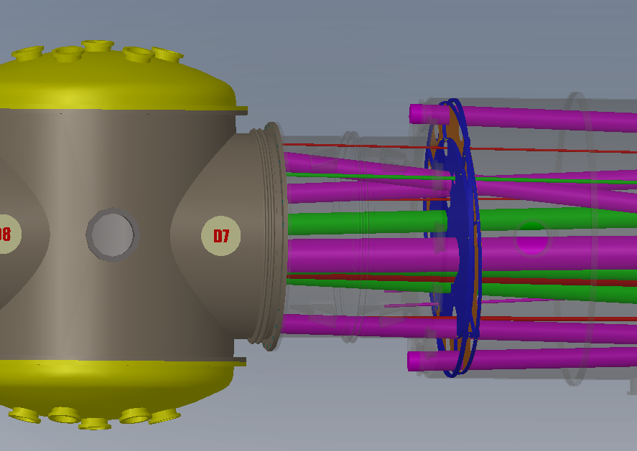
Figure 1: MCA1, H1-L1, HAM2

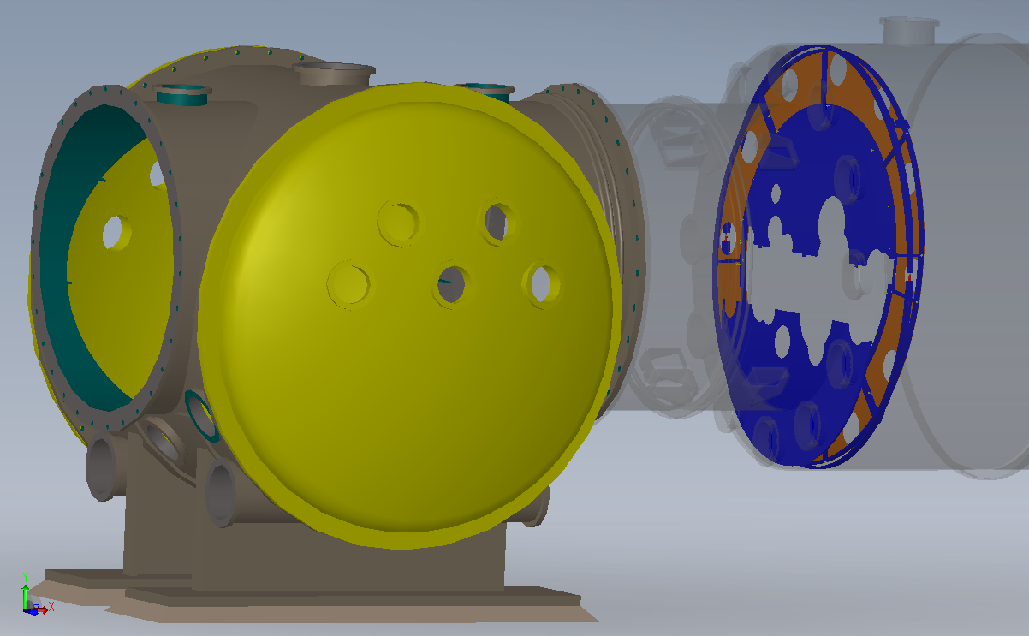

Figure 2: Bottom Central Portion of Baffle Sitting inside Mode Cleaner Tube

Mode Cleaner Tube Baffle Ring Assembly

Refer to MODE CLEANER TUBE BAFFLE RING ASSEMBLY Drawing D1002863 for BOM and drawing.

Top Ring Assembly (on workbench)

In cleanroom, lay down MC Tube baffle ring _top (D1000777) on the workbench, with chamfer side facing upward. Insert 3/8-16 x 7/8 L oval point set screw (TOP-1614-N) 6 places so that set screws stick out about ¼” on other side of ring.
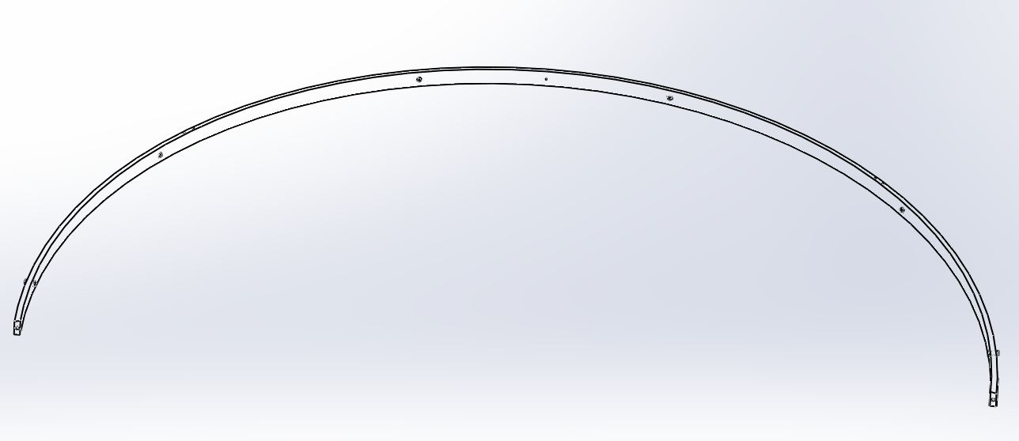
D1000777

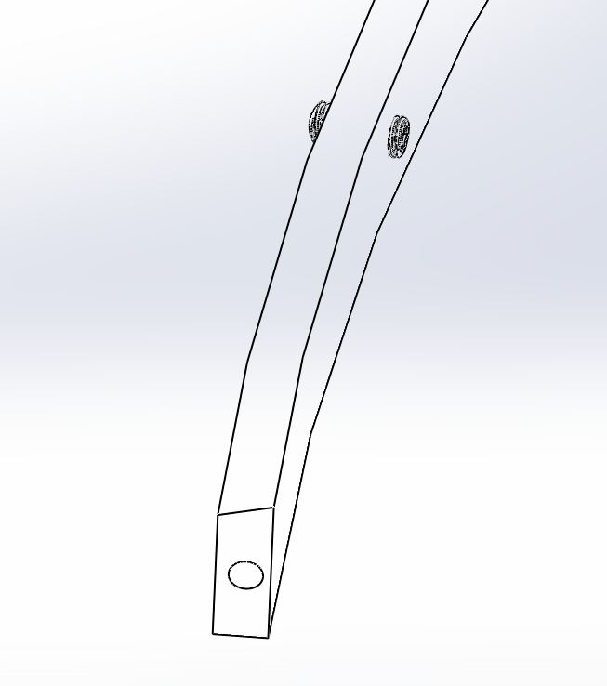

Position D1000784, Mount standoff spacer on 45 degree to the left, attach with two washers (WF-10) and 10-32 x ¾ L SHCS (C-1012-N).

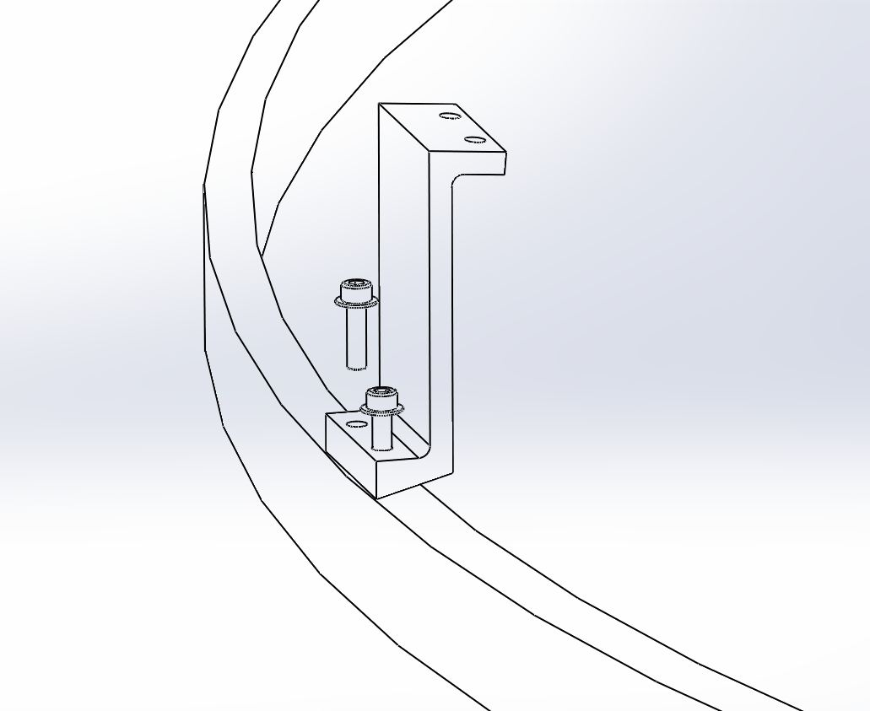
D1000784
D1000777

Attach D1000780, Center Mount bracket top at 45 degree to the right on the same ring, attach with two 10-32 x ¾” L SHCS (C-1012-N), no washer.

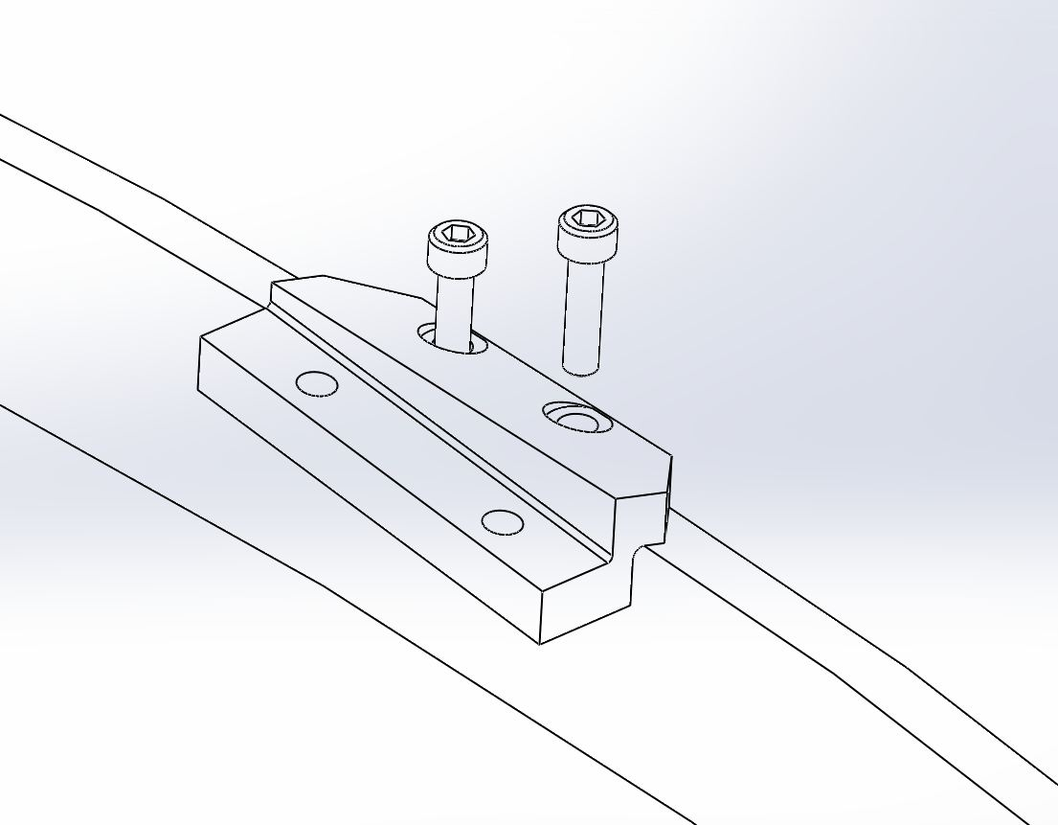
D1000780
D1000777

Screw entire threaded portion of D1000778 (Turn buckle screw) into each end of the ring-top, D1000777.

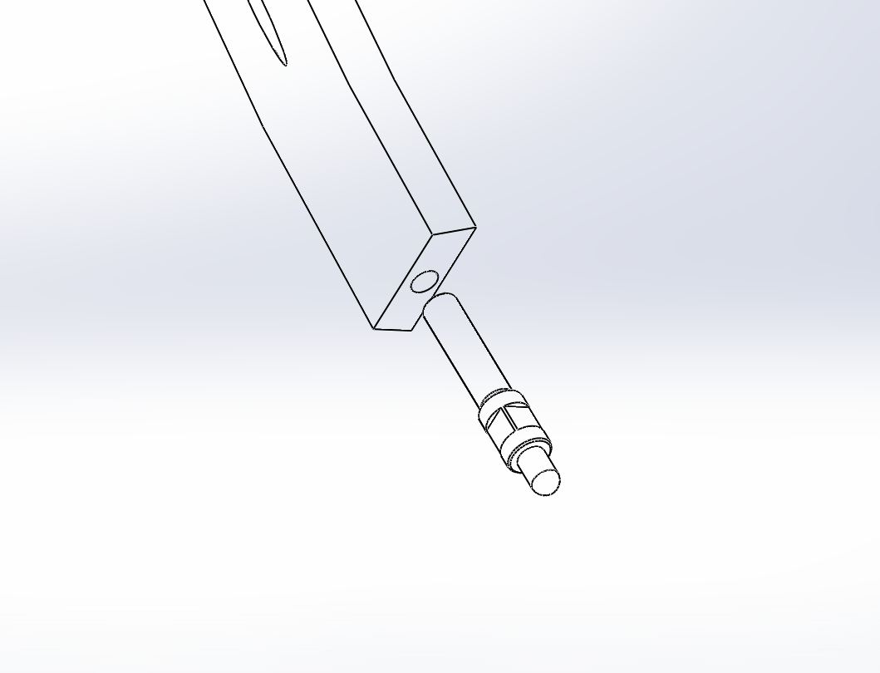
D1000778
D1000777

D1000777
D1000780
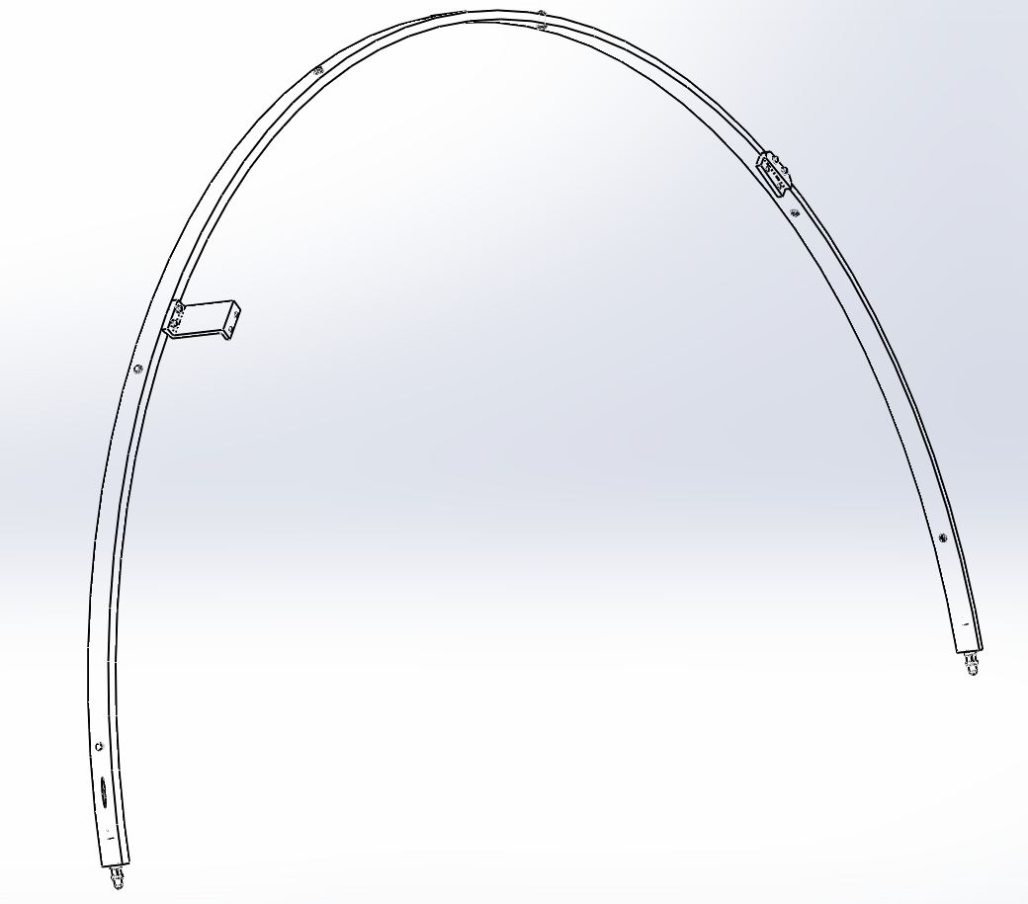
D1000778
D1000784

Bottom Ring Assembly (on workbench)

Place D1000776 on workbench supported by four D1102164 (3¼” Aluminum block) with chamfer side facing upward. Insert 3/8-16 x 7/8 L oval point set screw (TOP-1614-N) 6 places so that set screws stick out about ¼” on other side of ring.

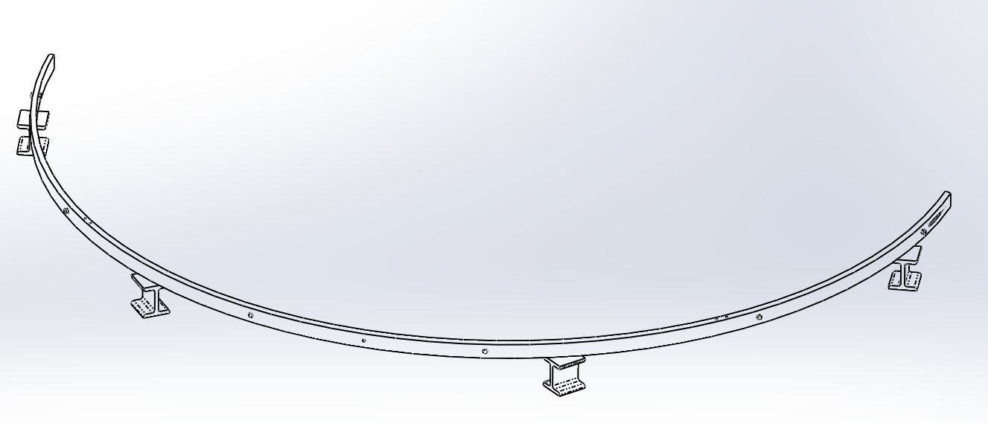
D1102164 4 Places
4

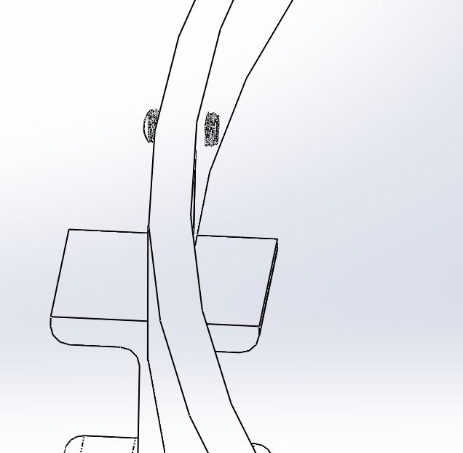
TOP-1614-N
6 Places
4

Position D1000779, Center mount bracket bottom at 45 degree to the right on the left, attach with two C-1012-N.

Attach D1000779 on 45 degree to the left with two 10-32 x ¾ L SHCS (C-1012-N), no washer.

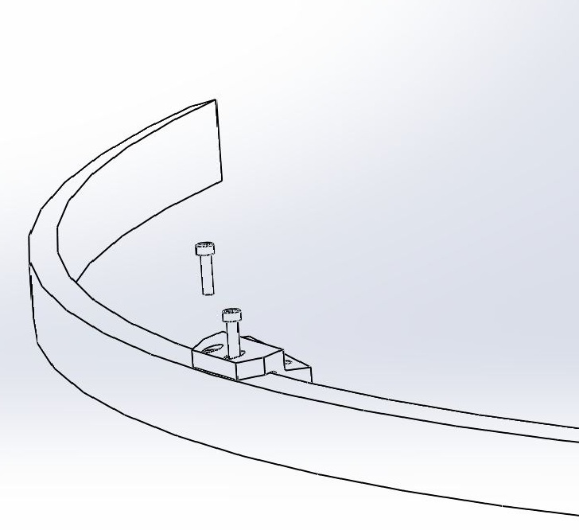
D1000779
D1000776

Attach D1000783, Mount Standoff spacer_ right on 45 degree to the right with two 10-32 x ¾ L SHCS (C-1012-N), no washer.

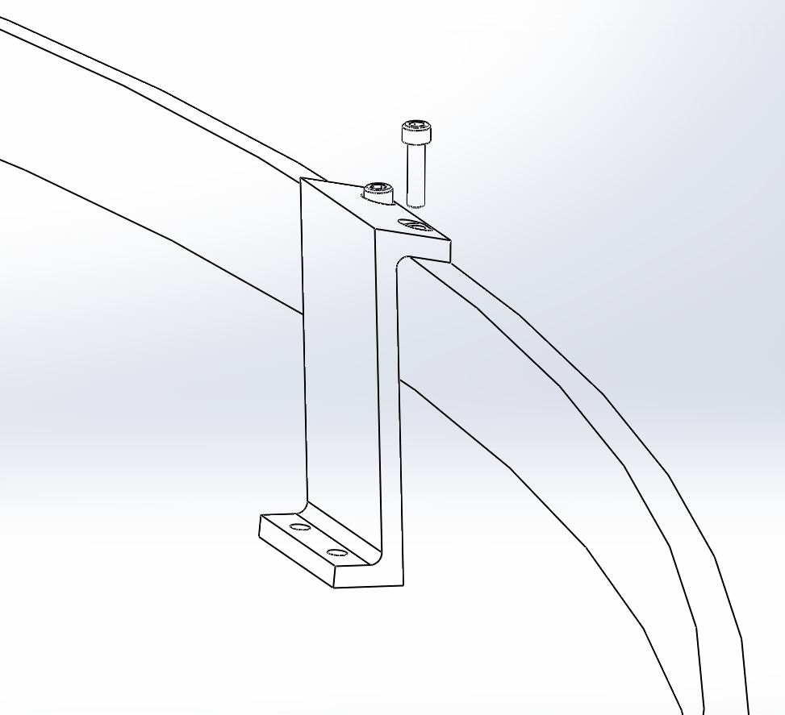
D1000783
D1000776

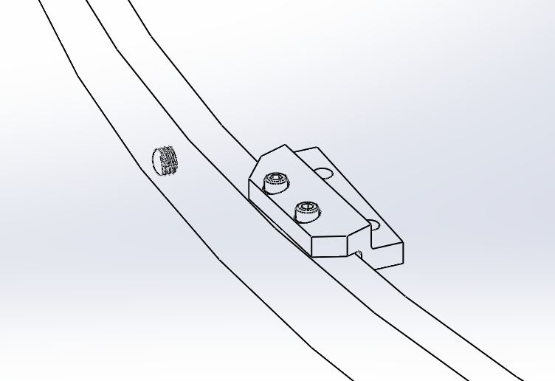

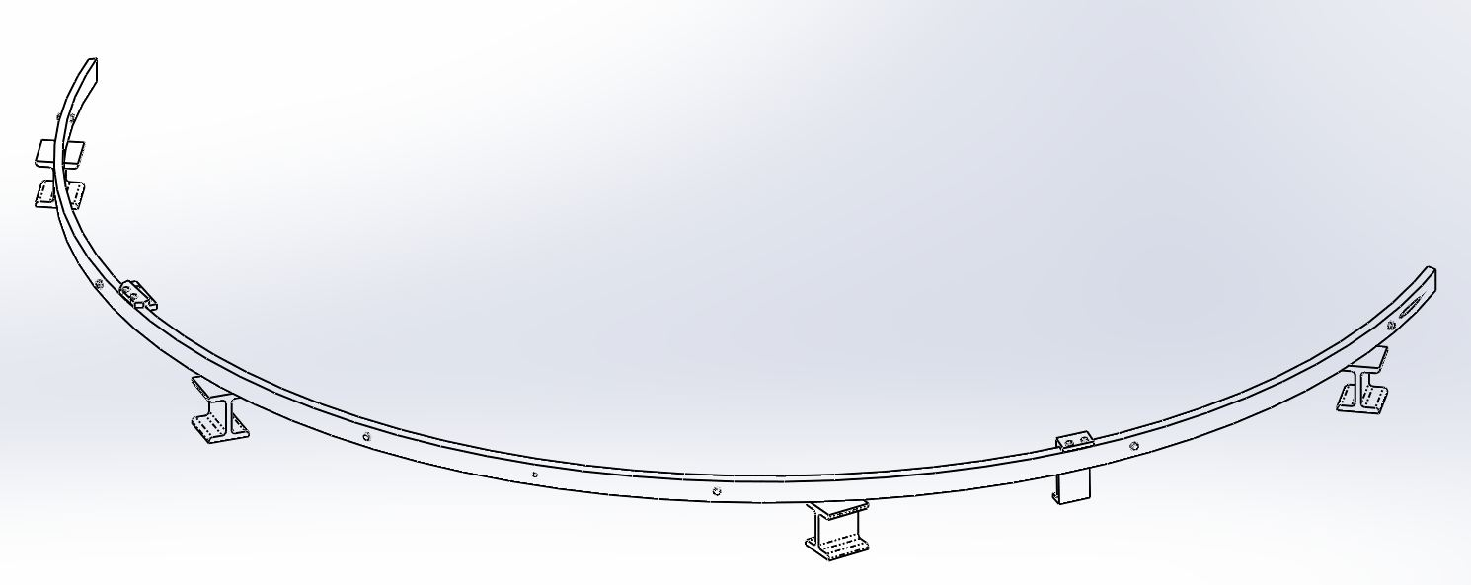
D1000783
D1000776
D1000779

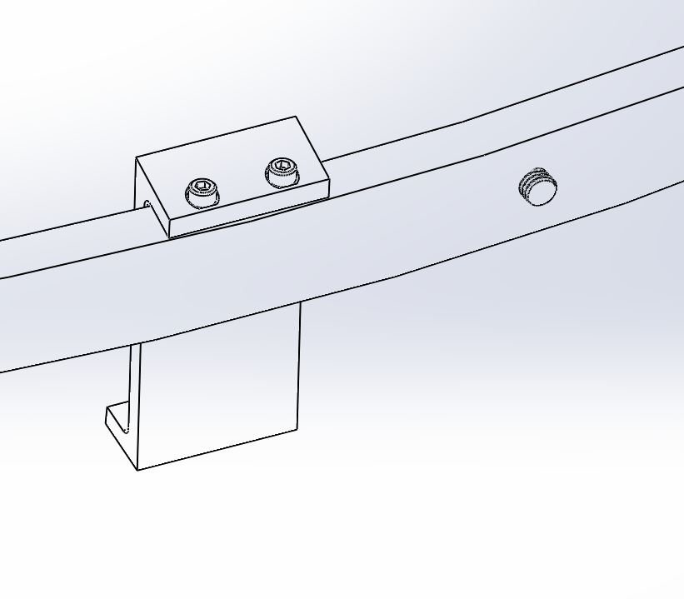

Mode Cleaner Tube Baffle Framing Assembly
See Drawing D1002864.

Upper Viewport Framing Assembly (on workbench)

Place D1002867 (Mode Cleaner Tube Baffle Upper Brace) on the workbench, with tapped holes facing upward.

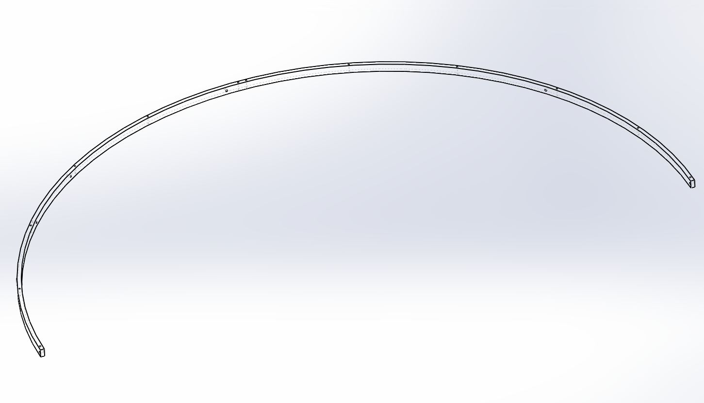
D1002867
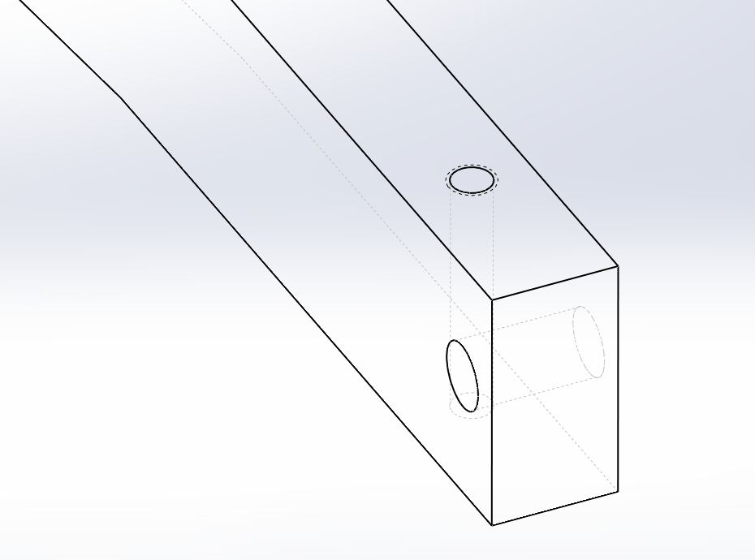

Align D1100121*( Inner upper left brace) to be concentric inside of D1002867. Make sure four tapped holes face upward.
* Install D1002869 instead of D1100121 for all baffles except MCA1.

D1002867
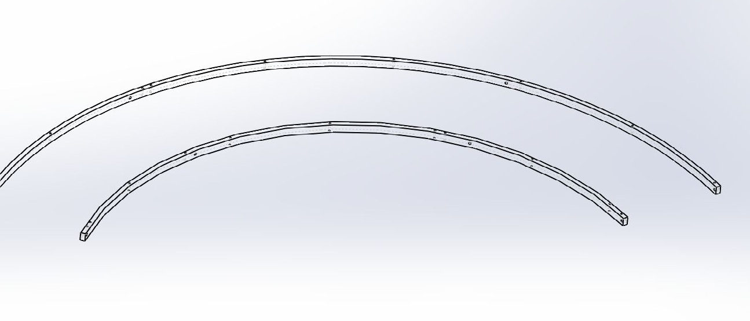
D1100121
Tapped holes

Attach four D1002871 between D1002867 and D1100121* using BU-2016-N (1/4-20 x 1"L BHCS) with a washer (WF-25) on both ends. Tapped holes face downward and toward D1100121.
* Install D1002869 instead of D1100121 for all baffles except MCA1.

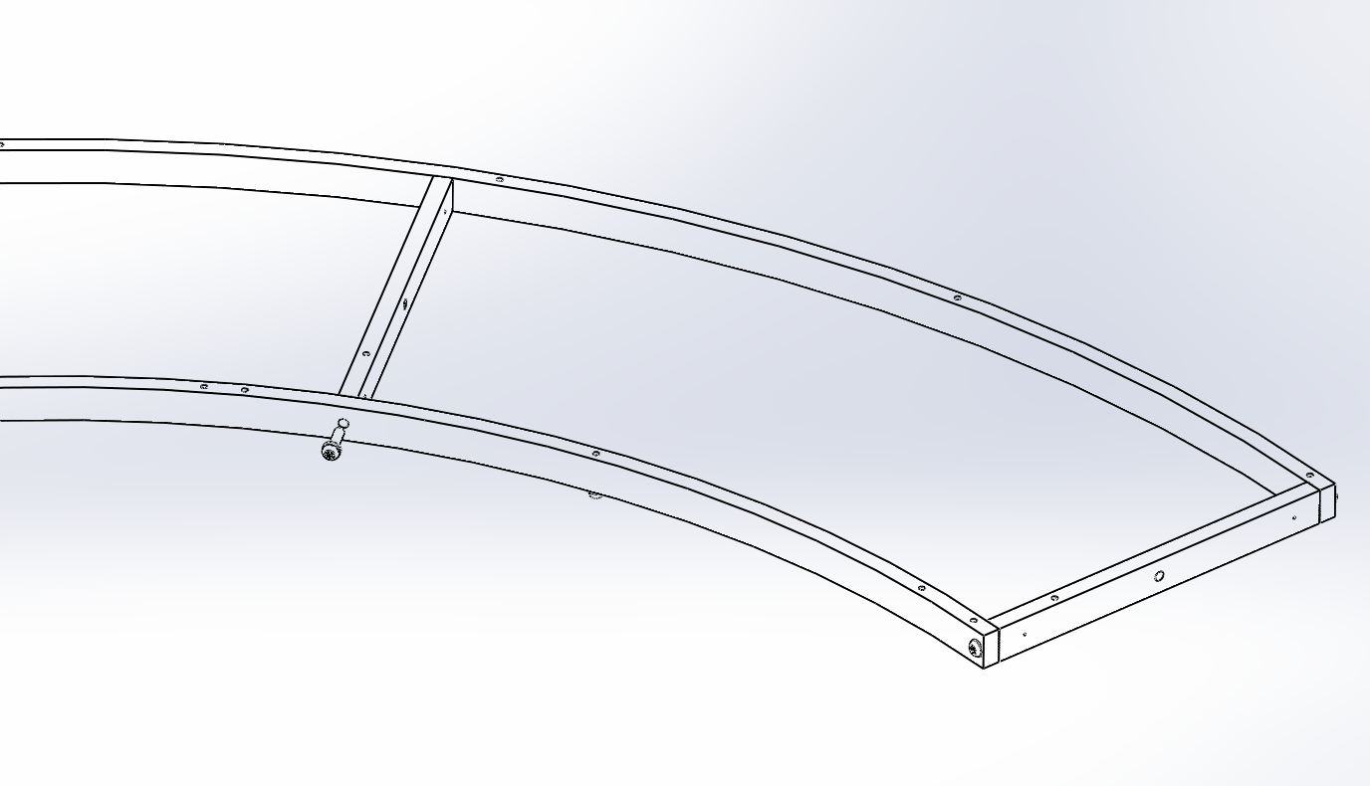
D1002867
D1100121
Tapped Holes
D1002871

Set D1100277 to be concentric inside of D1002867. There is a gap between D1100277* and D1100121*. Two tapped holes face upward.

* Install D1002869 (instead of D1100277 and D1100121) for MCA2, MCA3, MCA4, MCB1, MCB2, MCB3, and MCB4 baffles.

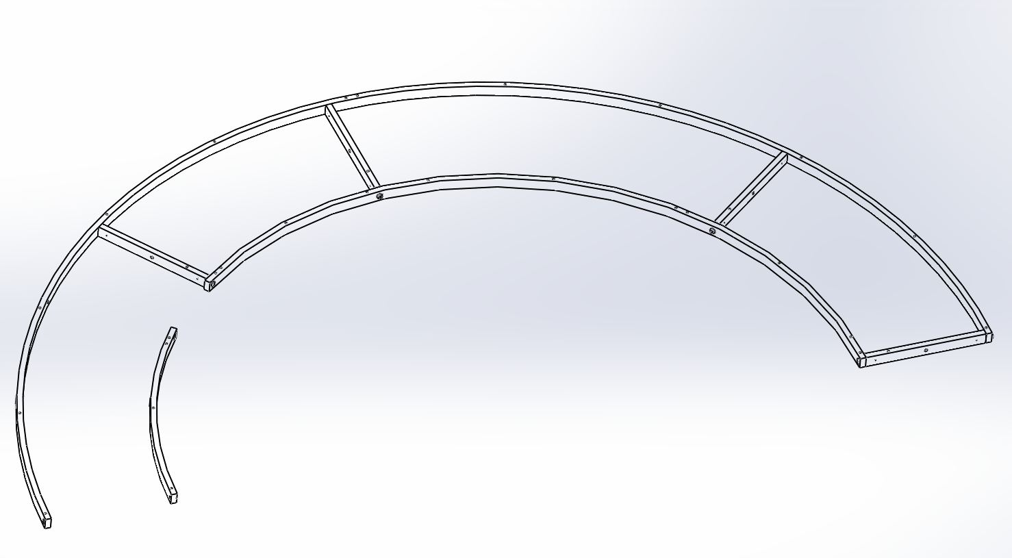
D1100277
D1002867
D1100121

Attach two more D1002871 between D1002867 and D1100277 using BU 2016-N (1/4-20 X 1" BHCS) and WF-25 (1/4" washer) on both ends.

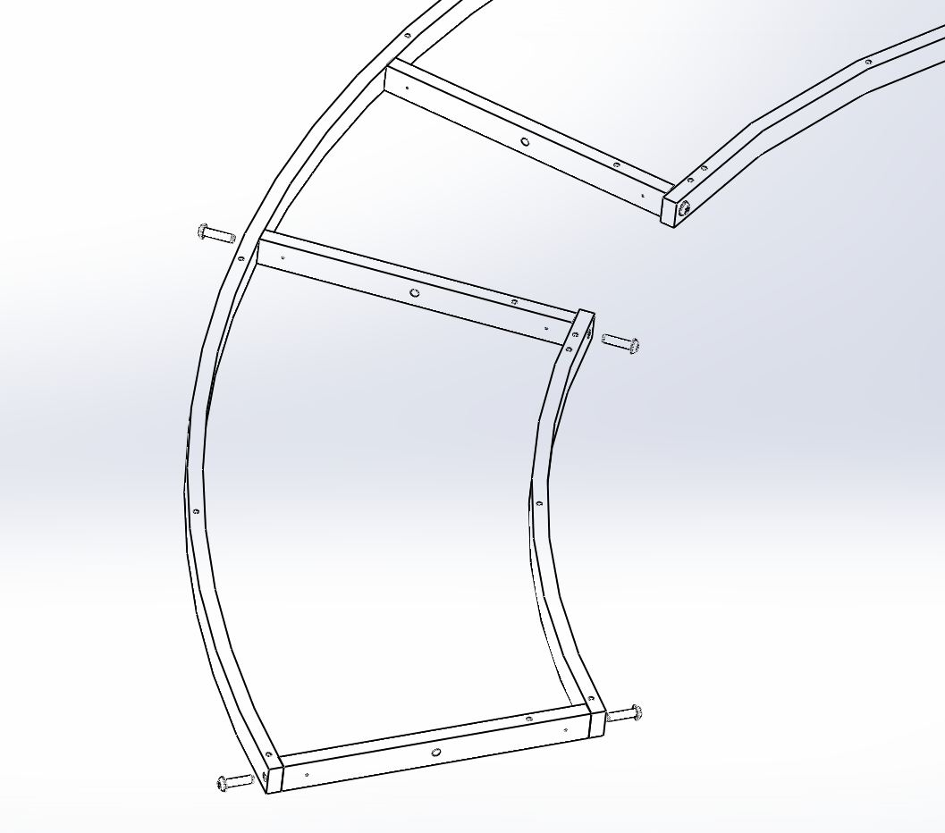
D1002871
D1100277
D1002867

At this time, all BU-2016-N screws are not quite tightened because theymight need to loosen to line up holes.

Place D1101150* with Super #8 finish facing upward on top of assembled parts. Match half moon cutout with gap.
* D1003118-00 to be installed for MCA2, MCA3, and MCA4.
D1003118-01 to be installed for MCB1
D1003118-02 to be installed for MCB2
D1003118-03 to be installed for MCB3
D1003118-04 to be installed for MCB4

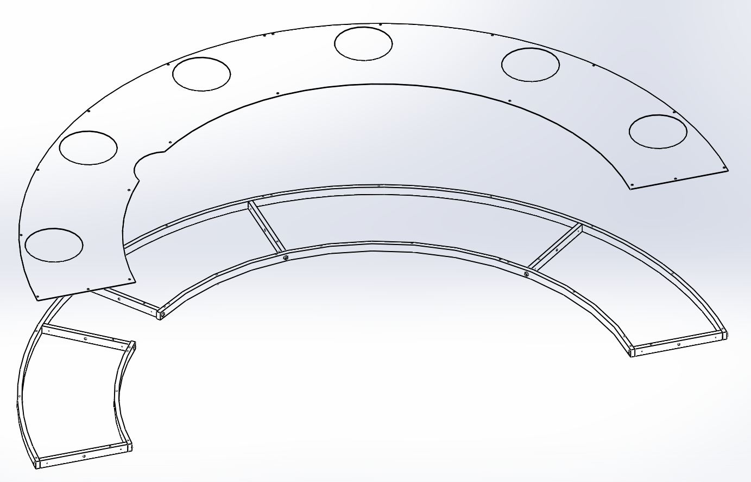
D1101150
Super #8 Finish side
Half moon
Gap

Clearance holes in viewport plate should align with tapped holes on rings. Attach with BU-1006-N(10-32 X 5/8"L BHCS, SS) and WF-10 (#10 SS Washer), 14 places.

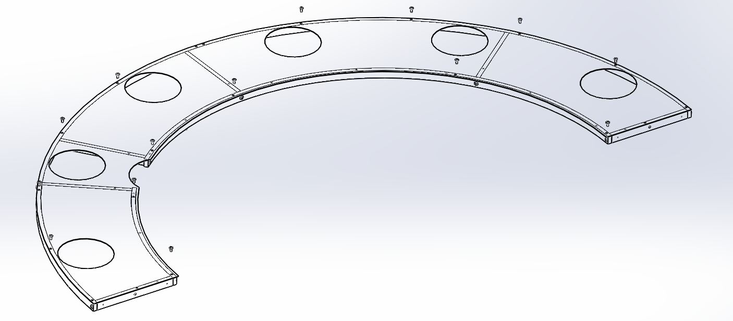

Make sure workbench is clear and covered with ??? to protect Super #8 surface.

Turn the Viewport Framing Assy over and place D1101159 on D1002871 (the spoke). Attach with C-1010-N (10-32 X 5/8"L, SHCS, SS) and WF-10 (#10 Washer, SS), 2 places.

D1101159
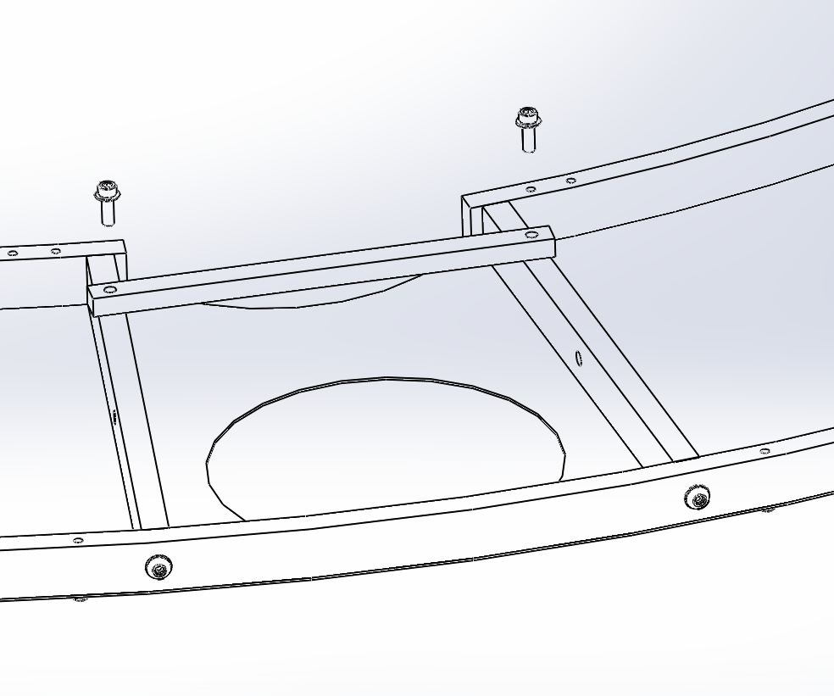
D1002871

Lower Viewport Framing Assembly (on workbench)

Place D1001926 (Mode Cleaner Tube Baffle Lower Brace), on the workbench, with tapped holes facing upward.
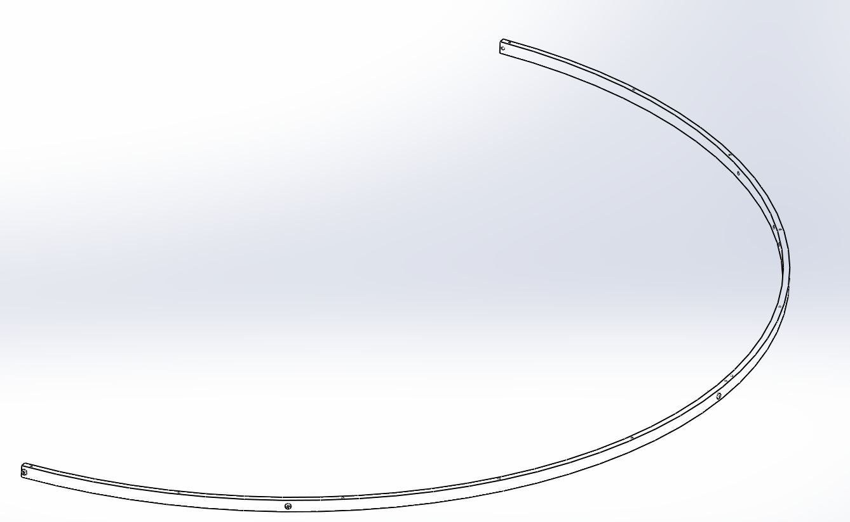
Tapped Holes

Set D1002868* to be concentric inside the D1001926 ring. Use BU-2016-N (1/4-20 X 1"L, BHCS, SS) and WF-25 (#1/4 Washer) to connect 2 rings with D10002871. Make sure these threaded tap holes are facing upward.

* D1100312 and D1100350 to be used instead of D1002868 for MCA3.
D1002868
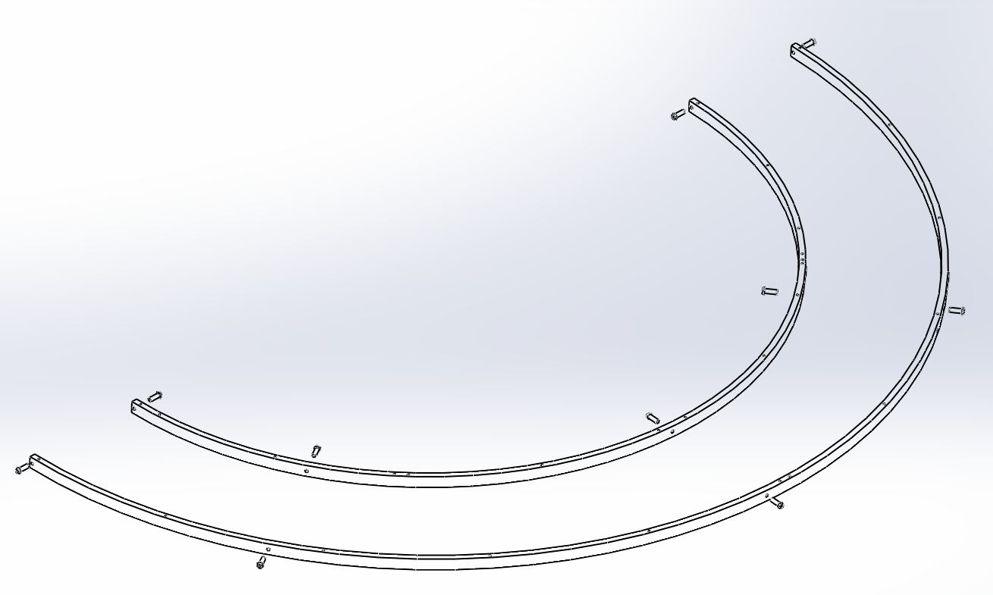
Tapped Holes
D1001926

Attach five D1002871 between D1002867 and D1100121* using BU-2016-N (1/4-20 x 1"L BHCS) with a washer (WF-25) on both ends. Tapped holes face downward and toward D1100121.

* Install D1002869 instead of D1100121 for all baffles except MCA1.
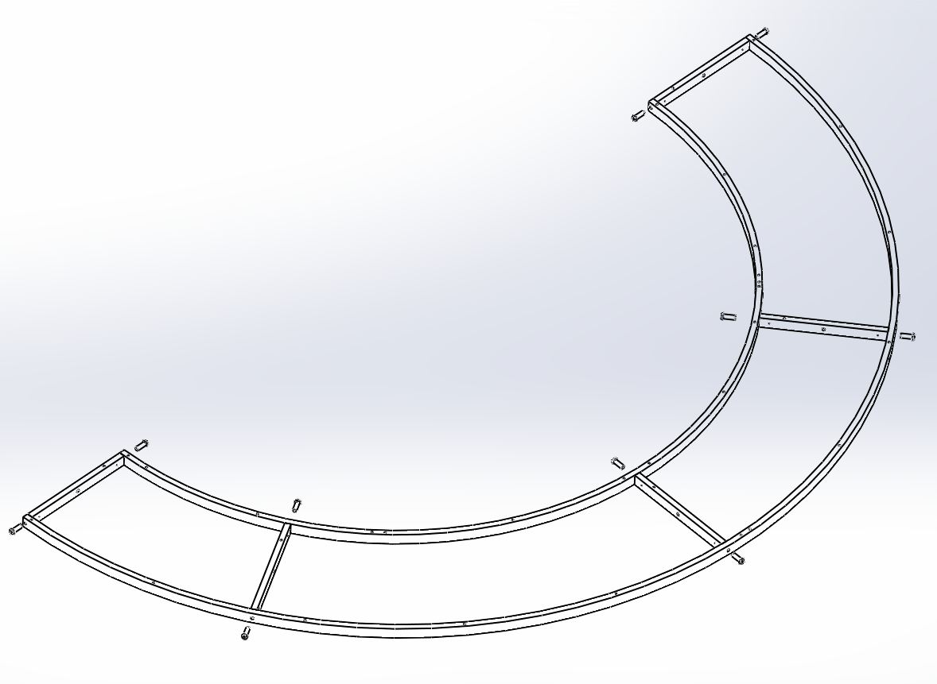
D1002871
D1001926
D1002868

At this time, all BU-2016-N hardware is not quite tightened because they might need to loosen to line up holes.

Prepare to bring D1003119-00* on top of assembled parts. (MCA1,2,4)

Note: D1101152 to be installed for MCA3
D1003119-01 to be installed for MCB1
D1003119-02 to be installed for MCB2
D1003119-03 to be installed for MCB3
D1003119-04 to be installed for MCB4
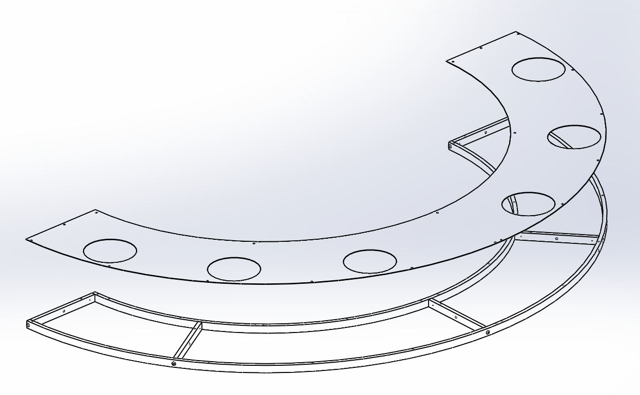
Super #8 side
D1003119-00

Clearance holes in viewport plate should align with tapped holes on rings. Attach with BU-1006-N (10-32 X 5HCS, SS) and WF-10 (#10 Washer, SS).

BU-1006-N and WF-10
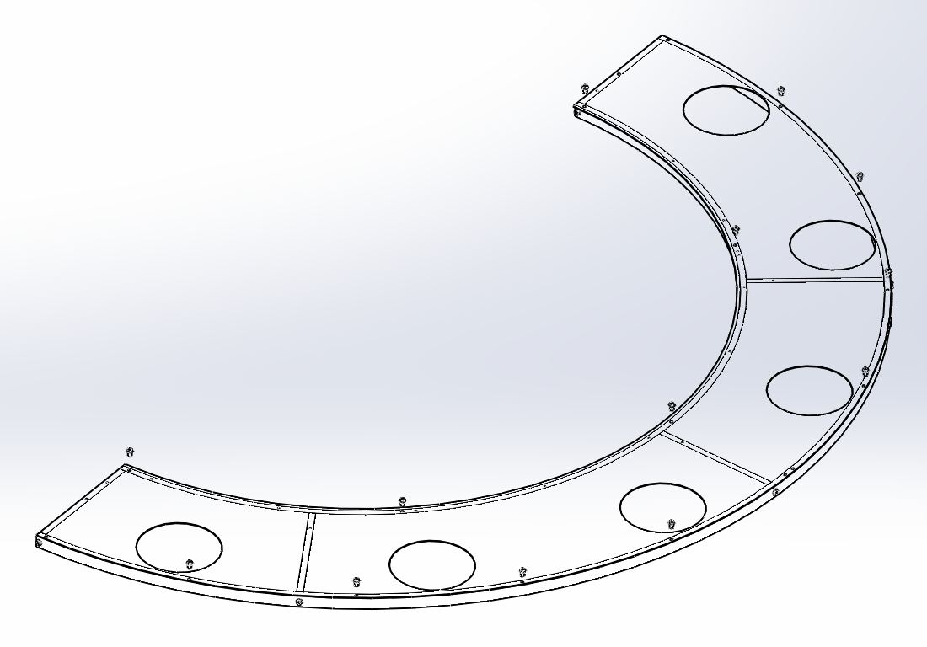

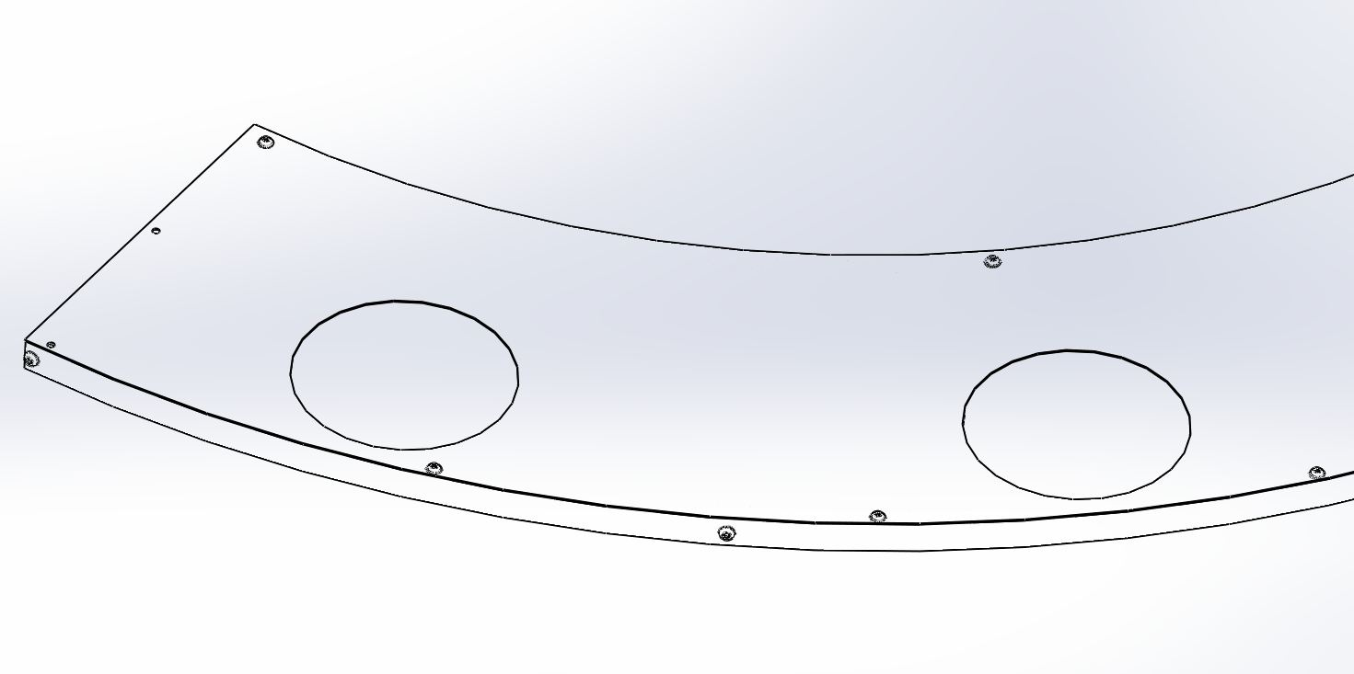

Lower assembly viewport for MCA3 (on workbench)

5.2.1 Place D1100312 to be concentric to D1001926. First and second tapped holes of D1100312 face upward.

5.2.2 Lay D1100350 concentric to D1001926 and match with D1100312. Last tapped hole at end of D1100350 faces upward.

5.2.3 Repeat step 5.2.4 for fastening outer and inner rings with D1002871.

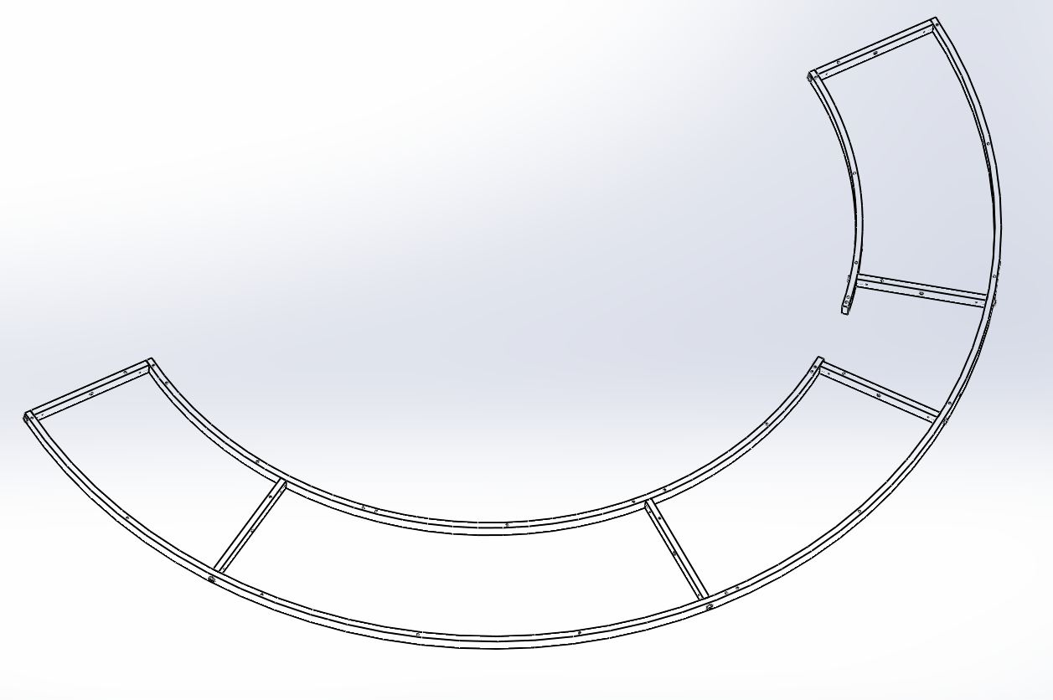
D1002871
D1100312
D1100350
D1001926
Tapped Holes

5.2.4 Set D1101152 on top of assembled parts. Make sure half-moon cutout match a gap of two inner rings. Super #8 finish side is up
D1101152

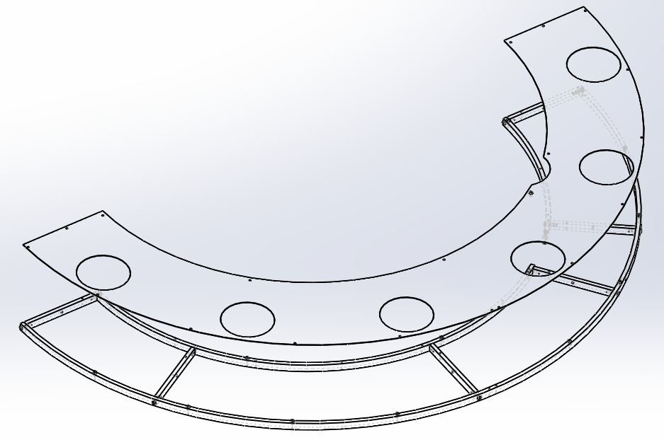
Super #8 side
Half-moon cutout and gap

5.2.5 Follow step 5.2.6 to fasten viewport plate to assembled parts.

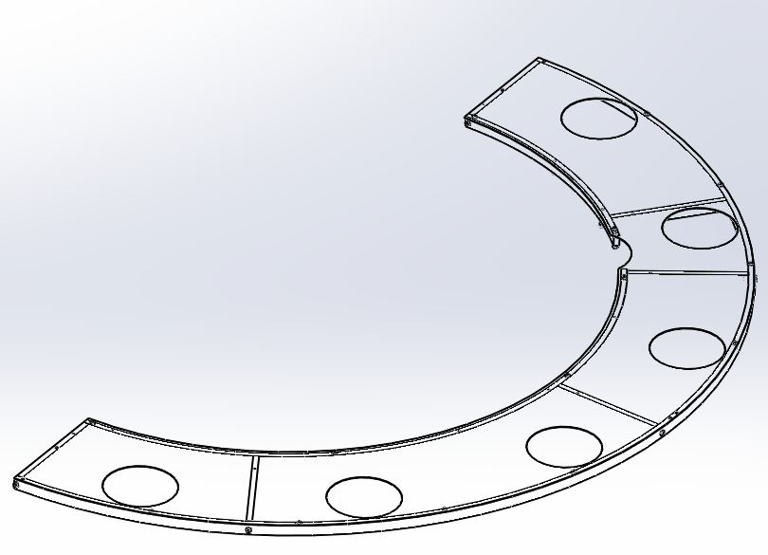
BU-1006-N WITH WF-10

Make sure workbench is clear and covered with C3 polyester or equivalent material to protect Super #8 surface.

Turn the Viewport Framing Assy over and place D1101160 (the spoke). Attach with C-1010-N (10-32 X 5/8"L, SHCS, SS) and WF-10 (#10 Washer, SS), 2 places.

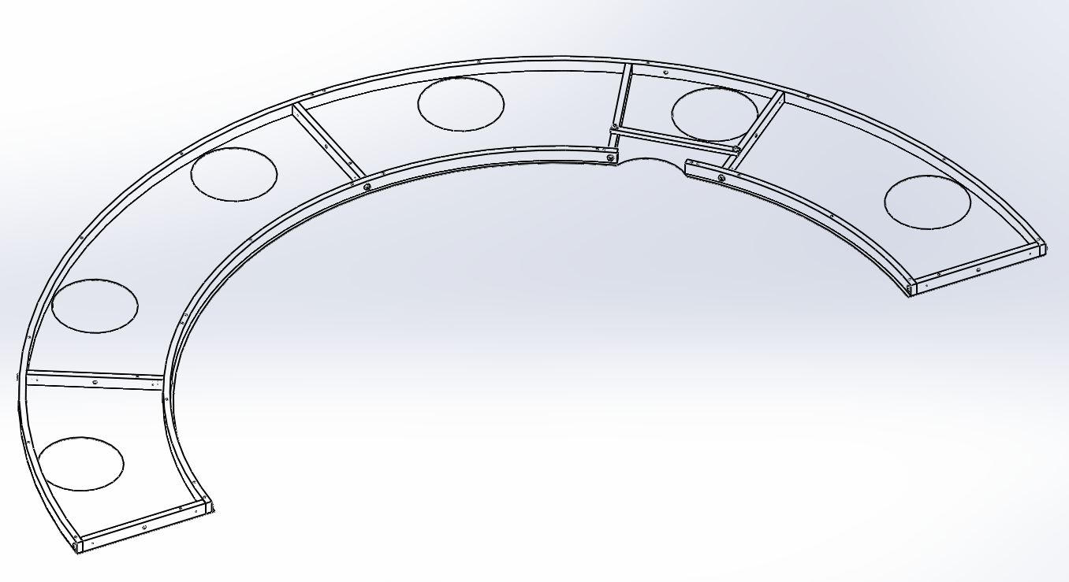
D1101160

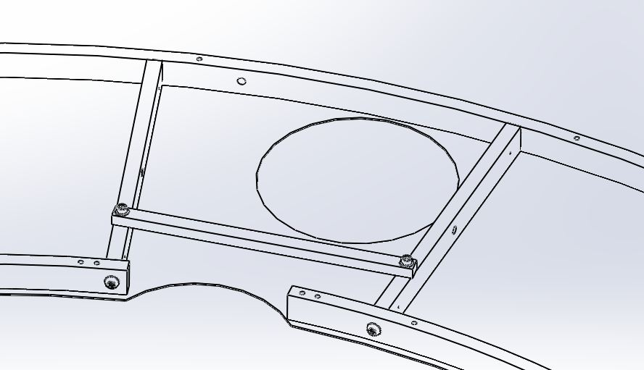
C-1010-N with WF-10

Aperture Framing Assembly (on workbench)

Aperture assembly for MCA1 and MCA3. No framing involved. Plates attach directly to viewport assembly.

D1100468 and D1100469 to be installed for MCA1


D1100468
D1100469

D1100512 and D1100513 to be installed for MCA3

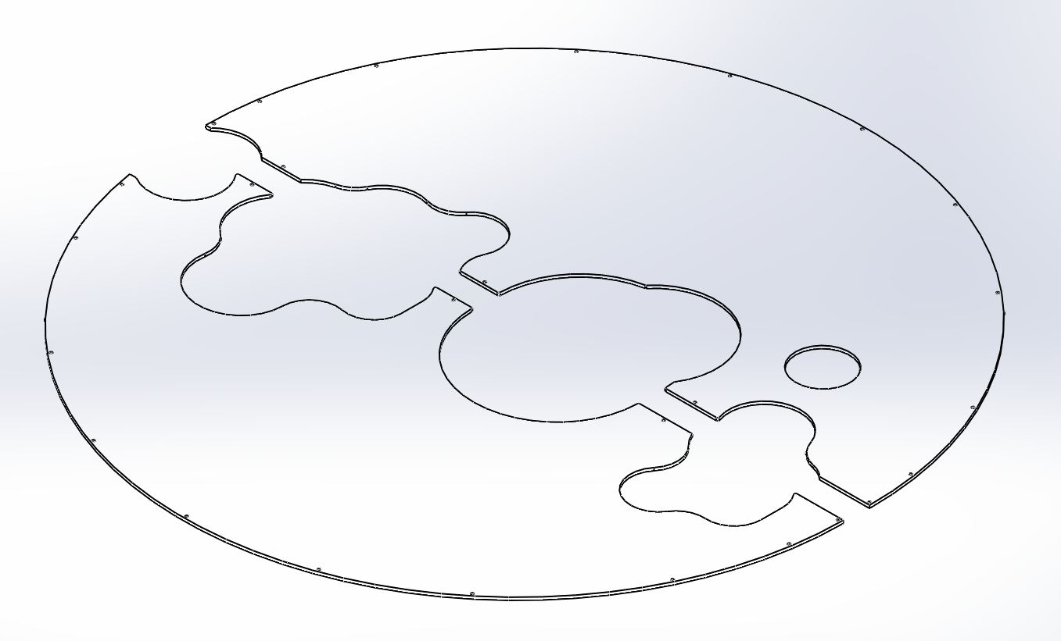
D1100512
D1100513

Aperture Framing Assembly (on workbench) for MCA2, 4, MCB1, 2, 3, 4.

MCA2 and MCA4 have same parts and orientation.

Place D1002996, 2 pieces of D1002998 and D1002997 with tapped holes facing upward on workbench. Use C-1014-NA (10-32 X 7/8"L, SHCS, SS) with WF-10 (#10 washer, SS) to tighten them together.

D1002998
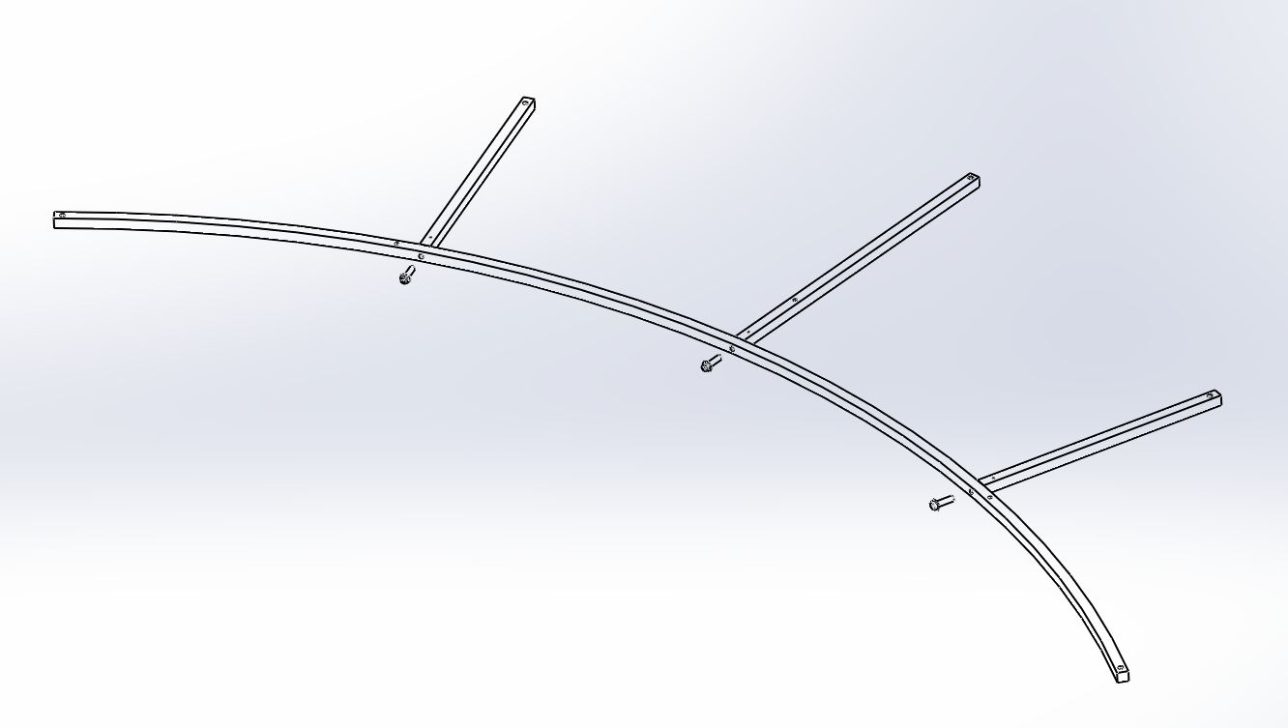
D1002996
D1002997
C-1014-NA & WF-10

5.3.2 Place D1003109 on top of structure frame.
Super #8 finish faces upward. Be careful to handle aperture plate.

5.3.3 Insert BU-1006-NA with WF-10 to secure the aperture plate to structure frame.

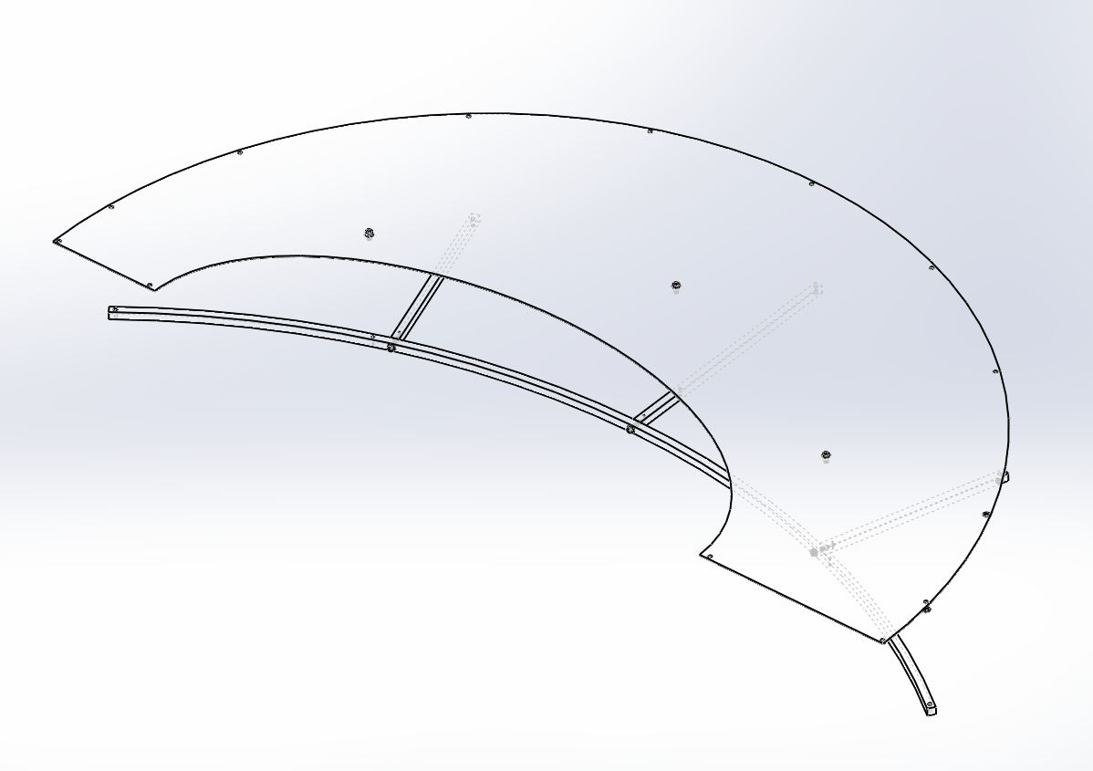
D1003109-1*
Super #8 side
* MCA2 & 4
D1003110 for MCB2 & 4
D1002995 for MCB1 & 3
BU-1006-NA with WF-10

5.3.4 Attach D1101973 to ends of the aperture to stiffen aperture assembly when carrying it to the tube.

5.3.5 Use 10-32 screw with wing nut to hold up aperture assembly while carrying them to the tube.
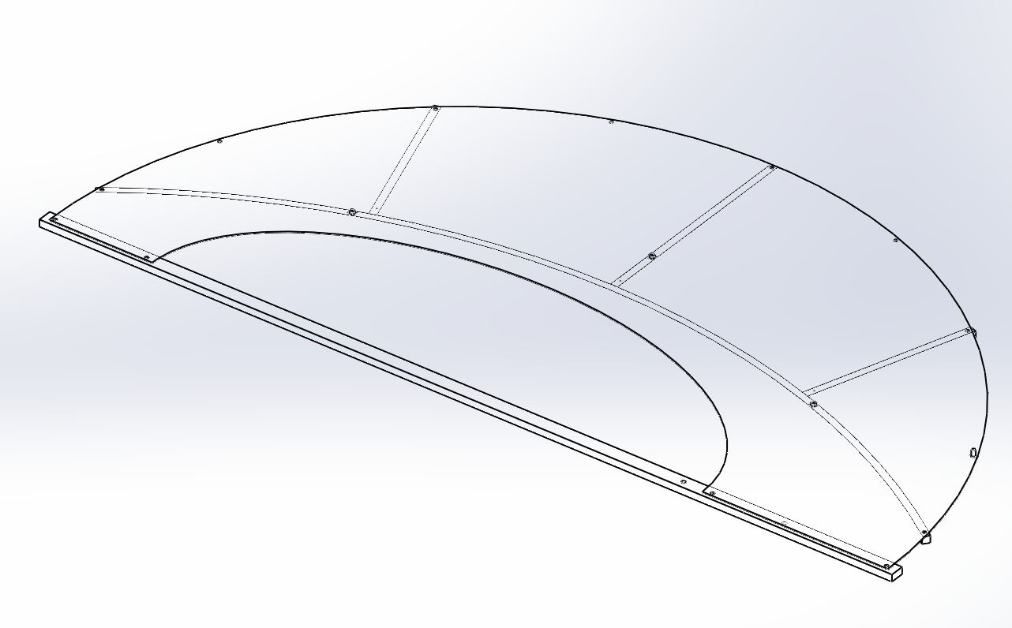
D1101973
10-32 SHCS and wing nuts
Refer to drawing D1102116_MC Tube baffle, Aperture Support Bar Assembly

Insert 10-32 SHCS with #10 washer though aperture plate and D1101973 and tighten with wing nut. Do it same for the other end.

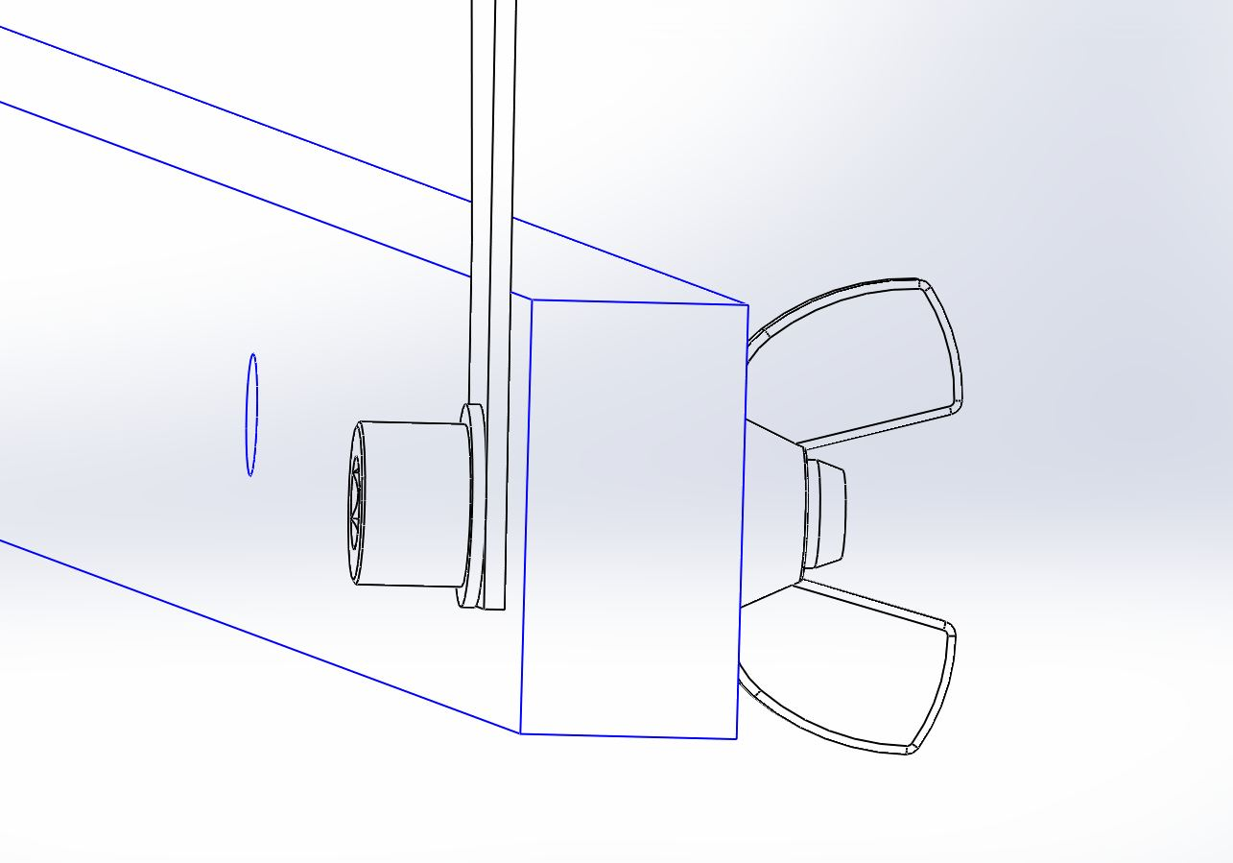
10-32 SHCS and wing nuts

Repeat step 5.3.1. to 5.3.5 and make sure super #8 finish side upward.

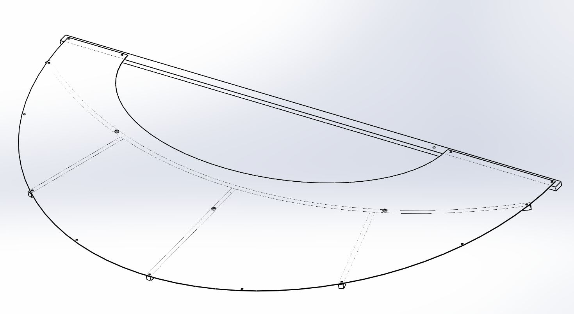
Super #8 side
D1003109-2

Assemble MCB1 aperture parts

Place D1002995 on top of structure frame.
Super #8 finish side upward. Be careful to handle an aperture plate.
Insert BU-1006-NA with WF-10 to secure aperture plates to structure frame.
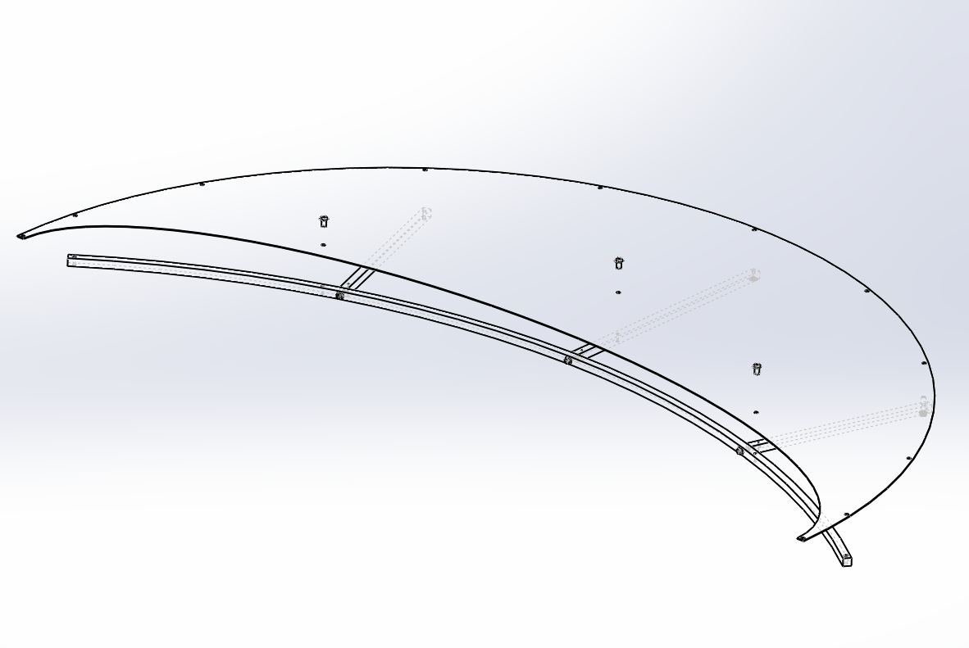
Super #8 side
D1002995
BU-1006-NA and WF-10
Use D1101973 to keep two ends of the aperture NOT wobbled when carrying it to the tube.
Insert 10-32 SHCS and WF-10 to hold up D1002998 and D1002995 while carrying them into tube.
10-32 SHCS and wing nut
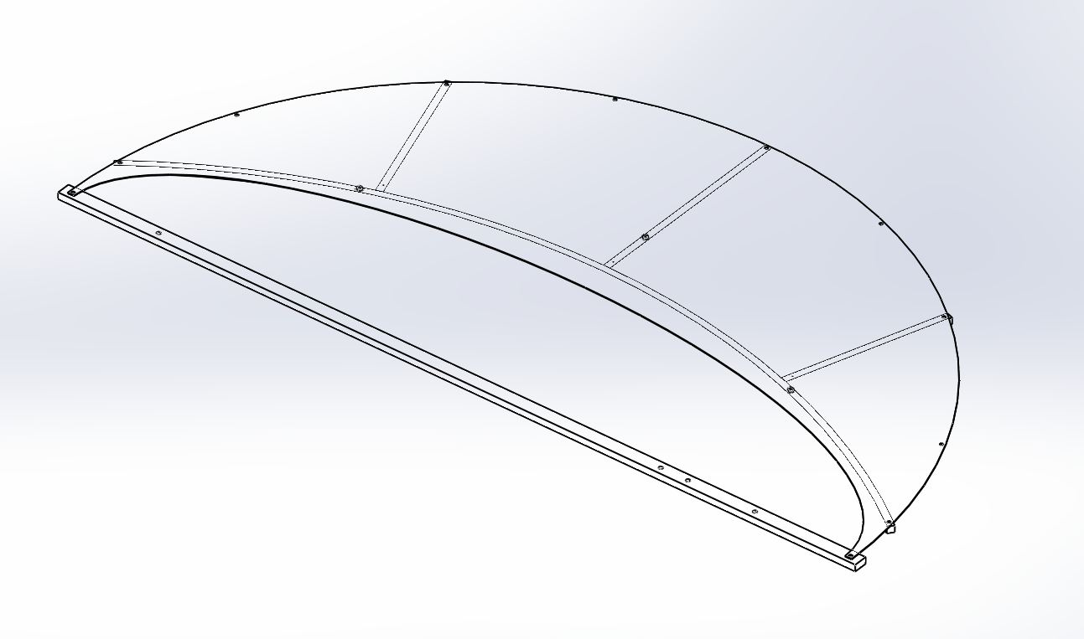
D1101973

Repeat a process to assemble second set of MCB1 aperture.

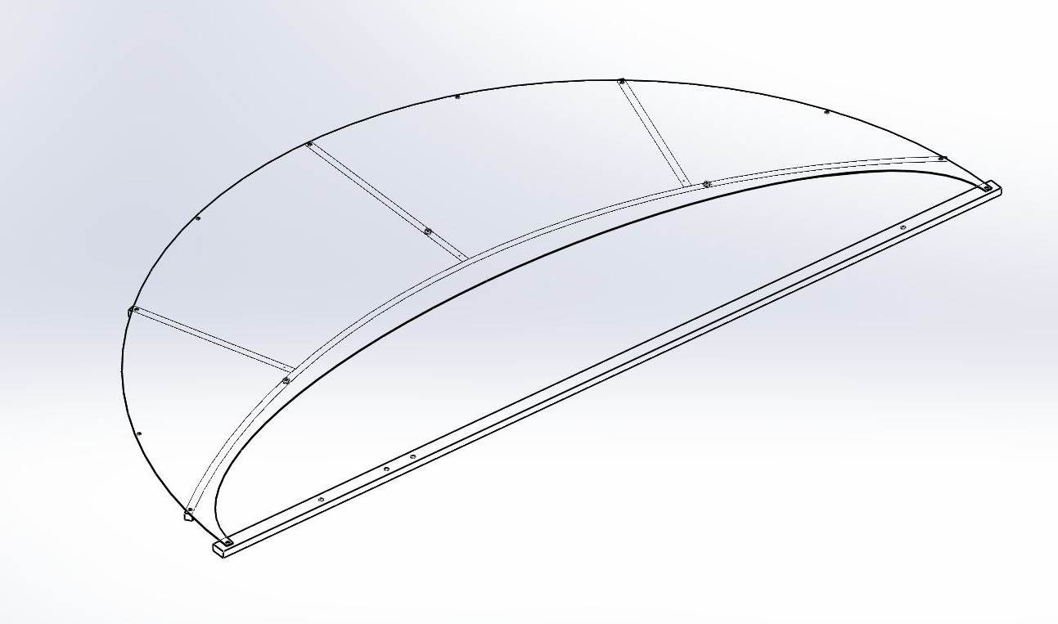
Super #8 side

For other aperture framing assembly as MCB1, MCB2, MCB3, and MCB4, use same parts as D1002996, D1002997, and D1002998 but there are different aperture plates and orientations.

(See drawing D1002864)

D1003110 to be installed as MCB2
D1003110 to be installed as MCA4

Note: MCB4 at HAM 10-H2, assemble aperture plates are to be installed as mirror image of MCB2.

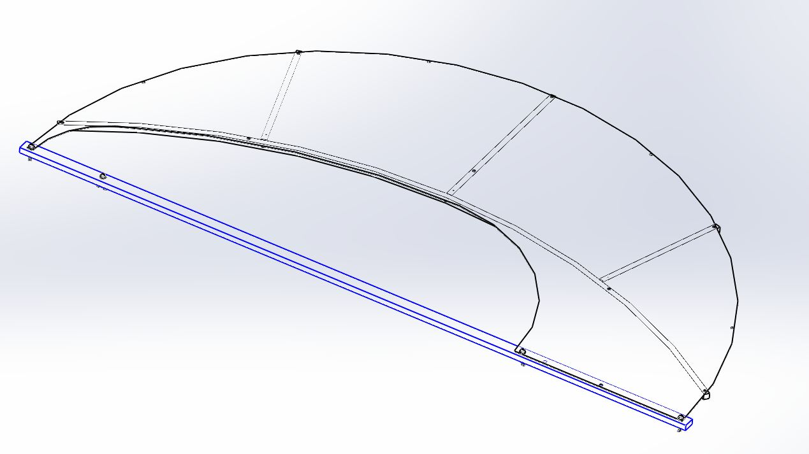
D1003110-1

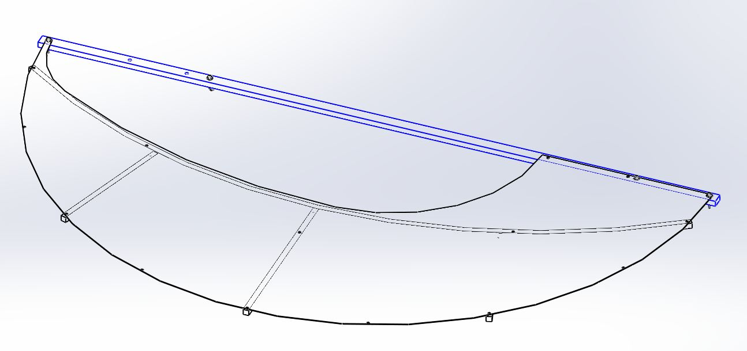
D1003110-2

Installation of Ring Assembly into beam tube

Carry the top and bottom ring separately. Transport D1000776 into the bottom of Mode Cleaner tube section and set in position. Next place D1000777 above D1000776 and align D1000778 (turn buckle) into the holes at the ends of D1000776. The orientation of the rings are such that the chamfered edges is away from the closest HAM chamber (toward the tube).
D1000778

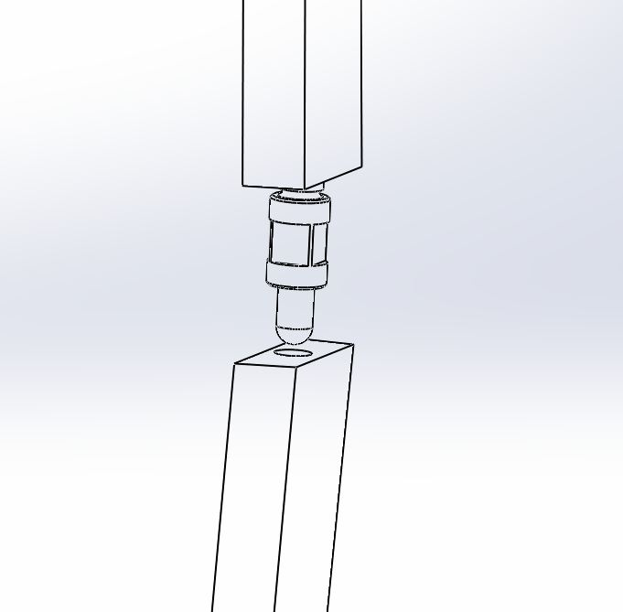

Clearance hole on D1000776

Use 4 pieces of D1200289 (Set block) for lower outer ring and 2 pieces for upper ring to keep rings hold against inside tube wall.

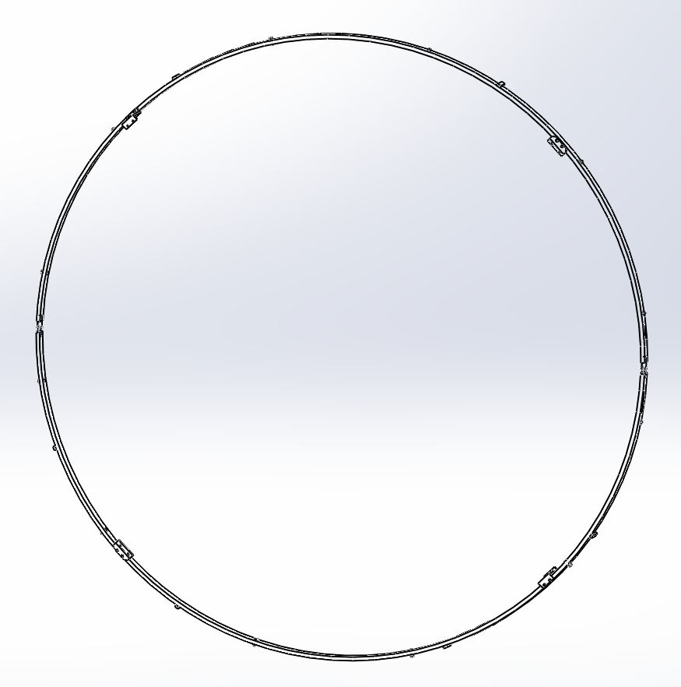
D1000777
D1000779
D1200289

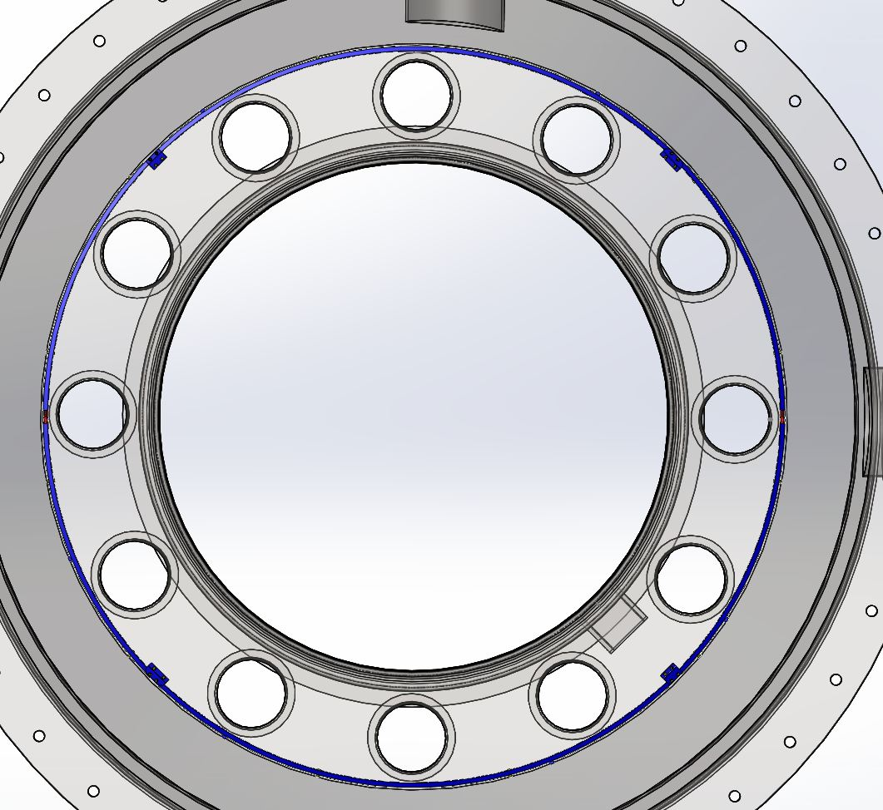

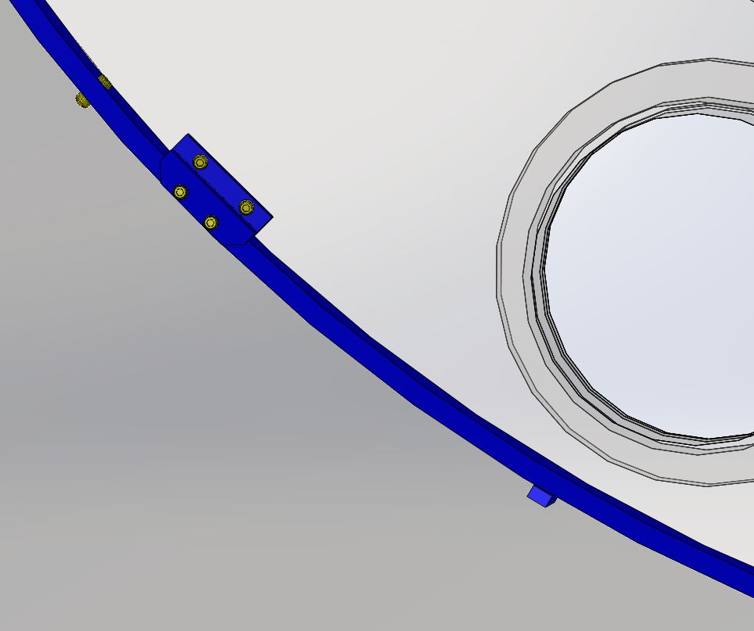
D1200289
TOP-1614-N
Mode Cleaner Tube
D1101756
Alignment tooling

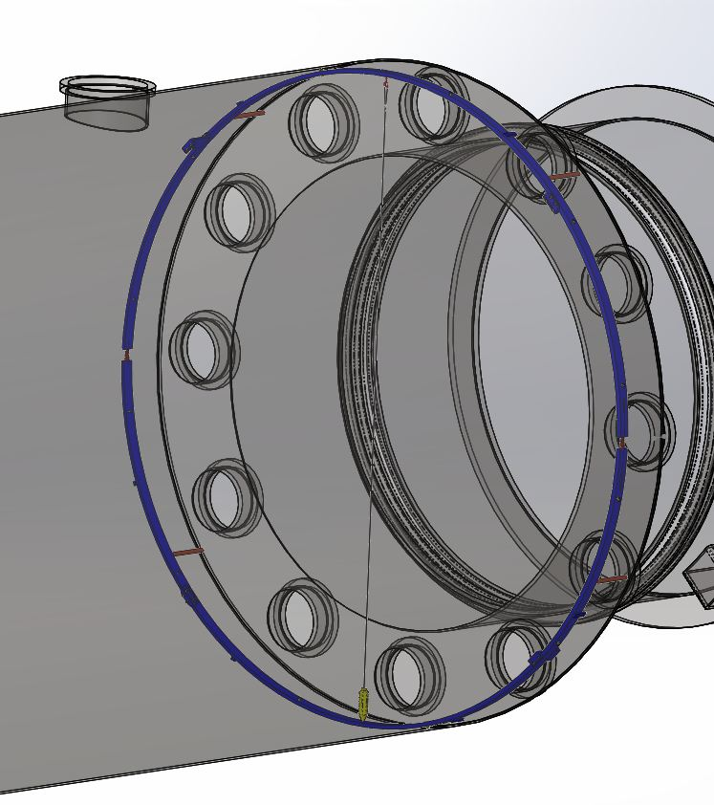
Chamfer edge

Place Alignment tooling, D1101756 between the flat surfaces of these rings against inside wall of the tube. See view above.

Attach plumb bob: Attach eyebolt to the top ring with .064 Dia. Wire and plumb bob at the end of the wire.

Eyebolt and wire (.005-.009")
Plumb Bob

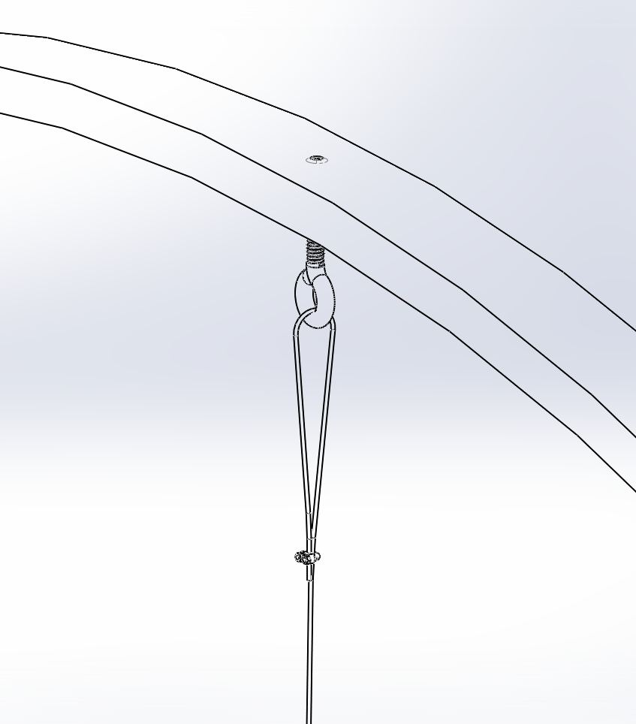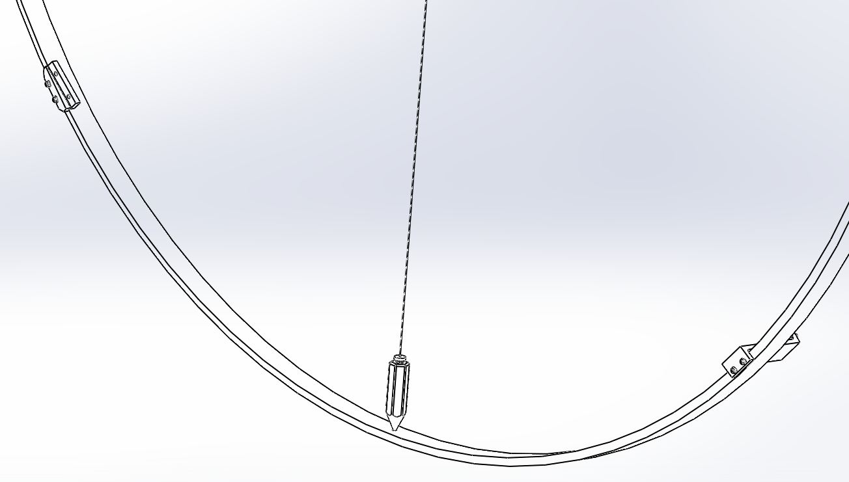

6.1.4. Calibrate the plumb bob to line up concentrically to a hole of the bottom ring. Use plumb bob and alignment block to align rings in the tube.

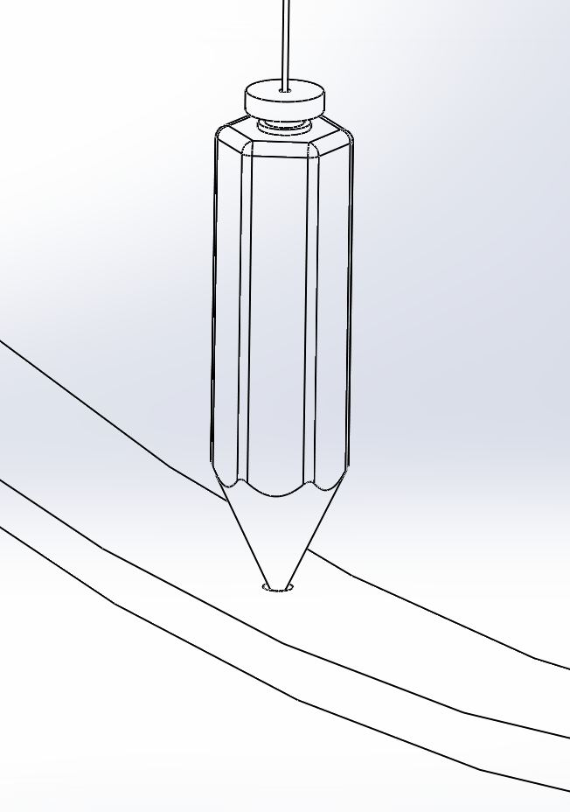
D1000776

Use 3/8” wrench to torque D1000778 (turn buckles screws) evenly so each half ring places against the tube and make sure to remove the D1101756 (alignment tool) when the ring is in place.

Make sure standoff spacers (D1000783, D1000784) and mount bracket (D1000779, D1000780) are tight.

Install Viewport Framing
See Drawing D1002864.

Install the Upper Viewport Framing Assembly
MCA1 at HAM2_H1-L1

Bring the upper viewport plate framing through the chamber and into the mode cleaner tube section. Place diagonally to be mounted to top half of the ring. Be careful to align the upper viewport plate framing behind brackets and standoff spacer.

Tip: For MCA1, the half-moon cutout is shown on the left viewport plate.

Half-moon cutout See Fig 7.1.3
D1101150 - (MCA1)
D1003118-00 (MCA2,3,4)
D1003118- 01 (MCB1)
D1003118-02 (MCB2)
D1003118-03 (MCB3)
D1003118-04 (MCB4)
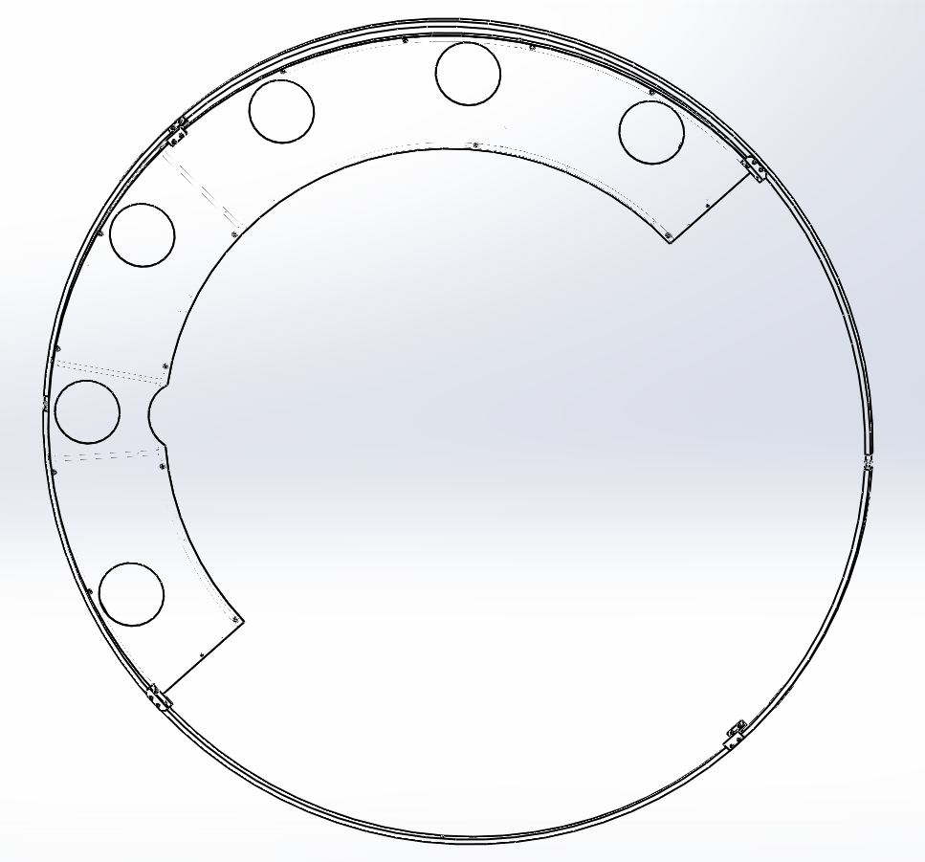

See next page See next page
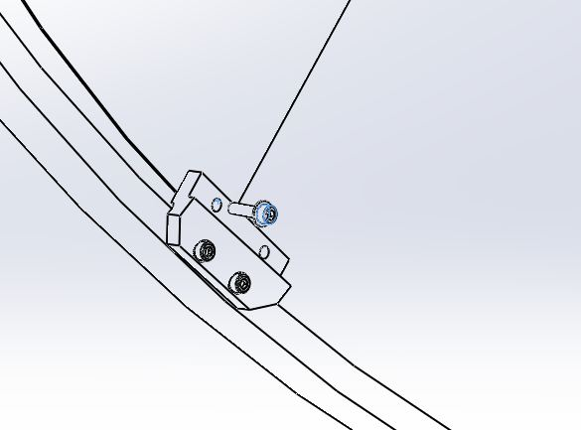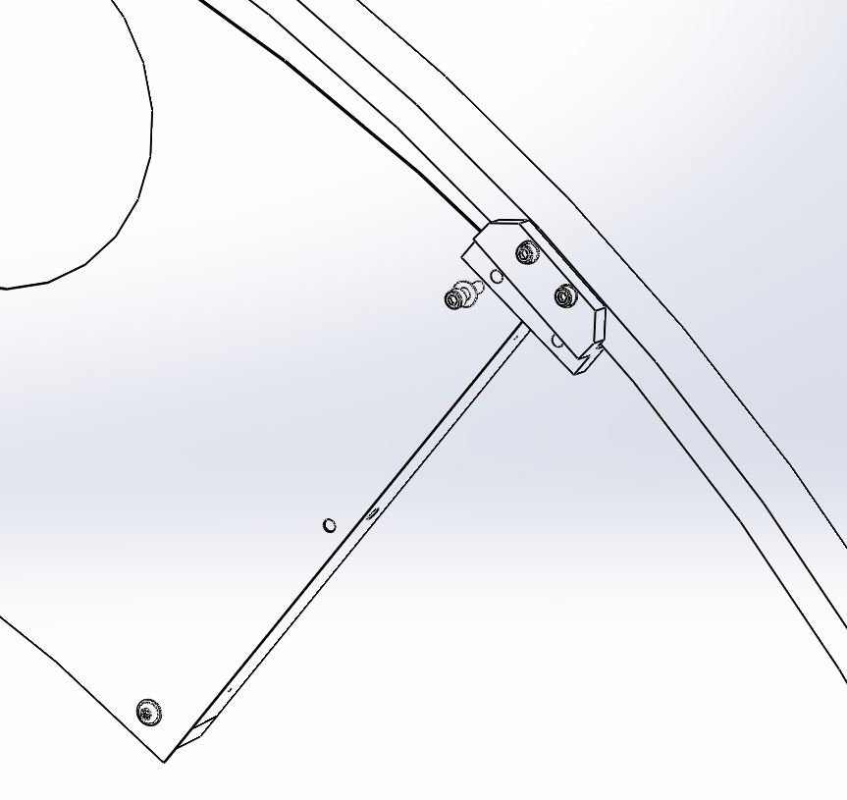

Insert one C-1012-N (10-32 X 3/4"L, SHCS, SS) with one WF-10 (#10 washer, SS) to tighten each end of the viewport plate to the brackets.

Use two C-1012-N to attach the middle of the left viewport plate to the bracket.

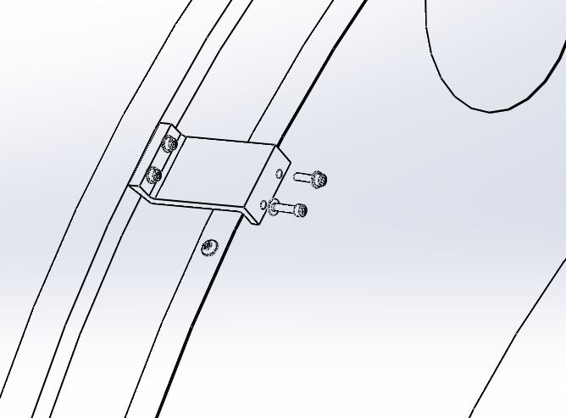

Install the lower viewport framing

MCA1 at HAM2-H1-L1

Carry the lower viewport plate framing assembly and place it behind the brackets and standoff spacers on the ring. Attach C-1012-N with WF-10 to mount it on the ring.
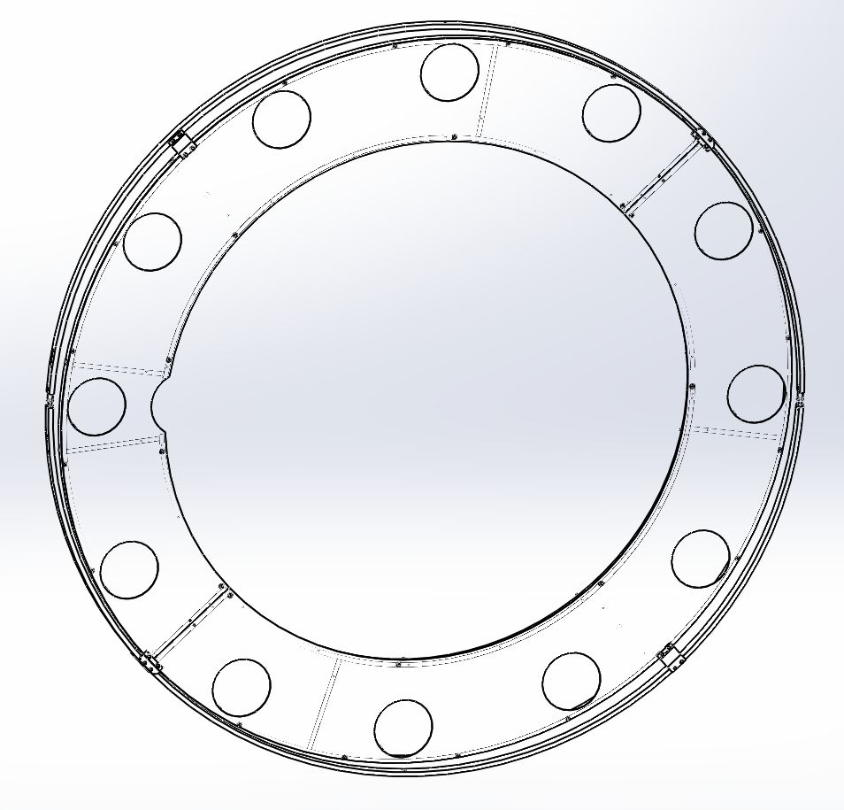
D1003119 - (MCA1,2,4)
D1101152-00 (MCA3)
D1003119- 01 (MCB1)
D1003119-02 (MCB2)
D1003119-03 (MCB3)
D1003119-04 (MCB4)

See Fig 7.2.2
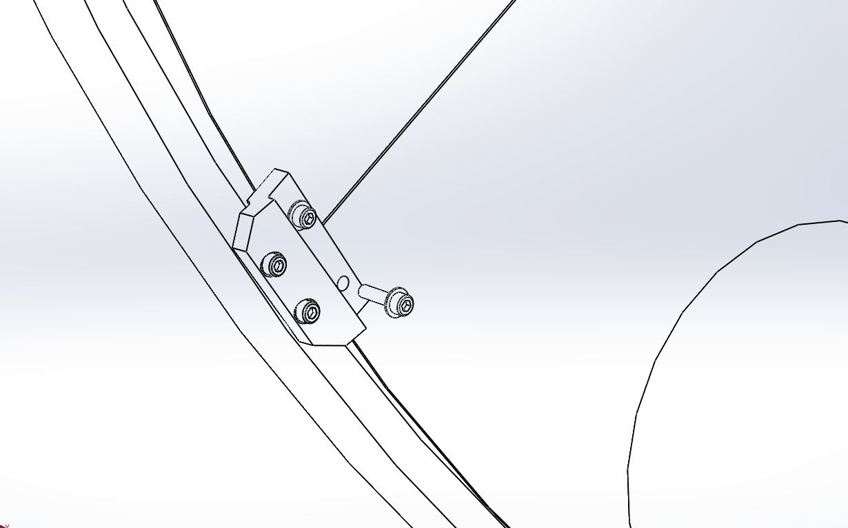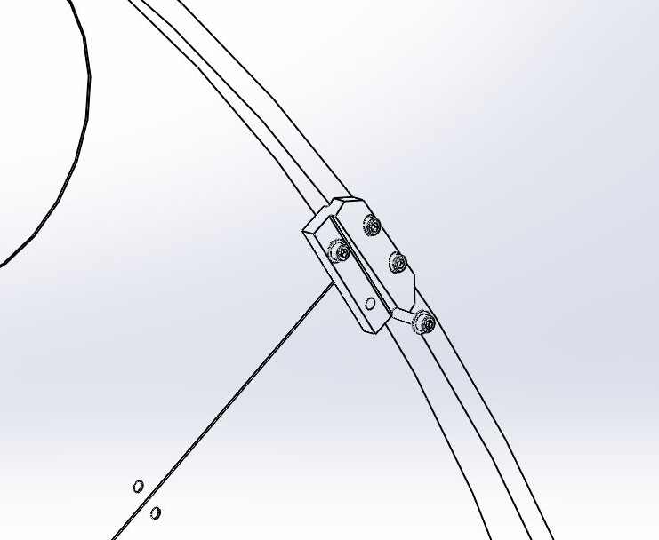

Insert two C-1012-N without WF-10 to secure the middle of the right viewport plate framing.

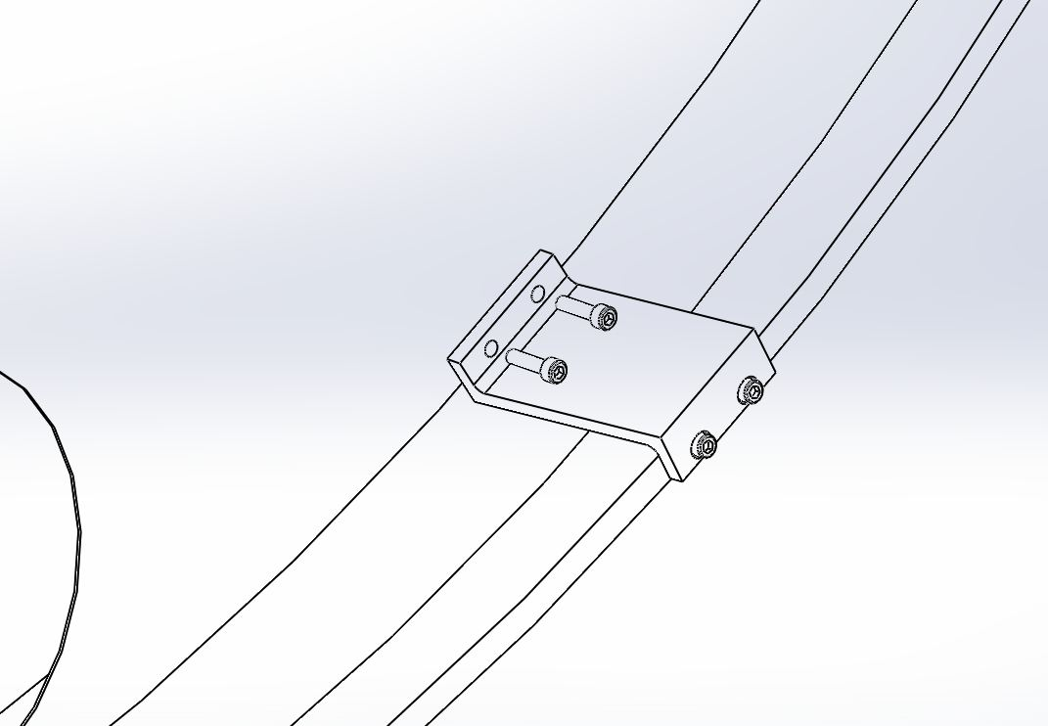Fig.7.2.2
C-1012-N

From the back side of the baffle ring, attach both viewport assemblies with a C-2024-N(1/4-20 X 1.5"L, SHCS, SS), N-2520-NA (1/4" Hex Nut, SS) and two WF-25 (1/4" Washer, SS). This applies to all assemblies.
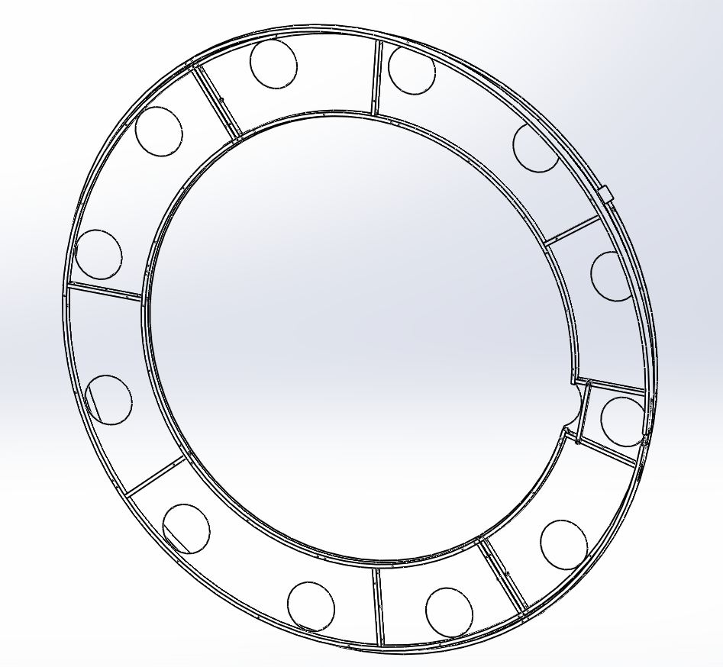

C-2024-N with WF-25 and N-2520-NA

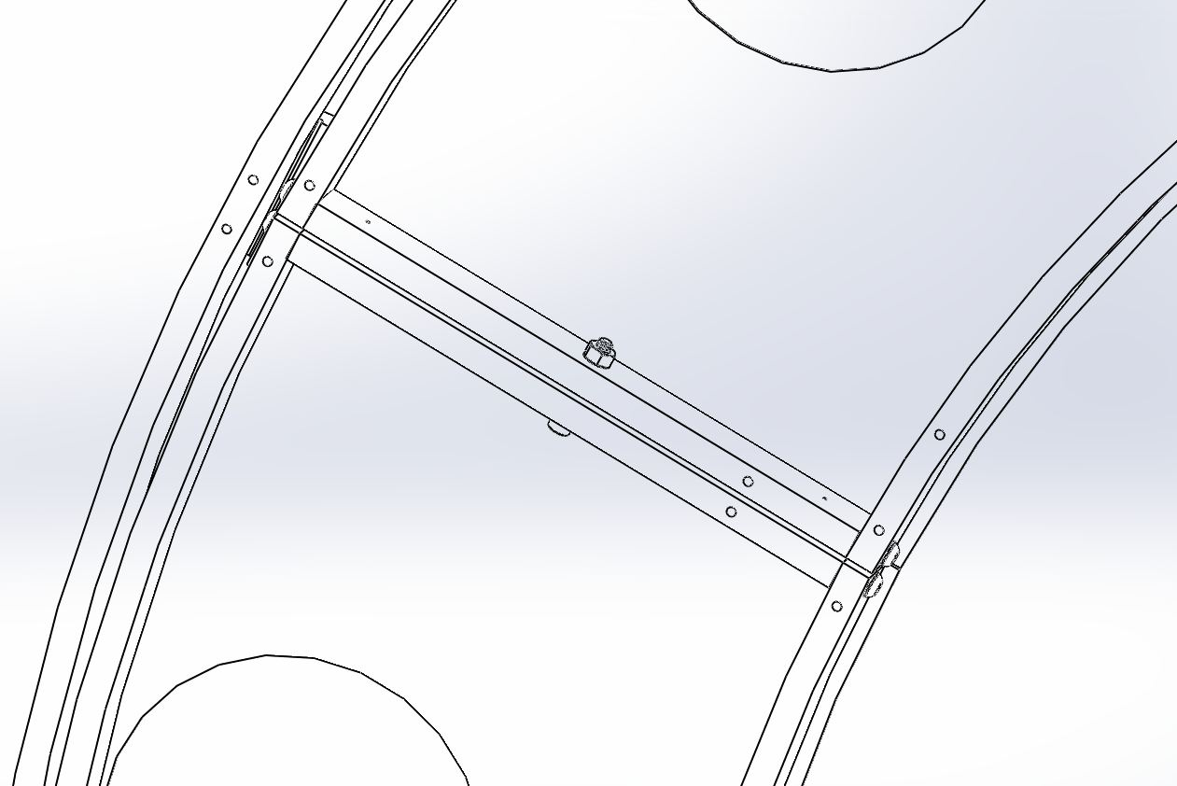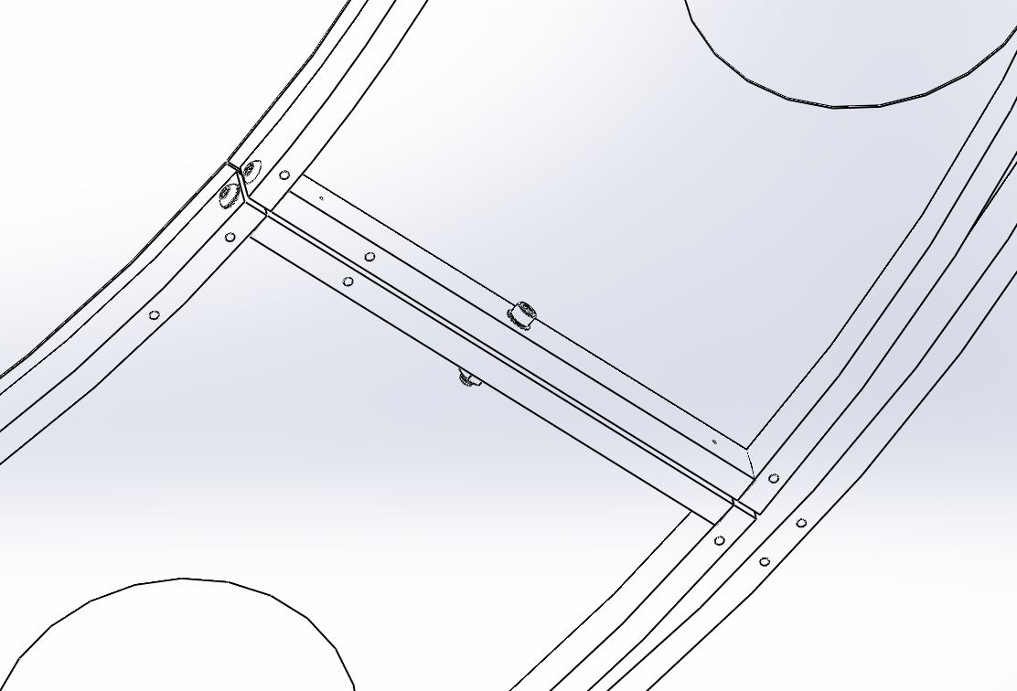
Fig.7.2.3

Install Aperture Plates of Mode Cleaner Tube Baffle Assembly
(See Drawing D1002864 for complete BOM and drawings)

Assemble aperture plates on viewport ring of MCA1

Carry D1100468 (MCA1 Upper Aperture) into the tube and set it up against the inner frame. Use nine of C-1010-N(10-32 X 5/8"L, SHCS, SS) with WF-10(#10 Washer, SS) to bolt the aperture plate to inner frame.* Make sure cutout of the aperture plate match the half-moon of viewport plate.

*Tip: Line up visible holes to threaded tapped holes of the inner ring. Secure center top hole with one C-1010-N and WF-10 so it can hang loosely on the inner ring, then insert the rest of C-1010-N with WF-10 into tap holes as shown.

Center top hole

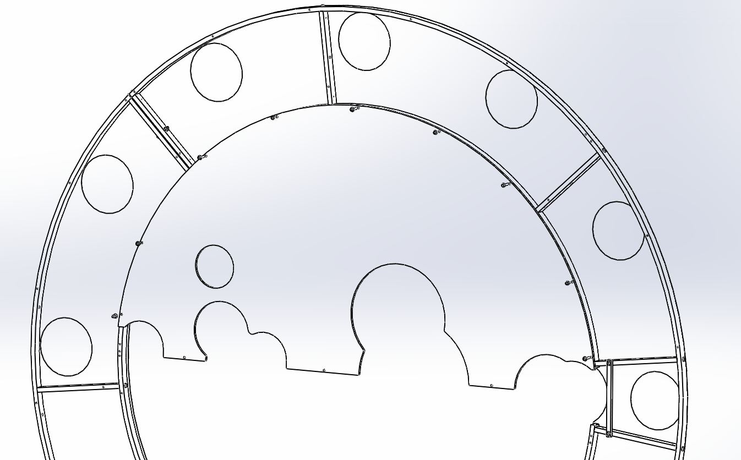

Match the cutout of D110468 to half-moon on viewport plate.

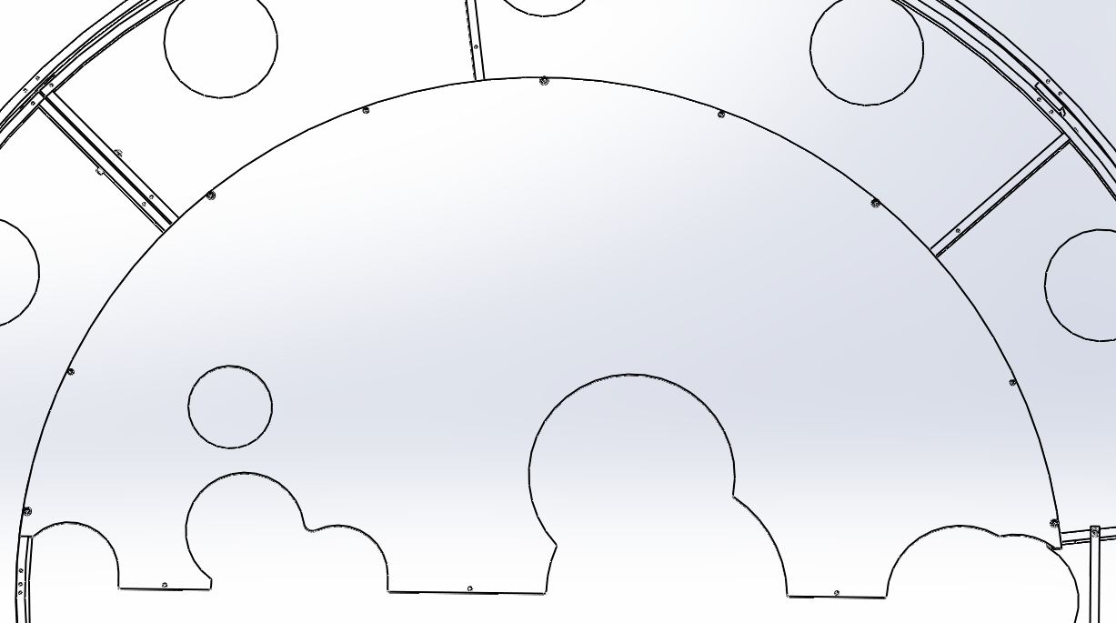

C-1010-N with WF-10

Leave these tapped holes unscrewed

Bring in D1100469 to set it so cutouts to be matched to upper aperture and half-moon on viewport plate and align all visible holes*.

C-1010-N with WF-10

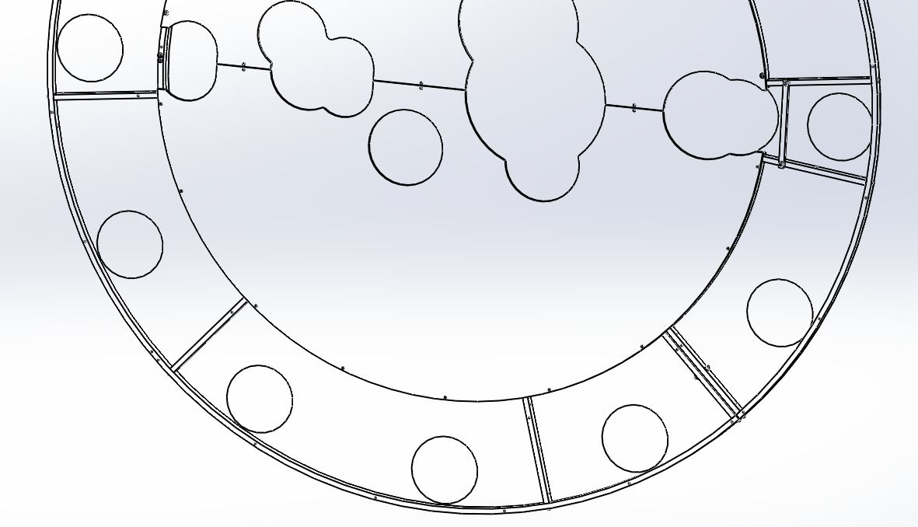

*Tip: After matching cutouts with other plates, let it rest on bottom of the tube. Hold one side of the aperture and align with a tap hole on the side (either left or right side), then insert a C-1010-N with WF-10 to keep it in place. Hold up other side to align with tap hole and repeatedly insert C-1010-N with WF-10.

Left side of the aperture C-1010-N and WF-10
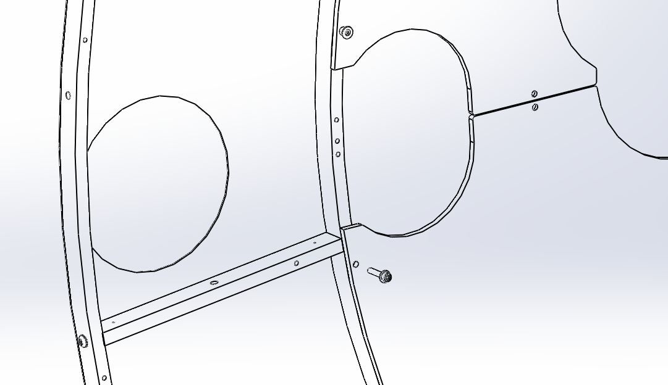

Right side of the aperture
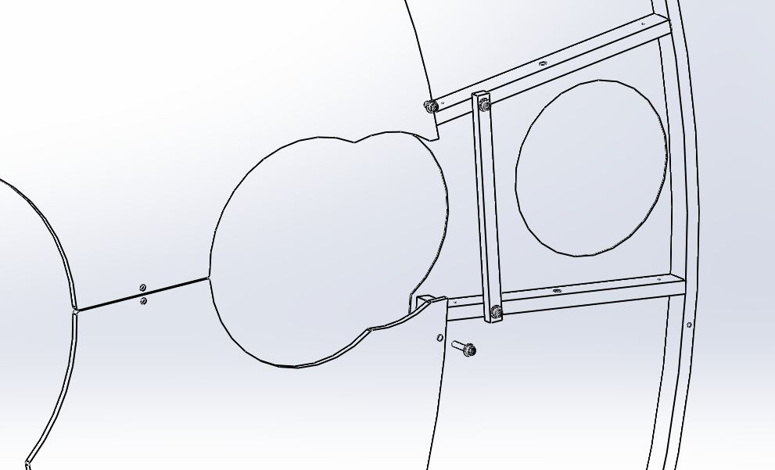

C-1010-N and WF-10

In the process all cutout holes should be aligned as in figure below.

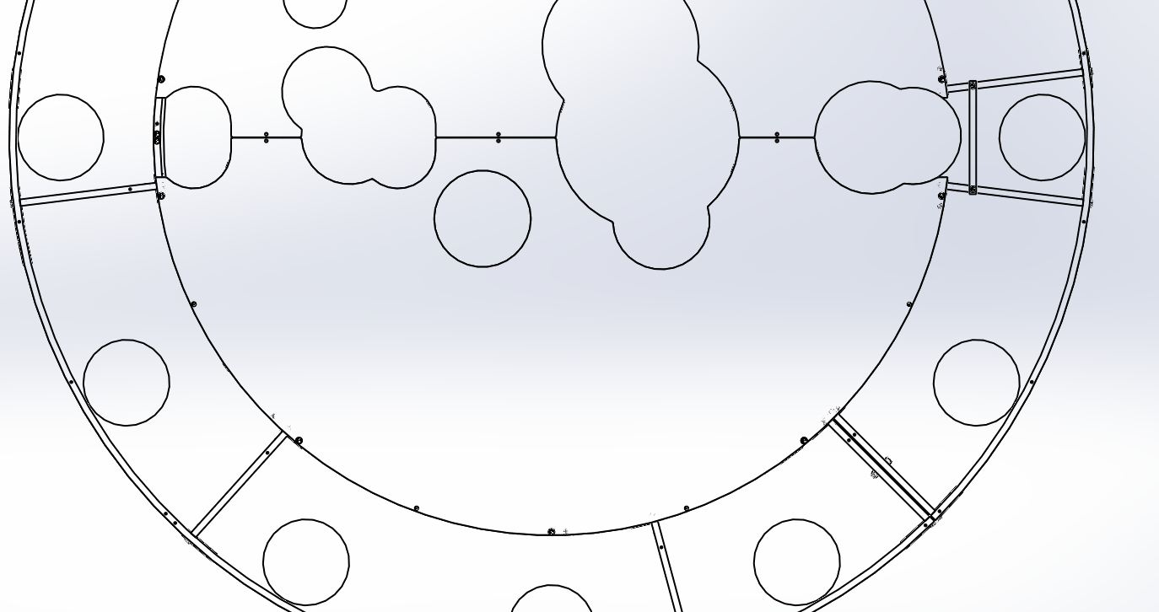

Attach D1100987 (Aluminum Aperture Clip) on chamber side. Reach in from the spool through cutout to install FA-1010-N (10-32 X 5/8"L, FHCS, SS) into countersunk holes and tighten it into D1100987.

Note: Use captive Allen wrench to make sure flat head screws DO NOT fall into the tube. (Wiha: MagicRing Screw Holding-Ball End)

FA-1010-N

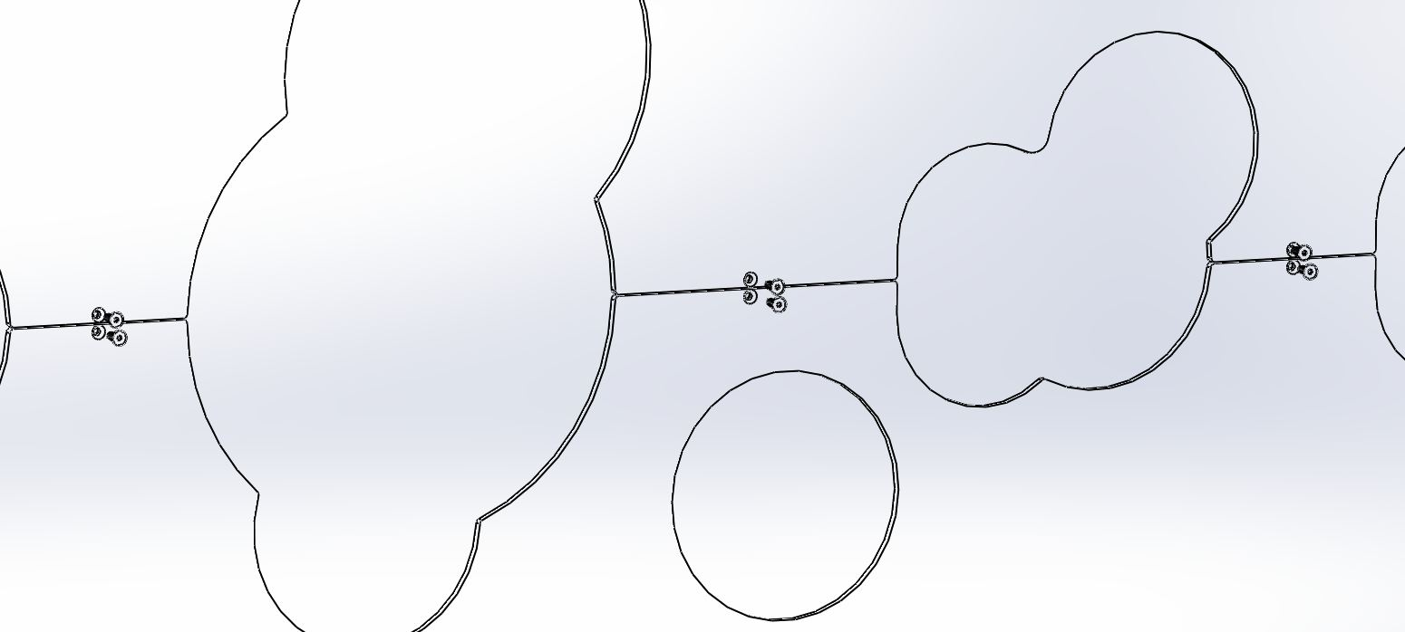
View from Mode Cleaner Tube
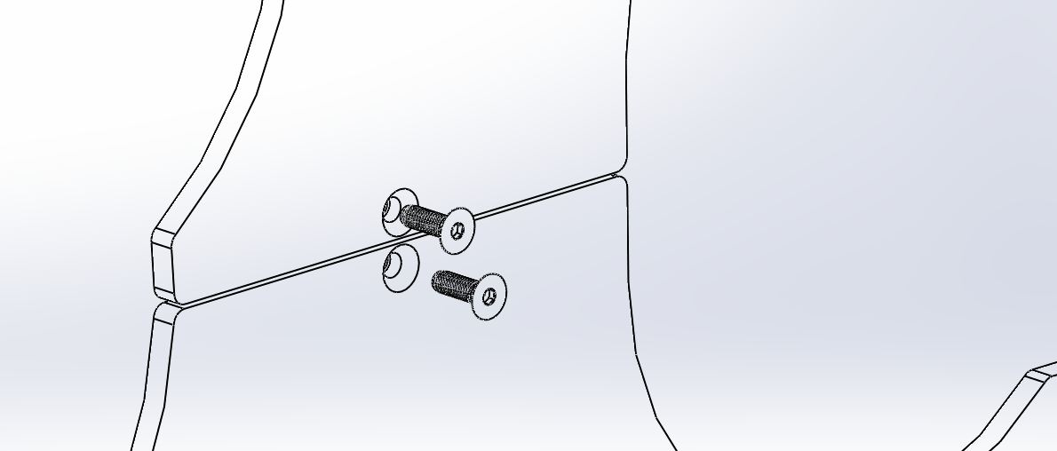

FA-1010-N

D1100987

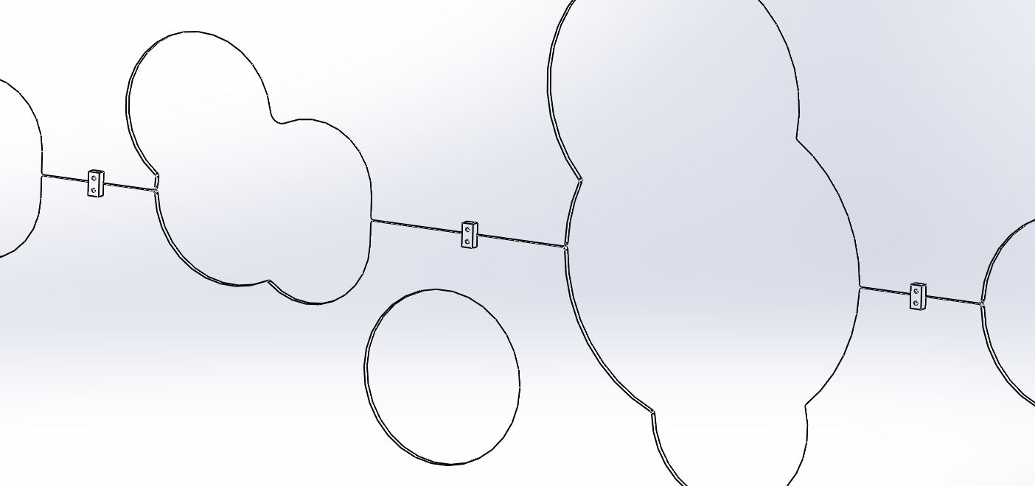

MCA1 at HAM2-H1-L1
Completed assembly viewed from inside the tube

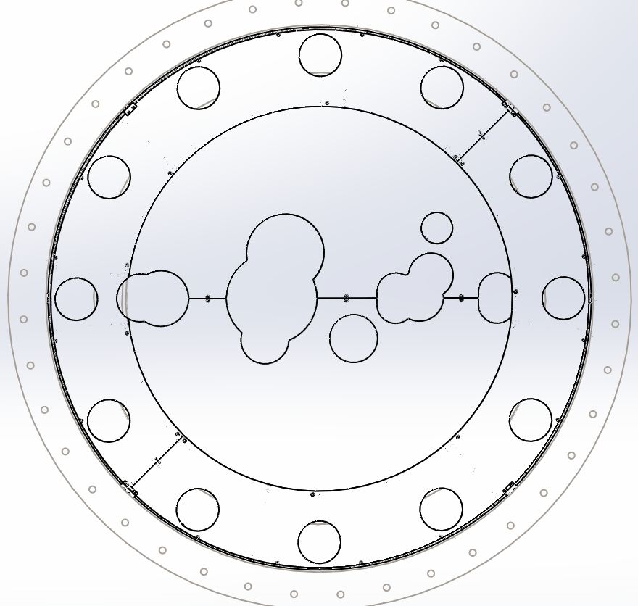

Completed assembly from the spool (chamber).
Make sure viewports match up.

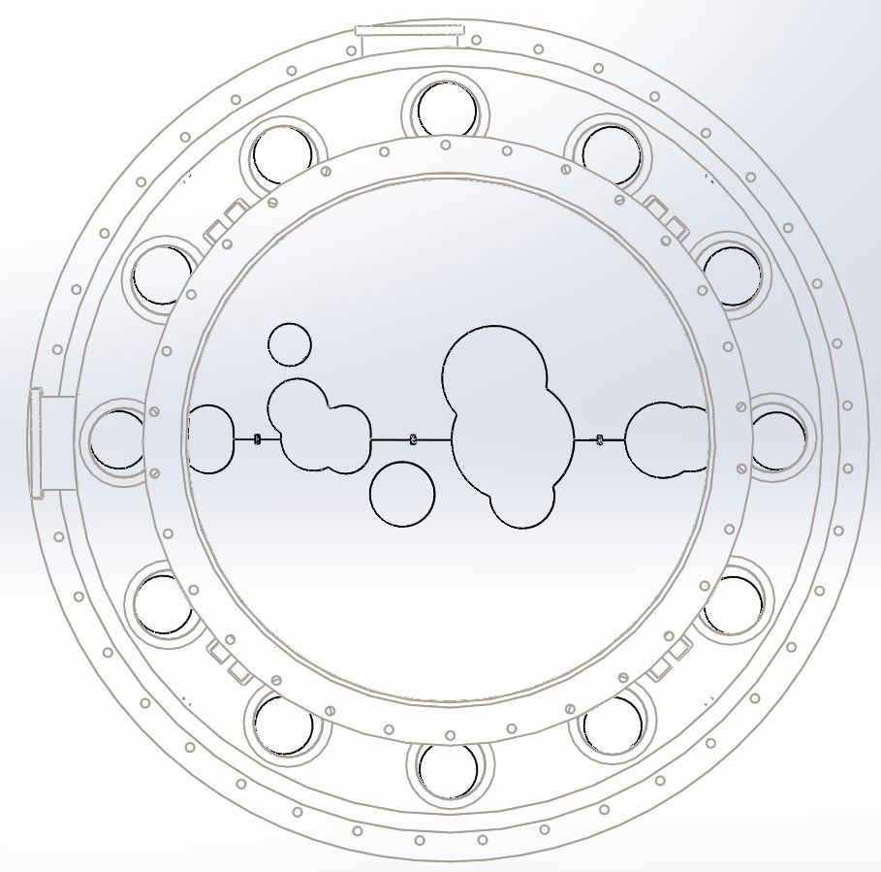

Assemble aperture plates onto viewport ring of MCA2

8.2.1. Bring in assembled aperture plate parts as shown below, upper aperture assembly.

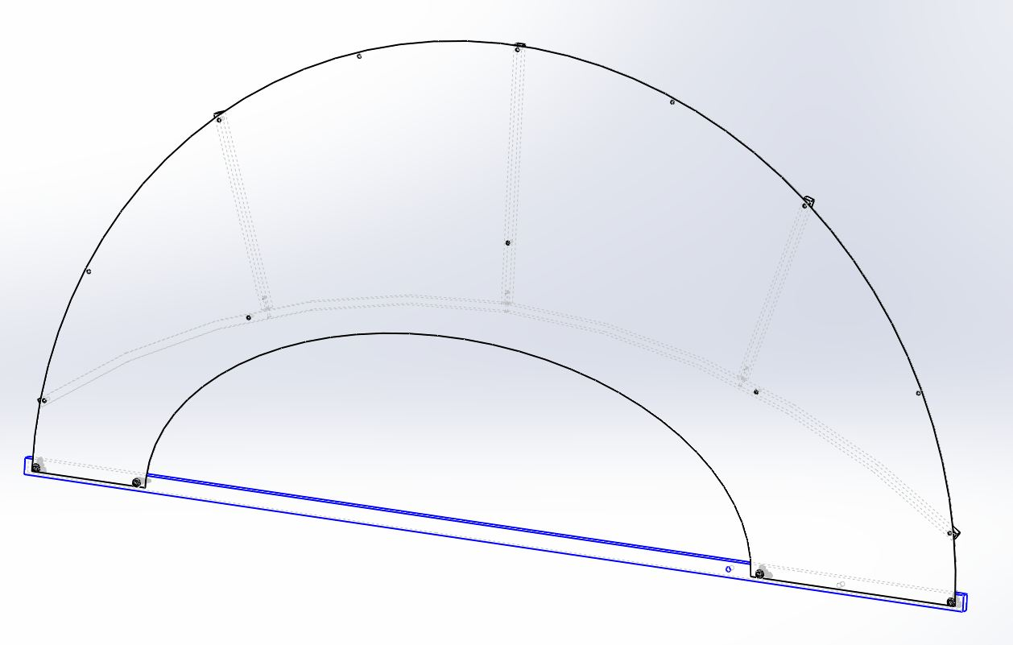
8.2.2 After attaching one C-1016-N(10-32 X 1"L, SHCS, SS) and WF-10(#10 Washer, SS) on center top tapped hole, carefully remove D1101973(Aperture Support Bar) out of the tube. Continue installing four C-1016-N through the aperture frame to viewport frame. Next install six C-1008-N(10-32 X 1/2"L, SS) with WF-10 through aperture plate into viewport frame.
Center top tapped hole
C-1016-N with WF-10
C-1016-N with WF-10

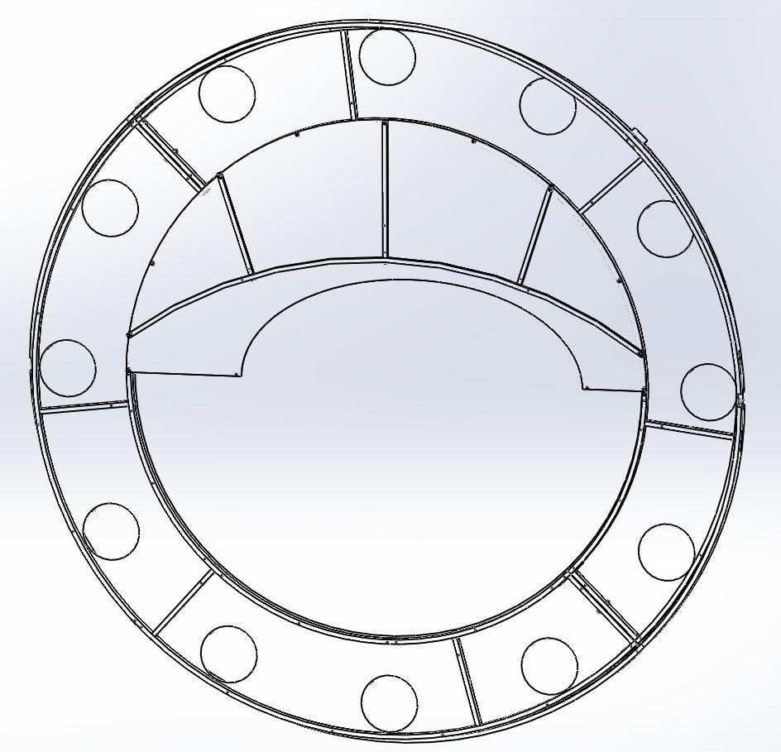
C-1008-N with WF-10

C-1016-N with WF-10
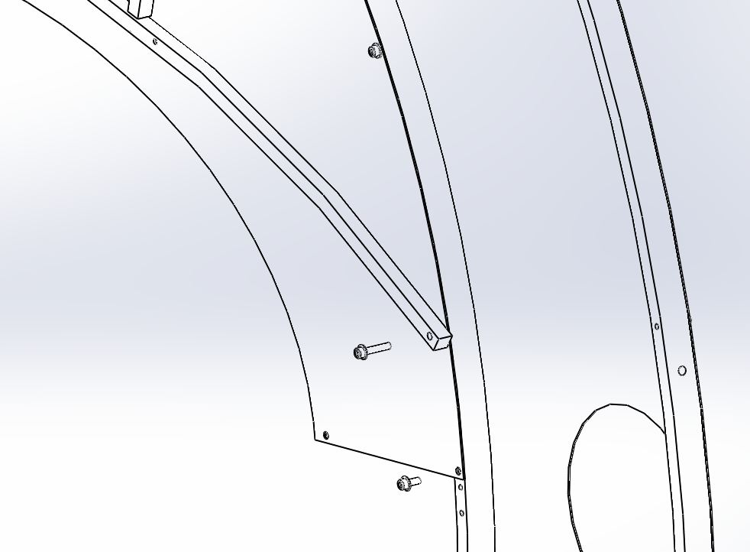
C-1008-N with WF-10

8.2.3 Bring in assembled lower aperture plate assemblies as shown below.

Carry assembled aperture assemblies in opposite orientation of upper assembly.

Oval cutout on lower half

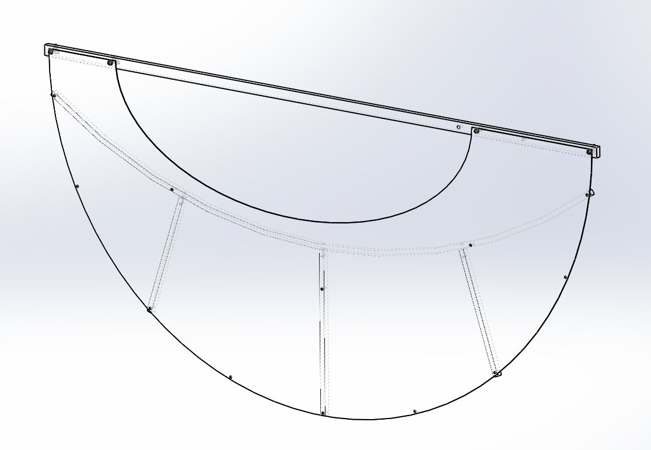

8.2.4 Remove D1101973 (support bar) before installing five C-1016-N (10-32 X 1"L, SHCS, SS) through the aperture frame to viewport frame. Next install six C-1008-N(10-32 X 1/2"L, SS) with WF-10 (#10 washer, SS) through aperture plate into viewport frame.

C-1008-N with WF-10
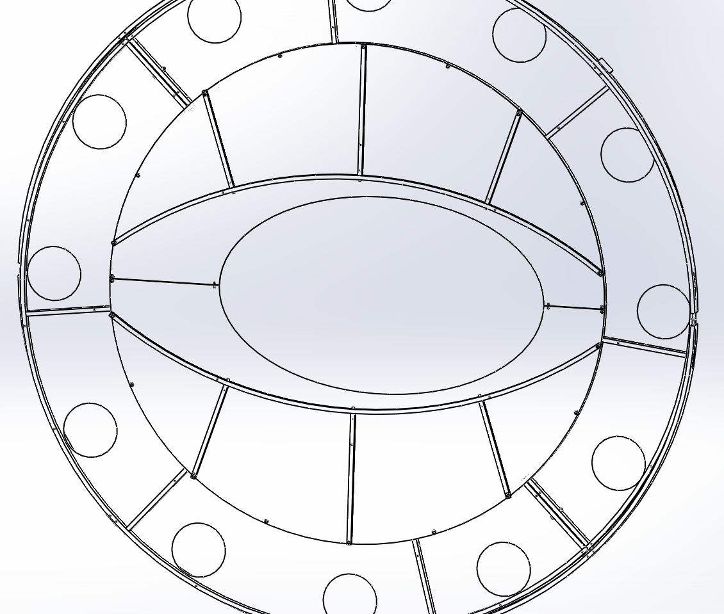
C-1016-N with WF-10
C-1016-N with WF-10

8.2.5 Attach D1003059 (SS Aperture Clip) on chamber side. Reach in from the spool through cutout to install BU-1006-NA (10-32 X 5/8"L, BHCS, Ag-SS) with WF-10 (#10 Washer, SS) into clearance holes and tighten it into D1003059.

D1003059

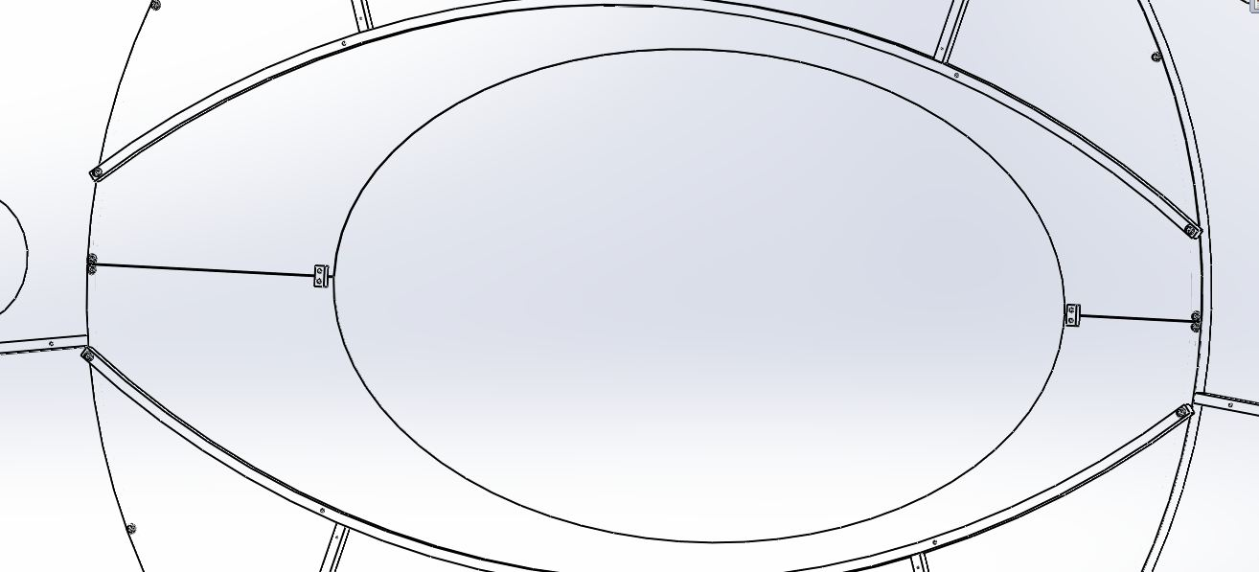

Note: Use captive Allen wrench to make sure flat head screws DO NOT fall into the tube. (Wiha: MagicRing Screw Holding-Ball End)

BU-1006-NA with WF-10
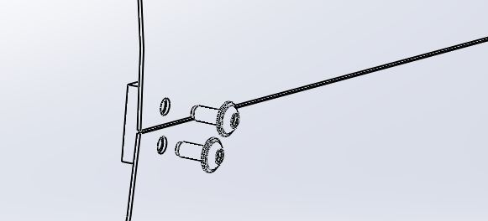

8.2.6 Installation of Mode cleaner tube baffle completed of MCA2 and MCA4.

MCA2 at HAM 5-H1-L1
MCA4 at HAM 11-H2
Completed assembly viewed from inside the tube

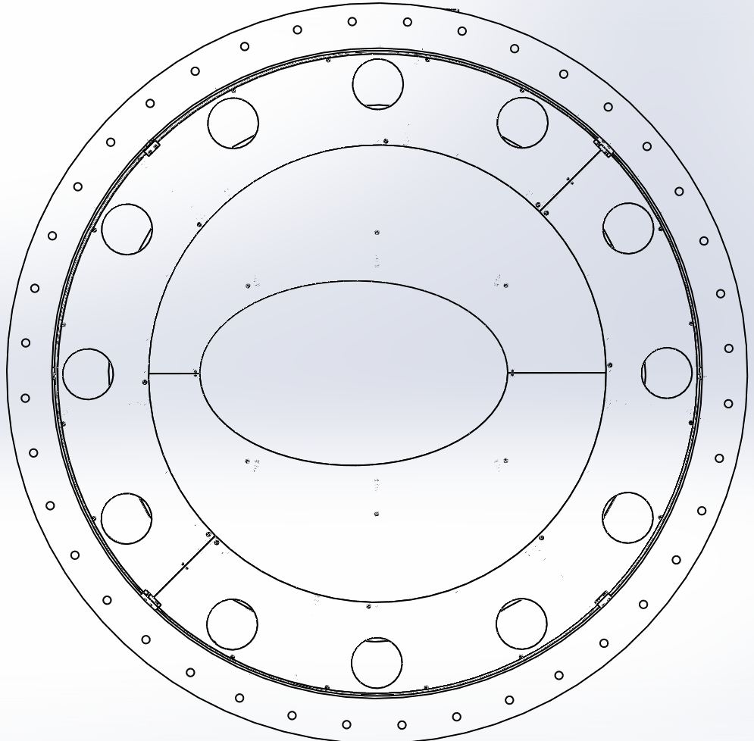

Completed assembly from the spool (outside the tube).
Make sure viewports match up.

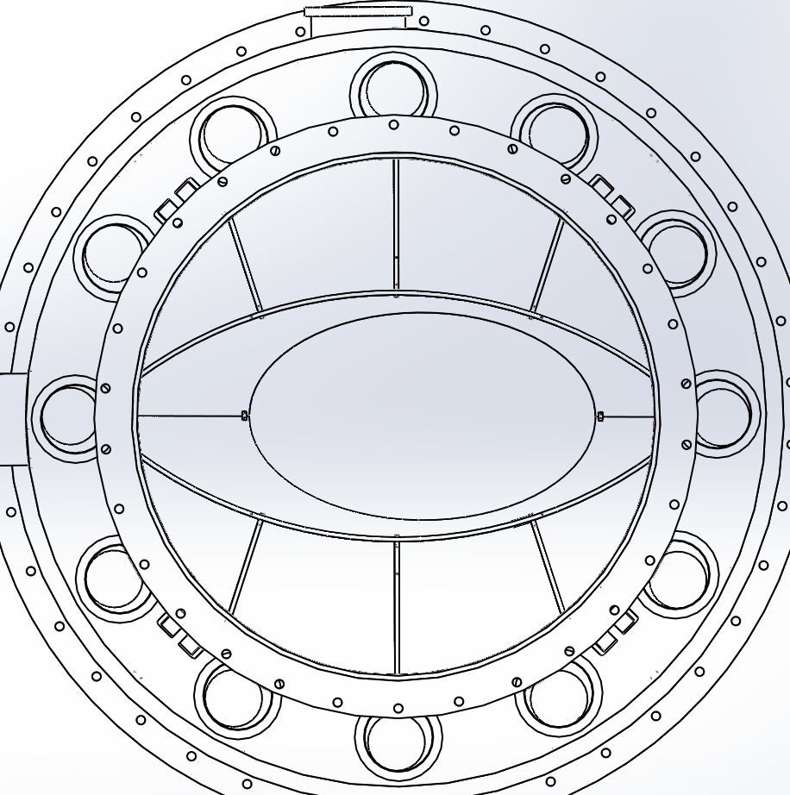

Assemble aperture plates onto viewport ring of MCA3

8.3.1 Match the cutout of D110512 (upper aperture plate, MCA3)to half-moon on viewport plate. Use nine C-1010-N(10-32 X 5/8"L, SHCS, SS) with WF-10 (#10 Washer, SS) to bolt the aperture plate to inner ring*. Make sure cutout of the aperture plate matches the half-moon of the viewport plate. Repeat for D1100513 (lower aperture plate, MCA3))

*Tip: Line up visible holes of aperture plate to threaded tap holes of the inner ring. After secure center top hole a C-1010-N with WF-10 so it can hang loosely on the inner ring, then insert the rest of C-1010-N with WF-10 into tap holes as shown.

Center hole
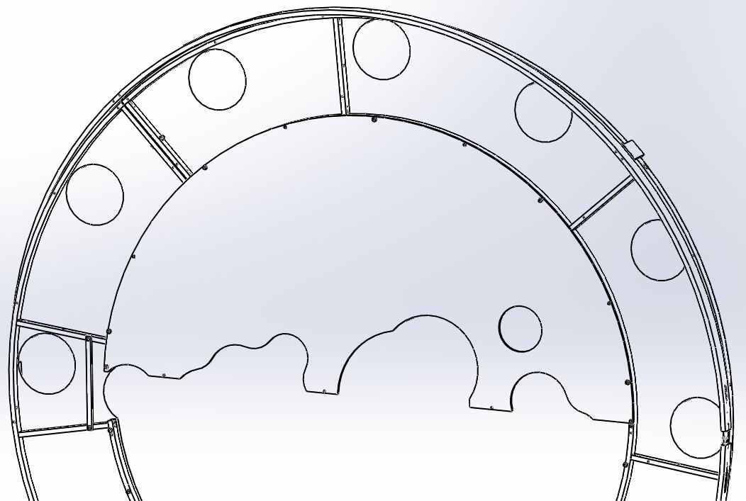
D1100512

Half-moon

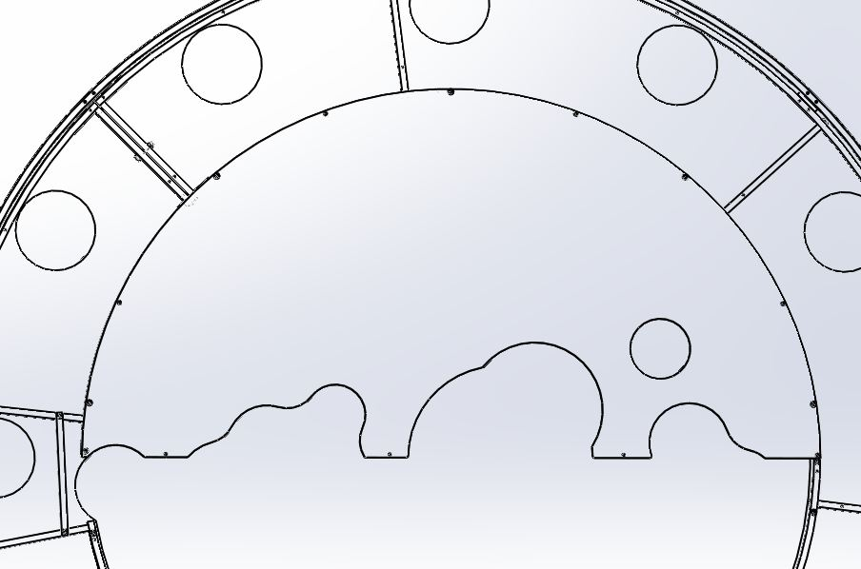

Use nine of C-1010-N with WF-10 to bolt the aperture plate to inner ring.
Make sure cutout of the aperture plate match up lower assembled aperture plate
parts and half-moon of viewport plate.
D1100512

Half-moon matchups
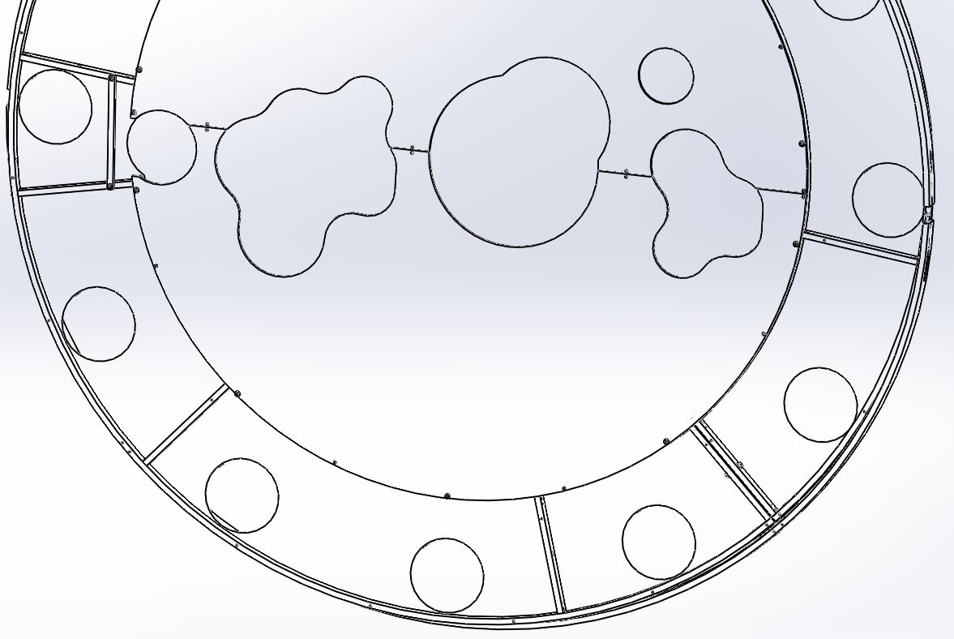
D1100513

8.3.5 Attach D1100987 (Aluminum Aperture Clip) on chamber side. Reach in from the spool through cutout to install FA-1010-N (10-32 X 5/8"L, FHCS, SS) into countersunk holes and tighten it into D1100987.

Note: Use captive Allen wrench to make sure flat head screws DO NOT fall into the tube. (Wiha: MagicRing Screw Holding-Ball End)

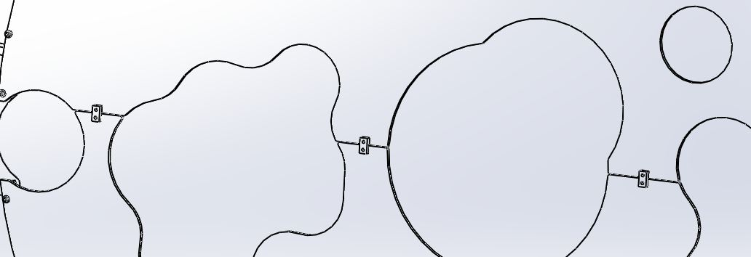
D1100987

8.3.6 Installation of Mode cleaner tube baffle completed of MCA3.

MCA3 at HAM 8-H2
Completed assembly viewed from inside the tube
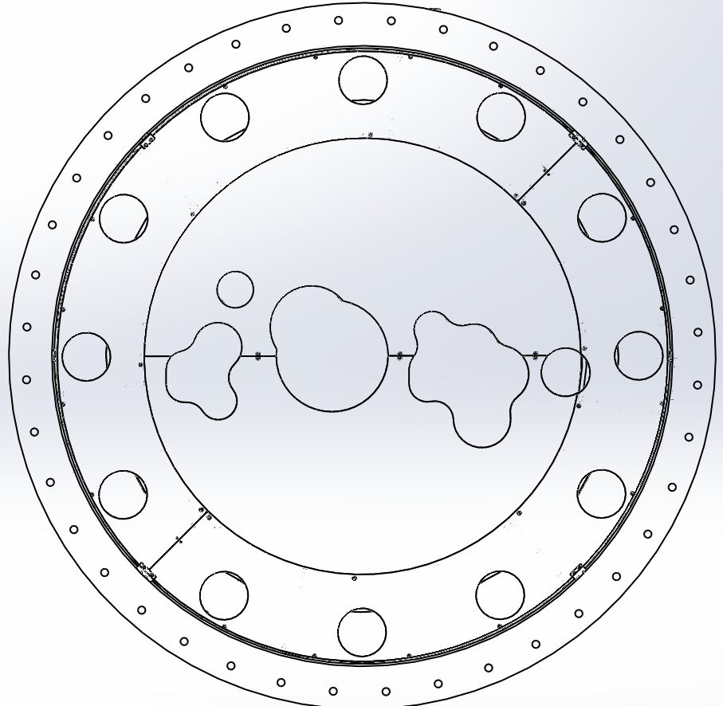

Completed assembly from the spool (outside the tube).
Make sure viewports match up.

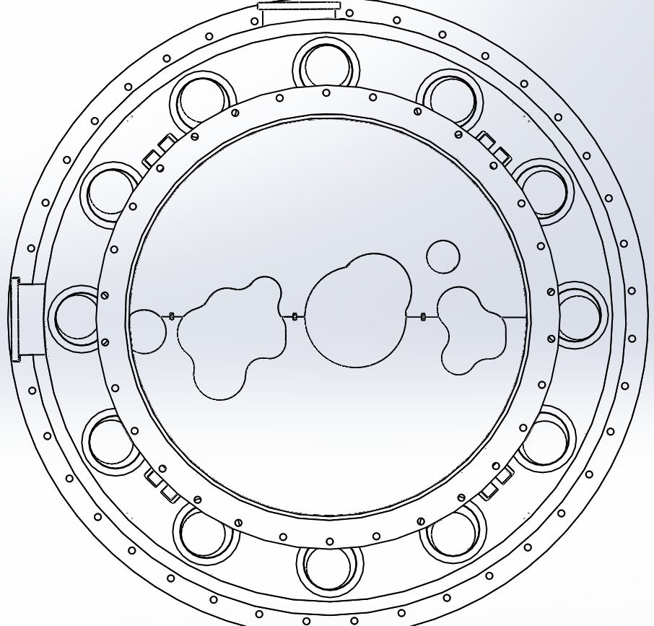

MCB1 at HAM 3-H1-L1
Completed assembly viewed from inside the tube

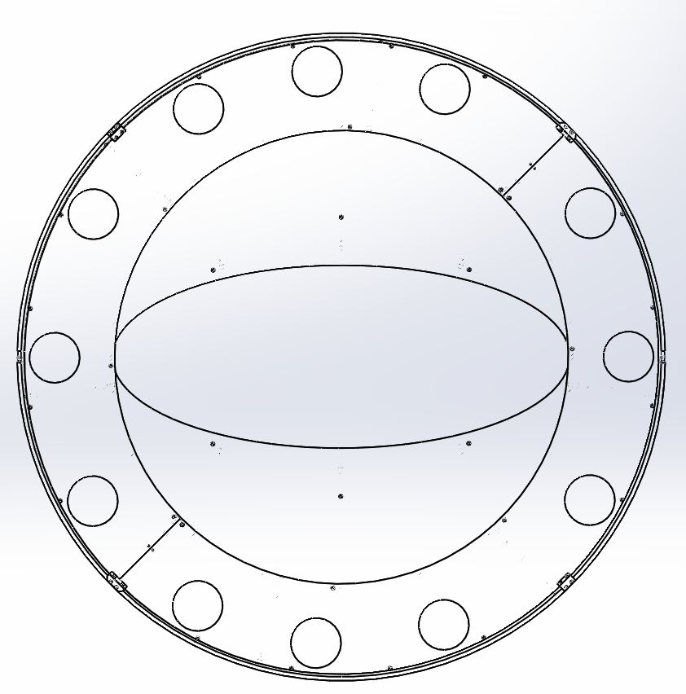

Note: Be aware of odd viewport locations on plates

Completed assembly viewed from the spool (outside the tube)
Make sure viewports match up

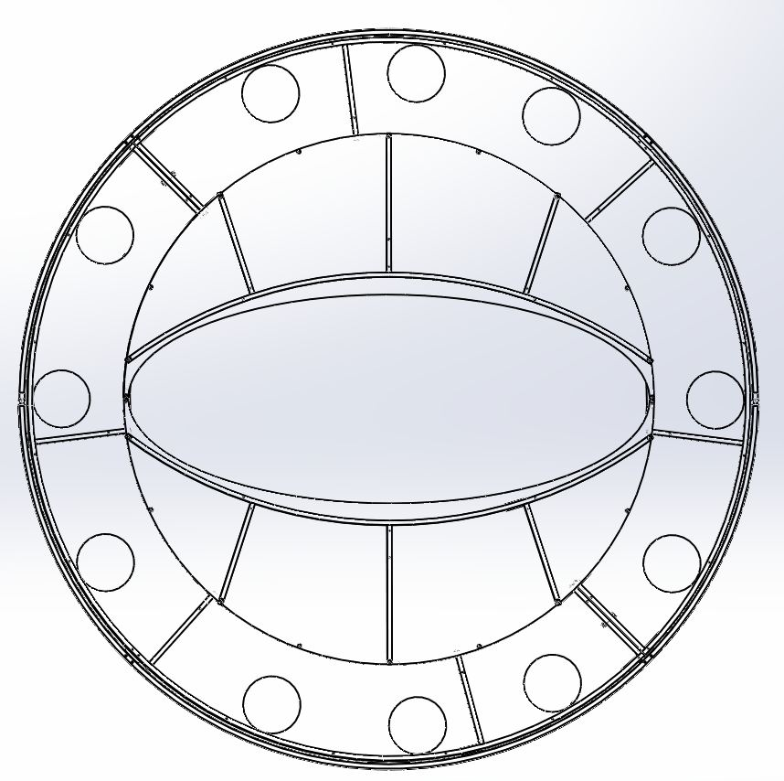

MCB2 at HAM 4-H1-L1
Completed assembly viewed from inside the tube

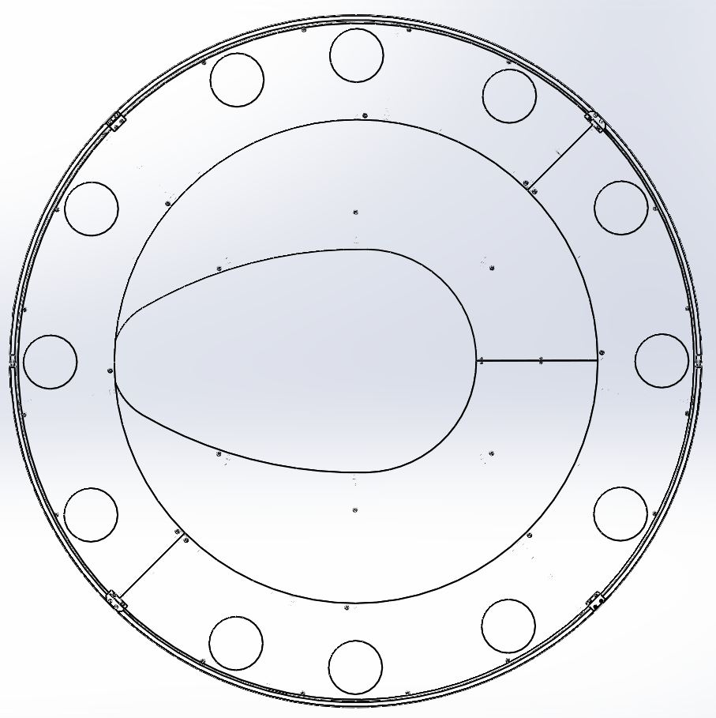

Note: Be aware of odd viewport locations on plates

Completed assembly viewed from outside the tube
Make sure viewports match up

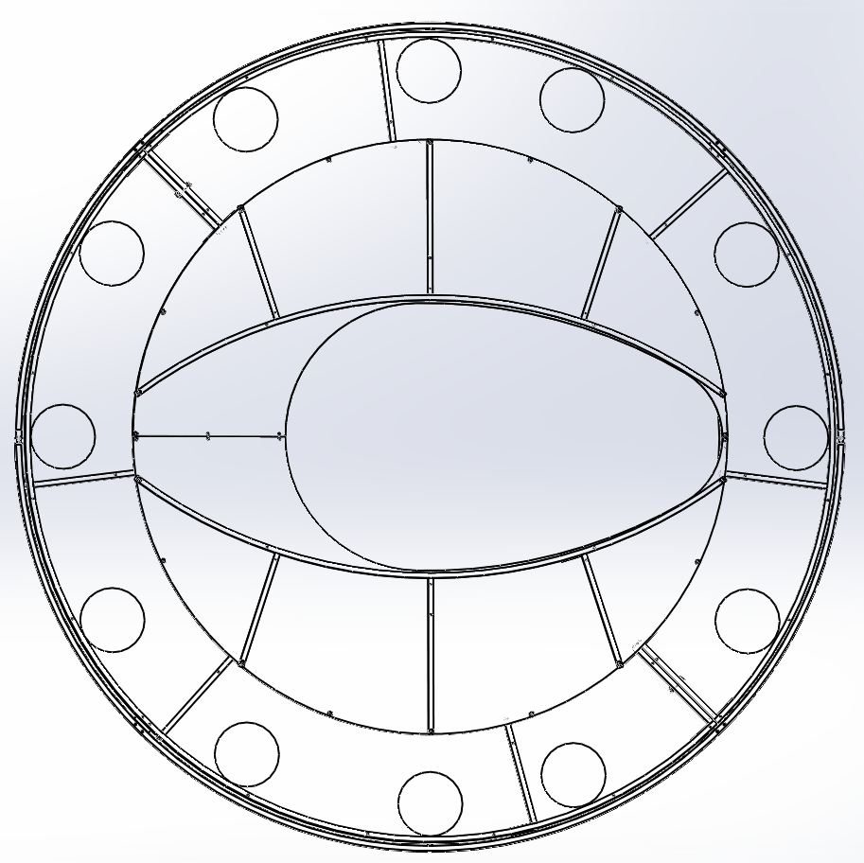

MCB3 at HAM 9-H2
Completed assembly viewed from inside the tube

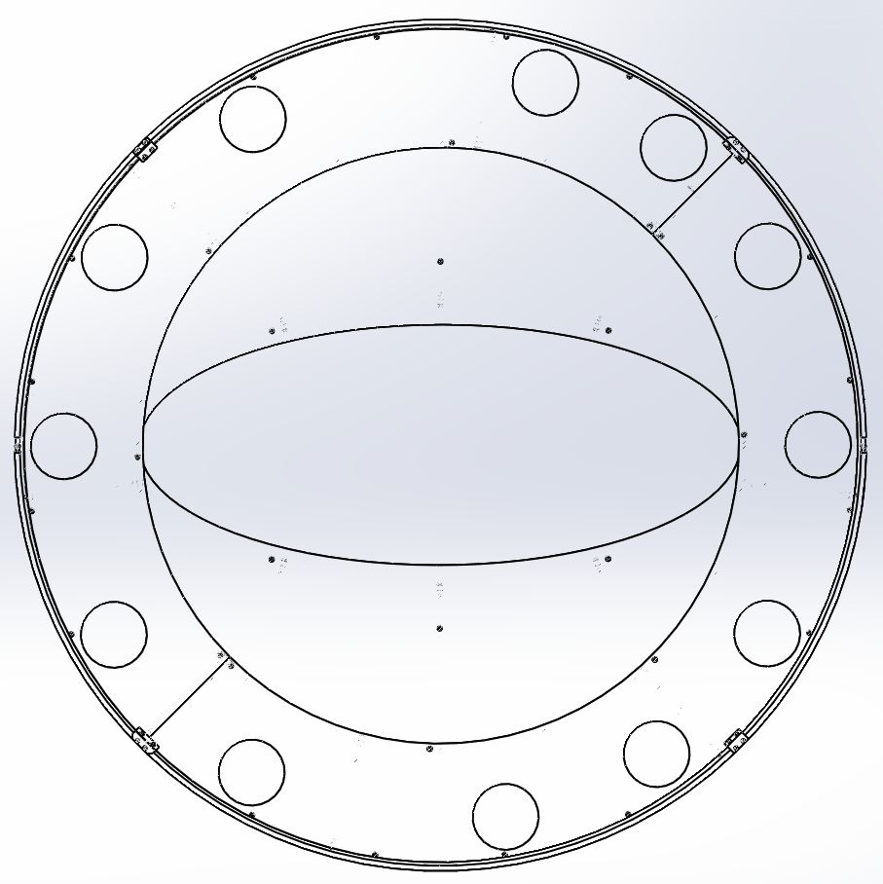

Completed assembly viewed from outside the tube
Make sure viewports match up with spool piece

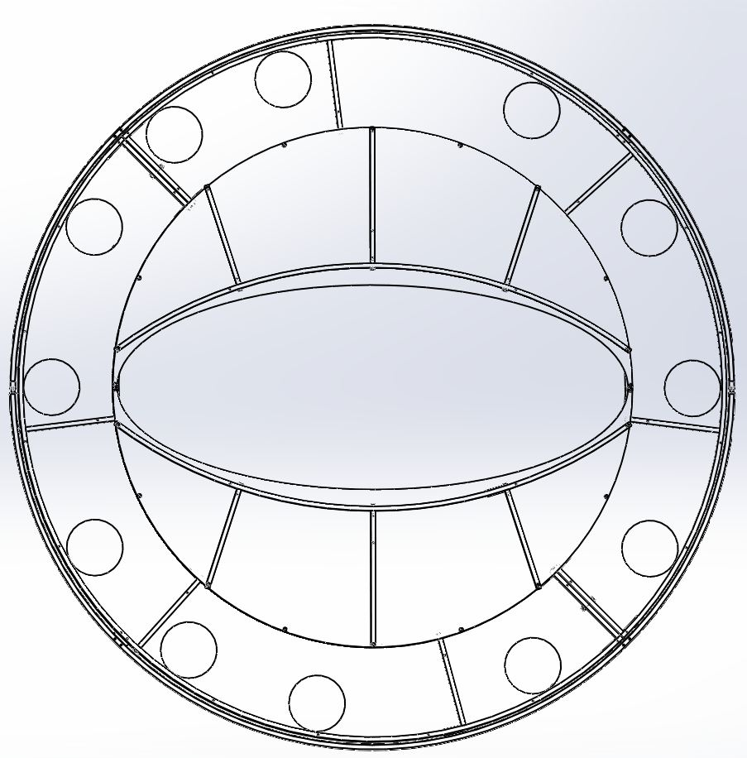

Note: Be aware of odd viewport locations on plates.

MCB4 at HAM 10-H2
Completed assembly viewed from inside the tube

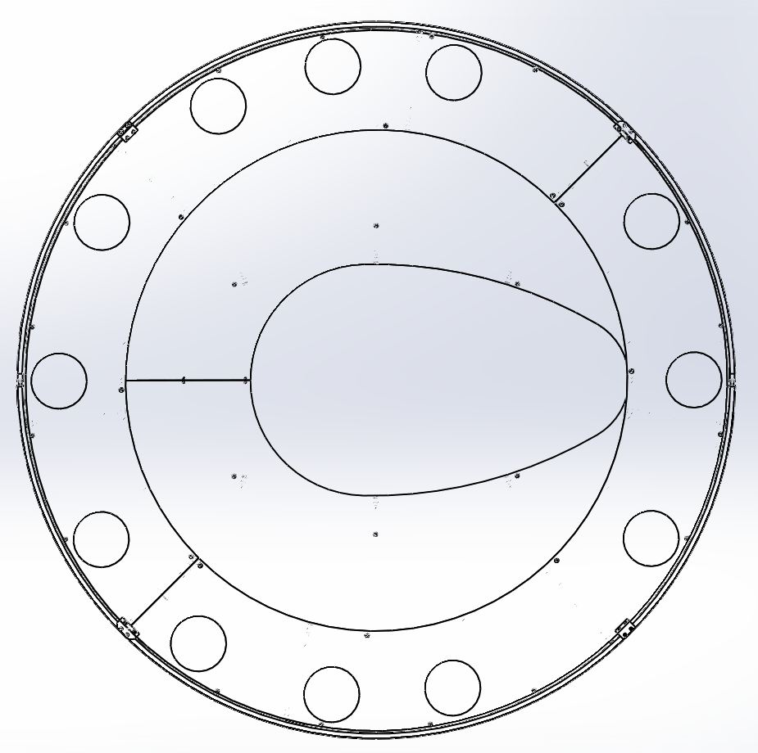

Completed assembly viewed from outside the tube
Make sure viewports match up with spool piece.

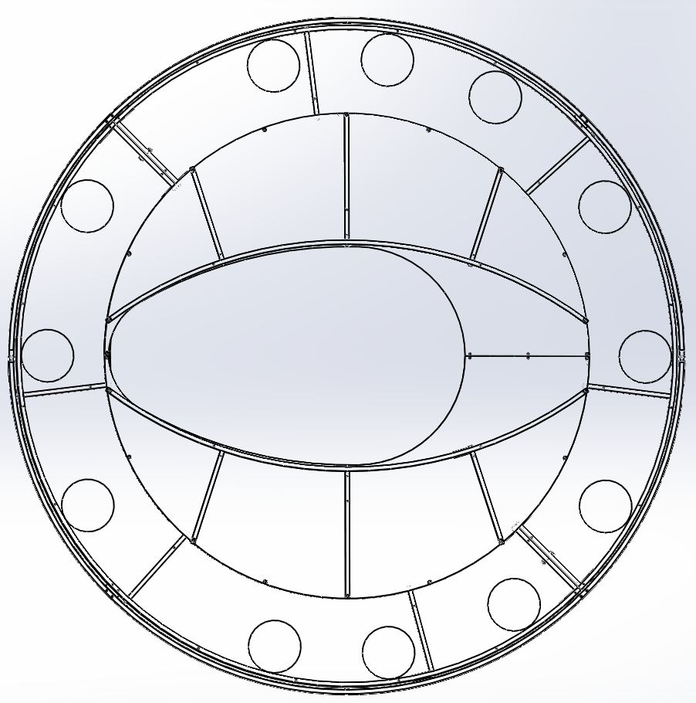

Note: Be aware of odd viewport locations on plates.

