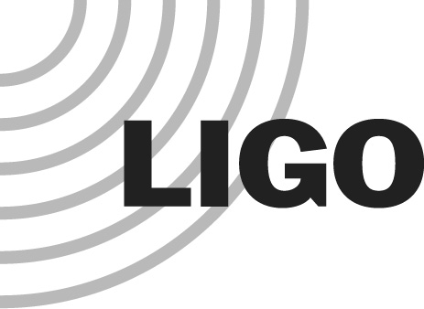
LIGO LABORATORY
MS 18-34
PASADENA CA 91125

TEL: 626.395.2129
FAX: 626.304.9834
LIGO HANFORD OBSERVATORY
PO BOX 159
RICHLAND WA 99352

TEL: 509.372.8106
FAX: 509.372.8137
LIGO LIVINGSTON OBSERVATORY
PO BOX 940
19100 LIGO LANE
LIVINGSTON LA 70754

TEL: 225.686.3100
FAX: 225.686.7189

MEMORANDUM

DATE: July 28, 2026

TO: | Ligo Laboratory, LIGO Science Collaboration
FROM: | Carol Wilkinson (Advanced LIGO Project Manager)  Dennis Coyne (LIGO Chief Engineer)
SUBJECT: | Record of Decision/Agreement (RODA)
Refer to: | LIGO-M040004-00-M

The LIGO Laboratory has established a formal means of rapidly capturing agreements and decisions in written form. Currently agreements or decisions are typically captured in meeting minutes, email or occasionally in technical memoranda. Generally the intent is to formally document these agreements and decisions in large, formal documents which are usually updated at the time of major reviews (e.g. subsystem requirements documents, subsystem design documents). The frequency of these updates is too long to ensure that decisions and agreements are not forgotten. For contracts we have established a Technical Direction Memo (TDM) as the means to formally capture agreements and decisions which effect a LIGO contract. The Record of Decision/Agreement (RODA) is meant to provide the same function for non-contractual agreements or decisions.

The attached RODA form is largely self-explanatory. The decision author or the parties to the agreement are signatories on the form. Signatures are to be made using the Adobe AcroBat Digital Signature Tool before filing an Adobe Acrobat file into the LIGO Document Control Center (DCC). The RODA documents are management category documents and should be given a group code "Y" (i.e. document number LIGO-Myyxxxx-zz-Y, where the revision code, zz, is a number, not a letter⊗). If the decision or agreement needs to be modified or updated, then it is re-issued with the next revision. If the decision or agreement needs to be invalidated, then a revision should be issued with a statement to this effect; The latest revision of a RODA document is always the relevant one.

Attachment: RODA form

 The RODA is not configuration controlled with a Document Change Notice (DCN) form. Hence the revision code is not a letter but always remains a draft or numbered revision. This is meant to avoid the overhead of issuing a DCN for every RODA and again when decisions and agreements are also captured into major documentation such as subsystem design requirements documents.

