California Institute of Technology  MS 18-34, 1200 E. California Blvd.  Pasadena CA 91125 USA  TEL: 626.395.2129  FAX: 626.304.9834  www.ligo.caltech.edu |  | LIGO Livingston Observatory  P.O. Box 940  Livingston LA 70754 USA  TEL: 225.686.3100  FAX: 225.686.7189  www.ligo-la.caltech.edu | LIGO Hanford Observatory  P.O. Box 159  Richland WA 99352 USA  TEL: 509.372.8106  FAX: 509.372.8137  www.ligo-wa.caltech.edu |  | Massachusetts Institute of Technology  MIT NW22 – 295, 185 Albany St.  Cambridge MA 02139 USA  TEL: 617.253.4824  FAX: 617.253.7014  www.ligo.mit.edu
Date: | June 21, 2011 |  |  | Refer to: |  | T1100331-v1
Subject: | B&K MTC Hammer Guide
To:
From: | Kristen Holtz

- Basics and Helpful Hints
  - Getting Started
    - Open PULSE > Applications > Modal Analysis > MTC Hammer
  - Viewing and Moving the Geometry
    - Hold “shift” and click and move the mouse up and down to zoom in and out.
    - Hold “Ctrl” and click and move the mouse to move the entire geometry up, down, or to the side.
    - If you just click and move the mouse, then the geometry will rotate.
- Set-up
  - Hardware Setup
    - It is important to complete the hardware setup first because the input modules cannot be added to the PULSE system manually. In order for the measurement sequence to be accurate, you must plug in the accelerometers and hammer into the input modules and the modules must be detected by the PULSE labshop. You must continue the setup process with the configuration you plan on using for your measurement.
    - If the input modules are not being detected, hit “Clear and Detect HW” (see Figure 1). If this still does not work, open Front-end Setup and see if the desired modules are being detected. Otherwise you can Browse and Add devices. Once the front-end setup matches the expected setup, you can hit apply configuration. Now hitting “Clear and Detect HW” on the Hardware Setup screen of the PULSE LabShop should show your configuration accurately.
    - Some elements, in our case the hammer, have to be added manually. Just double-click the transducer family window of the correct row (see figure 1) and add in the title. Similarly, add the transducer type into the appropriate window.
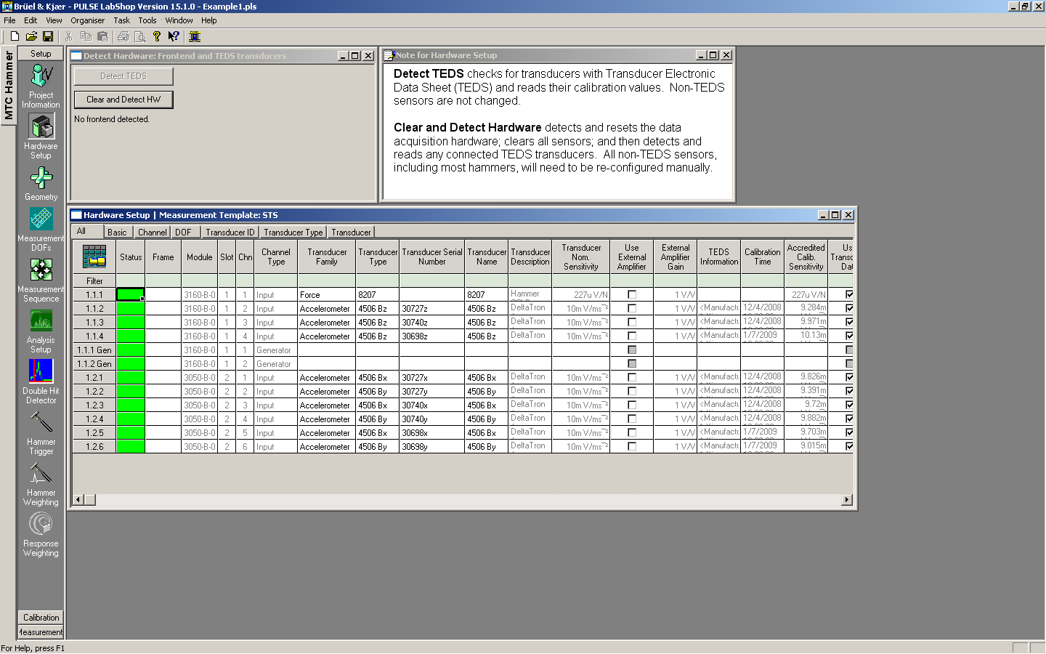
Figure 1: The “Clear and Detect HW” button is boxed in the upper left corner. The Transducer Family and Type windows can be found near the center of the screen.

  - Measurement DOFs
    - In the transducer list, your inputs should be listed. If your input is an accelerometer with three input channels, then hopefully the PULSE LapShop recognizes this as one entity as shown in Figure 2.

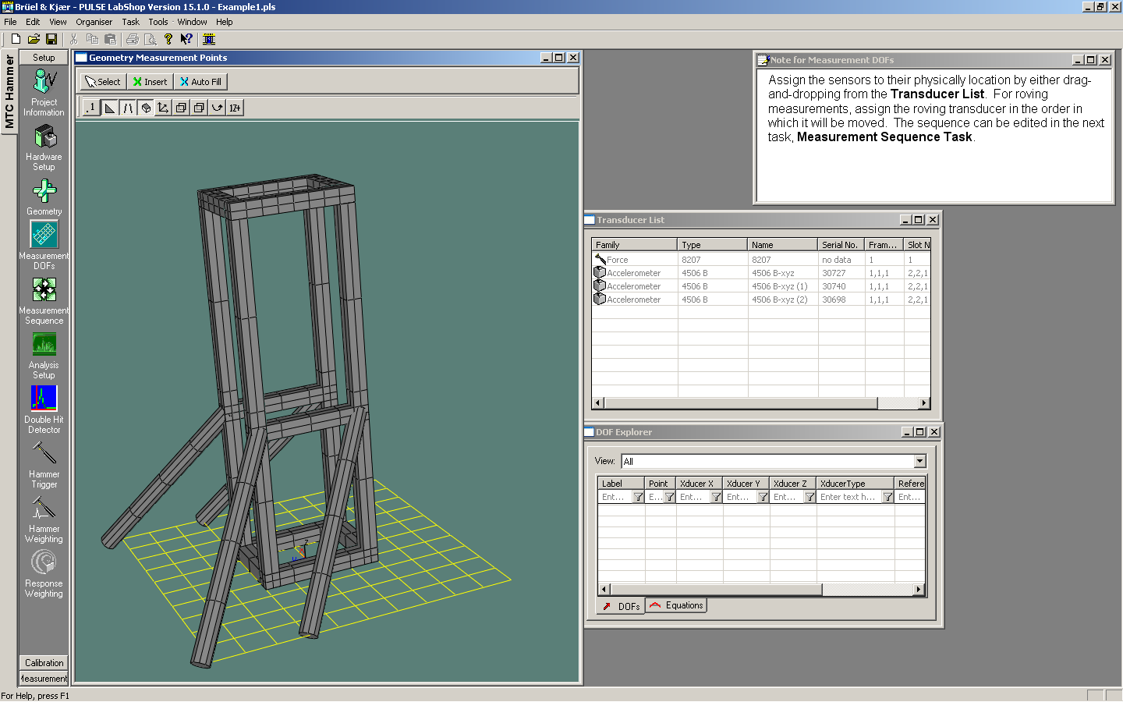
Figure 2: The transducers (the accelerometers and hammer) should show up in the transducer list, ideally combining multiple channel inputs (X, Y, Z) into each respective accelerometer.

    - To add a degree of freedom, simply click on the desired transducer in the transducer list and then click on the point (a vertex in the mesh) where you want that transducer to go. (Figure 3)
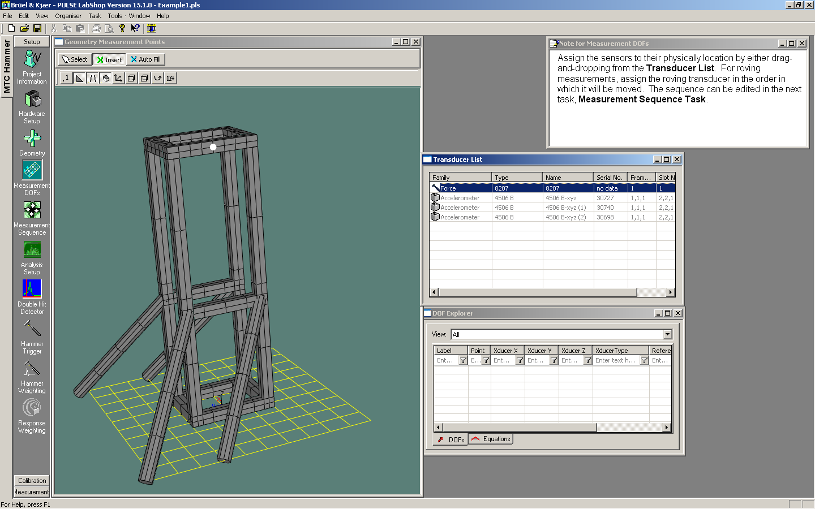
Figure 3: Select the transducer from the transducer list then place the white dot at a cross in the mesh.

    - To change the direction of this degree of freedom, right-click on the image and select “Properties”. You will then be able to change the direction.
    - Continue adding degrees of freedom. The measurement sequence will naturally make pairs of all the different combinations of excitation and response. (Figure 4)
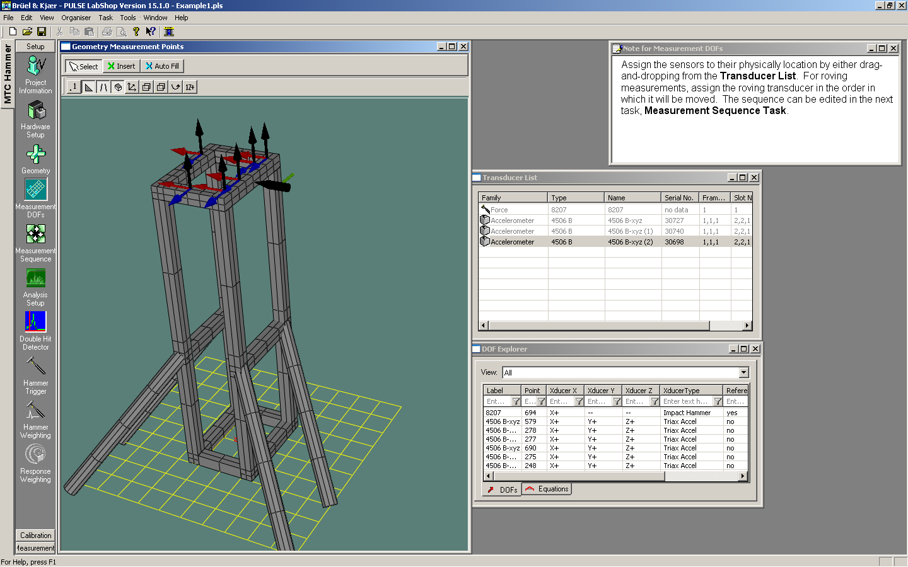
Figure 4: Add and edit degrees of freedom the same way you added the excitation point. It is easiest in the end to put different accelerometers next to each other. To minimize number of measurements, you want to use each accelerometer equally.
    - If the degree of freedom is in an odd place such that it is not lined up with the global coordinate system but instead at an angle, the software will naturally have the degree of freedom pointed such that the accelerometer can be placed in this direction. (Figure 5)
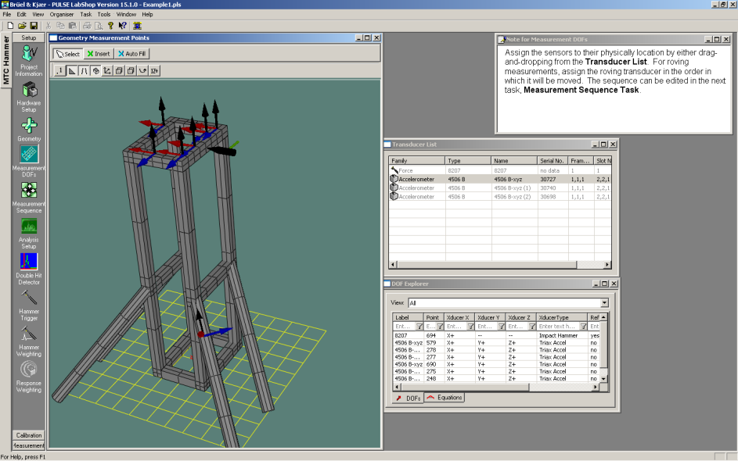
Figure 5: Degrees of freedom on oddly angled surfaces will align with the coordinate system of that surface.

  - Measurement Sequence
    - The measurement sequence that will be generated automatically will use the order in which the accelerometer degrees of freedom were attached to decide the order. There are several icons at the top of the “Sequence Editor”, within the “Measurement Sequence” window/task, that will allow you to change the measurement order (see figure 6).
Highly recommended: Changes order from same hammer location and roving accelerometers to same accelerometer location with roving hammer (i.e. can minimize accelerometer movement)
Delete current measurement sequence
Order points: Manually
Order points [Recommended]: Order based on shortest point path.
Order points: Order by point number
Order points: Order that you put in DOFs in Measurement DOFs stage
Figure 6: Sequence editor options

  - Analysis Setup
    - Here you can change the span and resolution (lines) of your analysis. Ideally the data collection time T will be close to the time for which your structure rings after it is hit.
  - Hammer Trigger
    - After setting up some accelerometer(s) on the structure, click “initialize” then “start”, then excite the structure with the hammer. Then move the blue bar so that the top is just below the top of the hammer peak and the bottom is above the zero line. Hit “Apply”. (Figure 7).

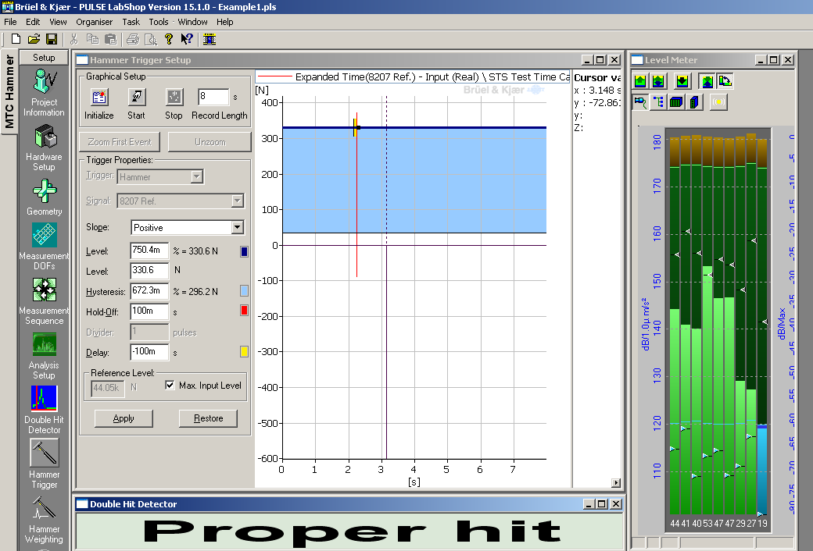
Figure 7: Drag the blue box to be inside of the excitation peak.
- Measurement
  - Measurement
    - Click “Initialize” then “Start”. The PULSE LabShop will assume you are taking the measurements in whatever order you have set it up in already. If you highlight the measurement number, the Measurement Display will show you where the excitation point and accelerometers are placed for that measurement. (Figure 8)
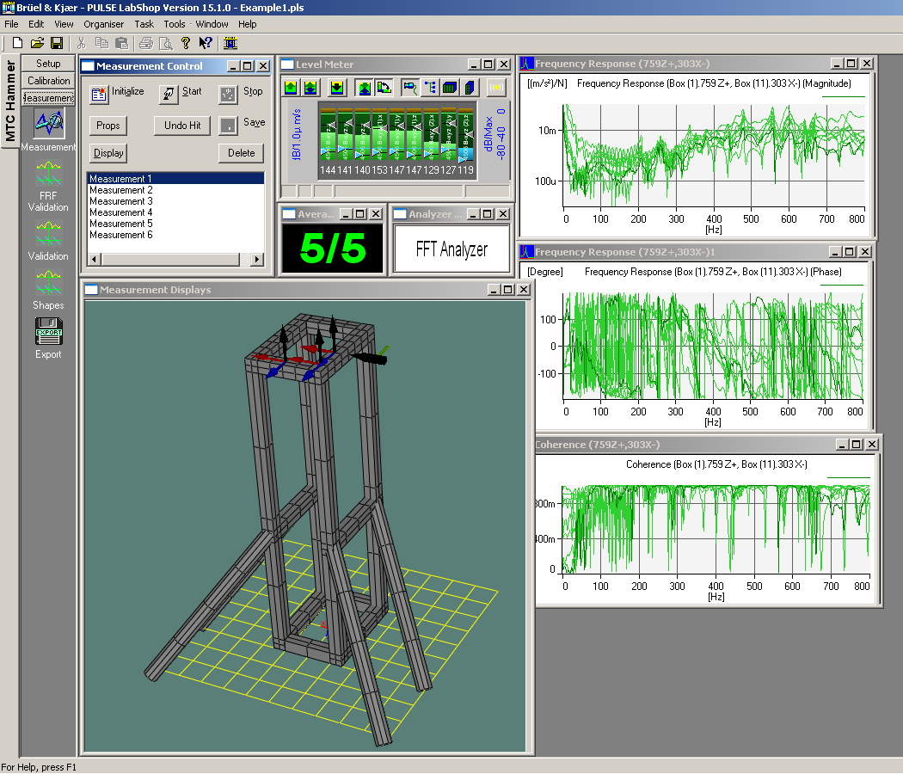
Figure 8: Hit Initialize then Start. Make sure you are taking the measurement that is highlighted and shown on the Measurement Display.
  - FRF Validation – Viewing the Mode Shapes
    - The easiest way to change your view of the mode shapes is by right clicking on the animation and hovering over animation. You will see the menu in Figure 9. For optimal viewing, select Dwell, Deformed (and unselect undeformed), Interpolation and Relative Scale.

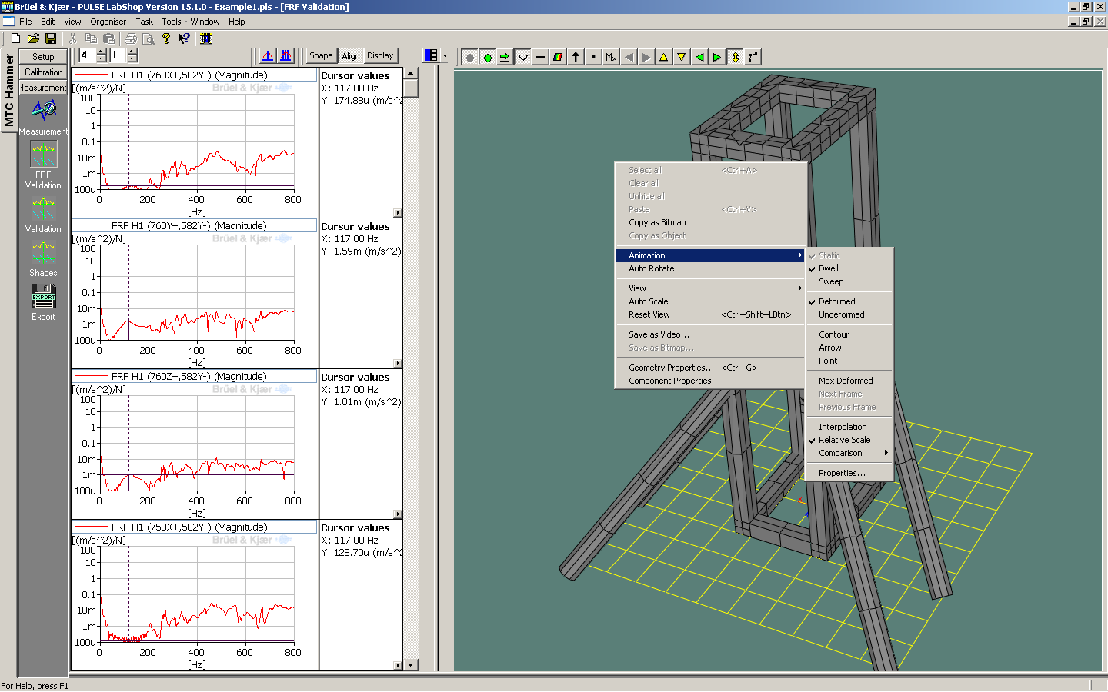
Figure 9: Viewing the Mode Shapes
    - You can also play around with the speed and amplitude of the vibrations that show the modes in order to see it better.
    - If you right-click on the animation you can also “Save as video”, which allows you to save the animation so others can see it.
    - The “Geometry Properties” option in the right-click menu may also give you many options that may be useful.
  - Export
    - There are many ways you can extract the information from this experiment. The most effective way right now is to click on settings and select “PULSE File ASCII” as the export format. It is unnecessary to export the shapes or geometry. Then select all of the measurements (or the ones you want) and “Frequency Response H1 as your possible functions. Click “Export”. Once exported, the files can be opened in Microsoft Excel and will show the frequency, magnitude, and phase.

