LIGO Laboratory / LIGO Scientific Collaboration

LIGO- E1100607-v5 LIGO 09/26/2013

SLC ITM Manifold/Cryopump Baffle
Assembly and Installation Document

Mike Smith, Heidy Kelman, and M.Hillard

Distribution of this document:
LIGO Scientific Collaboration

This is an internal working note
of the LIGO Laboratory.

California Institute of Technology  LIGO Project – MS 18-34  1200 E. California Blvd.  Pasadena, CA 91125  Phone (626) 395-2129  Fax (626) 304-9834  E-mail: info@ligo.caltech.edu | Massachusetts Institute of Technology  LIGO Project – NW22-295  185 Albany St  Cambridge, MA 02139  Phone (617) 253-4824  Fax (617) 253-7014  E-mail: info@ligo.mit.edu
LIGO Hanford Observatory  P.O. Box 159  Richland WA 99352  Phone 509-372-8106  Fax 509-372-8137 | LIGO Livingston Observatory  P.O. Box 940  Livingston, LA 70754  Phone 225-686-3100  Fax 225-686-7189
http://www.ligo.caltech.edu/

Table of Contents
1 Introduction 5
1.1 Special Equipment and Personnel Safety 6
1.1.1 Clean Room 6
1.1.2 Safety Equipment 6
1.1.3 Personnel 6
2 ITM Manifold Cryopump Baffle Assembly 7
2.1 Overview of the ITM Manifold Cryopump Baffle Assembly 7
2.2 Serial Number Tracking 8
3 ITM Manifold-Cryopump Baffle Assembly Procedure 11
3.1 ITM Manifold Cryopump Baffle Box Assembly 11
3.2 Preload the Suspension Springs 22
3.3 Attach Top Suspension Ring to Baffle Alignment/Balance Fixture 25
3.4 Mount the Suspension Blade Spring to the Top Suspension Ring D0902815 25
3.5 Attach Lift Fixture Stop Bracket 27
3.6 Insertion of Baffle into Alignment/Balancing Fixture 29
3.7 Installing Face Plates 30
4 Balancing the Baffle Assembly in the Balancing Fixture 31
4.1 Height Adjustment 31
4.2 Vertical Balance 32
4.3 Axial Balance 32
4.4 Lateral Balance 32
4.5 Removing the Baffle from the Balancing Fixture 33
4.6 Remove Blades and Support Ring 34
5 Manifold Cryopump Baffle Installation 35
5.1 Support Ring D1002084 Installation at End Station 35
5.2 Blade Spring Installation 38
5.3 Manifold Cryopump Baffle Installation 39
5.4 Verify Height and Balance 41
5.5 Attaching Eddy Current Damping Copper Plate 42
5.6 Final Acceptance Test Documentation 43

Table of Figures
Figure 1: Manifold/Cryopump Baffle Lift/Assembly Fixture 11
Figure 2: Cylinder 12
Figure 3: Weldment 12
Figure 4: Center Cylinder placed on Lift/Assembly Fixture 13
Figure 5: Attaching Weldment Subassembly to Center Cylinder 13
Figure 6: Right-Left Weldment attachment adapter placement 14
Figure 7: Right L-Bracket 15
Figure 8: L-Bracket Attachment Detail 15
Figure 9: Installing Threaded Male-to-Male Adapters 16
Figure 10: Adding Bottom Weldment 17
Figure 11: Insertion of Suspension Rod through L-bracket 18
Figure 12: Lower Magnet Plate with Magnets 19
Figure 13: Turnbuckle Assembly 19
Figure 14: Long Turnbuckle attachment 20
Figure 15: Short turnbuckle attachment 21
Figure 16: Blade Pre-load Fixturing 22
Figure 17: Baffle Alignment/Balance Fixture 23
Figure 18: Pre Load Spring Blade by Hanging Weights 24
Figure 19: Preloaded Spring Blade Restrained with the Bend Fixture Shim 25
Figure 20: Top Suspension Ring Mounted to Alignment/Balance Fixture 26
Figure 21: Blade alignment 26
Figure 22: Install Stop Brackets 27
Figure 23: Lift/Assembly with Baffle Supported by Crane 28
Figure 24: Suspension Rods and Spring Blade attachment 29
Figure 25: Attach Face Plates to Outer Cylinder 30
Figure 26: Three Face Plates Attached 31
Figure 27: Height Adjustment bolts 31
Figure 28: Balance Weights 32
Figure 29: Adapter Removed from Manifold Tube for Baffle Insertion 36
Figure 30: Support Ring installation 36
Figure 31: Support Ring Installed in A-7 Adapter 37
Figure 32: Blade alignment in chamber 38
Figure 33: Pre-tensioned Blades Mounted to Ring in spool with Shims. 38
Figure 34: Baffle between spool and gate valve 39
Figure 35: Baffle insertion into Adapter 40
Figure 36: Installed Baffle Suspended by Spring Blades 41
Figure 37: Attaching Eddy Current Damping Plate to the Support Ring 42
Figure 38: Setting the Damping Plate Gap 43

CHANGE LOG

Date, version | Summary of Changes
8/11/13  V2 | - Update installation drawings
5/21/13  V3 | - Added significant detail to the document
5/23/13  V4 | - Added safety details for installation
09/26/13  V5 | - Incorporated changes and updates from ETM procedure

Introduction
This document describes the assembly and installation procedures for the ITM Manifold Cryopump Baffles, D0902617.
Each Manifold Cryopump Baffle will be installed in the A-7 Adapter at the IFO End Station under Class A clean room standards.
LIGO standards must be followed, as presented in the LIGO Contamination Control Plan E0900047. Clean room garb including UHV gloves should be worn when working with parts.
All tools that come in contact with the Manifold Cryopump Baffle assembly will be cleaned to Class B standards.
This procedure must be read before beginning the assembly and installation of the ITM Manifold Cryopump Baffle.

Special Equipment and Personnel Safety

Clean Room
The Manifold Cryopump Baffle will be assembled within a Class A clean room that covers the opening of the manifold where it will be installed.
The clean room must have provisions for an opening in the roof so that a lanyard, attached to an overhead crane, can be introduced into the clean room from above for moving the Baffle lifting fixture with the Baffle around within the clean room and into the entrance flange of the manifold tube. The clean room must have clear floor space for the Assembly Fixture and the Balancing Fixture.
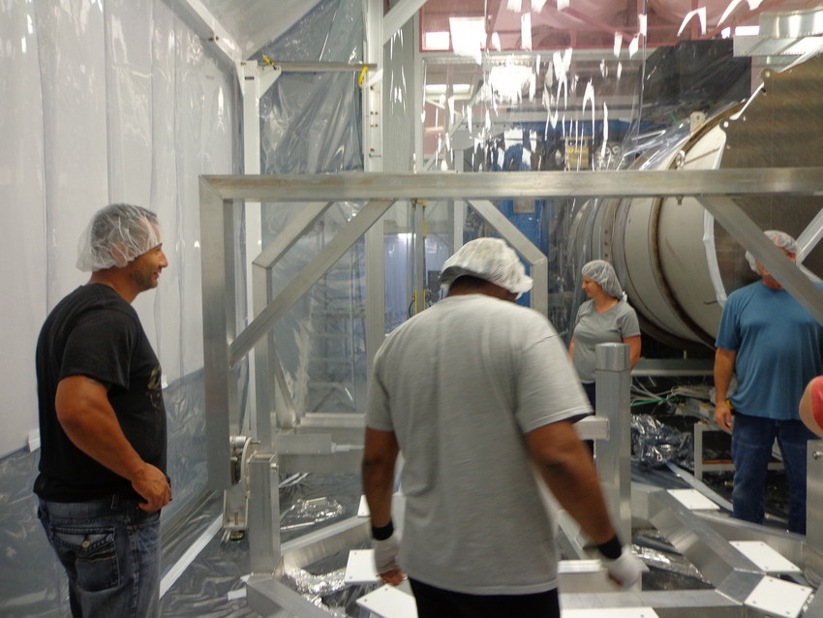

Safety Equipment
All assembly and installation personnel outside the vacuum manifold must wear safety-toed shoes and hard hats. Personnel inside the vacuum manifold must wear safety-toed shoes. Personnel working in the vicinity of the stressed spring blades must also wear safety glasses. Fall protection equipment must be used by employees working at heights of 6 feet or greater above ground where the area of activity is not protected by guard rails or other suitable barriers.

Personnel
The following personnel will be required whenever the Manifold Cryopump Baffle is being lifted by the overhead crane:
1 crane operator
2 tag line holders
1 spotter

ITM Manifold Cryopump Baffle Assembly

Overview of the ITM Manifold Cryopump Baffle Assembly
The Manifold Cryopump Baffle is comprised of the following sub-assemblies and fixtures.

Drawing Number | Description | Image
D1101398, ITM | Baffle Radial Segment Assembly
D1002402 | Balance Weight Assembly –  2 per assembly | 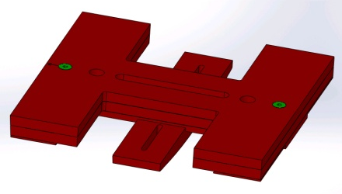
D1002084 | Outer Ring Assembly
D1101192 | Manifold Cryopump Baffle Lift/Assembly Fixture  - approximate dimension are 10’ x 6’ x 7’ | 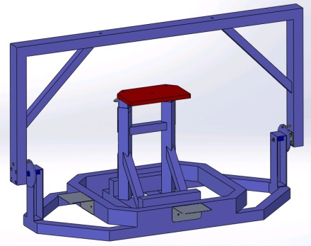
D1002675 | Manifold Cryopump Baffle Alignment Fixture  - approximate dimension are 7’ x 6’ x 8’.

Serial Number Tracking
Serial Number of the installed baffle assembly shall be the same serial number as part D1001348.
All serialized parts used in this assembly should be tracked and recorded below as they are used:

D0902617 | ITM-X & ITM-Y |  | Manifold Cryopump Baffle Assembly |  | Same as D1001348
Assembly | Part Number | Rev | Part Name | Qty | SNs
 | D1001970 | v4 | SUSPENSION ROD | 2
 | D1100821 | v2 | LOWER COPPER PLATE | 2
D0902617 | - |  | Manifold Cryopump Baffle Assembly, ITM | 1 | Same as D1001348
 | D0902655 |  | MCB SEG SUBASSY WELDMENT, ITM, BOTTOM | 1
 | D0902654 |  | MCB SEG SUBASSY WELDMENT, ITM, RIGHT | 1
 | D0902656 |  | MCB SEG SUBASSY WELDMENT, ITM, LEFT | 1
 | D1300646 |  | Bracket Shim | 1
 | D1101503-1/-2 |  | UPPER FACE PLATE, ITM | 2
 | D1101501 |  | LOWER FACE PLATE, ITM | 1
 | D1000111 | v3 | MCB L-BRACKET | 2
 | D1001348 |  | MCB CYLINDER-SCRAPER ASSY | 1
 | D1002641 | v2 | HALF FACE BRACKET | 3
 | D1100820 | v2 | LOWER MAGNET PLATE | 2
D1100865-01 |  |  | TURNBUCKLE ASSEMBLY | 1 | Same as D1102459-01
 | D1100866-01 | v2 | LONG ROD | 1
D1102459 |  | v3 | TURNBUCKLE HANDLE | 1 | Same as D1102459-01
 | D1102459-01 | v2 | TURNBUCKLE BODY | 1
 | D1102459-02 | v2 | TURNBUCKLE ROD END | 1
D1100865-02 |  |  | TURNBUCKLE ASSEMBLY | 2 | Same as D1102459-01
 | D1100866-02 | v2 | SHORT ROD | 2
D1102459 |  | v3 | TURNBUCKLE HANDLE | 2 | Same as D1102459-01
 | D1102459-01 | v2 | TURNBUCKLE BODY | 2
 | D1102459-02 | v2 | TURNBUCKLE ROD END | 2
D1002402 | - |  | BALANCE WEIGHT ASSEMBLY | 2 | Same as D1002403
 | D1002403 | v3 | VERTICAL WEIGHT | 2
 | D1002404 | v3 | LOWER HORIZONTAL WEIGHT | 2
 | D1002417-1 | v3 | UPPER HORIZONTAL WEIGHT (7.5 LBS.)
 | D1002417-2 | v3 | UPPER HORIZONTAL WEIGHT (3.75 LBS.)
 | D1002418 | v3 | MID HORIZONTAL WEIGHT | 2
D1002084 |  |  | OUTER RING ASSEMBLY | 1 | Same as D1001348
 | D1100822 | v3 | LOWER SHIM | 2
 | D0902815 | v2 | MCB SUSPENSION RING, TOP | 1
 | D0902816 | v2 | MCB SUSPENSION RING, BOTTOM | 1
 | D0902817 | v2 | MCB BLADE | 2
 | D1300645 |  | FHCS, modified | 8
 | D0902819 | v2 | BLADE SPRING BRACKET | 2
 | D0902820 | v2 | BLADE SPRING BLOCK | 2
 | D1000778 | v1 | TURN BUCKLE SCREW | 4

ITM Manifold-Cryopump Baffle Assembly Procedure
Class A Hardware Needed:
Qty: 6 - C-1008-N SCREW SOCKET HEAD CAP_ 10-32 x 1/2" L
Qty: 39 - C-1006-N SCREW, SOCKET HEAD CAP_10-32 x 3/8" L
Qty: 20 - 95316A400 MALE-MALE THREADED ADAPTER 10-32
Qty: 93 - N-1032-A HEX NUT, 10-32 THRD SIZE Ag-PLATED
Qty: 138 - WF-10 FLAT WASHER,. #10 SCREW SIZE
Qty: 4 - C-2008-N SOCKET HEAD CAP SCREW, SHC, 1/4-20 x 1/2" L
Qty: 8 - WF-25 FLAT WASHER 1/4 SCREW SIZE
Qty: 4 - N-2520-A HEX NUT, 1/4-20 THRD SIZE Ag-PLATED
This hardware includes that needed for the Copper Eddy Current Damper Plate.

Class B Needed:
1/8” Hex Key
5/32” Hex Key
¼” Combination Wrench
3/8” Combination Wrench
7/16” Combination Wrench

ITM Manifold Cryopump Baffle Box Assembly
The Manifold Cryopump Baffle box will be assembled on the Lift/Assembly Fixture D1101192 shown in Figure 1.
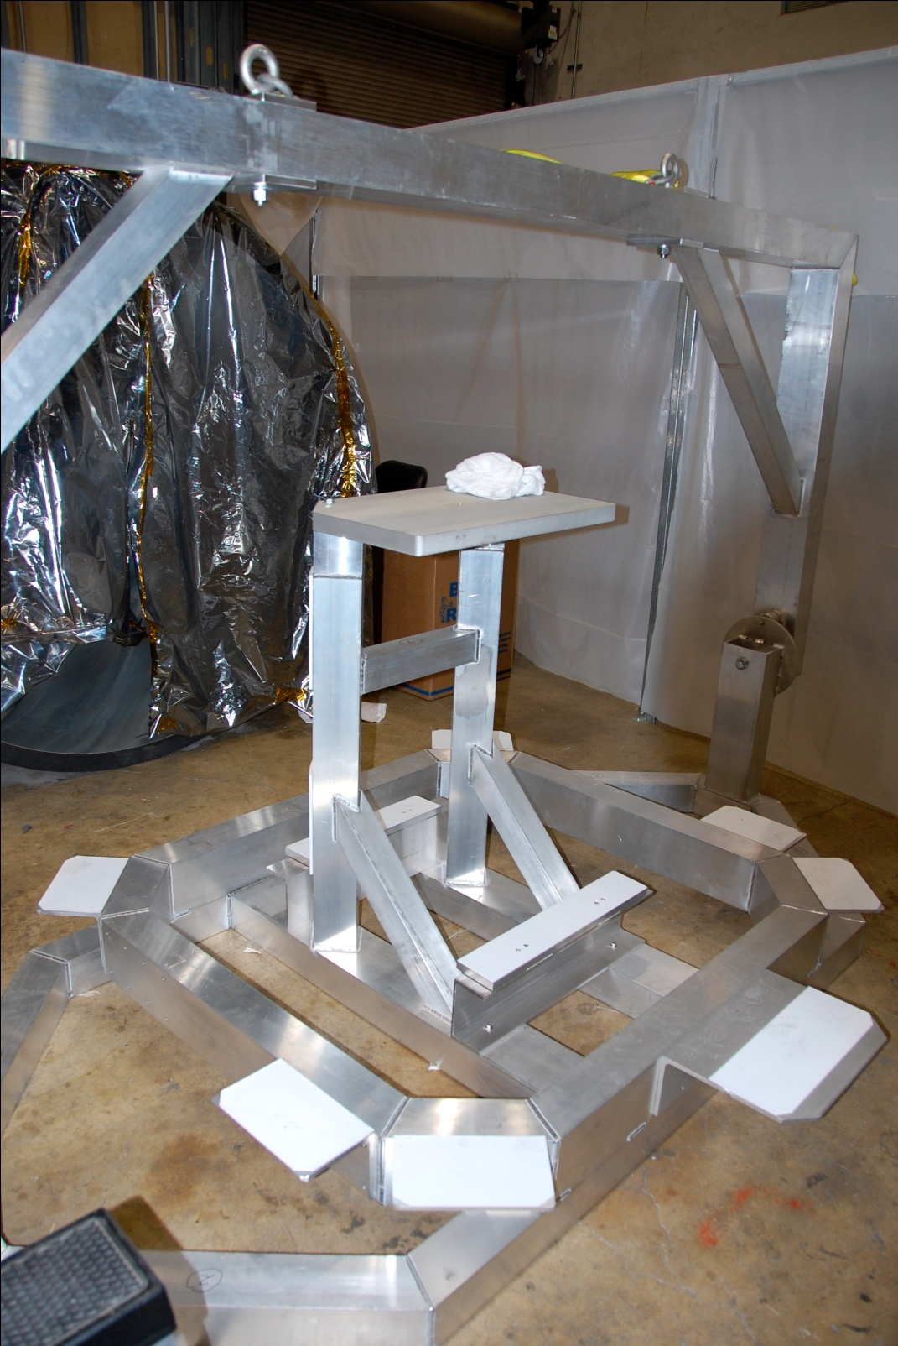
Figure 1: Manifold/Cryopump Baffle Lift/Assembly Fixture
- Before starting assembly, reamed out the 15 holes around the top of the Cylinder D1001348. Rework must be performed in clean environment with clean tools being careful to remove any particulates generated.
Figure 2: Cylinder
- In addition, reamed out the 5 holes around the top of each Weldment. Rework must be performed in clean environment with clean tools being careful to remove any particulates generated.
Figure 3: Weldment
- Place the center cylinder (D1001348) onto the Lift/Assembly Fixture, as shown in Figure 4. The angled baffle plate that is welded to the inside of the cylinder, which is at the bottom of the baffle, must be exactly opposite the lifting bars of the Lift/Assembly Fixture.

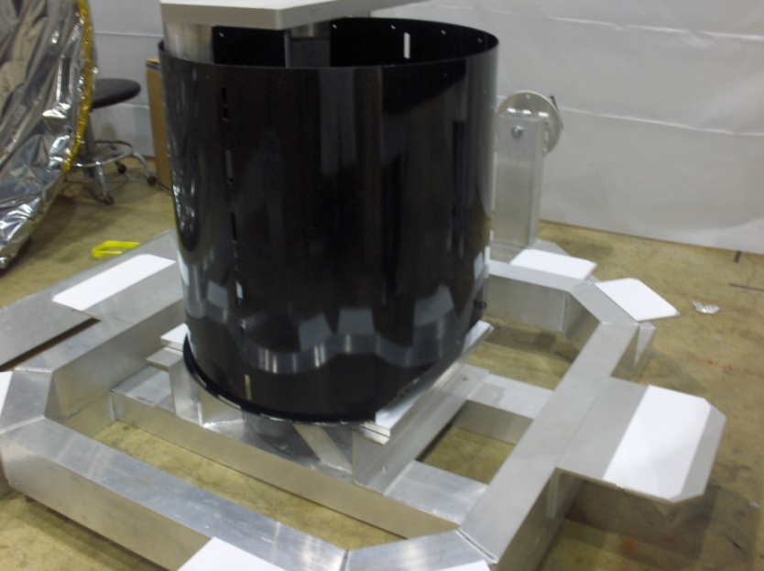
Lifting Bars
Angled Baffle Plate
Figure 4: Center Cylinder placed on Lift/Assembly Fixture

- Place Right Weldment (D0902654) on the Lift/Assembly Fixture around the center cylinder. Bolt loosely to the cylinder, 5 places.

C-1006-N SCREW, SOCKET HEAD CAP_10-32 x 3/8" L QTY = 5

N-1032-A HEX NUT, 10-32 THRD SIZE Ag-PLATED QTY = 5

WF-10 FLAT WASHER, #10 SCREW SIZE QTY = 10

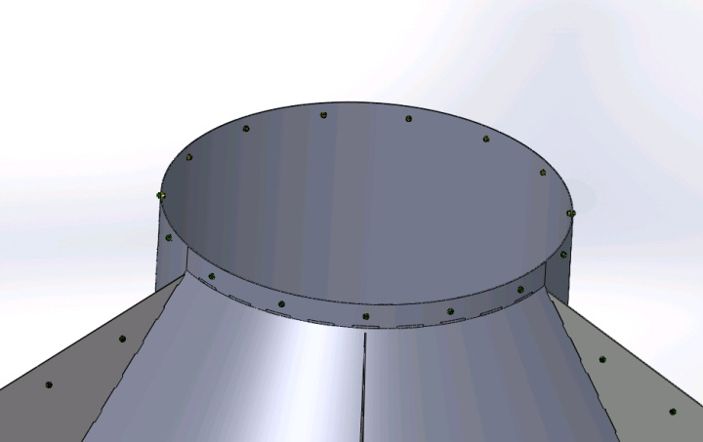
Figure 5: Attaching Weldment Subassembly to Center Cylinder

- Install threaded Male-to-Male Adapters to the baffle on the Right Weldment, 6 places, as shown in Figure 6.

95316A400 MALE-MALE THREADED ADAPTER 10-32 QTY = 6

N-1032-A HEX NUT, 10-32 THRD SIZE Ag-PLATED QTY = 6

WF-10 FLAT WASHER, #10 SCREW SIZE QTY = 6

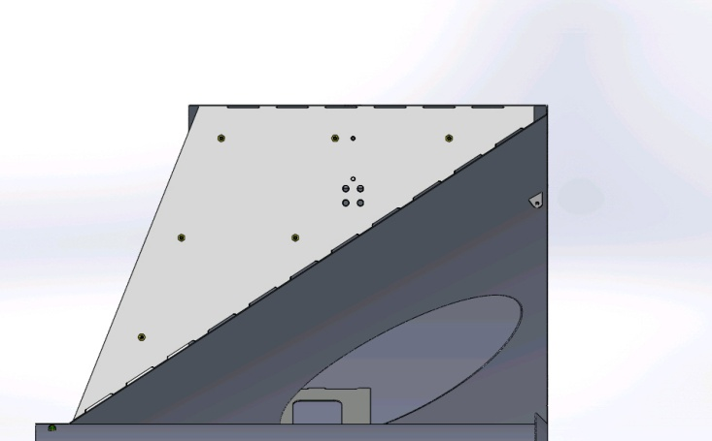
Figure 6: Right-Left Weldment attachment adapter placement

- Place the Left Weldment Subassembly (D0902656) on the Lift/Assembly Fixture around the center cylinder beside the Right Weldments so that the 6 threaded Male-to-Male Adapters on the Right Weldment are inserted into the holes.

- Bolt Left Weldment loosely to the cylinder, 5 places.

C-1006-N SCREW, SOCKET HEAD CAP_10-32 x 3/8" L QTY = 5

N-1032-A HEX NUT, 10-32 THRD SIZE Ag-PLATED QTY = 5

WF-10 FLAT WASHER, #10 SCREW SIZE QTY = 10

NOTE: DO NOT ATTACH RIGHT WELDMENT TO LEFT WELDMENT YET.

- Attach one L-brackets (D1000111) to Right Weldment and insert hardware, 4 places.

WF-10 FLAT WASHER, #10 SCREW SIZE QYT = 4

BU-1016-N BUTTON HEAD SOCKET CAP SCREW, #10-32 x 1" L QTY = 4
Figure 7: Right L-Bracket

- Insert Bracket Shim (D1300646) on to boss of the L-Bracket. Hold in place while attaching the other L-Bracket (D1000111) to Left weldment and attaching hardware, 4 places.

N-1032-A HEX NUT, 10-32 THRD SIZE Ag-PLATED QTY = 4

WF-10 FLAT WASHER,. #10 SCREW SIZE QTY = 4

Figure 8: L-Bracket Attachment Detail

- Loosely bolt the Left Weldment to the Right Weldment at the Male-to-Male Adapters, 6 places.

N-1032-A HEX NUT, 10-32 THRD SIZE Ag-PLATED QTY = 6

WF-10 FLAT WASHER, #10 SCREW SIZE QTY = 6

- Tighten hardware attaching L-Brackets to hold Bracket Shim in place.

- Install threaded Male-to-Male Adapters on open side panels of both the Right and Left Weldments, 7 places each.

95316A400 MALE-MALE THREADED ADAPTER 10-32 QTY = 14

N-1032-A HEX NUT, 10-32 THRD SIZE Ag-PLATED QTY = 14

WF-10 FLAT WASHER, #10 SCREW SIZE QTY = 14

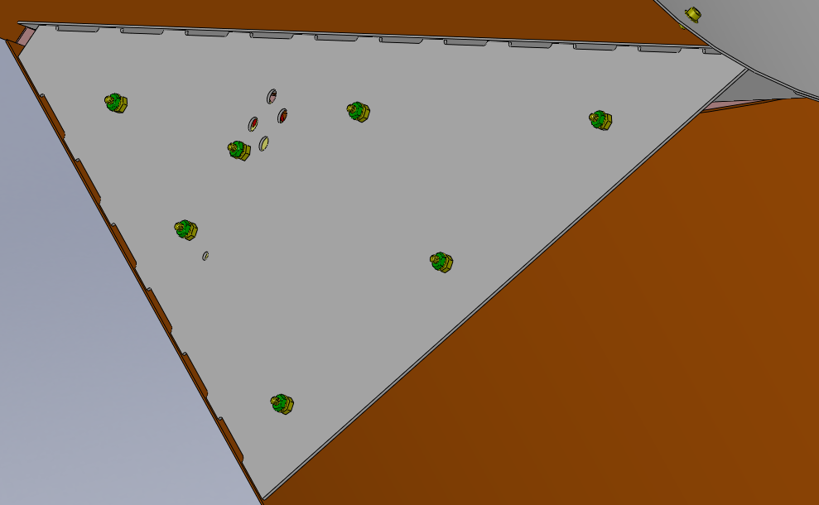
Figure 9: Installing Threaded Male-to-Male Adapters

- Place Bottom Weldment (D0902655) on the Lift/Assembly Fixture between Right and Left Weldments so that the 7 threaded Male-to-Male Adapters on the Right and Left Weldment are inserted into the holes.

- Bolt it loosely to the cylinder, 5 places.

C-1006-N SCREW, SOCKET HEAD CAP_10-32 x 3/8" L QTY = 5

N-1032-A HEX NUT, 10-32 THRD SIZE Ag-PLATED QTY = 5

WF-10 FLAT WASHER, #10 SCREW SIZE QTY = 10
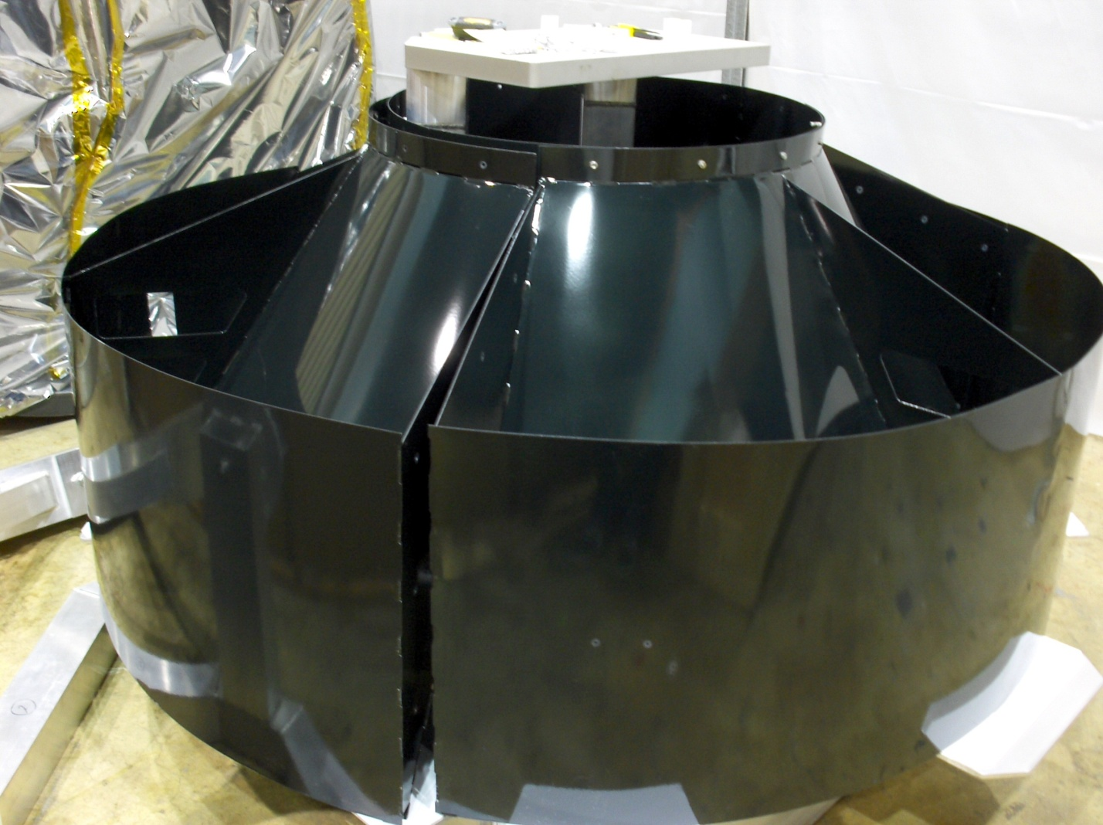
Figure 10: Adding Bottom Weldment
- Attach to Left Weldment so that the 7 threaded Male-to-Male Adapters on the Bottom Weldment are inserted into the holes. Bolt loosely to the Left Weldment, 7 places.

N-1032-A HEX NUT, 10-32 THRD SIZE Ag-PLATED QTY = 7

WF-10 FLAT WASHER,. #10 SCREW SIZE QTY = 7

- Attach to Right Weldment so that the 7 threaded Male-to-Male Adapters on the Bottom Weldment are inserted into the holes. Bolt loosely to the Right Weldment, 7 places.

N-1032-A HEX NUT, 10-32 THRD SIZE Ag-PLATED QTY = 7

WF-10 FLAT WASHER, #10 SCREW SIZE QTY = 7

- Tighten all hardware.
- Insert the bottom end of the Suspension Rod D1001970 through the clearance hole in the L-bracket in two places, as shown in Figure 11 and capture with one nut above and one nut below the L-bracket.

N-2520-A HEX NUT, 1/4-20 THRD SIZE Ag-PLATED QTY = 4

Figure 11: Insertion of Suspension Rod through L-bracket

- Attach Lower Magnet Plates D1100820, to the Weldment Bottom in two places, use washer and nut in place.

- Using the Magnet Placement Tool D1200635, place 4 pairs of magnets within the recesses in each steel magnet plate. Each pair of magnets must alternate polarity, and the succeeding pair must alternate polarity with the proceeding pair.

CAUTION! These magnets are extremely strong and may cause damage to fingers and hands if trapped beneath the magnet. The general insertion procedure is to first stick the magnet to the edge of the plate, and then slide the magnet until it pops into the recess in the plate. A weak “test” magnet is also useful for determining the relative polarity of the magnets before insertion—the actual polarity (N or S) does not matter, only that the polarity between adjacent magnets must alternate as described previously.

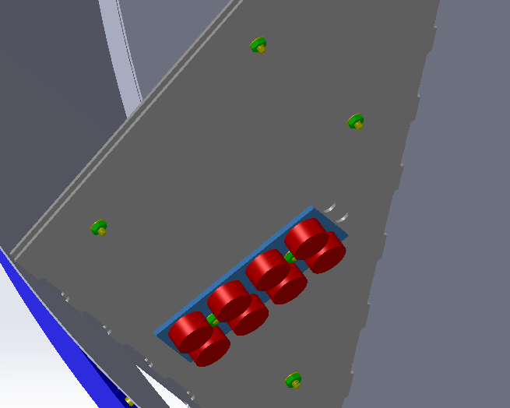
Figure 12: Lower Magnet Plate with Magnets

- Assemble 1 Long Turnbuckles. Measured length after assembly should be about 19.3”.

D1102459-01 Turnbuckle Body QTY = 1

D1102459-02 Turnbuckle Rod End QTY = 1

D1100865-01 Turnbuckle Long Rod QTY = 1

Figure 13: Turnbuckle Assembly

- Attach the long turnbuckle D1100865-01 to the brace bracket tabs that are welded to the Bottom Weldment baffle cone and inner cylinder.

C-1008-N SCREW, SOCKET HEAD CAP_10-32 x 1/2" L QTY = 2

N-1032-A HEX NUT, 10-32 THRD SIZE Ag-PLATED QTY = 2

WF-10 FLAT WASHER, #10 SCREW SIZE QTY = 4
Figure 14: Long Turnbuckle attachment

- Assemble 2 Short Turnbuckles. Measured length after assembly should be about 18.3”.

D1102459-01 Turnbuckle Body QTY = 2

D1102459-02 Turnbuckle Rod End QTY = 2

D1100865-02 Turnbuckle Long Rod QTY = 2

- Attach 2 short turnbuckles D1100865-02 to the brace bracket tabs that are welded to the Left and Right Weldment baffle cones and inner cylinder.

C-1008-N SCREW, SOCKET HEAD CAP_10-32 x 1/2" L QTY = 4

N-1032-A HEX NUT, 10-32 THRD SIZE Ag-PLATED QTY = 4

WF-10 FLAT WASHER, #10 SCREW SIZE QTY = 8

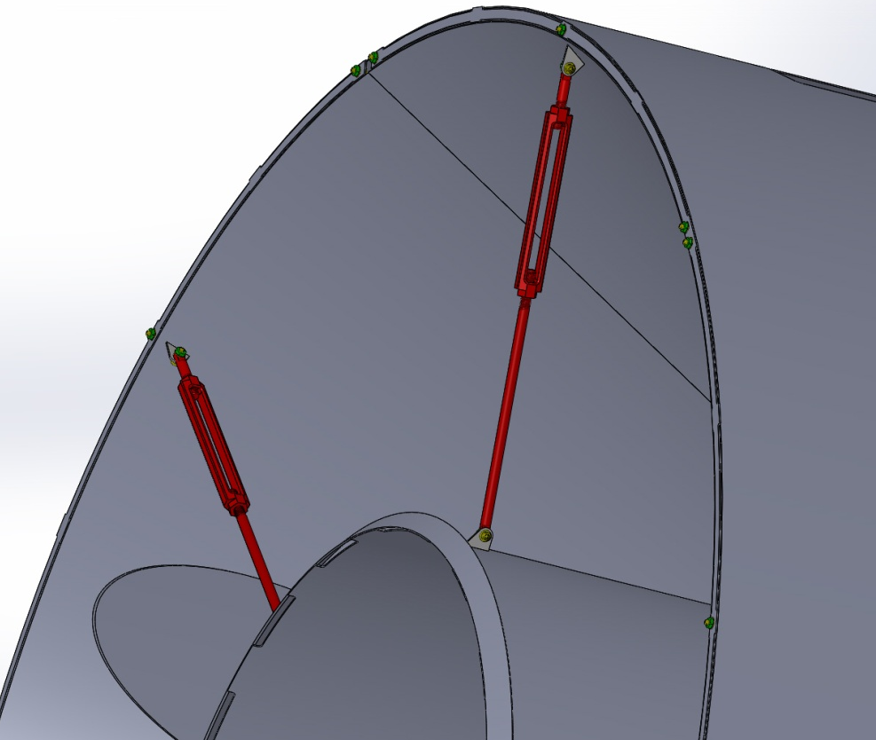
Figure 15: Short turnbuckle attachment

- Hand tighten the turnbuckles uniformly to provide tension against the inner cylinder on three sides, as needed.
Note: Do not overtighten the turnbuckle and distort the inner cylinder.

Preload the Suspension Springs
- Select Spring Blades (D0902817) from pre-determined pairs in LIGO-DOCUMENT-E1300420.

- Refer to Figure 16, place the Blade Spring Bracket D0902819 (item 4) on top of the wide end of the Blade Spring D0902817 (item 3).

- Attach the Blade Bend Fixture D1101297 (item 7) by means of 4 Titanium Threaded Studs (D1300622) with N-1024-NA nuts (item 8), sandwiching the Blade Spring Bracket between the Blade Spring and the Blade Bend Fixture. Threaded Studs should be snug but not torqued, to allow for perfect centering of the blade once bend is applied.
Figure 16: Blade Pre-load Fixturing

- Then, mount the Blade/Bracket/Bend Fixture assembly to the block on the vertical side of the Manifold Cryopump Baffle Alignment/Balance Fixture (D1002675) with four (D1300645), #1/2-13 FHCS modified screws (item 5), refer to Figure 17.

Figure 17: Baffle Alignment/Balance Fixture

- Hang weights using the Bending Hook Assembly (D1101298), as shown in Figure 18, until the blade tip barely touches the bending fixture. Record weight required to bend the spring and the S/N of the spring. The design load for each spring is about 160 lbs.

Blade Serial Number: _____________________ Bend Weight: __________________________

Blade Serial Number: _____________________ Bend Weight: __________________________

WARNING: The weights could fall off the support plate and cause damage to personnel; do not place feet or other body parts underneath the weights. If the Spring Blade were to lose tension suddenly, due to breakage of the tensioning fixture, it could create a projectile hazard.

NOTE: Safety-toed shoes and safety glasses must be worn during this procedure.

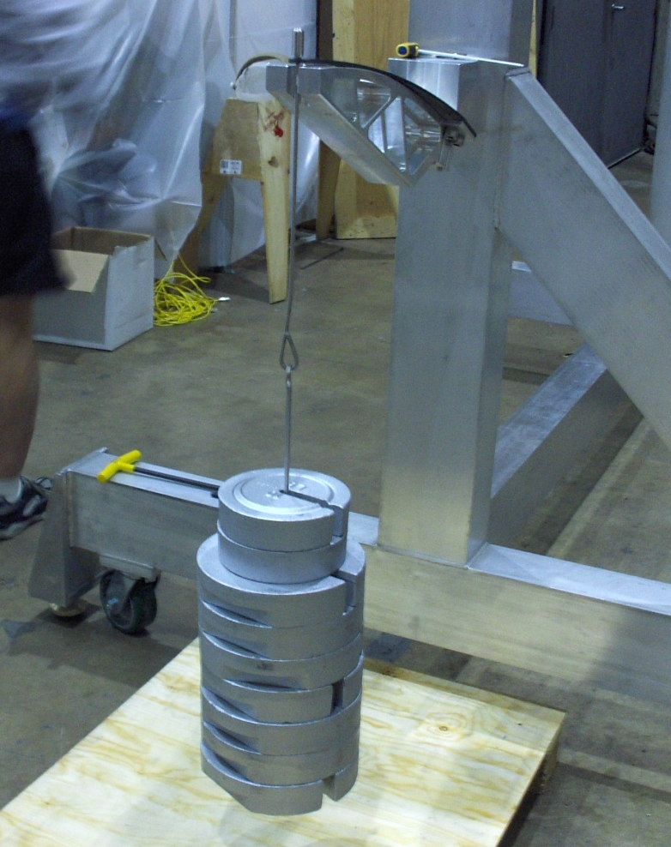
Figure 18: Pre Load Spring Blade by Hanging Weights

- Verify that the spring tip is centered about the slot in the bend fixture. If some bias is observed, very slightly loosen the #10-24 bolts at the base of the spring and push the fixture in the proper direction. Immediately retighten the bolts and check the alignment. If it is good, torque the bolts to 23 in-lbs.
- After the spring is bent to match the curvature of the Bend Fixture, secure the tip of the blade spring to the Bend Fixture by attaching the Bend Fixture Shim (D1101341) with two Titanium Threaded Studs (D1300622) and N-1024-NA nuts placed through the clearance holes of the Bend Fixture, as shown in Figure 19. Torque these two 10-24 bolts to 23 in-lbs.
- Remove the balance weights and the hook.
- Repeat the process with the 2nd Spring Blade.

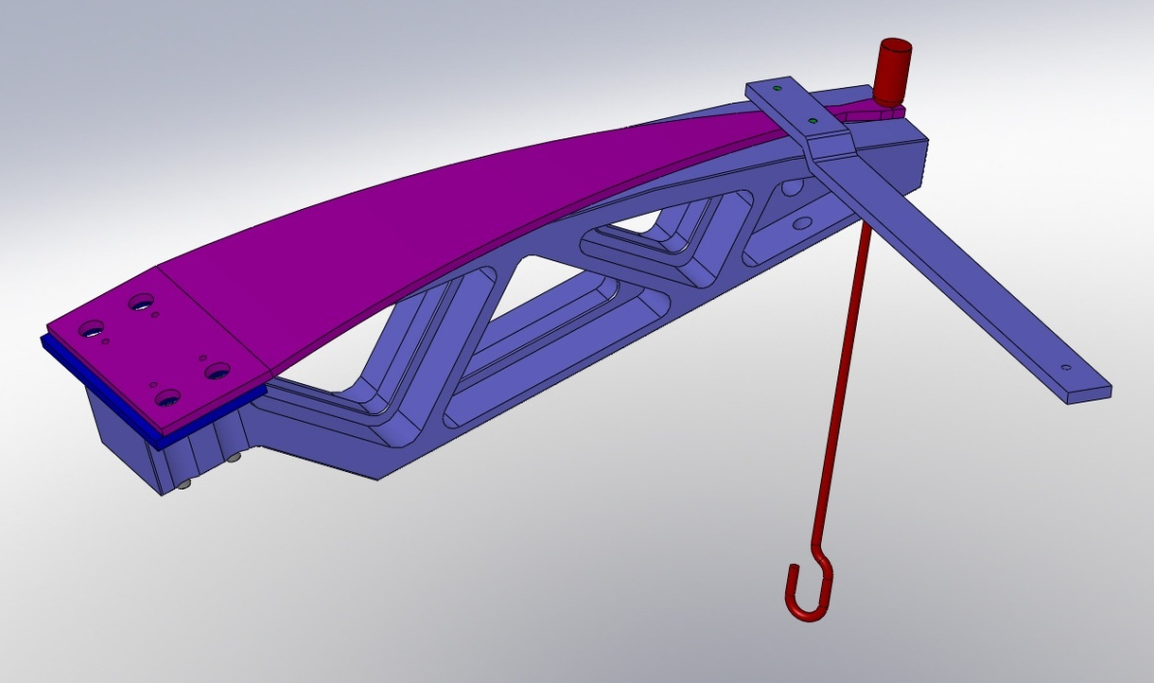
Bend Fixture Shim
Figure 19: Preloaded Spring Blade Restrained with the Bend Fixture Shim

Attach Top Suspension Ring to Baffle Alignment/Balance Fixture

- Attach a Class B Top Suspension Ring of the Outer Ring Assembly to the Alignment/Balance Fixture.
- Attach a Plumb Bob with an eye-bolt from the 10-24 tapped hole at the center of the Top Ring to hang down toward a mark at the center of the lower cross member of the Balance Fixture.
- Clock the Top Ring within its attachment clearance holes so that the plumb bob points to the center of the bottom cross member.
- Once Top Ring is well aligned, tighten attaching hardware.

Mount the Suspension Blade Spring to the Top Suspension Ring D0902815
- Mount the wide end of the Blade, with the Bend Fixture Assembly and the Bend Fixture Shim attached, to the Top Suspension Ring (D0902815) using four D1300645 1/2-13 FHCS modified screws. Move the Blade assembly within the clearance holes of the Suspension Ring mounting so that the tip of the Blade is centered within the width of the Top Suspension Ring before securely tightening the #1/2-13 mounting bolts.

- Repeat this step to install both blades. These procedures apply to the balance fixture assembly as well as to the assembly into the actual manifold tube.
- Torque all 8 FHCS to 43 ft.-lbs.

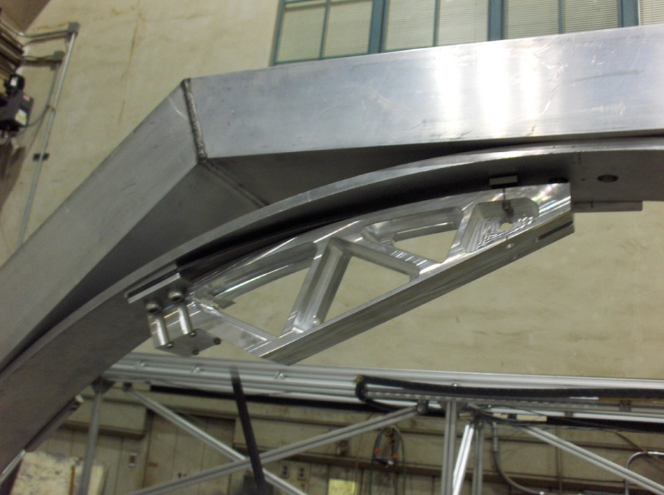
Figure 20: Top Suspension Ring Mounted to Alignment/Balance Fixture

NOTE: DO NOT REMOVE THE BEND FIXTURE SHIM.

- Verify that the blade tips are perfectly in line with each other. Adjust at FHCS screws if needed.

Figure 21: Blade alignment

- Remove the two titanium studs with nuts that attach the Bend Fixture Shim to both Bend Fixtures, and remove the four titanium studs with nuts that attach the Bend Fixtures to the Blades. As these screws are loosed, the Blade will spring up toward the Top Suspension Ring, and the Bend Fixture Shim will be captured between the Blade and the Ring.
- Scribe a line on the Top Ring showing where the Bend fixture Shims are located. This is to allow accurate placement when blades are removed from the Balancing Fixture.
- Remove the Bend Fixture and save it for future use when the Baffle is removed from the Balancing Fixture.

Attach Lift Fixture Stop Bracket
A NOTE: Special Equipment and Personnel are needed for the following procedures.
1 crane operator
2 tag line holders
1 spotter
1 assembly technicians

- Attach Manifold Cryopump Baffle Lift Fixture Stop Brackets (D1101776) to both lifting arms so that the baffle does not slide on the teflon support pads.
Figure 22: Install Stop Brackets

- Attach the Lift/assembly Fixture D1101192 to an overhead lifting crane by means of lifting straps. Attach 2 tag lines, one to each of the lifting hooks in the Lift/assembly Fixture. While the tag line holders are guiding the lifting fixture, lift the baffle high enough above the floor to enable the baffle assembly to rotation by 90 degrees.

- The spotter and the assembly technician will remove the pins on the handle hinges and spin the whole baffle by 90 degrees until the Baffle cylinder axis is horizontal and is in the correct orientation for insertion into the Balancing Fixture, as shown in Figure 23.
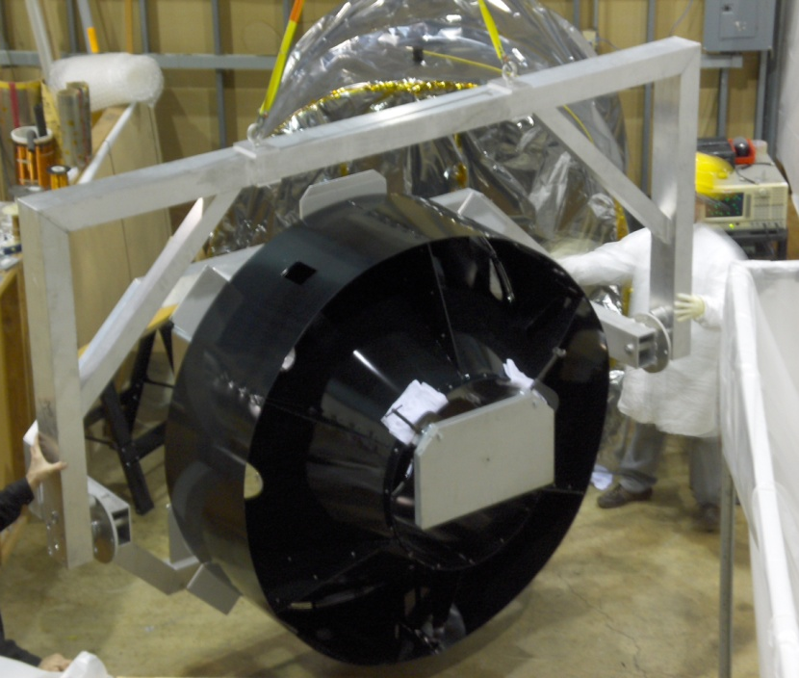
Figure 23: Lift/Assembly with Baffle Supported by Crane

Insertion of Baffle into Alignment/Balancing Fixture

NOTE: Special Equipment and Personnel needed for the following procedures.
1 crane operator
2 tag line holders
1 spotter
3 assembly technician

- While the tag line holders are guiding the lifting fixture, use the overhead crane to transport the Manifold Cryopump Baffle, supported by the lifting fixture, underneath the Baffle Alignment/Balance Fixture.
- The spotter and the assembly technician will maneuver the Baffle until the clearance holes for the suspension rods in the baffle outer cylinder align with the holes in the tips of the blade springs.
- Set the height of the Manifold Cryopump Baffle, by using the crane, so that the Suspension Rod threads protrudes through the Spring Blades.
- Insert the upper threaded shank of each Suspension Rod through the hole in the tip of the blade and fasten with an Ag-Plated ¼-20 nut and washer, as shown in Figure 24. A hemostat, McMaster Carr P/N 5383A24 or 5383A26 can be used to reach in and hold the nuts above the Blade Spring while the Suspension Rod is threaded through the nut. Securely tighten the nut above the Blade Spring with the Long-Thin 7/16” Wrench by using a pair of pliers to hold the suspension rod below the spring.
!! WARNING - Take great care not to impart any torsion to the suspension rod.
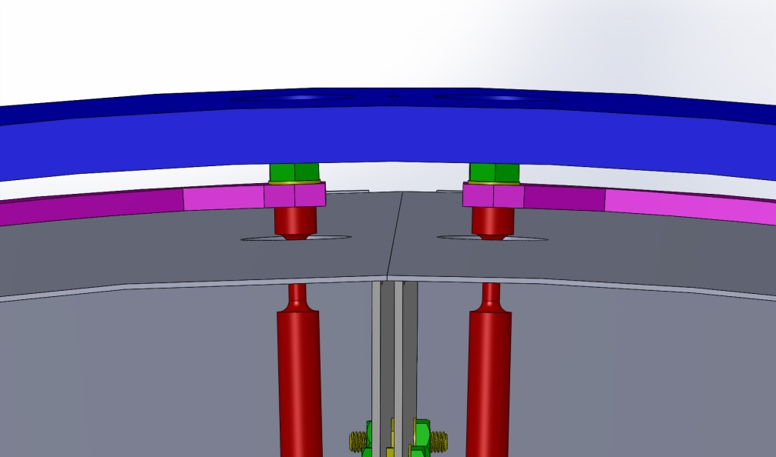
Figure 24: Suspension Rods and Spring Blade attachment
- While the tag line holders are guiding the lifting fixture and the spotter and the assembly technician are maneuvering the Baffle, use the crane to lower the Lift/Assembly Fixture and pull it away from the Balancing Fixture, so that the Baffle is freely suspended within the Balancing Fixture.

Installing Face Plates

- Attach the Upper Face Plates--Left (D1101503-1/-2) and Lower Face Plate (D1101501) to the Weldments using three Half Face Brackets (D1002641) on the inner edges. The outer edges are attached at 6 places per each Face Plate. Super 8 side faces out away from baffle.

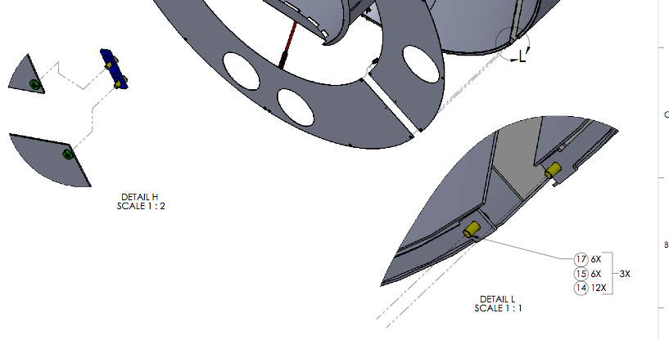
Figure 25: Attach Face Plates to Outer Cylinder

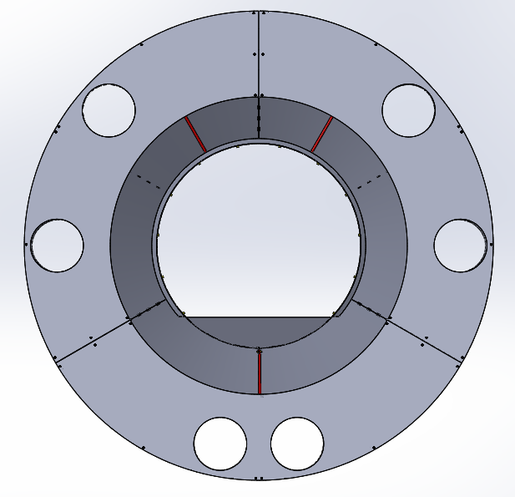
Upper Side Face Plate, Right
Upper Side Face Plate, Left
Lower Face Plate
Figure 26: Three Face Plates Attached

Balancing the Baffle Assembly in the Balancing Fixture

Height Adjustment
- Loosen the nuts on the top side of the L-Brackets. Place the D1300658 Manifold Cryopump Alignment Tool on top of the baffle between the Spring Blade tips. Adjust the height of the baffle by turning the nuts on the bottom side of the L-Brackets until the Alignment Tool is even with the Top Ring. When correct height is reached (0.75”), tighten the top nuts.
Figure 27: Height Adjustment bolts

Vertical Balance
- Assemble Balance Weights on baffle using Balance Weight Assembly Drawing D1002402. Variable Balance Weights (D1002417) are determined by LIGO-DOCUMENT-E1300420. Attach weights to the top of the bottom cylinder with the engraved arrow pointing away from the Face Plates (Figure 28) until the spring blades pull away from the support ring just enough so that the Bend Fixture Shims D1101341 can be removed. This should create a gap of approximately 0.263in between the top side of the blade and the inside of the support ring.
- Remove the Bend Fixture Shims.

WARNING: If the suspended Baffle were to become detached from the support rods, fingers could be crushed between the Blade and the top support ring.

- The Baffle is now balanced vertically within the Balancing Fixture.

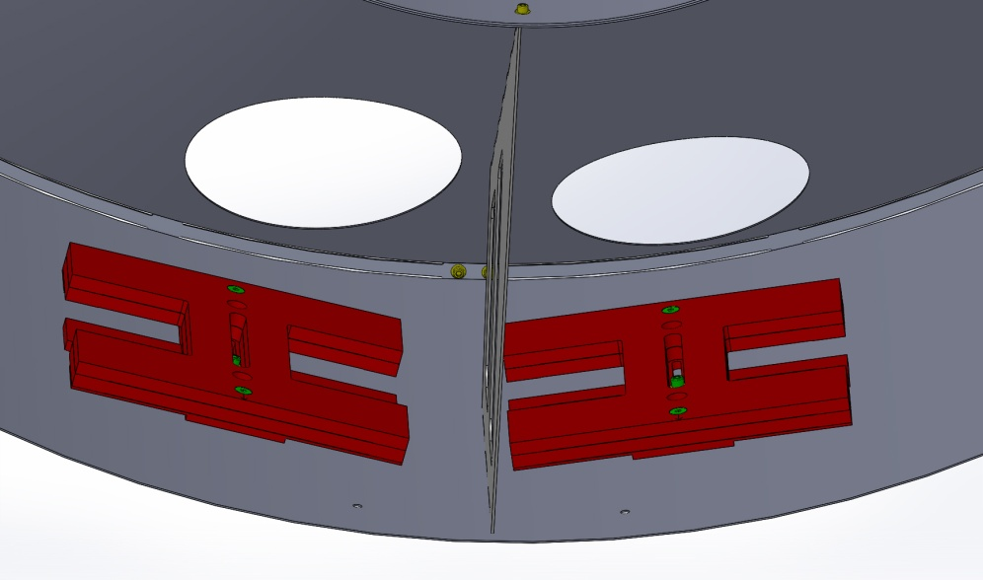
Figure 28: Balance Weights
Note: the Spring Blade bend weights were pre-measured along with the actual suspended baffle plus balance weights. Matched pairs of blades should be used whenever possible, see E1300420.

Axial Balance
- Carefully place a Level inside the Cylinder in the same direction as the beam travels. Shift the Balancing Weights axially to adjust the tilt of the baffle.

Lateral Balance
- Insert the D1300658 Manifold Cryopump Alignment Tool between the left side of the baffle and the Outer Ring. Shift the Balancing Weights laterally to adjust the roll of the baffle. Repeat on the right side of the baffle.

- Continue until the gap between the baffle outer cylinder and the suspension ring is approximately equal on the left and right sides as measured using the D1300658 Alignment Tool.
!! Warning - Take great care not to scratch the baffle surfaces while moving the masses.
- Tighten all bolts, and Torque to 32 in-lbs.
Note: the Eddy Current Damping Cu plates are not assembled at this stage.

Removing the Baffle from the Balancing Fixture

NOTE: Special Equipment and Personnel needed for the following procedures.
1 crane operator
2 tag line holders
1 spotter
3 assembly technician

- Re-insert the Bend Fixture Shims (D1101341) between the Blades and the Top Suspension Ring at the scribe marks.
- While the tag line holders are guiding it, use the lifting crane to insert the Lift/Assembly Fixture (D1101192) inside the inner cylinder of the Baffle assembly.
- Back away the ¼-20 nuts on the top side of the L-Brackets only. This will reduce the risk of bending the Suspension Rod when the baffle is lifted.
- The spotter and the assembly technician will maneuver the Baffle while the lifting fixture is being raised with the crane so that the weight of the Baffle box is supported by the Lift/Assembly Fixture and not by the suspension rods, and the Baffle weight is released from the Blades. The Blades will rise upwards toward the top support ring and capture the Bend Fixture Shims between the Blade and the support ring.

WARNING: If the suspended Baffle were to become detached from the support rods, fingers could be crushed between the Blade and the top support ring.

- The baffle will rise off of the L-Brackets.
- Remove the nuts that fasten the top ends of the Suspension Rods to the Blades.
- Do not loosen or remove the nuts on the bottom of the L-Bracket.
- Do not remove the nuts on the suspension rods on the L-bracket.

- The spotter and the assembly technician will maneuver the Baffle while the lifting fixture is being lowered with the crane so that the weight of the Baffle box is supported by the Lift/Assembly Fixture and removed from the Balance Fixture.
- While the tag line holders are guiding the lifting fixture and the spotter and the assembly technician are maneuvering the Baffle, use the crane to pull the Lift/Assembly Fixture with the supported Baffle box away from the Balancing Fixture.

Remove Blades and Support Ring
- Re-attach the Bend fixture to the bent Blade at the wide end and to the Bend Fixture Shim at the tip with the Titanium Threaded Studs & nuts, as was shown in Figure 20.
- Then, remove the Blade, Bend Fixture, and Bend Fixture Shim assembly from the top support ring by removing the four D1300645 ½-13 bolts. Do this for both Blades, and set them aside for subsequent installation into the manifold tube.

Manifold Cryopump Baffle Installation
Class A Hardware Needed:
Qty: 8 - WF-10 FLAT WASHER,. #10 SCREW SIZE
Qty: 4 - N-2520-A HEX NUT, 1/4-20 THRD SIZE Ag-PLATED
Qty: 10 - WF-25 FLAT WASHER 1/4" Sz, .47" OD, .02"-.04" Thk, Dash No. C416
Qty: 8 - V1156 2-116 VITON O-RING
Qty: 4 - C-2008-N SOCKET HEAD CAP SCREW, SHC, 1/4-20 x 1/2" L

Class B Hardware Needed:
Qty: 4 - 92196A254 10-24 x 2-1/4” SHCS
Qty: 4 - 92200A246 10-24 x 7/8” SHCS

Class B Tools Needed:
1/8” Hex Key
5/32” Hex Key
¼” Combination Wrench
3/8” Combination Wrench
2 x 7/16” Combination Wrench
Long-Thin 7/16” Wrench
Pliers

Support Ring D1002084 Installation at End Station

- Remove the A-1 Viewport Adapter D961140 from the D961144 A-7 Adapter, as shown in Figure 29.
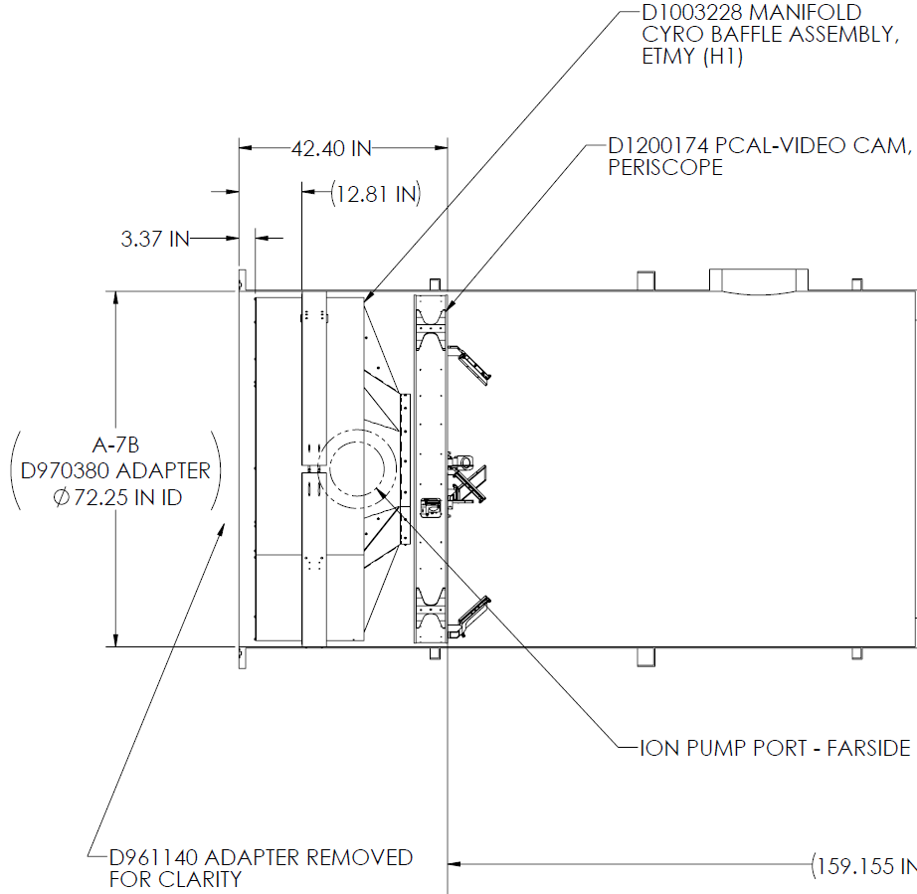

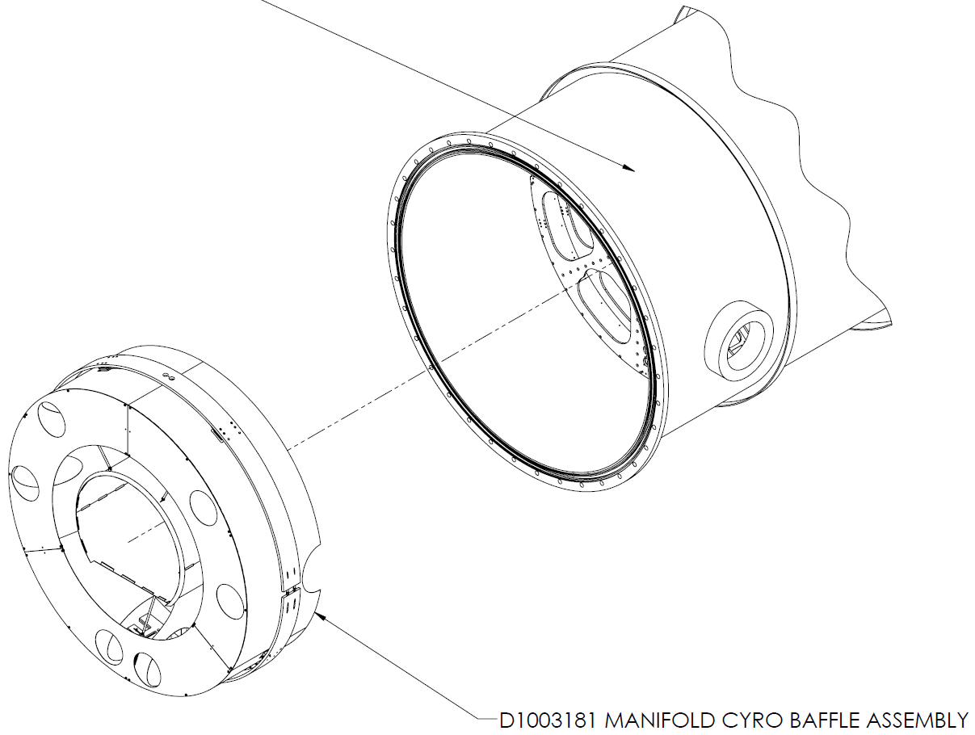
Figure 29: Adapter Removed from Manifold Tube for Baffle Insertion

Note: The PCal-Video Cam Periscope assembly will have been temporarily positioned upright inside the Adapter tube to allow access of personnel entering from the BSC chamber to walk to the opening of the Adapter tube and assist in the installation of the Baffle from inside the adapter tube.

- Attach Flange Protectors D1300496 and Baffle Alignment Tooling D1300609 to spool flange.
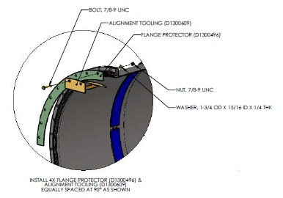
Figure 30: Support Ring installation

- Pre-assemble the Top and Bottom Support Rings D1002084 and place the support ring assembly inside the manifold tube at a distance 12.81 inches beyond the outer surface of the flange, as shown in Figure 30: Support Ring installation.
Note: the beveled side of the support ring must face toward the ETM in the BSC.

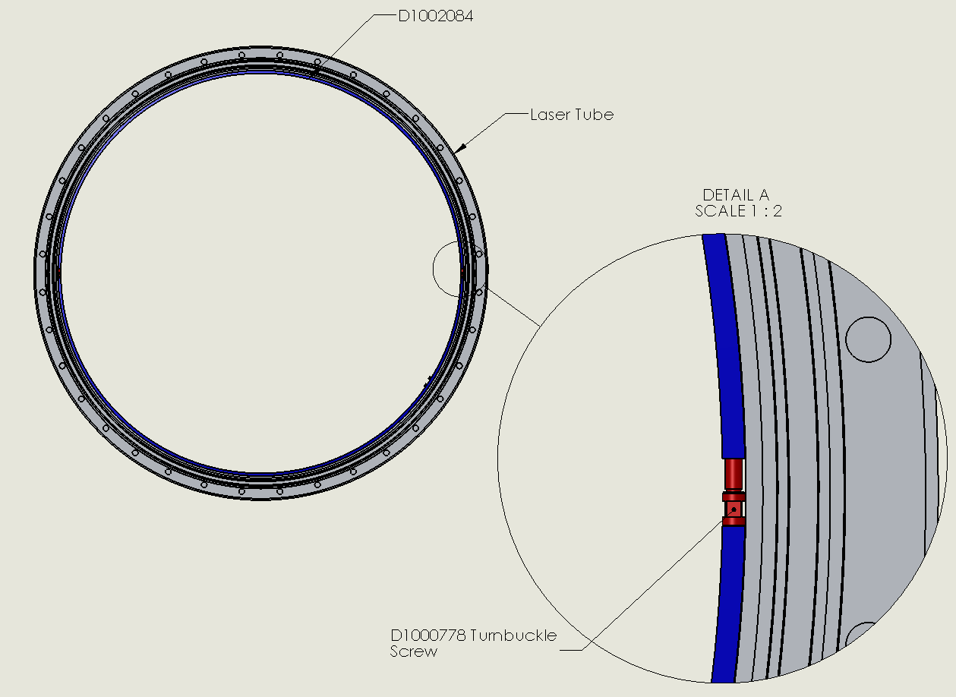
Figure 31: Support Ring Installed in A-7 Adapter

- Suspend a Plumb Bob at the center of the Top Ring to hang down to just above the 0.25 in clearance hole at the center of the Bottom Ring.
- Clock the ring assembly so that the plumb bob points to the center of the hole.
- Secure the support ring assembly against the inside of the manifold tube by tightening the turnbuckle screws D1000778.
- Remove the Plumb Bob from the Vacuum Manifold

Blade Spring Installation
- Mount the wide end of the Blade, with the Bend Fixture Assembly and the Bend Fixture Shim attached, to the Top Suspension Ring (D0902815) using four D1300645 1/2-13 FHCS screws. Move the Blade assembly within the clearance holes of the Suspension Ring mounting so that the tip of the Blade is centered within the width of the Top Suspension Ring before securely tightening the #1/2-13 mounting bolts.
- Repeat this step to install both blades. These procedures apply to the balance fixture assembly as well as to the assembly into the actual manifold tube.
- Torque all 8 FHCS to 43 ft.-lbs.
NOTE: DO NOT REMOVE THE BEND FIXTURE SHIM.

- Verify that the blade tips are perfectly in line with each other. Adjust at FHCS screws if needed.

Figure 32: Blade alignment in chamber
- Remove the two titanium studs with nuts that attach the Bend Fixture Shim to both Bend Fixtures, and remove the four titanium studs with nuts that attach the Bend Fixtures to the Blades. As these screws are loosed, the Blade will spring up toward the Top Suspension Ring, and the Bend Fixture Shim will be captured between the Blade and the Ring.
- Remove the Bend Fixture Assembly, but do not remove the captured Bend Fixture Shims D1101341, as shown in Figure 33.
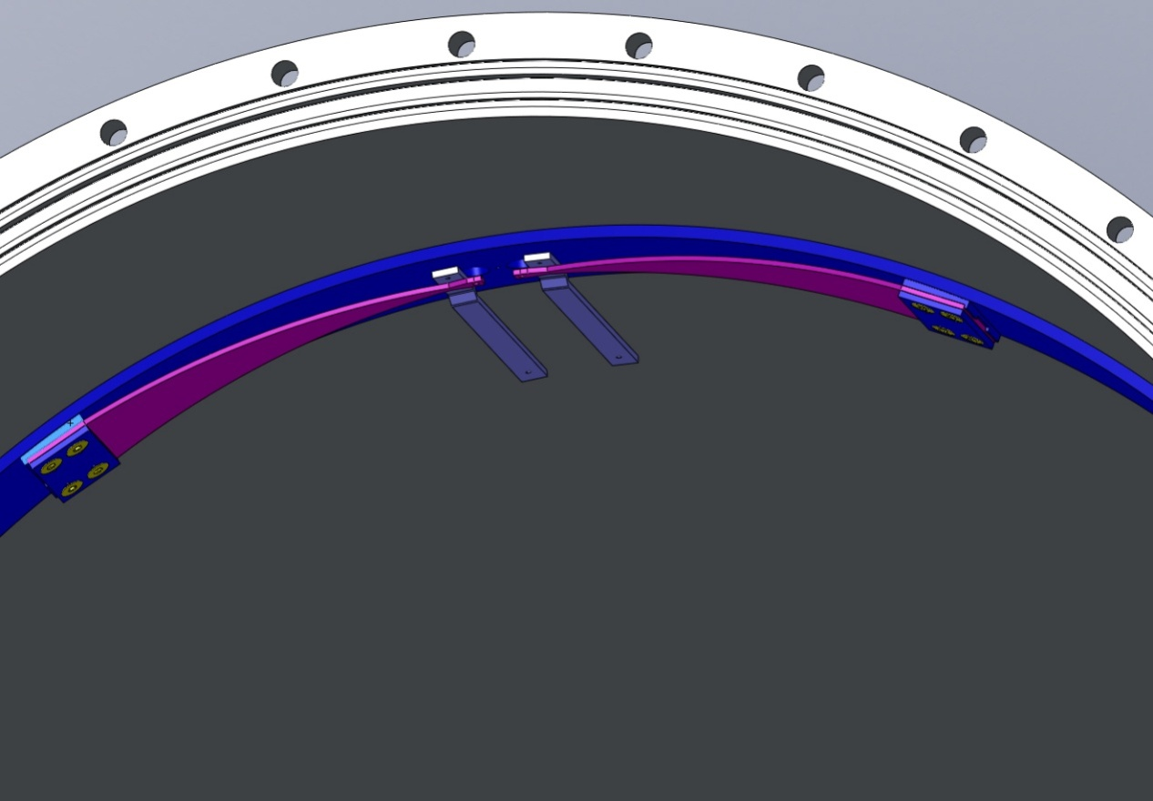
Figure 33: Pre-tensioned Blades Mounted to Ring in spool with Shims.

Manifold Cryopump Baffle Installation
NOTE: Special Equipment and Personnel needed for the following procedures.
1 crane operator
2 tag line holders
1 spotter
1 assembly technician

WARNING! During this installation procedure, care must be taken to not damage the vacuum
system flanges or the plumbing in the vicinity of the gate valves.
- While the tag line holders are guiding it, use the lifting crane to transport the Manifold Cryopump Baffle, supported by the lifting fixture, between the open spool and the Gate Valve as shown in Figure 34.
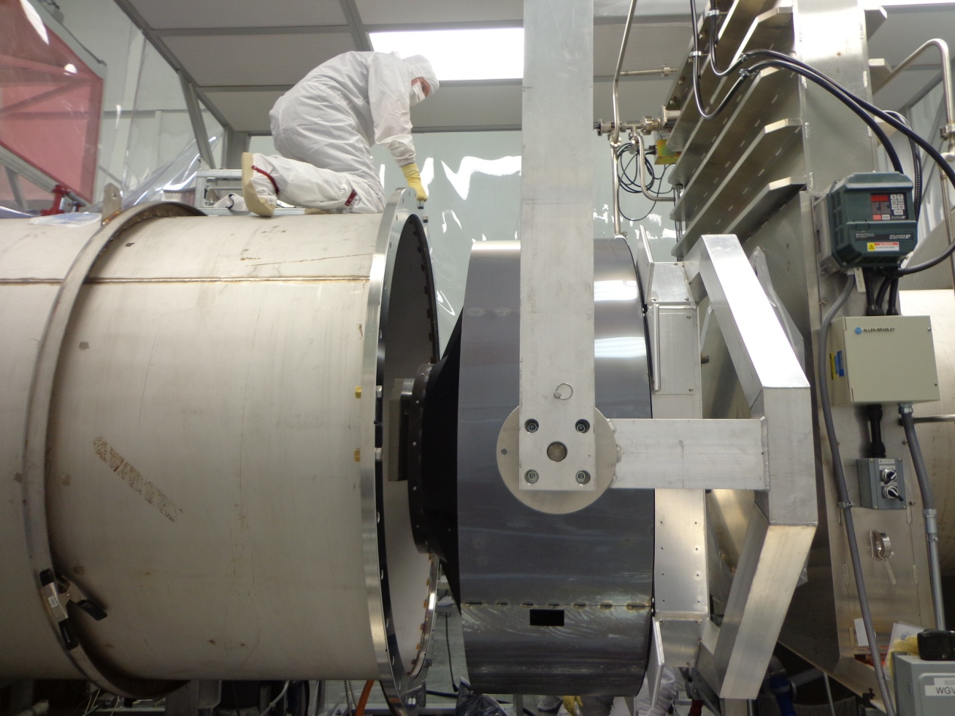
Figure 34: Baffle between spool and gate valve
- While the tag line holders are guiding it, use the lifting crane to transport the Manifold Cryopump Baffle, supported by the lifting fixture, through the opening of the Adapter as was shown in Figure 35.

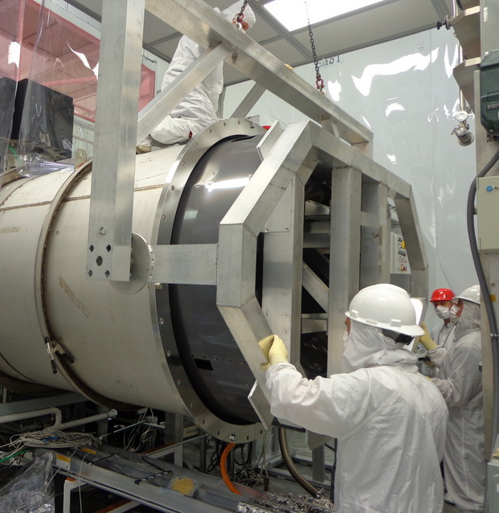
Figure 35: Baffle insertion into Adapter

- The spotter and the assembly technician will maneuver the Baffle so that the clearance holes in the baffle outer cylinder for the suspension rods align with the holes in the tips of the blade springs.
- Insert the suspension rods through the clearance holes in the Baffle and secure them firmly to the tips of the blade springs. This is very tricky; the nuts must be inserted with the use on a hemostat McMaster Carr P/N 5383A24 and 5383A26.

N-2520-A HEX NUT, 1/4-20 THRD SIZE Ag-PLATED QTY = 2

WF-25 FLAT WASHER 1/4 SCREW SIZE QTY = 2

- The height of the Baffle with the crane should be approximately 0.75” from the top and bottom support rings, if the lower nuts on the L-Brackets were not disturbed. Tighten the upper nuts on the L-Brackets.

- While the tag line holders are guiding the lifting fixture and the spotter and the assembly technician are maneuvering the Baffle, lower the lifting fixture with the crane until the Baffle is supported by the spring blades. At this point, the Baffle should be balanced vertically with the Spring Blades equally spaced within the gap between the top support ring and the Baffle outer cylinder, and the Bend Fixture Shims should be free.
- Use the crane to pull the Lift/Assembly away from the opening of the manifold tube and park it out of the way.
WARNING! Care must be taken to not damage the vacuum system flanges or the plumbing in the vicinity of the gate valves.
- Remove the Bend Fixture Shims.
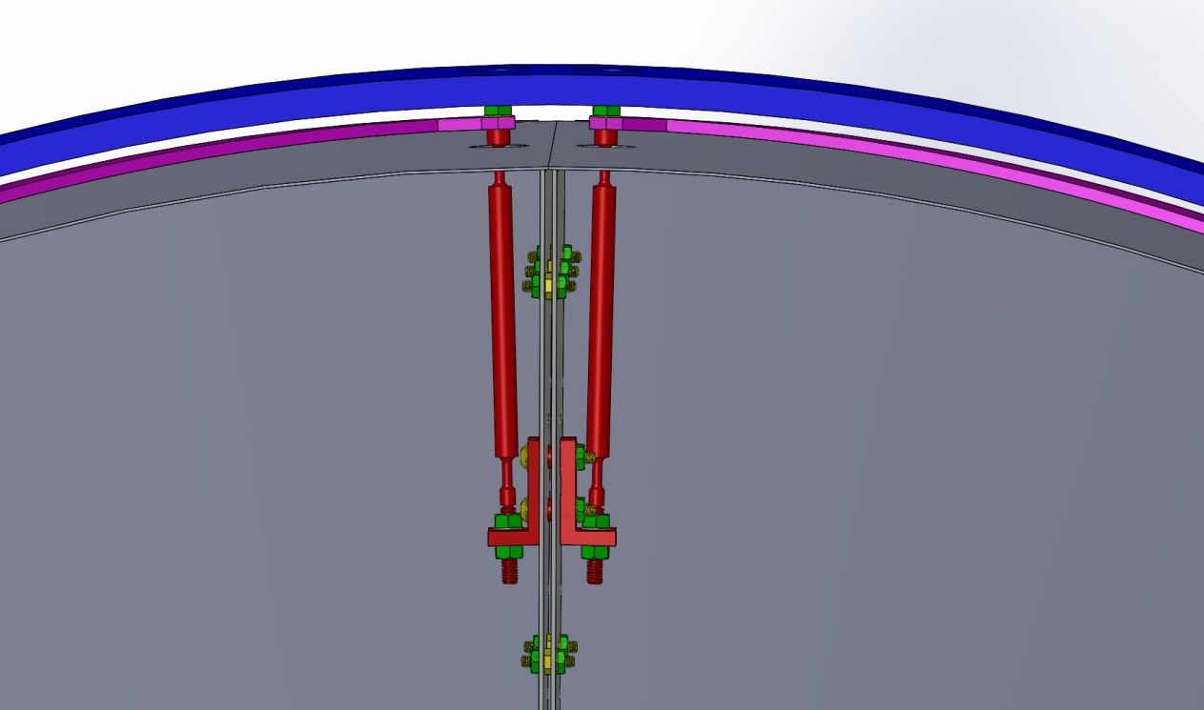
Figure 36: Installed Baffle Suspended by Spring Blades

Verify Height and Balance

- Place the D1300658 Manifold Cryopump Alignment Tool on top of the baffle between the Spring Blade tips. Verify spacing is 0.75”. If necessary, repeat steps in Section 4.1.
- Place the D1300658 Manifold Cryopump Alignment Tool on each side of the baffle. Verify spacing is approximately 0.75” equal gaps, left and right, between the outer cylinder and the support ring. If necessary, repeat steps in Section 4.4.
- Carefully place a Level inside the Cylinder in the same direction as the beam travels. Verify axially alignment. If necessary, repeat steps in Section 4.3.

Attaching Eddy Current Damping Copper Plate
The eddy-current damping mechanism consists of a copper plate mounted to the outer support ring and magnets on a steel plate mounted to the support ribs of the suspended baffle.

- Insert o-rings into the grooves of the Manifold Cryopump Baffle Lower Copper Plate D1100821, 4 places each.
- Insert the Manifold Cryopump Baffle Lower Copper Shim D1100822 and Manifold Cryopump Baffle Lower Copper Plate D1100821 through the rectangular opening in the bottom portion of the baffle outer cylinder and attach them to the bottom support ring, as shown in Figure 37 and Figure 38.

C-2008-N SHCS, 1/4 - 20 X ½” LONG QTY = 4

FA-2010-N FHCS, 1/4 - 20 X 5/8” LONG QTY = 8

WF-25 FLAT WASHER 1/4 SCREW SIZE QTY = 4

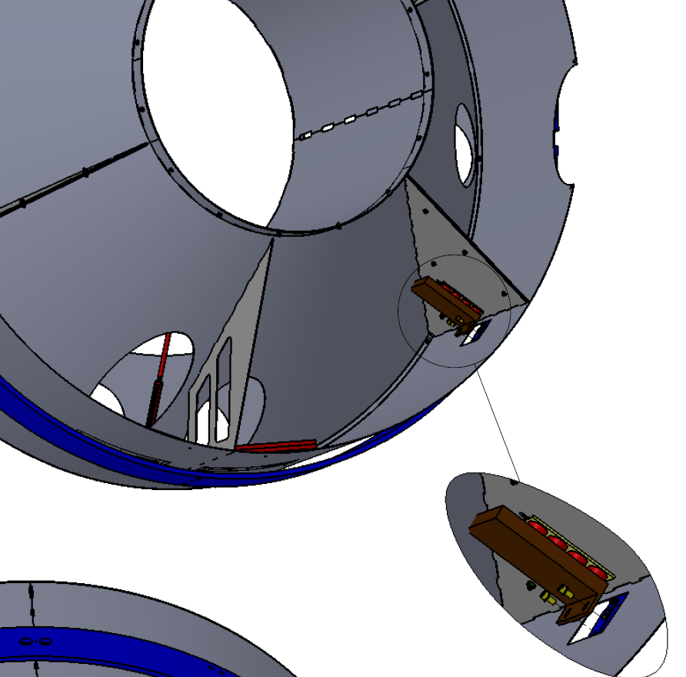
Figure 37: Attaching Eddy Current Damping Plate to the Support Ring

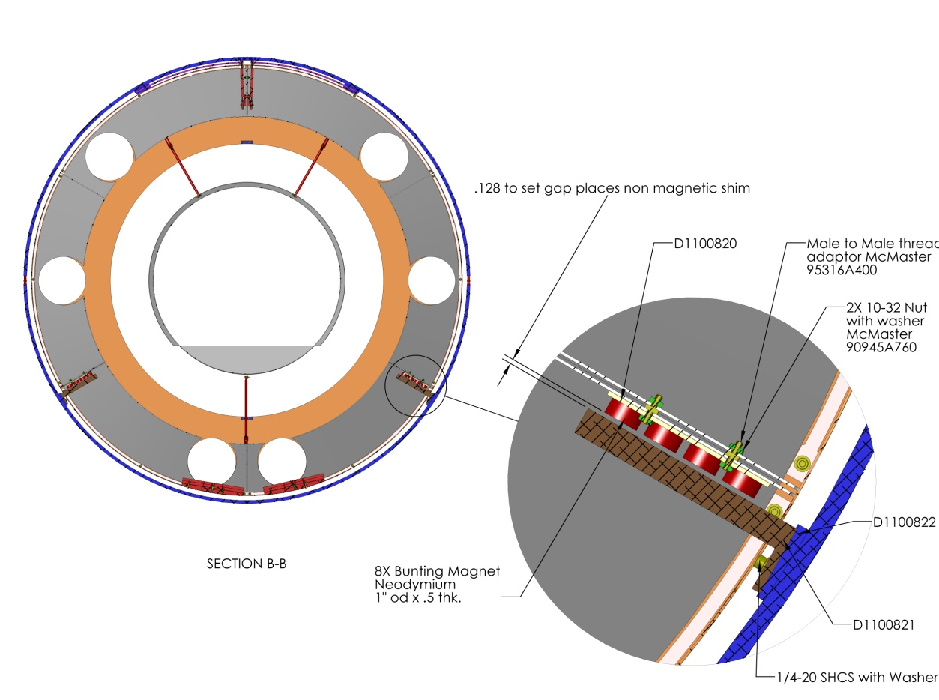
Figure 38: Setting the Damping Plate Gap

- Place the D1300616 Gap Gauge between the Copper Plate and the face of the magnets. Slide Copper Plate D1100821 toward the magnets to set a 0.128in gap between the Copper Plate and the face of the magnets. Then, secure the mounting bolts to the support ring, as shown in Figure 38.

Final Acceptance Test Documentation
- Perform impulse-test and a ring-down to confirm that the quality factor of the suspended Baffle meets the damping requirements. If necessary, appropriate motion transfer functions will be measured.
- Complete applicable sections of the Acceptance Results Document located at E1300423.
- This completes assembly and install of the Manifold Cryopump Baffle.

