**Q3000 Four Quadrant Photodiode Measurements**

**LIGO T1100029-v2**

**R. Abbott, Caltech**

**7 January, 2011**

1. The circuit model shown in Figure 1 was extracted from measurements taken on an HP4195A, RF Impedance Analyzer. The diode had 5 volts DC of reverse bias during these measurements. The calibration of the analyzer was checked using known components (resistors, capacitors, and inductors) to verify the accuracy of the analyzer calibration. Measurement error is less than 5%.

Figure

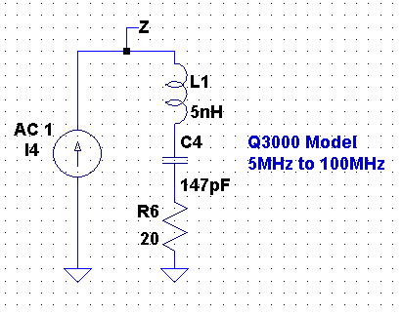

1. The simulated magnitude vs. frequency is shown in Figure 2. The markers are an overlay of the actual measured data points as an indicator of the fit.

Figure

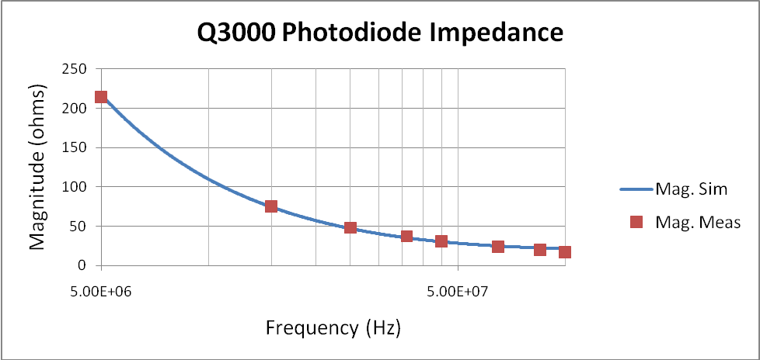

1. Table 1 shows the data taken during the measurement of the Q3000 on the impedance analyzer.

Table

|  |  |  |
| --- | --- | --- |
| **Frequency (Hz)** | **Mag. Meas. (ohms)** | **Phase. Meas. (deg)** |
| 5.00E+06 | 214 | -84 |
| 1.50E+07 | 75 | -74 |
| 2.50E+07 | 48 | -66 |
| 3.60E+07 | 37 | -59 |
| 4.50E+07 | 31 | -55 |
| 6.50E+07 | 24 | -48 |
| 8.50E+07 | 20 | -43 |
| 1.00E+08 | 17 | -38 |

1. Data was taken on the effect of bias voltage on the diode capacitance. All the measured data was taken at 45MHz. Results are shown in Table 2.

Table

|  |  |  |
| --- | --- | --- |
| **Reverse Bias (VDC)** | **Series Capacitance (pF)** | **Series Resistance (ohms)** |
| 0 | 313 | 12.1 |
| 1 | 208 | 15.4 |
| 2 | 176 | 16.7 |
| 3 | 158 | 17.3 |
| 4 | 146 | 17.7 |
| 5 | 137 | 17.9 |

1. In order to use this model in a spice simulation, the following circuit topology should be used.

