LIGO Laboratory / LIGO Scientific Collaboration

LIGO-T070079-00 ADVANCED LIGO 04/03/2007

Report to the HAM SAS Evaluation Committee

David Ottaway, Dennis Coyne, Virginio Sannibale and Riccardo Desalvo

Distribution of this document:
LIGO Scientific Collaboration

This is an internal working note
of the LIGO Laboratory.

California Institute of Technology  LIGO Project – MS 18-34  1200 E. California Blvd.  Pasadena, CA 91125  Phone (626) 395-2129  Fax (626) 304-9834  E-mail: info@ligo.caltech.edu | Massachusetts Institute of Technology  LIGO Project – NW17-161  175 Albany St  Cambridge, MA 02139  Phone (617) 253-4824  Fax (617) 253-7014  E-mail: info@ligo.mit.edu
LIGO Hanford Observatory  P.O. Box 1970  Mail Stop S9-02  Richland WA 99352  Phone 509-372-8106  Fax 509-372-8137 | LIGO Livingston Observatory  P.O. Box 940  Livingston, LA 70754  Phone 225-686-3100  Fax 225-686-7189
http://www.ligo.caltech.edu/

Introduction
The aim of this report is to inform the HAM SAS evaluation committee on the results of the recent installation and commissioning of the HAM SAS at the LIGO LASTI facility. This report will specifically address the criteria that the review committee has been asked to evaluate in its charge. For reference these criteria have been included in Section 3. The review committee was not asked to review management, staffing, or contingency and the committee is also not asked to make a comparison with the baseline. Hence the aforementioned issues will not be covered in this report
In addition to the authors of this report the following people have made significant contributions to the installation and commissioning of the HAM SAS at LASTI: Ben Abbott, Yoichi Aso, Mark Barton, Valerio Boschi, Carlo Galli, Gianni Gennaro, Yumei Huang, Jameson Quave, Alberto Stochino , Chiara Vanni, Hiro Yamamoto and Sany Yoshida
The opinions expressed in this report are those of the authors.

Configurations Used During these Tests
The table payload that was used to assess the utility of the HAM SAS system as installed in LASTI is included in the following two figures.
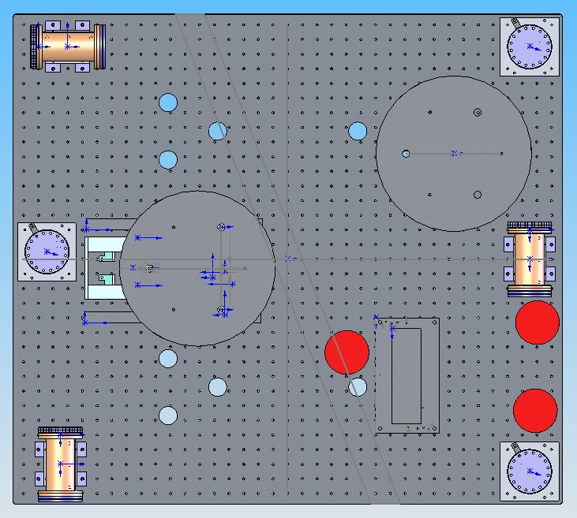
Figure ‎2-1 Top view of the HAM SAS optical table configuration during the tests at LASTI
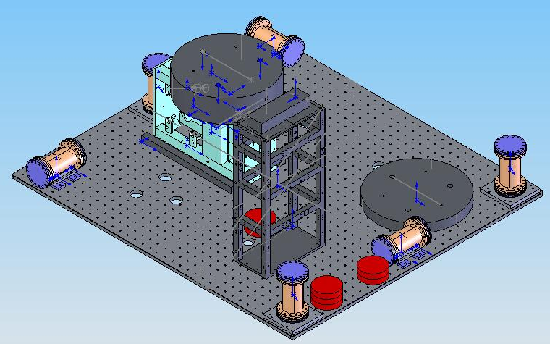
Figure ‎2-2 Isometric View of the HAM SAS Optical Table Layout used for the tests at LASTI
The small vacuum cans shown in Figure ‎2-1 and Figure ‎2-2 contain L4Cs that act as witness geophones.

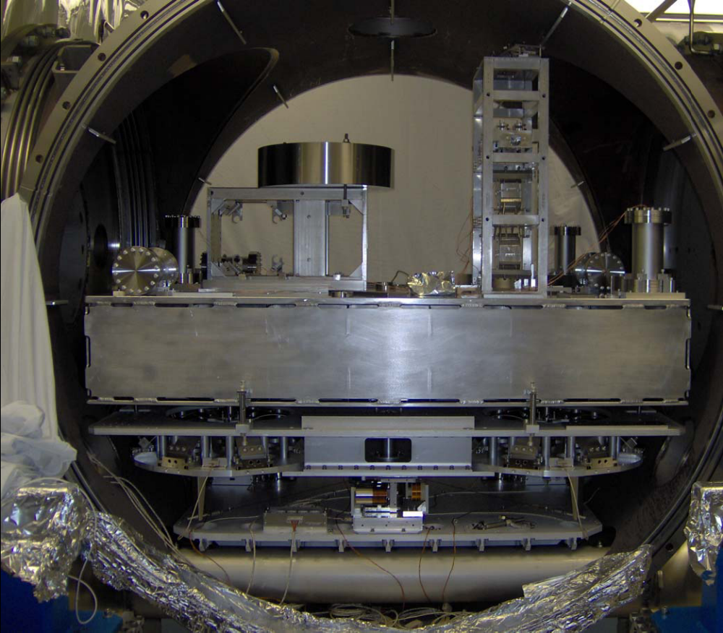
Figure ‎2-3 Photograph of the HAM SAS Optical Table Layout used for the tests at LASTI

Review Criteria Addressed

Vacuum compatibility of the HAM SAS system, including materials compatibility, compensation for buoyancy, and implications of floor tilt.
The materials used in the HAM SAS constructions are
- Stainless steel,
- Zinc-free Aluminum alloys (series 5000 and 6000)
- Maraging steel (Nickel plated)
- Soft iron (Nickel plated)
- NdFeB magnets
- OHFC Copper
- PEEK
- Kapton
- Cycom 3001 polyimide adhesive
- Silver plating (on some stainless steel screws)
All of these materials have been approved for use in the LIGO vacuum system and treated with UHV compatible cleaning and assembly processes. The details of the cleaning processes are reported in Appendix 1.
All parts, screws and nuts were individually cleaned and etched after the dirty initial assembly and full disassembly.
After washing and etching all metal parts were baked at 200 degrees for a day.
At all stages the parts were wrapped in clean aluminum foil and stored in clean plastic containers before re-assembly.
Assembly was performed in a custom clean room, itself residing inside a positive pressure, filtered air, grey room, using clean room grade tools and structures, with personnel in full clean room dress. Several LIGO personnel supervised at different times that all clean room procedures were correctly followed. All tools were cleaned to the LIGO Class B standard in accordance with M990034-C.
The only allowed lubricant for assembly was analysis grade alcohol.
After assembly and tuning, the entire assembly was baked at 135°C for a day in the stainless steel oven, with a boil-off nitrogen atmosphere, in the grey room adjacent to the clean room.
This step has the double scope of ensuring complete burnout of creep in the spring blades and to outgas any possible contaminant (possible alcohol residuals, or deposition from personnel breathing) that may have polluted the assembly.
The assembly was then packed in UHV grade aluminum foil and plastic wrapping when still hanging below the oven cap, then lowered in a second layer, air proof plastic bag waiting in the laminated wood crate. The air proof plastic bag was welded shut and then provided with a suitable air filter to avoid pressurization and bag explosion when airborne.
The crates were provided with impact monitors. The 5g & 10g monitors tripped, but the 20g monitors did not. There was no shipping damage at all.
The crates were opened on the LASTI loading dock and the contents were transferred to a cleanroom prior to opening the inner bags.
Installation machinery was constructed in vacuum compatible materials, washed and packed to maintain its class B cleanliness and assure that the SAS assembly maintain its class A cleanliness.
Buoyancy was dealt with by removing 350 grams of compensation mass immediately prior to replacing the HAM doors prior to pump. During pump down the HAM SAS position was maintained using a DC positioning servo utilizing the LVDT position sensors and the voice coil actuators. The currents sent to the voice coil actuators were periodically offloaded using the soft spring stepper motors. Using this technique there were no problems noticed during the pumpdown and the SAS system maintained its floating conditions throughout the pump-down.

Form and fit of the HAM SAS system in a LIGO HAM chamber, including compatibility with the existing support structure (piers, scissor tables, crossbeams, support tubes and (at LLO only) the HEPI system).
The SAS assembly, as well as a fully populated optical bench (including a triple pendulum installation, clearing the HAM chamber ceiling by ~20 mm) was performed sliding the parts on the rails, of custom designed and built, elevator jig, with no significant problems.
The insertion rail system is designed to raise the optical table sufficiently to clear HEPI structures for insertion in the HAM chamber. Due to the height of the HEPI assembly, parts like the triple structures will not clear the HAM ceiling if mounted to the optics table prior to HAM-SAS installation. Either these tall parts have to be inserted subsequently, or perhaps HEPI can be partially disassembled. This restriction exists only in the HAMs provided with HEPI.

Effectiveness and ease (duration, skills required, repeatability/ predictability) of the HAM SAS installation and 'tuning', characterization, and integration/commissioning
The HAM SAS system arrived as an assembled unit minus the optics table and its payload from Galli and Morelli. The HAM SAS was installed into a LASTI HAM chamber in two steps. First the HAM SAS minus the optics table and its payload was installed into the LASTI Yend chamber. Then the optics table and its payload were installed and mated to the HAM SAS. The depth of the combined Initial LIGO HAM optics table and HAM SAS made the concurrent installation of both components unfeasible (as noted above). This is actually an advantage; One can integrate the optic table with most or all of the payload elements and then insert as a finished assembly, on top of HAM-SAS.
The system was transported from the LASTI loading dock to the cleanroom on a custom made cart. The cart was designed to enable effective transfer of the HAM SAS from the cart to the installation elevator system. A photograph of the HAM SAS mounted on the elevator is shown in Figure ‎3-3. In this figure the elevator rails are clearly shown. This method of installation was very effective for installing the HAM SAS minus the optics table. However a full structural analysis should be performed on this structure before it is routinely used to install the optics table and its payload. This load exceeded a metric ton and the elevator did not feel qualitatively sturdy enough to handle this load. In addition to this one of the elevator uprights mounts rather close to the vacuum flange. In a couple of instances due to user error the elevator was dragged against the vacuum flange. Steps should be taken in the future to prevent this from occurring again (for example use of a Teflon spacer).
The optics table mounts to the GAS filters using a four point quasi-kinematic mounting system. Either during installation or in shipment one of the ball bearings became unseated. This appears to have put significant lateral residual stress on at least one of the mounts to the GAS springs. The coaxial, vertical LVDT associated with one of the GAS filters had a rubbing contact problem (see details in T070080).
The payload mass (optics table and its payload) that was specified after measurements by the HAM SAS team at Galli and Morelli was found too excessive by 35 kg (~3.5 % error, which is not unexpected based on available scales). This caused significant problems as the test layout provided by LASTI did not have sufficient flexibility to remove 35 kg and a re-design and layout for the tests was needed. In future the total payload of the HAM SAS should include at least 100 kg of small size counterweight. This should not be an overly onerous constraint given that required payload minus the optics table for the current version of HAM SAS is approximately 700 kg (versus a requirement of 510 kg).
The HAM SAS did not have accurate fiducial references to mount the optics table to the GAS filters. This was done by eye and an accuracy of about one millimeter was achieved. This did not seem to cause significant problems later on in the balancing of the load on the vertical GAS filters.
In a couple of instances the HAM SAS was found to be bi-stable which made balancing the table virtually impossible. In addition to this the violent nature of this instability would almost certainly destroy a triple if it was released from its stops. In each of these unstable cases the cause of the instability was traced to a fixable mechanical problem. Care must be taken to ensure that the HAM SAS is operating in a regime where no bi-stability exists in the allowable operating regime before a triple is released from its stops. It is necessary to completely install the optics table payload before the stability of the HAM SAS can be checked because naturally the stability of the HAM SAS is effected by the mass of the payload and its vertical extent. This bi-stability is readily tuned away by changing a series of easily accessible springs.
To get the HAM SAS table floating in the horizontal direction it is necessary to adjust the levelness of the support table using the scissor tables located outside of the HAM chamber. In the first instance this took about a half a day. This time is as much a reflection of the poor condition of the scissor tables as it is on the ease of leveling the HAM SAS support table. In addition to this it was necessary to tune the rotation about z direction by changing the stiffness of some easily accessible springs. This had to be done iteratively with the HAS SAS support table leveling with resonant frequency of the Inverted Pendulums set to approximately 100mHz. These steps took a fair amount of mechanical intuition. However none of it was so specialized that it could not be readily transferred to a skilled operator.
At present we have not released the triple from its stops. Once we have assured ourselves that the system has adequate stability while under servo-control (including electro-magnetic anti-spring feedback), we can consider releasing the triple suspension from its mechanical stops. At this time we are confident that this can be done satisfactorily and will be attempted in a vent roughly scheduled for 2 to 3 weeks time from now.
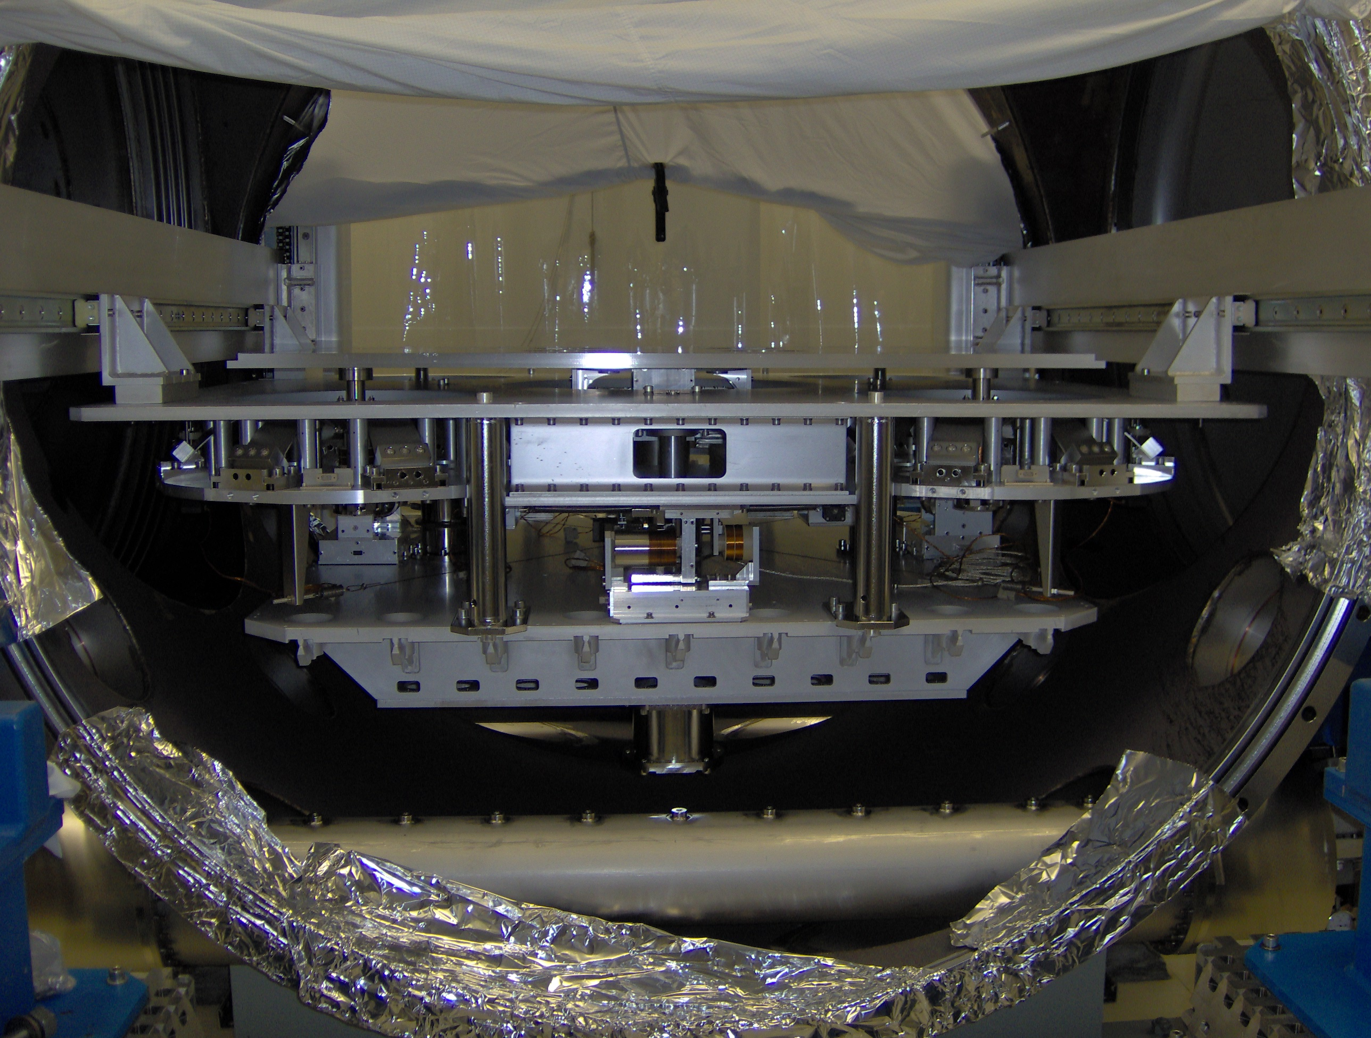
Figure ‎3-3 HAM SAS located on the elevator installation fixture
In mechanically tuning the system for the first time it was clear that significant mechanical knowledge is needed however these skills appear to be transferable to a skilled operator.
The vertical resonance of the GAS springs were set individually for a given payload to 200 mHz by compressing the GAS filters during assembly in Italy. When the unit was tested at LASTI it was noticed that the vertical frequency was now around 400 mHz. At present this is not fully understood. Possibly the residual lateral stress mention above is the cause for this difference. It was successfully re-tuned to 200 mHz by iteratively compressing GAS filters in-situ.

Seismic attenuation factor of the HAM SAS, including total rms motion (without a HEPI system) and ground tilt sensitivity and any indication of self-generated noise (electronic/controls, and/or mechanical)
The seismic attenuation of the HAM SAS system was measured. Before launching into this discussion it is worthwhile to consider the difference between the LASTI seismic environment during the measurement and a typical worst case site spectrum which is shown in Figure 3-4. It is clear that LASTI environment is considerably noisier than the sites above 1Hz. Below 1 Hz the seismic ground motions are pretty comparable with the exception of between 0.1 Hz – 0.2 Hz in which case the sites sample spectra are noisier.
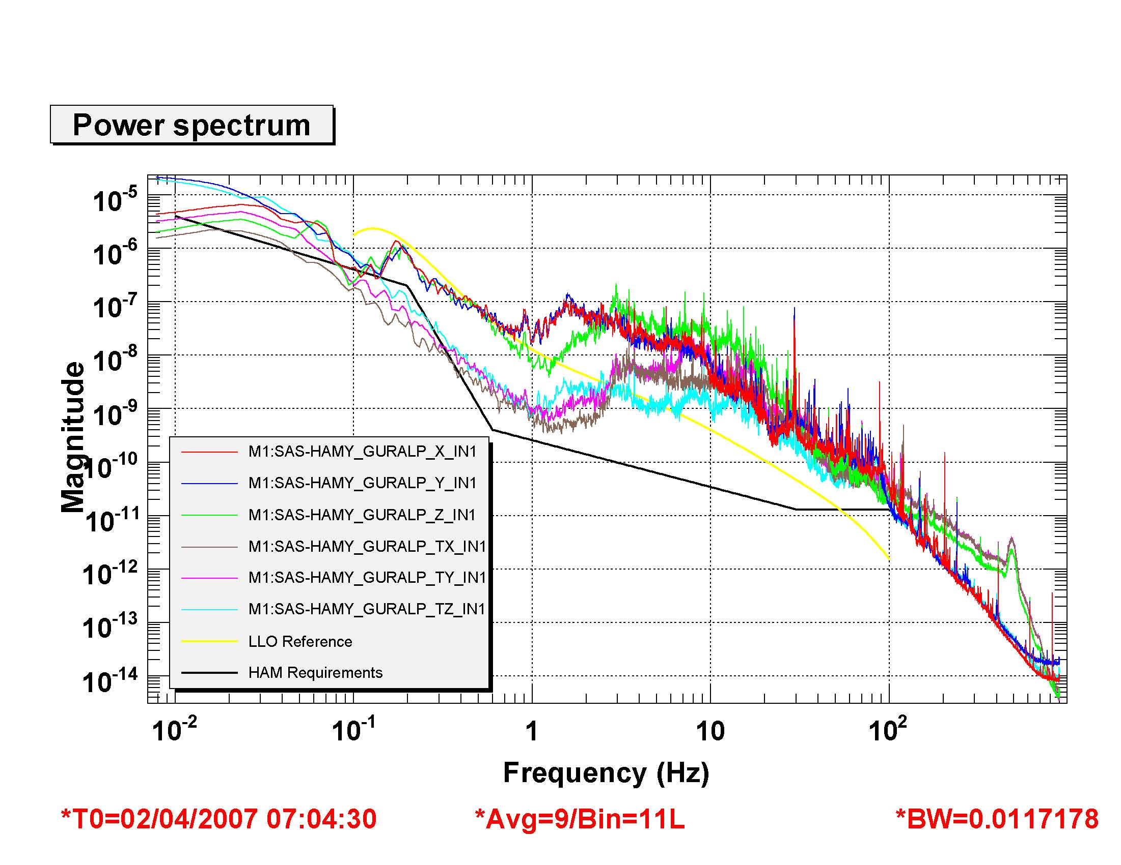
Figure 3-4 A Comparison of the ground motion at LASTI during the isolation measurements and the expected ground motion at LLO. Note the vertical axis units are in m/√Hz

The isolation performance data shown here is the best that we have currently achieved. It was measured during a seismically quiet period and also has the benefit of the electromagnetic anti-springs to lower the frequency of the resonant modes of the vertical isolation stage.
The horizontal isolation is presented in Figure 3-5 and the relevant coherence with ground degrees of freedom are contained in Appendix 2. These results show that the seismic isolation requirement is close to being met above 1 Hz with the exception of the band between 10 Hz and 30 Hz. This band is polluted due to undamped resonances of vertical, stepper motor driven, tuning springs. These resonances have been successfully damped in the horizontal set of these springs using eddy current damping and we have no reason to believe that these resonances will not also be removed using this technique. The spectrum below 1 Hz is currently our biggest concern. This measurement was taken with no damping of the horizontal modes and appreciable ground amplification is occurring between 20mHz and 0.2 Hz. By locking the table to the ground at these frequencies using servo control it should be possible to damp out the large peaks. This will prevent us from achieving isolation at the microseism. It is possible that reducing the resonant frequency of the horizontal modes to 30 mHz will improve this situation and this should be done next time we vent. Interestingly there is significant coherence between the vertical motion of the ground and both Y and X direction translation between 0.1 Hz and 0.2 Hz. Very little coherence is observed with ground tilts.
The vertical isolation is shown in Figure 3-6. In this case the vertical isolation requirement is close to being met from 0.1 Hz up. There are a couple of exceptions. The spring resonances discussed earlier shows up in the band between10 Hz and 30 Hz and these should be easily suppressed by eddy current damping. Between 0.1 Hz and 0.8 Hz and 1.7 Hz and 15 Hz high coherence with the ground motion in the vertical direction is observed. So certainly it is reasonable to expect that the requirement will be met above 2 Hz with the ground motion at the observatories. In the vertical direction significant suppression (~4) of the microseism occurs.
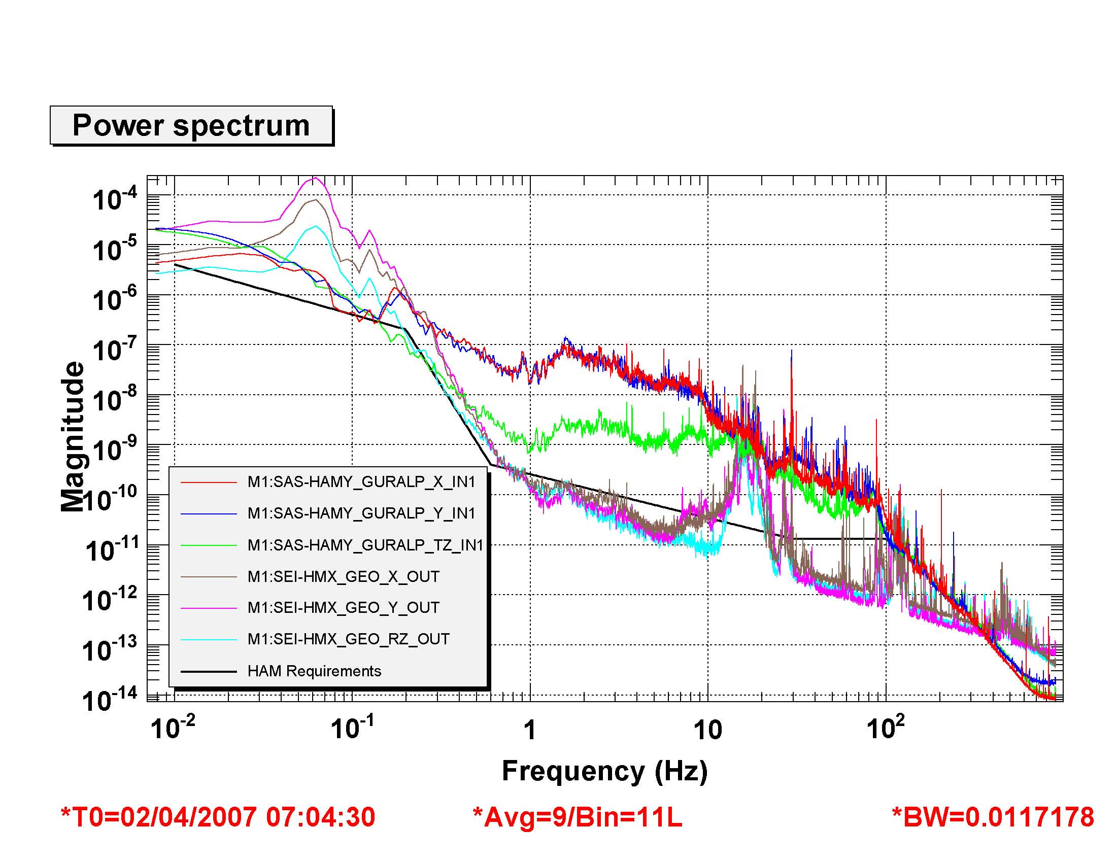
Figure 3-5 Horizontal Isolation Performance of HAM SAS. Note the vertical axis units are in m/√Hz. The Guralps are mounted on the ground and the GEO signals are the table geophones.
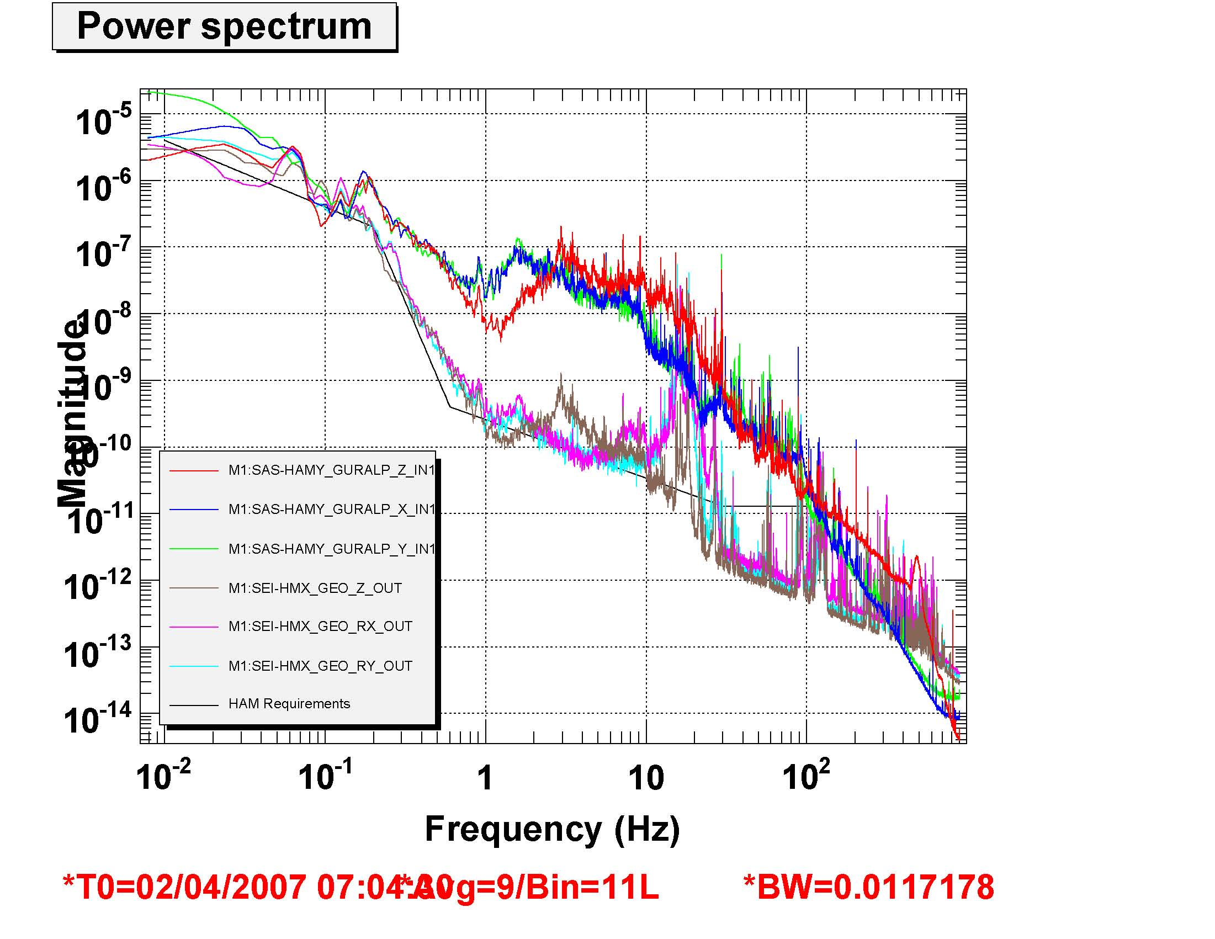
Figure 3-6 Vertical Isolation Performance of HAM SAS Note the vertical axis units are in m/√Hz

Long term pointing stability and long-term control stability (as a function of temperature, floor tilt, other accessible and likely variables)
Collecting data now using an optical lever monitor. This section will be provided very soon.

Efficacy of optics table mechanical "locks" and limiters for safety (integrating optics table payloads) and for earthquakes
The system is provided with simple locks that can be engaged without special tooling in as little as three minutes and freeze the system in its working position without vibrations. They are robust enough to allow personnel to walk on the table (more detail in T070080). If the operator forgot to engage the stops and jump on the table, it would simply hit the end-stops at the end of the10 mm range (reduced to 5 mm in this prototype in the horizontal direction). No damage is expected to the HAM mechanism or to the optical table, but no prediction can be made for the payload in this case. Indeed if an operator were to lean on the optics table without locking the table any un-locked triple would hit its earthquake stops and risk damage.
In case of earthquake, the earthquake force would be filtered by the SAS mechanism for excursions up to 10 mm. It is not currently known what would happen to the payload if a large earthquake caused the table to hit its end stops (i.e. ground motion in excess of the 10 mm gaps).

Margin against instability
After a loose joint in the tip/tilt stabilization assembly (aka “roll bar assembly”) was fixed there were no signs of tilt instability in the system, when appropriate spring stiffness is used.
To prevent driving into the stops, voltage limiters, or watchdogs in the supervisory control system, could be implemented on the coil drivers if deemed necessary.
Regarding mechanical stability, the working point of the system is the softest point of the frequency versus position graphs. Any deviation from the working point brings the system to stiffer GAS spring location and more stability.
The LVDT sensors do not saturate for the entire actuation range. If the system was manually tuned outside the foreseen actuation range, the sensor gain could be reduced to cover the extended range

DC compatibility of the HAM SAS and triple installation (mechanically locking HAM-SAS and aligning to an optical reference)
The payload integration scenario is as follows:
• Mechanically lock the HAM-SAS system (both the Inverted Pendulum (IP) and the Geometric Anti-Spring (GAS) filter stage) so that the optics table is stationary, level and locked at its proper height. Note the LVDT position sensor readings for this aligned state.
• Place the payload elements, such as a Mode Cleaner triple suspension, on the table in their appropriate positions and aligned using optical references to each other and to elements in other chambers.
• Release the HAM-SAS optics table with all suspended payload elements locked with their earthquake stops
• Balance the optics table to be level again (same LVDT readings) by adjusting trim masses. The overall mass on the optics table is adjusted until the lowest GAS frequency is about 100 mHz. Likewise the overall mass on the “spring box” is also adjusted until the IP frequency is about 50 mHz.
• Mechanically lock the optics table again,
• Release each suspended element from their earthquake stops,
• Release the optics table from its mechanical locks while keeping the controls in heavy damping and fast integrator positioning conditions
• Offload actuators with small mass adjustments or stepper motors
• After finishing internal alignment transit to low damping, low frequency e.m. spring, slow integrators configuration
It is expected that there will be slight deviations from levelness, translation and yaw once the optics table has been released. All of the payload optical elements can then be brought back into static alignment by commanding biases to the 6-degree-of-freedom, HAM-SAS controls to drive back to the desired LVDT readings (just as is the case for HEPI and its inductive position sensors). Alternatively, tip, tilt and yaw can be commanded by OSEM centering signals from appropriately oriented suspended optics (or by optical levers from non-suspended optics mounted to the table if there are no suitable OSEMs) or from suitably oriented optical levers.

The LVDT sensitivity is about 0.2 microns/count. The low bandwidth integral gain controller can hold a commanded position to within +/-10 counts, or +/- 2 microns (see 3/26 LASTI elog entry). The LVDTs are displaced from the center of the table by ~0.5 m, so the angular control is good to about +/- 4 microradians, not including long term drift of the LVDTs (which is addressed in charge #5). We have repeatedly commanded the 6 degrees of freedom of the optics table to +/- 5000 counts, or +/- 1 mm, or more using just the electromagnetic actuators. Using the stepper motors, the optics table can be moved over even greater range.

Although a mode cleaner triple suspension is currently part of the HAM-SAS prototype payload, it has not been used for alignment testing to date (4/1/2007). Recently an optical lever was set up to monitor the mode cleaner mirror/mass (which is still clamped by its earthquake stops). A demonstration of the capability to command a pitch and yaw bias could be made in the near term.

Controllable or negligible coupled dynamic interaction of the HAM-SAS and a triple pendulum suspension. Damping servo interaction between triple and SAS? Effect on the global controls?
Hiro Yamamoto, Sanichiro Yoshida and the the SLU group developed a model of the AdvLIGO Input Mode Cleaner (IMC). They developed a Mode Cleaner model consisting of three triple suspensions based on Mark Barton’s state space model of the MC triple suspension. They placed the IMC on a HAM-SAS model, based on Valerio Boschi’s state space model derived from the Maple simulation. Using this IMC model the SLU group simulated the frequency noise on the Mode Cleaner’s transmitted light due to Mode Cleaner’s length fluctuation. For this simulation, a ground displacement model of the Hanford site (the standard ground motion used by SimLIGO) was fed into the base of the HAM-SAS model. Currently, only translational displacement is used for the simulation. The result of this simulation indicates that the frequency fluctuation is on the order of 1e-3 Hz/rtHz at 0.1 Hz, 1e-5 Hz/rtHz at 1 Hz, and 1e-9 Hz/rtHz for >100 Hz. The frequency fluctuation in the 100 Hz – 200 Hz range is four orders of magnitude better than the equivalent calculation they performed previously for the Initial LIGO mode cleaner (single suspended optics on the Initial LIGO HAM seismic isolation model).

Using the coupled triple suspension and HAM-SAS state space models, the SLU group have analyzed the effect of back reaction from the triple suspension to the HAM-SAS (the horizontal model) with a realistic ground motion as seismic input (see T070017-00). While imposing the translational component normal to the optic (X direction) of a typical ground motion to the base of the seismic isolation model, the resulting optic motion was computed for the following four conditions: (a) triple suspension free hanging with no back reaction considered, (b) triple suspension free hanging with back reaction considered (back reaction via the suspension point associated with pendulum motion), (c) triple suspension local-damped with no back reaction considered, and (d) triple suspension local-damped with back reaction considered (the back reaction associated with pendulum motion plus the local damping actuation force). The differences between cases (a) and (b) and between cases (c) and (d) were not substantial, indicating that the effect of back reaction is negligible. This result is consistent with a previous analysis in which white noise was used as the seismic noise input, using the same HAM-SAS and triple suspension model.

With realistic seismic motion input (translational motion in the X-arm direction only) to the base of HAM-SAS model coupled to the triple suspension model, the IMC locks very stably. The frequency dependence of the computed IMC length fluctuation is similar to the requirement (T060075-00) in the frequency range of 0.1 – 10 Hz (5e-13 m/rtHz at 0.1 Hz and 5e-17 m/rtHz at 10 Hz), except for an order of magnitude higher peak at 1 Hz, and a factor of two higher peaks at 2.8 Hz, 3.8 Hz, and 5 Hz. All these peaks appear in the spectrum of the triple pendulum’s position motion, indicating that the local damping needs to be improved. Currently the triple pendulum model assumes the position Q-value to be infinite.

A near term test of the dynamic interaction of the MC triple pendulum suspension damping controls and the HAM-SAS system is possible. After the Electro-Magnetic Anti-Spring (EMAS) tuning of the vertical modes has been accomplished and stable controls verified, a quick vent of the system would allow us to free the triple suspension.

Judgement on the ease of integration into a hierarchical control system (tidal/microseism tracking, quasi-DC suspension force minimization, etc.)

The design requirements document for the Advanced LIGO Seismic Isolation (SEI) system are stated in document E990303-03 with more recent considerations regarding required isolation performance yet to be incorporated from document T060075-00. The only requirements with regard to hierarchical control are the need to provide +/- 90 microns of tidal correction (with a time constant of no longer than 10 minutes) and +/- 10 microns of microseismic correction (with a time constant of no longer than 0.1 minute). The HAM-SAS system has sufficient range to meet these requirements. The control bandwidth (upper unity gain frequency) for HAM-SAS is certainly high enough for tidal correction. However it is not yet clear whether the control bandwidth is high enough to be effective for active microseismic compensation (either by feedback for feedforward correction), without compromising in-band isolation performance by noise injection (say at 1 Hz). We expect that the maximum upper unity gain frequency can be established experimentally within the next couple of weeks.
The vertical coils are calibrated at 4 counts/mN which with +/- 6700 counts at saturation correspond to a peak force of +/- 1.7 N. The horizontal actuator strength is similar. Switching
on integral control with high gain and high damping can move the system position on the order of 1 mm in 10 to 20 s. This is only advisable with significant damping gain. With nominal, low noise, controls a 2 mm step command in position is zeroed, within 100 microns, in 200 seconds (see Figure 3-5).
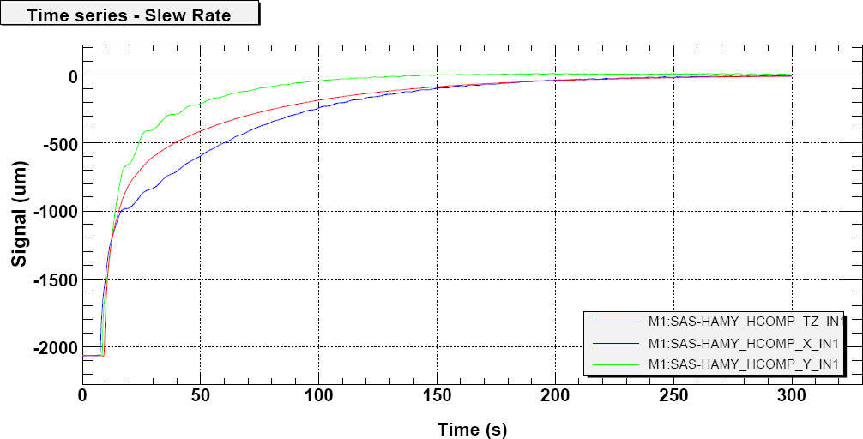
Figure 3-5 System response to a step position command with nominal, low noise, operation control compensator

The effect of cable compliance on the isolation performance
The system was tested with no problem with two 25 pin cables instrumenting the geophones and the triple pendulum on the optical bench, as well as the SAS internal cabling and the Witness LVDT cabling. No problem is expected from heavier cabling, provided that the cabling is properly strain relieved when leaving ground or the bench surface.

Adaptability, extensibility, re-configurability to handle payload variations (position and range in mass properties)
The possibility of a tilt-instability of the HAM SAS due to extended vertical payloads was established well before the HAM SAS arrived at LASTI. A significant contributor to this tilt instability is the vertical extent of the payload. For Advanced LIGO the table with the highest vertical moment is HAM 2 in the stable recycling geometry which requires a payload consisting of a recycling mirror type triple and three modecleaner type triples. For this worst case scenario the table payload has characteristics listed in Table 1 and for comparison the payload characteristics of the HAM SAS are shown in Table 2. The tables clearly show that the vertical moment of the HAM SAS LASTI test exceeds the anticipated worst case scenario in Advanced LIGO by at least 40 %. Hence we have built in significant safety margin in these tests.

Mass Element | Susp. Type | Susp. Mass | Sus. Height | Non Susp. Mass | Non Susp. Mass Height | Total Mass | Mass Moment
MC1 | MC Triple | 9 kg | 0.826 m | 36 kg | 0.388 m | 45 kg | 21.402 kg m
MC2 | MC Triple | 9 kg | 0.826 m | 36 kg | 0.388 m | 45 kg | 21.402 kg m
MMT3 | RM Triple | 38.3 kg | 0.796 m | 40.4 kg | 0.537 m | 78.7 kg | 52.18 kg m
RM | MC Triple | 9 kg | 0.826 m | 36 kg | 0.388 m | 45 kg | 21.40 kg m
Totals |  | 65.3 kg |  |  |  | 213.7 kg | 116.3 kg m
Table 1 Mass and vertical moment properties for HAM 2 in the stable recycling geometry case

The total mass payload of the HAM SAS system is set by the properties of the GAS filters and the inverted pendula. Changes in the moments of inertia will primarily affect the resonant frequencies of the angular degrees of freedom. The frequencies can be altered by changing the stiffness of the angular stabilization springs which are simple to swap out when vented.

HAM SAS Triple | Mass | Susp Point | Mass | Center of Mass | Mass Moment
BSC Leg Element 1 |  |  | 277 kg | 0.469 m | 130.1623 kg m
LOS Cage |  |  | 22 kg | 0.197 m | 4.3307 kg m
MC Triple | 9 kg | 0.826 m | 36 kg | 0.39 m | 21.402 kg m
Total |  |  |  |  | 155.895 kg m
Table 2 Mass properties and vertical moment properties for LASTI HAM SAS payload

Reliability and repairability/serviceability of the in-vacuum sensors and actuators
The system is instrumented with simple coils both for its sensing and actuation and there is no power implemented that can overheat them significantly. Barring direct hits during accesses, the only expected failure mode is connector failures.
Due to a design mistake, one of the actuation coils suffered wiring shearing when the actuator structure unintentionally acted as horizontal end stops. This mistake is now corrected and no further wiring failures are expected.
The accident happened in the least accessible of the sensing/actuation units, while the system was already installed inside the HAM chamber. The fault (about the worst that can be imagined for a mature system) was repaired in situ.
Following the accident (obviously on top of eliminating the accident source), we redesigned the bolting structure to allow even easier replacements and/or repairs in future.

Cost and schedule
Schedule.
After a decision has been made on whether to switch to the HAM-SAS baseline or not, a few relatively minor changes to the mechanical system need to be incorporated into the design (see the T070080 for details). In fact many of these changes have already been incorporated into the revised drawings. However, these drawings must be reviewed before proceeding. In addition, good practice requires a Final Design Review (FDR) for the HAM-SAS system (in addition to the evaluation process which is underway now). These activities are called out in the proposed schedule below. In is assumed that in parallel with this FDR process, the NSF review and approval of phase 2 of the mechanical fabrication contract can occur.
The mechanical fabrication contractor has given a 6 month rough estimate for the duration of the fabrication for another HAM-SAS system. Their initial estimate for the prototype unit was 5.5 months (~4/12 to ~10/1/2006). The system was shipped late (12/19) due to changes in the design and welding problems, which have been resolved. A 6 month schedule is not unreasonable. Note that Galli & Morelli have the requisite maraging steel already in-hand for two units.
The enhanced LIGO schedule (M. Zuker, 11/20/2006) calls for delivery of a HAM SEI system on 10/1 and another on 11/30. A new unit fabricated, cleaned, assembled, tuned and tested/accepted at the mechanical contractor’s site would not be available till ~12/3. We estimate that a second unit would follow about 1 month later (~12/31). If the first unit for enhanced LIGO is needed sooner, then the current prototype could be reworked. The schedule for this rework, given the relatively minor changes involved should approximately meet the desired enhanced LIGO schedule (delivery ~10/12).

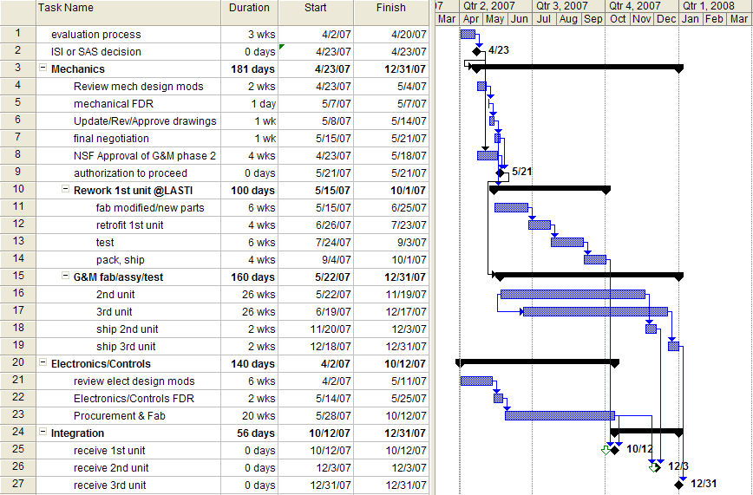

When will “all of the HAM-SAS testing be done”? As soon as the decision has been made, we think sufficient testing will have been accomplished to inform the mechanical design, especially the long lead large structure procurement/fabrication. One might imagine the need for more time and testing for ancillary mechanical elements such as improved adjustment capability for the mechanical (earthquake) stops. Control system development and testing will continue on the prototype for as long as possible to improve performance and understanding.

Cost.
N.B.: In the estimates below a factor of 1.3 USD/€ has been used. No attempt has been made to cover uncertainty in the US dollar to Euro conversion factor.

The original HAM-SAS prototype funding request can be found here:
http://www.ligo.caltech.edu/~phil/ChangeBoard/M060034-00-P.pdf
Nearly final costing for the HAM-SAS prototype is addressed in M070026-00 and CR070001-00.

On 3/30, Galli & Morelli provided a written estimate for the cost of a new HAM SAS (clean assembly) at about €300K ($390K) and an Optical Bench and two Support Tubes at about €50K ($65K). The original bid for the HAM-SAS system (no optics bench, no support tubes) was €277K ($360K) The original bid for the Optics Bench and two Support Tubes was €30.0K ($39K) and €19.2K ($25K) respectively, or €49.2K ($64K) total per set.
Based on the cost increases experienced on the HAM-SAS prototype (see M070026-00 and CR070001-00), Coyne estimates that the HAM-SAS G&M contract phase 2 effort will cost ~$450K for the 2nd unit and ~$410K for the 3rd unit (as compared to G&M’s rough estimate of ~$390K).
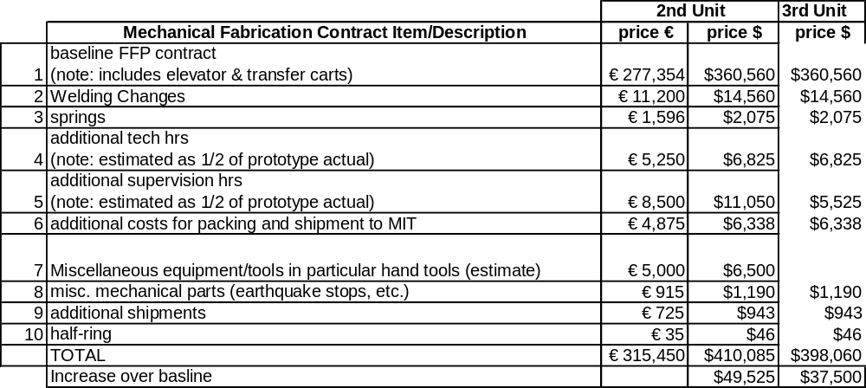
Looking at the other factors contributing to the prototype cost increase over the baseline, we can also expect a $40K increase due to the following factors:
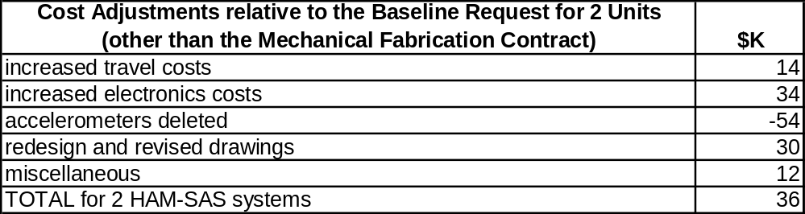
The total costs then for two additional HAM-SAS systems plus 2 optics tables and 4 support tubes is as follows:
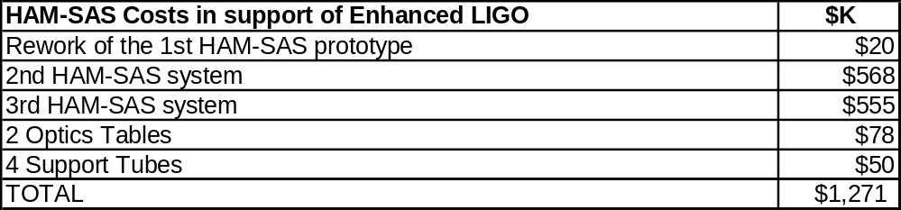
Note that the optics tables and the support tubes do not need to be part of the HAM-SAS mechanical fabrication contract (they can be procured from another source is desired). Some of these costs are shared by the Adv. LIGO program.

.
- Material and parts cleaning procedures
Stainless steel was washed, etched, most parts electropolished, neutralized and washed
Aluminum underwent basic etching and scrubbing, acid etching (more than one cycle when necessary)
Maraging and soft iron where etched before plating, then neutralized and washed
After etching or plating, all of the metal parts where de-ionized water rinsed and dried before baking, which was performed in a similarly cleaned stainless steel oven in boil-off nitrogen atmosphere at 200oC for a day (plus a day of ramp-up and one of ramp-down).
The NdFeB magnets, all of the SH alloy, bakeable up to 150°C were washed in warm alcohol and ultra sound for 30 minutes, then baked to 135 degrees.
Peek was treated like the NdFeB magnets before coiling.
OHFC copper is used in wiring, most comes pre-coated in Kapton.
The coil wiring is made in clean conditions (the coiler spools where cleaned and the coiler wrapped in aluminum paper) and then washed in warm alcohol and ultra sound for 30 minutes before painting with kapton resin (for immobilization).
The polyimide (Cycom, similar to kapton) resin was thermally polymerized with its require temperature profile, then kept at ~200 degree for a day for outgassing.

- Isolation Performance Coherence Measurements
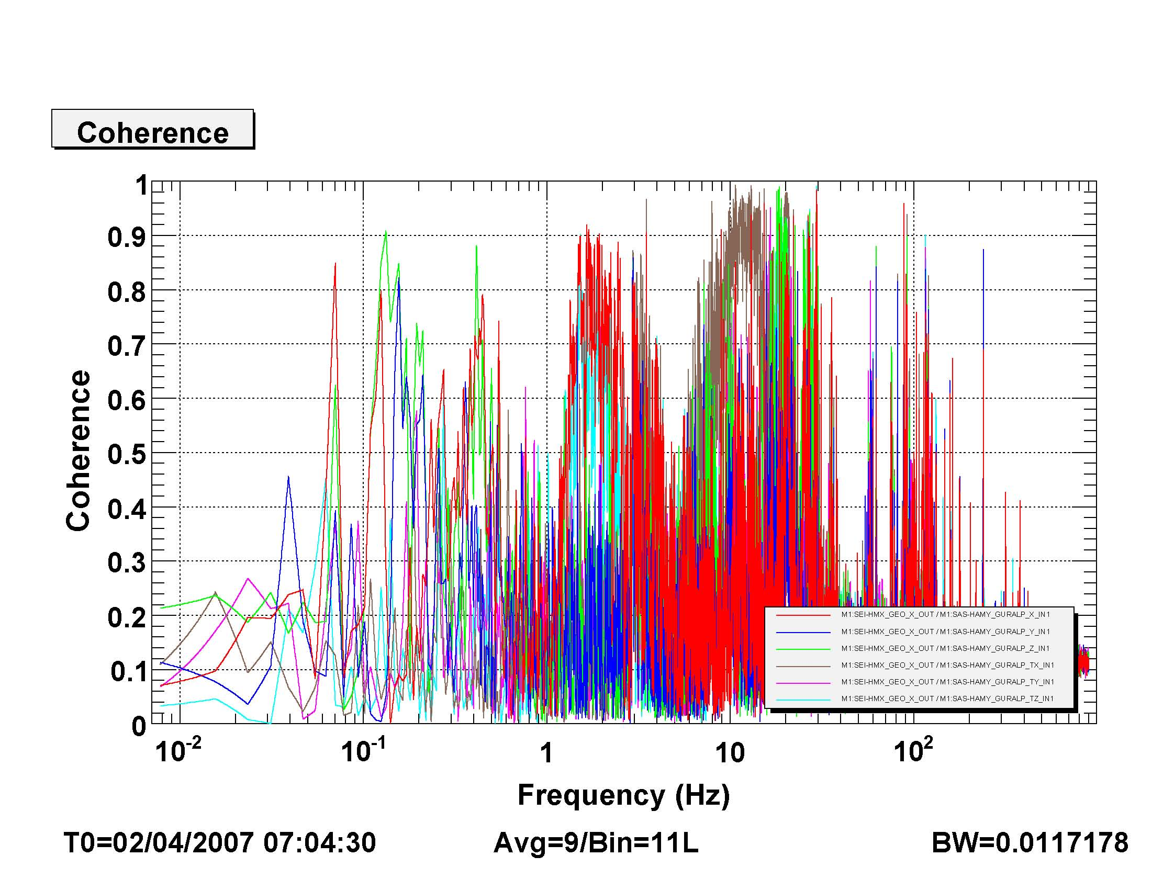
Figure 3-7 Coherence between the X degree of freedom and the different motions of the floor as measured by Guralp Seismometers
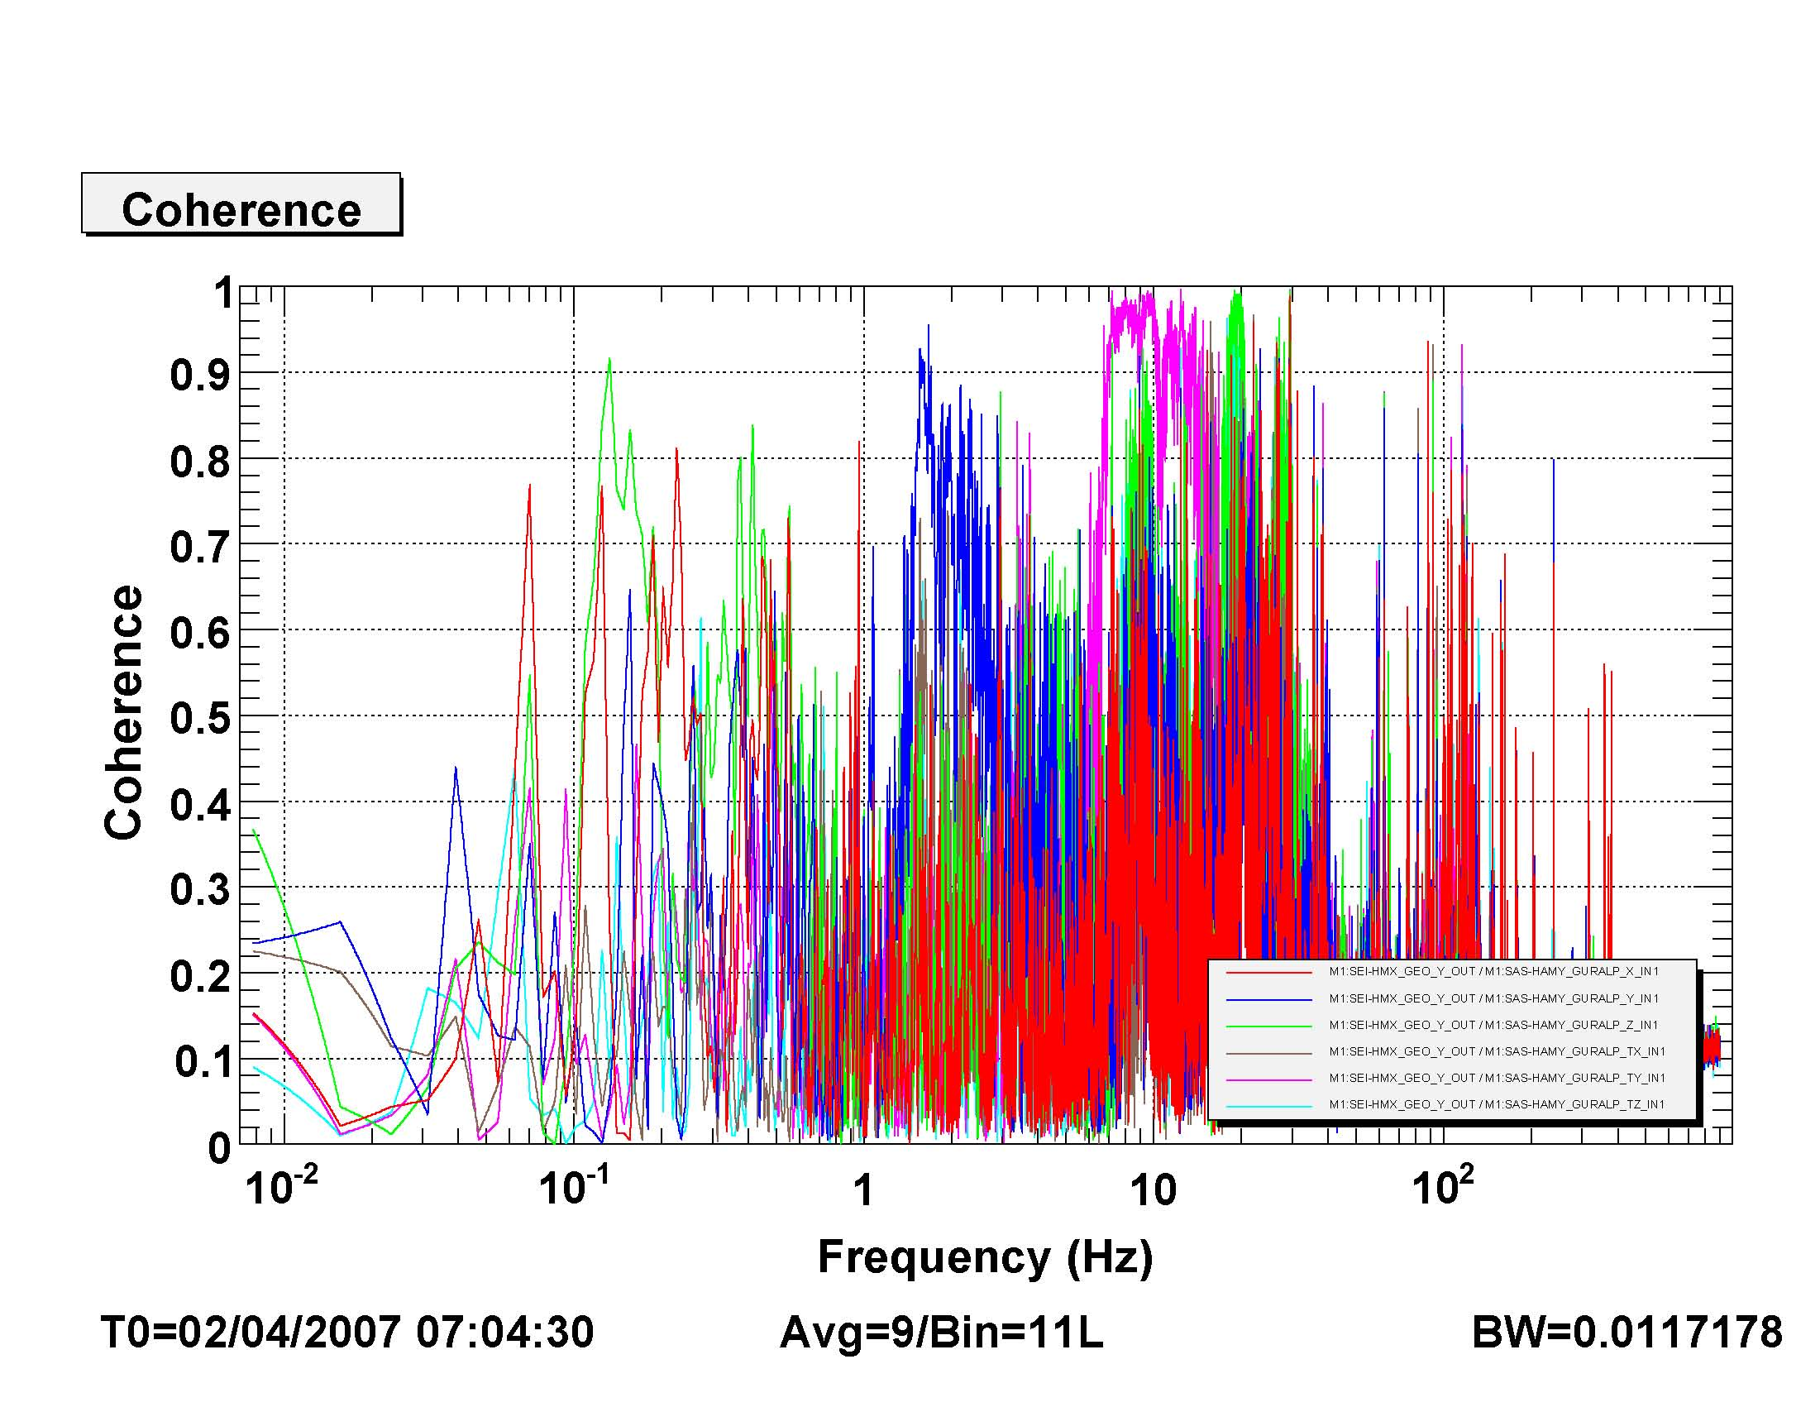
Figure 3-8 Coherence between the Y degree of freedom and the different motions of the floor as measured by Guralp Seismometers
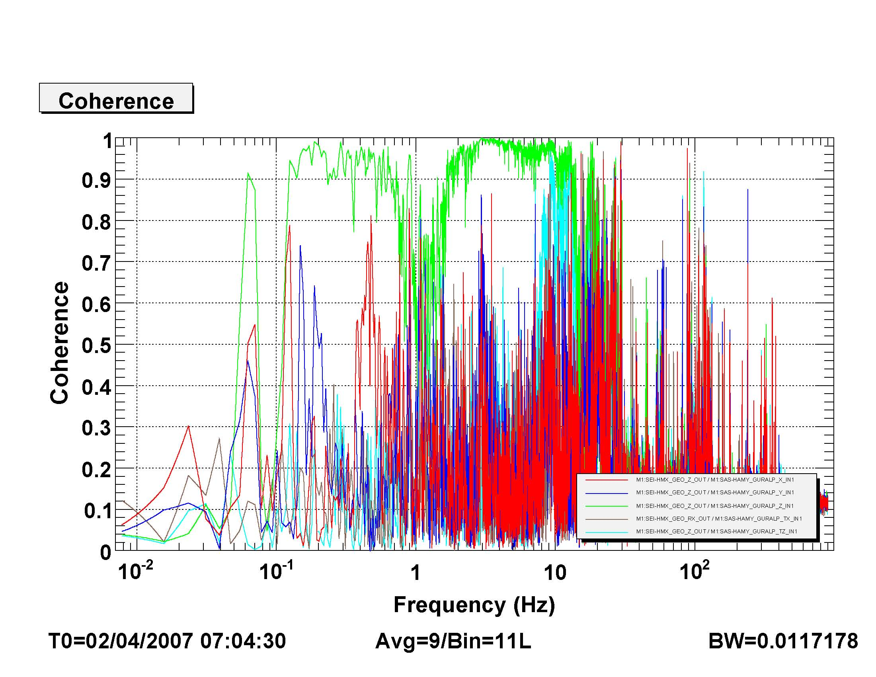
Figure 3-9 Coherence between the Z degree of freedom and the different motions of the floor as measured by Guralp Seismometers
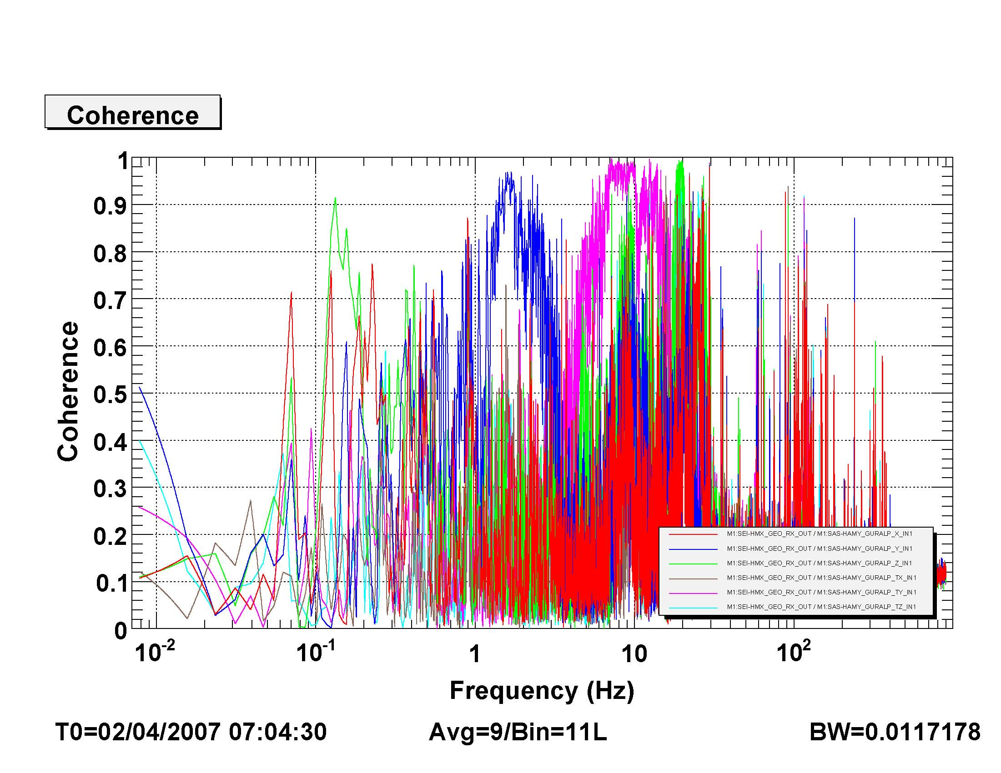
Figure 3-10 Coherence between the Rotation about X degree of freedom and the different motions of the floor as measured by Guralp Seismometers
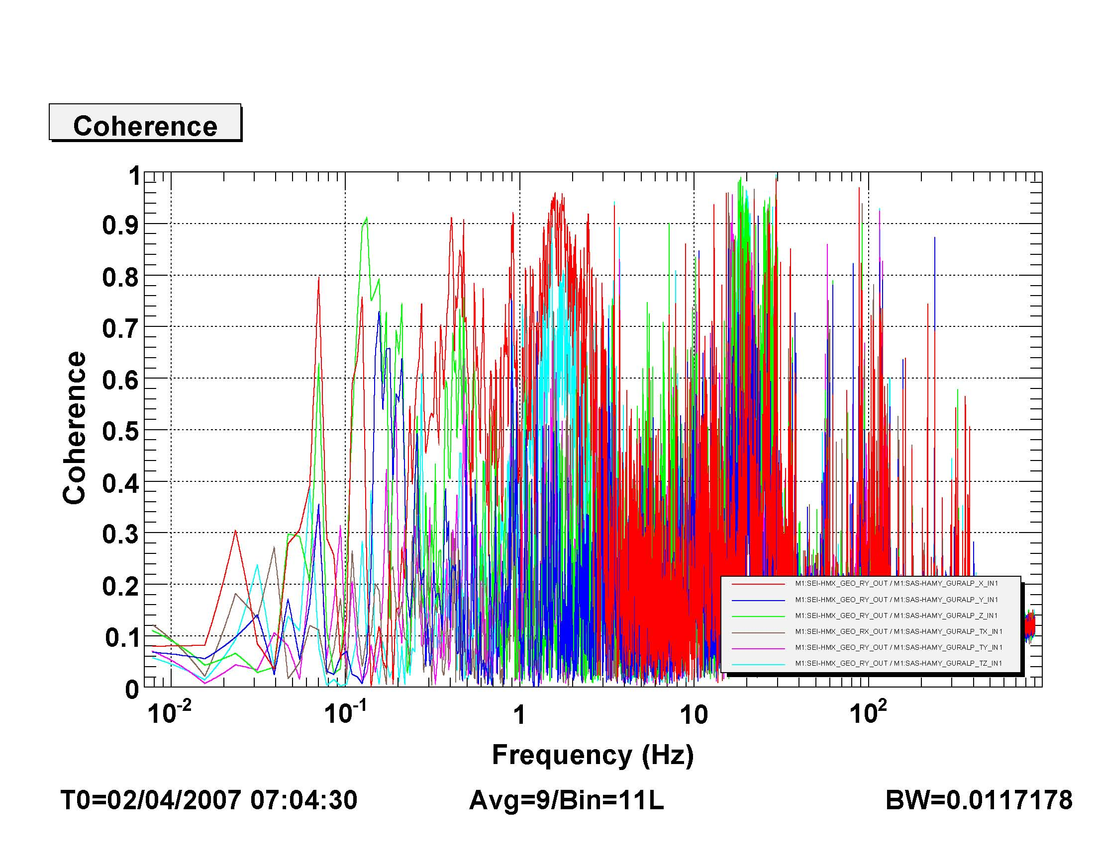
Figure 3-11 Coherence between the Rotation about Y degree of freedom and the different motions of the floor as measured by Guralp Seismometers
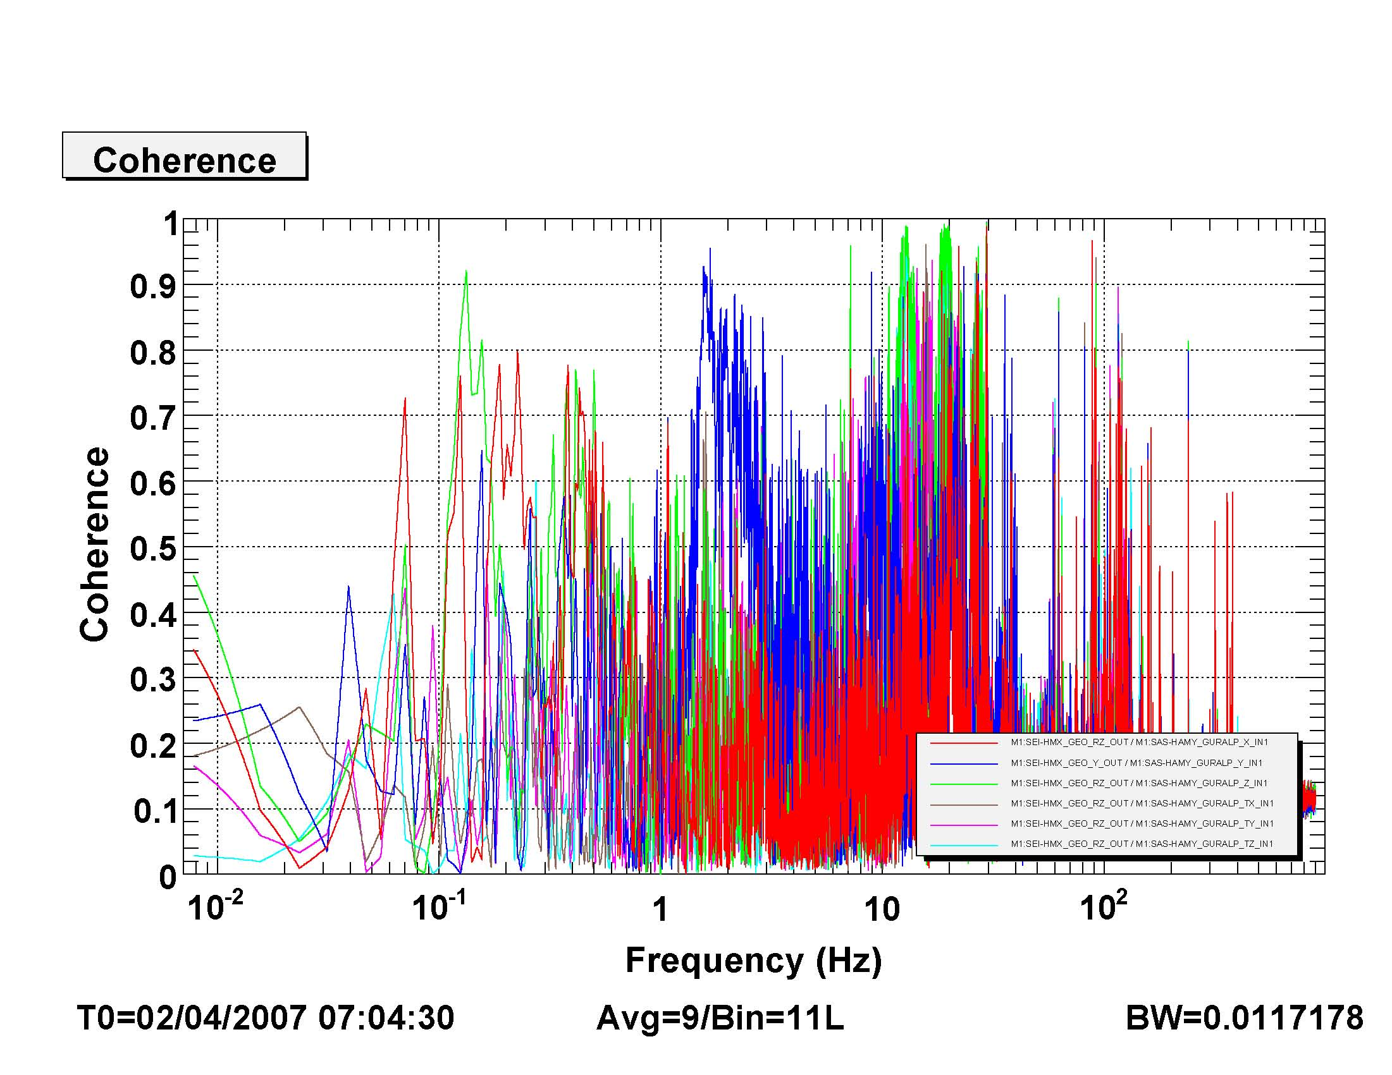
Figure 3-12 Coherence between the Rotation about Z degree of freedom and the different motions of the floor as measured by Guralp Seismometers

