LIGO Laboratory / LIGO Scientific Collaboration

LIGO- T060039-00 ADVANCED LIGO 12 May 2006

AdvLIGO quad suspension controls prototype
suspension and adjustment method

Mark Barton, Tim Hayler, Calum Torrie

Distribution of this document:
LIGO Science Collaboration

This is an internal working note
of the LIGO Project.

California Institute of Technology  LIGO Project – MS 18-34  1200 E. California Blvd.  Pasadena, CA 91125  Phone (626) 395-2129  Fax (626) 304-9834  E-mail: info@ligo.caltech.edu | Massachusetts Institute of Technology  LIGO Project – NW17-161  175 Albany St  Cambridge, MA 02139  Phone (617) 253-4824  Fax (617) 253-7014  E-mail: info@ligo.mit.edu
LIGO Hanford Observatory  P.O. Box 1970  Mail Stop S9-02  Richland WA 99352  Phone 509-372-8106  Fax 509-372-8137 | LIGO Livingston Observatory  P.O. Box 940  Livingston, LA 70754  Phone 225-686-3100  Fax 225-686-7189
http://www.ligo.caltech.edu/

Introduction

Scope
This document summaries the apparatus and methods used to assemble the quadruple pendulum controls prototype during the period October 2005 to April 2006, covering the various assemblies of the suspension from the dirty and clean builds at Caltech to the installation in the vacuum chamber at LASTI. It is written as an instruction manual, and could serve as such if the prototype were ever reassembled from scratch, but it is intended primarily as a historical record. Unless otherwise noted every step described has actually been tried, if not quite in the indicated sequence. In a few cases untried but obvious improvements are suggested as a guide to future assembly procedures for the noise prototype.

Version History
“pre03” (should have been pre00-20060220) Assorted edits by Mark B. (The LIGO document number T060039 was assigned. Since we’re working up to the -00 revision, the “pre03” annotation that was attached is a misnomer.)
“pre04”: (should have been pre00-20060301) Includes comments and pictures from Calum!
pre00-20060308 – more edits by MB.
pre00-20060312 – more edits by MB.
00 – stuff on installation of OSEMs from experience at LASTI by MB.

Procedure

Lower structure pre-assembly

Lower structure pre-assembly tooling
- Optic table with ¼-20 threads at 1” pitch, table dimensions 1.75” x 35” x 47”
- (Optional) Lazy Susan bearing 10” OD
- (Optional) Optics breadboard with ¼-20 threads at 1” pitch, table dimensions 0.5” x 24” x 24”
- Short palette allows assemblies to be lifted by fork lift trolley.
- Two rails with rollers mounted on the optic table (item (c))
- Two carriages to mount each chain of the suspension (lower structure is dog clamped to the carriage).
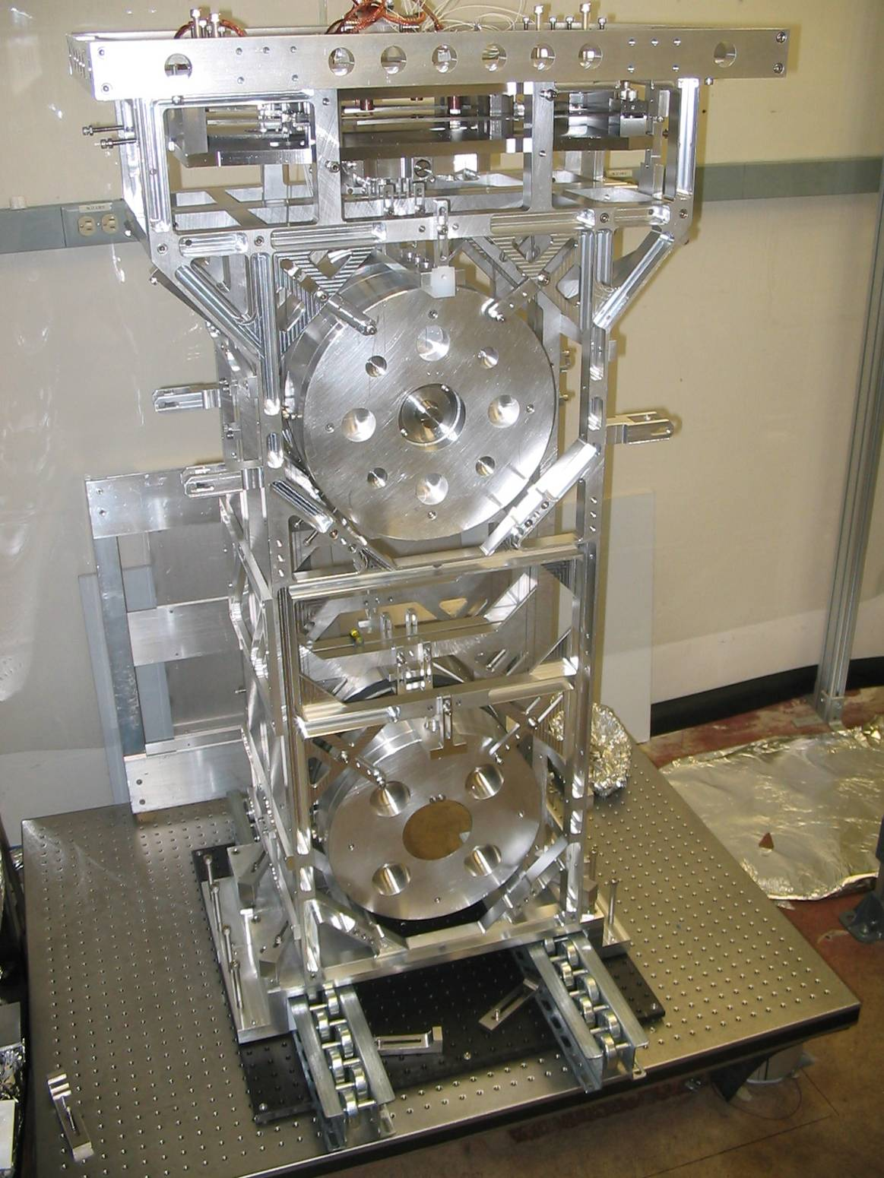

Fig 1. Lower structure on rails. (CT)

Set up lower structure
- Put the Lazy Susan on the optical table and the breadboard on top. For safety, secure the breadboard to the optical table with screws at the centre of the front and back edges until such time as the ability to rotate the breadboard is actually required.
- Add rollers to the breadboard and secure with dog-clamps.
- Put the carriages on the rollers.
- Clamp the structure onto the carriage.

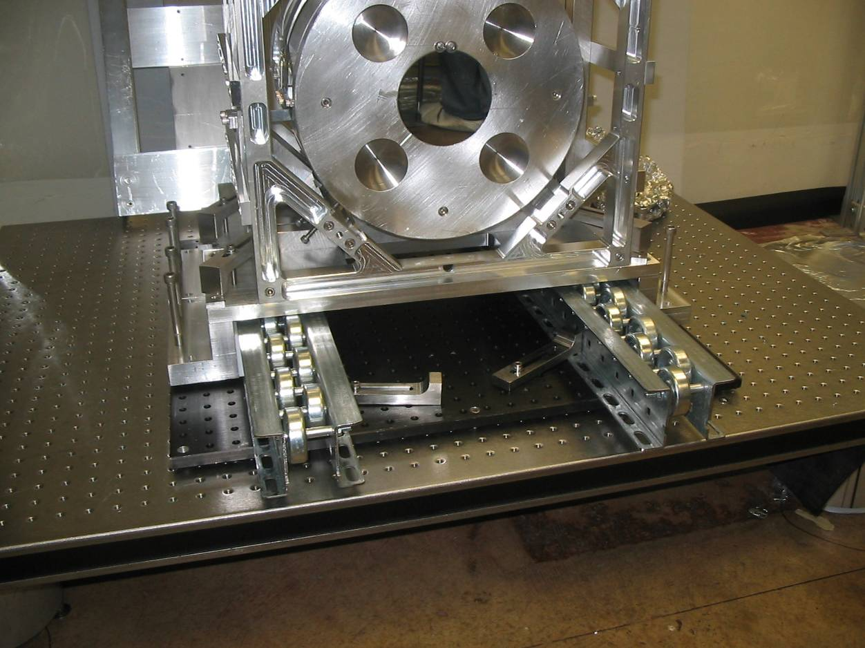

Fig 2. Lower structure clamped by dog clamps onto the carriage. (CT)
- Raise the carriages off the rollers using the four bolts in the corners of each carriage as feet, and use dog clamps to restrict lateral movement.
- Install Teflon pads onto the lower structure. Teflon pads make it easier to slide masses into the structure. Make sure the groove in the pads matches the groove in the structure (groove allows penultimate wire loops to pass under the penultimate mass). The pads under the test mass are thicker to give slack in the test mass wires.

Install masses
- Install the upper intermediate (UI) mass of the reaction chain: Place two blocks (3”x 2” x 1”) resting on the cross members that span between the face plates. With the help of an assistant, lift the mass up and over the structure, and lower it onto the blocks. Install the F-shaped brackets over the mass and install the bolts that hold the mass up to the brackets. Finally remove the blocks. Attach the UIM OSEMs if they are not already mounted but don’t spend any time precisely locating them – only their mass is important in the next few sections. (When repeating this step for the main chain UIM, make sure the magnet assemblies are fully retracted – otherwise there is a risk of them being damaged.) The trim mass unit on the top of the UIM should not be installed yet – it interferes with the connection of the wires from the top mass in Section 2.3.
- Route the wire loops of a penultimate mass wire assembly into the groove on the penultimate pads and under the central guide bolt. Do not attach the wire clamps to the UI mass blades yet.
- Install the penultimate mass of the reaction chain on top of the wires. Attach the penultimate mass OSEMs if they are not already mounted but don’t spend any time precisely locating them – only their mass is important in the next few sections. (When repeating this step for the main chain penultimate mass, make sure the magnet assemblies are not installed – there is too great a risk of them being damaged.)
- Install the reaction chain test mass. The penultimate mass and test mass should either be installed with ergonomic arm (or for the case of the metal masses, assembled in the structure) so as to reduce the weight the installer has to handle to less than 10 kg!
- Clock the two bottom masses using the pair of clocking tools. Each clocking tool has two fingers that extend to a preset length. Start with the fingers retracted a few millimetres. Bolt one tool on each side of the structure next to one of the masses, one with the fingers above the vertical center line of the mass and one with the fingers below. Misalign the mass slightly in roll so as to narrow the gaps between the fingers and the flats on the sides of the optic. Then extend the fingers fully so as to push on the flats, rotating the mass back to the properly clocked position. Repeat for the other mass.
- Use the T shaped fingers to ensure the masses are correctly aligned in x.
- Fit the test mass wires to the test mass and penultimate mass with their clamps.
- Connect the penultimate wires to the UI mass: lower the UI mass on its stops using the bolts holding it to the F-shaped brackets. Additional adjustment can be made by pushing the blades down by their stops until they are flat. First connect one side of the penultimate wires to the UI mass by connecting blade wire clamps to blades, making sure the wires are threaded through the test mass wires. Before connecting the second side to the UI mass, again make sure the wires are threaded through the test mass wires, and then trace the wires from one side of the mass to the other making sure the wires do not cross, connect blade wire clamps to blades. Put tension into the wires so that they enter the grooves in the break off at the penultimate mass.
- If the electrostatic drive plate has not already had wiring attached, the wires should be soldered on now. Run the electrostatic and OSEM cabling up the chain, securing it under the cable anchors at each level. Make sure that the loops of cable between the masses are as loose as possible without fouling on any part of the structure. Coil the excess length neatly on the top of the lower structure so that it won’t pull on the masses when they are suspended.
- Tension the wires supporting the penultimate mass by backing off the UI blade stops so that the UI blades move up. (If necessary move the UI mass up with stops or lab jack attached to an independent frame.) Partially pull out the Teflon pad under the penultimate mass until the back safety stops are able to replace the pad in supporting the mass, continue removing the pad until the front safety stops are able to support the mass. Now lower the safety stops until the penultimate mass suspends.
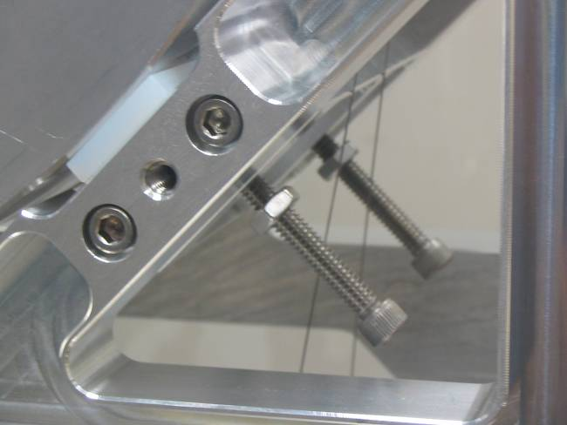

Fig 3. Teflon pads and safety stops

- Suspend the test mass, remove the Teflon pads under the test mass in the same way as in (9) then lower the safety stops until the test mass hangs. Because of the additional weight on the suspension you have to once again lower the penultimate mass stops.
- Repeat from Step 1 for the second chain, omitting the steps involving cabling.

Suspend and adjust bottom two masses
- Check the relative pitch of the penultimate mass and test mass: For each chain, immobilize the penultimate mass by bringing up the stops beneath it. Using a spirit level placed on top, level the penultimate mass in pitch by tweaking the stops. Move the spirit level down and check that the test mass is also level in pitch. In the case of a large error, remake the wires. In the case of a small error, move one of the wires out of its groove as it passes underneath the test mass so as to effectively shorten it. (When repeating this step for the main chain, the trick of moving the wire out of the groove is not available.)
- Check the relative pitch of the UI and penultimate masses: For each chain, free the penultimate and test masses and immobilize the UI mass, ensuring it is level in pitch and roll. Check that the lower masses are then also level. In the case of a small error, adjust the pitch trim masses on the penultimate mass (NOTE: these are available on the controls prototype but won’t be on the main chain of the noise prototype – we should eliminate the need by better control of fabrication or provide an alternative.)
Interjection: what wasn’t done at this point but probably should have been was some sort of check on the longitudinal yaw of the lower masses relative to the UIM. The blade spring installation jig for the UIM blades is not very effective, so it’s possible for the blade tips to be displaced forwards and backwards so as to produce a significant yaw of the lower masses. For small errors this can be corrected by rotating the wire clamps on the tips of the blades, but larger errors require the blade clamp bolts to be loosened and the blade tips moved. This latter adjustment is not possible with the UIM mass installed in the structure. Thus if the pendulum has to be reassembled from scratch, ideally a better jig will be designed and used. Failing that, or possibly as well, a check here would be desirable. What’s mainly needed is a check that, with the UIM level and the lower masses hanging, the wires down from the UIM are centred front-to-back relative to the UIM. This was attempted with a depth gauge but it was difficult to do it accurately because the diagonal sections on the edges of the UIM mean there is no convenient reference opposite the blade tip in two of the four places one would want to measure. What would be good is some sort of simple template that would mate with a feature of the UIM (e.g., one of the holes in the bottom plate through which the wire passes) with a pair of notches through which the wires would pass if they were correctly centered.

Preparation for final installation
- When the suspension is hanging correctly, lock all masses in position via blade stops, safety stops and clamps, there should be some tension in all wires. The UI blades should be in their nominal position.
- Fit the T shaped pieces between the structures to stop the masses touching.
- Move both chains together on rollers and fix the chains together using the five cylindrical spacers.
- Raise the structure via the bolts on the carriage off the rollers.
- Dog clamp the carriage to prevent it moving.
- For transport ensure the masses are locked in all directions and the blades tips are held, such that the tension in the wires is reduced. The set of stops that need to be checked are as follows:
  - PEN. / TEST MASS
    - Front face 10, 2 and 6pm
    - Top, add LIGO number, line contact, see figure 16. (For transport use Teflon between the line contact and the mass.
    - 4 stops, 2 at 5pm and 2 at 7pm, reference figure 3
    - Between chains, add LIGO number, using T shaped bumpers
  - UI MASS
    - Blade stops
    - Top and bottom use F piece [insert LIGO number]
    - Transverse and longitudinal use e-quake stops (in this case stainless steel SHCS with rounded ends and jam nuts)

Upper structure pre-assembly

Pre-assembly tooling
- Short (Aluminum) palette allows assemblies to be lifted by fork lift trolley (genie).
- Optical table / 3 table legs allowing ergonomic assembly!
- Fork lift trolley.
- Two lab jacks.
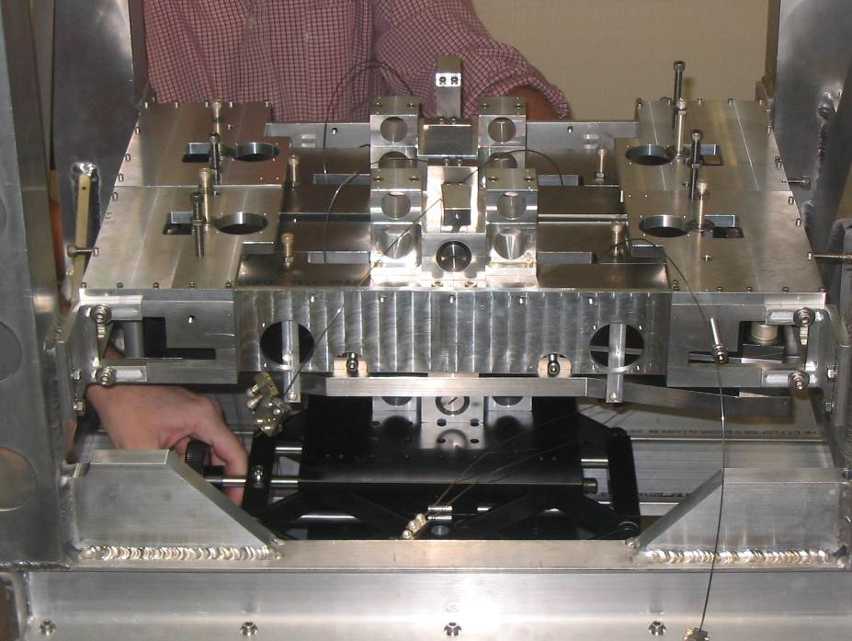

Fig 4. Top masses in the tablecloth

Installation of top blades into upper structure
Note: The top blades are supported by the upper structure, their position in the upper structure relative to the seismic table is critical in determining the final position of the optics in the vertical z dimension. For the purposes of setting the position of the top blades in the upper structure, the top surface of the structure becomes a datum representing the seismic table. An interface piece between the structure and the top blades sets their position in the z dimension. However the top surface of the upper structure is not known until all the welding is complete, and the top and bottom surface of the structure have been machined flat and parallel to each other, this makes it necessary for the final machining of the interface piece to be done after the upper structure is complete. The dimension from the upper survace of the tip of the top blade to the top surface of the upper structure (seismic table) is 106mm.
  - Set upper structure on palette.
  - Set interface piece on screws at correct height in upper structure, clearance holes on 3/8th screws.
  - Install top blade cartridges.
  - Set top blades flat with the top blade stops.
  - Install tablecloth apart from top plates and hat [reference LIGO drawing number].
  - Set up two lab jacks on the palette cross-member, underneath where the top masses will go.
  - Ensure the local control magnets and eddy current damping units are not installed on the top masses.
  - Hold the two top masses together above the tablecloth and lower them at the same time until they rest on the lab jacks. This joint installation is necessary because their geometry is jigsaw-like making it impossible to install them inside the tablecloth boundary individually.
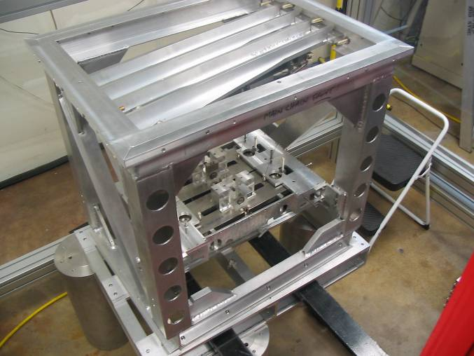

Fig 5. Upper structure with top stage and top mass installed, shown on aluminum palette supported on 3 table legs for ergonomic assembly. (CT)
  - Raise top masses on the lab jacks and connect the top mass wires to the top blades.
  - Lower lab jacks until there is some tension in the wires.
  - Fit the top plates to the tablecloth.
  - For each top mass insert the two large bolts which screw into the mass and hold it up to the tablecloth and the four smaller bolts that screw into the table cloth and hold the mass down away from the table cloth. The stops used here are SHCS with rounded ends and jam nuts.
  - Lock the top mass in position with the stops on the tablecloth so that there is tension in top mass wires. Make sure it is approximately the correct position in Z, symmetrical in X, Y and yaw, and approximately level in pitch and roll.

“3 in 1” Assembly

Installation of upper structure
- Make sure the upper optic table is level in pitch and roll.
- Raise the upper structure up onto the optic table using the fork lift trolley (genie).

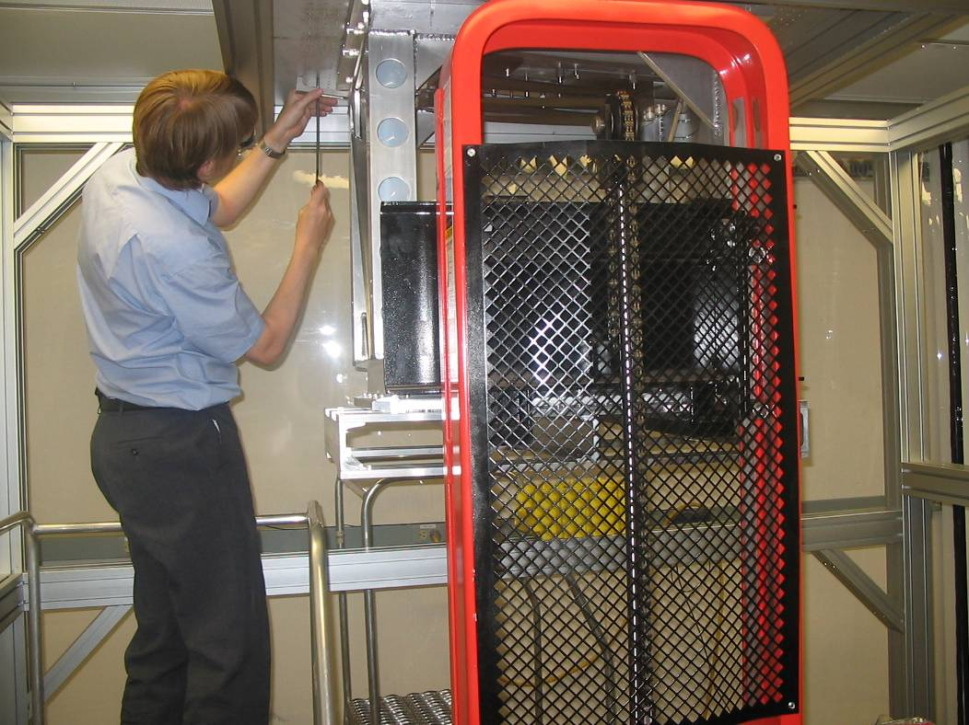
Figure 6: see item 1 bove.
- Bolt upper structure to optic table with dog clamps, 16, reference LIGO-D050178. (CT)

Installation of lower structure
- Move the pre-assembled lower structure onto the forks of the fork lift trolley and move it underneath the upper structure. (In future iterations of this procedure it will be placed on the the installation tooling - see reference document by Ken Mailand and Calum Torrie TBC.)
- Raise the lower structure so that there is about a 3/8” gap between the implementation ring and the upper structure.
- Bolt the implementation ring to the upper structure. Spacers are needed between ring and structure to allow for a short upper structure resulting from greater than expected post-machining to meet the tolerances on the drawings. First insert all bolts and spacers, leaving each bolt loose about two turns so as not to interfere with the insertion of subsequent spacers. Then tighten all bolts.
- Unbolt lower structure from implementation ring.
- Raise the lower structure to the uppermost point on the implementation ring range (28mm range).

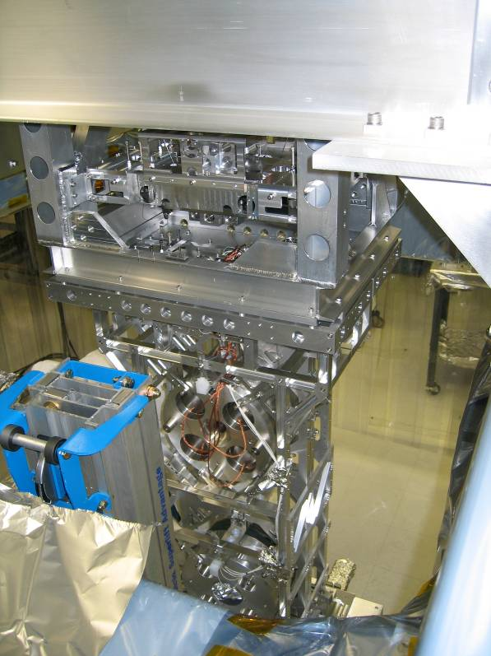
Figure 7: See item 7 above
- Use the slack in the UI wires to connect them to the top masses.
- Slacken the nuts on the bolts holding the top masses up so that there is plenty of scope (≈10 mm) for them to move downwards in the next step.
- Lower the structure and remove the slack in the UI wires.
- Structure should now be at the lowest point on the range.
- Install the trim mass units on top of the two UIMs.

Adjustments on suspended masses
Reference: Pendulum parameter descriptions and naming convention, LIGO-T040072-01-R

Suspend and check bottom two stages
For both chains:
- Remove upper stops from test mass and reaction mass.
- Remove fingers from between test mass and reaction mass.
- Back off lower stops from test mass and reaction mass until both are suspended.
- Repeat preceding three steps for penultimate level.
- Double-check relative pitch of lower three stages as in Section 2.1.3, Step 12.

Suspend and adjust pitch of bottom three stages
For each chain:
- Make sure the top mass is level in pitch and roll using a spirit level.
- Free the bottom three stages and check the pitch of the UI mass with the spirit level.
- If the UI mass is pitched, loosen the screws on one of the blade-tip wire clamps for the wires leading down to the penultimate mass and rotate it slightly so as to move the wire attachment point towards the edge of the mass that needs to be pitched down. If necessary, repeat with the other blade-tip wire clamp. (The extra checks suggested in the interjected commentary in Section 2.1.2 are intended to reduce the correction required here to the level where it can be done with small twists of the wire clamps rather than motions of the whole blades.)

Adjust pitch of all four stages
The pitch adjustment is done on the top mass by a displacement mechanism acting on the wire clamps, the mechanism is made up of two screws pushing on either side of the clamp about a pivot point, when one screw is released the other screw is free to push the clamp mechanism about the pivot point in the desired direction. The mechanism was designed to be used while the chains were separated; because the chains are hanging together half of the mechanism cannot be accessed. The following is a workaround.
For each chain:
- Check that the lock screws for the wire clamps on the bottom of the top mass are in the centre of their range. (If not, loosen them, centre them and retighten them.)
Interjection: what is actually desirable here is some sort of check that the attachment points for the wires supporting the top mass are centred front-to-back relative to it. If this can be achieved then getting yaw right in subsequent steps should be straightforward. However it was difficult to do this well for lack of good reference surfaces to use with the depth gauge, so the position of the lock screws in their slots was used as a proxy. As with the UIM, a simple template that keyed with the top mass and had a slot through which the wire would pass when it was correctly centred would be very helpful. For the noise prototype it might well be good to eliminate the adjustment on one side completely. If the wire on one side is centred by design to usual machining tolerances, the other side should come close enough to central during the adjustment for pitch to make yaw right at the same time.
- Extend the magnets on the main chain upper intermediate mass so that the flags are as close as possible to the OSEMs but without the flags entering the gap between the circuit boards. (This minimizes the perturbation to the pitch due to the weight of magnets and screws when the magnets are extended fully in subsequent sections.) Similarly, on the reaction chain penultimate mass, set the movable section of each OSEM near to the working position, which turns out to be almost fully entered.
Interjection: It might also be worth considering having dummy magnet assemblies that could be installed temporarily in 2.1.3 Step 3 and 2.2.2 Step 7, identical to real ones except without flags. In any case, the take-home message is that the perturbation to the pitch from exercising the OSEM and magnet hardware at one level can be surprisingly large compared to the range of an OSEM at another level, so it’s important to do as much pre-positioning as possible to reduce the number of iterations required.
- Free the bottom three stages.
- Have an assistant hold the top mass, taking particular care not to let it move too far in pitch.
- Remove the upper stops on the top mass and back off the others.
- Loosen the lock screws for the wire clamp on one side.
- Loosen the pusher screw for the loose wire clamp on your side.
- Using a screwdriver or the like, lever the loose wire clamp toward you. (The mass will tend to pitch strongly toward you and your assistant should keep it under control.)
- Tighten the pusher screw gradually until the pitch is corrected.
- Very carefully tighten the lock screws.
- Check that the level has not been disturbed. If it has, try repeating from Step 6, aiming off by the amount of any perturbation introduced by the lock screws.
Interjection: If there is no stable point, the correction for wire flexure and blade lateral compliance is probably off. If the instability is small, it can be corrected by adding extra trim mass to the UI mass or the penultimate mass. Adding the trim to the penultimate mass gives approximately twice the correction because it stretches two blade springs at once, but will not be applicable to the noise prototype.

Adjust longitudinal position, separation, and yaw
- Check that the average separation and relative yaw between the chains is approximately the same at the test mass and penultimate mass levels. There can be a substantial yaw at both levels at this point, as long as it’s the same. If not, there is probably some gross problem such as a stop not backed off.
- Check that the average separation and relative yaw between the chains is approximately the same at the penultimate mass and UI levels. If not, try to improve matters by rotating the blade-tip wire clamps on one of the UIMs in opposite directions. If that is not enough, do the same with the other UIM. If that fails, the blades in the UIM may have to be loosened in their clamps and rotated. (Rotating the blades requires reversing the 3-in-1 assembly procedure and removing one or both UIMs from the lower structure!) After any such adjustments the pitch of the bottom three masses in the affected chains will have to be revisited as per Section 2.4.2.
- Check that the average separation and relative yaw between the chains is approximately the same at the UI mass and top mass levels. If not, try to improve matters by rotating the blade-tip wire clamps on the top mass in opposite directions. If that fails, the blades in the top may have to be loosened in their clamps and rotated. (This can be done by inserting the lock screws to immobilize the mass with respect to the tablecloth, loosening the blade clamp bolts, and pushing on the tip to set the position. Before retightening the clamp bolts, check that the tip has not moved so far as to foul on the adjustment mechanism for the wires from the top blade springs.) After any such adjustments the pitch of all four masses will have to be revisited as per Section 2.4.3.
- Check the relative yaw of the top two masses. If they are not parallel, first double-check the centring of the adjustable wire clamps on the top mass for the top wires – the lock screws should be centred in their slots. If not, revisit Section 2.4.3.
- Then, use the top blade adjustment mechanisms to set longitudinal position, separation and yaw of the two top masses (the other masses should then be correct). A useful reference is the magnet attachment points on each end of both top masses, which should be centred horizontally in the circular ports for attachment of side local-control OSEMs. Some people find the “Betsy tool” (a Perspex sheet with holes matching the OSEM attachment holes and a set of crosshairs indicating the centre) to be helpful. The magnet attachment points track the tips of the corresponding top blade springs. Thus, …
- For each spring:
- Loosen the lock screws on either side of the main clamp screws. (Note that this will cause the spring tip and one side of the entire chain to droop and should not be done if any magnets have been installed.)
- Loosen either the pusher or puller screw depending on the desired direction of motion. (Note that each blade cartridge pivots about its centre, so the base has to be moved in the direction opposite that desired for the tip.)
- Tighten the other screw until the blade has been rotated sufficiently to move the corresponding magnet attachment point into position. (If you run out of range, it may be possible to gain an extra mm or two by loosing the screws attaching the block holding the puller and pusher screws and moving it over.)
- Retighten the lock screws.
- Check the gaps between the pairs of masses: it should be very close to 5 mm on each side at each of the four levels.
- Adjust the vertical position of the tablecloth at front and back so that the magnet attachment points for the face OSEMs are centred vertically in the OSEM attachment ports. Again the Betsy tool may be helpful. (Horizontal centering is done in the next section.)

Adjust vertical height
- Check that any vertical offset between the penultimate masses is the same as the vertical offset between the UIMs. If not, add or subtract mass from the reaction chain to make them equal. The amount of mass required will be about 500 grams per millimetre of differential offset.
- Do the same check between the top mass level and the UIM level. If the offsets are different, add or subtract trim mass to/from either of the UIMs as convenient. The amount of mass required will be about 300 g/mm.
- Check that the top masses are at the same height. If not, add or subtract trim mass to/from either of the top masses as convenient. The amount of mass required will be about 300 g/mm.

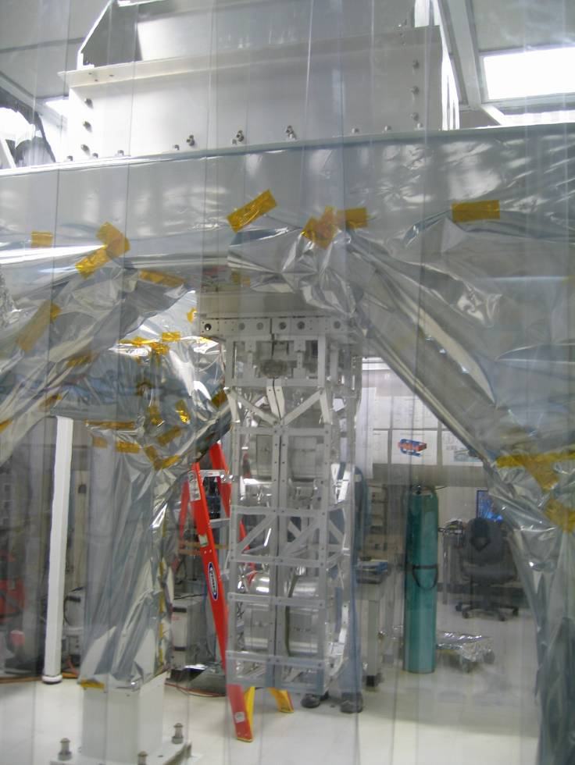
Figure 8: Quad suspended from the LASTI solid stack on the test stand (CT)

Adjust transverse position
Ideally a transverse adjustment should not be needed. However if the chains are misaligned in transverse (as they were in practice at Caltech) there is no alternative but to move the blade cartridges sideways. Some of the screw holes on the back chain have been slotted to allow this, but if something equally unfathomable happens and a contrary adjustment is required, more slots may have to be opened out, using clean tools.
- Adjust the transverse position of the tablecloth until the magnet attachment points for the face OSEMs on the main chain top mass are centred horizontally in the OSEM attachment holes.
- If the magnet attachment points on the reaction chain are not also lined up, measure the discrepancy.
- Measure the gaps between the ends of the blade cartridges for the reaction chain to the inside of the frame at the top of the upper structure. Add or subtract the discrepancy measured in the previous step as appropriate so as to calculate the size the gaps need to be to bring the reaction chain to the correct position.
- Loosen the bolts holding the two blade cartridges, and using a large screwdriver or the like, lever on the end of each cartridge until the gaps have been reduced or enlarged to the desired size.
- Retighten the bolts.

Install/Adjust OSEMs

Connect OSEMs
- Run the free end of the OSEM and ESD cables from the lower structure via the anchor point on the top mass (if used) to the anchor point on the lower back edge of the upper structure.
- Lay out the local control OSEMs on the tablecloth near where they are to be installed and route the rest of the octopus cables clear of suspension wires and the like back to a convenient anchor point.
- Run the extension cabling back to the vaccum feedthrough (or, for in-air test, the simulated vacuum feedthroughs).
- Plug in all the OSEMs and perform electrical tests. In particular:
- Check that, from outside the vacuum as near as possible to the equipment rack, the coils, LEDs and PDs are visible with a multimeter on the appropriate pins. (The coils should be about 18 ohms, the LEDs should be a diode with a 1.1 V forward drop, and the PDs should be diodes with about a 0.6 V forward drop.)
- Check that with the power applied, the GEO driver boxes show all local control OSEM LEDs drawing current, tat none of the power supplies are drawing excessive current, and that all OSEMs are lit up when viewed with an IR viewer.
- Check that the MEDM screen of the computer shows sensible open-light voltages for all the OSEMs (about -20000 to -25000 counts for the local control OSEMS and -1800 to -2100 counts for the global control OSEMs).
- Check that the MEDM screen shows the voltages going to zero when a small tool is inserted in the shadow sensor gap, and that the channel that goes to zero corresponds with where the OSEM is mounted or slated to be mounted.
- Make a table of all the open-light voltages. For later convenience, make a second column by calculating 50% of each voltage.

Adjust penultimate mass OSEMs
NOTE: This section is difficult and presents grave risk of damage to the OSEMs. It should not be attempted with fewer than 3 people – one to do the adjustments (the adjuster), one to hold the mass (the assistant) and one to watch the computer and call out progress (the caller).
- Make sure that both chains are free.
- Position the adjuster on the reaction chain side of the structure and the assistant on the main chain side.
- Bring the stops underneath and on the outside (back) face of the reaction chain penultimate mass in to just touch the mass. Be as careful as possible not to perturb the position or orientation of the mass.
- Using symmetrical pressure from fingers placed just above the wire clamps on each side, press down and out against the stops to check that the mass is snug against all of the stops at once and does not move slightly before encountering them or to rock between different positions. The adjuster should try this first, pulling toward him/herself, and then releasing and adjusting stops until the mass is snug.
- Then the assistant should try it, reaching around the main chain masses and pushing, with the adjuster checking that the mass doesn’t roll. Before any operations on the OSEMs in subsequent steps, and especially whenever any OSEM is temporarily removed, the adjuster should announce what is to be done and get verbal and visual confirmation that the assistant is stabilizing the mass. Between operations, the assistant should be allowed to rest. Also, if there is any suspicion that the mass has rolled, any removed OSEMs should be replaced and the assistant should ease up momentarily to let the springs correct the orientation.
Interjection: What’s really needed here is a better system of stops that would do something like what the assistant is tasked with. (It’s hard to imagine what would work but it’s probably still valuable to put the wish list out there just in case.) The cables on the reaction chain prevent the upper clamp fixture from being fitted easily and it’s not really suitable for this procedure in any case. Similarly, the T-pieces that keep the lower masses of the chains apart are fine for transport but not suitable for working on one chain with the other free. If it’s necessary to persevere with some version of the current procedure, thought needs to be given to protecting the fibres – pushing on the wire clamps is easy and unobjectionable but pressing on or even near the ears is unthinkable.
- Bring the face and side stops in to touch the main chain penultimate mass as for the reaction chain and then fit the upper clamp fixture. Check that the mass is securely immobilized and not only does not shift when hands are withdrawn but withstands moderate roll force as from screwing in a magnet assembly. It’s not necessary to be quite as painstaking as with the reaction chain because it’s only for safety and transverse alignment.
- With the reaction chain penultimate mass stabilized by the assistant, remove one OSEM, remove any dummy magnet from the main chain and install a magnet assembly with flag.
- Replace the OSEM, adjusting its position in vertical and transverse using the slop in the attachment screws so that the flag is centred between the circuit boards.
- Have the caller verify that with the OSEM screwed in far enough, the output voltage of the sensor goes close to zero (20-50 counts or less). The working point for the OSEM is quite close to the limit of its range. Be careful not to apply too much torque on the adjustment screws when the OSEM is near fully entered, or it is possible to crush the top of the ceramic insulators around some of the screws holding the OSEM together.
- Repeat the preceding three steps for the other OSEMs.
- Free the main chain penultimate mass.
- With the assistant stablilizing the mass, adjust the OSEMs in and out until the caller announces that the outputs are at the half way points calculated earlier.
- Release the mass, back off the stops and check that the output voltages are still close to half. If not, reintroduce the stops and restabilize the mass, having the caller monitor to check that the voltages are not perturbed from whatever they came out to. Then adjust the OSEMs again to set the voltages to half. Repeat this step as necessary until convergence is achieved.

Adjust upper intermediate mass OSEMs
This section is easier and could probably be done with just two people, an adjuster and a caller, but a second person in the chamber as a spotter and general assistant couldn’t hurt.
- Bring up the end stops on both the upper intermediate masses to just touch, and then tighten them quite firmly, working a little at at time at both ends so as not to perturb the position. (Since most of the other horizontal stops are close to useless, friction on the end stops has to suffice to prevent longitudinal, vertical, roll and yaw motion in the next few steps.) Then bring in the stops that push down from above to just touch, checking that the masses don’t pitch.
- Sight through the OSEMs to check visually that, when later extended, the flags will be well-centred in the gap between the circuit boards. If necessary, use the adjustment range provided by the slots in the OSEM mounting brackets to correct the alignment.
Interjection: The adjustment provisions in the brackets here need to be revisited. The downward half of the range of the vertical slots can’t be used because the OSEM holder ring runs into the crossbar between the uprights. The original version of the piece with the uprights doesn’t have slots, and in the revision that does, the slots can’t be used unless the screw on one side is omitted.
- One OSEM at a time, screw the magnet forward so that the flag enters between the circuit boards. Check that the alignment is still good, and have the caller verify that the output voltage goes to near zero (less than -20 to -50 counts). Screw the magnet back out until the voltage is at half maximum.
- Release the masses, back off the stops and check that the output voltages are still close to half. If not, very carefully adjust the magnets some more until the proper working point is achieved.
- Bring up the stops on the main chain and tighten the set screws on the magnet positioning screws. (Truth be told, the screws were so sloppy in their threads and the adjustment was so fiddly that we didn’t bother attempt this.)
- Check that the masses are still adequately level in pitch at each level of the chains, especially at the test mass level. If not add trim mass as appropriate.
- Check that adjustment of the penultimate mass OSEMs is still good. If not iterate Step 13 of the previous section and Step 4 of this one until convergence is achieved.

Adjust tablecloth
The tablecloth has no provision for longitudinal adjustment so the longitudinal position and yaw of the chains were set to the table cloth in Section 2.4.4.
- Loosen the bolts holding the tablecloth to the upper structure in vertical at both front corners so that they just barely hold. Have an assistant support the front edge of the tablecloth so that it doesn’t fall on the upper masses during the next two steps.
- Loosen completely the bolts holding the tablecloth to the upper structure in vertical at both back corners, supporting the tablecloth so that it doesn’t drop.
- Using the Betsy tool or otherwise, move the back edge of the tablecloth vertically until the magnet assembly mounting holes on the midline of the reaction chain upper mass are vertically centred in the holes in the back edge of the tablecloth.
- Tighten the bolts at the back corners just enough to prevent the tablecloth dropping, but continue to support it manually in case it does.
- Have the assistant completely loosen the bolts at the front corners and adjust the front edge of the tablecloth in the same way.
- Retighten the bolts at the front corners just enough to stop the tablecloth from dropping and continue to support it at both front and back.
- Loosen the bolts that prevent the tablecloth moving horizontally and adjust it in transverse until the magnet assembly mounting holes on the midline of the reaction chain upper mass are horizontally centred in the holes in the back edge of the tablecloth.
- Double check that all the OSEMs are centered vertically and horizontally and tighten all bolts fully.

Install magnets and adjust local control OSEMs
- Remove any dummy magnet assemblies and fit magnet assemblies with flags. Note that while there is a hole for fitting a magnet at both the left and right ends of each top mass, only the ones not obstructed by the diagonal braces of the upper structure are used.
- One at a time, fit the OSEMs to the tablecloth, using the slop in the mounting screws to ensure that the magnets are centred between the circuit boards.
- With the assistance of the caller, verify that as the OSEM is entered, the voltage goes to near zero, as well as appearing on the correct channel on the MEDM screen.
- Adjust each OSEM in and out until its voltage is at half maximum.

Summary of Recommendations
- We need a solution to the mystery of the transverse offset between the chains. This could involve better tolerancing, better installation, or just making the slots that were added in the blade cartridge mounts a part of the design and sorting it out after the chains are hanging.
- The adjustment mechanism for the top blades needs to not sag when the lock screws are loosened.
- We need more reliable blade installation tooling that can locate the tips of the blades to much better than 1 mm in the top and upper intermediate masses. It should probably key with the actual tips, rather than trying to locate them indirectly from the base.
- We need a better adjustment mechanism for the wire clamps in the top mass. It should have a push-pull mechanism that allows it to be operated easily with access to just one side. The adjustment on one side should be eliminated, or there should be a détente or an easily measured reference point to allow it to be centred easily. The other side should also have an reference point. Lock screws that perturb the position less would be good. More clearance between the mechanisms and the blades would be good.
- We need a similar adjustment mechanism on the upper intermediate mass.
- The ability to add and subtract trim mass should be added to the design of the UI masses, as it is on the top masses.
- The slots on the OSEM brackets on the upper intermediate mass need to be rethought to allow the full range of motion originally intended.
- From the point of view of the mechanics, it’s probably optimal for the cables from one level to come horizontally off the top of the mass in the longitudinal direction, loop gently around and be clamped similarly on the top or bottom of the next mass. However the tops of the penultimate and test masses are currently earthquake stop contact locations, so one or the other should be moved slightly to one side.
- The stops need to be rethought generally. For OSEM alignment purposes it needs to be possible to take a single chain from hanging to immobilized at either the upper intermediate or penultimate levels, without perturbing the position of either chain, and preferably without an assistant.

APPENDIX 1 Shipping
We shipped the quad assembled in 2 sections, each mounted on an aluminum pallet. Each ½ of the quad on its pallet was loaded into a crate that was pre-lined with clean “bags”. Each quad was double-wrapped in foil, as shown.
It should be noted that for future crates the feet should be tall enough and wide enough to allow a genie / pallet jack to pass underneath!!
Each stage in the quad was locked down using ¼-40 SHCS with jam and double jam nuts where appropriate.

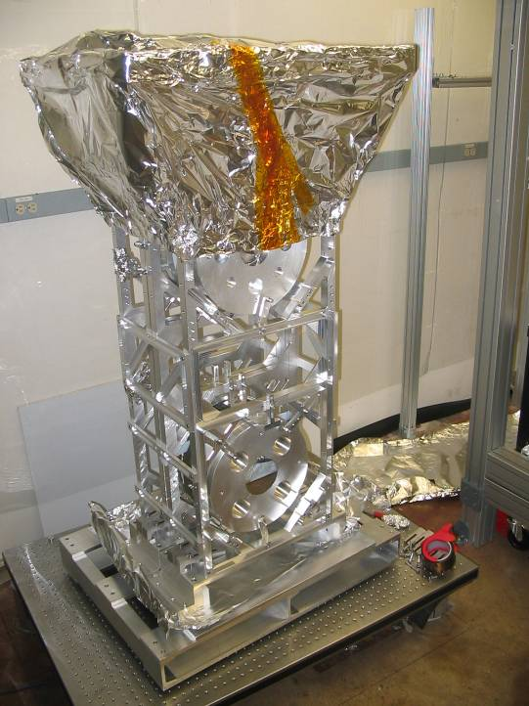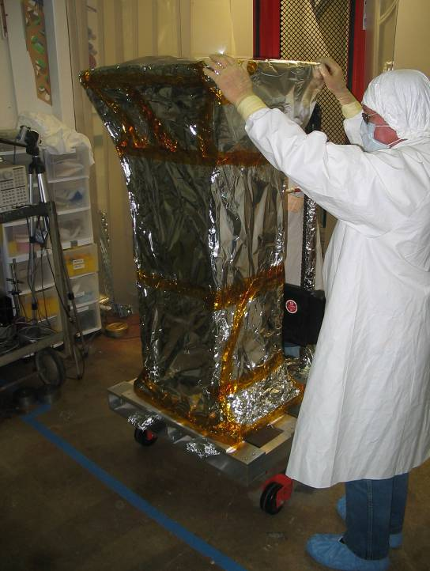
Figure 9 and 10: Lower structure and masses fully assembled and prepared for shipping CT)

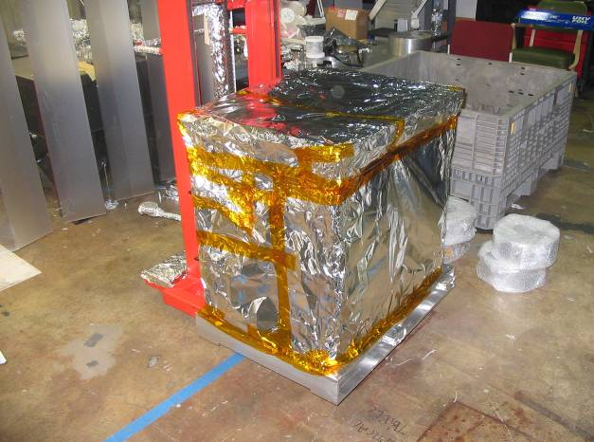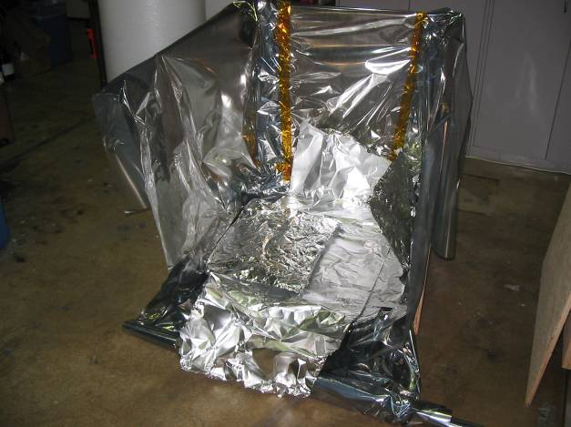
Figure 11 and 12 Upper structure wrapped and prepared for shipping, and its crate. (CT)

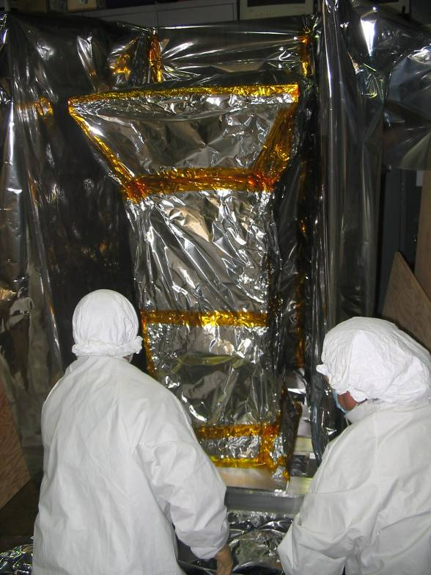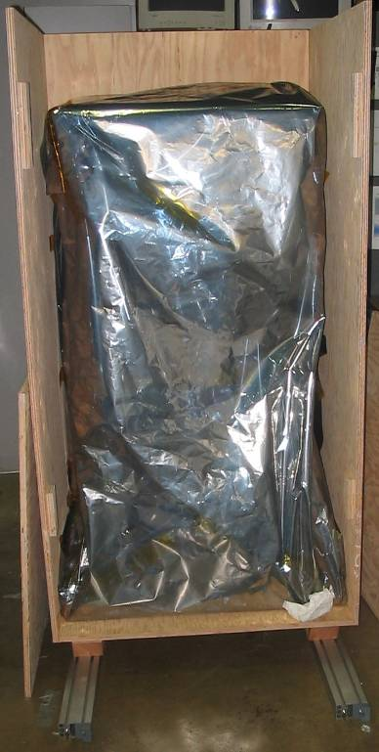

Figure 13 and 14: Lower structure moving into its crate and fully wrapped (CT)

APPENDIX 2 Repair (single chain removal)
In the process of the assembly of the quad at Caltech and LASTI we had to remove one half of the lower structure for the following repair jobs:
- Resoldering wires in the ESD at the test mass level.
- Replacing OSEMS and OSEM brackets at the UI stage
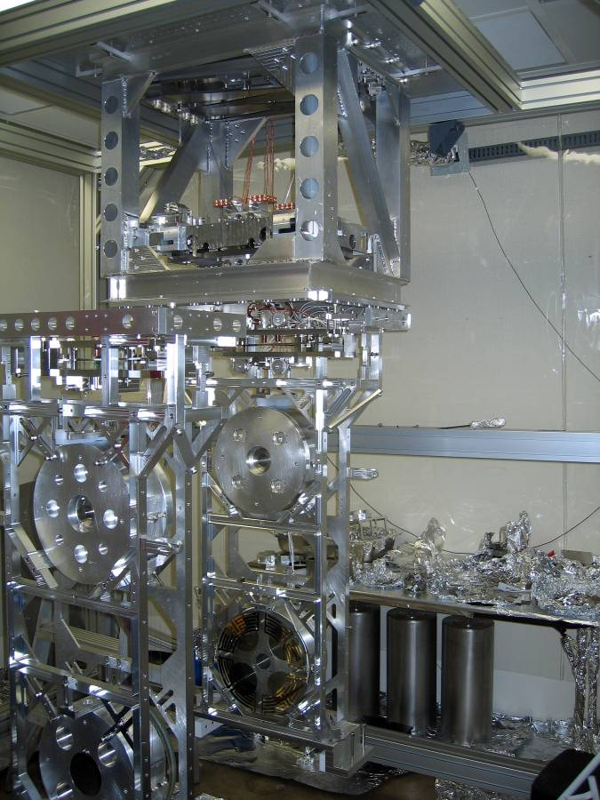
15
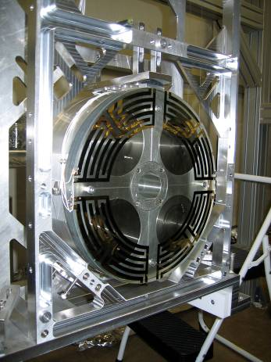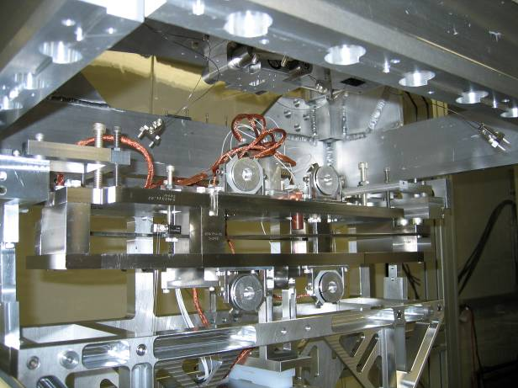
16 17

