TEMPERATURE STABILIZED ELECTRO-OPTIC MODULATOR:
THEORY OF OPERATION AND ASSEMBLY

DCC#: LIGO-E030494-00-D

Mike Marquez
Luke Williams

TABLE OF CONTENTS

Electrical System (Marquez)………………………………………3 - 21
Electronics Bill of Materials (Marquez)…………………………..22 - 25
Notes for Machinist (Williams)……………………………….……26
Assembly Instructions (Williams)…………………………………27 - 52

ELECTRICAL SYSTEM

RF MODULATION

The purpose of the electro-optic modulator (EOM) is to add upper and lower frequency sidebands (±ω_{r}) to the LIGO laser. The sidebands are produced when the laser passes through the RTP crystal. The RF power is amplified by a tuned LC circuit with a resonant frequency of approximately 180 MHz.

The RF section of the modulator is comprised of a 4-hole flange mount right angle SMA jack receptacle (Johnson Components 142-1711-001) mounted on the RF shield. The SMA connector is soldered to a toroid constructed from an Amidon Associates T-68-12 iron powder core. The toroid is wound with a 20 AWG enameled copper wire sheathed with Teflon tubing. The purpose of the Teflon tubing is to avoid arcing when large power levels are used to drive the modulator. The number of windings is approximately 5¼. The remaining side of the toroid is soldered to the copper plate (mechanical drawing #12, DCC#: LIGO-D030484-00-D) that is used to make electrical connection with the crystal. The crystal is held from below by an aluminum plate (mechanical drawing #9, DCC#: LIGO-D030481-00-D), which is connected to the ground of the SMA connector. The resonant frequency is determined by the inductance of the toroid, the capacitance of the crystal, and the parasitic capacitances of the circuit and enclosure. This resonant frequency can be tuned by “tweaking” the spacing between the windings of the toroid.

TEMPERATURE CONTROL

The temperature control circuitry is designed to maintain the RF shield of the modulator at a temperature near 303 K and stable within 0.010 K. The control circuitry consists of the following main components: thermistor bridge, instrumentation amplifier, PI controller, high current unity gain amplifier, and thermoelectric coolers.

Thermistor Bridge

There are two thermistor bridges attached to the RF shield of the modulator. One is attached to the bottom of the RF shield. The other is attached to the top. Either one of the two bridges can be used to control the feedback circuitry. The other is available for out-of-loop measurements. The schematic and PCB layout for the thermistor bridge can be found in the Orcad Designs folder under Thermistor Bridge/Version2/Rev1. The schematic project file is named THERMISTOR_BRIDGE_V2_R1.opj and can be opened and edited in Orcad Capture CIS. The layout file is named THERMISTOR_BRIDGE_V2_R1.MAX and can be opened and edited using Orcad Layout Plus.

Figure 1 depicts the schematic for the thermistor bridge. P1 and P2 are individual pads on the PCB board to make wire connections to a power supply. P1 and P2 should be connected to a +12V source. Capacitor C1 serves as a bypass to non-DC noise on the supply line. R1 and R2 form the sensing leg of the thermistor bridge. R1 is the thermistor. The thermistor used is a BC Components 2322 640 55104 NTC thermistor available from Digikey (BC1490-ND). R2 is a Digikey P100KFCT-ND. The relationship between the thermistor’s resistance and its temperature can be approximated by the following exponential equation:

R_{t}=R₀e^{β(1/T-1/To)}

where R₀ is the resistance at 298 K, β is a material constant, T is the temperature of the thermistor, and T₀ is 298 K. For the BC Components 2322 640 55104 NTC thermistor used in the bridge R₀=100kΩ +/-1% and β=4190K ±1.5%. At 303 K the resistance of the thermistor is approximately 80kΩ.

The voltage V_{th} on the sensing leg can be calculated by applying voltage division to that leg and is:

V_{th}= (R2/(R1+R2))*V_{S}

Since R1 is a function indirectly related to the temperature, V_{th} increases with temperature.

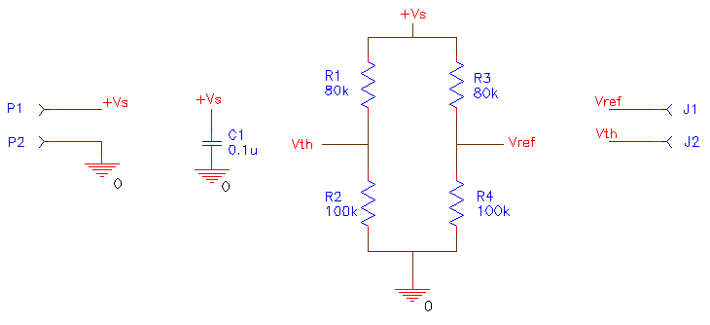
Figure 1. Schematic of Thermistor Bridge.

Resistors R3 (Digikey P80.6KFCT-ND) and R4 (Digikey P100KFCT-ND ) form the reference leg of the bridge. The voltage V_{ref} is given by:

V_{ref}= (R4/(R3+R4))*V_{S}

and is constant. When R1 is at 303 K and equals 80kΩ the voltages V_{th} and V_{ref} will be equal. These two voltages are then measured off the individual pads J1 and J2.

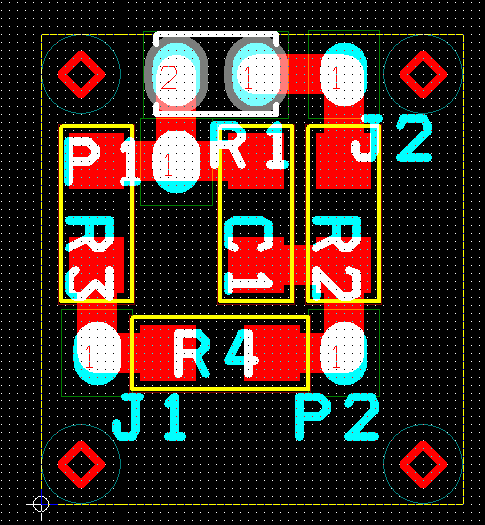

Figure 2. Thermistor bridge (enlarged view).

An enlarged view of the bridge is depicted in Figure 2. The actual board measures 0.530” by 0.590”. The blue represents the top layer of a two-layer board. The red is the bottom layer. The thermistor is loaded from the bottom side. All other components are loaded from the top.

Instrumentation Amplifier

The purpose of the instrumentation amplifier is to take the output signals, V_{ref} and V_{th}, from the two thermistor bridges and provide an initial gain of 21 V/V. The instrumentation amplifier is included above the thermal shield, inside a sheet metal housing. This is to keep it as close as possible to the bridges in an effort to reduce noise pickup. The schematic and PCB layout for the instrumentation amplifier can be found in the Orcad Designs folder under \Instrumentation Amplifier\Version2\Rev1. The schematic project file is named Instrumentation_Amplifier_V2.opj and can be opened and edited in Orcad Capture CIS. The layout file is named INSTRUMENTATION_AMPLIFIER_V2.MAX and can be opened and edited using Orcad Layout Plus.

The instrumentation amplifier includes on board power supply filtering and voltage regulation. The schematic for this section of the board is depicted in Figure 3.

P1 is a three pin Molex Series 6373 vertical friction lock header (Digikey WM2701-ND) used to bring positive and negative 15V power supplying sources and a ground connection to the board. R1 and R3 (Digikey 10.0XBK-ND) are used for power supply decoupling. Note: Not shown on the schematic are ferrite beads (Digikey M2306-ND) that are placed on the leads of R1 and R3 to provide inductive coupling. One ferrite bead should be placed on each lead of R1 and R3.

C1 and C5 (Digikey P4910-ND) are used for supply bypassing at the input of voltage regulators U1 (Digikey LM340T-12) and U2 (Digikey LM320T-12). R2 and R4 (Digikey 1.00KXBK-ND) are used to provide a sufficient load to U1 and U2 so that they do not become unstable. C2 and C6 (Digikey P10987-ND) provide board wide power supply bypassing. C3, C4, C7 and C8 (Digikey P4910-ND) provide local bypassing for each of the power supply pins of U3 and U4.
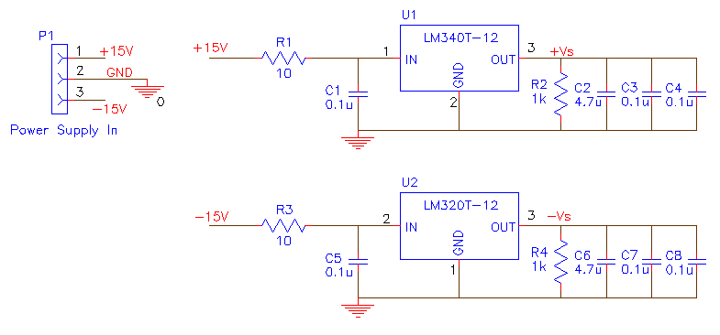
Figure 3. Schematic of power supply filtering and voltage regulation on instrumentation amplifier.

P2 and P3 are two pin Molex Series 6373 vertical friction lock headers (Digikey WM2700-ND) used to provide the positive +12V bias voltage for each of the two thermistor bridges individually. J1 and J3 (Digikey WM2700-ND) bring the V_{th} and V_{ref} voltage from each thermistor bridge to their respective instrumentation amplifier. U3 and U4 (Analog Devices AD620BN) are instrumentation amplifiers whose gain is set for each by an individual resistor across pins 1 and 8. Resistors R5 and R6 (Caddock Electronics TN130-2.49K-0.025%-05PPM) set the gain for U3 and U4, respectively, by the following relationship:

G = (49.4 kΩ/R) +1

For R5 and R6 equal to 2.47kΩ, G is approximately 21 V/V. R5 and R6 are Type TN Lab Grade Low TC Precision Film Resistors specifically developed for use in 0°C to +70°C applications which require a low temperature coefficient (5 ppm/°C ) and a high degree of precision (±0.025%). The voltage at the reference terminals (pins 5) of U3 and U4 define the zero output voltage. By grounding these pins, the output of U3 and U4 is ideally 0V when their respective input voltages, V_{th} and V_{ref}, are equal (i.e. no error).

J2 and J4 are two pin Molex Series 6373 vertical friction lock headers (WM2700-ND) used to provide the output of the instrumentation amplifiers to the input of the PI controller board.
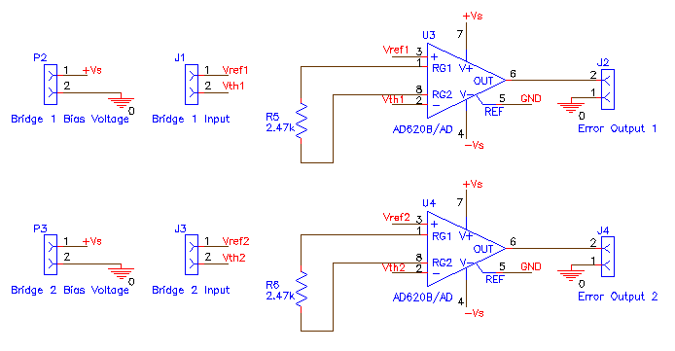
Figure 4. Schematic of instrumentation amplifier.

The instrumentation amplifier board is depicted in Figures 4 and 5. The actual board measures 2.1” by 3.2”. The blue represents the top layer of a two-layer board. The red is the bottom layer. All components are loaded from the top.

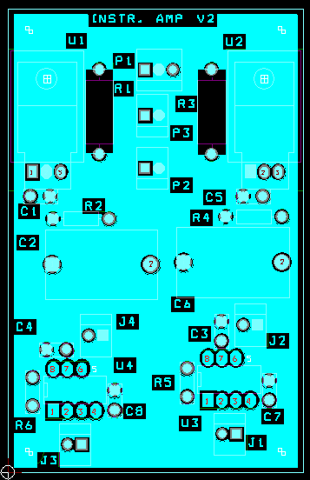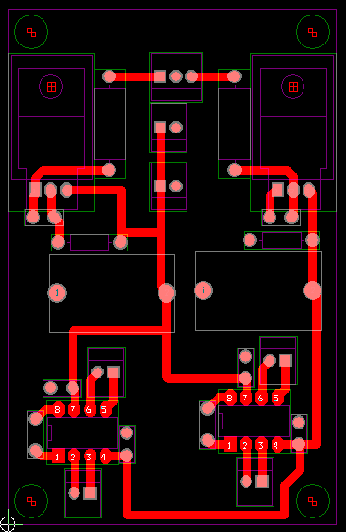

Figure 5. Instrumentation amplifier board.

PID Controller

The purpose of the PID controller is to take the amplified error output signal of one channel of the instrumentation amplifier and process that signal by providing proportional (P), integral (I), and derivative (D) gain. Numerous experiments as of the writing of this document indicate a proportional gain, K_{p}, setting of about 5 and a integral gain, K_{i}, setting of about a 1 s time constant provide reasonably good results. No good results have yet been achieved with differential gain, K_{d}. The PID controller is located outside the modulator’s thermal shield and is connected to the output of the instrumentation amplifier via cable. The schematic and PCB layout for the instrumentation amplifier can be found in the Orcad Designs folder under \PID Controller\Version 1\Rev1. The schematic project file is named PID Controller.opj and can be opened and edited in Orcad Capture CIS. The layout file is named PID CONTROLLER.MAX and can be opened and edited using Orcad Layout Plus.

The PID controller includes on board power supply filtering and voltage regulation. The schematic for this section of the board is depicted in Figure 6.

P1 is a three pin Molex Series 6373 vertical friction lock header (Digikey WM2701-ND) used to bring positive and negative 15V power supplying sources and a ground connection to the board. R1 and R3 (Digikey 10.0XBK-ND) are used for power supply decoupling. Note: Not shown on the schematic are ferrite beads (Digikey M2306-ND) that are placed on the leads of R1 and R3 to provide inductive coupling. One ferrite bead should be placed on each lead of R1 and R3.

C1 and C8 (Digikey P4910-ND) are used for supply bypassing at the input of voltage regulators U1 (Digikey LM340T-12-ND) and U2 (Digikey LM320T-12-ND). R2 and R4 (Digikey 1.00KXBK-ND) are used to provide a sufficient load to U1 and U2 so that they do not become unstable. C2 and C9 (Digikey P10987-ND) provide board wide power supply bypassing. C3, C4, C5, C6, C7, C10, C11, C12, C13 and C14 (Digikey P4910-ND) provide local bypassing for each of the power supply pins of U3, U4, U5, U6 and U7.
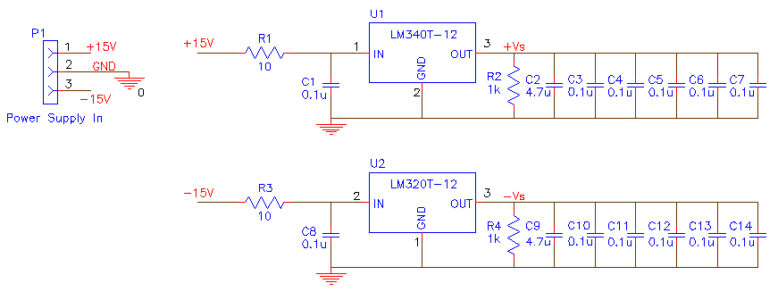
Figure 6. Schematic of power supply filtering and voltage regulation on PID controller.

J1 is a two pin Molex Series 6373 vertical friction lock header (WM2700-ND) used to bring in the amplified error signal from the output of the instrumentation amplifier into the PID controller for signal processing. U3 is an Analog Devices OP-27GP operational amplifier (Newark 79C3751) combined with R5 (Digikey 100KXBK-ND) to form a unity gain voltage follower. The purpose of this circuit is to avoid loading the output of the instrumentation amplifier.

J2, J3, and J5 (Digikey WM6503-ND) are jumpers used to independently connect the individual proportional, integral, and/or differential gain stages to the input error signal or to a null value (GND).

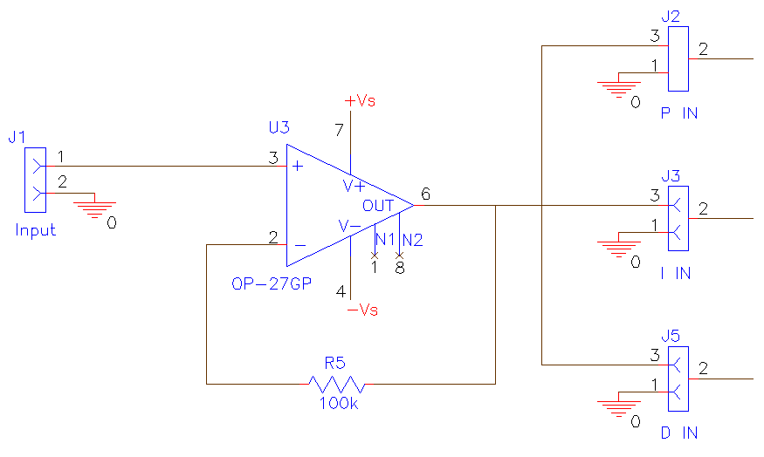
Figure 7. Schematic of unity gain voltage follower for input error signal.

U4 (Newark 79C3751), R6 (Digikey 100KXBK-ND), R7 (Digikey 499KXBK-ND), and R8 (Digikey 499KXBK-ND) form an inverting amplifier and comprise the proportional gain portion of the PID controller. The gain of this circuit is given by:

G=-R7/R6

Resistor R8 is added and set to the same value as R7 for the purpose of offsetting the effect of the op amp’s input current. The values for R6, R7, and R8 shown in the figure are to set the proportional gain to approximately 5 V/V. This is the value that provided reasonable good results during experimental trials.

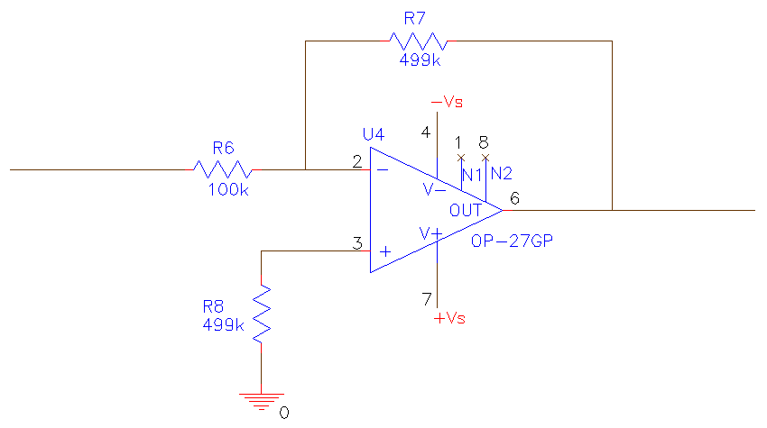
Figure 8. Schematic of proportional gain stage on PID controller.

Figure 9 depicts the integral gain stage of the PID controller. The topology of the circuit is taken from the IC Op-Amp Cookbook (3rd Edition) by Walter G. Jung.

U5 (Analog Devices AD548KN, Newark 66F6727) , C15 (Digikey P10979-ND), R9 (Digikey 9.09KXBK-ND), R10 (Digikey 1.00KXBK-ND), R11 (Digikey 174KXBK-ND), and J4 (Digikey WM6502-ND) form the integral gain stage of the PID controller. Resistors R9, R10, and R11 form a T network used to obtain an integral time constant that is larger than what would be possible with a single resistor. This is partly due to the fact that a resistor with a very large value may be shunted by the parasitic resistance of the printed circuit board. Also large capacitances in the feedback of the op amp may also cause problems. The gain for this circuit is:

G=-1/(R_{e}*C15*s)

where R_{e}= (R9*R10 + R9*R11 + R10*R11)/R10

For the values shown in the figure, R_{e}=1.765MΩ and G=-0.567/s.

Jumper J4 allows the integrating circuit to be reset whenever it is switched out of the circuit. Theoretically, the integrator would maintain a constant value over periods where its input was set to zero. However in practice, leakage currents cause C15’s charge to change while the input of the integrator is set to zero. To offset this behavior, whenever the integrator is switched out of the PID control loop, C15 should be shorted with a jumper to discharge the capacitor.

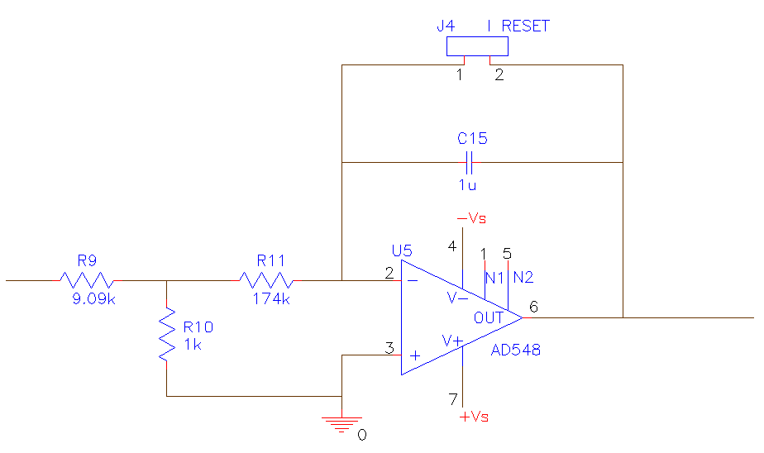
Figure 9. Schematic of integral gain stage of PID controller.

Figure 10 depicts the differential gain stage of the PID controller. The topology of the circuit is taken from the IC Op-Amp Cookbook (3rd Edition) by Walter G. Jung. NOTE: As of the writing of this document, the differential stage has not been successfully tuned during experimentation and the depicted circuit and the associated component values are meant only to serve as a starting point.

U6 (National Semiconductor LF356N, Digikey LF356N-ND), C16 (Digikey EF1106-ND), C17 (Digikey 1309PH-ND), R12 (Digikey 15.0XBK-ND), and R13 (Digikey 866KXBK-ND) comprise the differential gain stage of the PID controller. The basic configuration of the differentiator would be comprised only of C16 and R13. The gain equation for this basic form is:

G=-R13*C16*s

However in this basic form the differentiator is susceptible to stability and noise problems. The stability problem is dealt with by adding resistor R12 to form a resistive “stop”. The value of R12 is chosen so that it is 3.16 times the reactance of C16 at the frequency, f₀, where the 1/β line intersects the gain curve, or:

R12=3.16/(2*PI*f₀*C16)

The noise problem arises as a result of the rise in gain with increasing frequency. This results in a great increase in high frequency noise. This noise problem is dealt with by adding C17 such that its reactance is equal to the resistance of R13 at a specified crossover frequency of f_{C}, or:

C17=1/(2*PI*f_{C}*R13)

A more thorough discussion of the integral and differential gain circuits can be found in the IC Op-Amp Cookbook (3rd Edition) by Walter G. Jung.

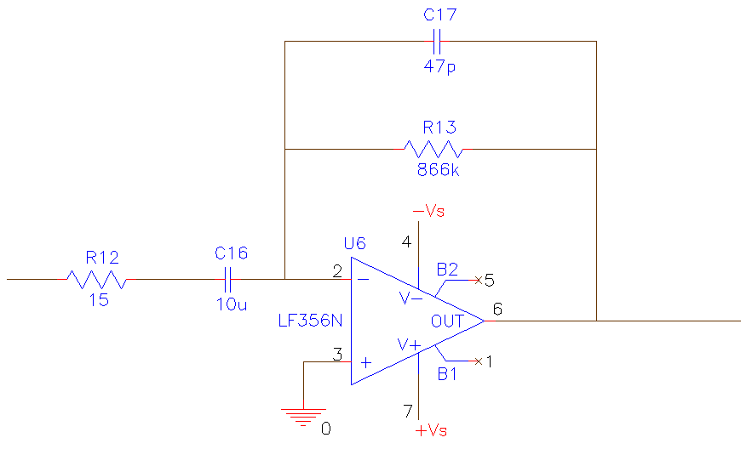
Figure 10. Schematic of derivative gain stage of PID controller.

The output stage of the PID controller is depicted in Figure 11. This circuit uses U7 (Analog Devices OP27GP, Newark 79C3751) in an inverting summer configuration.

The outputs of the proportional, integral, and differential gain stages are connected to R14 (Digikey 100KXBK-ND), R15 (Digikey 100KXBK-ND), and R16 (Digikey 100KXBK-ND), respectively. J6 (Digikey WM6806-ND) is a dual row breakaway header that allows each of the three individual signals to be added to the output independently.

The gain of the output stage, assuming all gain stages are connected, is:

V_{OUT} = - ( (R17/R14)*V_{P} + (R17/R15)*V_{I} + (R17/R16))*V_{D})

R18 (Digikey 100KXBK-ND) is added and set to the same value as R17 (Digikey 100KXBK-ND) for the purpose of offsetting the effect of the op amp’s input current. The values for R14, R15, R16, R17, and R18 shown in the figure are set such that:
V_{OUT} = - ( V_{P} + V_{I} + V_{D})

J7 (Digikey WM2700-ND) is the output connector of the PID controller and is connected to the input of the high current unity gain amplifier.
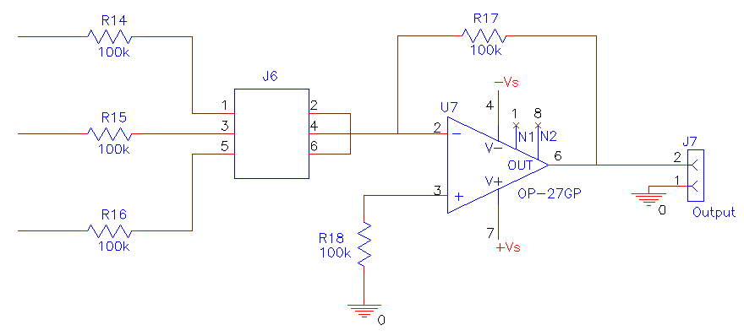
Figure 11. Schematic of the output stage of the PID controller.

The PID controller is depicted in Figures 12 and 13. The actual board measures 5.0” by 4.0”. The blue represents the top layer of a two-layer board. The red is the bottom layer. All components are loaded from the top.

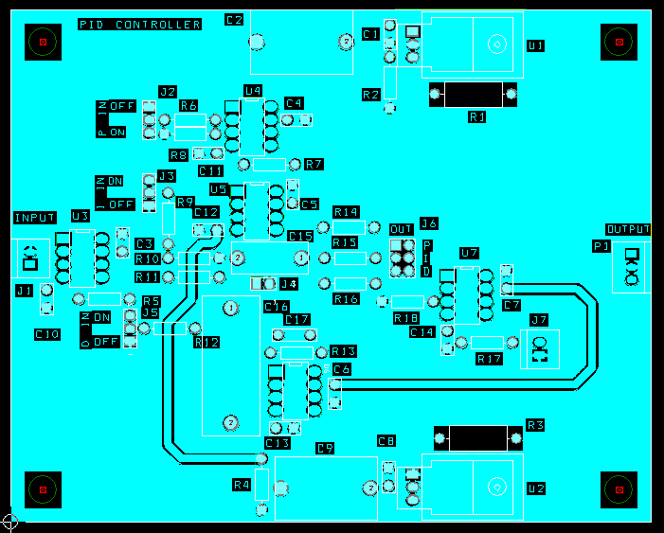

Figure 12. Top of PID controller board.
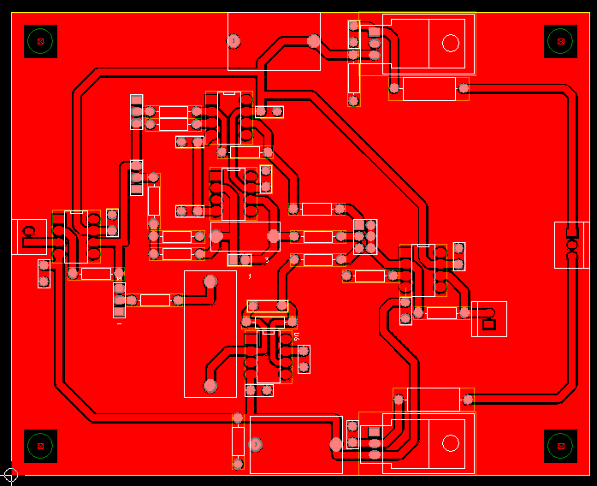

Figure 13. Bottom of PID controller board.

High Current Unity Gain Amplifier

The purpose of the High Current Unity Gain Amplifier is to serve as an output stage so that the control signal output of the PID controller is provided to the thermoelectric coolers at the required higher current (up to 3A). The schematic and PCB layout for the amplifier can be found in the Orcad Designs folder under \High Current Unity Gain Amplifier\Version 1\Rev 1. The schematic project file is named HIGH_CURRENT_UNITY_GAIN_AMPLIFIER.OPJ and can be opened and edited in Orcad Capture CIS. The layout file is named HIGH_CURRENT_UNITY_GAIN_AMPLIFIER.MAX and can be opened and edited using Orcad Layout Plus.

Figure 14 depicts the power supply decoupling and bypassing portion of the amplifier board. P1 and P2 (Pomona 3267) bring in the positive and negative power supplies onto the board. The maximum ratings are ±30V. However, due to limitations on the ability to remove heat from U1, smaller power supply values should be used. Since the thermoelectric cooler load is about 5Ω and has a maximum current rating of about 3.6A, the power supply rails should be limited to no more than ±15V. In fact a lesser value should be used to avoid thermal runaway of the thermoelectric coolers. Thermal runaway occurs when the thermoelectric cooler, in an attempt to cool, generates more heat than it is capable of removing from the system.

P3 (Pomona 3267) is the ground connection. L1 and L2 (Newark 50B3457) are ferrite beads used as wideband chokes. C3 and C5 (Digikey P10987-ND) provide power supply bypassing at the board level. If these capacitors are not used, a substantial amount of AC noise will appear on the power supply pins of U1. C4 and C6 (P4910-ND) are used to provide bypassing immediately adjacent to the power supply pins of U1.
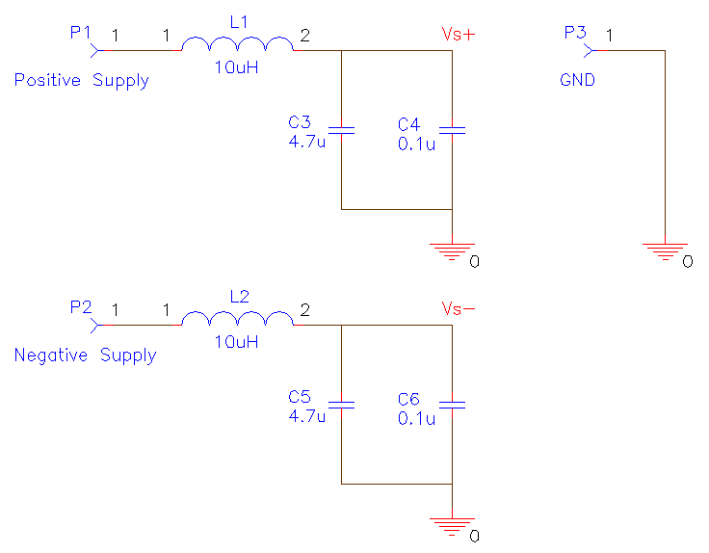
Figure 14. Schematic of power supply decoupling and bypassing portion of the amplifier board.

D1 and D2 (Digikey 1N4148DICT-ND) provide input voltage protection by restricting the input voltage at J1 to fall within the range of the positive and negative power supplies. J1, J2, J3 and J4 (Pomona 3267) form the input and output connections for the amplifier. U1 is a power operational amplifier (National Semiconductor LM675) capable of sourcing up to 3 A of current. The circuit configuration below places it in unity gain operation. Per the datasheet, the LM675 is not unity gain stable and requires outside compensation. Operation stability is provided by the addition of resistors R1, R2 and R3 and capacitors C1 and C2. As per the datasheet, R1 (Digikey 1.00KXBK-ND), R2 (Digikey 10.0KXBK-ND) and C1 (Digikey 1325PH-ND) are selected to meet the following two conditions:

R₁C₁ >= 1/(2* Π *500kHz)

R1<=(Rs+R2)/10

R3 (Digikey BC1.0W-2CT-ND) and C2 (Digikey E1224-ND) form an R-C "snubber" circuit that is specified on the datasheet for all circuit configurations that use the LM675. The circuit is needed to avoid oscillations under certain loading conditions.
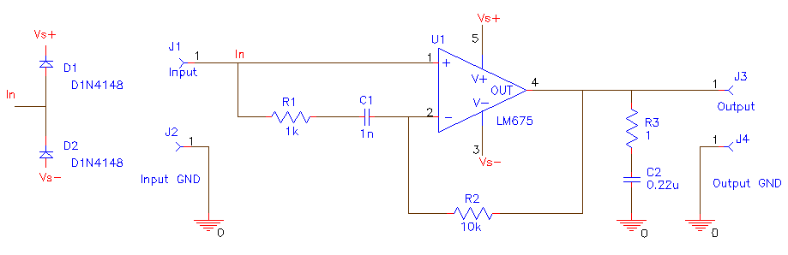

Figure 15. Schematic of high current unity gain amplifier.

Not shown on the schematic is the large required heat sink needed to remove heat from U1. Since U1 can be made to source up to 30 W, a rather large heat sink is required. The heat sink currently being used was purchased from a surplus vendor, Marlin. P. Jones and Associates, Inc. The catalog number of the heat sink is 14088 HS. Since this was a surplus part, there is no guarantee that it will be available in the future. If not, a suitable replacement that mates to a TO-220 package must be found. The heat sink should be at least as large as the current part. Since the predrilled holes on the current heat sink did not accommodate the small size of U1, a custom copper plate was made to serve as an adapter. In addition, silicon thermal grease was applied to all mating surfaces. Note: Failure to remove the heat from U1 quickly enough will cause the part to not function properly. This can be observed by measuring the voltage from the output to the input with a digital multimeter. Ideally the unity gain amplifier will have a 0 V voltage difference across these two nodes. In practice, under proper operating conditions there will be a very small voltage difference. When U1 overheats, a significant voltage difference will result. The output voltage may even differ in sign from the input voltage. Generally speaking, the output voltage will not track the input voltage.

The High Current Unity Gain Amplifier is depicted in Figures 16 and 17. The actual board measures 4.25” by 4.0”. The blue represents the top layer of a two-layer board. The red is the bottom layer. All components are loaded from the top.

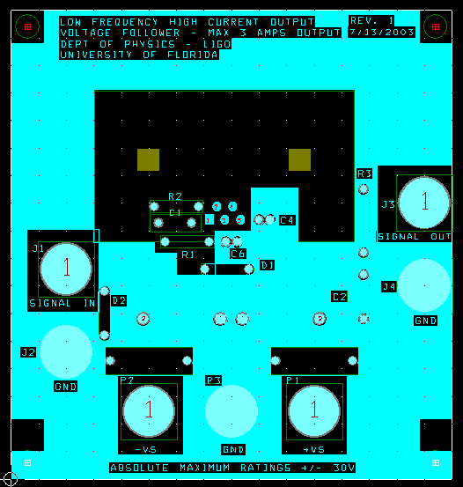

Figure 16. Top of high current unity gain amplifier board.
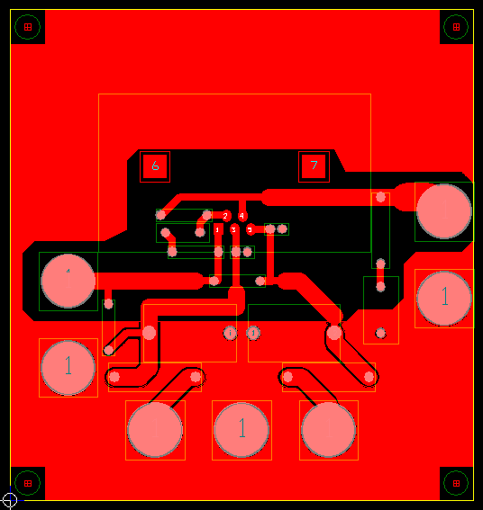

Figure 17. Bottom of high current unity gain amplifier board.

THERMOELECTRIC COOLERS

Two thermoelectric coolers (TE Technology, Inc. TE-63-1.4-2.5) are used to provide the necessary heating and cooling to the RF shield.

CABLING AND CHASIS

As of the time of this writing, a chassis has not been constructed and cabling has not been completed. However, a nearly comprehensive part list has been assembled.

The thermal shield of the modulator encloses the thermistor bridges and the thermoelectric coolers. The instrumentation amplifier is located directly above the thermal shield inside a sheet metal cover. The thermoelectric coolers are connected to the output of the high current unity gain amplifier via a red (Mouser Electronics 565-1581-2) and black (Mouser Electronics 565-1581-0) banana jack. The polarities of the jacks indicate the sign of the voltage to be applied to cool the RF shield.

It is envisioned that the chassis will house the main power supply, PID controller and high current unity gain amplifier. The connections from the chassis to the modulator utilize AMP CPC connectors. Both the modulator and the chassis will each have one CPC 9 pin square flanged receptacle (Digikey A1372-ND) mounted on them. A 9 pin cable will connect them utilizing two CPC 9 pin plugs (Digikey A1374-ND). The flanges will house 9 pins each (Digikey A1008-ND). The plugs will house 9 sockets each (Digikey A1009-ND). A CPC cable clamp/shell (Digikey A1330-ND) should be used on each flanged receptacle and plug to provide strain relief.

The pin assignments are as follows:

1 Thermistor* Pin #1
2 Channel 1 Signal
3 Thermistor* Pin #2
4 Channel 1 GND
5 Channel 2 GND
6 Channel 2 Signal
7 –15V In
8 +15V In
9 GND (Power)

*For optional use with Wavelength Electronics HTC3000 Controller

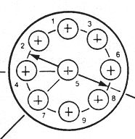

Figure 18. Pin numbers on AMP CPC connector.

A dual power supply (Newark 48F6001) capable of sourcing +15V at 3A and -15V at 3A will be used to power both the temperature control circuits and thermoelectric coolers. A chassis large enough to accommodate the power supply, the PID controller and the high current unity gain amplifier may be purchased (Newark 87F1788) or constructed. A combined line switch/filter/fuse module (Newark 17B7605) will be included on the chassis.

The details of the remaining wiring is not yet known. However the following parts will need to be included: 8 Molex two position connector housings (Digikey WM2011-ND), 2 Molex three position connector housings (Digikey WM2012-ND), 22 female connector terminals (Digikey WM2312-ND), 5 red banana plugs (Mouser Electronics 565-1825-2) and 4 black banana plugs (Mouser Electronics 565-1825-0).

Temperature Stabilized Modulator Electrical Components Estimated Bill of Materials
RF Section
 |  |  |  | Unit |  | Part
Part Reference | Qty | Vendor | Part Number | Price |  | Price
J1 | 1 | Electronic Hardware, LTD | JO-142-1711-001 | 18.000 |  | $ 18.00
L1 | 1 | Amidon Inductive Components | T-68-12 | 0.550 |  | 0.55
 |  |  |  |  |  | $ 18.55
Thermistor Bridge #1
 |  |  |  | Unit |  | Part
Part Reference | Qty | Vendor | Part Number | Price |  | Price
C1 | 1 | Digikey | PCC104BCT-ND | 0.343 |  | $ 0.34
J1 | 1 | N/A | N/A | - |  | -
J2 | 1 | N/A | N/A | - |  | -
P1 | 1 | N/A | N/A | - |  | -
P2 | 1 | N/A | N/A | - |  | -
R1 | 1 | Digikey | BC1490-ND | 1.910 |  | 1.91
R2,R4 | 2 | Digikey | P100KFCT-ND | 0.117 |  | 0.23
R3 | 1 | Digikey | P80.6KFCT-ND | 0.117 |  | 0.12
PCB Board | 1 | PCB Express | Express #1 Service (2 LAYER,0.59"L X 0.53"W, MIN ORDER) | 40.000 |  | 40.00
 |  |  |  |  |  | $42.60
Thermistor Bridge #2
 |  |  |  | Unit |  | Part
Part Reference | Qty | Vendor | Part Number | Price |  | Price
C1 | 1 | Digikey | PCC104BCT-ND | 0.343 |  | $ 0.34
J1 | 1 | N/A | N/A | - |  | $ -
J2 | 1 | N/A | N/A | - |  | $ -
P1 | 1 | N/A | N/A | - |  | $ -
P2 | 1 | N/A | N/A | - |  | $ -
R1 | 1 | Digikey | BC1490-ND | 1.910 |  | $ 1.91
R2,R4 | 2 | Digikey | P100KFCT-ND | 0.117 |  | $ 0.23
R3 | 1 | Digikey | P80.6KFCT-ND | 0.117 |  | $ 0.12
PCB Board | 1 | PCB Express | Express #1 Service (2 LAYER,0.59"L X 0.53"W, MIN ORDER) | 40.000 |  | $ 40.00
 |  |  |  |  |  | $ 42.60

Instrumentation Amplifier
 |  |  |  |  |  |  |  | Unit |  |  |  | Part
Part Reference | Qty |  | Vendor |  | Part Number |  |  | Price |  |  |  | Price
C1,C3,C4,C5,C7,C8 | 6 |  | Digikey |  | P4910-ND |  |  | 0.740 |  |  |  | $ 4.44
C2,C6 | 2 |  | Digikey |  | P10987-ND |  |  | 2.810 |  |  |  | 5.62
J1,J2,J3,J4,P2,P3 | 6 |  | Digikey |  | WM2700-ND |  |  | 0.620 |  |  |  | 3.72
P1 | 1 |  | Digikey |  | WM2701-ND |  |  | 0.950 |  |  |  | 0.95
R1,R3 | 2 |  | Digikey |  | 10.0XBK-ND |  |  | 0.108 |  |  |  | 0.22
R2,R4 | 2 |  | Digikey |  | 1.00KXBK-ND |  |  | 0.108 |  |  |  | 0.22
R5,R6 | 2 |  | Caddock Electronics |  | TN130-2.49K-0.025%-05PPM |  |  | 11.830 |  |  |  | 23.66
U1 | 1 |  | Digikey |  | LM340T-12-ND |  |  | 0.900 |  |  |  | 0.90
U2 | 1 |  | Digikey |  | LM320T-12-ND |  |  | 1.920 |  |  |  | 1.92
U3,U4 | 2 |  | Newark |  | 05F7110 |  |  | 8.500 |  |  |  | 17.00
Ferrite beads | 4 |  | Digikey |  | M2306-ND |  |  | 0.120 |  |  |  | 0.48
PCB Board | 1 |  | PCB Express |  | Express #1 Service (2 LAYER, 3.3"L X 2.1"W,MIN ORDER) |  |  | 40.000 |  |  |  | 40.00
 |  |  |  |  |  |  |  |  |  |  |  | $ 99.12
High Current Unity Gain Amplifier
 |  |  |  |  |  |  |  | Unit |  |  |  | Part
Part Reference | Qty |  | Vendor |  | Part Number |  |  | Price |  |  |  | Price
C1 | 1 |  | Digikey |  | 1325PH-ND |  |  | 0.140 |  |  |  | $ 0.14
C2 | 1 |  | Digikey |  | E1224-ND |  |  | 0.410 |  |  |  | 0.41
C3,C5 | 2 |  | Digikey |  | P10987-ND |  |  | 2.810 |  |  |  | 5.62
C4,C6 | 2 |  | Digikey |  | P4910-ND |  |  | 0.740 |  |  |  | 1.48
D1,D2 | 2 |  | Digikey |  | 1N4148DICT-ND |  |  | 0.230 |  |  |  | 0.46
J1,J2,J3,J4,P1,P2,P3 | 7 |  | Pomona Electronics |  | 565-3267 |  |  | 0.900 |  |  |  | 6.30
L1,L2 | 2 |  | Newark |  | 50B3457 |  |  | 0.300 |  |  |  | 0.60
R1 | 1 |  | Digikey |  | 1.00KXBK-ND |  |  | 0.108 |  |  |  | 0.11
R2 | 1 |  | Digikey |  | 10.0KXBK-ND |  |  | 0.108 |  |  |  | 0.11
R3 | 1 |  | Digikey |  | BC1.0W-2CT-ND |  |  | 0.320 |  |  |  | 0.32
U1 | 1 |  | Digikey |  | LM675T-ND |  |  | 5.680 |  |  |  | 5.68
Heat sink | 1 |  | Marlin. P. Jones & Assoc., Inc |  | 14088 HS |  |  | 1.950 |  |  |  | 1.95
PCB Board | 1 |  | PCB Express |  | Express #1 Service (2 LAYER,4.25"L X 4.00" W,MIN ORDER) |  |  | 45.000 |  |  |  | 45.00
 |  |  |  |  |  |  |  |  |  |  |  | $ 68.18
PID Controller
 |  |  |  |  |  |  | Unit |  |  |  | Part
Part Reference |  | Qty |  | Vendor |  | Part Number | Price |  |  |  | Price
C1,C3,C4,C5,C6,C7,C8,C10,C11,C12,C13,C14 |  | 12 |  | Digikey |  | P4910-ND | 0.740 |  |  |  | $ 8.88
C2,C9 |  | 2 |  | Digikey |  | P10987-ND | 2.810 |  |  |  | 5.62
C15 |  | 1 |  | Digikey |  | P10979-ND | 0.630 |  |  |  | 0.63
C16 |  | 1 |  | Digikey |  | EF1106-ND | 4.580 |  |  |  | 4.58
C17 |  | 1 |  | Digikey |  | 1309PH-ND | 0.072 |  |  |  | 0.07
J1,J7 |  | 2 |  | Digikey |  | WM2700-ND | 0.620 |  |  |  | 1.24
J2,J3,J5 |  | 3 |  | Digikey |  | WM6503-ND | 0.350 |  |  |  | 1.05
J4 |  | 1 |  | Digikey |  | WM6502-ND | 0.310 |  |  |  | 0.31
J6 |  | 1 |  | Digikey |  | WM6806-ND | 0.530 |  |  |  | 0.53
P1 |  | 1 |  | Digikey |  | WM2701-ND | 0.950 |  |  |  | 0.95
R1,R3 |  | 2 |  | Digikey |  | 10.0XBK-ND | 0.108 |  |  |  | 0.22
R2,R4,R10 |  | 3 |  | Digikey |  | 1.00KXBK-ND | 0.108 |  |  |  | 0.32
R5,R6,R14,R15,R16,R17,R18 |  | 7 |  | Digikey |  | 100KXBK-ND | 0.108 |  |  |  | 0.76
R7,R8 |  | 2 |  | Digikey |  | 499KXBK-ND | 0.108 |  |  |  | 0.22
R9 |  | 1 |  | Digikey |  | 9.09KXBK-ND | 0.108 |  |  |  | 0.11
R11 |  | 1 |  | Digikey |  | 174KXBK-ND | 0.108 |  |  |  | 0.11
R12 |  | 1 |  | Digikey |  | 15.0XBK-ND | 0.108 |  |  |  | 0.11
R13 |  | 1 |  | Digikey |  | 866KXBK-ND | 0.108 |  |  |  | 0.11
U1 |  | 1 |  | Digikey |  | LM340T-12-ND | 0.900 |  |  |  | 0.90
U2 |  | 1 |  | Digikey |  | LM320T-12-ND | 1.920 |  |  |  | 1.92
U3,U4,U7 |  | 3 |  | Newark |  | 79C3751 | 2.750 |  |  |  | 8.25
U5 |  | 1 |  | Newark |  | 66F6727 | 6.310 |  |  |  | 6.31
U6 |  | 1 |  | Digikey |  | LF356N-ND | 0.940 |  |  |  | 0.94
Ferrite beads |  | 4 |  | Digikey |  | M2306-ND | 0.120 |  |  |  | 0.48
PCB Board |  | 1 |  | PCB Express |  | Express #1 Service (2 LAYER, 5.0"L X 4.0"W,MIN ORDER) | 52.500 |  |  |  | 52.50
 |  |  |  |  |  |  |  |  |  |  | $ 97.11

Thermoelectric Cooler Section
 |  |  |  | Unit |  | Part
Part Reference | Qty | Vendor | Part Number | Price |  | Price
J1 | 1 | Mouser Electronics | 565-1581-2 | 0.950 |  | $ 0.95
J2 | 1 | Mouser Electronics | 565-1581-0 | 0.950 |  | 0.95
TEC1,TEC2 | 2 | TE Technology, Inc. | TM-TB-63-1.4-2.5 | 18.400 |  | 36.80
 |  |  |  |  |  | $ 38.70
CHASIS AND CABLING
 |  |  |  | Unit |  | Part
Part Reference | Qty | Vendor | Part Number | Price |  | Price
Connector Housing 2 Positions | 8 | Digikey | WM2011-ND | 0.210 |  | $ 1.68
Connector Housing 3 Positions | 2 | Digikey | WM2012-ND | 0.270 |  | 0.54
Connector Terminal Female | 22 | Digikey | WM2312-ND | 0.254 |  | 5.59
CPC 9 Pin Square Flanged Receptacle | 2 | Digikey | A1372-ND | 2.810 |  | 5.62
CPC 9 Pin Plug | 2 | Digikey | A1374-ND | 3.400 |  | 6.80
CPC Cable Clamp/Shell | 4 | Digikey | A1330-ND | 2.380 |  | 9.52
CPC Pin | 18 | Digikey | A1008-ND | 0.179 |  | 3.22
CPC Socket | 18 | Digikey | A1009-ND | 0.189 |  | 3.40
Banana Plug (Red) | 5 | Mouser Electronics | 565-1825-2 | 1.300 |  | 6.50
Banana Plug (Black) | 4 | Mouser Electronics | 565-1825-0 | 1.300 |  | 5.20
Banana Jack (Red) | 1 | Mouser Electronics | 565-1581-2 | 0.950 |  | 0.95
Banana Jack (Black) | 1 | Mouser Electronics | 565-1581-0 | 0.950 |  | 0.95
Dual Power Supply(+15V@3A,-15V@3A) | 1 | Newark | 48F6001 | 97.310 |  | 97.31
Line Switch/Filter/Fuse Module | 1 | Newark | 17B7605 | 17.030 |  | 17.03
Chasis | 1 | Newark | 87F1788 | 76.570 |  | 76.57
 |  |  |  |  |  | $ 240.88
 |  |  | GRAND TOTAL ELECTRONIC COMPONENTS |  |  | $ 647.74

NOTES FOR MACHINIST

- Do not assemble
- Green ink indicates threaded holes
- Pin holes are diameter .0625MIN, .0630MAX
- Pins are diameter .0626 to .0628, stainless steel
- Interference locational fits LN1
- Holes for 3/8th screws and pins are .200 deep, with .200 of joining material, leaving .025 length clearance

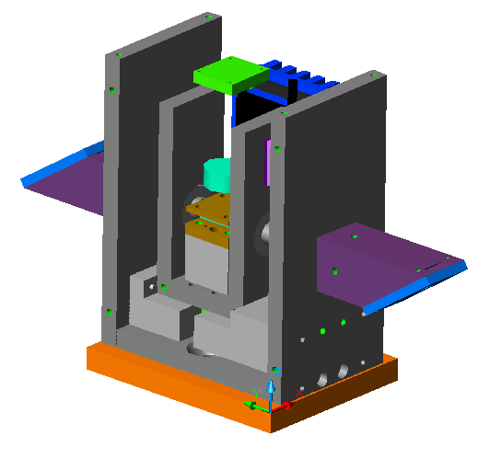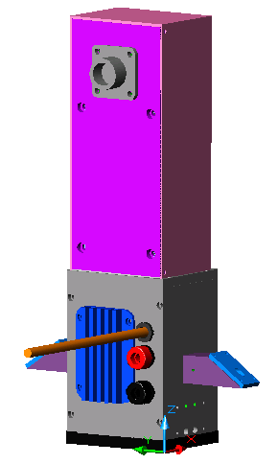
ASSEMBLY INSTRUCTIONS

This section of the manual explains how to assemble the EOM. The assembly begins at the bottom and ends at the top. There are two stages in the assembly process. In the first stage, parts are permanently attached, so a clear understanding of the instructions is crucial. In the second stage, the parts are not permanently attached, so mistakes can be remedied easily.

The following sections describe the CAD drawings of the parts, the fasteners used to assemble the EOM, the Five Axis Aligner, and the step-by-step assembly instructions.

Figure 19 below shows the assembled electro-optic modulator.

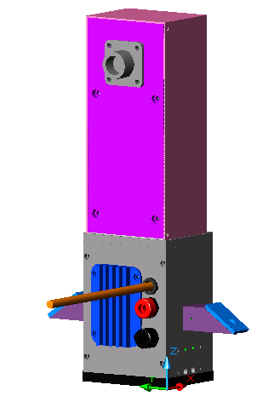
Figure 19. Assembled electro-optic modulator.

CAD DRAWINGS

The Mechanical Desktop drawings are located on the LIGO-MECHANICAL computer at the University of Florida. The assembly file, named assembly.dwg, is located in the folder electro-optic_modulator, which is in the desktop folder PROJECTS BY LUKE. The parts in the drawing are assembled in the same order, and with the same mating constraints, as the actual modulator. To view the constraints, click on the model tab (top left of screen) and then expand the parts tree as needed. Detailed drawings of the individual parts are in the parts folder. The detailed drawings are also available in the LIGO Document Control Center (DCC) in both PDF and DWG formats. The PDF versions do not print to the correct scale. Table 1 matches the part numbers used in this manual with the DCC numbers.

PART NAME | DRAWING NUMBER | DCC NUMBER
EOM Lower Temperature Shield | 1 | LIGO-D030472-00-D
EOM Front Temperature Shield | 2 | LIGO-D030473-00-D
EOM Temperature Standoff | 3 | LIGO-D030474-00-D
EOM Long Temperature Standoff | 4 | LIGO-D030475-00-D
EOM Lower RF Shield | 5a  and  5b | LIGO-D030476-00-D  and  LIGO-D030477-00-D
EOM Tube Insulator | 6 | LIGO-D030478-00-D
EOM SMA Shim | 7 | LIGO-D030479-00-D
EOM Crystal Standoff | 8 | LIGO-D030480-00-D
EOM Crystal Mount | 9 | LIGO-D030481-00-D
EOM Long Tube | 10 | LIGO-D030482-00-D
EOM Short Tube | 11 | LIGO-D030483-00-D
EOM Copper Plate | 12 | LIGO-D030484-00-D
EOM Upper RF Shield | 13 | LIGO-D030485-00-D
EOM Temperature Shield Side A | 14 | LIGO-D030486-00-D
EOM Temperature Shield Side B | 15a  and  15b | LIGO-D030487-00-D  and  LIGO-D030488-00-D
EOM Cold Sink Pad | 16 | LIGO-D030489-00-D
EOM Cold Sink | 17 | LIGO-D030490-00-D
EOM Upper Temperature Shield | 18 | LIGO-D030491-00-D
EOM Instrumentation Amplifier Pad | 19 | LIGO-D030492-00-D
EOM Instrumentation Amplifier Bracket | 20 | LIGO-D030493-00-D
EOM Instrumentation Amplifier Cover | 21 | LIGO-D030494-00-D
EOM Brewster Mount | 22 | LIGO-D030495-00-D
EOM Brewster Cover | 23 | LIGO-D030496-00-D

Table 1. DCC numbers for modulator parts.

FASTENERS

Several types of fasteners are used in the assembly. Unless otherwise stated, the screws are stainless steel #2-56 socket head cap screws. In the following instructions, these screws will be described only by their length. Other types of screws will be described explicitly when needed. Many parts are also connected by stainless steel, .0625” diameter pins. These pins will be described only by their length. Once the pins are pressed into place, they cannot be removed, so be careful.

FIVE AXIS ALIGNER

The base of the assembly is the Five Axis Aligner, made by New Focus (part # 9082). It is shown in figure 20. The aligner has two main parts, which can be separated at any time be loosening a set screw.
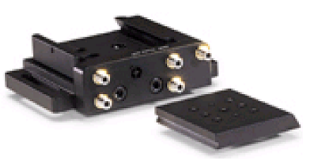
Figure 20. New Focus Five Axis Aligner (9082).

ASSEMBLY OF PERMANENTLY CONNECTED PARTS

STEP 1: Bolt the removable plate of the Five Axis Aligner to the lower temperature shield (drawing #1) with two ¼-20 X 3/8” slotted flat machine screws (see figure 21).
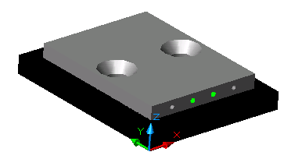
Figure 21. Lower temperature shield and removable plate from Five Axis Aligner.

Put these parts aside and get the Front and Rear Temperature Shields (drawing #2).

Also, get the Temperature Standoff (drawing #3) and the Long Temperature Standoff (drawing #4).

STEP 2: Loosely attach the standoffs to the temperature shields (non-counterbored side). The shorter standoff uses two ¼” screws. The longer standoff uses two 3/8” screws (see figure 22).

Permanently connect the front/rear temperature shields to the standoffs with 3/8” pins. Use a press to insert the pins. You may need to wiggle the temperature standoff to align the pinholes.

Tighten the loose screws.
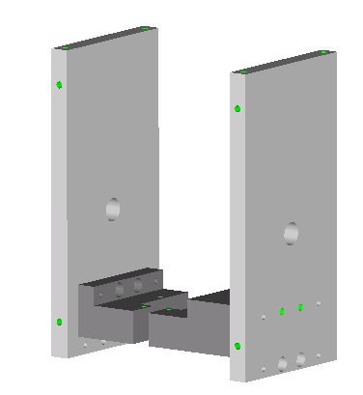
Figure 22. Temperature standoffs and front/rear temperature shields.

STEP 3: Loosely join the three subassemblies with four 3/8” screws.

Permanently connect the front and rear temperature shields to the lower temperature shield with four 3/8” pins.

Tighten the screws (see figure 23).
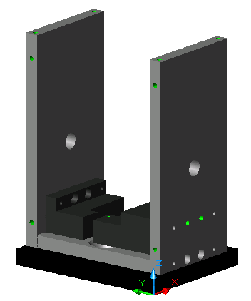

Figure 23. Front and rear temperature shields attached to lower temperature shield.

STEP 4: Set the assembly aside and get the Lower RF Shield (drawing #5) and a thermistor board.

There is a blind hole on the bottom of the lower RF shield. Fill the hole with thermal paste.

Put a piece of Kapton (slightly smaller than the thermistor board) on the RF shield to electrically insulate it from the thermistor board.

Place the thermistor board on the RF shield so that the thermistor fits into the blind hole. Wipe away any excess thermal paste.

Attach the board to the shield with four #0-80 X 3/8” socket head cap screws (see figure 24). The screws should be tight enough to make good thermal contact, but not so tight that the thermistor shatters.

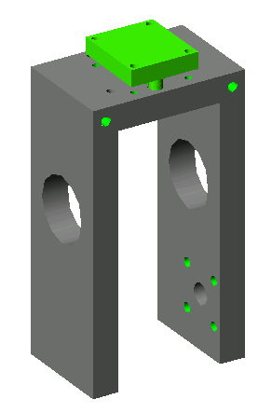
Figure 24. Thermistor board attached to lower RF shield.

STEP 5: Get two Tube Insulators (drawing #6) and put them in a freezer for an hour.

Take them out and insert them into lower RF shield (see figure 25). Use a press if necessary.

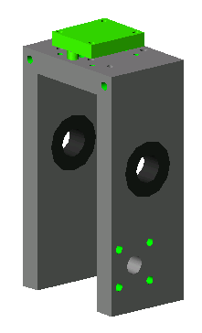
Figure 25. Tube insulators pressed into lower RF shield.

STEP 6: Get the Right-Angle SMA Connector (Johnson Components, part # 142-1711-001) and the SMA Shim (drawing #7).

Slide the shim onto the SMA connector and bolt it to the lower RF shield with two ¼” screws (see figure 26).

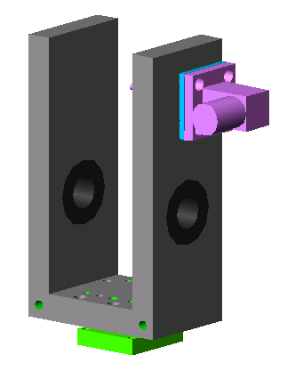
Figure 26. Right-angle SMA and shim bolted to lower RF shield.
STEP 7: Loosely bolt the lower RF shield to the temperature standoffs with two #0-80 X 3/8” socket head cap screws.

Permanently connect the lower RF shield to the temperature standoffs with two 3/8” pins.

Tighten the screws (see figure 27).

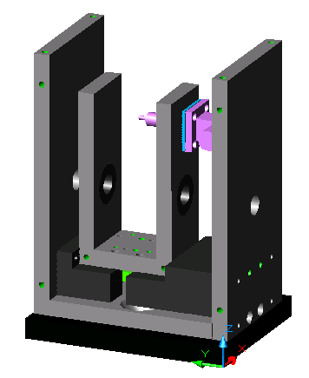
Figure 27. Lower RF shield attached to temperature standoffs.

STEP 8: Get the Crystal Standoff (drawing #8) and the Crystal Mount (drawing #9).

Loosely connect the crystal standoff and the crystal mount to the lower RF shield with two ¾” screws.

Permanently connect the three parts with two ¾” pins.

Tighten the screws (see figure 28).

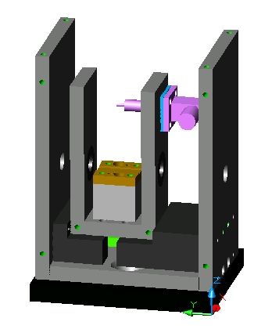
Figure 28. Crystal mount and crystal standoff joined to lower RF shield.

STEP 9: Get the upper temperature shield (drawing #18) and bolt it to the tops of the front rear temperature shields with four 3/8”screws (see figure 29). The purpose of this is to strengthen the assembly for the following step.

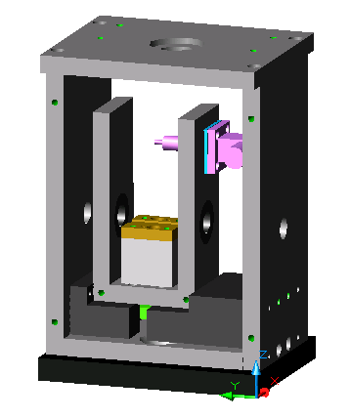
Figure 29. Upper temperature shield bolted to front and rear temperature shields.

STEP 10: Get the Long Tube (drawing #10) and the Short Tube (drawing #11).

Notice that the tubes each have two features on the outside. The first is a large groove and the second is a very small groove. The ends of the tubes that do not have grooves will be pressed into the holes in the front and rear temperature shields. The purpose of the very small grooves is to tell you when the tubes have been pressed in far enough. The small grooves should meet the outside surfaces of the front and rear temperature shields. If assembled correctly, the groove-less ends of the tubes will be 0.025” from the crystal mount. The long tube goes into the side with the SMA connector. Press the tubes in accordingly. Remove the upper temperature shield (see figure 30).

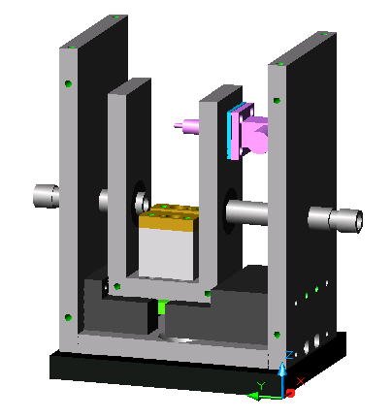
Figure 30. Long and short tubes pressed into assembly.

The basic chassis of the modulator is now assembled, and cannot be disassembled.

ASSEMBLY OF NON-PERMANENTLY CONNECTED PARTS

STEP 11: Assemble the custom toroid inductor based on the instructions in the electronics section of this manual.

Solder one end of the inductor to the pin on the right-angle SMA that is inside of the RF shield.

Solder the other end to the inductor to the Copper Plate (drawing #12).

Put the crystal into the crystal mount (center it) and bolt the copper plate over the crystal with four nylon #2-56 X 3/8” fillister head machine screws (see figure 31). The toroid inductor will probably be at an angle, rather than flat like the picture shows.

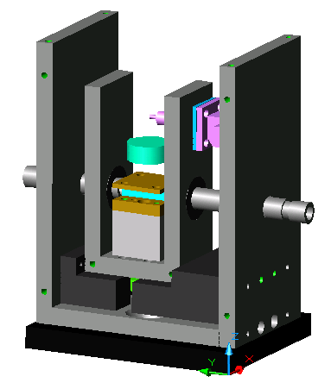
Figure 31. Copper plate and toroid inductor installed in RF shield.

STEP 12: Get the Upper RF Shield (drawing #13). Attach it to the lower RF shield with four 3/8” screws (see figure 32).

Attach the other thermistor board to the top of the RF shield (see step 4).

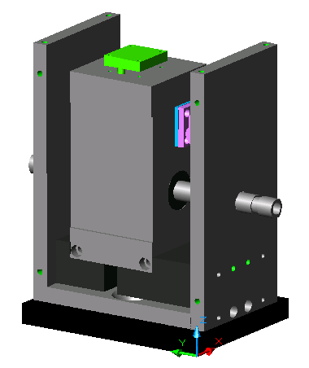
Figure 32. Upper RF shield and second thermistor.

STEP 13: Set the assembly aside and get the part Temperature Shield Side A (drawing #14). Also, get a red and a black banana jack (Mouser Electronics #565-1581-2 and 565-1581-0, retaining nuts included), two plastic washers (McMaster-Carr #95630A217), and two plastic shoulder washers (McMaster-Carr #91145A162).

Insert the shoulders into the .312” diameter holes, so that the flanges are on the same side as the pocket.

Insert the banana plugs into the flanged sides of the shoulders, with the red one higher (see figure 33). Place a plastic washer on each of the plugs threaded shafts, and then secure them with the retaining nuts.

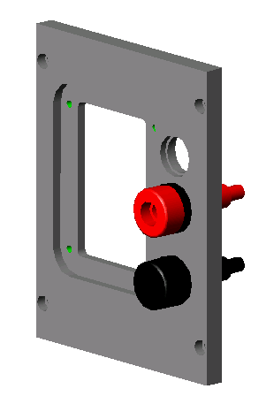
Figure 33. Banana plugs, shoulder washers, and plastic washers mounted to side A temperature shield.

STEP 14: Get a rubber grommet (McMaster-Carr #9311K77) and cut it down from an outside diameter of 0.625” to 0.425”.

Run the SMA cable through the grommet and then push the grommet through the counterbored hole on the side temperature shield (see figure 34). A small flat head screwdriver will help.

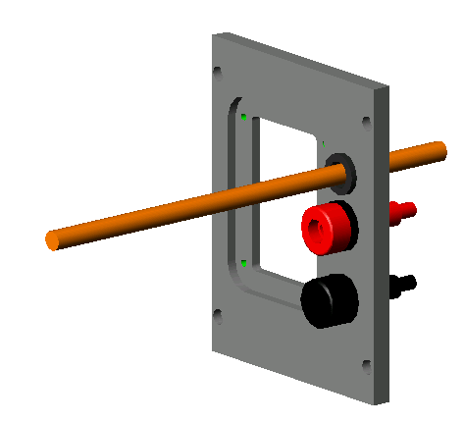
Figure 34. SMA cable and grommet in side temperature shield.

STEP 15: Get a peltier (thermo-electric) cooler (TE Technology #TM-TB-63-1.4-2.5) and stick it to the slot in the upper RF shield with a thin layer of thermal paste. The wires from the peltier cooler should face down, and the face closest to the wires should face away from the RF shield (see figure 35).

Solder the red wire on the peltier to the red banana plug in figure 34.

Thread the black wire under the long tube to the other side of the assembly.

Slide a piece of shrink rap down the black wire, and then solder the black wire to the red wire on a second peltier cooler.

Slide the shrink rap back over the joint and heat shrink it.

Thread the remaining black wire back to the first side and solder it to the black banana plug.

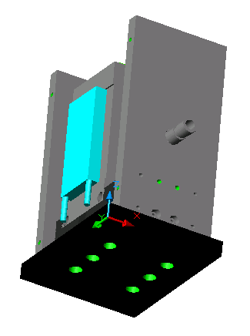
Figure 35. Peltier cooler stuck to RF shield with thermal paste.

STEP 16: Screw the SMA cable onto the SMA connector.

Attach the side temperature shield to the chassis with four 3/8” screws (see figure 36). The red and black wires from the lower thermistor bridge thread up beside the RF shield on the side with the short tube. The gray and brown wires thread up the side with the long tube.

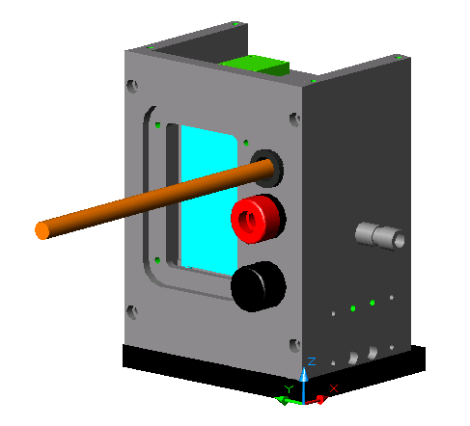
Figure 36. Side temperature shield A attached to chassis.

STEP 17: Get a Cold sink Pad (drawing #16) and a Cold Sink (drawing #17).

Put a light layer of vacuum grease on both sides of the cold sink pad and set it in the pocket of the side temperature shield.

Lightly coat the recessed part of the cold sink with thermal paste.

Put the cold sink into the pocket. Make sure that the peltier sits flush against both the cold sink and the RF shield.

Attach the cold sink to the side temperature shield with four ¼” screws (see figure 37). Do not tighten the screws unless the peltier is sitting flush, or it will crack. Tighten the screws in a star pattern (like changing a car tire). The peltier can handle 200 psi of clamping pressure as long as it is loaded evenly.

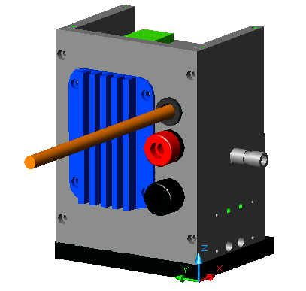
Figure 37. Cold sink and pad mounted to side A temperature shield and peltier cooler.

STEP 18: The second peltier cooler, Temperature Shield Side B (drawing #15), cold sink pad, and cold sink mount to the other side of the modulator in the same fashion (see steps 15-17 and figure 38).

Make sure that the wires on the second peltier face down, and are close to the face that is farthest away from the RF shield.

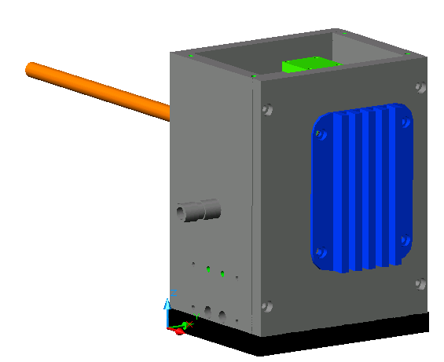
Figure 38. Cold sink and pad mounted to side B temperature shield and peltier cooler.

STEP 19: Get the upper temperature shield (drawing #18) and place a grommet (McMaster-Carr #9311K77) in the big hole (see figure 39).

Run the wires from the thermistor boards through the grommet.

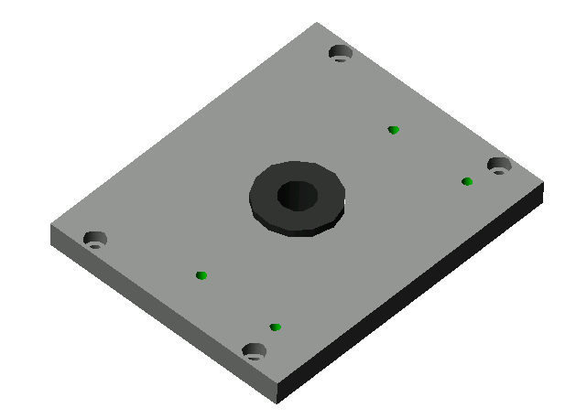
Figure 39. Grommet in upper temperature shield.

STEP 20: Attach the upper temperature shield to the chassis with four 3/8” screws (see figure 40). The four threaded holes should be on the opposite side from the SMA cable.

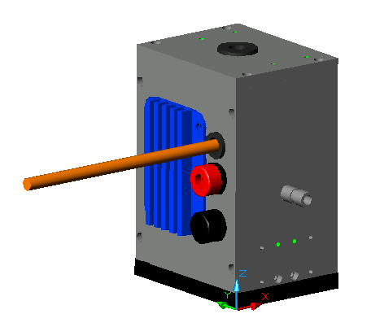
Figure 40. Upper temperature shield attached to chassis.
STEP 21: Get the I. A. pad (drawing #19) and the I. A. bracket (drawing #20).

Put the pad on top of the upper temperature shield, and then put the bracket on top of the pad.

Attach the bracket to the temperature shield with four 3/8” screws. The vertical face of the bracket should be on the same side as the SMA cable (see figure 41).

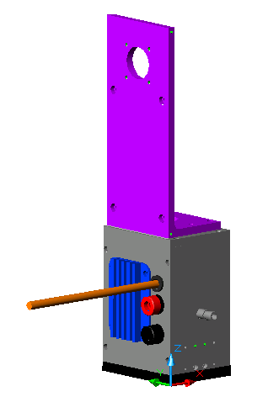
Figure 41. I. A. bracket and pad attached to upper temperature shield.

STEP 22: Attach four hexagonal nylon standoffs (McMaster-Carr #92745A320) to the I. A. bracket with four #4-40 X ¼” screws.

Place the instrumentation amplifier board on the standoffs (letters facing up, components facing out, see figure 42).

Attach the instrumentation amplifier board to the standoffs with four #4-40 nuts.

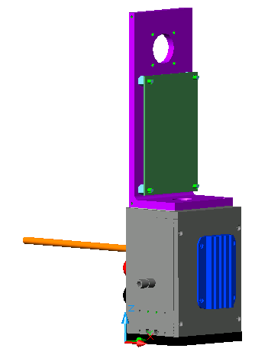
Figure 42. Instrumentation amplifier board and standoffs attached to I. A. bracket.

STEP 23: Attach the black plastic 9-pin AMP CPC connector (Digikey A1372-ND) to the I. A. bracket with four #4-40 X 3/8” screws (see figure 43).

Connect all the wires as described in the electronics section.

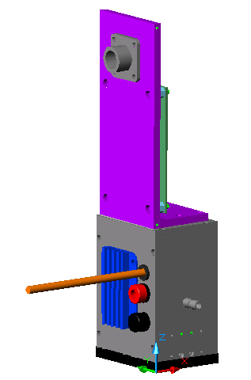

Figure 43. Nine pin plug attached to I. A. bracket.

STEP 24: Slide the I. A. Cover (drawing #21) over the I. A. bracket and attach it with four ¼” screws (see figure 44).

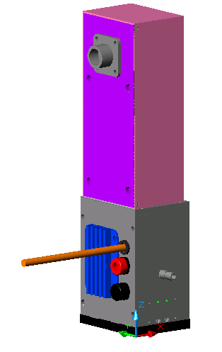
Figure 44. I. A. cover attached to I. A. bracket.

STEP 25: Get the Brewster Mount (drawing # 22), Brewster Window (CVI, part # BW-8.0-2.0-SS), and Brewster Cover (drawing # 23). Also, get some 1/32” thick neoprene.

Cut two rectangles out of the neoprene, each .125” X .325”.

Place the Brewster window in the Brewster mount, and put pieces of neoprene on top of the top and bottom edges of the Brewster window. Do not clean the neoprene with solvents, or it will become gooey and smear the window.

Place the Brewster cover on top and loosely attach it with four #0-80 X 3/16” socket head cap screws (see figure 45).

Look through the hole in the cover and make sure that the neoprene pads are not visible. Once they are adjusted out of view, gently tighten the screws until the window is securely clamped.

Make another Brewster window assembly by repeating step 25.

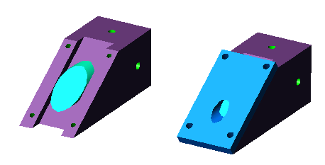
Figure 45. Brewster window and Brewster cover attached to Brewster mount.

STEP 26: Attach each Brewster mount to a tube on the chassis (see figure 46). Note that each mount has four available holes. Only two holes are needed, provided that they are perpendicular to each other. Use whichever holes are most convenient. The mounting screws are1/4” and fit into the large grooves on the tubes.

Figure 46. Fully assembled modulator.

The modulator is now fully assembled.

