LIGO Laboratory / LIGO Scientific Collaboration

LIGO-F1000025-v1 LIGO 19 April 2011

aLIGO SUS Quad Metal-Build Test Report Template

Mark Barton, Robert Lane

Distribution of this document:
LIGO Scientific Collaboration

This is an internal working note
of the LIGO Laboratory.

California Institute of Technology  LIGO Project – MS 18-34  1200 E. California Blvd.  Pasadena, CA 91125  Phone (626) 395-2129  Fax (626) 304-9834  E-mail: info@ligo.caltech.edu | Massachusetts Institute of Technology  LIGO Project – NW22-295  185 Albany St  Cambridge, MA 02139  Phone (617) 253-4824  Fax (617) 253-7014  E-mail: info@ligo.mit.edu
LIGO Hanford Observatory  P.O. Box 1970  Mail Stop S9-02  Richland WA 99352  Phone 509-372-8106  Fax 509-372-8137 | LIGO Livingston Observatory  P.O. Box 940  Livingston, LA 70754  Phone 225-686-3100  Fax 225-686-7189
http://www.ligo.caltech.edu/

Table of Contents
1 Introduction 3
1.1 Scope 3
1.2 References 3
1.3 Revision History 3
1.4 Acronyms 3
2 Traveler 5
3 Tests 5
3.1 OSEM and In-Vacuum Cabling Tests 5
3.2 Open-Light Counts and MEDM Input Screens. 6
3.3 Balancing 6
3.4 OSEM Adjustment 7
3.5 Actuator Sign Test - Top Masses 7
3.6 DOF Output Tests 7
3.7 DOF Input Tests 9
3.8 DOF Open Loop Tests 10
3.9 OSEM Basis Decoupling 10
3.10 DOF open Loop Step Tests 10
3.11 DOF Servo Stability Test 10
3.12 DOF Servo Step Test 10
3.12.1 M0 Servo Damping: 10
3.12.2 R0 Servo Damping: 12
3.13 Transfer Function Tests 14
3.13.1 MO TF 14
3.13.2 R0 TF 16
3.14 Range Tests 18
3.14.1 Pitch 18
3.14.2 Yaw 19
3.15 Post-ECD TF 19
3.15.1 M0 Post-ECD TF 19
3.15.2 R0 Post-ECD TF 21

Introduction

Scope
This document is a report of the tests conducted in order to verify that the metal build of each quad suspension was completed correctly. See E1000494, aLIGO SUS Quad Suspension Metal-Build Testing Procedure.

References
D080273: AdL SUS BSC Test Stand Wiring
E1000006: aLIGO Quad Suspension Metal-Build Assembly Procedure
E1000494: aLIGO SUS Quad Suspension Metal-Build Testing Procedure
E1000495: aLIGO SUS Quad Suspension Testing and Commissioning Documentation
E1000502: aLIGO SUS Test Stand Shakedown Procedure
E1000516: aLIGO SUS Quad Suspension Assembly Process Travelers
E1000517: aLIGO SUS Quad Suspension Metal Build Test Reports
E1000520: aLIGO SUS Quad Suspension Monolithic Build Testing Procedure
F1000008: Quad Suspension Process Traveler Template
F1100006: aLIGO SUS Quad Transfer Function Modes Template
M1000211: Subsystem-Level and System-Level Testing Requirements
T010007: Cavity Optics Suspension Subsystem Design Requirements Document
T010103: Advanced LIGO Suspension System Conceptual Design
T1000238: Quad Suspension AdvLIGO Test Plan (Obsolete)
T1100117: aLIGO SUS File/Directory Naming Convention

Revision History
3/2/2011 pre-version 1

Acronyms
Ag Silver
aLIGO Advanced Laser Interferometer Gravitational-Wave Observatory
COS Core Optics Support
CP Compensator Plate
DCC Document Control Center
DOF Degrees of Freedom
DTT Diagnostics Test Tool
ERM End Reaction Mass
LASTI LIGO Advanced System Test Interferometer
LED Light Emitting Diode
LHO LIGO Hanford Observatory
LIGO Laser Interferometer Gravitational-Wave Observatory
LLO LIGO Livingston Observatory
mA milli-Amp
MEDM Motif-based Display Editor and Manager
OSEM Optical Sensor Electromagnetic Motor
PD Photo Diode
PU Penultimate
PUM Penultimate Mass
S/N Serial Number
SS Stainless Steel
SUS Suspensions
TBD To Be Determined
TF Transfer Function
UI Upper Intermediate
UIM Upper Intermediate Mass

Traveler
Quad: N Traveler Number: E1000XXX

Tests

OSEM and In-Vacuum Cabling Tests
Cable P/N: S/N:
Cable P/N: S/N:
Cable P/N: S/N:
Cable P/N: S/N:

 | Pins | Cable 1 | Cable 2 | Cable 3 | Cable 4
RES (Ohms) | 1, 14
LED (V) | 15, 2
PD (V) | 3, 16
RES (Ohms) | 4, 17
LED (V) | 18, 5
PD (V) | 6, 19
RES (Ohms) | 7, 20
LED (V) | 21, 8
PD (V) | 9, 22
RES (Ohms) | 10, 23
LED (V) | 24, 11
PD (V) | 12, 25
Table 1 In-Vacuum Cabling Tests

Open-Light Counts and MEDM Input Screens.
The absolute value of the open-light counts should be greater than 25,000 Counts.
Record the OSEM serial numbers, open-light counts, the offset and gain applied in MEDM.
Location | BOSEM S/N |  | Location | BOSEM S/N |  | Location |  | BOSEM S/N |  | Location | AOSEM S/N
M0 Face1 |  |  | R0 Face1 |  |  | UI UL |  |  |  | PEN UL
M0 Face2 |  |  | R0 Face2 |  |  | UI UR |  |  |  | PEN UR
M0 Face3 |  |  | R0 Face3 |  |  | UI LL |  |  |  | PEN LL
M0 Left |  |  | R0 Left |  |  | UI LR |  |  |  | PEN LR
M0 Right |  |  | R0 Right
M0 Side |  |  | R0 Side
Table 2 OSEM Location and S/N

M0 | White Count | Offset | Gain |  | R0 | White Count | Offset | Gain
F1 |  |  |  |  | F1
F2 |  |  |  |  | F2
F3 |  |  |  |  | F3
Left |  |  |  |  | Left
Right |  |  |  |  | Right
Side |  |  |  |  | Side
Table 3 OSEM White Count, Offset, and Gain

Balancing
M0 | Mass (kg) | Height (mm) | Pitch (deg) |  | R0 | Mass (kg) | Height (mm) | Pitch (deg)
Top Mass |  |  |  |  | Top Mass
UI Mass |  |  |  |  | UI Mass
Pen. Mass |  |  |  |  | Pen. Mass
Test Mass |  |  |  |  | Test Mass
Table 4 Mass Location and Pitch
- Need to document trim masses: utilize photography and/or a detailed list with diagram to show location of all trim masses to get new moments of inertia

OSEM Adjustment
Record the OSEM Dark-Light (minimum) raw counts. Dark-Light counts should be less than 200 Counts.

M0 | Dark Count |  | R0 | Dark Count
F1 |  |  | F1
F2 |  |  | F2
F3 |  |  | F3
Left |  |  | Left
Right |  |  | Right
Side |  |  | Side

Actuator Sign Test - Top Masses
Confirm that sign of step was correct.
 | M0 |  |  | R0
 | Face 1 |  |  | Face 1
 | Face 2 |  |  | Face 2
 | Face 3 |  |  | Face 3
 | Left |  |  | Left
 | Right |  |  | Right
 | Side |  |  | Side

DOF Output Tests
Include screen capture of each DOF to confirm correct filter settings.
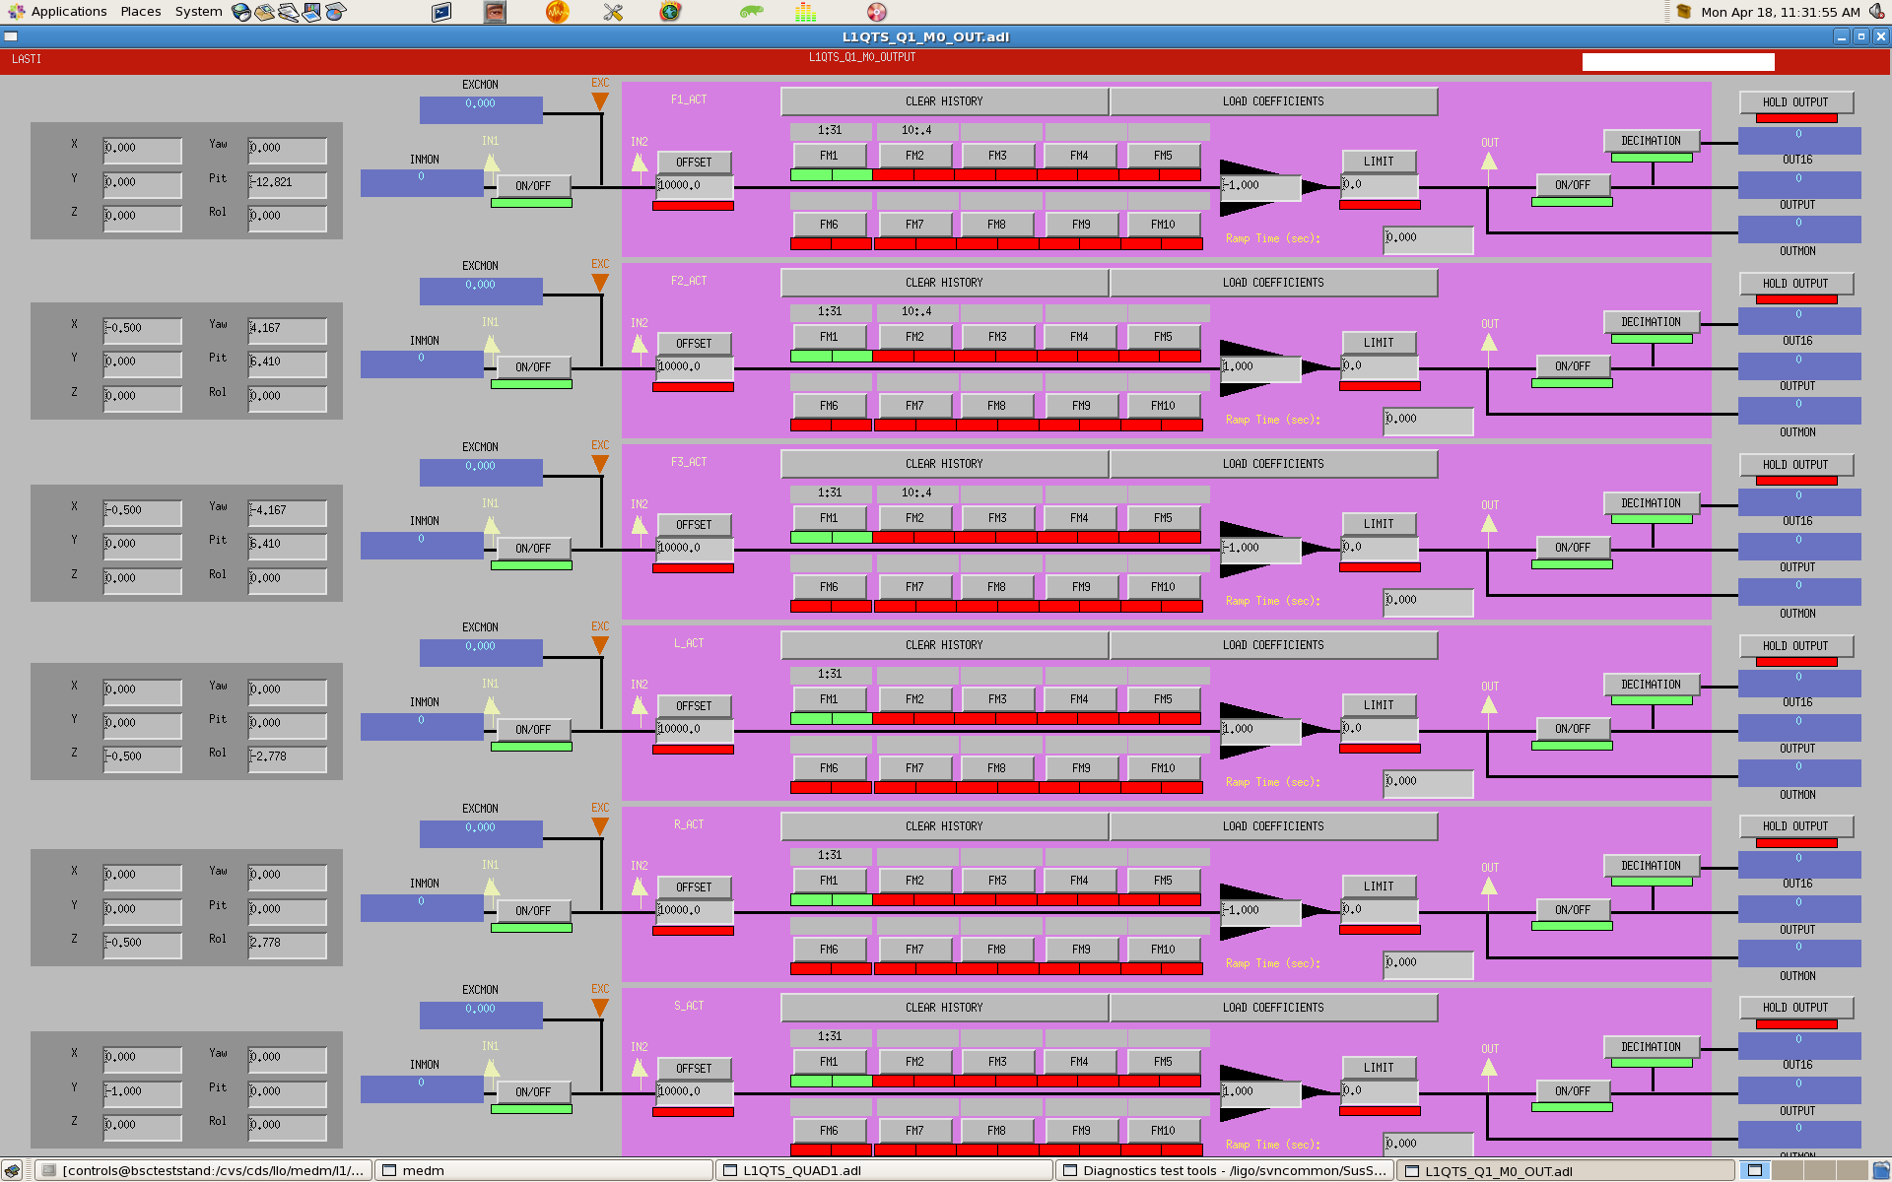
Figure 1 M0 Output Filter

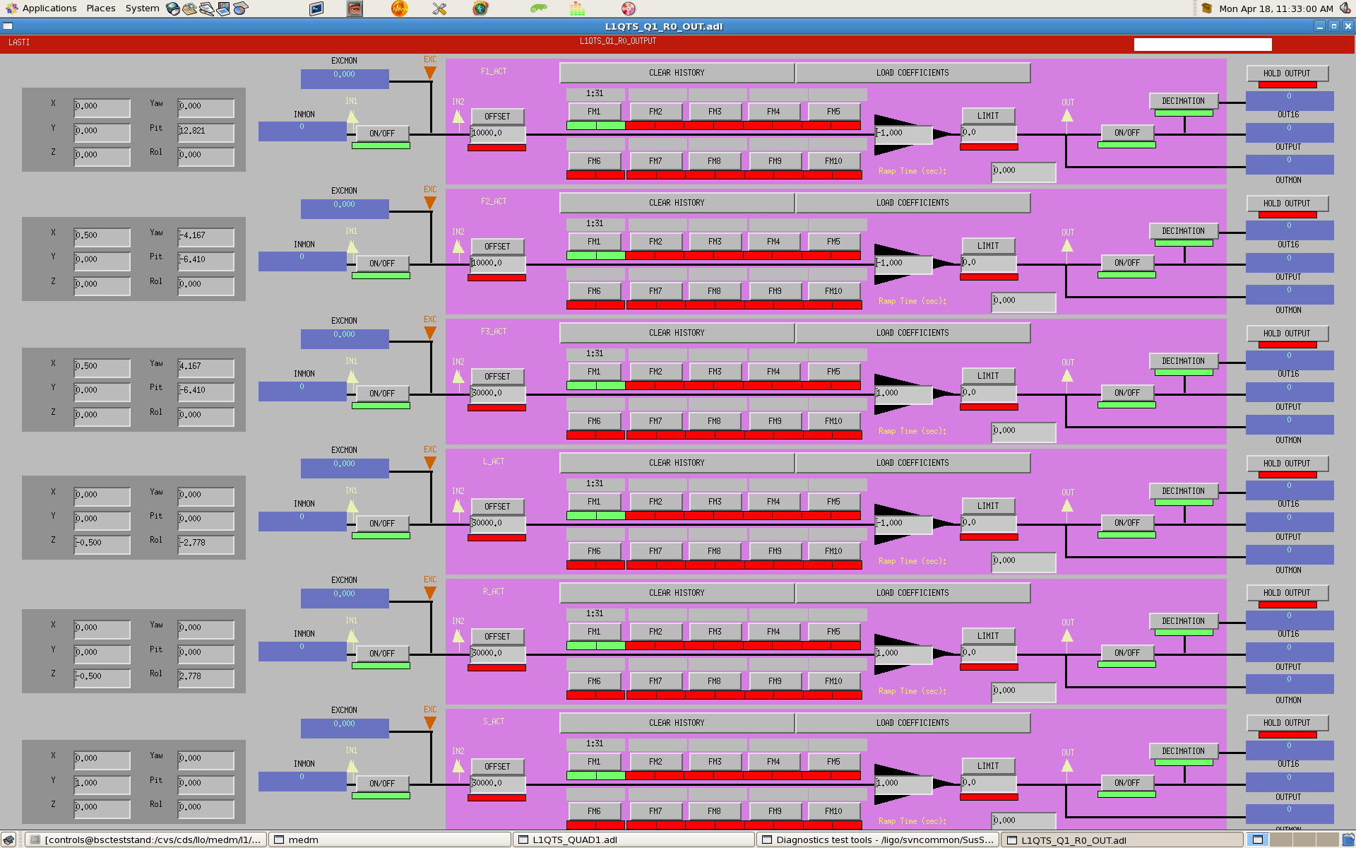
Figure 2 R0 Output Filter

DOF Input Tests
Include screen capture of each DOF to confirm correct filter settings.
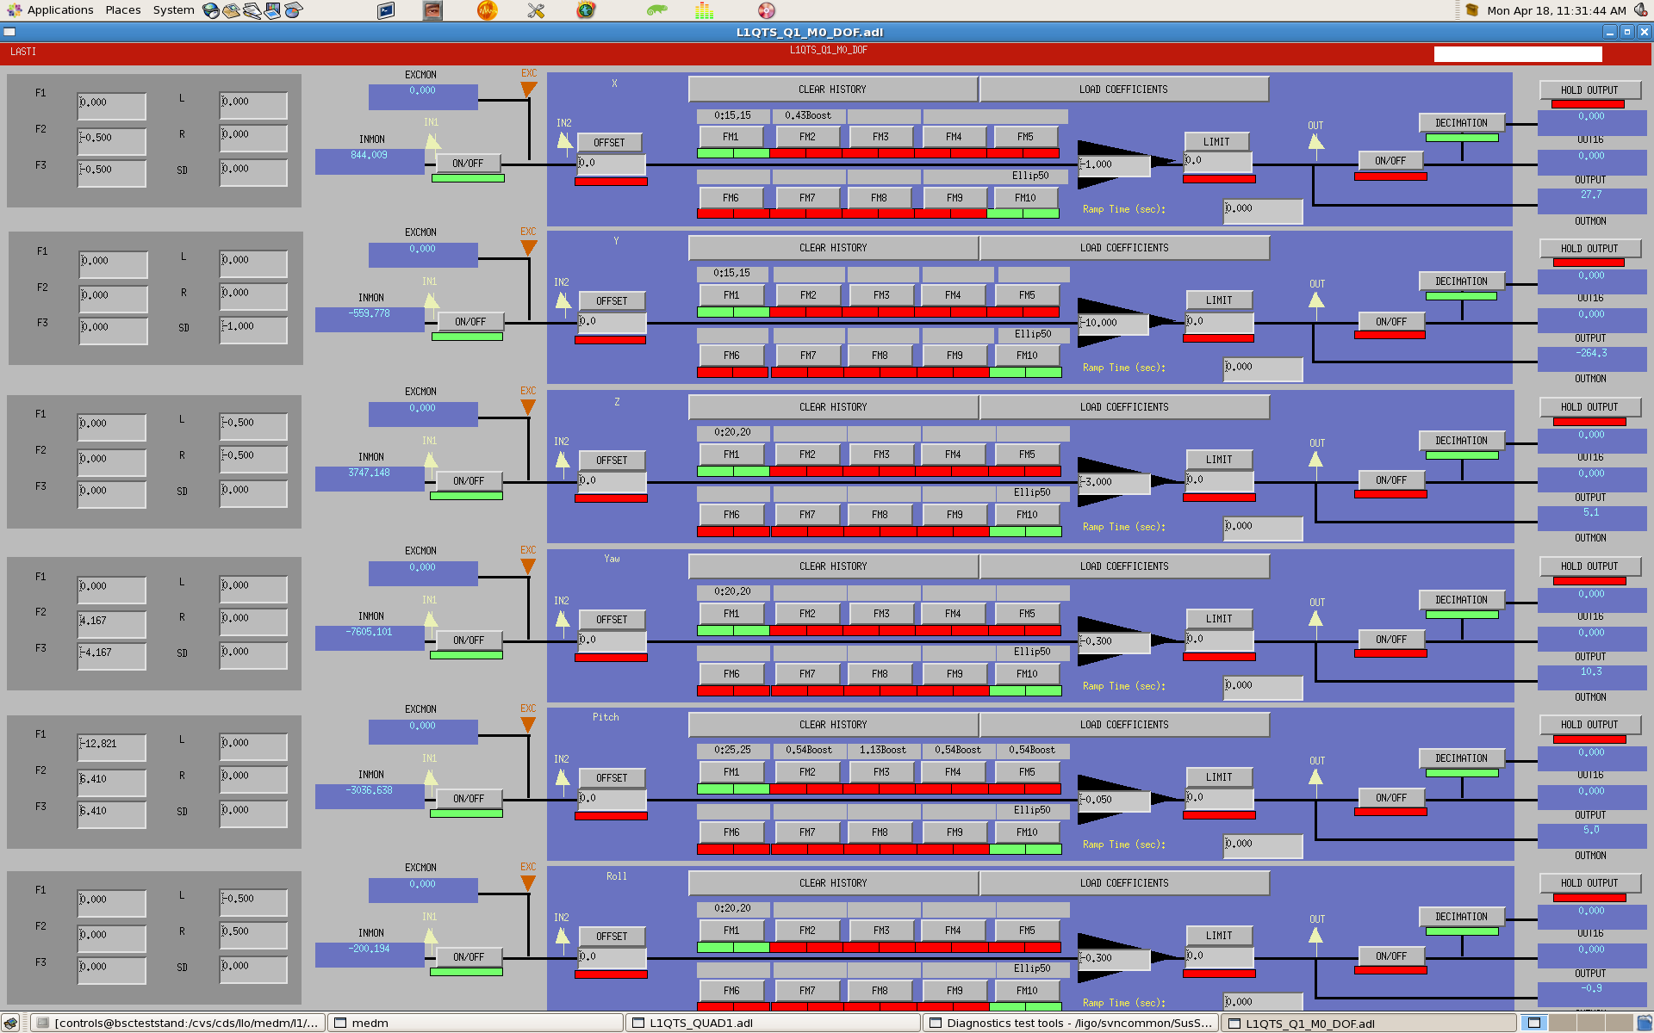
Figure 3 M0 DOF
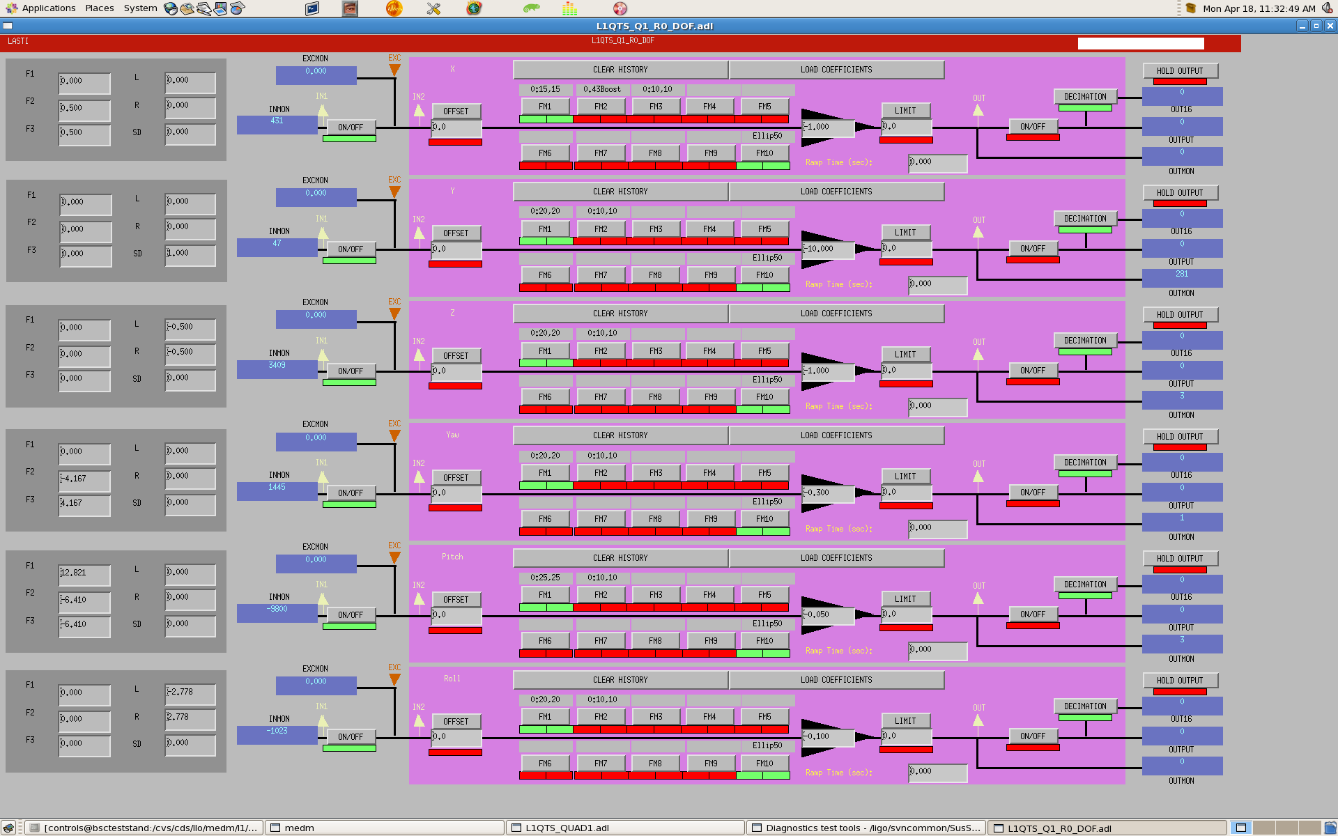
Figure 4 R0 DOF

DOF Open Loop Tests
Glass build: apply x, y, etc. actuation and monitor sensor equilibrium (DC Response.)

OSEM Basis Decoupling
Record screen capture of the cursor windows for each axis of decoupling illustrating levels of coupling. (Include screen shot of six OSEM basis’ for M0 and R0 driving Yaw, Vertical, and X.)

DOF open Loop Step Tests
 | M0 |  |  | R0
 | Face 1 |  |  | Face 1
 | Face 2 |  |  | Face 2
 | Face 3 |  |  | Face 3
 | Left |  |  | Left
 | Right |  |  | Right
 | Side |  |  | Side

DOF Servo Stability Test
For each channel confirm that signals remained level and stable as each DOF output filter was disabled.

DOF Servo Step Test
/ligo/svncommon/SusSVN/sus/trunk/QUAD/Xnn/QUADnn/BUILDnn/SAGM0/DATA
/ligo/svncommon/SusSVN/sus/trunk/QUAD/Xnn/QUADnn/BUILDnn/SAGR0/DATA

M0 Servo Damping:
Figure 5 YYYY-MM-DD-HHMM-M0-xSD

Figure 6 YYYY-MM-DD-HHMM-M0-ySD

Figure 7 YYYY-MM-DD-HHMM-M0-zSD

Figure 8 YYYY-MM-DD-HHMM-M0-rollSD

Figure 9 YYYY-MM-DD-HHMM-M0-pitchSD

Figure 10 YYYY-MM-DD-HHMM-M0-yawSD

R0 Servo Damping:
Figure 11 YYYY-MM-DD-HHMM-R0-xSD

Figure 12 YYYY-MM-DD-HHMM-R0-ySD

Figure 13 YYYY-MM-DD-HHMM-R0-zSD

Figure 14 YYYY-MM-DD-HHMM-R0-rollSD

Figure 15 YYYY-MM-DD-HHMM-R0-pitchSD

Figure 16 YYYY-MM-DD-HHMM-R0-yawSD
Include XML copies of each DOF on both chains on SVN and in a compressed directory on DCC.

Transfer Function Tests
/ligo/svncommon/SusSVN/sus/trunk/QUAD/Xnn/QUADnn/BUILDnn/SAGM0/DATA
/ligo/svncommon/SusSVN/sus/trunk/QUAD/Xnn/QUADnn/BUILDnn/SAGR0/DATA

MO TF
Figure 17 YYYY-MM-DD-HHMM-M0-xTF

Figure 18 YYYY-MM-DD-HHMM-M0-yTF

Figure 19 YYYY-MM-DD-HHMM-M0-zTF

Figure 20 YYYY-MM-DD-HHMM-M0-rollTF

Figure 21 YYYY-MM-DD-HHMM-M0-pitchTF

Figure 22 YYYY-MM-DD-HHMM-M0-yawTF

R0 TF

Figure 23 YYYY-MM-DD-HHMM-R0-xTF

Figure 24 YYYY-MM-DD-HHMM-R0-yTF

Figure 25 YYYY-MM-DD-HHMM-R0-zTF

Figure 26 YYYY-MM-DD-HHMM-R0-rollTF

Figure 27 YYYY-MM-DD-HHMM-R0-pitchTF

Figure 28 YYYY-MM-DD-HHMM-R0-yawTF

Imbed an XML copy of the transfer function results for each DOF on SVN and in a compressed directory on the DCC.
- Include Quad Specific version of F1100006 aLIGO SUS Quad Transfer Function Modes spread sheet with TF peaks for all DOF.
Note: Correct (4 for yaw, 3 for vertical, 8 for longitudinal/pitch and 7 for transverse/roll).
- Fundamental pitch mode is above the fundamental pendulum mode?

Range Tests

Pitch
 | +Pitch (mRad) | -Pitch (mRad)
M0
R0

Yaw
 | +Yaw (mRad) | -Yaw (mRad)
M0
R0

Post-ECD TF
/ligo/svncommon/SusSVN/sus/trunk/QUAD/Xnn/QUADnn/BUILDnn/SAGM0/DATA
/ligo/svncommon/SusSVN/sus/trunk/QUAD/Xnn/QUADnn/BUILDnn/SAGR0/DATA

M0 Post-ECD TF
Figure 29 YYYY-MM-DD-HHMM-M0-xTF-pECD

Figure 30 YYYY-MM-DD-HHMM-M0-yTF-pECD
Figure 31 YYYY-MM-DD-HHMM-M0-zTF-pECD

Figure 32 YYYY-MM-DD-HHMM-M0-rollTF-pECD

Figure 33 YYYY-MM-DD-HHMM-M0-pitchTF-pECD
Figure 34 YYYY-MM-DD-HHMM-M0-yawTF-pECD

R0 Post-ECD TF
Figure 35 YYYY-MM-DD-HHMM-R0-xTF-pECD

Figure 36 YYYY-MM-DD-HHMM-R0-yTF-pECD

Figure 37 YYYY-MM-DD-HHMM-R0-zTF-pECD

Figure 38 YYYY-MM-DD-HHMM-R0-rollTF-pECD

Figure 39 YYYY-MM-DD-HHMM-Ro-pitchTF-pECD
Figure 40 YYYY-MM-DD-HHMM-R0-yawTF-pECD

